Hostel Management System
System design overview — with diagrams and plain-language explanations

1. Overview
The Hostel Management System is a full-stack, real-world application built to digitize and streamline hostel operations for a college. It covers student residency, attendance, safety, and communication across four user groups: students, parents, wardens, and hostel administration. It replaces manual, paper-based processes — outing registers, in-person approvals, physical attendance sheets — with a connected mobile-and-backend system that gives every stakeholder real-time visibility into what matters to them.

2. Problem Statement
College hostels currently manage outings, attendance, complaints, and emergencies through disconnected, manual processes: physical registers for entry/exit, phone calls for outing approvals, no real-time visibility for parents into their child's whereabouts, and no structured way to raise or track complaints. This creates delays, record-keeping errors, and — most importantly — safety gaps during emergencies, where minutes matter and there is no automated alerting.

3. Objectives
- Give students a single app to request outings, chat with wardens, raise complaints, and trigger emergency alerts
- Give parents visibility into their child's outing status, with the ability to approve or reject requests
- Give wardens a dashboard to manage approvals, monitor students on their floor/hostel, and respond to alerts in real time
- Automate biometric attendance capture and reconcile it against outing records
- Replace manual registers with an auditable, searchable digital system

4. User Roles
Four roles use the system, each with a different, deliberately restricted set of permissions:
Role | Core capabilities
Student | Request outings; 1-on-1 chat with assigned warden only; file complaints; trigger emergency alerts; view own attendance; receive warden announcements
Parent | Approve/reject outing requests; receive emergency alerts; chat with warden — no access to geofence/location data
Warden | Approve/reject outings; 1-on-1 chat with students; broadcast announcements; receive geofence-breach and emergency alerts; manage complaints; view hostel-wide attendance
Admin | Manage hostels/rooms/staff at institution level; view cross-hostel reports; access audit logs; configure geofence boundaries

5. Core Features

5.1 Outing request and approval workflow
A student submits a request with a reason and expected return time. It is routed to the parent and/or warden for approval, and its status is tracked through pending, then approved or rejected, then completed or overdue. The 'overdue' status is not manually checked — it comes from reconciling the approved request against real fingerprint-scanner attendance logs at the gate.
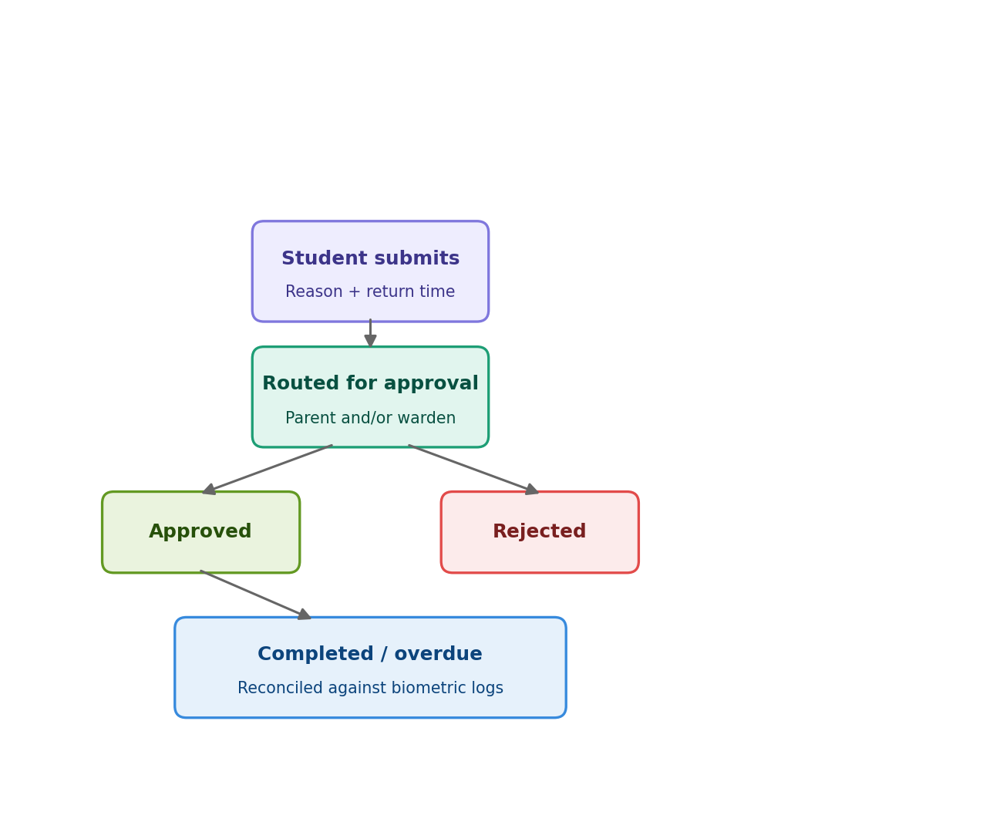
Figure 1 — Outing request and approval workflow

5.2 Biometric attendance
Fingerprint scanners at hostel gates log entry and exit automatically. These logs are reconciled against active outing requests, which is what allows the system to detect an overdue return without anyone manually checking a register.

5.3 Geofencing
Virtual boundaries are defined around the hostel or campus, and optionally around an outing's permitted radius. Rather than continuously streaming the student's live GPS location — which drains battery and creates a much larger privacy surface — the app periodically checks the student's location against the boundary, and only contacts the backend when an actual crossing happens. Access to this breach data is restricted to the warden and admin roles only.
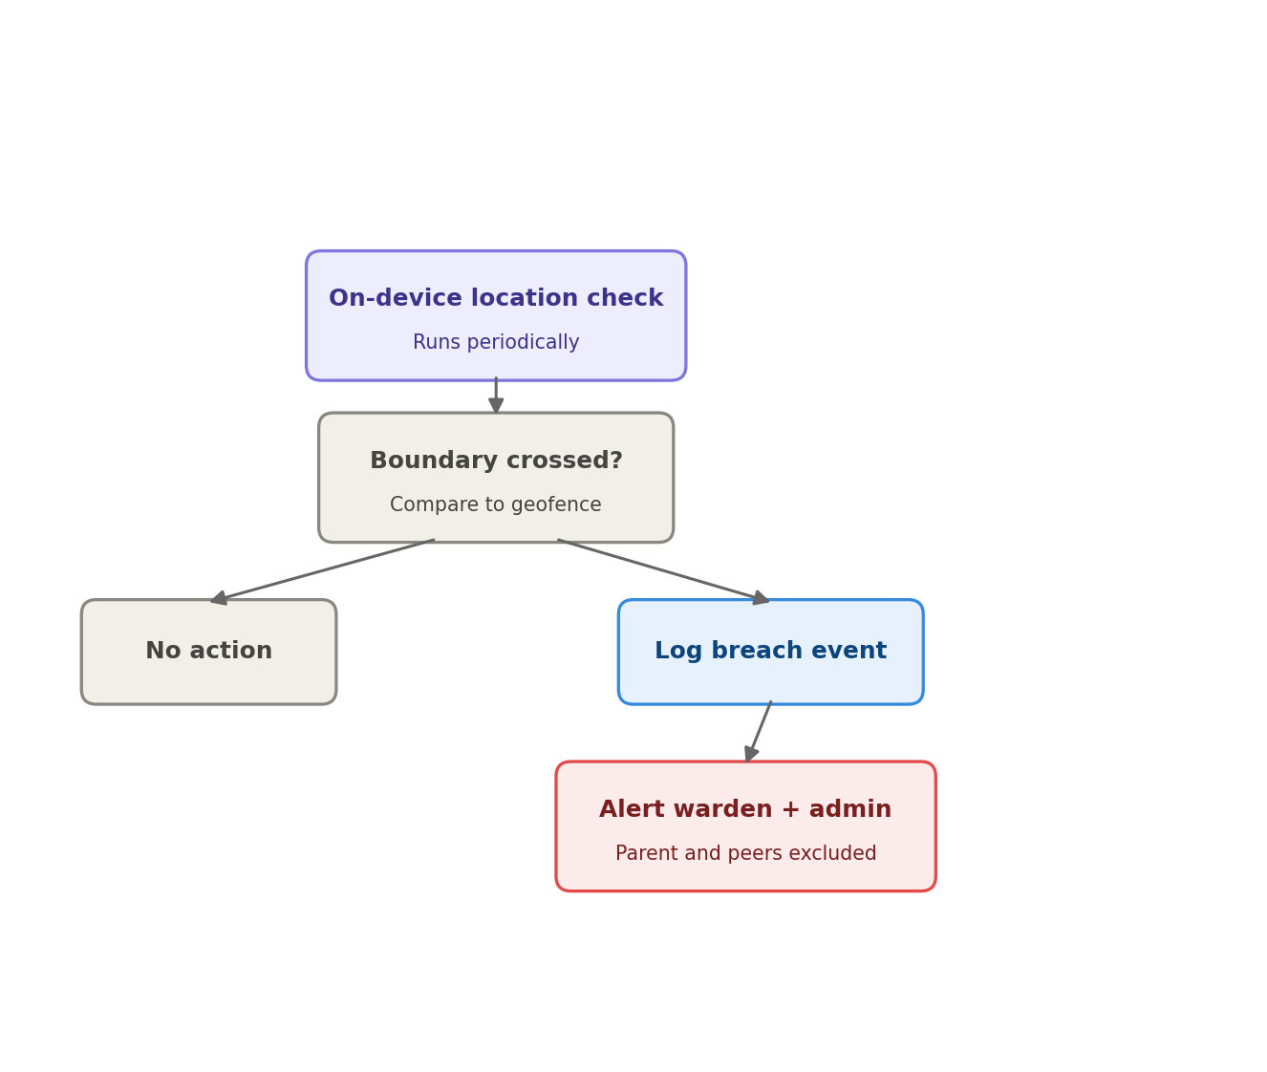
Figure 2 — Geofence boundary check and breach handling

5.4 Emergency alerts
This is the most safety-critical path in the system, and it is deliberately built to work with or without a data connection, and to never wait behind other traffic. When the device is online, the alert bypasses the normal notification queue entirely and goes through a dedicated, synchronous handler straight to a high-priority push notification (FCM) and a direct WebSocket event to the warden's app. When there is no data connection at all, the app falls back to sending the alert as an SMS directly over the cellular network — independent of WiFi or mobile data — to the warden's number and to an SMS gateway number. The gateway's inbound webhook relays the event back to the backend once connectivity returns, so it still gets logged and reaches admin. The student's last cached GPS fix is included either way, since GPS does not require a data connection.
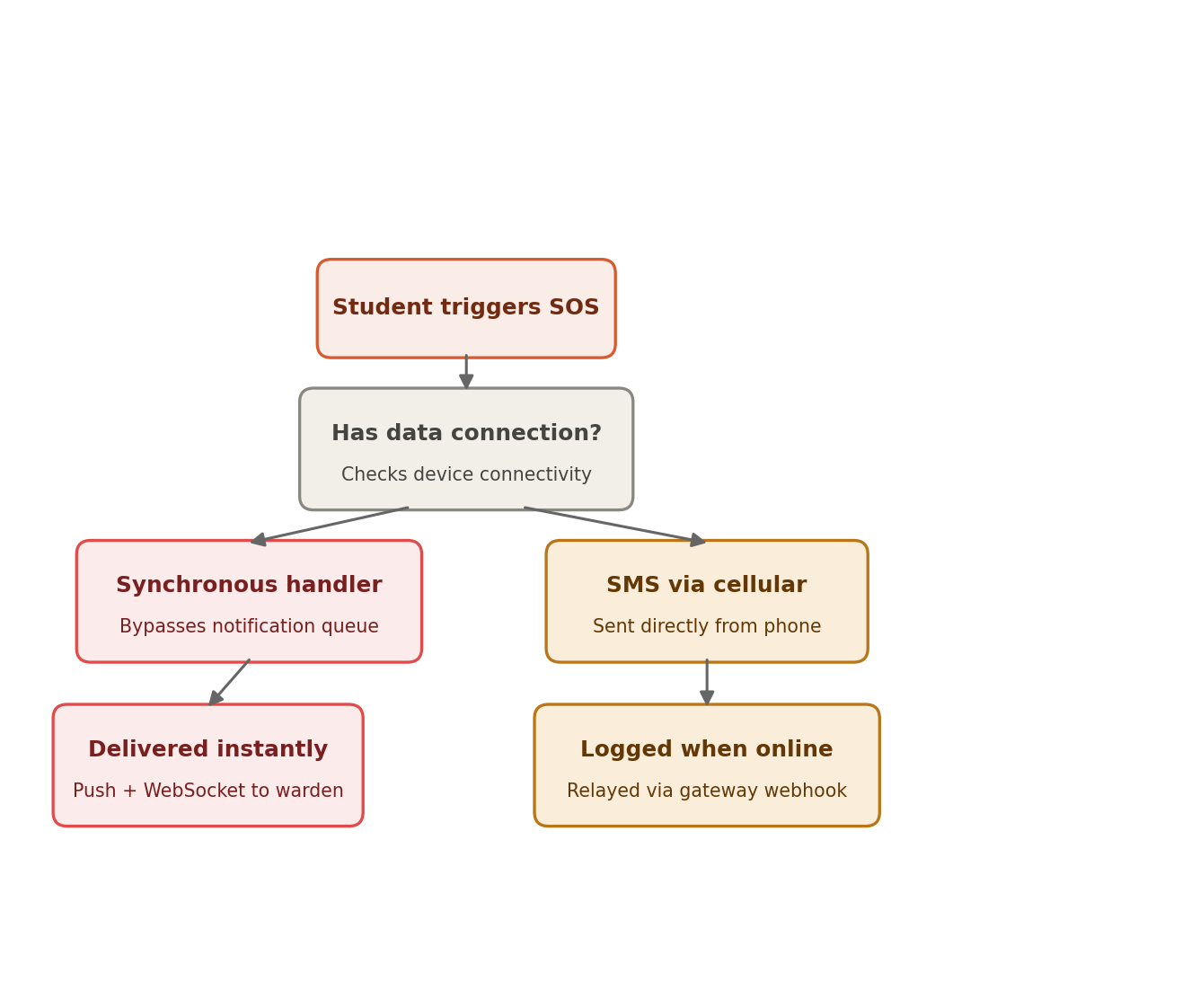
Figure 3 — Emergency alert flow: online versus offline

5.5 Chat and warden announcements
Students can message only their assigned warden — there is no student-to-student or student-to-parent channel. Parents have a separate 1-on-1 channel with the same warden. Announcements are structurally different: a warden can broadcast a single one-directional message to every student in their hostel at once. Unlike emergency alerts, announcements deliberately go through the same background queue as other routine notifications — a broadcast to hundreds of students should never block the warden's request or the server, and a short delivery delay is expected and acceptable.
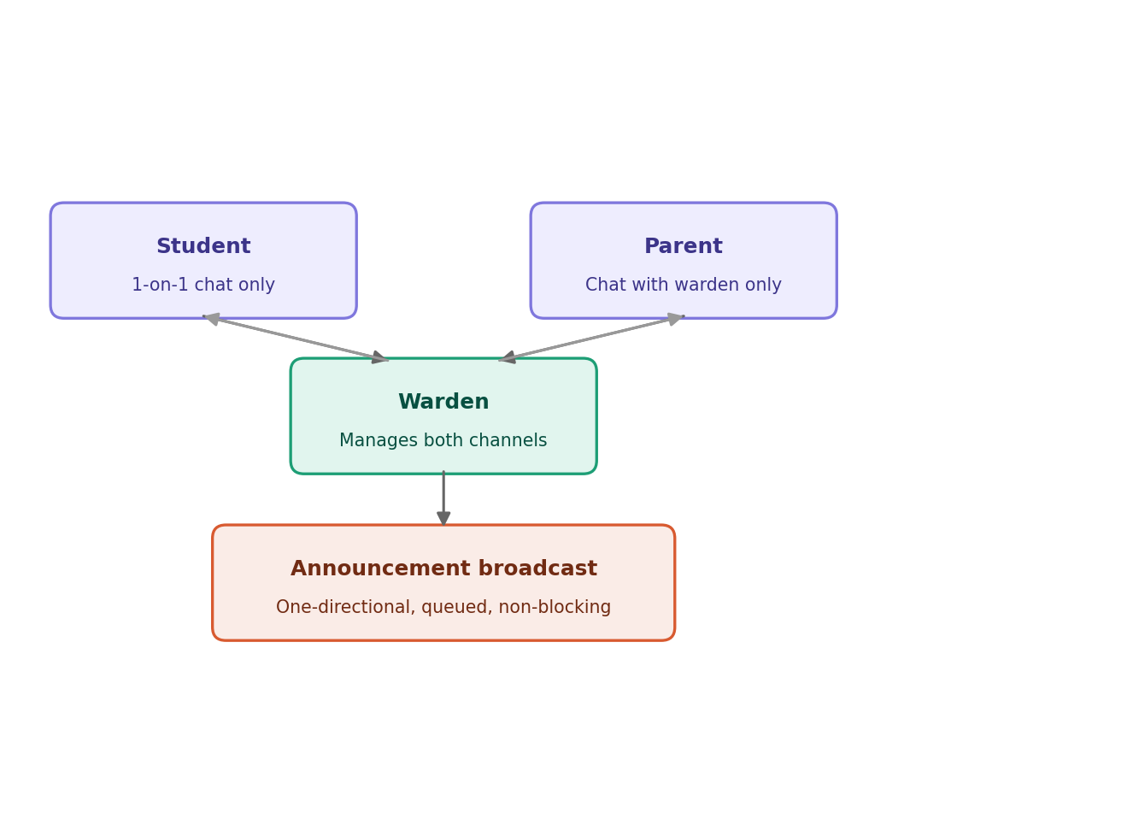
Figure 4 — Chat channels versus broadcast announcements

5.6 Complaints management
Students file complaints — maintenance, mess, and so on — with optional photo attachments, tracked through to resolution. A complaint can be routed to the assigned warden by default, or directly to admin. The direct-to-admin option exists specifically so a complaint about the warden, or one needing institution-level attention, is not stuck going through the same person it may be about.
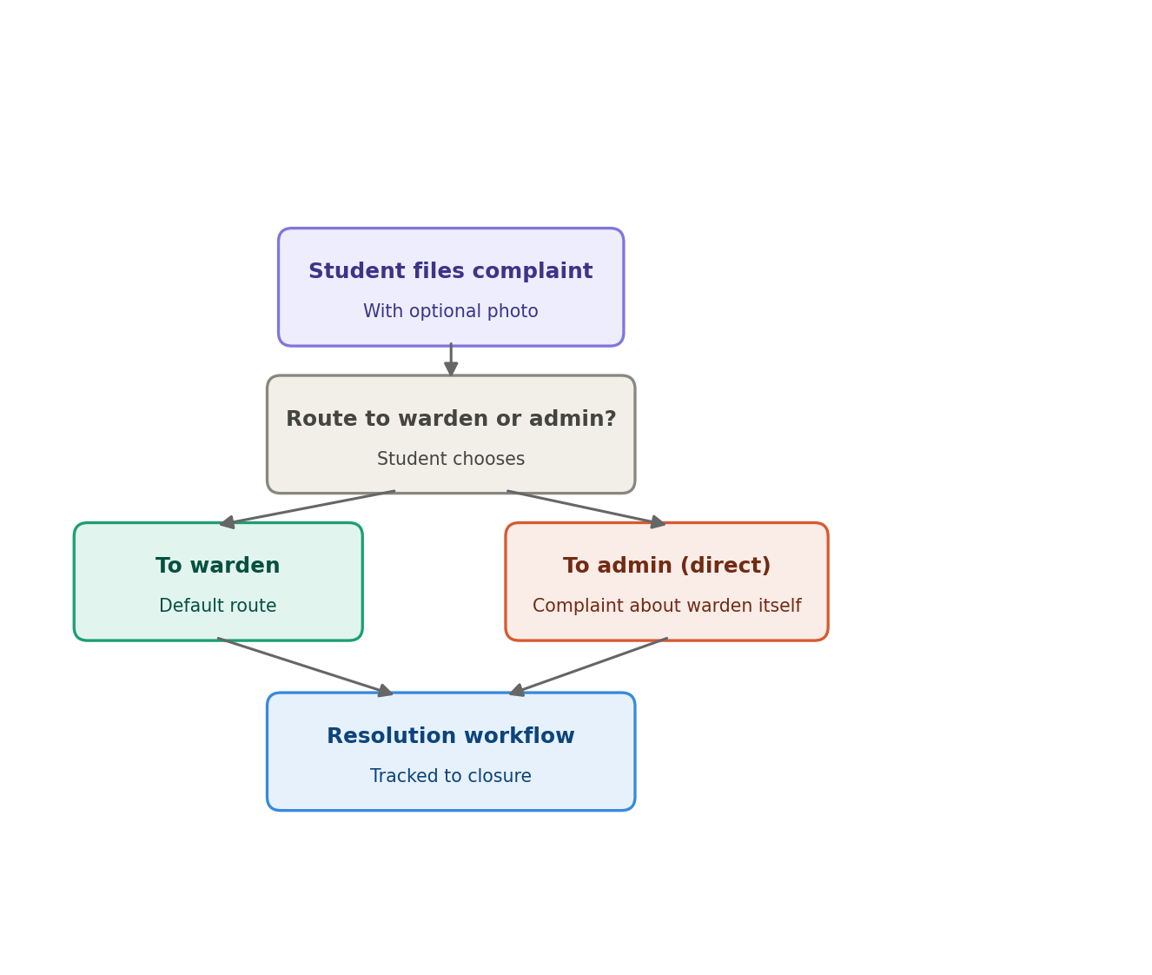
Figure 5 — Complaints routing and resolution workflow

5.7 Notifications
Routine push notifications, with SMS fallback, cover approvals, alerts, and complaint status changes.

6. System Architecture
The system follows a modular monolith pattern: one deployable backend, cleanly divided into independent modules by business capability, sitting behind a single API gateway. This was a deliberate choice over full microservices — it gives clean separation of concerns without the operational overhead of running and coordinating many independently-deployed services, which is not justified at this project's scale.
At a high level: the Flutter apps (Student, Parent, Warden) talk to a single API gateway, which handles authentication, role-based access, and rate limiting. From there, requests split into a synchronous path — core services talking directly to the database for operations that need an immediate response, like submitting an outing request — and an asynchronous path, where a queue and background workers handle anything that talks to a slow external service, like sending an SMS or push notification, so those never block the user-facing request.
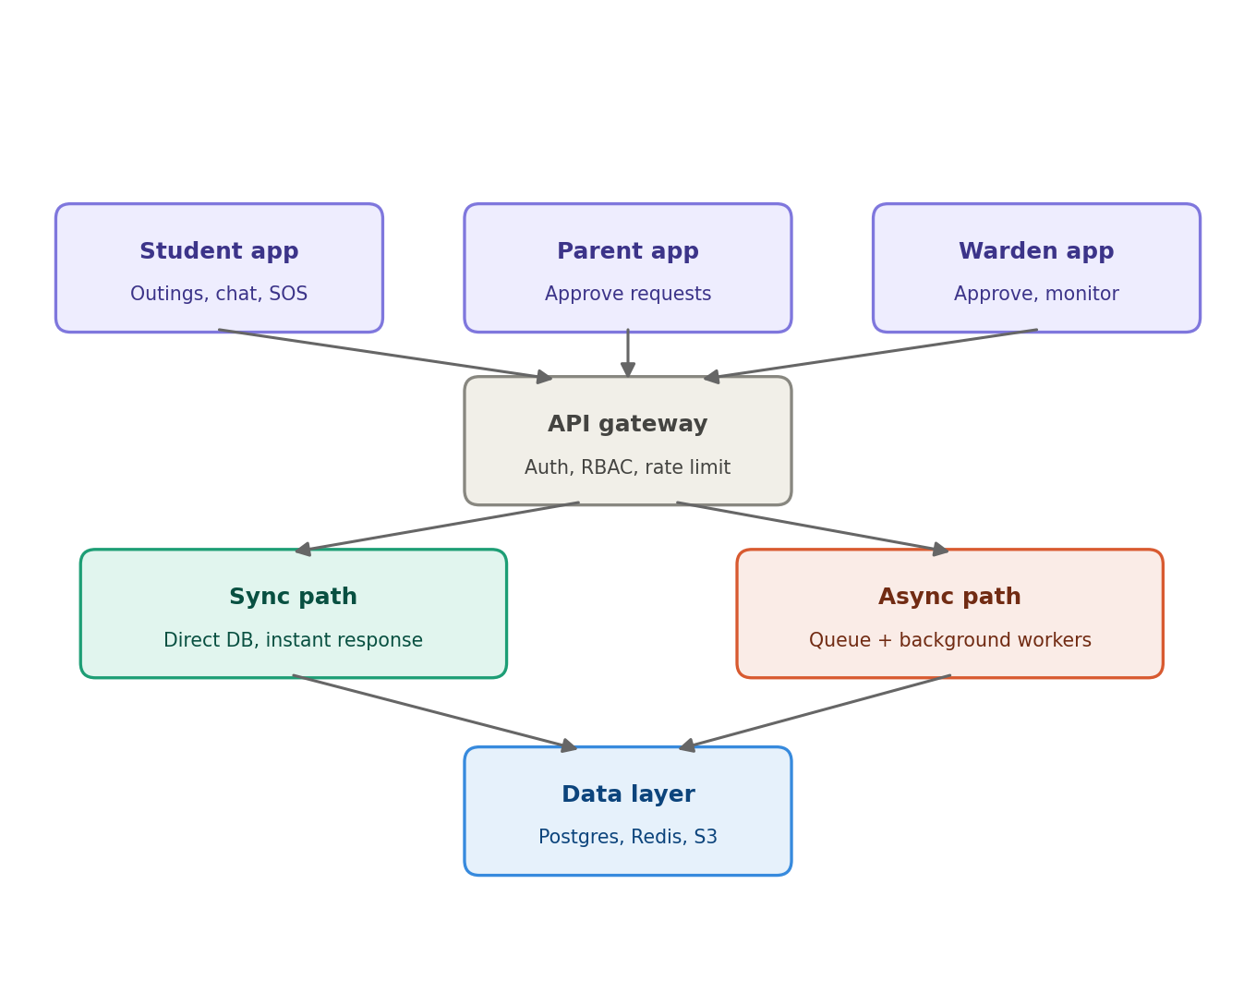
Figure 6 — High-level system architecture

6.1 The API gateway pipeline
Every request passes through three checks, in order, before it reaches any backend module. Authentication validates the JWT access token. The role check (RBAC) confirms this specific role is allowed to hit this specific route. The rate limit check, backed by Redis, blocks a user sending requests too fast. Failing any one check stops the request immediately with the appropriate error — 401, 403, or 429 — before it ever touches the backend.
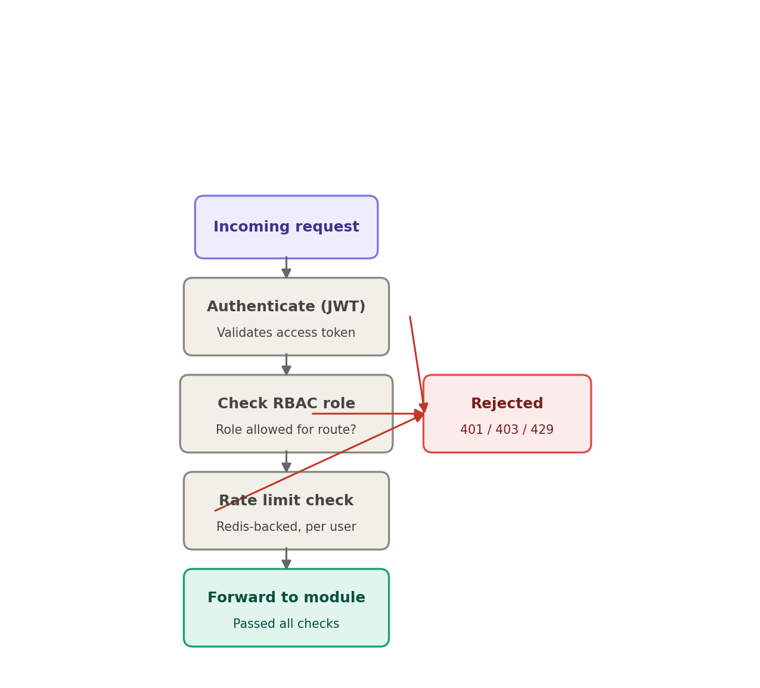
Figure 7 — API gateway request pipeline

6.2 Backend modules
Once a request clears the gateway, it lands inside one of seven modules within the single deployable backend: auth, outings, biometrics, alerts, location, chat, and notifications. The alerts module is the one exception that bypasses the async queue for speed; notifications handles everything routine through the queue for scale.
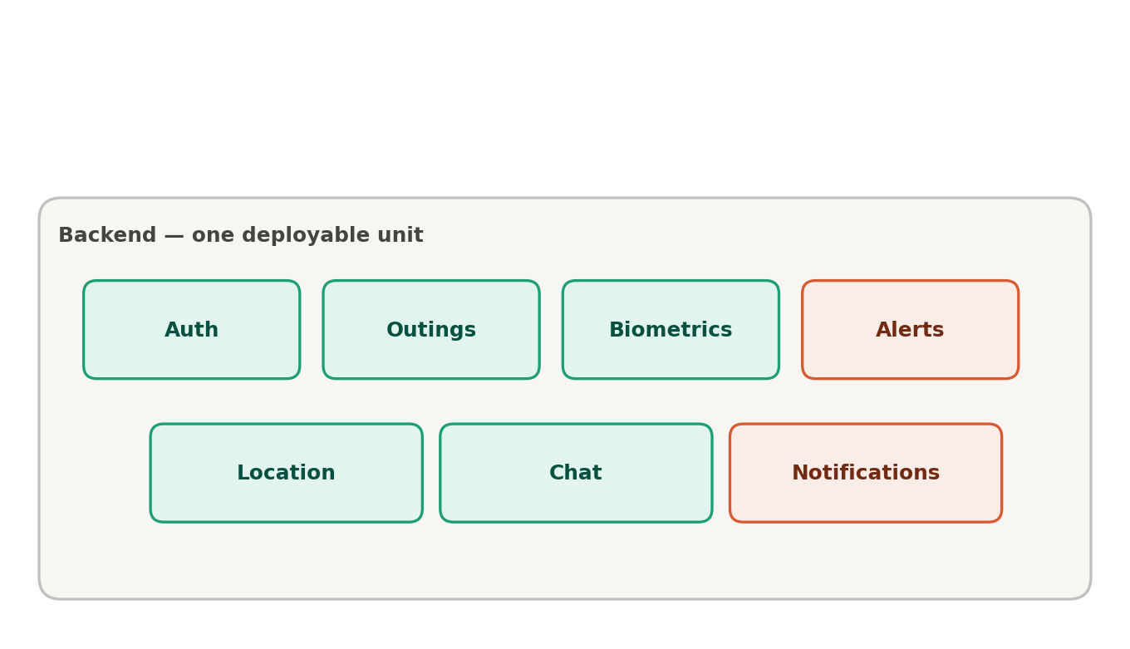
Figure 8 — Backend modules inside the modular monolith
Real-time features — chat and emergency alerts — run over WebSockets (Socket.IO), backed by a Redis pub/sub adapter so the real-time layer can scale across multiple server instances rather than being pinned to one.

7. Data Layer
The data layer is deliberately split across four purpose-built stores rather than one single database, because the data itself has fundamentally different shapes and access patterns.
Store | Purpose
Postgres (primary) | System of record for all structured, relationship-heavy data — users, hostels, rooms, outing requests, biometric logs, geofence events, complaints, and audit logs. Chosen over a document store because the data is inherently relational and needs enforced integrity and multi-step transactions.
Read replica | A continuously-synced, read-only copy used for reporting and dashboard queries, so heavy analytical reads never compete with live writes.
Redis | Shared, in-memory storage doing three jobs: caching frequently-read data, storing session/refresh-token state, and acting as the pub/sub backbone for the real-time layer.
Object storage | Binary files — complaint photos, ID proofs, exported reports — kept out of the relational database and referenced by URL.
On-device caching, separately, runs inside each Flutter app using Hive/SQLite. This is a private, per-user, client-side store for offline resilience and instant load of personal data — distinct from and complementary to Redis, which serves shared data to all users from the server side.
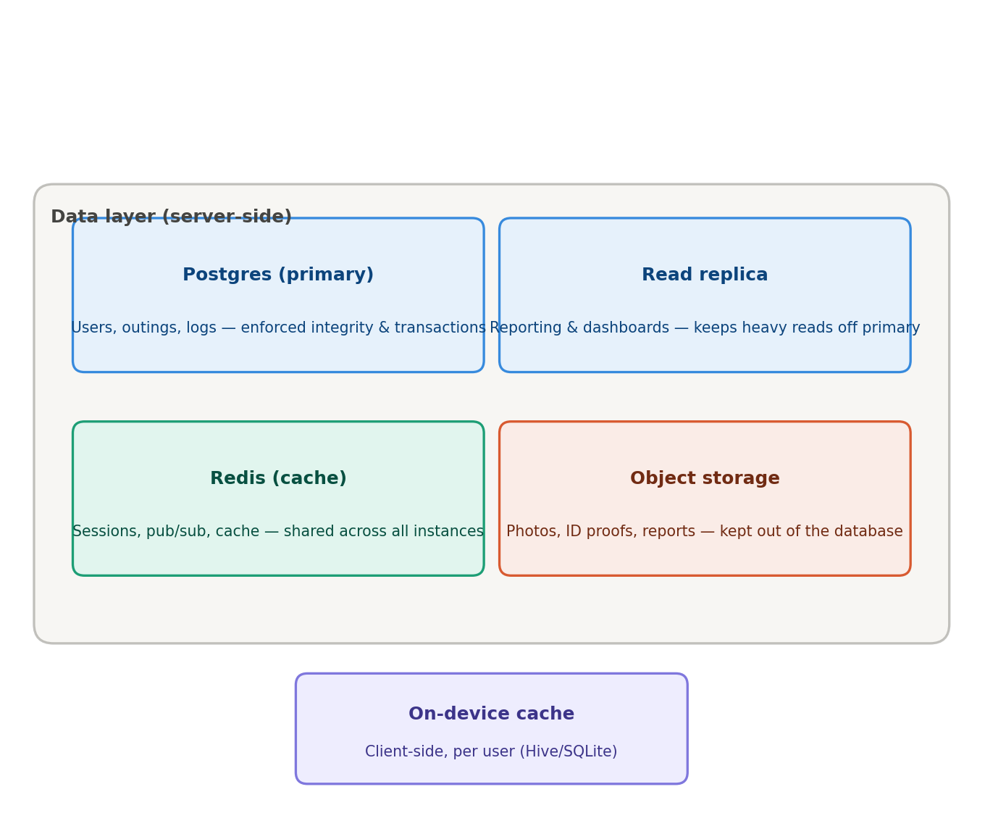
Figure 9 — The four data stores and how they divide responsibility

8. Technology Stack
Layer | Technology | Why
Client apps | Flutter | Single codebase across Student, Parent, and Warden apps on both iOS and Android
Backend | Node.js + Express | I/O-heavy workload well-suited to Node's async model
Real-time | Socket.IO + Redis adapter | WebSocket-based chat and live alerts, horizontally scalable
Auth | JWT (short-lived access + rotating refresh tokens) | Stateless, mobile-friendly; refresh rotation adds revocability
Primary database | PostgreSQL | Relational integrity, transactions, mature tooling
Cache / sessions | Redis | Shared cache, session store, Socket.IO pub/sub
Async processing | RabbitMQ/SQS + background workers | Decouples slow external calls from the request path
Object storage | S3/GCS-compatible storage | Files and attachments
Push notifications | Firebase Cloud Messaging | Free, reliable, cross-platform
SMS | Twilio / MSG91 | Fallback delivery when push fails; also the inbound webhook for offline emergency alerts
Offline emergency SMS | Native SMS plugin on-device | Sends the SOS alert over the cellular network with no data connection
Admin MFA | TOTP authenticator app | Required second factor for the high-privilege admin role
Maps / geofencing | Google Maps API | Defines hostel boundaries and checks breach events
Biometric hardware | Mantra/ZKTeco fingerprint SDK | Standard for Indian hostel/institutional attendance hardware
Deployment | Docker on managed container hosting | Reproducible deployments without self-managed Kubernetes overhead

9. Security
Security is applied in layers, rather than relying on any single checkpoint. This is often called defense in depth: a request is checked for role-based access at the API gateway, then checked again, independently, at the service layer. WebSocket connections — used for chat and emergency alerts — are a separate entry path, so they re-validate the JWT on connect, and re-check authorization every time a client tries to join a specific chat room or announcement channel.
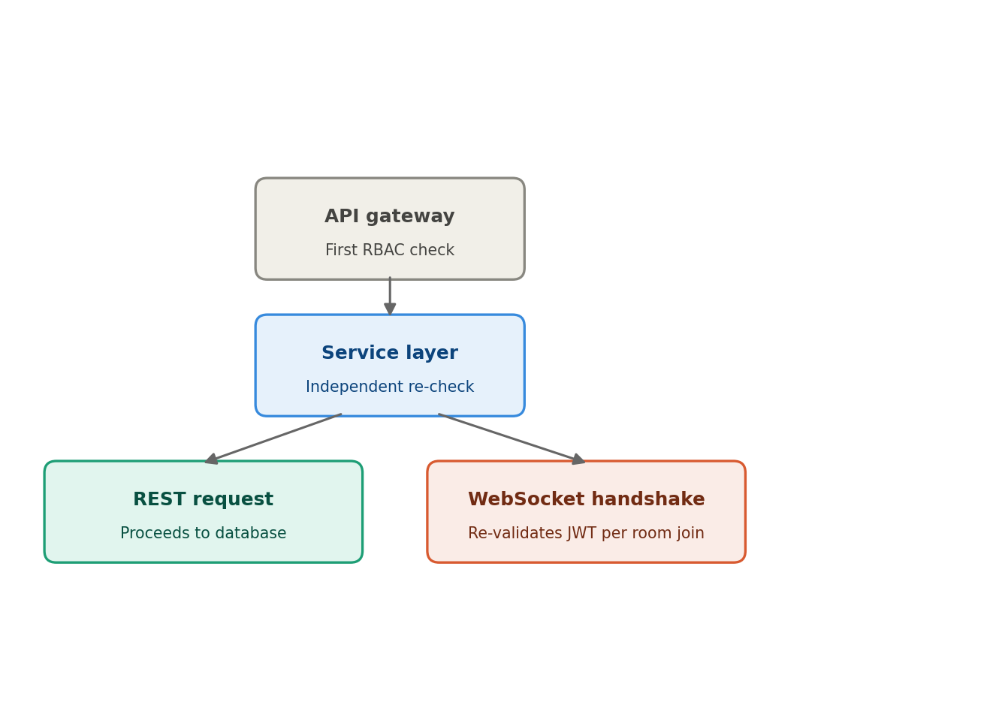
Figure 10 — Defense in depth: RBAC checked twice, WebSocket checked separately
The rest of the security measures in place:
- Bcrypt/Argon2id password hashing
- Short-lived JWT access tokens with rotating, Redis-backed refresh tokens, revocable per device
- Geofence-breach events and any location data are scoped to warden and admin roles only, enforced server-side — never assumed safe just because the client-side UI hides it
- Mandatory MFA (TOTP) for the admin role, with a shorter access-token and refresh-token lifetime than other roles
- Chat channels are scoped per-pair at the database and Socket.IO room level, so there is no mechanism for a student to join another student's room or reply individually to a broadcast
- Parameterized queries throughout, to prevent injection
- Server-side input validation and sanitization on every endpoint
- Rate limiting at the gateway, backed by Redis
- HTTPS enforced end-to-end with HSTS
- Encryption at rest for the database and object storage
- Audit logging of all approval/rejection actions and location-history access
- File upload validation (type and size), with storage kept outside the web root

9.1 Data retention
Sensitive data is not kept indefinitely by default. Geofence events are retained for 90 days and then purged, unless tied to an open complaint or emergency case. Chat history is retained live for 12 months, then archived to cold storage. Audit logs — the accountability record — are retained for 3 years. Retention windows are configurable by admin, but these defaults exist specifically so data does not linger unnecessarily.

10. Scalability Considerations
The system is designed to comfortably support the target scale of 10 hostels, roughly 8,000 students, and roughly 500 staff. Stateless API instances behind a load balancer allow horizontal scaling — none of them hold session state locally, since that lives in Redis, so instances can be added or removed freely. The read replica takes reporting load off the primary database, and the queue with background workers ensures notification volume never blocks a user-facing request. Switching from continuous live location tracking to geofencing significantly reduces load in particular: instead of thousands of GPS pings per student per day, the system only records the comparatively rare boundary-crossing events.
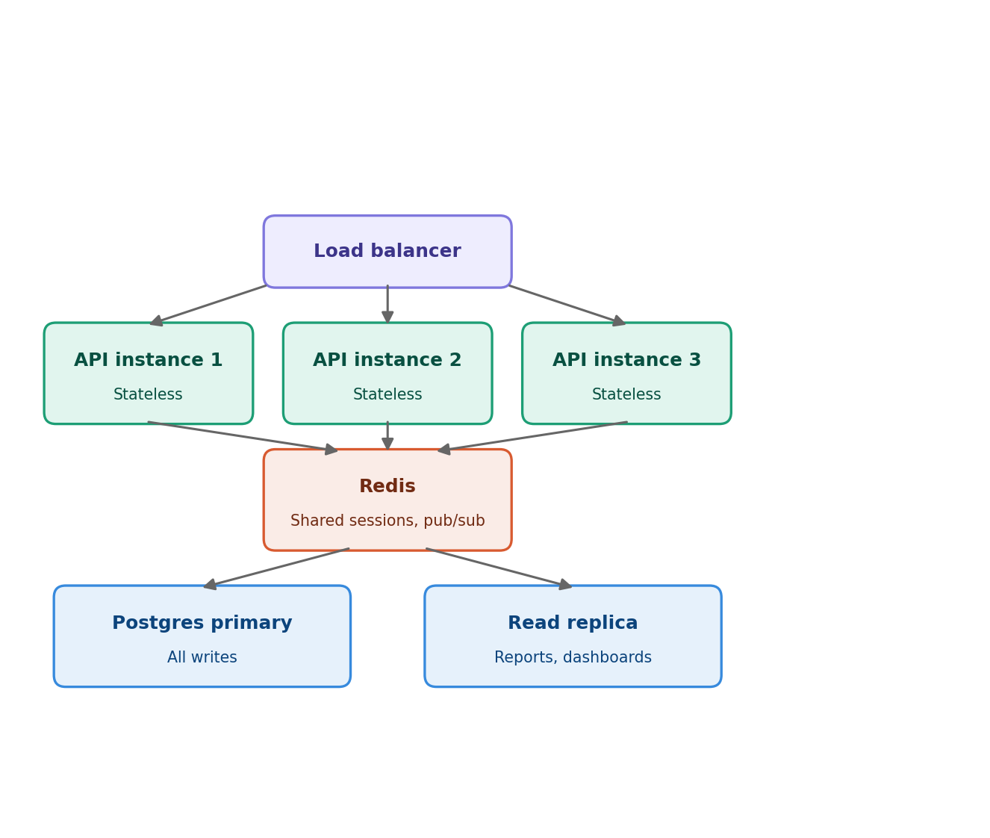
Figure 11 — Load balancing, stateless instances, and the primary/replica split

11. Production Readiness
Beyond the application code, the system is designed with the operational scaffolding a real, safety-relevant deployment requires: automated CI/CD (test, build, deploy), centralized logging and error tracking, uptime and health-check monitoring, automated and tested database backups, and a documented disaster-recovery runbook — since this system is relied on for time-sensitive safety features like emergency alerts, not just convenience features.

12. Summary
This project demonstrates end-to-end system design for a real, multi-stakeholder application: relational database modeling with enforced integrity, a modular backend architecture balancing synchronous and asynchronous processing, real-time communication at scale, hardware integration with biometric scanners, and the security and operational practices needed before real students' safety-relevant data can depend on it.

Appendix A — Key Concepts Explained Simply
This appendix is for anyone reading the report who is not from a technical background. It explains a few terms used above using everyday comparisons, before showing how each one applies to this project.

A.1 What is an API?
An API is simply the agreed-upon way two pieces of software talk to each other — like a restaurant menu. A customer does not walk into the kitchen and cook their own food; they tell the waiter what they want using the menu's format, and the kitchen sends back a dish. In this project, the 'menu' is the fixed set of requests the Student, Parent, and Warden apps are allowed to make — such as 'submit an outing request' or 'send a chat message' — and the fixed shape of the answer they get back.

A.2 What is a gateway?
The gateway works like the front desk of an office building. Before anyone can reach a specific department (a specific backend module), they must pass the front desk first. The front desk does not do the actual work — it only checks: are you allowed in this building at all, do you have the right badge for the floor you are going to, and are you trying to come in an unreasonable number of times in a row. Only after clearing the front desk does a request reach the department that can actually help.

A.3 What is a pipeline?
A pipeline is a sequence of checks performed one after another, in a fixed order — the same way a passenger moves through airport security. Passengers are not checked for identity and boarding pass at the same instant; they move through stations in order, and failing any one station stops them right there.
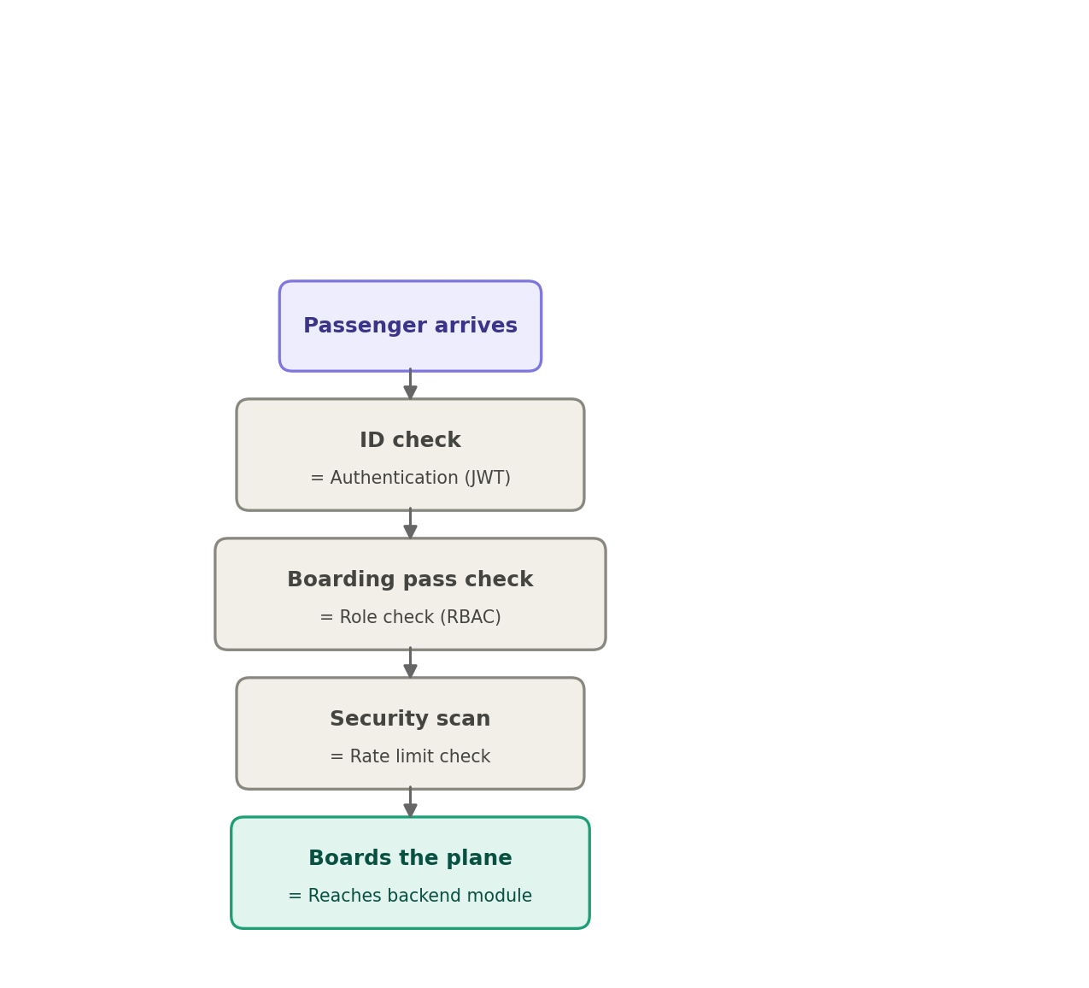
Figure 12 — The gateway pipeline explained as an airport security analogy
In other words: the front-desk building has three checkpoints lined up in a row, and a request has to clear all three before it is let further in.

A.4 Why check permissions twice? (Defense in depth)
This is the part that is easy to misunderstand: why does the backend service re-check a user's role if the gateway already checked it? Because the gateway is like the security guard at the building's main entrance — but once inside, a second guard checks the badge again at the specific floor being entered. This matters because the front desk is not the only way in. In this system, the WebSocket connection used for live chat and emergency alerts is a separate entry path, like a side door, and it needs its own independent check rather than trusting that the front door was already cleared. The principle, stated plainly: do not rely on a single checkpoint to catch everything — place a checkpoint at every entrance, because there is more than one way in.

A.5 Synchronous versus asynchronous — phone call versus text message
A synchronous (sync) action is like making a phone call: the caller waits on the line until they get an immediate answer. A student submitting an outing request needs to know right away whether it was submitted, so this happens synchronously — straight to the database, with an instant reply.
An asynchronous (async) action is like sending a text message: the sender keeps doing other things, trusting that the message will be delivered and answered when the recipient is free. When a warden broadcasts an announcement to 300 students, the server does not need to send all 300 notifications before letting the warden move on — the job is placed in a queue, and background workers deliver it while the warden's app is already free to do other things.
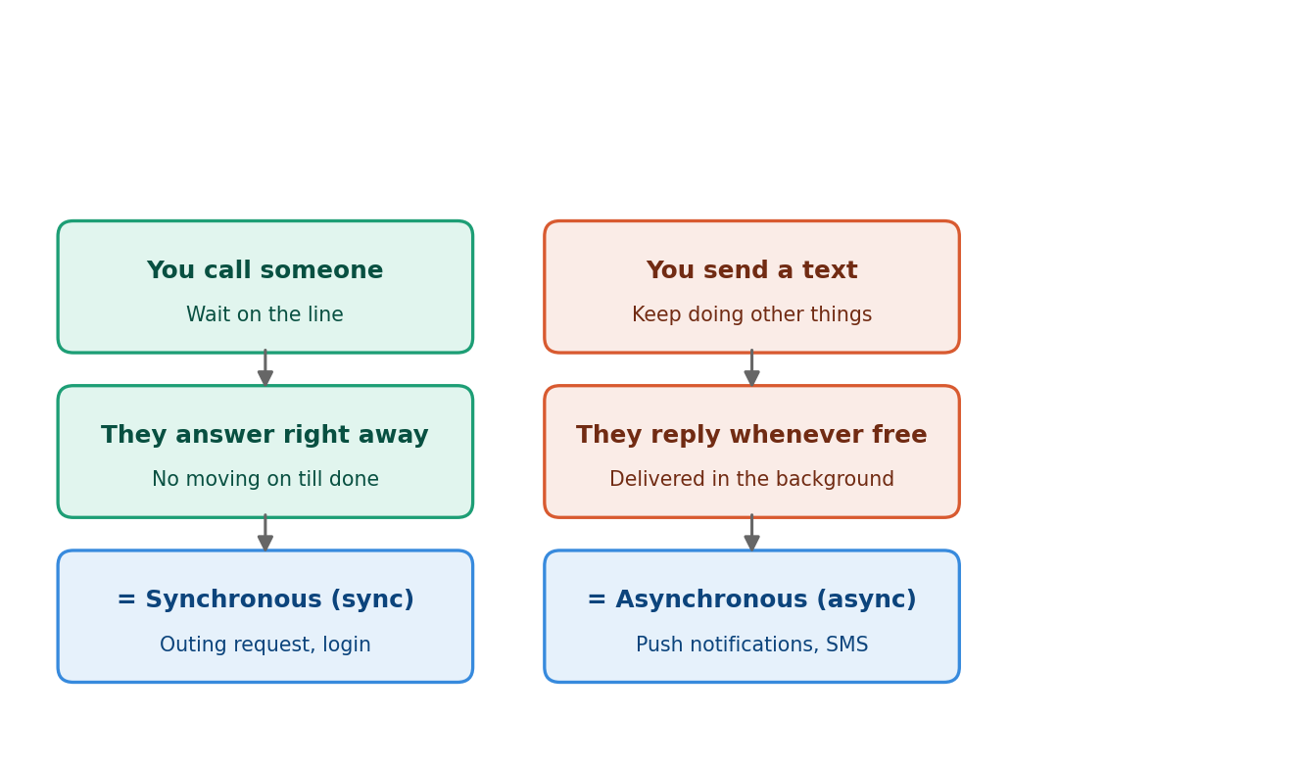
Figure 13 — Synchronous versus asynchronous, explained as a phone call versus a text message
The one deliberate exception is the emergency alert: it does not wait in the background queue the way a routine announcement does, because a message that simply 'gets there eventually' is not good enough when a student may be in danger. It is built to be as close to instant as a phone call, precisely because minutes matter.

A.6 Putting it all together
The architecture provides separation of concerns and room to scale. The data layer gives each kind of data the storage system best suited to it. The outing workflow is the everyday transactional loop, reconciled automatically against real hardware. The emergency alert path is the one place the system deliberately trades uniformity for raw speed, because it is the one feature where a delay of even a few seconds carries real risk. Every other design decision in this project — the choice of database, the split between synchronous and asynchronous processing, the layered security checks — exists in service of that same underlying goal: giving students, parents, and wardens a system that is fast where it needs to be fast, careful where it needs to be careful, and honest with each role about exactly what it can and cannot see.

