**B. Tech Project Report**

On

**PICK AND PLACE ROBOTIC ARM**

Submitted to



**NATIONAL INSTITUTE OF TECHNOLOGY, DURGAPUR**

In Partial Fulfilment for MES754 in

**MECHANICAL ENGINEERING**

Under the Supervision of

**DR. RATNESH KUMAR**

Submitted by:

|  |  |
| --- | --- |
| **NAME** | **ROLL NO:** |
| SUBBY KUMARI | 21ME8005 |
| MENAKA SIRISHA | 21ME8056 |
| SAHIL PRASAD SHAW | 21ME8076 |

|  |
| --- |
| ***ACKNOWLEDGEMENT*** |

This dissertation would not have been possible without the guidance and the help of several individuals who in one way or another contributed and extended their valuable assistance in the preparation and completion of this study.

We would like to express our gratitude to National Institute of Technology, Durgapur for including Final-Year Project as a one-credit course which has provided an opportunity to gain practical working experience in the organization.

Our sincere gratitude to Dr. Asit Baran Puri, Head of Department, Mechanical Engineering, for giving us this opportunity.

We are thankful to Dr. Ratnesh Kumar for devoting time and explaining how tasks are done and assigning us with various tasks throughout the semester.

|  |
| --- |
| ***TABLE OF CONTENTS*** |

|  |  |  |
| --- | --- | --- |
| **Sl. No.** | **Contents** | **Page No.** |
| 1. | Abstract | 4 |
| 2. | Introduction | 5 |
| 3. | Literature Review | 6 |
| 4. | Theory | 9 |
| 5. | CAD Drawing: Parts and Assembly | 29 |
| 6. | Simulation | 33 |
| 7. | Conclusion | 36 |
| 8. | Bibliography | 37 |

|  |
| --- |
| ***ABSTRACT*** |

This project involves the design and construction of a Pick and Place Robotic Arm, a versatile tool capable of executing precise mechanical tasks. The robotic arm, featuring five degrees of freedom, is equipped to perform complex actions such as picking and placing objects with minimal human intervention. The system uses servo motors and a microcontroller to provide motion control, enabling seamless operation. The arm is designed for compact workspaces, demonstrating potential applications in automation, material handling, and assembly processes. By combining affordability and functionality, this project emphasizes the feasibility of robotic solutions for everyday tasks, paving the way for greater integration of robotics in various domains.

|  |
| --- |
| ***INTRODUCTION*** |

Robotics has emerged as a transformative force in automation, significantly impacting industries such as manufacturing, logistics, and healthcare. The Pick and Place Robotic Arm exemplifies this technological shift by offering an efficient and precise solution for object handling tasks. This robotic system, with its five degrees of freedom, enables the arm to perform complex movements, making it suitable for applications requiring dexterity and accuracy. The arm's design incorporates servo motors, a gripper mechanism, and an intuitive control system, enabling seamless operation. This project aims to demonstrate the feasibility of using robotic arms for repetitive tasks, thereby reducing human intervention and enhancing process efficiency. The following report presents a comprehensive guide to the assembly, control, and applications of the Pick and Place Robotic Arm, underscoring its potential in modern automation.

|  |
| --- |
| ***LITERATURE REVIEW*** |

**1.Design and Development of a Self-Adaptive, Reconfigurable and Low-Cost Robotic Arm by Kemal Oltun Evliyaoğlul, Meltem Elitaş**

Variety of tasks can be performed by a robotic arm when we do some changes in it, i.e., changing the number of links, it can be made self- adaptable. These aspects of a robotic arm are discussed by the author in this paper. The paper represents a basic robotic solution to fulfill different applications with the help of it. The Design consists of two panels which have their individual wiring with it, thus as per the application required the panels are arranged and servo motors are connected to perform the task.

**2. Design and Structural Analysis of a Robotic Arm by Gurudu Rishank Reddy and Venkata Krishna Prashanth Eranki**

In this paper the authors have successfully built a 4 degrees of freedom robotic arm used for handling metal sheets in a conveyor system. Reducing manual handling of sheet from stack to shearing machine is the main reason for designing this pick and place robotic arm. Two pneumatic cylinders for the feeding mechanism, and a robotic arm for the workers’ safety were designed. Integration of the manipulator position sensor in the robot’s control unit is done by RCC which is installed in the robotic arm. Robot’s ability to interact with the surroundings is possible with the help of RCC control. A self-optimisation system is provided by the manipulator depending upon the given conditions. Self-awareness system of the robot will ensure safety on site. Suction effect is produced by the vacuum cup(which is at the end effector) on the surface of the object. Continuous path, acceptable degree of freedom, speed control, repeatability and high resolution were the major factors which were processed by the manipulator.

**3.Industry Based Automatic Robotic Arm by Dr. Bindu A Thomas, Stafford Michahial, Shreeraksha.P, Vijayashri B Nagvi, Suresh M**

This paper includes the design of an automatic robotic arm which is based on industrial applications. A functional prototype was constructed. This framework would make it simpler for man to maintain a strategic distance from the danger of dealing with objects which could be unsafe at the working environment. The utilization of robots is strongly suggested for Businesses particularly for security and profitability reasons. In their design work, they included a manipulator with 5 degrees of freedom. The microcontroller issues order to the individual channels that make up the link. The electric motor operates as per given command and the speed of the motor as well as the direction and motion is controlled by the microcontroller. Meanwhile, in the mode of operation of the robot, an obstacle sensor was programmed by the microcontroller such that it detects the presence of the obstacle in 10 cm of radius. If an obstacle is sensed for the first time it pauses the work. Again, if the problem is not cleared, a feedback system such as buzzer gets turned on to bring this problem on notice of a personnel to clear the object.

**4. Design Analysis of a Remote Controlled “Pick and Place” Robotic Vehicle by B.O.Omijeh And R.Uhumwamgho International Journal of Engineering Research and Development 2014.**

This paper presents a design analysis of a Remote Controlled "Pick and Place" Robotic vehicle, focusing on safety precautions in the workplace and environment. The vehicle has a five-degree robotic arm with a base on top and four drive wheels that are selectively powered to propel it. The design methodology includes hardware, software, and implementation. A prototype was built to validate the design specifications, and the results were satisfactory. Robots are highly recommended for industries for safety and productivity reasons. The design of the robot makes it easier for humans to handle hazardous objects in their environment and workplace, achieving complex and complicated duties faster and more accurately.

**5.A survey on Arduino Controlled Robotic Arm by Ankur Bhargava**

In this paper a 5 Degree of Freedom (DOF) robotic arm has been developed. It is controlled by an Arduino Uno microcontroller which accepts input signals from a user by means of a set of potentiometers. The arm is made from four rotary joints and end effector also, where rotary motion is provided by a servomotor. Each link has been first designed using Solid works Sheet Metal Working Tool Box and then fabricated using a 2mm thick Aluminium sheet. The servomotors and links thus assembled with fasteners produced the final shape of the arm. The Arduino has been programmed to provide rotation to each servo motor corresponding to the amount of rotation of the potentiometer shaft. A robot can be defined according to the nature of the relative movements between the links that constitute it.

**6.Modeling and Simulation of 5 DOF Educational Robot By Mohammed Abu Qassem, Iyad Abuhadrous, Hatem Elaydi.**

In this study paper they have built a virtual software through which they can control the manipulator consisting of 5 degrees of freedom. This software is being used for educational purposes and for educating people about the functioning of the robotic arm. In this they have designed a 5 degrees of freedom, robotic arm which consists of servo motors for the functioning of the joints and the end actuator. In this paper they have also discussed the simulation results which were carried out on the robotic arm. The results show that they have used card generated motion for the communication between the controller and the robotic arm due to which the time resolution for the accurate positioning of the arm is 1μs and to generate extremely smooth moves a dc motor control was used.

|  |
| --- |
| ***THEORY*** |

Pick and place robots are commonly used in modern manufacturing environments. Pick and place automation speeds up the process of picking up parts or items and placing them in other locations. Automating this process helps to increase production rates. Pick and place robots handle repetitive tasks while freeing up human workers to focus on more complex work.

### Types of Pick and Place Robots

Pick and place robots are categorized based on their design, movement capabilities, and application focus. Below are the primary types:

#### 1. Robotic Arms

* **5-Axis Robotic Arms**: Ideal for standard pick and place operations, these robots work efficiently in a single plane.
* **6-Axis Robotic Arms**: Designed for complex tasks requiring twisting or reorienting objects before placement. They offer enhanced flexibility and are widely used in industrial settings.

#### 2. Cartesian Robots

* These robots move along three orthogonal axes (X, Y, Z) using Cartesian coordinates, offering high precision and simplicity.
* They are constructed with linear actuators and various drive mechanisms like belts or ball screws, making them suitable for tasks demanding high accuracy.

#### 3. Delta Robots

* Characterized by their lightweight arms and advanced vision systems, Delta robots excel in high-speed applications such as packaging and assembly line sorting.
* Their unique design includes three arms operating on four axes, providing rapid and precise movements.

#### 4. Fast Pick Robots

These robots specialize in high-speed picking applications, handling up to 300 SKUs per hour.

* They are ideal for industries with medium- to high-volume demands, such as e-commerce and retail, particularly for handling fast-moving items.

#### 5. Collaborative Robots (Cobots)

* Cobots work alongside human associates, enhancing productivity and efficiency by guiding workers to pick locations and optimizing task routes in real-time.
* They are equipped with advanced safety features, allowing safe interaction with humans without the need for physical barriers.

**The major components used in this pick-and-place robotic setup are:**

* **Arduino Uno** (Microcontroller)
* **HC-05 Bluetooth Module** (Wireless communication)
* **Servo Motors** (MG996 and MG90 for actuation)
* **External Power Source** (For servo motor power)
* **Arduino Uno**

The Arduino UNO is a popular microcontroller board used in various robotics projects due to its simplicity, affordability, and versatility. In a Pick and Place robotic arm, the Arduino UNO can serve as the central controller, managing the arm's movement, the gripper's operation, and interfacing with various sensors and actuators.

Purpose of Arduino UNO in a Pick and Place Robotic Arm:

The Pick and Place Robotic Arm is an automated system designed to pick up items from one location and place them in another, typically in industrial applications like assembly lines, packaging, or material handling. The Arduino UNO is a microcontroller-based platform that coordinates all the actions of the robotic arm, including controlling motors, actuators, sensors, and the gripper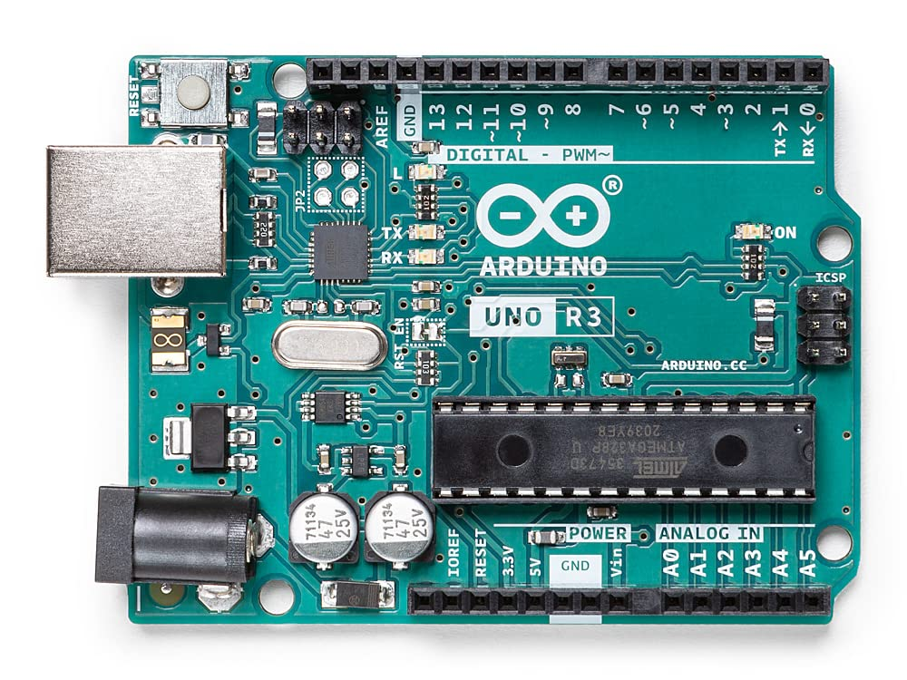

**Arduino Uno** (Microcontroller)

* **HC-05 Bluetooth Module**

The HC-05 Bluetooth module is a widely used device that provides wireless communication between a microcontroller (like the Arduino UNO) and external devices (such as smartphones, tablets, or computers). In a Pick and Place Robotic Arm, the HC-05 module enables remote control of the robotic arm via Bluetooth, allowing operators to send commands or adjust settings wirelessly, enhancing flexibility and ease of operation.

Purpose of HC-05 Bluetooth Module in a Pick and Place Robotic Arm:

The Pick and Place Robotic Arm is an automated robotic system designed to pick up objects from one location and place them in another, typically used in industries such as assembly lines or packaging. The HC-05 Bluetooth module in this system provides a way to control the robotic arm wirelessly. By pairing the HC-05 module with a smartphone or a PC, an operator can control the movement of the arm, the gripper, or other robotic operations remotely, without being physically connected to the system.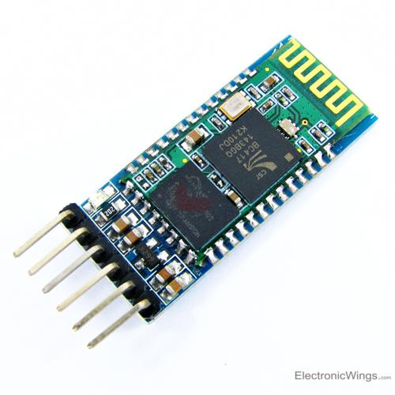

**HC-05 Bluetooth Module**

* **Servo Motors** (MG996 and MG90 for actuation)

Purpose of Servo Motors in a Pick and Place Robotic Arm:

In a Pick and Place robotic arm, the main purpose of servo motors is to control the movement of the robotic arm’s joints, allowing for precise and accurate positioning of the arm and its gripper to pick up and place objects. Servo motors, like the MG996 and MG90, are integral to the arm’s functionality due to their high torque, precise control, and ease of integration with microcontrollers like Arduino UNO.

Servo Motors Overview:

**MG996 Servo Motor:**

The MG996 is a high-torque servo motor with better strength and precision. It is commonly used in robotic arms where higher load-bearing capacity is needed. It provides high torque, making it suitable for heavy-duty tasks such as lifting, rotating, or moving the robotic arm’s joints.

Torque: It provides approximately 9-12 kg·cm of torque (at 4.8V).

Speed: Approximately 0.2 sec/60° (at 4.8V).

It is used for larger robotic arms or when the arm needs to handle heavier objects. The MG996 is typically used in the shoulder and elbow joints of a robotic arm where more torque is required for lifting and moving larger objects.

**MG90 Servo Motor:**

The MG90 is a smaller, low-torque servo motor that is typically used for lighter tasks. It is more compact and affordable compared to the MG996.

Torque: Approximately 2-3 kg·cm of torque (at 4.8V).

Speed: Approximately 0.1 sec/60° (at 4.8V).

It is ideal for smaller robotic arms or applications where the weight of the object being picked is lighter and precision in movement is a priority. The MG90 is typically used in the wrist or gripper joints, where high precision and moderate torque are sufficient for delicate movements or gripping smaller objects

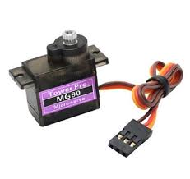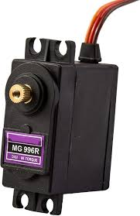

**MG996 SERVO MOTOR MG90 SERVO MOTOR**

* **POWER SOURCE**

In a Pick and Place robotic arm, the power source is crucial for providing the necessary electrical energy to operate the various components of the arm, including motors, servos, sensors, controllers, and actuators. The efficiency, reliability, and longevity of the robotic arm depend on the quality and capability of the power source used.

Purpose of Power Source in a Pick and Place Robotic Arm:

The power source in a robotic arm provides the electrical energy required to drive the system's motors (e.g., servos, DC motors), sensors, microcontroller (such as Arduino), and other electronic components. Depending on the type and complexity of the robotic arm, the power source can vary in terms of voltage, current, and type (AC, DC, or battery-powered). The power source ensures that the robotic arm can carry out its tasks effectively, including picking objects from one location and placing them in another.

**CIRCUIT DIAGRAM:**

This circuit diagram illustrates the control system for a robotic arm driven by servo motors and operated through a smartphone. The system utilizes an Arduino Uno microcontroller to coordinate the movement of six servos corresponding to various joints (waist, shoulder, elbow, wrist roll, wrist pitch, and gripper). An HC-05 Bluetooth module enables wireless communication between the Arduino and a custom-built smartphone app. A dedicated 5V external power source is used to ensure stable and sufficient power for the servos, with all ground lines connected to establish a common reference point. The wiring reflects a systematic approach to interfacing multiple actuators with precise control signals from 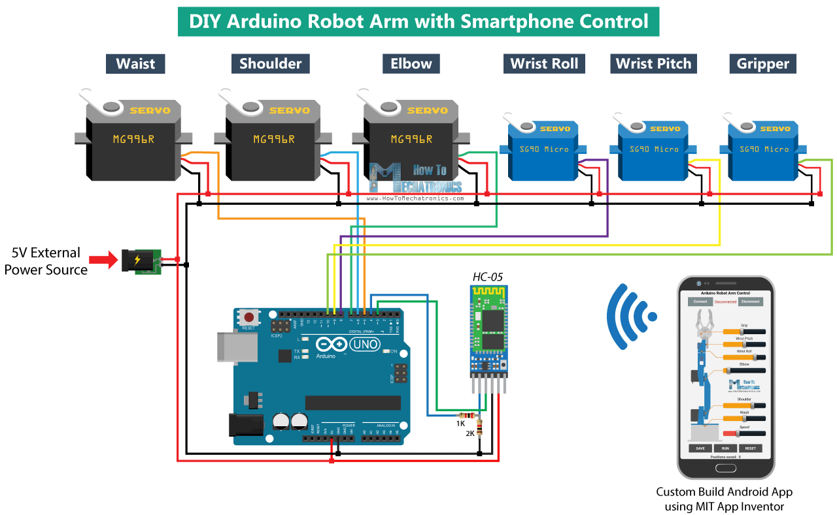the Arduino.

The connections in the circuit are established as described below, ensuring a systematic and efficient configuration suitable for the robotic arm's operation.

* **Servo Motors**:
  + The six servo motors (MG996R and SG90) are connected to the Arduino's PWM pins for precise control signals.
  + Their power (VCC) and ground (GND) pins are connected to a 5V external power source to handle the motors' current demands.
* **Arduino Uno**:
  + The Arduino serves as the control unit, providing PWM signals to the servo motors via its digital pins.
  + It is connected to the HC-05 Bluetooth module for receiving wireless commands from the smartphone app.
* **HC-05 Bluetooth Module**:
  + The HC-05 module's **TX** pin connects to the Arduino's **RX** pin, and it's **RX** pin connects to the Arduino's **TX** pin for data communication.
  + A voltage divider (using 1KΩ and 2KΩ resistors) ensures safe voltage levels for the HC-05's RX pin.
* **Power Source**:
  + A dedicated 5V external power source is used to power the servo motors.
  + The GND of the external power source is connected to the Arduino's GND to maintain a common ground reference.
* **Smartphone Control**:
  + Commands are sent from the custom app via Bluetooth, received by the HC-05 module, and processed by the Arduino to control the robotic arm.
  + This organized wiring ensures efficient operation of the robotic arm with stable communication and power distribution.

**KINEMATIC MODELLING**

1. **Forward Kinematics**

The forward kinematics shows the transformation from one frame into another one, starting at the base and ending at the end-effector. A commonly used convention for selecting frames of reference in robotic applications is the Denavit-Hartenberg or DH convention, as shown in Figure 2. In this method, to set one reference frame relative to another, only four parameters are needs instead of six, which are normally required for 3D motion. These parameters are (di, ai, θi, and αi), which tell the location of a link-frame of the robot from a previous link-frame. The transformation matrix between two neighbouring frames is expressed, as shown below.

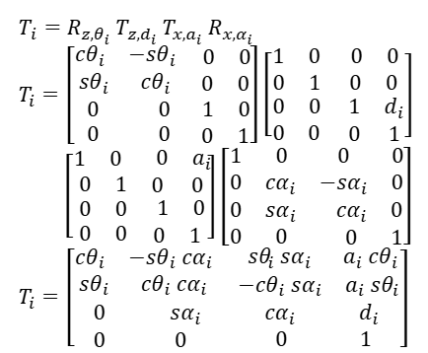

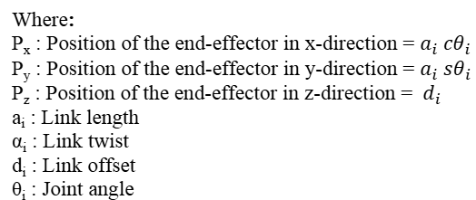

The parameters for the 5 DOF robotic arm used are listed in Table 1, where shows rotation about the z-axis, rotation about the x-axis, transition along the z-axis, and transition along the x-axis. By substituting the D-H parameters in Table in the equation above, we can obtain the individual transformation matrices T10 to T54, and a global matrix of transformation T50, as illustrated in Figure 3.

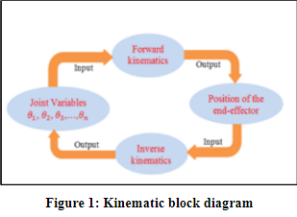

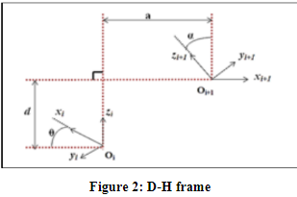

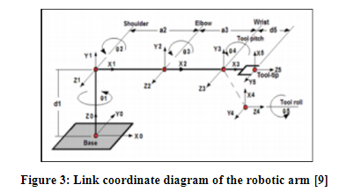

**Table 1: DH parameters for the robotic arm**

|  |  |  |  |  |
| --- | --- | --- | --- | --- |
| Link | ai | αi | di | Θi |
| 1 | 0 | 90 | 97 | Θ1 |
| 2 | 120 | 0 | 0 | Θ2 |
| 3 | 90 | 0 | 0 | Θ3 |
| 4 | 0 | 90 | 0 | Θ4 |
| 5 | 0 | 0 | 28 | Θ5 |

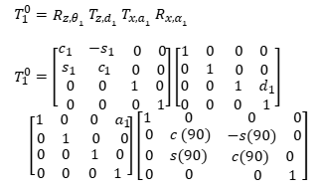

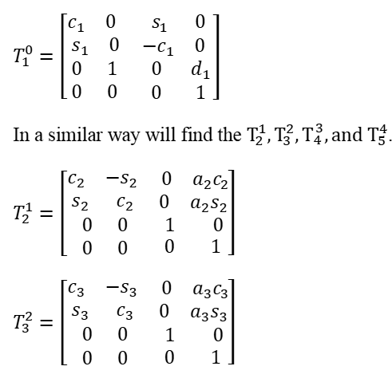

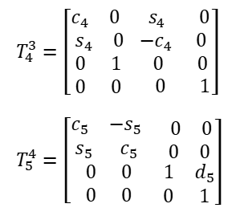

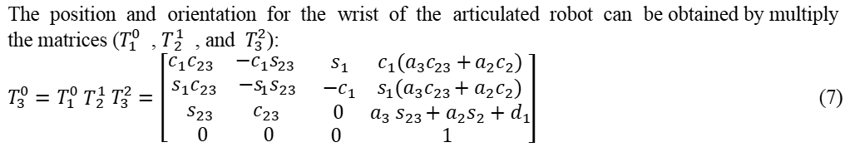

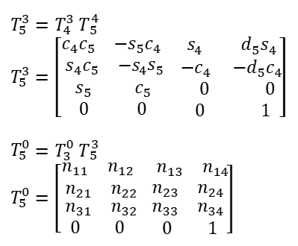

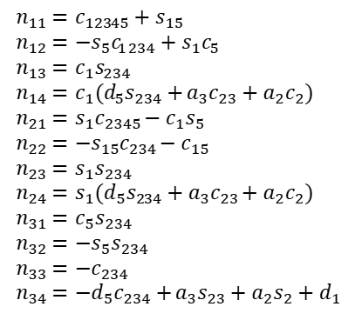

The following forward analysis is achieved on MATLAB using “Peter-Corke ToolBox” and “Symbolic Math ToolBox”. The DH-parameter is substituted with the dimensions of the robotic arm model.

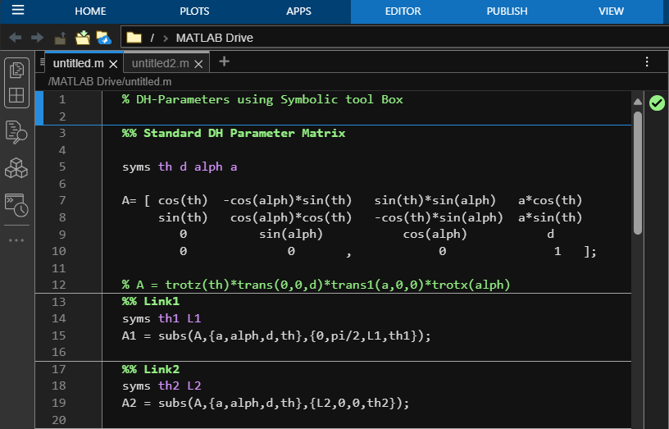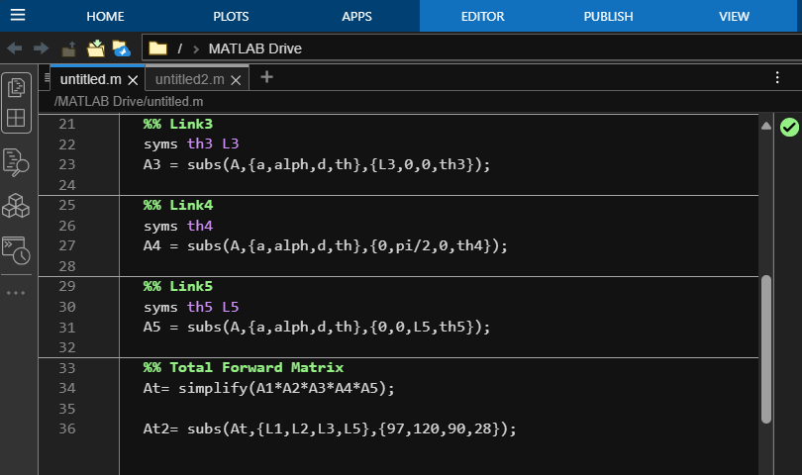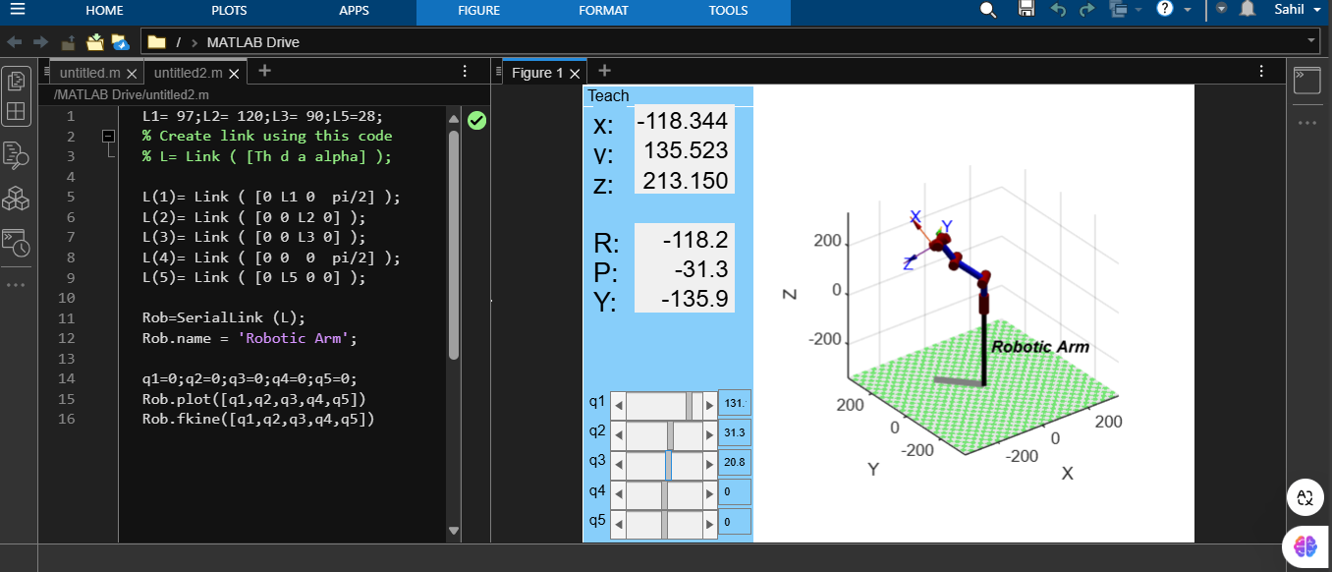

1. **Inverse kinematics**

A geometric approach or algebraic method can be obtained by the inverse kinematics of the robot arm, in this work, an algebraic method is used to obtain the inverse kinematics of a 5 DOF robotic arm. To find the first joint will be using the below:

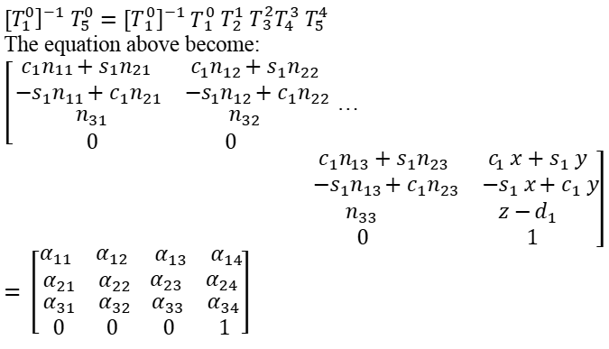

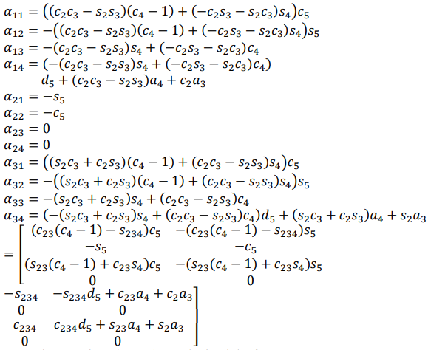

From the equations above, we obtained the Θ1

Picture 15

In a similar way will find the other joint angles:

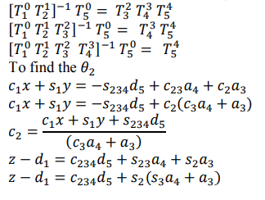

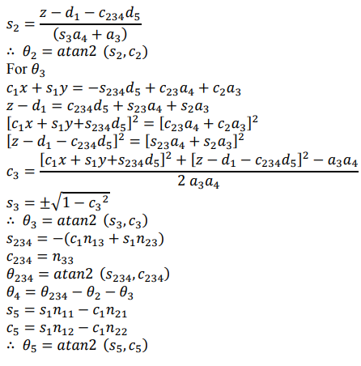

**III. Velocity kinematics**

Jacobian matrix is used to calculate the velocity kinematics using a matrix, which depends on the changes of the joint velocities into Cartesian velocities. This matrix is important in control of the movement of the robotic arm, used to achieve smooth path planning, and used to determine the dynamic equation. The relationships between the joint velocity and the linear and angular velocity of the end effector are shown following:

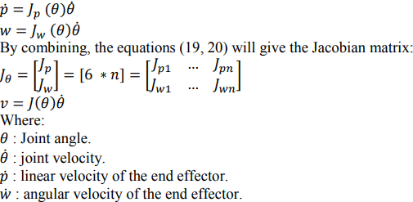

The number of rows in the Jacobian matrix equal to the number of DOF in the cartesian coordinate (three linear and three angular) while the number of columns equal to the number of DOF in the joint. The matrix of Jacobian can be obtained using the following equations:

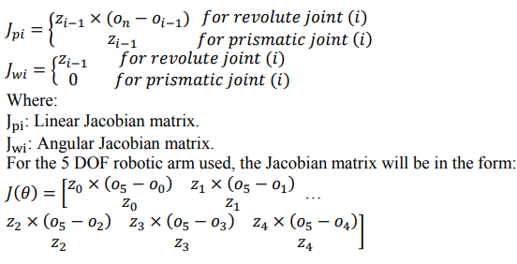

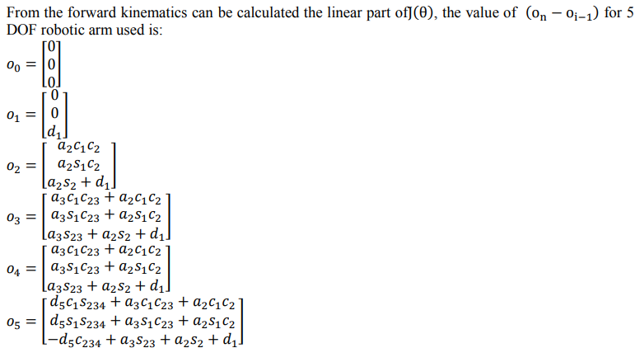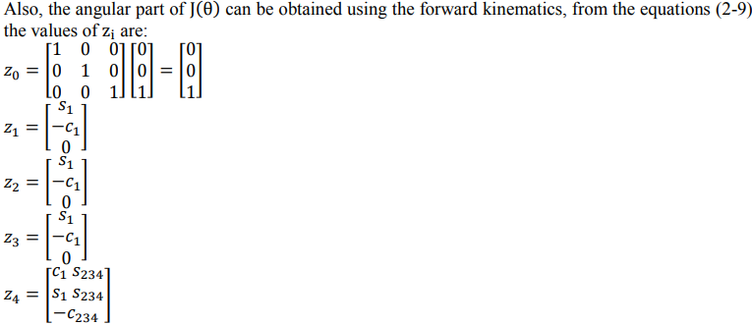

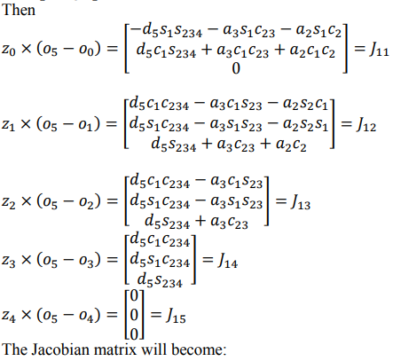

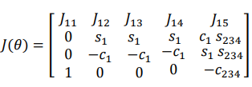

|  |
| --- |
| ***CAD DRAWINGS: PARTS AND ASSEMBLY*** |

**1. 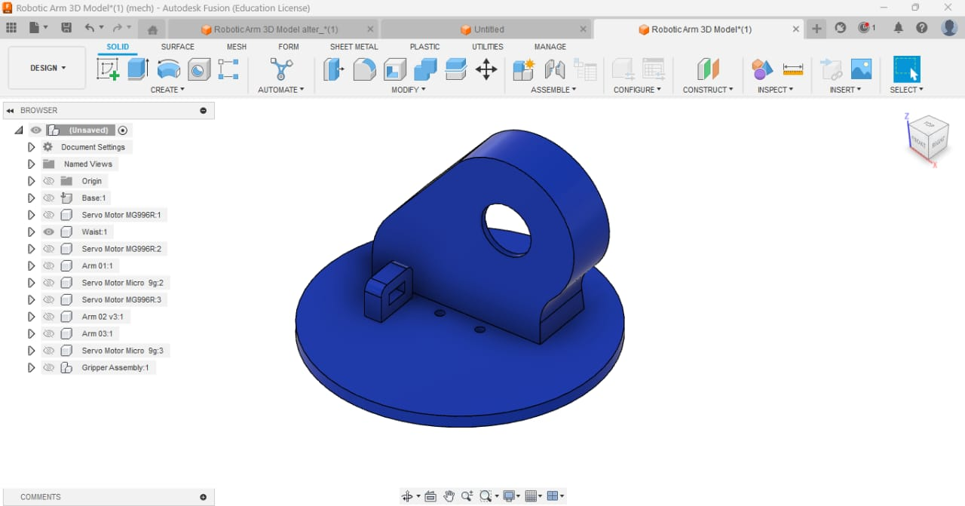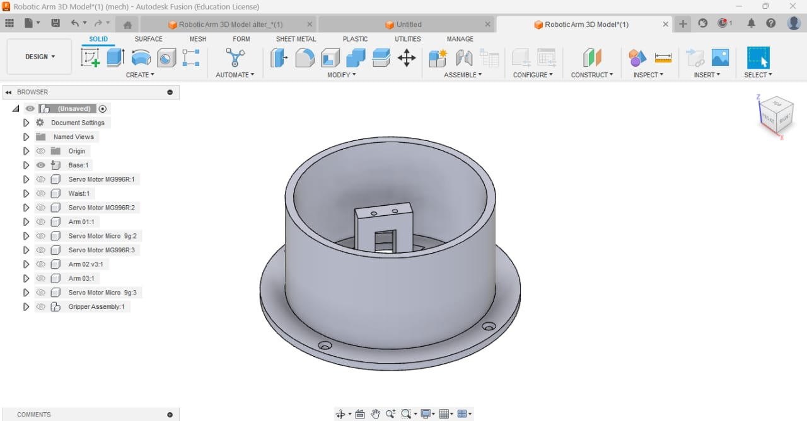BASE:** The base serves as the foundational structure of the robotic arm. It provides stability and support for the entire assembly, ensuring precise movements and maintaining balance. The base often contains mounting holes or fixtures to secure it to a surface, preventing displacement during operation.

**2. WAIST:** The waist acts as the primary rotational joint of the robotic arm, enabling horizontal rotation. This joint allows the arm to cover a larger working area and facilitates the movement of upper arm segments. It is driven by a servo motor (MG996R) to achieve precise angular motion.

**3. ARM SEGMENTS**

**3.1.Arm01**  
The first arm segment is attached to the waist and extends upward. It serves as a support structure for the upper arms and is connected via rotational joints. This segment facilitates the vertical movement of the robotic arm.

**3.2.Arm02**  
This is the second arm segment, responsible for extending the arm’s reach. It is connected to Arm 01 through a joint, allowing angular adjustments to achieve various positions in the 3D workspace. A servo motor (MG996R) controls its movement.

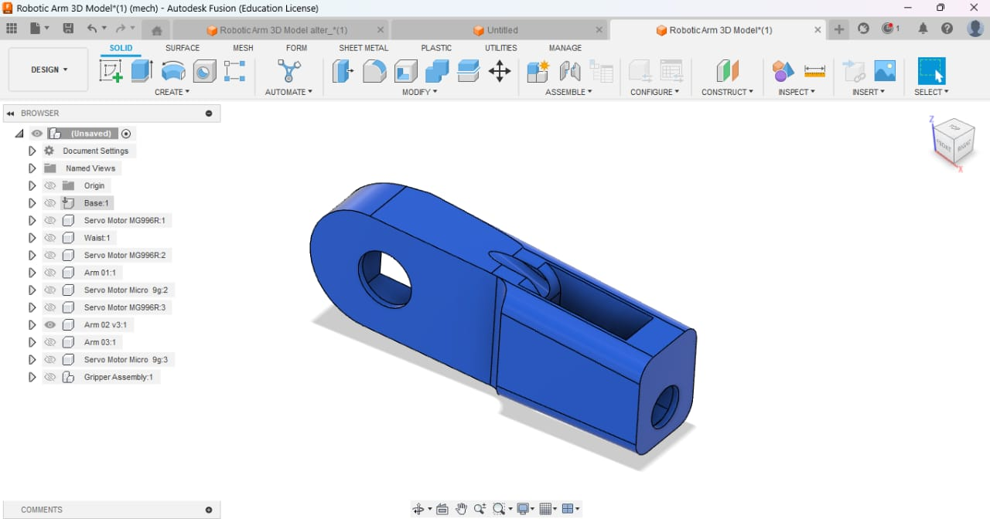**3.3.Arm03**  
This is the third and final segment of the arm, connected to Arm 02. It further extends the arm’s reach and provides additional flexibility to access hard-to-reach locations. It is controlled by a servo motor (MG996R) to enable precise positioning.

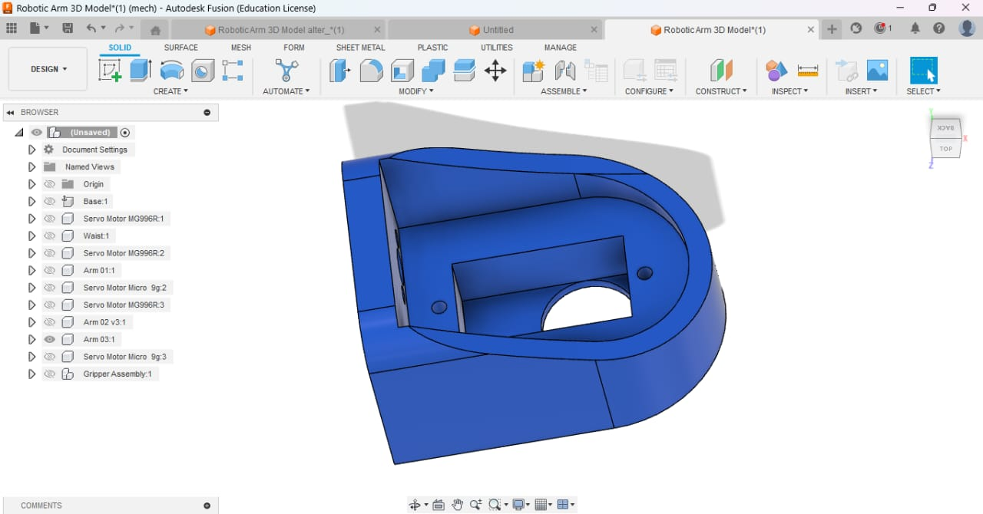 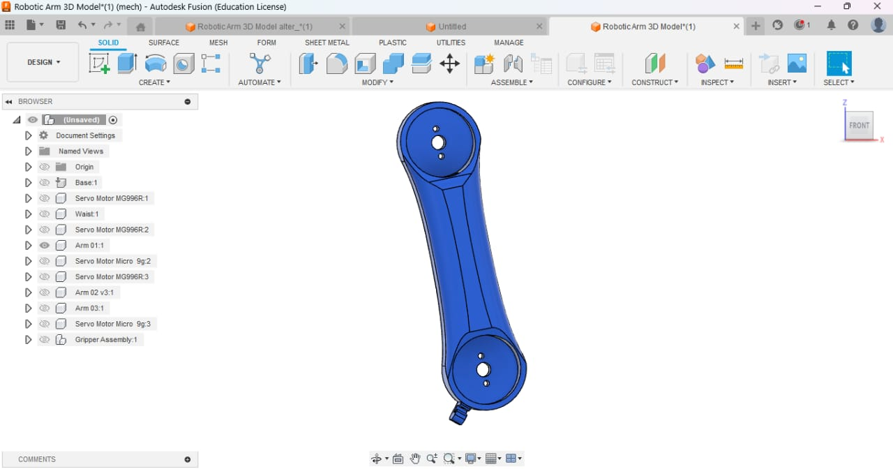**4. GRIPPER ASSEMBLY:** The gripper assembly is the end effector of the robotic arm, used to pick up, hold, and place objects.

It consists of two or more gripping fingers that open and close using a micro servo motor. The gripper design allows it to handle objects of various sizes and shapes, making it a versatile component for pick-and-place tasks.

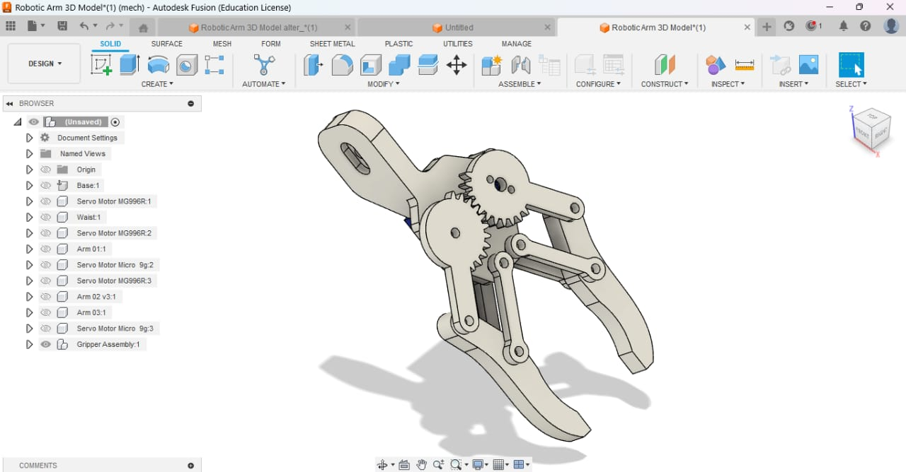

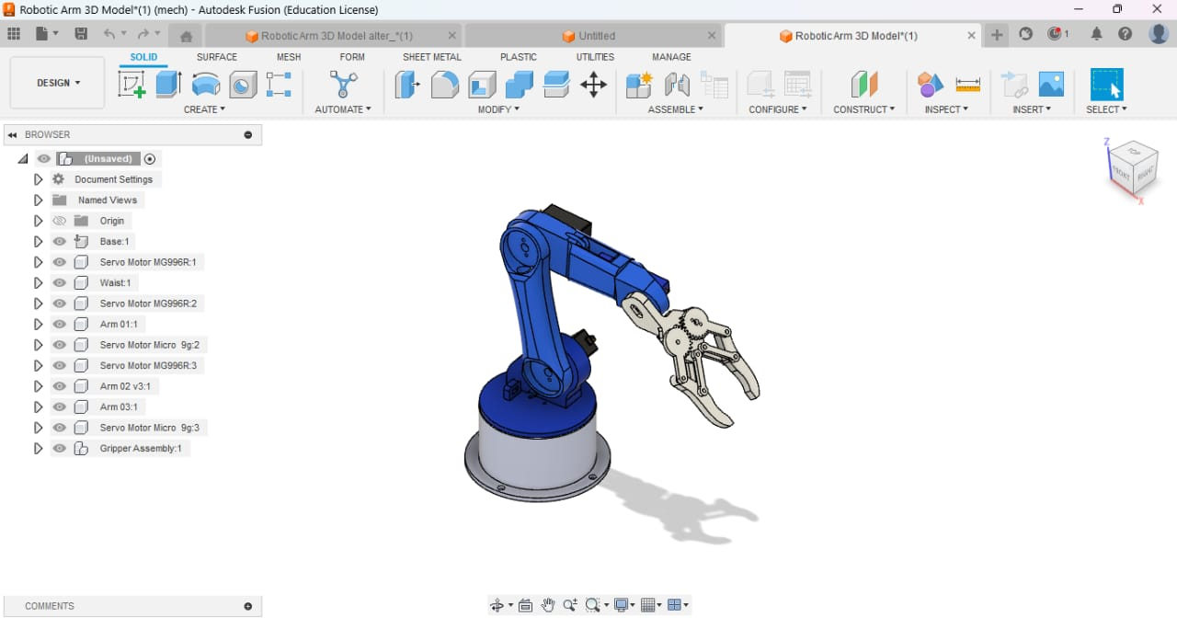**5. ASSEMBLY:** The pick-and-place robotic arm is an articulated structure with a base, waist, three arm segments, and a gripper assembly. The assembly process begins with attaching the base to a stable surface, followed by the mounting of the waist joint. The arm segments (Arm 01, Arm 02, and Arm 03) are connected sequentially, each linked by a servo motor that provides controlled rotation. The gripper assembly is attached at the end of Arm 03, enabling object manipulation. Servo motors are integrated at strategic positions to facilitate rotational and gripping movements. The overall design enables precise and versatile motion, making it suitable for pick-and-place automation tasks.

|  |
| --- |
| ***SIMULATION*** |

The simulation is achieved by applying Load of 10N on the Gripper base. It is performed on Autodesk Fusion.

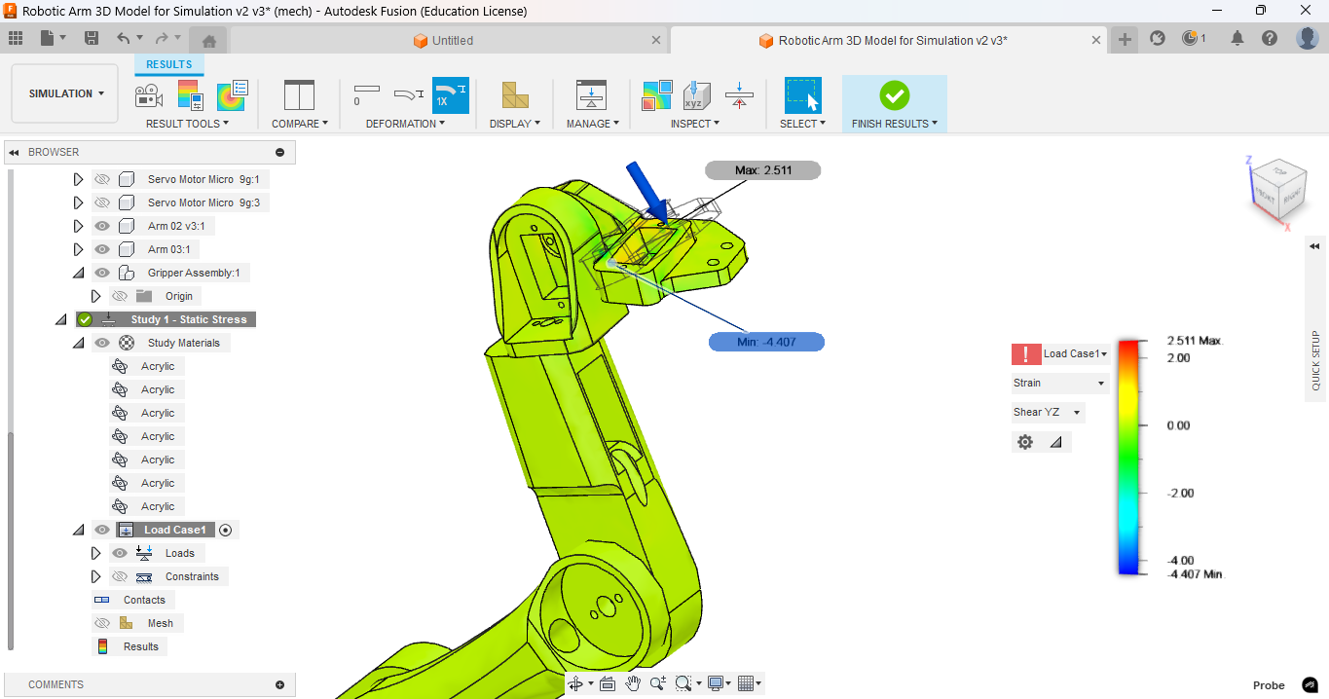

Figure: Strain (Shear YZ)

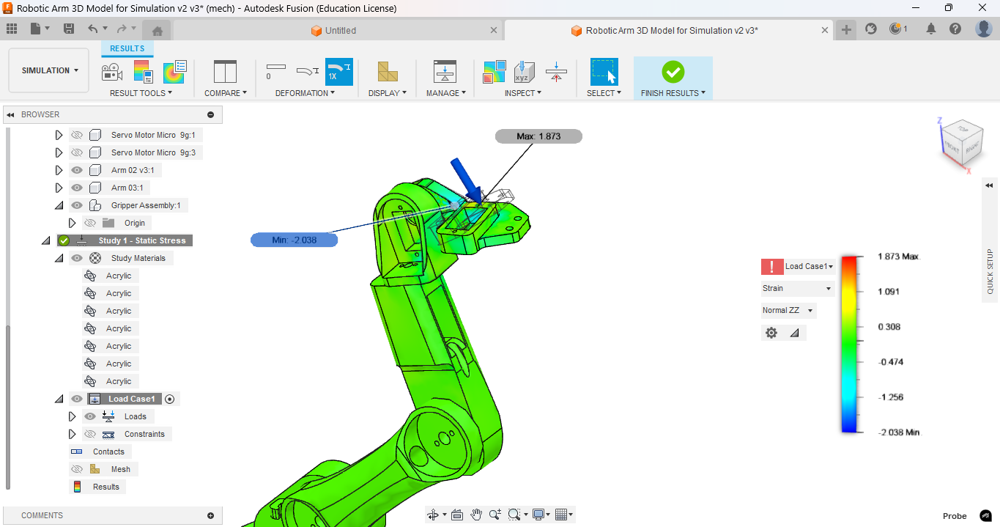

Figure: Strain (Normal ZZ)

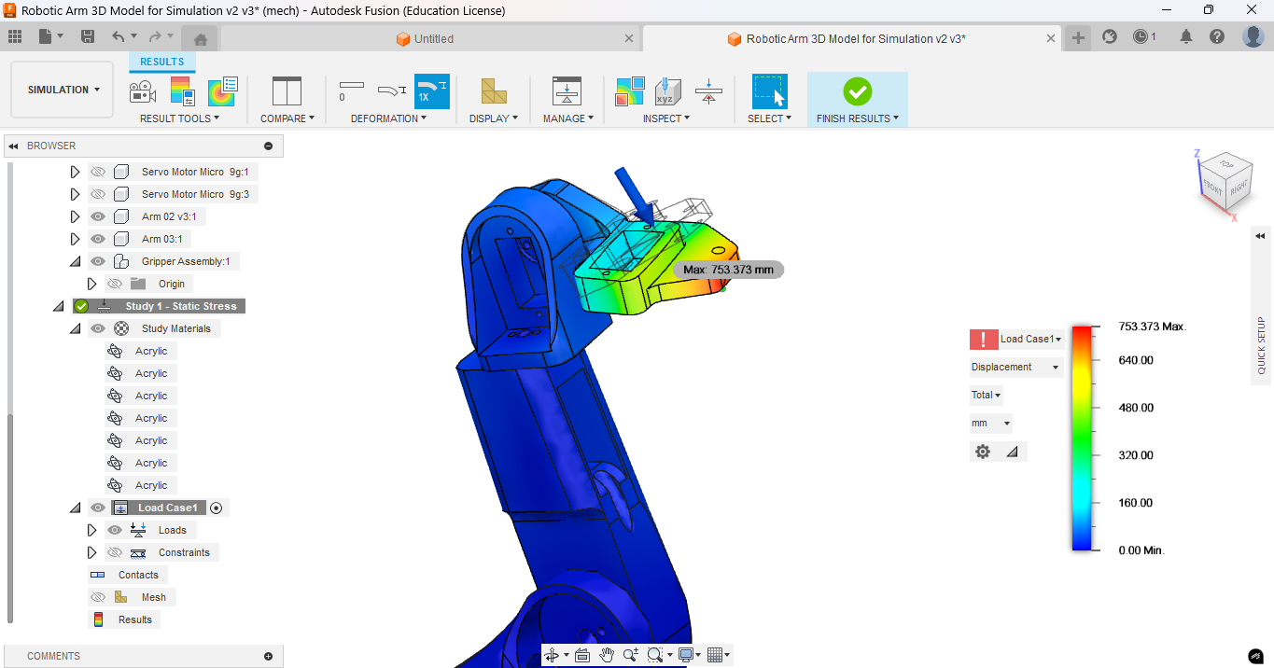

Figure: Displacement (in mm)

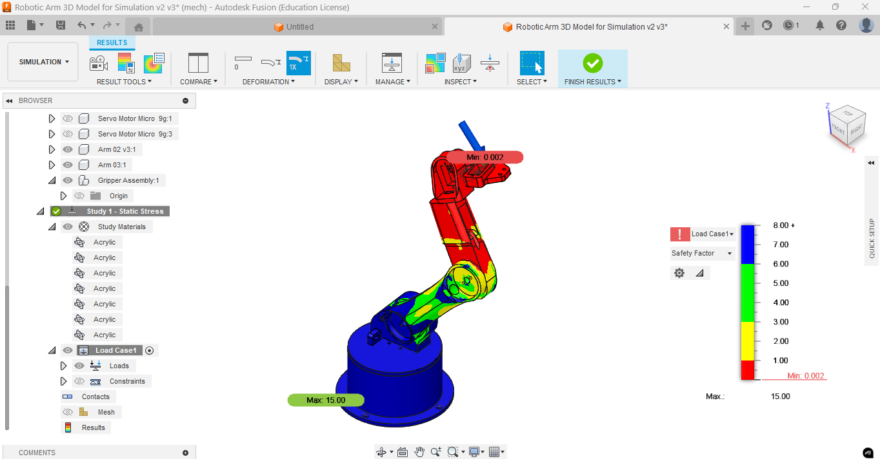

Figure: Safety Factor

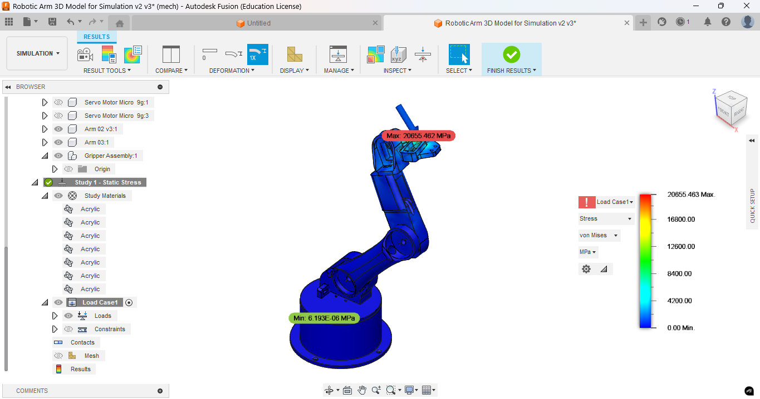

Figure: Stress-Von Mises (in MPa)

|  |
| --- |
| ***CONCLUSION*** |

The development of the Pick-and-Place Robotic Arm demonstrates the potential of robotics in automating repetitive tasks with precision and efficiency. This project successfully highlights the integration of servo motors, microcontrollers, and CAD-based design to achieve a five-degree-of-freedom robotic system. The arm's ability to perform pick-and-place operations with minimal human intervention showcases its application in industrial automation, assembly lines, and material handling. By leveraging cost-effective components and intuitive control mechanisms, this project emphasizes the feasibility of affordable robotic solutions. The results affirm that such systems can reduce human effort, increase production speed, and enhance workplace safety.

|  |
| --- |
| ***BIBLIOGRAPHY*** |

* [www.matlabonline.org](http://www.matlabonline.org)
* <https://petercorke.com>
* https://youtube.com/@dramrzamel