**CSP - Map Coloring Problem**

Programming Project 2

Intelligent Systems

Submitted By-

Sahil Rasane(801135252)

1. Problem Formulation-

The main aim of the map coloring problem is to find out the minimum number of colors required to color a given figure without assigning the same colors to the neighbors. .In the case of this specific problem, the scope is defined for the map of two countries. We are considering two countries USA and Australia. The defined color domain consists of red, blue, green and yellow.

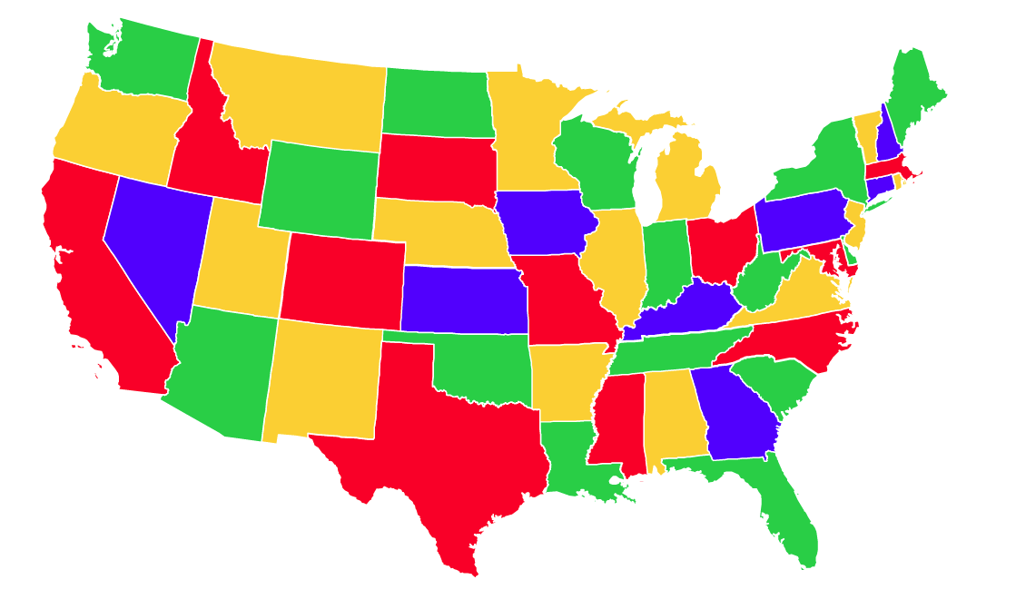

1. Approach-

The problem can be considered as a constraint satisfaction graph problem. A coloring of a graph G assigns a color to each vertex of G, with the restriction that two adjacent vertices never have the same color. We are going to use the following approaches for solving the CSP map coloring problem-

* 1. **Depth First Search-**

The Depth First Search (DFS) portion of the algorithm uses the recursive function solve. This function returns a list of legal values for each node. The Minimum Remaining Value (MRV) is implemented in order to determine if the assignment of variables are complete. Since this execution is only limited to Depth First Search, it can be referred to as backtracking. It the current path cannot continue calculations, the algorithm will backtrack to the most recent node with an alternate path. The algorithm will proceed forward down this path until a solution is found or backtracking occurs again. The Depth First Search Only/Backtracking algorithm was applied to both the map of the United States of America as well as the map of Australia.

* 1. **Depth First Search and Forward Checking-**

This option in the program operates the same as the Depth First Search only function however, this function also applies forward checking. This is done to provide a better solution by helping to predict conflicts or problems which may occur in the future when assigning color to the various states as well as the neighboring states.

* 1. **Depth First Search, Forward Checking and Propagation through Singleton Domains-**

This method in the program conducts the same evaluations as the previously defined method. On the other hand, this method incorporates the singleton domain functionality. The Singleton aspect of the program only allows on instance of the dictionary of the states to be created. However, it as allows the instance to create and give access to other instances. This is particularly useful to declare and obtain unique and private classes which restricts an object to only one.

* 1. **Depth First Search with Heuristic-**

This is function applies all of the same calculation as the primarily mentioned Depth First Search method. Nonetheless, this function applies the use of the heuristic for an attempt to decrease the amount of time taken to calculate the final result of which colors should be for which states and the neighbors of the state.

* 1. **Depth First Search with Heuristic and Forward Checking-**

This function closely resembles the previous method but implements both heuristic and forward checking when compared to the original Depth First Search function. This function uses forward checking in order to predict any foreseeable problems or discrepancies while applying the power of heuristic. Again, in theory this will result in a more conscience and time efficient solution when compared to all of the previous methods.

* 1. **Depth First Search with heuristic, Forward Checking and singleton-**

This method in theory should have the best solution in the shortest amount of time. This is because this method has all of the aforementioned algorithm enhancements. This will selection will implement backtracking, while checking for any problems in the future. It will also only replicate one instance of an object which is allowed to produce other instances. Finally, the heuristic function is applied for the best results.

1. **Global Variables-**

•painted –

This is a dictionary variable which was used to stored the states of each map during each runtime implementation.

•retreat –

This is a global counter which was used to keep track of the number of backtracks or reverse transformations.

•singleton –

This global variable is treated as a Boolean and only records a 0 or 1. This value is used in the program to determine if a singleton option was chosen by the user.

•heuristic_for_depth_first_search–

This is variable which is used to state whether the heuristic for the depth first search function is used. This variable will contain a Boolean 0 or 1.

1. Source Code-

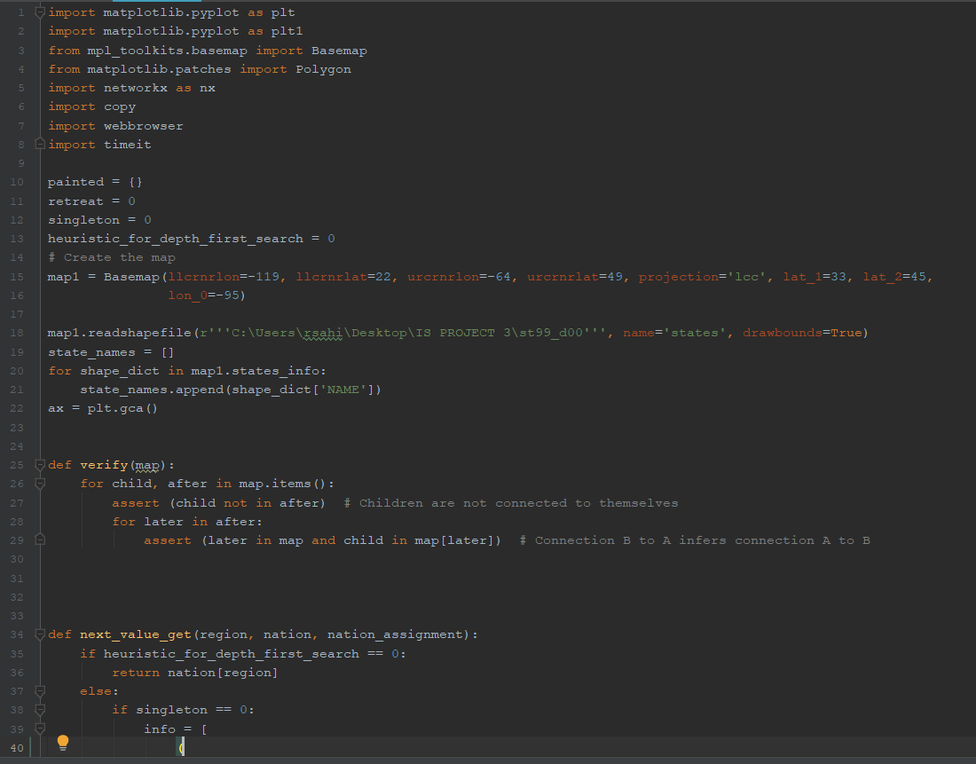

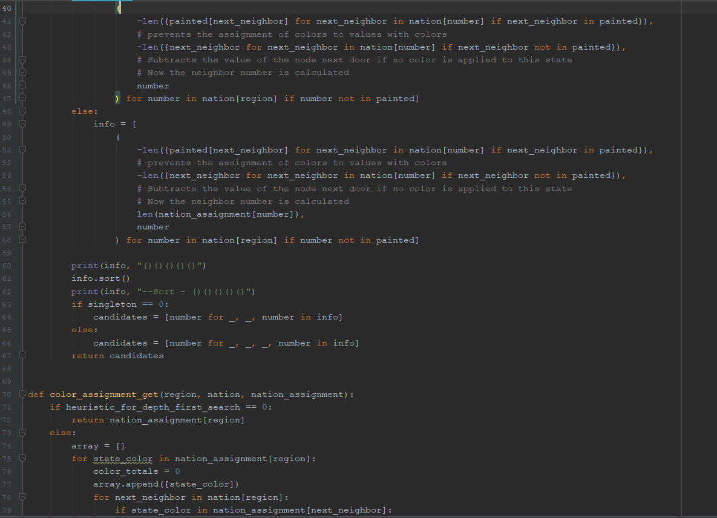

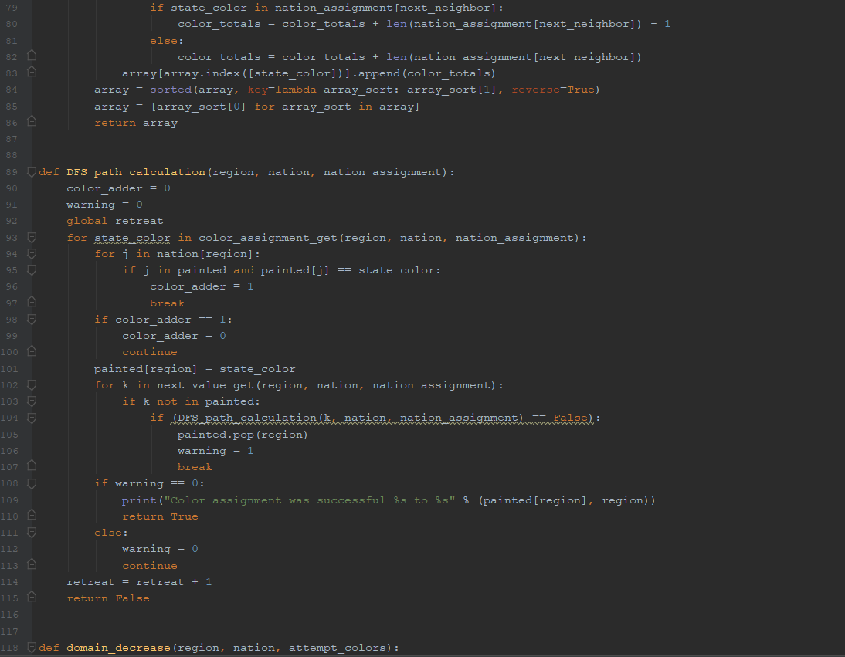

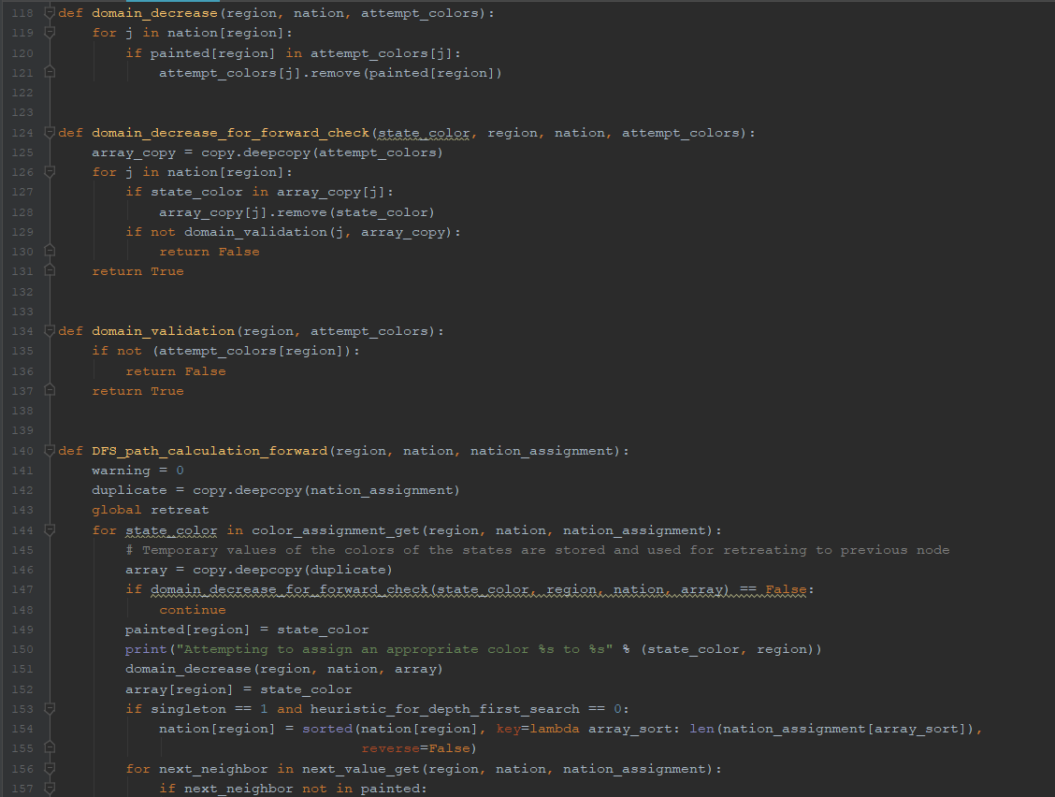

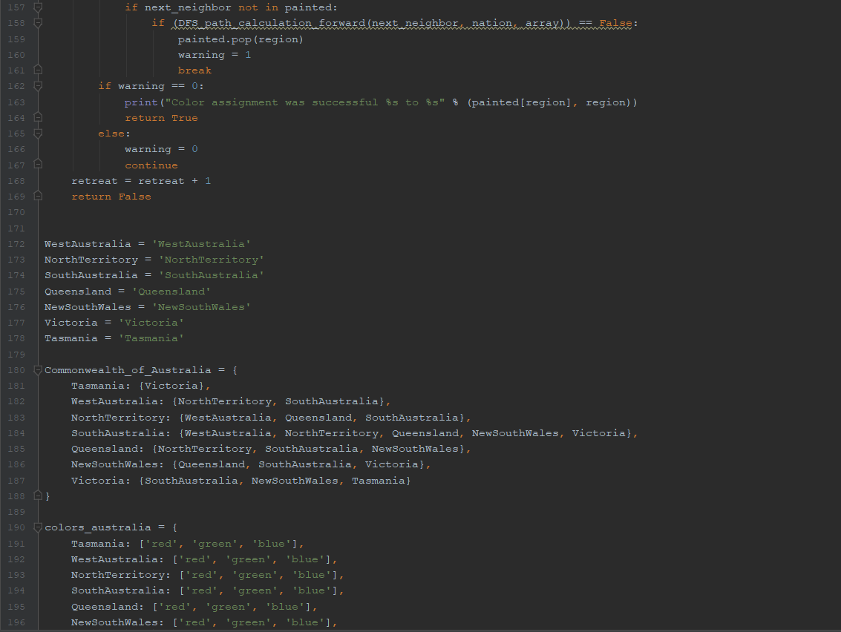

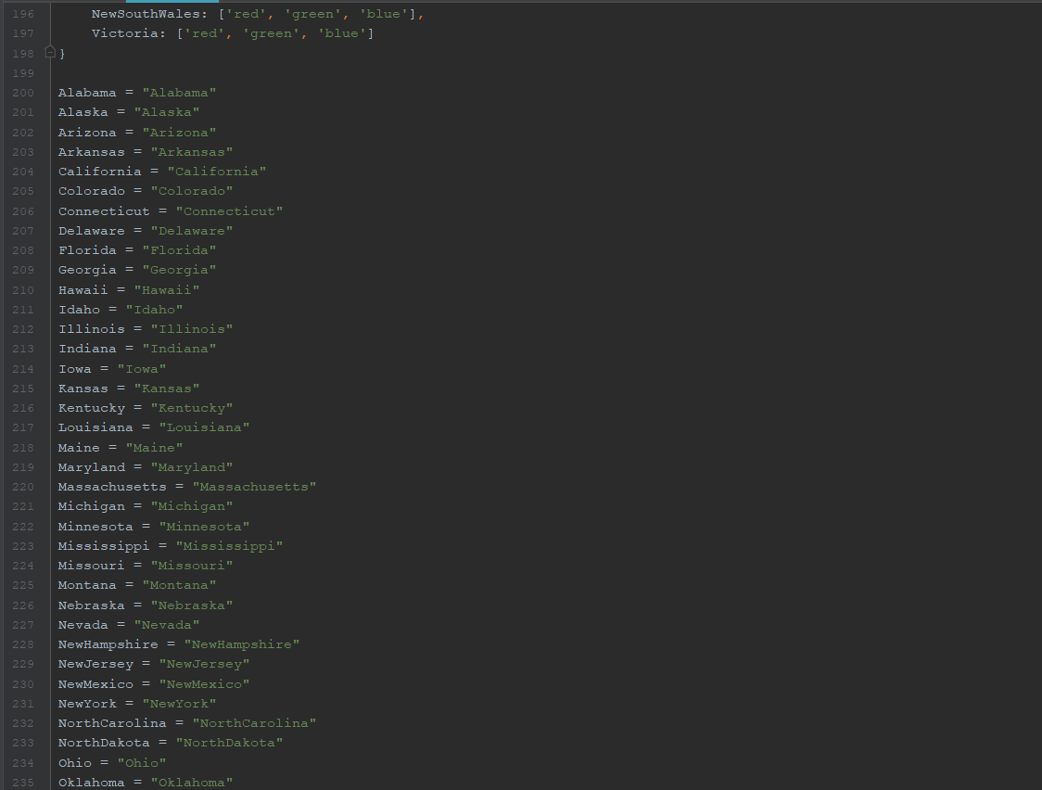

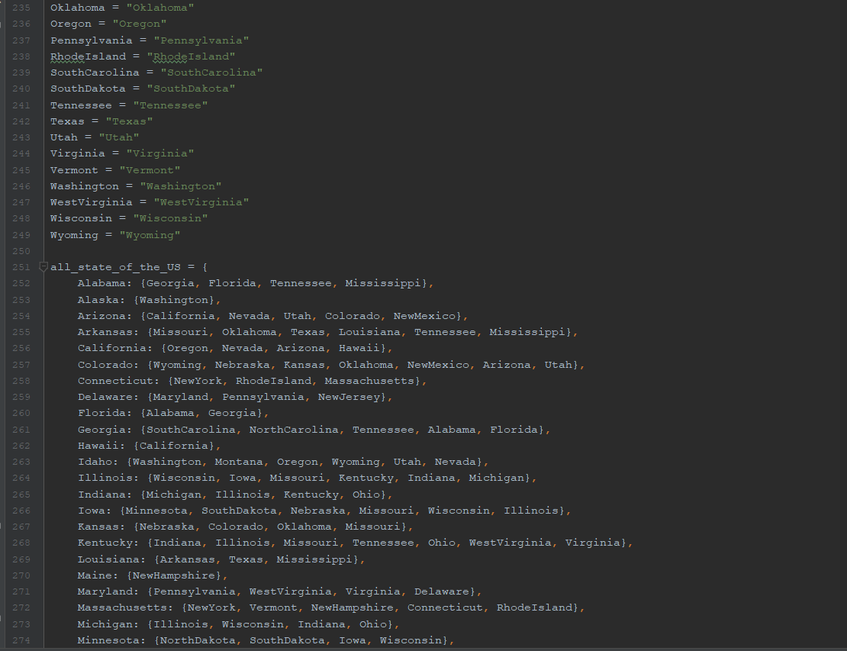

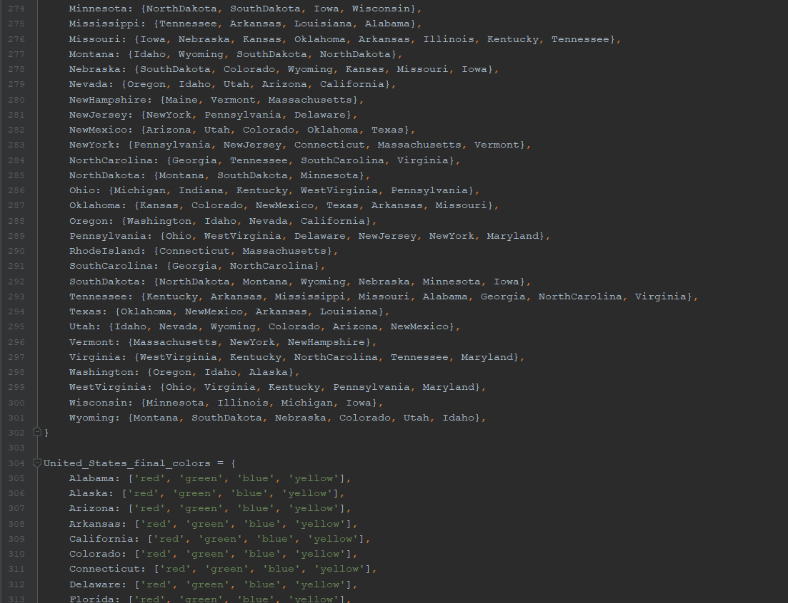

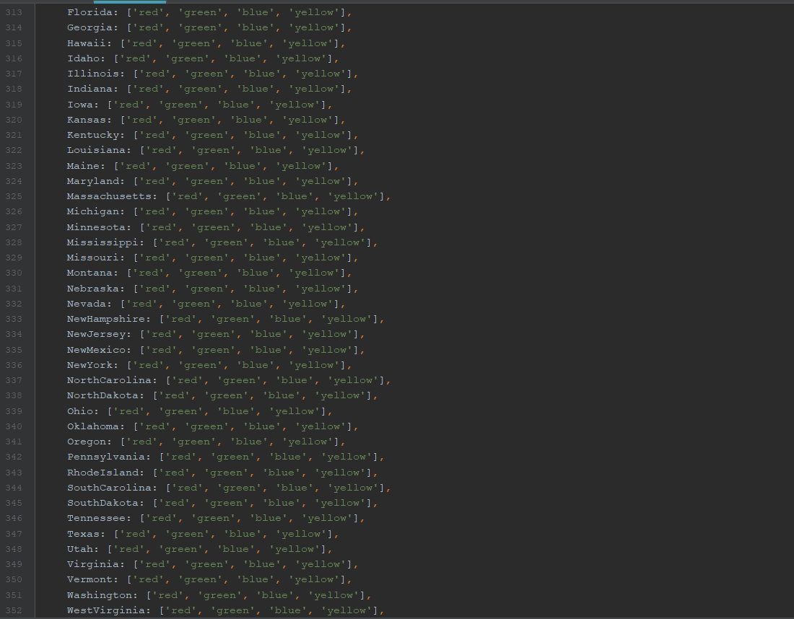

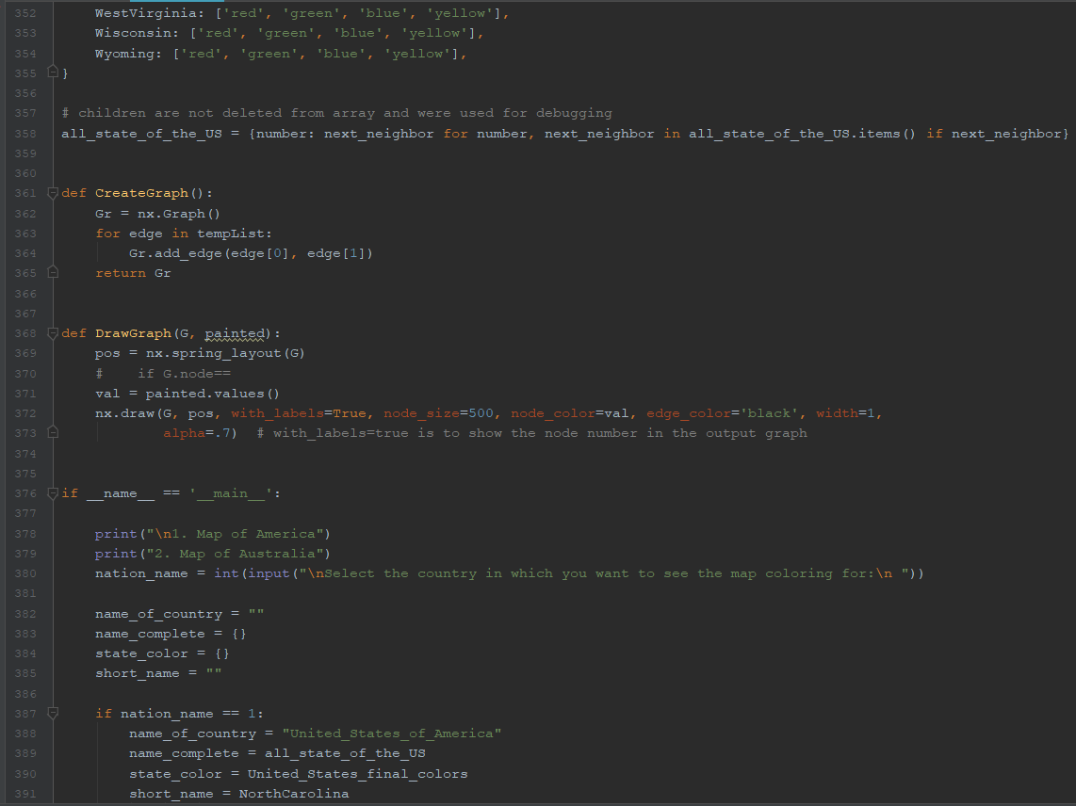

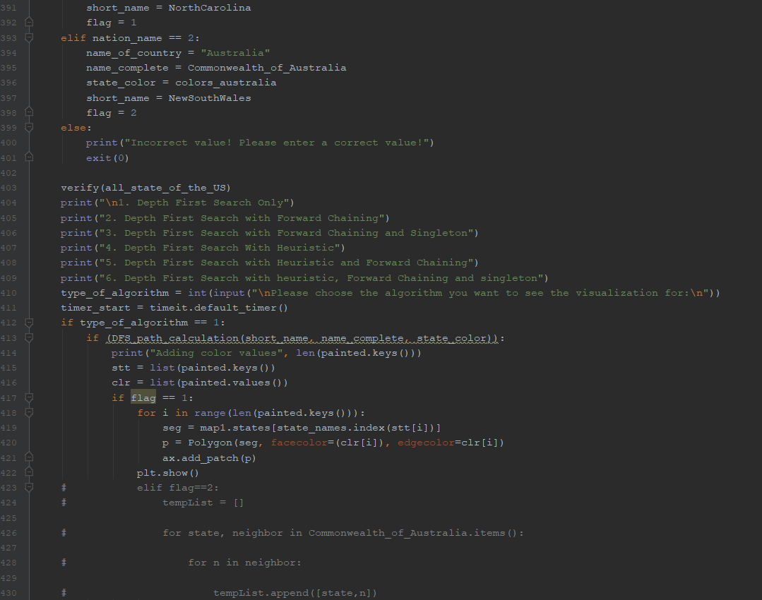

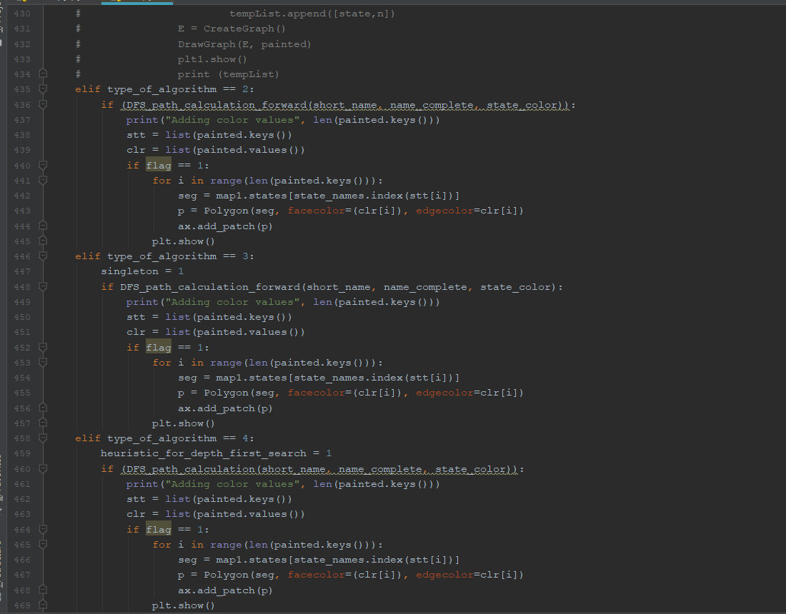

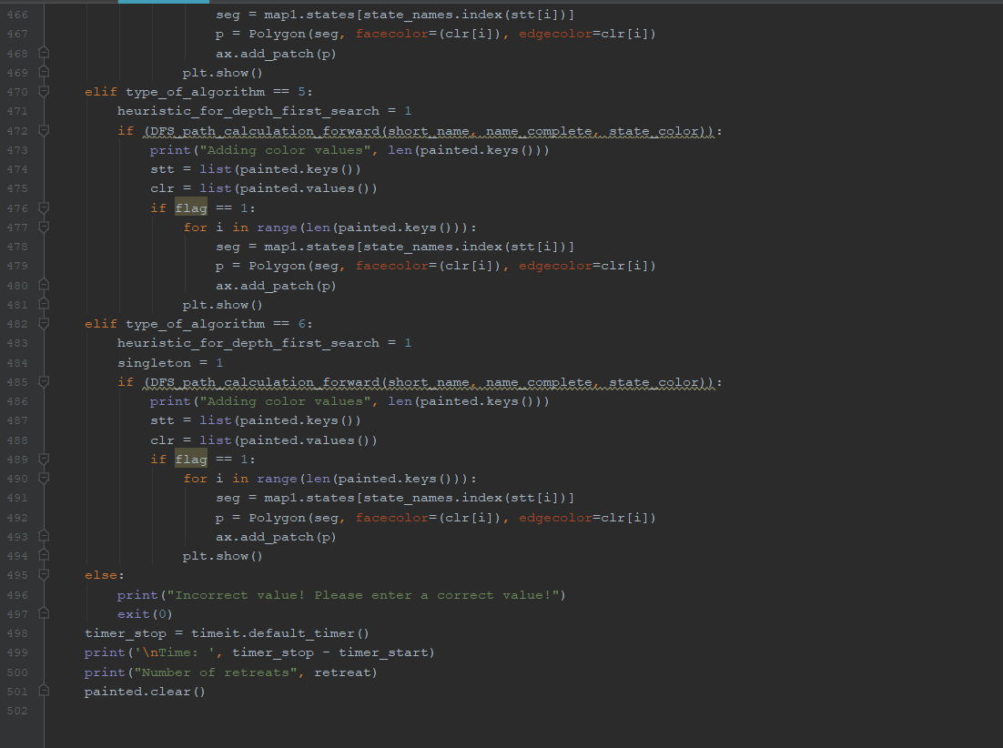

1. Execution-
2. 1. Map of America
3. 2. Map of Australia
4. Select the country in which you want to see the map coloring for:
5. 1
6. 1. Depth First Search Only
7. 2. Depth First Search with Forward Chaining
8. 3. Depth First Search with Forward Chaining and Singleton
9. 4. Depth First Search With Heuristic
10. 5. Depth First Search with Heuristic and Forward Chaining
11. 6. Depth First Search with heuristic, Forward Chaining and singleton
12. Please choose the algorithm you want to see the visualization for:
13. 2
14. Attempting to assign an appropriate color red to NorthCarolina
15. Attempting to assign an appropriate color green to Georgia
16. Attempting to assign an appropriate color red to Florida
17. Attempting to assign an appropriate color blue to Alabama
18. Attempting to assign an appropriate color yellow to Tennessee
19. Attempting to assign an appropriate color red to Kentucky
20. Attempting to assign an appropriate color green to WestVirginia
21. Attempting to assign an appropriate color blue to Ohio
22. Attempting to assign an appropriate color green to Indiana
23. Attempting to assign an appropriate color blue to Illinois
24. Attempting to assign an appropriate color red to Iowa
25. Attempting to assign an appropriate color green to Minnesota
26. Attempting to assign an appropriate color yellow to Wisconsin
27. Attempting to assign an appropriate color red to Michigan
28. Color assignment was successful red to Michigan
29. Color assignment was successful yellow to Wisconsin
30. Attempting to assign an appropriate color red to NorthDakota
31. Attempting to assign an appropriate color green to Montana
32. Attempting to assign an appropriate color red to Idaho
33. Attempting to assign an appropriate color green to Utah
34. Attempting to assign an appropriate color red to NewMexico
35. Attempting to assign an appropriate color blue to Colorado
36. Attempting to assign an appropriate color yellow to Wyoming
37. Attempting to assign an appropriate color blue to SouthDakota
38. Attempting to assign an appropriate color yellow to Colorado
39. Attempting to assign an appropriate color blue to Wyoming
40. Attempting to assign an appropriate color yellow to SouthDakota
41. Attempting to assign an appropriate color blue to NewMexico
42. Attempting to assign an appropriate color red to Colorado
43. Attempting to assign an appropriate color blue to Wyoming
44. Attempting to assign an appropriate color yellow to SouthDakota
45. Attempting to assign an appropriate color yellow to Wyoming
46. Attempting to assign an appropriate color blue to SouthDakota
47. Attempting to assign an appropriate color yellow to Colorado
48. Attempting to assign an appropriate color blue to Wyoming
49. Attempting to assign an appropriate color yellow to SouthDakota
50. Attempting to assign an appropriate color yellow to NewMexico
51. Attempting to assign an appropriate color red to Colorado
52. Attempting to assign an appropriate color blue to Wyoming
53. Attempting to assign an appropriate color yellow to SouthDakota
54. Attempting to assign an appropriate color yellow to Wyoming
55. Attempting to assign an appropriate color blue to SouthDakota
56. Attempting to assign an appropriate color blue to Colorado
57. Attempting to assign an appropriate color yellow to Wyoming
58. Attempting to assign an appropriate color blue to SouthDakota
59. Attempting to assign an appropriate color blue to Utah
60. Attempting to assign an appropriate color red to NewMexico
61. Attempting to assign an appropriate color green to Colorado
62. Attempting to assign an appropriate color yellow to Wyoming
63. Attempting to assign an appropriate color green to NewMexico
64. Attempting to assign an appropriate color red to Colorado
65. Attempting to assign an appropriate color yellow to Wyoming
66. Attempting to assign an appropriate color blue to SouthDakota
67. Attempting to assign an appropriate color yellow to NewMexico
68. Attempting to assign an appropriate color red to Colorado
69. Attempting to assign an appropriate color yellow to Wyoming
70. Attempting to assign an appropriate color blue to SouthDakota
71. Attempting to assign an appropriate color green to Colorado
72. Attempting to assign an appropriate color yellow to Wyoming
73. Attempting to assign an appropriate color yellow to Utah
74. Attempting to assign an appropriate color red to NewMexico
75. Attempting to assign an appropriate color green to Colorado
76. Attempting to assign an appropriate color blue to Wyoming
77. Attempting to assign an appropriate color green to NewMexico
78. Attempting to assign an appropriate color red to Colorado
79. Attempting to assign an appropriate color blue to Wyoming
80. Attempting to assign an appropriate color yellow to SouthDakota
81. Attempting to assign an appropriate color blue to NewMexico
82. Attempting to assign an appropriate color red to Colorado
83. Attempting to assign an appropriate color blue to Wyoming
84. Attempting to assign an appropriate color yellow to SouthDakota
85. Attempting to assign an appropriate color green to Colorado
86. Attempting to assign an appropriate color blue to Wyoming
87. Attempting to assign an appropriate color blue to Idaho
88. Attempting to assign an appropriate color red to Utah
89. Attempting to assign an appropriate color green to NewMexico
90. Attempting to assign an appropriate color blue to Colorado
91. Attempting to assign an appropriate color yellow to Wyoming
92. Attempting to assign an appropriate color blue to SouthDakota
93. Attempting to assign an appropriate color blue to NewMexico
94. Attempting to assign an appropriate color green to Colorado
95. Attempting to assign an appropriate color yellow to Wyoming
96. Attempting to assign an appropriate color yellow to NewMexico
97. Attempting to assign an appropriate color green to Colorado
98. Attempting to assign an appropriate color yellow to Wyoming
99. Attempting to assign an appropriate color blue to Colorado
100. Attempting to assign an appropriate color yellow to Wyoming
101. Attempting to assign an appropriate color blue to SouthDakota
102. Attempting to assign an appropriate color green to Utah
103. Attempting to assign an appropriate color red to NewMexico
104. Attempting to assign an appropriate color blue to Colorado
105. Attempting to assign an appropriate color red to Wyoming
106. Attempting to assign an appropriate color blue to SouthDakota
107. Attempting to assign an appropriate color yellow to Nebraska
108. Attempting to assign an appropriate color green to Missouri
109. Attempting to assign an appropriate color red to Arkansas
110. Attempting to assign an appropriate color green to Mississippi
111. Attempting to assign an appropriate color blue to Louisiana
112. Attempting to assign an appropriate color green to Texas
113. Attempting to assign an appropriate color yellow to Oklahoma
114. Attempting to assign an appropriate color red to Kansas
115. Color assignment was successful red to Kansas
116. Color assignment was successful yellow to Oklahoma
117. Color assignment was successful green to Texas
118. Color assignment was successful blue to Louisiana
119. Color assignment was successful green to Mississippi
120. Color assignment was successful red to Arkansas
121. Color assignment was successful green to Missouri
122. Color assignment was successful yellow to Nebraska
123. Color assignment was successful blue to SouthDakota
124. Color assignment was successful red to Wyoming
125. Attempting to assign an appropriate color yellow to Arizona
126. Attempting to assign an appropriate color red to Nevada
127. Attempting to assign an appropriate color green to Oregon
128. Attempting to assign an appropriate color red to Washington
129. Attempting to assign an appropriate color green to Alaska
130. Color assignment was successful green to Alaska
131. Color assignment was successful red to Washington
132. Attempting to assign an appropriate color blue to California
133. Attempting to assign an appropriate color red to Hawaii
134. Color assignment was successful red to Hawaii
135. Color assignment was successful blue to California
136. Color assignment was successful green to Oregon
137. Color assignment was successful red to Nevada
138. Color assignment was successful yellow to Arizona
139. Color assignment was successful blue to Colorado
140. Color assignment was successful red to NewMexico
141. Color assignment was successful green to Utah
142. Color assignment was successful blue to Idaho
143. Color assignment was successful green to Montana
144. Color assignment was successful red to NorthDakota
145. Color assignment was successful green to Minnesota
146. Color assignment was successful red to Iowa
147. Color assignment was successful blue to Illinois
148. Color assignment was successful green to Indiana
149. Attempting to assign an appropriate color red to Pennsylvania
150. Attempting to assign an appropriate color green to NewJersey
151. Attempting to assign an appropriate color blue to Delaware
152. Attempting to assign an appropriate color yellow to Maryland
153. Attempting to assign an appropriate color blue to Virginia
154. Color assignment was successful blue to Virginia
155. Color assignment was successful yellow to Maryland
156. Color assignment was successful blue to Delaware
157. Attempting to assign an appropriate color blue to NewYork
158. Attempting to assign an appropriate color red to Connecticut
159. Attempting to assign an appropriate color green to RhodeIsland
160. Attempting to assign an appropriate color yellow to Massachusetts
161. Attempting to assign an appropriate color red to NewHampshire
162. Attempting to assign an appropriate color green to Vermont
163. Color assignment was successful green to Vermont
164. Attempting to assign an appropriate color green to Maine
165. Color assignment was successful green to Maine
166. Color assignment was successful red to NewHampshire
167. Color assignment was successful yellow to Massachusetts
168. Color assignment was successful green to RhodeIsland
169. Color assignment was successful red to Connecticut
170. Color assignment was successful blue to NewYork
171. Color assignment was successful green to NewJersey
172. Color assignment was successful red to Pennsylvania
173. Color assignment was successful blue to Ohio
174. Color assignment was successful green to WestVirginia
175. Color assignment was successful red to Kentucky
176. Color assignment was successful yellow to Tennessee
177. Color assignment was successful blue to Alabama
178. Color assignment was successful red to Florida
179. Attempting to assign an appropriate color blue to SouthCarolina
180. Color assignment was successful blue to SouthCarolina
181. Color assignment was successful green to Georgia
182. Color assignment was successful red to NorthCarolina
183. Adding color values 50
184. Time: 0.5696182000010594
185. Number of retreats 69

6. Output-

For USA-

|  |  |  |  |  |  |  |
| --- | --- | --- | --- | --- | --- | --- |
|  | Depth First Search | Depth First Search Forward Checking | Depth First Search Forward Checking Singleton | Depth First Search with Heuristic | Depth First Search With Heuristic and Forward Checking | Depth First Search with heuristic, Forward Checking and singleton |
| Time 1 | 3.3530430000009801 | 2.43765390000044135 | 5.37774369999897317 | 5.36548469999979716 | 1.4096569000012096 | 3.39730210000016086 |
| Backtrack 1 | 32 | 7 | 0 | 0 | 0 | 0 |
| Time 2 | 5.2436789208223902 | 2.39912374864903920 | 2.57389402834892372 | 3.21384934723947392 | 4.2323832912823932 | 2.38430438294839200 |
| Backtrack 2 | 47 | 3 | 0 | 0 | 0 | 0 |
| Time 3 | 2.4673839473937397 | 4.2618282379281293 | 3.12839230484392303 | 5.23820298303829303 | 2.3839402383493479 | 1.82397349382948322 |
| Backtrack 3 | 34 | 12 | 0 | 0 | 0 | 0 |
| Time 4 | 3.2749348340458439 | 5.3289434839024892 | 2.32843034834934833 | 4.2138213023183292 | 2.3749493484943034 | 1.5623738292394293 |
| Backtrack 4 | 96 | 69 | 0 | 0 | 0 | 0 |

For Australia-

|  |  |  |  |  |  |  |
| --- | --- | --- | --- | --- | --- | --- |
|  | Depth First Search | Depth First Search Forward Checking | Depth First Search Forward Checking Singleton | Depth First Search with Heuristic | Depth First Search With Heuristic and Forward Checking | Depth First Search with heuristic, Forward Checking and singleton |
| Time 1 | 0.001573699999426026 | 0.0032750999998825137 | 0.0023141999990912154 | 0.003359799999088864 | 0.004919199998766999 | 0.0029577999994216952 |
| Backtrack 1 | 0 | 0 | 0 | 0 | 0 | 0 |
| Time 2 | 0.00123674934034834 | 0.00237344237823494 | 0.00453243424324544 | 0.00457845747458745 | 0.00467549327438653 | 0.00347358845784573 |
| Backtrack 2 | 0 | 0 | 0 | 0 | 0 | 0 |
| Time 3 | 0.00447389338349035 | 0.00348347485748435 | 0.00455473934743894 | 0.00565834734834830 | 0.00585068474937392 | 0.00543728934745983 |
| Backtrack 3 | 0 | 0 | 0 | 0 | 0 | 0 |
| Time 4 | 0.0057346348349349 | 0.0045843783459458 | 0.00487573834885739 | 0.00438574945849455 | 0.00483478549457944 | 0.00345783945745589 |
| Backtrack 4 | 0 | 0 | 0 | 0 | 0 | 0 |