**Da-14 Final Task**

Documentation

**Abstract**

This document provides an overview of a Business Analyst’s role in SDLC, Agile practices, and sprint management. It focuses on their contribution to aligning business goals with technical solutions and driving successful projects.

**Sahil Lokhande**

Sahillokhande987@gmail.com

**Business Analyst**

Business analysis is a combination of gaining insight from data using specific techniques, and performing tasks to identify the needs of a business—then, recommending changes and providing solutions that produce value for the stakeholders. Many of the solutions potentially have software and digital data-based components, but can also incorporate organizational changes, like improving processes, developing new policies, and engaging in strategic planning.

The International Institute of Business Analysis says a business analyst works to *"identify and define the solutions that will maximize the value delivered by an organization to its stakeholders. Business analysts work across all levels of an organization and may be involved in everything from defining strategy, to creating the enterprise architecture, to taking a leadership role by defining the goals and requirements for projects or supporting continuous improvement in its technology and processes."*

**What Does a Business Analyst Do?**

Business analysts are professionals who analyze a business or organization, by documenting its systems and processes, assessing its business model, identifying vulnerabilities, and devising solutions.

Tasks and duties can include:

* Identifying and prioritising the organisation's functional and technical needs and requirements
* Using SQL and Excel to analyse large data sets
* Compiling charts, tables, and other elements of data visualisation
* Creating financial models to support business decisions
* Understanding business strategies, goals, and requirements
* Planning enterprise architecture (the structure of a business)
* Forecasting, budgeting, and performing variance and financial analysis

Business analysts go by many other job titles, including: [Business Architect](https://www.simplilearn.com/business-architect-article), [Business Intelligence Analyst](https://www.simplilearn.com/business-intelligence-analyst-article), Business Systems Analyst, [Data Scientist](https://www.simplilearn.com/tutorials/data-science-tutorial/how-to-become-a-data-scientist), Enterprise Analyst, Management Consultant, Process Analyst, [Product Manager](https://www.simplilearn.com/how-to-become-product-manager-article), Product Owner, Requirements Engineer, Systems Analyst

The role of a Business analyst starts from defining and scoping the business areas of the organization, then eliciting the requirements, analyzing and documenting the requirements, communicating these requirements to the appropriate stakeholders, identifying the right solution and then validating the solution to find if the requirements meet the expected standards.

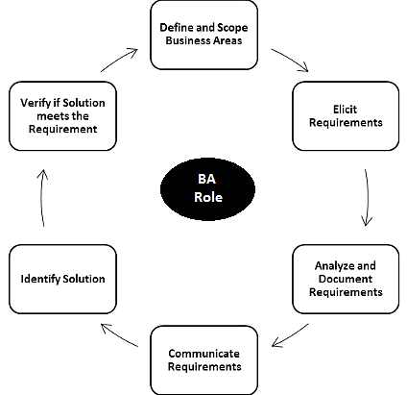

**Typical Duties of BA**

* Using data modelling techniques to identify ways in which an organisation can operate more effectively.
* Communicate with senior people in organisations to find out what they hope to achieve
* Formulate ways for businesses to improve, based on previous research
* Run workshops and training sessions
* Explore different solutions, their risks, benefits and impacts
* Proposing solutions to an organisation’s leaders, and keeping them updated with progress
* Creating documents to outline the proposed changes and the steps involved.
* Contributing to training and support for people affected by new systems and processes.

In Short,

**Focus:** Understand business needs, processes and challenges to suggest solutions using data and technology.

**Skills:** Communication, Stakeholder management, Business process analysis.

**Tools:** MS-Office, BI Tools.

**Future Scope:** Continuous demand, bridging business and technology gap.

**SDLC Life Cycle**

Software development life cycle (SDLC) is a structured process that is used to design, develop, and test good-quality software. SDLC, or software development life cycle, is a methodology that defines the entire procedure of software development step-by-step. The goal of the SDLC life cycle model is to deliver high-quality, maintainable software that meets the user’s requirements. SDLC in software engineering models outlines the plan for each stage so that each stage of the software development model can perform its task efficiently to deliver the software at a low cost within a given time frame that meets users requirements.

**What is the need for SDLC?**

SDLC is a method, approach, or process that is followed by a software development organization while developing any software. [SDLC models](https://www.geeksforgeeks.org/sdlc-models-types-phases-use)were introduced to follow a disciplined and systematic method while designing software. With the software development life cycle, the process of software design is divided into small parts, which makes the problem more understandable and easier to solve. SDLC comprises a detailed description or step-by-step plan for designing, developing, testing, and maintaining the software.

The [SDLC Model](https://www.geeksforgeeks.org/sdlc-models-types-phases-use)involves six phases or stages while developing any software:

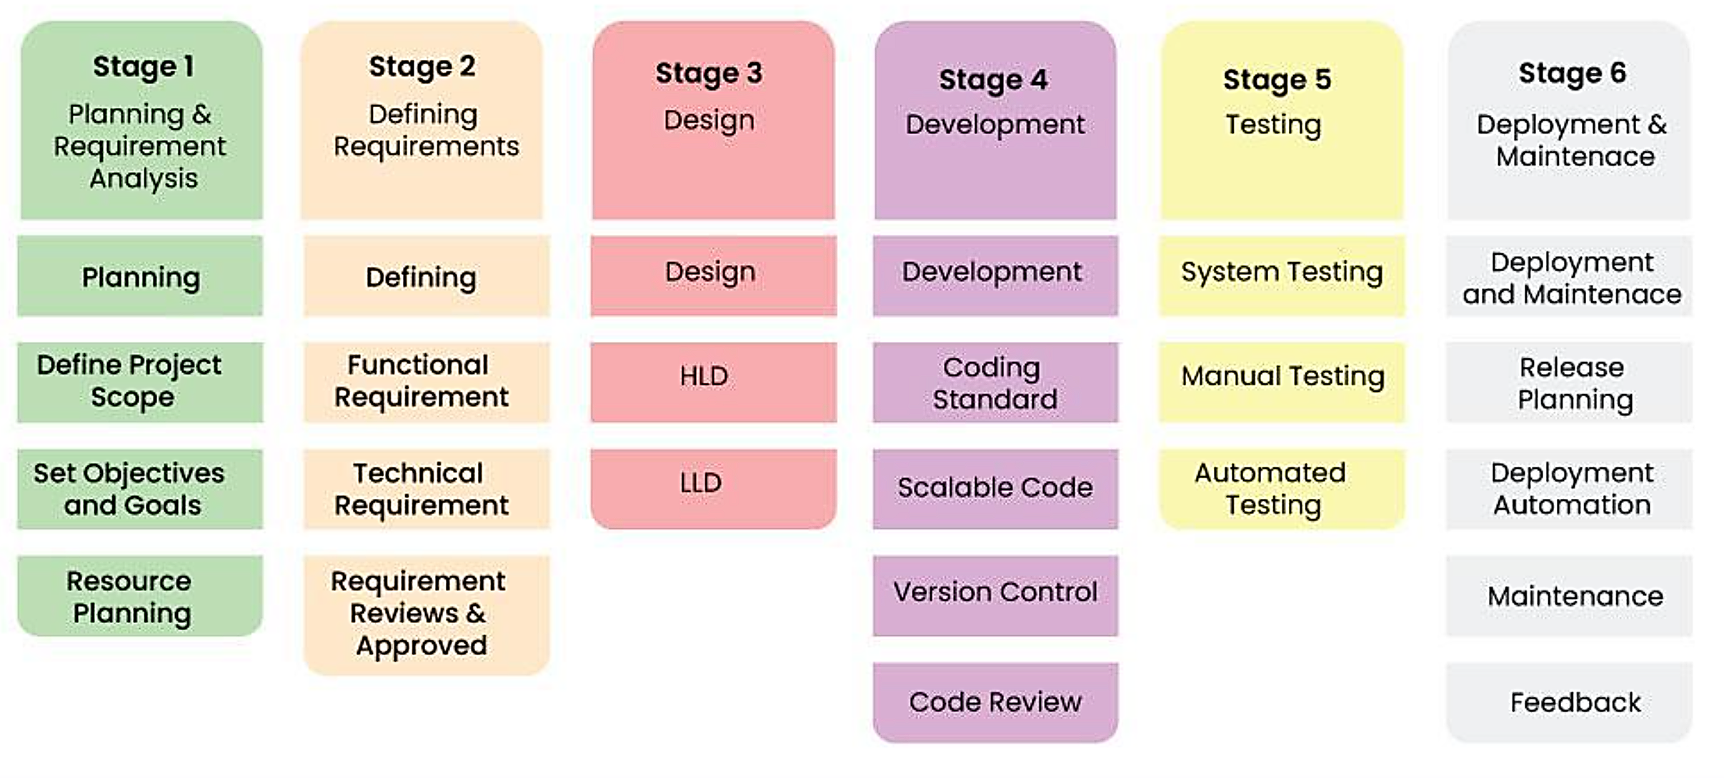

**Stage-1: Planning and Requirement Analysis**

Planning is a crucial step in everything, just as in[software development](https://www.geeksforgeeks.org/software-development). In this stage, [requirement analysis](https://www.geeksforgeeks.org/activities-involved-in-software-requirement-analysis)is also performed by the developers of the organization. This is attained from customer inputs, and sales department/market surveys. The information from this analysis forms the building blocks of a basic project. The quality of the project is a result of planning. Thus, in this stage, the basic project is designed with all the available information.

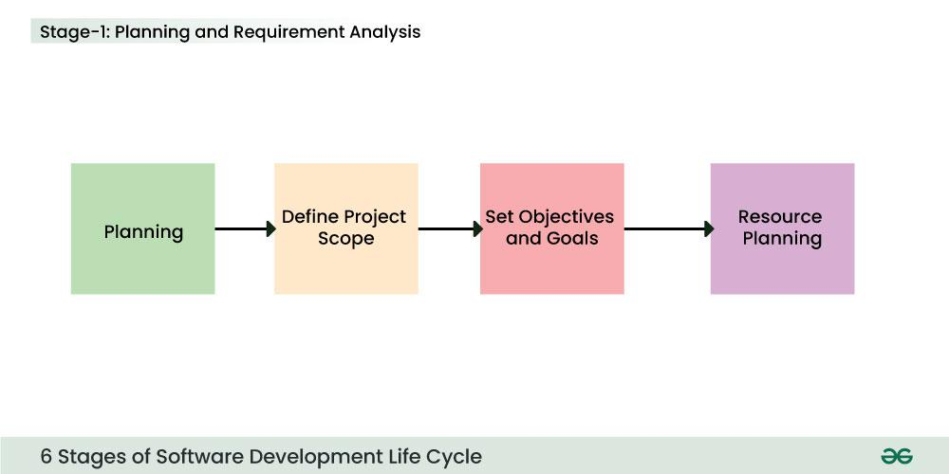

**Stage-2: Defining Requirements**

In this stage, all the requirements for the target software are specified. These requirements get approval from customers, market analysts, and stakeholders.   
This is fulfilled by utilizing SRS (Software Requirement Specification). This is a sort of document that specifies all those things that need to be defined and created during the entire project cycle.

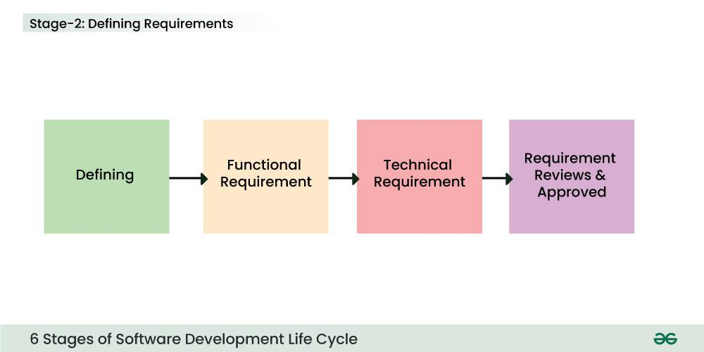

**Stage-3: Designing Architecture**

[SRS](https://www.geeksforgeeks.org/software-requirement-specification-srs-format) is a reference for software designers to come up with the best architecture for the software. Hence, with the requirements defined in SRS, multiple designs for the product architecture are present in the Design Document Specification (DDS).

This DDS is assessed by market analysts and stakeholders. After evaluating all the possible factors, the most practical and logical design is chosen for development.

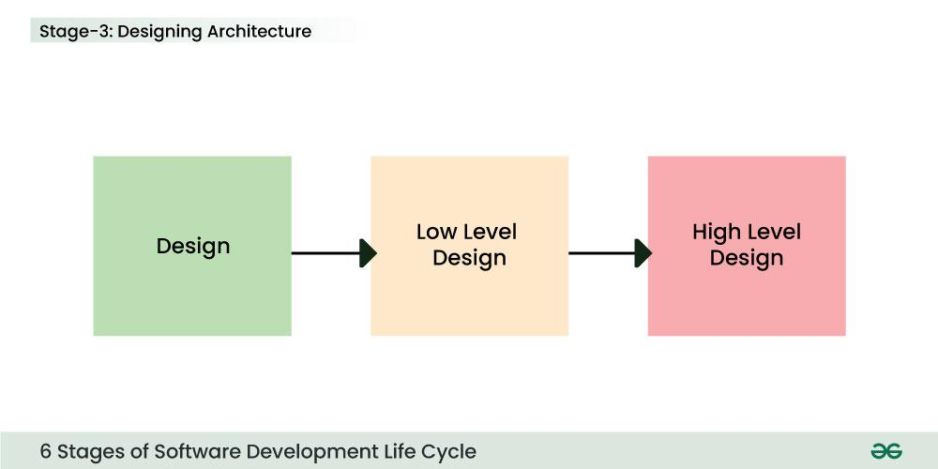

**Stage-4: Developing Product**

At this stage, the fundamental development of the product starts. For this, developers use a specific programming code as per the design in the DDS. Hence, it is important for the coders to follow the protocols set by the association. Conventional programming tools like compilers, interpreters, debuggers, etc. are also put into use at this stage. Some popular languages like C/C++, Python, Java, etc. are put into use as per the software regulations.

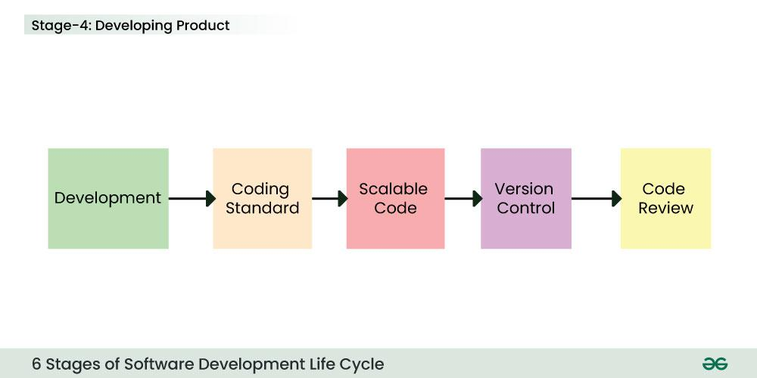

**Stage-5: Product Testing and Integration**

After the development of the product, testing of the software is necessary to ensure its smooth execution. Although, minimal testing is conducted at every stage of SDLC. Therefore, at this stage, all the probable flaws are tracked, fixed, and retested. This ensures that the product confronts the quality requirements of SRS.

Documentation, Training, and Support: [Software documentation](https://www.geeksforgeeks.org/overview-software-documentation) is an essential part of the software development life cycle. A well-written document acts as a tool and means to information repository necessary to know about software processes, functions, and maintenance. Documentation also provides information about how to use the product. Training in an attempt to improve the current or future employee performance by increasing an employee’s ability to work through learning, usually by changing his attitude and developing his skills and understanding.

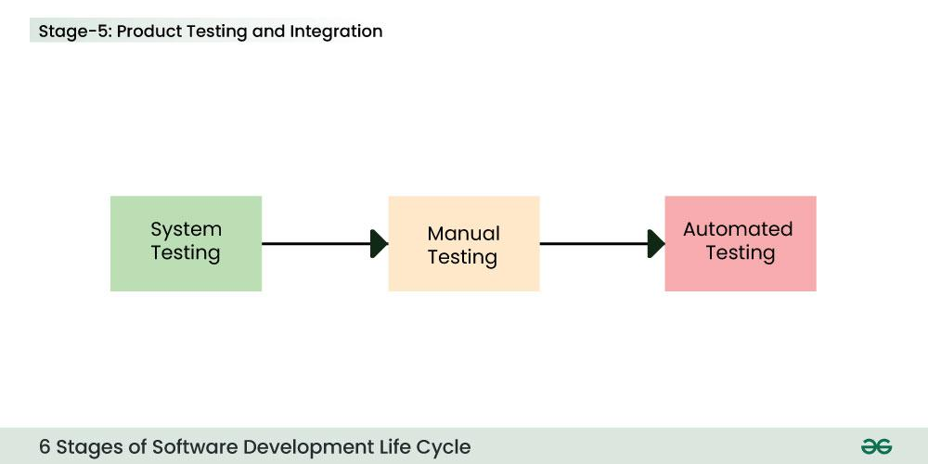

**Stage-6: Deployment and Maintenance of Products**

After detailed testing, the conclusive product is released in phases as per the organization’s strategy. Then it is tested in a real industrial environment. It is important to ensure its smooth performance. If it performs well, the organization sends out the product as a whole. After retrieving beneficial feedback, the company releases it as it is or with auxiliary improvements to make it further helpful for the customers. However, this alone is not enough. Therefore, along with the deployment, the [product’s supervision](https://www.geeksforgeeks.org/product-management).

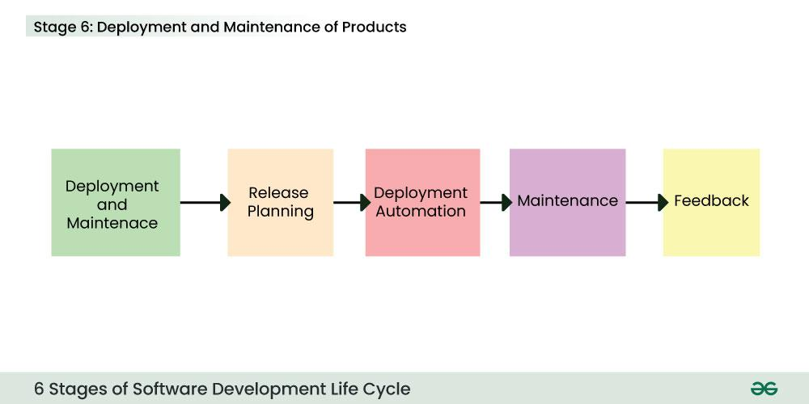

Here, we have listed the top five [most popular SDLC models](https://www.geeksforgeeks.org/top-8-software-development-models-used-in-industry/?ref=):

**1. Waterfall Model**

It is the fundamental model of the software development life cycle. This is a very simple model. The [waterfall model](https://www.geeksforgeeks.org/software-engineering-classical-waterfall-model)is not in practice anymore, but it is the basis for all other SDLC models. Because of its simple structure, the waterfall model is easier to use and provides a tangible output. In the waterfall model, once a phase seems to be completed, it cannot be changed, and due to this less flexible nature, the waterfall model is not in practice anymore.

**2. Agile Model**

The agile model in SDLC was mainly designed to adapt to changing requests quickly. The main goal of the [Agile model](https://www.geeksforgeeks.org/software-engineering-agile-development-models) is to facilitate quick project completion. The agile model refers to a group of development processes. These processes have some similar characteristics but also possess certain subtle differences among themselves.

**3. Iterative Model**

In the [Iterative model](https://www.geeksforgeeks.org/software-engineering-iterative-waterfall-model) in SDLC, each cycle results in a semi-developed but deployable version; with each cycle, some requirements are added to the software, and the final cycle results in the software with the complete requirement specification.

**4. Spiral Model**

The spiral model in SDLC is one of the most crucial SDLC models that provides support for risk handling. It has various spirals in its diagrammatic representation; the number of spirals depends upon the type of project. Each loop in the spiral structure indicates the Phases of the [Spiral model](https://www.geeksforgeeks.org/software-engineering-spiral-model).

**5. V-Shaped Model**

The [V-shaped model](https://www.geeksforgeeks.org/software-engineering-sdlc-v-model) in SDLC is executed in a sequential manner in V-shape. Each stage or phase of this model is integrated with a testing phase. After every development phase, a testing phase is associated with it, and the next phase will start once the previous phase is completed, i.e., development & testing. It is also known as the verification or validation model.

**6. Big Bang Model**

The [Big Bang model](https://www.geeksforgeeks.org/overview-of-big-bang-model) in SDLC is a term used to describe an informal and unstructured approach to software development, where there is no specific planning, documentation, or well-defined phases.

**Agile Sprint Cycle**

**Agile development methodology** focuses on Adaptive planning and change management. It focuses on developing and deploying the working software quickly in an iterative manner. This means that instead of developing the product entirely in one go, the product is made iteratively in multiple short and incremental cycles.

An "agile sprint cycle" refers to a fixed, time-boxed period within an Agile project management methodology where a team focuses on completing a specific set of tasks, usually lasting between one and four weeks, with the goal of delivering a working product increment by the end of the sprint; it involves planning, development, review, and reflection stages to continuously improve the product throughout the project lifecycle.

Sprints are fundamental in Agile frameworks like Scrum and Kanban, promoting iterative development and continuous improvement. Each sprint, lasting from one to four weeks, begins with planning, includes daily stand-up meetings for progress updates, and ends with a review and retrospective.

**What is a Sprint?**

In simplest words, "a sprint is a short and fixed time frame during which a specific set of tasks are meant to be performed". An Agile project will be broken down into a certain number of sprints, each sprint lasting for a fixed duration of time. Usually, each sprint runs for 2–4 weeks. A **Sprint Planning Meeting** occurs before the start of every sprint. That meeting defines what set of items could be developed and delivered in the upcoming sprint.

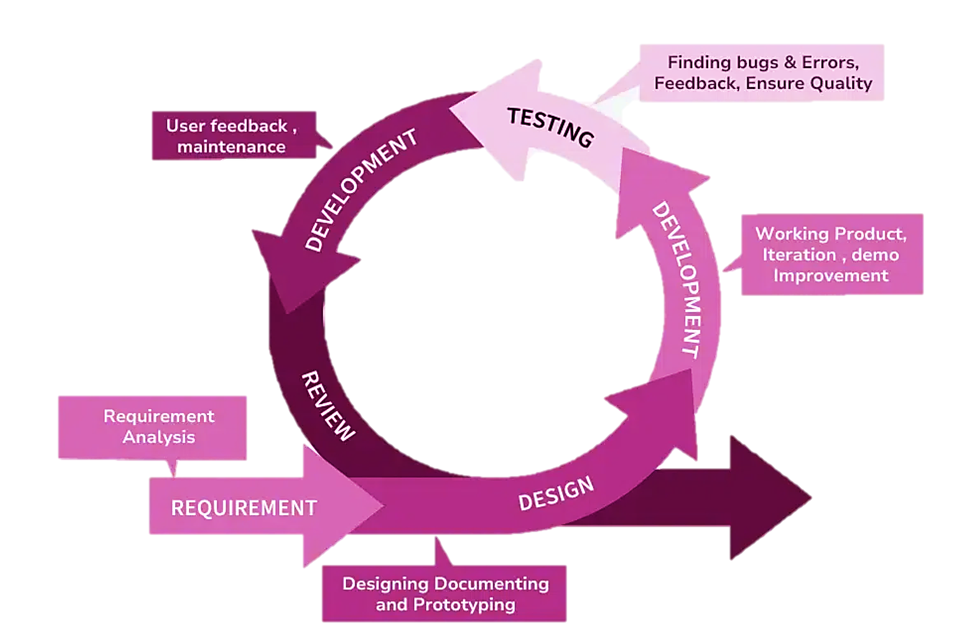

The Agile sprint cycle, or workflow, is the repetitive process that developers use to tackle a development project. A software project can take as many as ten sprint cycles. Although there is room for variation, most sprint cycles break down like this:

**Planning:** The team covers the top priority user stories, deciding what the spring can and will deliver. This stage includes items found in the backlog. The team also decides on the specific tasks necessary to complete the cycle.

**Backlog:** The backlog is a finalized list, agreed upon by the whole team, that defines what the development team will complete during the sprint. This backlog includes tasks and possible changes to the product.

**The Sprint:** This part is the time frame in which the actual incremental work must be completed and doesn’t exceed 30 days. The ideal sprint takes two weeks.

**Daily Scrum:** The Scrum is a short daily meeting led by the Scrum master, where the team comes to talk about the assignments they are working on, what they have finished, and any issues or obstacles that are blocking the work.

**Outcome:** The sprint’s outcome is just another way to say the result, which usually is a hypothetically usable product. The product owner gets the last word to decide if the product is ready or if it needs additional features.

**Sprint End:** At the conclusion of a sprint cycle, the team gets together for two final meetings:

* Sprint review. The team shows the completed work to the product owner, who ideally gives it the thumbs up.
* Sprint retrospective. The team talks about what it can do to improve processes in the future, in the spirit of continuous improvement. Consider this as self-evaluation.

**Project Planning**

**Domain:** E-Commerce **Budget:** Rs. 45,00,000/- **Duration:** 8 Months

**Why I choose E-commerce?**

* E-commerce projects can scale significantly and can have varied requirements.
* With increasing trends in online shopping and the digital transformation of businesses, an e-commerce platform project would have real business value.
* Team: Full Stack, Frontend, Backend, QA Tester, Project Manager, Business Analysy, UI/UX Designer.

**Sprint:**  
A sprint is a short duration of time in agile project management during which a team works to complete specific tasks. It typically lasts 2-4 weeks and is part of a continuous cycle aimed at delivering incremental value. Each sprint starts with planning, followed by development, testing, and ends with a review and retrospective.

*As we have to finished most of the task in first four month, we have to create sprint for first 4 months:*

|  |  |  |  |  |  |
| --- | --- | --- | --- | --- | --- |
| Month | Sprint | Sprint Duration | Sprint Focus | Team Included | Sprint Wise Budget |
| Month 1 | Sprint 1 | 2 Weeks | Foundation, Requirement Gathering and Documentation | Business Analyst, Project Manager | **₹ 1,85,000.00** |
| Sprint 2 | 2 Weeks | Platform Environment Setup, UI Designing | UIUX Designer, Full Stack developer, Frontend Dev, Backend Dev | **₹ 1,33,125.00** |
| Month 2 | Sprint 3 | 2 Weeks | Developing Frontend, Authentication system, Product management | Backend Dev, Full Stack Dev | **₹ 1,84,523.00** |
| Sprint 4 | 2 Weeks | Order Management, Shopping cart, QA Testing | QA Tester, Fullstack Dev | **₹ 2,09,000.00** |
| Month 3 | Sprint 5 | 2 Weeks | Integrating Payment Gateway, Testing Secure Payment Methods, Implement review system | Backend Developer, Frontend Developer | **₹ 2,36,856.00** |
| Sprint 6 | 2 Weeks | Designing admin dashboard, real time reporting for sales, order, test dashboard | QA Tester, Fullstack Dev | **₹ 1,61,460.00** |
| Month 4 | Sprint 7 | 2 Weeks | Final testing and If product meet clients requirement and check SRS documentation | Project Manager, QA tester, Fullstack Dev, Backend Dev | **₹ 1,30,750.00** |
| Sprint 8 | 2 Weeks | Deploy Product at Client’s environment | Developers, Project Manager, Business Analyst | **₹ 1,69,286.00** |

## **Budget Summary**

## **Team Details**

|  |  |  |
| --- | --- | --- |
| Role | Count | Salary |
| Frontend Developer | 1 | ₹ 40,000.00 |
| Backend Developer | 1 | ₹ 50,000.00 |
| Full Stack Developer | 1 | ₹ 60,000.00 |
| QA Tester | 1 | ₹ 37,000.00 |
| UI/UX Designer | 1 | ₹ 30,000.00 |
| Project Manager | 1 | ₹ 50,000.00 |
| Business Analyst | 1 | ₹ 40,000.00 |
| Data Analyst | 1 | ₹ 40,000.00 |

## **Budget Details**

|  |  |  |
| --- | --- | --- |
| Month | Sprint Name | Budget |
| 1 | Sprint 1 | **₹ 1,85,000.00** |
| 1 | Sprint 2 | **₹ 1,33,125.00** |
| 2 | Sprint 3 | **₹ 1,84,523.00** |
| 2 | Sprint 4 | **₹ 2,09,000.00** |
| 3 | Sprint 5 | **₹ 2,36,856.00** |
| 3 | Sprint 6 | **₹ 1,61,460.00** |
| 4 | Sprint 7 | **₹ 1,30,750.00** |
| 4 | Sprint 8 | **₹ 1,69,286.00** |

## **Tools/ Licenses/ Misc. Details**

|  |  |
| --- | --- |
| Category | Price For 1 Year |
| Tools & Licenses | ₹ 1,10,000.00 |
| Cloud Hosting & Infrastructure | ₹ 1,30,000.00 |
| Miscellaneous Expenses | ₹ 75,000.00 |
| Total: | **₹ 3,15,000.00** |

## **Total Project Budget**

|  |  |  |  |
| --- | --- | --- | --- |
| Duration | Salary Costs | Additional Costs | Total Budget |
| 4 Months | ₹ 13,88,000.00 | ₹ 3,15,000.00 | **₹ 17,03,000.00** |
| 8 Months | ₹ 27,76,000.00 | ₹ 3,15,000.00 | **₹ 30,91,000.00** |
| 1 Year | ₹ 41,64,000.00 | ₹ 3,15,000.00 | **₹ 44,79,000.00** |

**Project Development Summary: Sprint-Wise**

**Sprint 1: Platform Setup**

* **Focus**: Setting up the technical and foundational aspects of the project.
* **Key Tasks**:
  + Conduct detailed requirement gathering sessions with stakeholders to finalize business needs.
  + Set up repositories for version control and configure the development environment for team collaboration.
  + Establish timelines, workflows, and finalize the scope of work.
* **Outcome**: A clear project scope, technical setup, and roadmap for smooth execution.
* **Teams:** Business Analyst, Project Manager, Frontend Developer, Fullstack Developer.

**Sprint 2: UI/UX Design**

* **Focus**: Designing a responsive, intuitive, and visually appealing platform interface.
* **Key Tasks**:
  + Create wireframes and prototypes for key pages, ensuring usability and navigation ease.
  + Develop mobile-friendly designs for seamless access across devices.
  + Refine designs based on stakeholder feedback to ensure alignment with user expectations.
* **Outcome**: High-quality UI/UX designs ready for development.
* **Teams:** UI/UX Designer.

**Sprint 3: Frontend Development**

* **Focus**: Building the platform’s user interface using responsive and scalable technologies.
* **Key Tasks**:
  + Develop responsive web pages with proper layouts and navigation.
  + Implement cross-device compatibility to ensure a consistent user experience across various screen sizes.
  + Collaborate with the backend team for seamless integration of APIs and services.
* **Outcome**: A functional and responsive frontend interface.
* **Teams:** Frontend Developer, Backend Developer, Fullstack Developer.

**Sprint 4: Authentication & Product Management**

* **Focus**: Implementing secure user authentication and developing product management features.
* **Key Tasks**:
  + Implement user login, registration, and role-based access control for security and functionality.
  + Create CRUD operations for managing product catalogs.
  + Add features for categorizing products and tracking orders.
  + Test user authentication and product management modules for reliability and security.
* **Outcome**: Secure user access and robust product management system.
* **Teams:** Frontend Developer, Backend Developer, Fullstack Developer, QA Tester.

**Sprint 5: Shopping Cart & Checkout**

* **Focus**: Enabling customers to shop easily and securely.
* **Key Tasks**:
  + Develop shopping cart functionality allowing users to add/remove items.
  + Implement secure checkout processes, including address management and payment method integration.
  + Test the shopping and checkout flow for a seamless experience.
* **Outcome**: A complete and secure purchasing system for customers.
* **Teams:** Frontend Developer, Backend Developer, Fullstack Developer, QA Tester.

**Sprint 6: Payment Gateway Integration**

* **Focus**: Ensuring secure payments and integrating customer feedback systems.
* **Key Tasks**:
  + Integrate payment gateways like PayPal and RazorPay for diverse payment options.
  + Build a product review and rating system for customers to leave feedback.
  + Test and moderate the review system across various user profiles for reliability.
* **Outcome**: A secure payment system and a platform for customer feedback.
* **Teams:** Data Analyst, Fullstack Developer, QA Tester.

**Sprint 7: Admin Dashboard**

* **Focus**: Providing admins with tools for managing and monitoring platform performance.
* **Key Tasks**:
  + Design an intuitive dashboard UI for admin users.
  + Develop analytics reports for tracking sales, orders, and user activities in real time.
  + Test the dashboard functionalities to ensure data accuracy and ease of use.
* **Outcome**: A comprehensive admin panel with actionable insights and reports.
* **Teams:** UI/UX Designer, Frontend Developer, QA Tester.

**Sprint 8: Final Testing & Deployment**

* **Focus**: Ensuring platform readiness for public launch.
* **Key Tasks**:
  + Conduct a final round of testing, focusing on performance, security, and accessibility.
  + Refine the UI/UX based on feedback from stakeholders and testing results.
  + Deploy the platform to the production environment, followed by a public launch.
* **Outcome**: A polished, fully functional e-commerce platform ready for users.
* **Teams:** All Developers, QA Tester, Project Manager.