**Q37:** *P(R)* represents a pattern drawn by Julia in *R* rows. The following pattern represents *P(5)*:

*

* *

* * *

* * * *

* * * * *

Write a query to print the pattern *P(20)*.

**Solution:**

Set @number=0;

select repeat('* ', @number := @number+1)

from information_schema.tables

where @number <20;

**Q38:** *P(R)* represents a pattern drawn by Julia in *R* rows. The following pattern represents *P(5)*:

* * * * *

* * * *

* * *

* *

*

Write a query to print the pattern *P(20)*.

**Solution:**

Set @number=21;

select repeat('* ', @number := @number-1)

from information_schema.tables

where @number > 0;

**Q39:** Query the *Western Longitude* (*LONG_W*)where the smallest *Northern Latitude* (*LAT_N*) in STATION is greater than 38.7780 . Round your answer to  decimal places.

Input Format: The STATION table is described as follows:

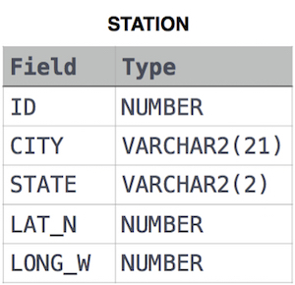

where *LAT_N* is the northern latitude and *LONG_W* is the western longitude.

**Solution:**

SELECT ROUND(LONG_W,4)

FROM STATION

WHERE LAT_N > 38.7780

ORDER BY LAT_N

LIMIT 1;

**Q40:** Query the smallest *Northern Latitude* (*LAT_N*) from STATION that is greater than 38.7780. Round your answer to  decimal places.

Input Format: The STATION table is described as follows:



where *LAT_N* is the northern latitude and *LONG_W* is the western longitude.

**Solution:**

SELECT ROUND(LAT_N,4)

FROM STATION

WHERE LAT_N > 38.7780

ORDER BY LAT_N

LIMIT 1;