**Q41:** Query the *Western Longitude* (*LONG_W*) for the largest *Northern Latitude* (*LAT_N*) in STATION that is less than 137.2345. Round your answer to  decimal places.

Input Format: The STATION table is described as follows:

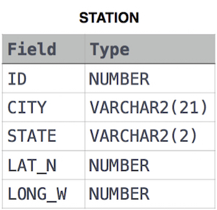

where *LAT_N* is the northern latitude and *LONG_W* is the western longitude.

**Solution:**

SELECT ROUND(LONG_W,4)

FROM STATION

WHERE LAT_N < 137.2345 ORDER BY LAT_N DESC

LIMIT 1;

**Q42:** Samantha was tasked with calculating the average monthly salaries for all employees in the EMPLOYEES table, but did not realize her keyboard's 0 key was broken until after completing the calculation. She wants your help finding the difference between her miscalculation (using salaries with any zeros removed), and the actual average salary.

Write a query calculating the amount of error (i.e.:  actual – miscalculated average monthly salaries), and round it up to the next integer.

The EMPLOYEES table is described as follows:

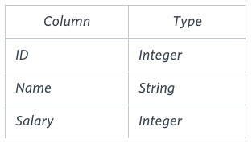

Note: *Salary* is per month.

Constraints: 1000<Salary<10^5

Sample Input

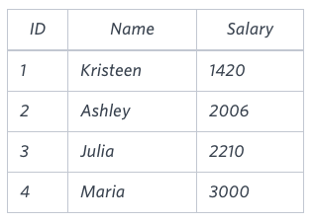

Sample Output

2061

Explanation

The table below shows the salaries *without zeros* as they were entered by Samantha:

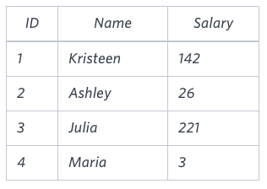

Samantha computes an average salary of 98.00. The *actual* average salary is 2159.00.

The resulting error between the two calculations is 2159.00 – 98.00=2061.00. Since it is equal to the integer 2061, it does not get rounded up.

**Solution:**

SELECT CEIL (AVG(SALARY)-AVG(REPLACE(SALARY,'0',''))) FROM EMPLOYEES;