**Q9:** Find the difference between the total number of **CITY** entries in the table and the number of distinct **CITY** entries in the table. The **STATION** table is described as follows:

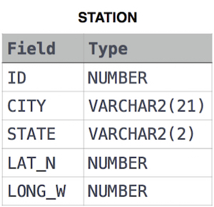

where LAT_N is the northern latitude and LONG_W is the western longitude.

For example, if there are three records in the table with CITY values 'New York', 'New York', 'Bengalaru', there are 2 different city names: 'New York' and 'Bengalaru'. The query returns , because total number of records number of unique city names 3-2-1.

**Solution:**

SELECT COUNT(CITY)- COUNT(DISTINCT CITY)

FROM STATION;

**Q10:** Query the list of *CITY* names starting with vowels (i.e., a, e, i, o, or u) from STATION. Your result *cannot* contain duplicates. The STATION table is described as follows:



where *LAT_N* is the northern latitude and *LONG_W* is the western longitude.

**Solution:**

SELECT CITY FROM STATION

WHERE LEFT(UPPER(CITY),1) IN ('A','E','I','O','U');

**Q11:** Query the list of *CITY* names ending with vowels (a, e, i, o, u) from STATION. Your result *cannot* contain duplicates.

Input Format

The STATION table is described as follows:



where *LAT_N* is the northern latitude and *LONG_W* is the western longitude.

**Solution:**

SELECT DISTINCT CITY FROM STATION

WHERE RIGHT(UPPER(CITY),1) IN('A','E','I','O','U');

**Q12:** Query the list of *CITY* names from STATION which have vowels (i.e., *a*, *e*, *i*, *o*, and *u*) as both their first *and* last characters. Your result cannot contain duplicates.

Input Format

The STATION table is described as follows:



where *LAT_N* is the northern latitude and *LONG_W* is the western longitude.

**Solution:**

SELECT DISTINCT CITY

FROM STATION

WHERE LEFT(UPPER(CITY),1) IN('A','E','I','O','U') AND

RIGHT(UPPER(CITY),1) IN('A','E','I','O','U');