**Q13:** Query the list of *CITY* names from STATION that *do not start* with vowels. Your result cannot contain duplicates. The STATION table is described as follows:

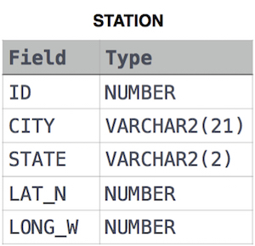

where *LAT_N* is the northern latitude and *LONG_W* is the western longitude.

**Solution:**

SELECT DISTINCT CITY

FROM STATION

WHERE LEFT(UPPER(CITY),1) NOT IN('A','E','I','O','U');

**Q14:** Query the list of *CITY* names from STATION that *do not end* with vowels. Your result cannot contain duplicates. The STATION table is described as follows:



where *LAT_N* is the northern latitude and *LONG_W* is the western longitude.

**Solution:**

SELECT DISTINCT CITY

FROM STATION

WHERE RIGHT(UPPER(CITY),1) NOT IN('A','E','I','O','U');

**Q15:** Query the list of *CITY* names from STATION that either do not start with vowels or do not end with vowels. Your result cannot contain duplicates. The STATION table is described as follows:



where *LAT_N* is the northern latitude and *LONG_W* is the western longitude**.**

**Solution:**

SELECT DISTINCT CITY

FROM STATION

WHERE LEFT(UPPER(CITY),1) NOT IN('A','E','I','O','U')

OR RIGHT(UPPER(CITY),1) NOT IN('A','E','I','O','U');

**Q16:** Query the list of *CITY* names from STATION that *do not start* with vowels and *do not end* with vowels. Your result cannot contain duplicates. The STATION table is described as follows:



where *LAT_N* is the northern latitude and *LONG_W* is the western longitude.

**Solution:**

SELECT DISTINCT CITY

FROM STATION

WHERE LEFT(UPPER(CITY),1) NOT IN('A','E','I','O','U')

AND RIGHT(UPPER(CITY),1) NOT IN('A','E','I','O','U');