**Q21:** Query a *count* of the number of cities in CITY having a *Population* larger than .

Input Format The CITY table is described as follows:

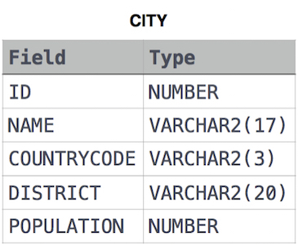

**Solution:**

SELECT COUNT(ID) FROM CITY

WHERE POPULATION > 100000;

**Q22:** Query the total population of all cities in **CITY** where *District* is **California**.

**Input Format.** The **CITY** table is described as follows:



**Solution:**

SELECT SUM(POPULATION) FROM CITY

WHERE DISTRICT = 'California';

**Q23:**  Query the average population of all cities in **CITY** where *District* is **California**.

**Input Format.** The **CITY** table is described as follows:



**Solution:**

SELECT AVG(POPULATION) FROM CITY

WHERE DISTRICT = 'California';

**Q24:** Query the average population for all cities in CITY, rounded *down* to the nearest integer.

Input Format. The CITY table is described as follows:



**Solution:**

SELECT ROUND(AVG(POPULATION))

FROM CITY;