**Q25:** Query the sum of the populations for all Japanese cities in CITY. The *COUNTRYCODE* for Japan is JPN.

Input Format. The CITY table is described as follows:

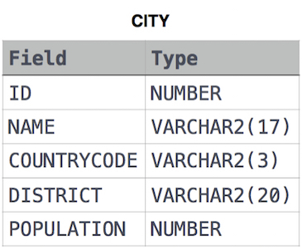

**Solution:**

SELECT SUM(POPULATION)

FROM CITY

WHERE COUNTRYCODE = 'JPN';

**Q26:** Query the difference between the maximum and minimum populations in **CITY**.

**Input Format.** The **CITY** table is described as follows:



**Solution:**

SELECT MAX(POPULATION) - MIN(POPULATION)

FROM CITY;

**Q27:**  We define an employee's *total earnings* to be their monthly salary x months worked, and the *maximum total earnings* to be the maximum total earnings for any employee in the **Employee** table. Write a query to find the *maximum total earnings* for all employees as well as the total number of employees who have maximum total earnings. Then print these values as 2 space-separated integers. **Input Format**

The **Employee** table containing employee data for a company is described as follows:

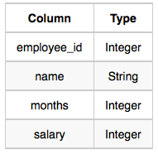

where *employee_id* is an employee's ID number, *name* is their name, *months* is the total number of months they've been working for the company, and *salary* is the their monthly salary.

**Sample Input**

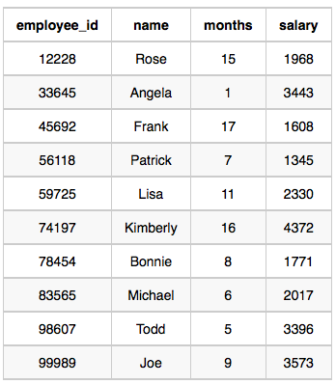

**Sample Output**

69952 1

**Explanation -** The table and earnings data is depicted in the following diagram:

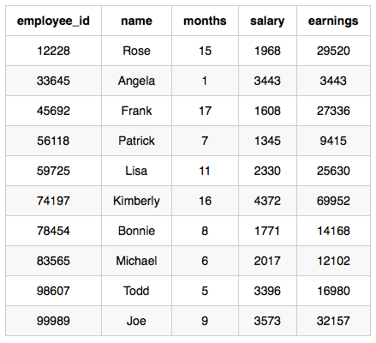

The maximum *earnings* value is 69952. The only employee with *earnings* 69952 is *Kimberly*, so we print the maximum *earnings* value (69952) and a count of the number of employees who have earned $69952 (which is 1) as two space-separated values.

**Solution:**

SELECT (months*salary) as earnings, COUNT(*)

FROM Employee

GROUP BY earnings

ORDER BY earnings DESC

LIMIT 1;

**Q28:** Query the following two values from the STATION table:

1. The sum of all values in *LAT_N* rounded to a scale of 2 decimal places.
2. The sum of all values in *LONG_W* rounded to a scale of 2 decimal places.

Input Format. The STATION table is described as follows:

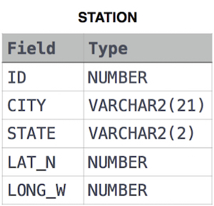

where *LAT_N* is the northern latitude and *LONG_W* is the western longitude.

**Output Format**

Your results must be in the form:

lat lon, where lat is the sum of all values in *LAT_N* and lon is the sum of all values in *LONG_W*. Both results must be rounded to a scale of  decimal places.

**Solution:**

SELECT ROUND(SUM(LAT_N), 2), ROUND(SUM(LONG_W), 2)

FROM STATION;