A Project Report On

“Online transection”

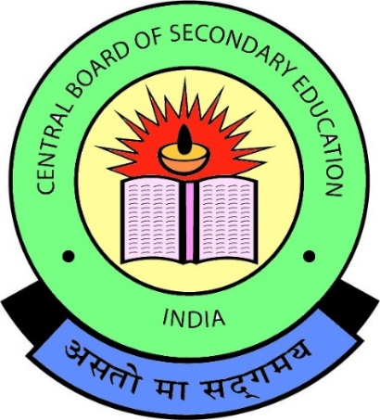

Submitted by

Sahil Saini

Class: XII

**Under the guidance of**

Mrs. Surbhi Jain

PGT(Informatics Practices)

Department of Computer Science

Oxford International Public School, Sanganer, Jaipur

INDEX

|  |  |  |
| --- | --- | --- |
| S.NO. | TOPICS | Pg.NO. |
| 1 | Acknowledgement |  |
| 2 | Certificate |  |
| 3 | Introduction |  |
| 4 | Hardware and software |  |
| 5 | Coding |  |
| 6 | Output |  |
| 7 | References |  |

AKNOWLEDGEMENT

We are thankful to our computer teacher Mrs. Surbhi Jain who helped and guided me while making this project. We would also like to thanks my Computer Department of our OXFORD INTERNATIONAL PUBLIC SCHOOL who helped and gave me time for the completion of my project.

NAME:

CLASS:



INTRODUCTION

This Project is Named as

“ONLINE TRANSCETION”.

As the Name Indicates this is all about Money Transfer weather it is

Bank to Bank Transfer

Paying Bills

Many Types Recharges (Mobile/DTH)

This Application have No risks

“YOUR MONEY IS SAFE”