### **Mugdha Kurkure**

### **B2 1911096**

**Q1 Draw graph of the function and its fourier series (with n=30, n=10)**

**f(x)=x^2 ,0≤x≤2π**

**For 30 Constants (n = 30)**

clc;

L = %pi;

x = 0:0.01:2*L; // vector of values of independent variable

f = x^2; // vector of values of function on which Fourier Series will be applied

// Euler's Constants for Fourier Series

a0 = (1 / (2 * L)) * inttrap (x, f);

for n = 1:30, // calculating 50 constants

f1 = f .* cos (n*x);

a(n) = (1/L) * inttrap (x, f1);

end;

for n = 1:30,

f2 = f .* sin (n*x);

b(n) = (1/L) * inttrap (x, f2);

end

subplot (2, 1, 1), plot (x, f); // plot of actual function

u=0; h=0;

for n=1:30,

u = u + a(n) * cos(n*x) + b(n) * sin(n*x);

// y = u;

fs = u + a0;

end;

subplot(2,1,2), plot(x,fs); //plots the graph of fourier series of function

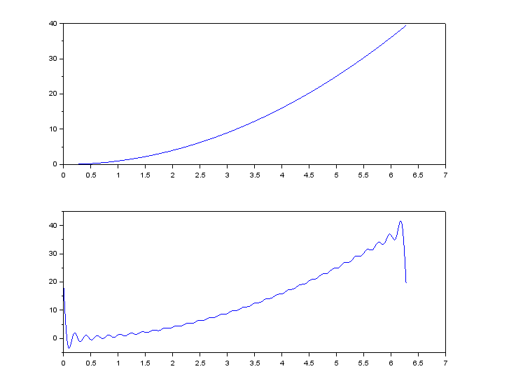

**For 10 Constants (n = 10)**

clc;

L = %pi;

x = 0:0.01:2*L; // vector of values of independent variable

f = x^2; // vector of values of function on which Fourier Series will be applied

// Euler's Constants for Fourier Series

a0 = (1 / (2 * L)) * inttrap (x, f);

for n = 1:10, // calculating 50 constants

f1 = f .* cos (n*x);

a(n) = (1/L) * inttrap (x, f1);

end;

for n = 1:10,

f2 = f .* sin (n*x);

b(n) = (1/L) * inttrap (x, f2);

end

subplot (2, 1, 1), plot (x, f); // plot of actual function

u=0; h=0;

for n = 1:10,

u = u + a(n) * cos(n*x) + b(n) * sin(n*x);

// y = u;

fs = u + a0;

end;

subplot(2,1,2), plot(x,fs); //plots the graph of fourier series of function

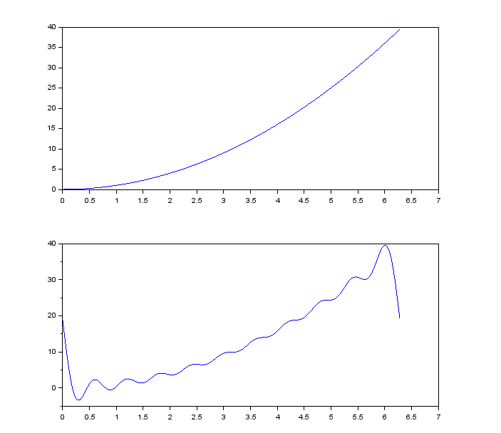

**Q2 Draw graph of the function and its fourier series (with n=50, n=10)**

**f(x)=xsinx ,0≤x≤2π**

**For 10 Constants (n = 10)**

clc;

L = %pi;

x = 0:0.01:2*L; // vector of values of independent variable

f = x.*(sin(x)); // vector of values of function on which Fourier Series will be applied

// Euler's Constants for Fourier Series

a0 = (1 / (2 * L)) * inttrap (x, f);

for n = 1:10, // calculating 50 constants

f1 = f .* cos (n*x);

a(n) = (1/L) * inttrap (x, f1);

end;

for n = 1:10,

f2 = f .* sin (n*x);

b(n) = (1/L) * inttrap (x, f2);

end

subplot (2, 1, 1), plot (x, f); // plot of actual function

u=0; h=0;

for n = 1:10,

u = u + a(n) * cos(n*x) + b(n) * sin(n*x);

// y = u;

fs = u + a0;

end;

subplot(2,1,2), plot(x,fs); //plots the graph of fourier series of function

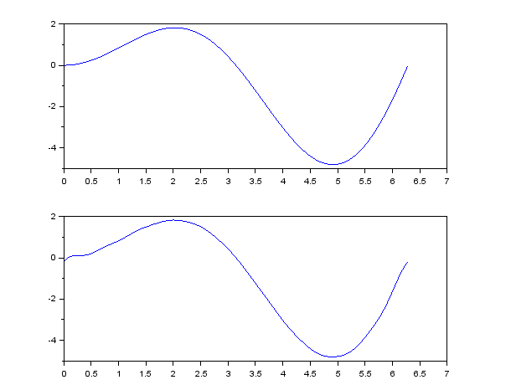

**For 50 Constants (n = 50)**

clc;

L = %pi;

x = 0:0.01:2*L; // vector of values of independent variable

f = x.*(sin(x)); // vector of values of function on which Fourier Series will be applied

limit = 50;

// Euler's Constants for Fourier Series

a0 = (1 / (2 * L)) * inttrap (x, f);

for n = 1:limit, // calculating 50 constants

f1 = f .* cos (n*x);

a(n) = (1/L) * inttrap (x, f1);

end;

for n = 1:limit,

f2 = f .* sin (n*x);

b(n) = (1/L) * inttrap (x, f2);

end

subplot (2, 1, 1), plot (x, f); // plot of actual function

u=0; h=0;

for n = 1:limit,

u = u + a(n) * cos(n*x) + b(n) * sin(n*x);

// y = u;

fs = u + a0;

end;

subplot(2,1,2), plot(x,fs); //plots the graph of fourier series of function

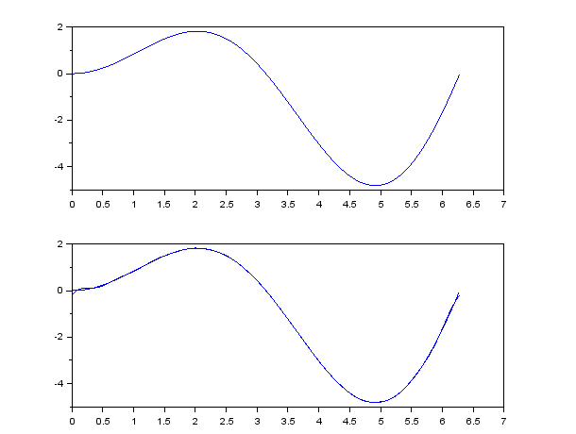

**Q3 Draw graph of the function and its fourier series (with n=70, n=10)**

**f(x)=e^(-x) ,0≤x≤2π**

**For 70 Constants (n = 70)**

clc;

L = %pi;

x = 0:0.01:2*L; // vector of values of independent variable

f = exp(-x); // vector of values of function on which Fourier Series will be applied

limit = 70;

// Euler's Constants for Fourier Series

a0 = (1 / (2 * L)) * inttrap (x, f);

for n = 1:limit, // calculating 50 constants

f1 = f .* cos (n*x);

a(n) = (1/L) * inttrap (x, f1);

end;

for n = 1:limit,

f2 = f .* sin (n*x);

b(n) = (1/L) * inttrap (x, f2);

end

subplot (2, 1, 1), plot (x, f); // plot of actual function

u=0; h=0;

for n = 1:limit,

u = u + a(n) * cos(n*x) + b(n) * sin(n*x);

// y = u;

fs = u + a0;

end;

subplot(2,1,2), plot(x,fs); //plots the graph of fourier series of function

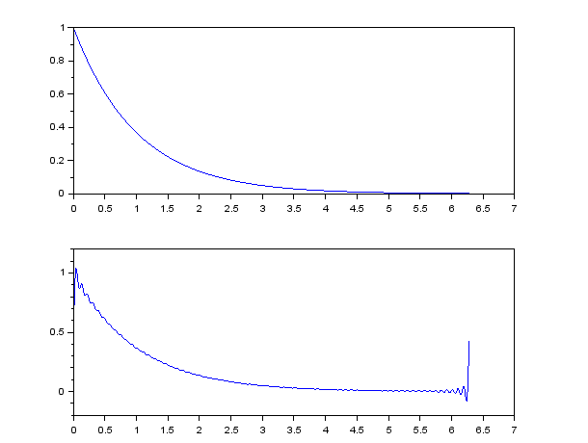

**For 10 Constants (n = 10)**

clc;

L = %pi;

x = 0:0.01:2*L; // vector of values of independent variable

f = exp(-x); // vector of values of function on which Fourier Series will be applied

limit = 10;

// Euler's Constants for Fourier Series

a0 = (1 / (2 * L)) * inttrap (x, f);

for n = 1:limit, // calculating 50 constants

f1 = f .* cos (n*x);

a(n) = (1/L) * inttrap (x, f1);

end;

for n = 1:limit,

f2 = f .* sin (n*x);

b(n) = (1/L) * inttrap (x, f2);

end

subplot (2, 1, 1), plot (x, f); // plot of actual function

u=0; h=0;

for n = 1:limit,

u = u + a(n) * cos(n*x) + b(n) * sin(n*x);

// y = u;

fs = u + a0;

end;

subplot(2,1,2), plot(x,fs); //plots the graph of fourier series of function

