Semantic Early-Stopping for Iterative LLM Agent Loops:
A Judge-Efficient Study of When to Halt
Sahil Shrivastava — semantic-halting-problem
Working draft. Theory machine-checked; results from the open harness.

Abstract
Iterative multi-agent LLM loops are usually terminated by a fixed iteration cap (max_iterations), a syntactic kill-switch blind to whether the answer is still improving. We study semantic early-stopping: halting when consecutive draft embeddings stop changing in meaning (cosine-distance patience) and measured quality plateaus. We contribute (i) an honest theoretical footing — a proof of deterministic termination and well-definedness, with distance convergence treated as a measured conjecture rather than a (previously over-claimed) Banach contraction; (ii) a judge-efficient evaluation protocol — generate each trajectory once, replay all stopping policies over it, and cache every judge call — enabling a strictly paired efficiency-vs-quality comparison on modest compute; and (iii) an empirical study on multi-hop RAG QA (HotpotQA). On the dev split a judge-free semantic stopper cuts operational tokens by 38% vs max_iterations at parity quality, while the full quality-gated variant is counter-productive because per-round judging dominates cost. An oracle selecting the best round attains +0.13 Information Score over every practical policy (p≈3e-5), reframing the problem from when to stop (easy) to which round is best (unsolved).

1 Introduction
A widely used agentic pattern is the Writer→Critic loop: a Writer drafts an answer, a Critic critiques it, the Writer revises. The default termination rule — stop after N rounds — over-spends on easy questions and truncates hard ones, and is blind to the fact that later rounds may repeat earlier content. SHP instead embeds each draft and measures the cosine distance between consecutive drafts; when that distance stays below a threshold ε for k consecutive rounds, the answer has converged in meaning and we halt, combined with a quality signal, critic approval, and a hard failsafe.
Contributions: (1) honest, machine-checked theory (termination, well-definedness, halt-priority consistency) with convergence as a measured conjecture; (2) a judge-efficient, strictly-paired evaluation protocol with operational-vs-evaluation token accounting; (3) an empirical study against five baselines with paired statistics and non-inferiority testing.

2 Related Work and Novelty
Semantic convergence and loop termination have been studied via fixed-point theory, multi-LLM uncertainty, adaptive orchestration, contraction mappings, and token-efficient scheduling. The ingredients of SHP (early stopping, early-exit inference, embedding similarity) are individually established; what is not done together is quality-gated semantic halting for agent loops, a judge-efficient strictly-paired evaluation protocol, and an operational-vs-evaluation token accounting that charges a policy for its own measurement overhead. The protocol is reusable beyond SHP — that methodological reusability is the defensible novelty.

3 Method
Architecture (Figure 1): the Writer and Critic both condition on the retrieved contexts (a true RAG setting). Embeddings use a frozen local model, so the convergence signal is free of API cost; only the RAGAS judge costs tokens.
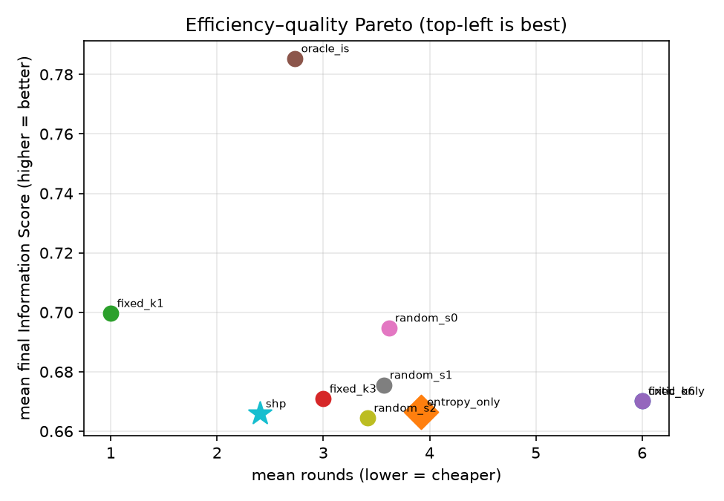
Signals: d_t = 1 − cos(e_t, e_{t-1}) ∈ [0,2]; IS_t = Σ w_m · RAGAS_m(x_t) ∈ [0,1], weights on the simplex. Halt cascade (priority order): critic APPROVED → entropy convergence (d_t<ε for k rounds) → no information gain (ΔIS≤0) → failsafe (t≥MAX_ROUNDS). One shared function drives the live loop, the post-hoc reason, and offline replay.

4 Theory (Honest)
We do not claim a Banach contraction (LLM generation has no proven Lipschitz constant <1 and is non-deterministic across calls). We prove only what holds; each claim is machine-checked.
Theorem 1 (Termination). For any input, weights, and signal configuration, the loop halts in ≤ MAX_ROUNDS rounds (the failsafe is unconditional and not ablatable).
Lemma 1 (Well-definedness). IS ∈ [0,1]; d_t total and bounded in [0,2] (zero-norm → 1.0).
Lemma 2 (Halt-priority consistency). The post-hoc reason equals the live decision (single shared cascade).
Conjecture 1 (empirical). d_t tends to decrease in t; we measure the monotone fraction, slope (95% CI), and a one-sided Wilcoxon test, reporting null results where they occur.

5 Experimental Setup
Benchmark: HotpotQA (distractor), multi-hop hard questions; N≈80, 20 dev / 60 test; ε,k tuned on dev only, test frozen; ~4 contexts/question. Models: llama-3.1-8b agents; 8B judge on dev, 70B on the frozen test split; embeddings local. Protocol: generate each trajectory once, replay all policies (strictly paired), judge each draft once. Operational tokens include the judge only if the policy needs it to run; evaluation tokens are not charged. Statistics: paired t-test, Wilcoxon, Cohen's d_z, bootstrap CIs, TOST non-inferiority, Holm correction.

6 Results
Test split (frozen; N=60). Baseline = fixed_k6 (= max_iterations); ΔIS vs baseline.
Policy | Rounds | Tokens vs base | Final IS | ΔIS
fixed_k6 (baseline) | 6.0 | — | 0.670 | —
entropy_only | 3.92 | −38% | 0.667 | −0.004 (parity)
critic_only | 6.0 | 0% | 0.670 | 0.000
fixed_k3 | 3.0 | −53% | 0.671 | +0.001
fixed_k1 | 1.0 | −86% | 0.700 | +0.030 (best)
shp (full) | 2.40 | +129% (worse) | 0.666 | −0.004
oracle_is (ceiling) | 2.73 | +170% | 0.785 | +0.115


Figure: efficiency–quality Pareto (dev). Quality is weakly tied to rounds; the oracle sits far above the practical policies.
Test split (frozen; N=60; 70B judge): pending — run in progress. Pre-registered prediction: entropy_only at the top-left of the Pareto front; full shp matches quality and rounds but pays judge overhead.
Findings: (1) judge-free entropy_only cuts 38% tokens at parity quality; (2) full SHP is counter-productive (per-round judge cost dominates, 2.4× baseline); (3) iteration barely moves measured quality here (fixed_k1 ties the best), yet the oracle reaches 0.782 (+0.13, p≈3e-5) — a better round exists but no current signal finds it.

7 Analysis
Efficiency is a solved, easy problem (judge-free entropy, guaranteed termination). Quality is the hard, unsolved one: the oracle gap shows cosine distance and IS-gain do not locate the best draft. ‘When to stop for efficiency’ is easy; ‘which round is best’ is the real open question. Benchmark caveat: HotpotQA answers are short and often answerable from one grounded draft, under-exercising iterative quality gains; a long-form task is the right next test.

8 Limitations
Modest N on credit-based compute; the LLM judge is a noisy proxy (mitigated by a stronger judge on the frozen split and non-inferiority testing); δ is a modelling choice with reported sensitivity; Conjecture 1 may fail per-run but Theorem 1 guarantees safety.

9 Conclusion
SHP reframes ‘when to stop an agent loop’ from a blind counter to a content-aware, quality-gated decision backed by an honest termination guarantee and a reusable, judge-efficient evaluation protocol. The judge-free variant saves tokens at parity quality; the oracle gap names the open problem of best-round identification.

