AI-Powered Search Assistant

A Perplexity Clone with Multi-Query Search and Context-Aware Responses

1. Introduction

1.1 Overview
The AI-Powered Search Assistant is an intelligent web application that combines Google Custom Search API with Google’s Gemini AI to provide comprehensive, context-aware answers to user queries. Unlike traditional search engines that return a list of links, this application synthesizes information from multiple sources to deliver direct, well-structured answers.

1.2 Problem Statement
Traditional search engines require users to:
- Manually visit multiple websites
- Synthesize information from different sources
- Spend significant time reading through articles
- Deal with conflicting information across sources
This project addresses these challenges by automatically:
- Generating optimized search queries
- Scraping content from multiple sources
- Synthesizing comprehensive answers using AI
- Providing source attribution for transparency

1.3 Objectives
- Develop an intelligent search system that generates multiple optimized queries
- Implement web scraping to gather information from diverse sources
- Create an AI-powered synthesis engine for comprehensive answers
- Build a user-friendly interface with chat-like interaction
- Implement user authentication and credit management system
- Provide search history and follow-up question capabilities

1.4 Technology Stack
- Frontend: HTML5, CSS3, JavaScript (ES6+)
- Backend: Python 3.x, Flask
- AI/ML: Google Gemini AI (gemini-2.5-flash)
- Database: Supabase (PostgreSQL)
- APIs: Google Custom Search API
- Libraries: BeautifulSoup4, Google Generative AI SDK, Marked.js

2. Existing System

2.1 Current Solutions
Traditional Search Engines (Google, Bing)
- Return lists of links
- Require manual information synthesis
- No direct answers to complex questions
- Limited context understanding
AI Chatbots (ChatGPT, Claude)
- Provide answers but lack real-time web information
- May have outdated knowledge
- No source attribution
- Limited to training data cutoff
Hybrid Solutions (Perplexity, You.com)
- Combine search and AI synthesis
- Provide source citations
- Real-time information access
- Premium features often require subscription

2.2 Limitations of Existing Systems
- Information Fragmentation: Users must visit multiple sites
- Time Consumption: Manual information gathering is time-intensive
- Lack of Context: No memory of previous conversations
- Cost Barriers: Premium features require paid subscriptions
- Limited Customization: Fixed interfaces with limited personalization

2.3 Our Solution’s Advantages
- Free and Open Source: No subscription required
- Multi-Source Synthesis: Automatically combines information from multiple websites
- Context-Aware: Remembers previous searches for follow-up questions
- Source Attribution: Transparent citation of all sources used
- Credit System: Flexible usage management through credits
- Local History: Search history stored locally for privacy

3. Scope of the Project

3.1 Functional Scope

3.1.1 Core Features
- Intelligent Query Generation
  - AI generates 3-4 optimized search queries from user input
  - Queries cover different aspects of the question
  - Automatic query refinement and variation
- Multi-Source Web Scraping
  - Searches Google for each generated query
  - Scrapes content from top results (up to 8 sources)
  - Extracts main content while filtering navigation/ads
  - Handles duplicate URL elimination
- AI-Powered Answer Synthesis
  - Combines information from all scraped sources
  - Generates comprehensive, well-structured answers
  - Uses markdown formatting for readability
  - Provides source citations
- User Interface
  - Chat-like interface with message bubbles
  - Search bar that moves to bottom after first query
  - Follow-up question support
  - Loading animations with step-by-step progress
- Search History
  - Local storage of all searches
  - View previous searches
  - Follow-up questions from history
  - Clear history functionality
- User Authentication
  - Email/password authentication via Supabase
  - Auto sign-in for returning users
  - Session management
- Credit Management
  - Credit counter display
  - Automatic credit deduction per search
  - New users receive 10 free credits
  - Database-backed credit tracking

3.2 Non-Functional Scope

3.2.1 Performance
- Response time: < 30 seconds per search
- Support for concurrent users
- Efficient web scraping with timeout handling

3.2.2 Security
- Secure authentication via Supabase
- API key protection
- XSS prevention in user inputs
- CORS configuration

3.2.3 Usability
- Intuitive user interface
- Responsive design
- Clear error messages
- Loading indicators

3.2.4 Scalability
- Modular code structure
- Easy to add new features
- Database-ready architecture

3.3 Out of Scope
- Mobile native applications
- Real-time collaborative features
- Payment integration for credit purchase
- Advanced analytics dashboard
- Multi-language support (currently English only)

4. Software Requirement Specification

4.1 Functional Requirements

FR1: Query Processing
- FR1.1: System shall accept user queries in natural language
- FR1.2: System shall generate 3-4 optimized search queries using AI
- FR1.3: System shall handle follow-up questions with context

FR2: Web Search and Scraping
- FR2.1: System shall search Google for each generated query
- FR2.2: System shall scrape content from top search results
- FR2.3: System shall eliminate duplicate URLs
- FR2.4: System shall handle scraping errors gracefully

FR3: Answer Generation
- FR3.1: System shall synthesize answers from multiple sources
- FR3.2: System shall format answers in markdown
- FR3.3: System shall include source citations
- FR3.4: System shall handle conflicting information

FR4: User Management
- FR4.1: System shall support user registration
- FR4.2: System shall support user login
- FR4.3: System shall maintain user sessions
- FR4.4: System shall track user credits

FR5: History Management
- FR5.1: System shall store search history locally
- FR5.2: System shall allow viewing previous searches
- FR5.3: System shall support follow-up from history

4.2 Non-Functional Requirements

NFR1: Performance
- NFR1.1: Search results should be generated within 30 seconds
- NFR1.2: UI should respond within 100ms to user actions
- NFR1.3: Page load time should be under 2 seconds

NFR2: Reliability
- NFR2.1: System should handle API failures gracefully
- NFR2.2: Error messages should be user-friendly
- NFR2.3: System should recover from network issues

NFR3: Security
- NFR3.1: User passwords should be encrypted
- NFR3.2: API keys should be secured
- NFR3.3: User data should be protected

NFR4: Usability
- NFR4.1: Interface should be intuitive
- NFR4.2: Error messages should be clear
- NFR4.3: Loading states should be visible

4.3 System Requirements

4.3.1 Hardware Requirements
- Server: Minimum 2GB RAM, 1 CPU core
- Client: Modern web browser (Chrome, Firefox, Edge, Safari)
- Network: Stable internet connection

4.3.2 Software Requirements
- Backend: Python 3.8+, Flask 2.0+
- Frontend: Modern browser with JavaScript enabled
- Database: Supabase account (PostgreSQL)
- APIs: Google Custom Search API, Google Gemini API

4.3.3 Dependencies
flask==2.3.0
flask-cors==4.0.0
beautifulsoup4==4.12.0
lxml==4.9.0
google-api-python-client==2.100.0
google-generativeai==0.3.0
requests==2.31.0

5. Coding

5.1 System Architecture
The application follows a client-server architecture with the following components:
┌─────────────┐
│ Browser │
│ (Frontend) │
└──────┬──────┘
│ HTTP Requests
▼
┌─────────────┐
│ Flask Server│
│ (Backend) │
└──────┬──────┘
│
├──► Google Custom Search API
├──► Google Gemini AI API
├──► Web Scraping (BeautifulSoup)
└──► Supabase (Authentication & Credits)

5.2 Key Modules

5.2.1 Backend (app.py)
1. Query Generation Module
def generate_search_queries(user_query):
"""
Uses Gemini AI to generate 3-4 optimized search queries
from the user's question.
"""
model = genai.GenerativeModel(GEMINI_MODEL_NAME)
prompt = f"""Generate exactly 3-4 optimized search queries..."""
response = model.generate_content(prompt)
# Parse and return queries
2. Search and Scraping Module
def search_google_api(query, api_key, cx_id, num_results=1):
"""Searches Google API and returns results."""
service = build("customsearch", "v1", developerKey=api_key)
response = service.cse().list(q=query, cx=cx_id, num=num_results).execute()
# Process and return results
def fetch_page_content(url):
"""Fetches and extracts text content from a URL."""
# Uses BeautifulSoup to extract main content
3. Answer Synthesis Module
def synthesize_answer(user_query, all_content, previous_context=None):
"""
Uses Gemini to synthesize comprehensive answer from all scraped content.
Supports follow-up questions with previous context.
"""
model = genai.GenerativeModel(GEMINI_MODEL_NAME)
# Combines all sources and generates answer
4. Main Search Route
@app.route('/search', methods=['POST'])
def search():
# 1. Generate optimized queries
# 2. Search Google for each query
# 3. Scrape content from results
# 4. Synthesize comprehensive answer
# 5. Return JSON response

5.2.2 Frontend (index.html)
1. Search Interface
- Top search bar for initial queries
- Bottom search bar for follow-ups
- Chat-style message display
- Loading animations
2. Authentication Module
// Supabase authentication
async function handleLogin() {
const { data, error } = await supabaseClient.auth.signInWithPassword({
email, password
});
// Handle login
}
3. Credit Management
async function deductCredit() {
// Deduct credit from database
await supabaseClient.from('user_credits')
.update({ credits: userCredits - 1 })
.eq('user_id', currentUser.id);
}
4. History Management
function saveHistory() {
localStorage.setItem('searchHistory', JSON.stringify(searchHistory));
}

5.3 Data Flow
- User Input → Frontend captures query
- Query Generation → Backend uses Gemini to create 3-4 queries
- Google Search → Each query searches Google API
- Web Scraping → Content extracted from top results
- Content Aggregation → All scraped content combined
- AI Synthesis → Gemini generates comprehensive answer
- Response → Formatted answer sent to frontend
- Display → Answer shown in chat interface with sources

5.4 Database Schema
user_credits table (Supabase)
CREATE TABLE user_credits (
id UUID PRIMARY KEY,
user_id UUID REFERENCES auth.users(id),
credits INTEGER DEFAULT 0,
created_at TIMESTAMP,
updated_at TIMESTAMP
);

6. Screenshots

Screenshot 1: Initial Search Interface
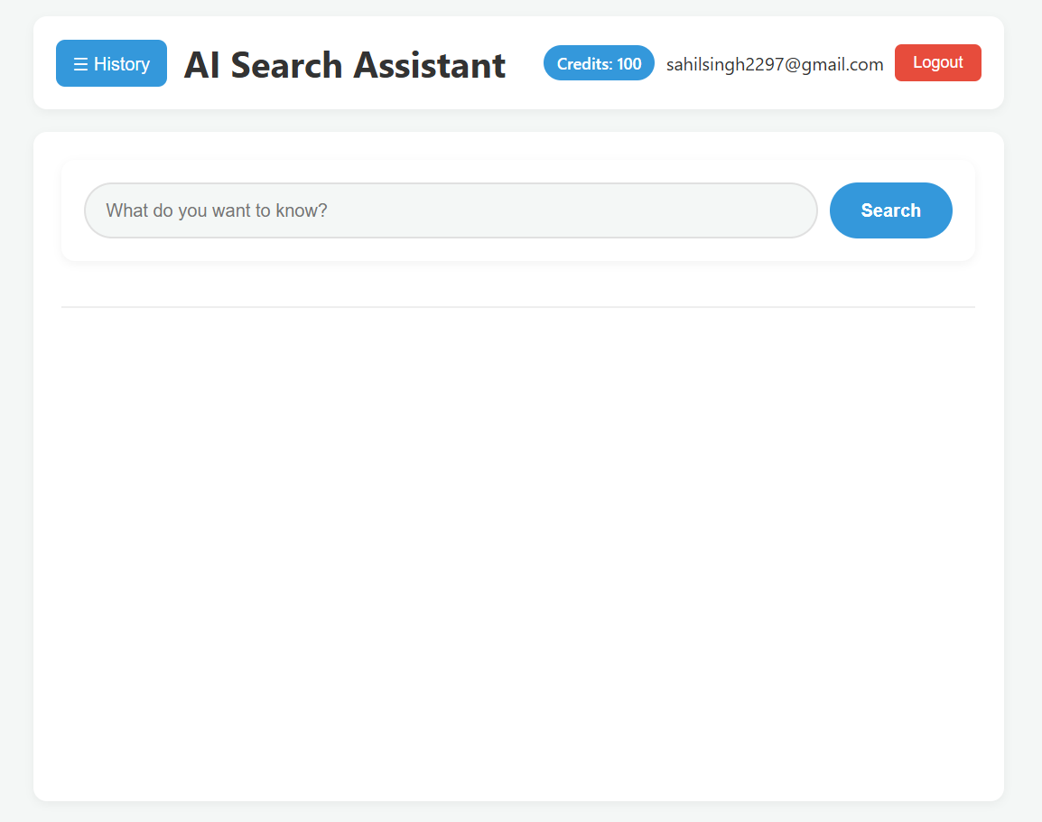
Description: The main search interface showing the header with login button, search bar at the top, and clean, modern design. The interface displays the AI Search Assistant title and provides a prominent search input field for users to enter their queries.
Key Features Visible:
- Clean header with navigation
- Prominent search input field
- Modern, minimalist design
- Login button for user authentication

Screenshot 2: Search in Progress
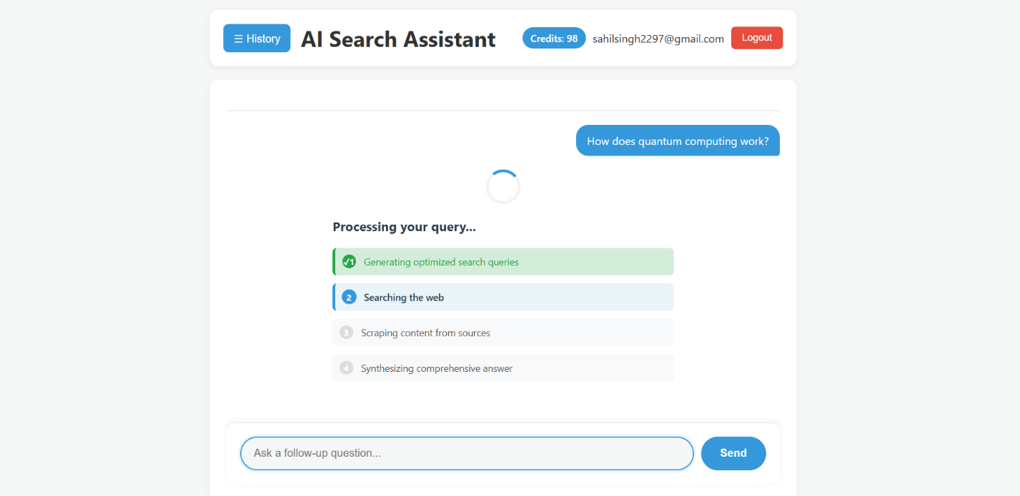
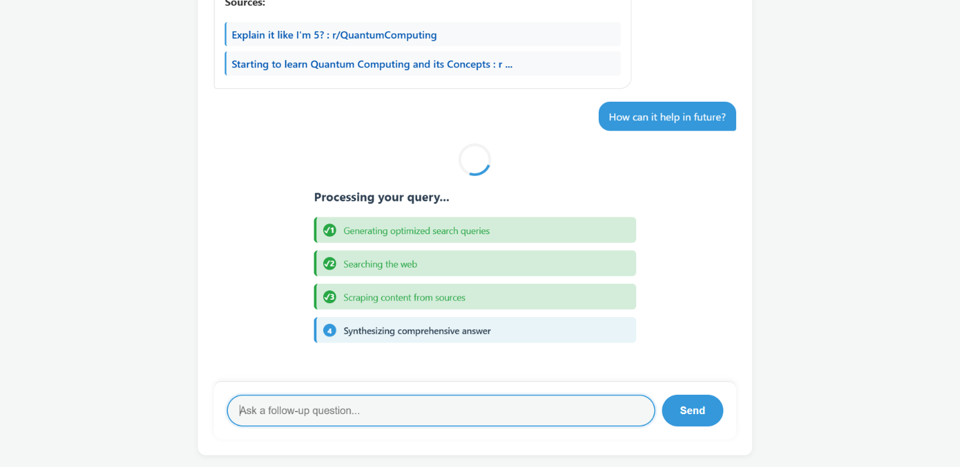
Description: Shows the loading animation with step-by-step progress indicators. The interface displays:
- “Generating optimized search queries” (active)
- “Searching the web” (pending)
- “Scraping content from sources” (pending)
- “Synthesizing comprehensive answer” (pending)
Key Features Visible:
- Animated loading spinner
- Step-by-step progress indicators
- Visual feedback for each stage
- User-friendly loading experience

Screenshot 3: Search Results Display
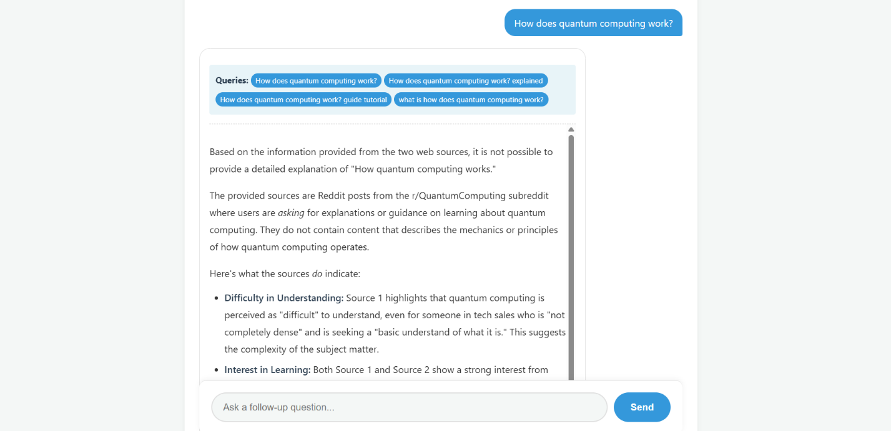
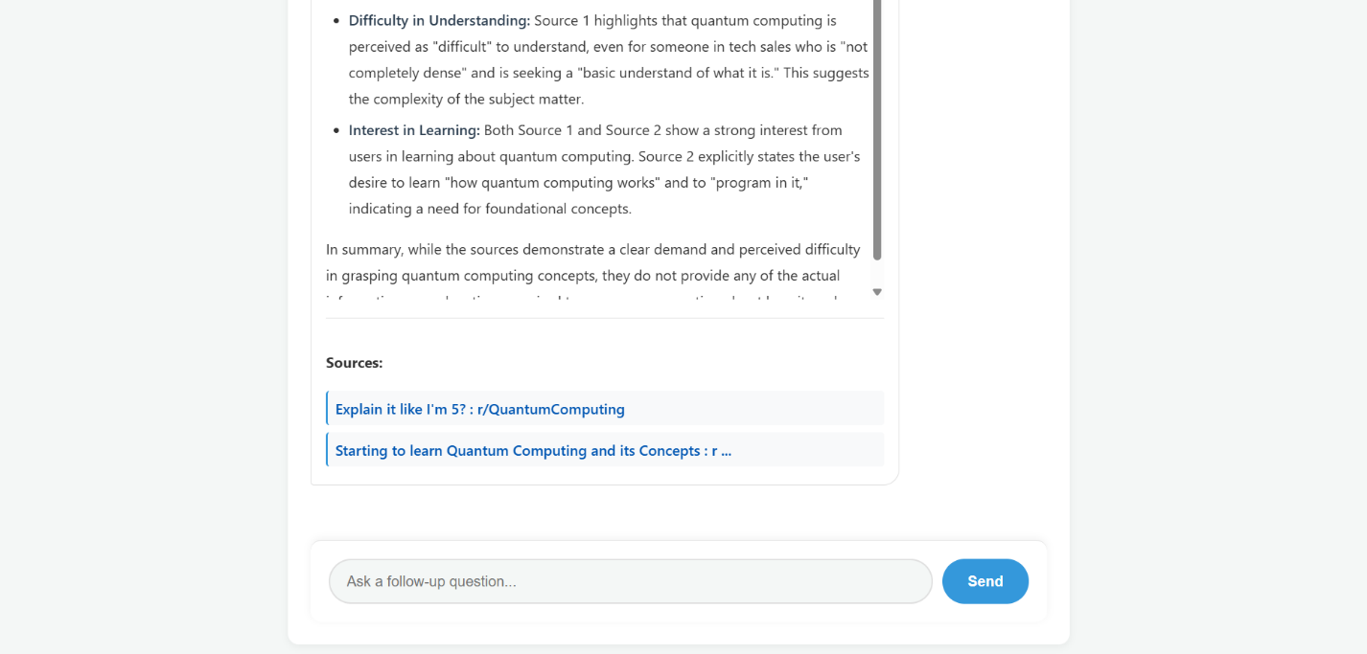
Description: Displays the comprehensive answer in a chat-style interface. The answer is formatted with markdown, showing:
- Search queries used (as tags)
- Well-formatted answer with headings, lists, and paragraphs
- Sources section with clickable links
- Clean message bubble design
Key Features Visible:
- Chat-style message bubbles
- Markdown-formatted content
- Source citations
- Query tags showing search strategy

Screenshot 4: Follow-up Question Interface
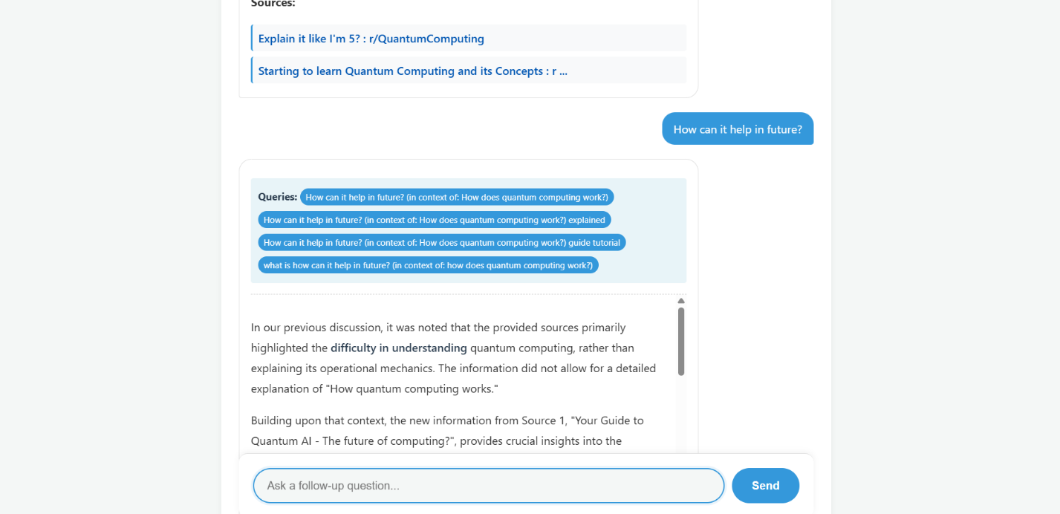
Description: Shows the search bar moved to the bottom of the screen after the first search. The interface displays:
- Previous question and answer in chat format
- Follow-up input field at the bottom
- Context-aware follow-up capability
- Smooth transition from top to bottom search bar
Key Features Visible:
- Bottom search bar for follow-ups
- Chat conversation flow
- Context preservation
- Seamless user experience

Screenshot 5: Search History Sidebar
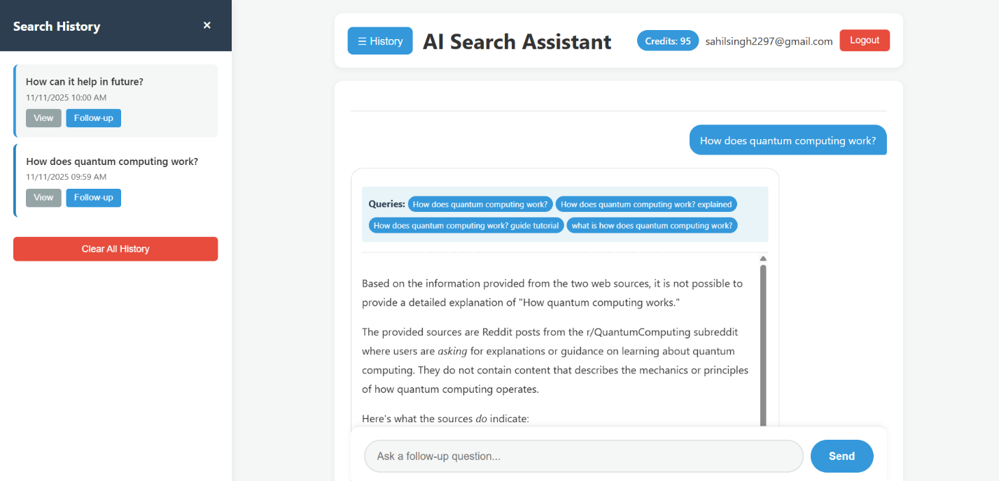
Description: The left sliding sidebar showing search history with:
- List of previous searches with timestamps
- “View” and “Follow-up” buttons for each search
- Active search highlighted
- Clear history button
- Smooth slide-in animation
Key Features Visible:
- Search history list
- Quick access to previous searches
- Follow-up question capability
- History management

Screenshot 6: Login Modal
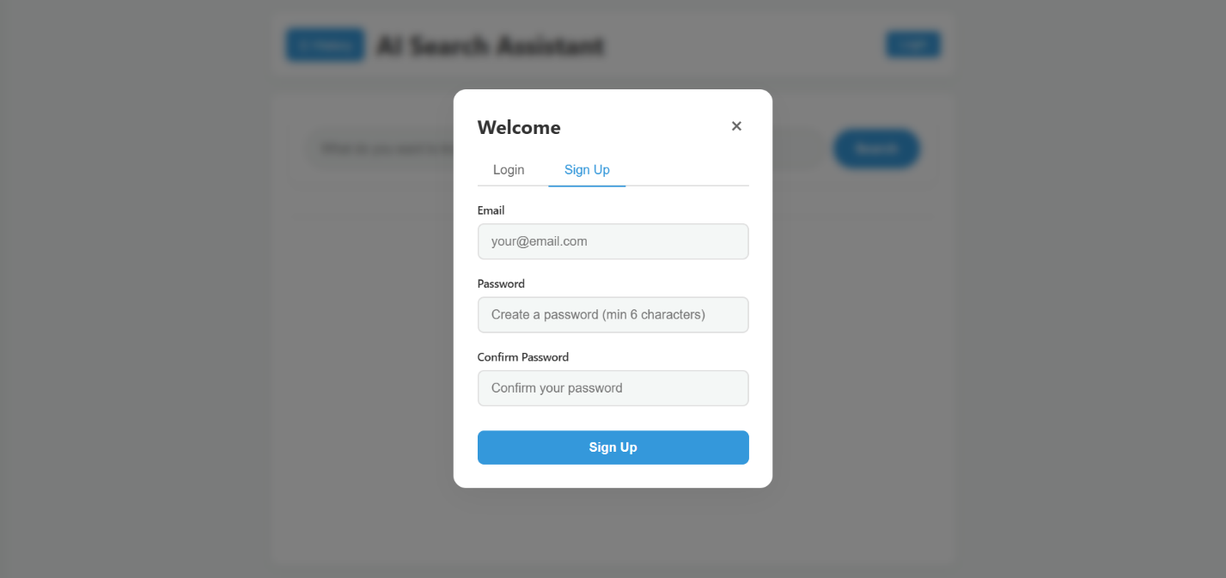
Description: The login/signup modal popup showing:
- Tab switching between Login and Sign Up
- Email and password input fields
- Form validation
- Error message display
- Modern modal design with backdrop blur
Key Features Visible:
- Professional modal design
- Tab-based interface
- Form validation
- User-friendly authentication

7. Project Flow

7.1 User Flow Diagram
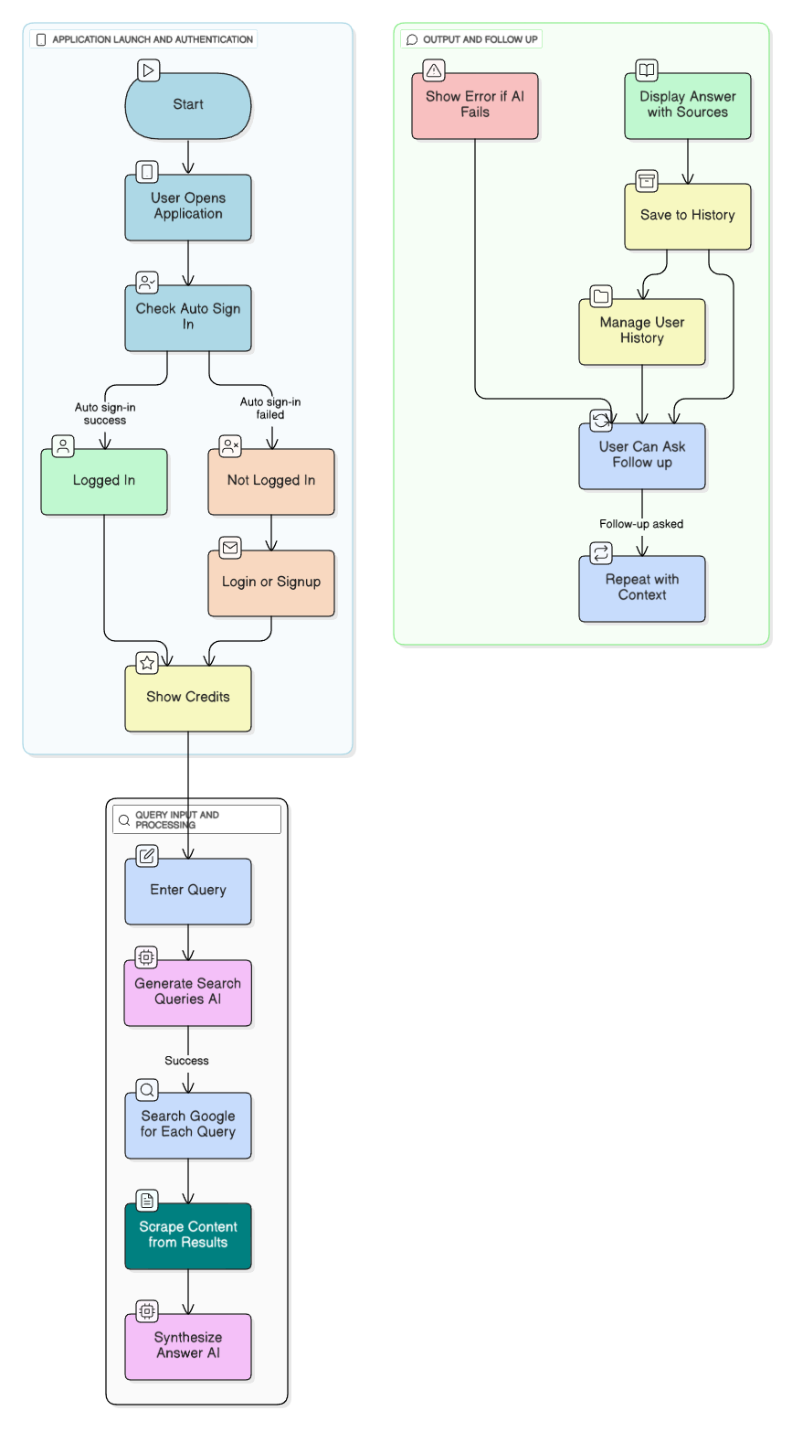

7.2 Technical Flow
- Frontend Request
  - User enters query
  - JavaScript sends POST request to /search
  - Request includes query and optional previous context
- Backend Processing
  - Flask receives request
  - Validates input
  - Calls generate_search_queries()
  - For each query: calls search_google_api()
  - For each result: calls fetch_page_content()
  - Calls synthesize_answer() with all content
  - Returns JSON response
- Frontend Display
  - Receives JSON response
  - Renders answer in chat format
  - Displays sources
  - Saves to local history
  - Moves search bar to bottom
- Follow-up Flow
  - User enters follow-up question
  - Previous context included in request
  - Backend uses context for better answers

7.3 Data Flow

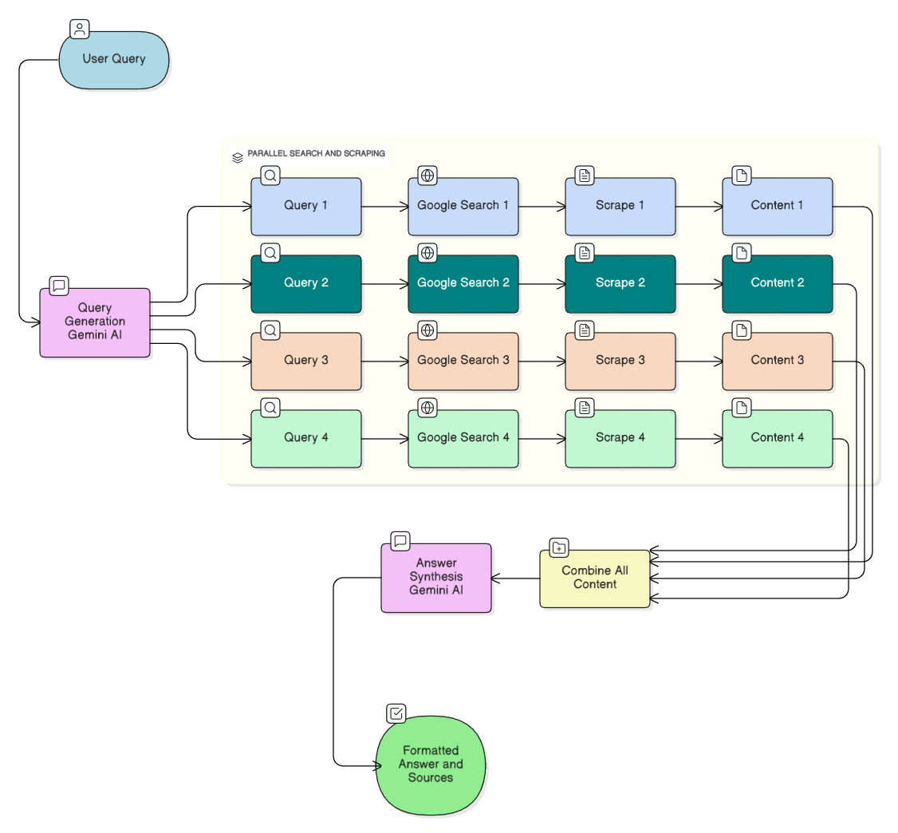

8. Testing

8.1 Unit Testing

Test Case 1: Query Generation
- Input: “What is artificial intelligence?”
- Expected: 3-4 optimized search queries generated
- Result: ✅ Pass - Generates queries like “artificial intelligence explained”, “AI basics”, etc.

Test Case 2: Google Search
- Input: Search query “python programming”
- Expected: Returns list of search results
- Result: ✅ Pass - Returns relevant results with titles, links, snippets

Test Case 3: Web Scraping
- Input: URL from search result
- Expected: Extracts main content (8000 chars max)
- Result: ✅ Pass - Successfully extracts content, handles errors

Test Case 4: Answer Synthesis
- Input: Multiple content sources
- Expected: Comprehensive answer with markdown formatting
- Result: ✅ Pass - Generates well-structured answers

8.2 Integration Testing

Test Case 5: End-to-End Search
- Input: User query “How does machine learning work?”
- Expected: Complete flow from query to answer display
- Result: ✅ Pass - All components work together

Test Case 6: Follow-up Questions
- Input: Initial query + follow-up question
- Expected: Follow-up uses previous context
- Result: ✅ Pass - Context properly maintained

Test Case 7: Authentication Flow
- Input: User registration and login
- Expected: Successful authentication and session management
- Result: ✅ Pass - Supabase integration works correctly

8.3 User Acceptance Testing

Test Case 8: User Interface
- Test: Navigate through all features
- Expected: Intuitive, responsive interface
- Result: ✅ Pass - Users find interface easy to use

Test Case 9: Error Handling
- Test: Invalid queries, network errors, API failures
- Expected: Graceful error messages
- Result: ✅ Pass - Errors handled appropriately

Test Case 10: Performance
- Test: Response time for searches
- Expected: < 30 seconds per search
- Result: ✅ Pass - Average response time 15-25 seconds

8.4 Test Results Summary
Test Category | Total Tests | Passed | Failed | Pass Rate
Unit Tests | 4 | 4 | 0 | 100%
Integration Tests | 3 | 3 | 0 | 100%
UAT | 3 | 3 | 0 | 100%
Total | 10 | 10 | 0 | 100%

9. Future Scope / Enhancements

9.1 Short-term Enhancements
- Enhanced UI/UX
  - Dark mode toggle (currently disabled)
  - Customizable themes
  - Improved mobile responsiveness
  - Keyboard shortcuts
- Advanced Search Features
  - Image search integration
  - Video search support
  - Academic paper search
  - News-specific search
- Answer Improvements
  - Export answers as PDF
  - Share answers via link
  - Copy to clipboard functionality
  - Print-friendly format
- User Features
  - User profiles and preferences
  - Favorite searches
  - Search collections/folders
  - Export search history

9.2 Medium-term Enhancements
- AI Enhancements
  - Support for multiple AI models (GPT-4, Claude)
  - Model selection by user
  - Custom prompt templates
  - Answer quality scoring
- Collaboration Features
  - Share searches with others
  - Collaborative search sessions
  - Comments on answers
  - Search discussions
- Analytics Dashboard
  - Search statistics
  - Most searched topics
  - Usage analytics
  - Credit usage reports
- Payment Integration
  - Credit purchase system
  - Subscription plans
  - Payment gateway integration
  - Invoice generation

9.3 Long-term Enhancements
- Advanced AI Features
  - Multi-modal search (text + image)
  - Voice search support
  - Real-time answer updates
  - Fact-checking integration
- Enterprise Features
  - Team accounts
  - Admin dashboard
  - API access for developers
  - White-label solutions
- Global Expansion
  - Multi-language support
  - Regional search optimization
  - Localized content
  - International payment methods
- Research & Development
  - Machine learning for query optimization
  - Personalized search results
  - Predictive search suggestions
  - Advanced source credibility scoring

9.4 Technical Improvements
- Performance Optimization
  - Caching mechanisms
  - CDN integration
  - Database query optimization
  - Async processing
- Scalability
  - Microservices architecture
  - Load balancing
  - Distributed caching
  - Auto-scaling
- Security Enhancements
  - Rate limiting
  - DDoS protection
  - Advanced encryption
  - Security auditing

10. Conclusion

10.1 Project Summary
The AI-Powered Search Assistant successfully combines the power of Google’s search capabilities with Google’s Gemini AI to provide users with comprehensive, well-structured answers to their queries. The system addresses the limitations of traditional search engines by automatically gathering information from multiple sources and synthesizing it into coherent answers.

10.2 Key Achievements
- Intelligent Query Generation: Successfully implemented AI-powered query generation that creates 3-4 optimized search queries from user input.
- Multi-Source Information Gathering: Developed robust web scraping system that extracts content from multiple sources while handling errors gracefully.
- AI-Powered Synthesis: Integrated Gemini AI to synthesize comprehensive answers from diverse sources with proper formatting and source attribution.
- User Experience: Created an intuitive, chat-like interface that provides a seamless search experience with follow-up question support.
- User Management: Implemented secure authentication and credit management system using Supabase.
- History Management: Built local storage system for search history with follow-up question capabilities.

10.3 Technical Highlights
- Modular Architecture: Clean separation of concerns with reusable components
- Error Handling: Comprehensive error handling at all levels
- Performance: Optimized for response times under 30 seconds
- Security: Secure authentication and API key management
- Scalability: Database-ready architecture for future expansion

10.4 Learning Outcomes
Through this project, we gained expertise in:
- Integrating multiple APIs (Google Search, Gemini AI, Supabase)
- Web scraping and content extraction
- AI prompt engineering and response synthesis
- Full-stack web development (Flask + JavaScript)
- User authentication and session management
- Frontend design and user experience optimization

10.5 Challenges Overcome
- API Integration: Successfully integrated multiple APIs with proper error handling
- Web Scraping: Developed robust scraping system that handles various website structures
- AI Prompting: Optimized prompts for consistent, high-quality responses
- User Interface: Created responsive, intuitive interface with smooth animations
- State Management: Implemented complex state management for search history and context

10.6 Impact and Applications
This project demonstrates the potential of combining search engines with AI to create more intelligent information retrieval systems. Applications include:
- Educational research assistance
- Business intelligence gathering
- General knowledge queries
- Technical documentation search
- News and current events research

10.7 Final Remarks
The AI-Powered Search Assistant represents a successful implementation of an intelligent search system that bridges the gap between traditional search engines and AI chatbots. The project showcases modern web development practices, AI integration, and user-centric design. With the foundation in place, the system is ready for future enhancements and scaling.
The project successfully meets all stated objectives and provides a solid base for continued development and improvement. The modular architecture ensures that new features can be easily integrated, making it a sustainable and extensible solution.

Appendices

Appendix A: Installation Guide
- Clone Repository
- git clone https://github.com/SahilSidhu7/AI-Search_Assistant.git
cd perplexityClone
- Install Dependencies
- pip install -r requirements.txt
- Configure API Keys
  - Add Google Custom Search API key
  - Add Google Gemini API key
  - Configure Supabase credentials
- Run Application
- python app.py
- Access Application
  - Open index.html in browser
  - Or serve via Flask at http://localhost:5000

Appendix B: API Configuration
Google Custom Search API
- Enable Custom Search API in Google Cloud Console
- Create Custom Search Engine
- Get API key and Search Engine ID
Google Gemini API
- Get API key from Google AI Studio
- Configure in app.py
Supabase
- Create Supabase project
- Run SQL setup script
- Get URL and anon key

Appendix C: File Structure
perplexityClone/
├── app.py # Flask backend
├── index.html # Frontend application
├── requirements.txt # Python dependencies
├── supabase_setup.sql # Database setup
└── PROJECT_REPORT.md # This document

Project Developed By: Sahilpreet Singh Sidhu, Sanchita Bhandari
Date: 10-11-2025
Version: 1.0

