Design

1. chat button
link: https://haptik.ai/
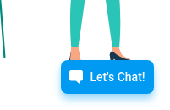

2. close button and refresh button design
link: https://www.mongodb.com/cloud/atlas/signup
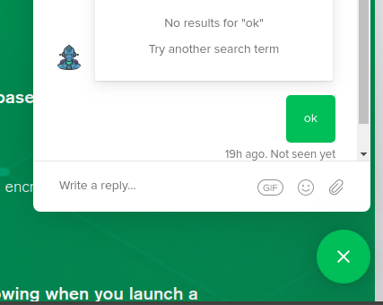

with cancel button, a refresh button just on left side
should also appear

3. chat header
link: https://www.samsung.com/in/wearables/watch-active-r500n/SM-R500NZKAINU/
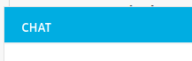

4. Saving chat design
link: https://www.samsung.com/in/wearables/watch-active-r500n/SM-R500NZKAINU/
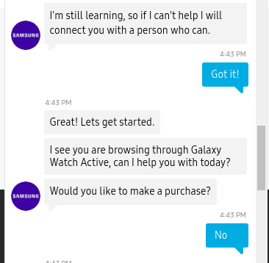

chat should be displayed in this design
(company logo is optional )

5. feedback form
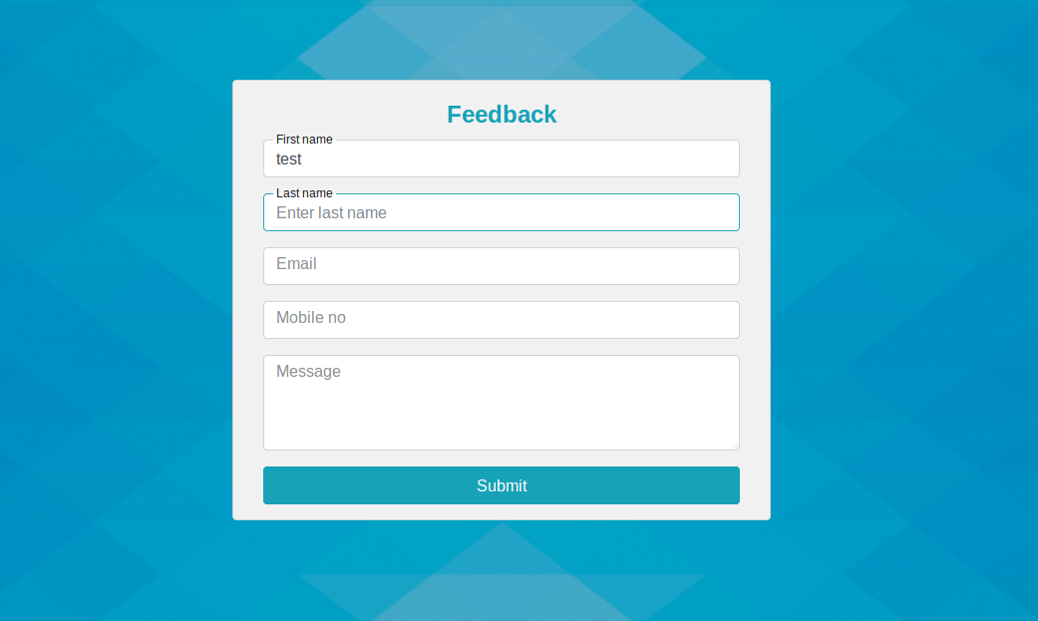
we have 3 fields in this at the moment
would appear in form only

