DAY-1

1). Write a Program to take input from the User and find Area of the Circle

**CODE:-**

num=float(input("Enter the Radius"))

print(num*3.14*num)

**OUTPUT:-**

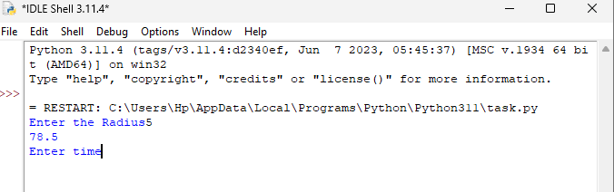

2).Write a Program to Take Input and find sum and average also percentage of any three number

**CODE:-**

n1=int(input("enter n1"))

n2=int(input("enter n2"))

n3=int(input("enter n3"))

sum=(n1+n2+n3)

print("sum=",sum)

avg=(n1+n2+n3)/3

print("avg=",avg)

per=(sum)/3*100

print("per=",per)

**OUTPUT:-**

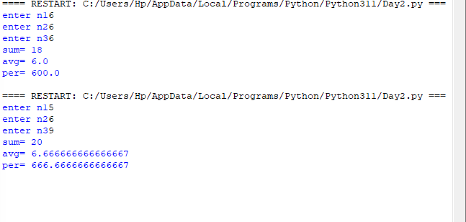

3).Write a Program To find Area of Triangle

**CODE:-**

base=float(input("Base"))

height=float(input("Height"))

Area=1/2*base*height

print("Area=",Area)

print(type(Area))

**OUTPUT:-**

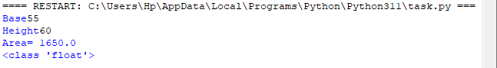

4).Write the Program to find the BMI

**CODE:-**

Weight=float(input("Enter Weaight"))

Height=float(input("Enter Height"))

BMI=Weight/(Height**2)

print(BMI)

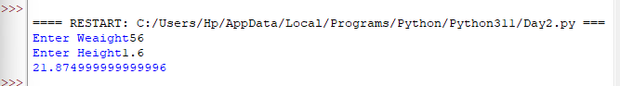

5).Write a Program to Calculate Simple Interest

**CODE:-**

p=int(input("Enter Principal"))

r=int(input("Enter Rate"))

t=int(input("Enter Time"))

SI=(p*r*t)/100

print("SI=",SI)

**OUTPUT:-**

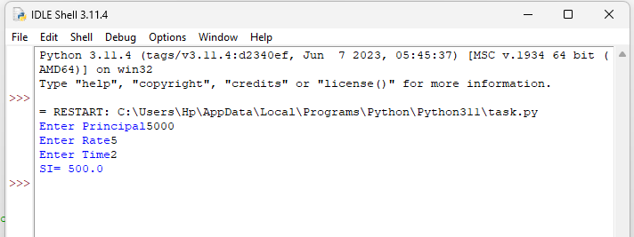

6). Write a Program to Calculate Compound Interest

**CODE:-**

P=float(input("Enter Principal"))

R=float(input(" Enter rate"))

T=float(input(" Enter Time"))

N=float(input(" NO.of. Term"))

Amount=(P*(1+R/N)**(N*T))

CI=Amount-P

print("CI=",CI)

**OUTPUT:-**

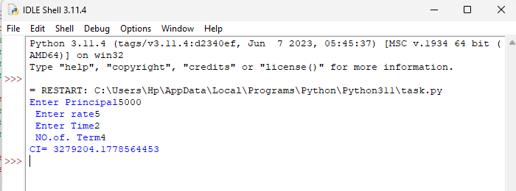

7).WAP to calculate EMI using square function

**CODE:-**

p=float(input("ENTER P"))

r=float(input("ENTER R"))

n=float(input("ENTER n"))

from math import*

emi=(p*r*(pow((1+r),n))/(pow((1+r),n-1)))

print(emi)

**OUTPUT:-**

