BRACT’s
Vishwakarma Institute of Technology, Pune
Practical Implementation Sheet
Department: CSE-AI Semester: 5 Academic Year: 2026-27
Division: E Batch: 3 Practical No: 1
Roll no: 44 PRN No: 12410016 Name of Student: Sahil Namdeo Tagade
Subject Name : Deep Learning

Problem Statement :
Install and configure TensorFlow/Keras in Google Colab. Perform data preprocessing, normalization, train-test splitting, and data visualization on a sample dataset.

Algorithm :
1. Install and import TensorFlow and Keras in the Google Colab environment, and print their versions to confirm successful installation.
2. Import the required libraries: NumPy, Pandas, Matplotlib, Seaborn, and the scikit-learn modules for dataset loading, train-test splitting and preprocessing.
3. Load a sample dataset (the Diabetes dataset from sklearn.datasets) and convert it into a Pandas DataFrame with appropriate feature column names and a target column.
4. Perform initial data exploration - check the shape of the dataset, column names, count of missing values, count of duplicate rows, and generate descriptive statistics using describe().
5. Perform data normalization/standardization on the feature matrix using StandardScaler so that all features have zero mean and unit variance.
6. Split the normalized data into training and testing sets using train_test_split() with a suitable test size (e.g., 20%) and a fixed random_state for reproducibility.
7. Visualize the dataset using multiple plots:
a. Histograms of all features to study their distributions.
b. A correlation heatmap to study relationships between features and the target.
c. Box plots to identify the spread and outliers in each feature.
d. A scatter plot (e.g., BMI vs Disease Progression) to study relationship between an important feature and the target.
e. A pair plot for a subset of features to visualize pairwise relationships.
8. Display and analyze the outputs to draw conclusions about the dataset's structure and readiness for model building.

Code :
# Assignment 1: Install and configure TensorFlow/Keras in Google Colab. Perform data preprocessing,
# normalization, train-test splitting, and data visualization on a sample dataset.

import tensorflow as tf
import keras
print("TensorFlow Version:", tf.__version__)
print("Keras Version:", keras.__version__)

# import libraries
import numpy as np
import pandas as pd
import matplotlib.pyplot as plt
import seaborn as sns
from sklearn.datasets import load_diabetes
from sklearn.model_selection import train_test_split
from sklearn.preprocessing import StandardScaler
print("Libraries Imported Successfully!")

# load dataset
diabetes = load_diabetes()
X = diabetes.data
y = diabetes.target
df = pd.DataFrame(X, columns=diabetes.feature_names)
df["Target"] = y
print("Dataset Loaded Successfully!")
df.head()

print("Shape of Dataset:")
print(df.shape)

print("\nColumn Names:")
print(df.columns)

print("\nMissing Values:")
print(df.isnull().sum())

print("\nDuplicate Rows:")
print(df.duplicated().sum())

df.describe()

# data normalization
scaler = StandardScaler()
X_scaled = scaler.fit_transform(X)
print("Data Normalized Successfully!")
print(X_scaled[:5])

# train test splitting
X_train, X_test, y_train, y_test = train_test_split(
X_scaled,
y,
test_size=0.20,
random_state=42
)
print("Training Data Shape:", X_train.shape)
print("Testing Data Shape:", X_test.shape)

# histogram
df.hist(figsize=(12,10), bins=15)
plt.suptitle("Distribution of Diabetes Dataset Features")
plt.show()

# correlation heatmap
plt.figure(figsize=(10,8))
sns.heatmap(
df.corr(),
cmap="coolwarm",
annot=False
)
plt.title("Correlation Heatmap")
plt.show()

# box plot
plt.figure(figsize=(12,5))
sns.boxplot(data=df.iloc[:, :-1])
plt.title("Box Plot of Features")
plt.xticks(rotation=45)
plt.show()

# scatter plot
plt.figure(figsize=(7,5))
plt.scatter(df["bmi"], df["Target"])
plt.xlabel("BMI")
plt.ylabel("Disease Progression")
plt.title("BMI vs Disease Progression")
plt.show()

# pair plot
small_df = df[["bmi", "bp", "s5", "Target"]]
sns.pairplot(small_df)
plt.show()

Output :
TensorFlow Version: 2.20.0
Keras Version: 3.13.2
Libraries Imported Successfully!
Dataset Loaded Successfully!

Shape of Dataset:
(442, 11)

Column Names:
Index(['age', 'sex', 'bmi', 'bp', 's1', 's2', 's3', 's4', 's5', 's6', 'Target'], dtype='object')

Missing Values: 0 for all columns
Duplicate Rows: 0

Data Normalized Successfully!

Training Data Shape: (353, 10)
Testing Data Shape: (89, 10)

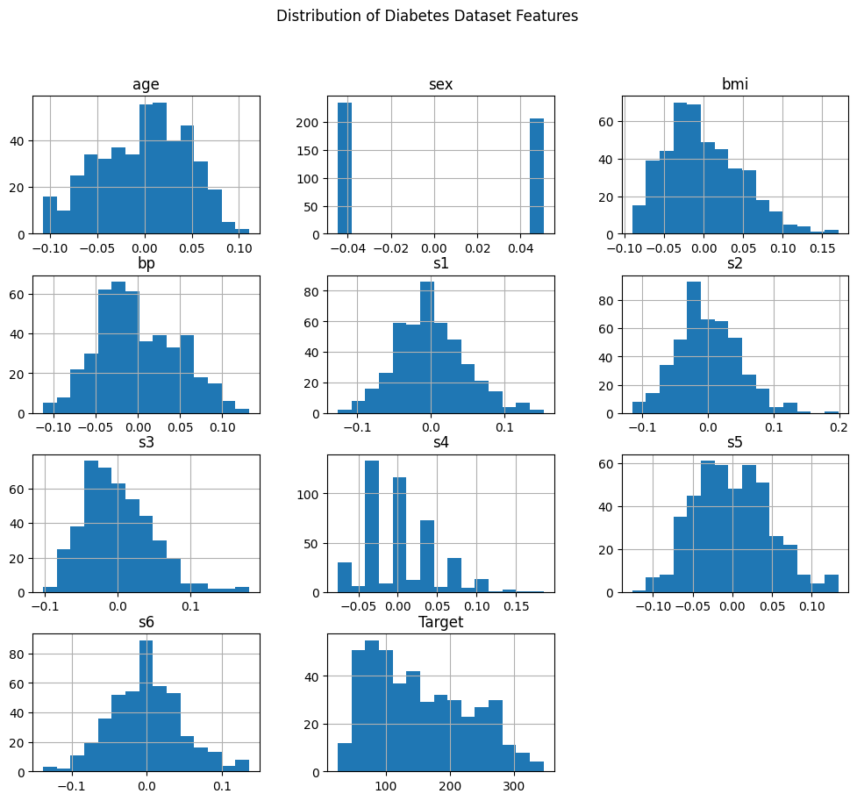
Fig 1: Distribution of Diabetes Dataset Features (Histograms)
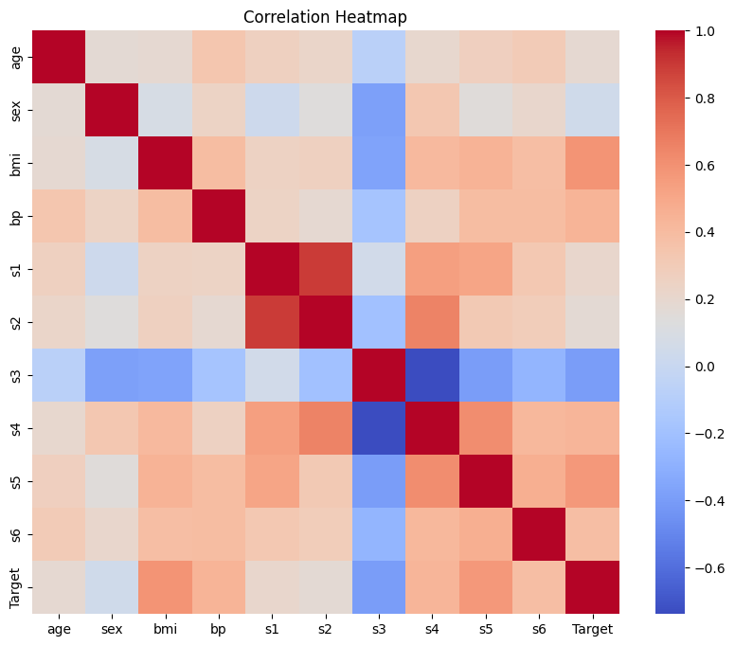
Fig 2: Correlation Heatmap
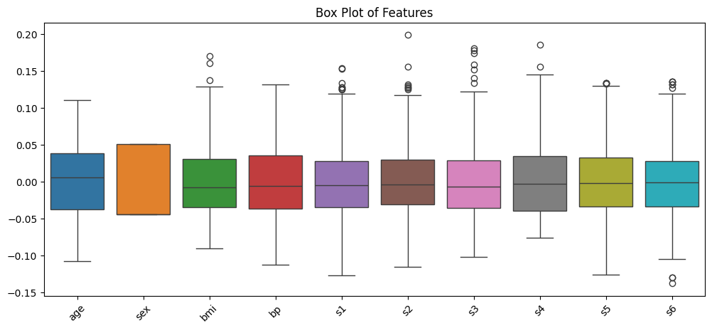
Fig 3: Box Plot of Features
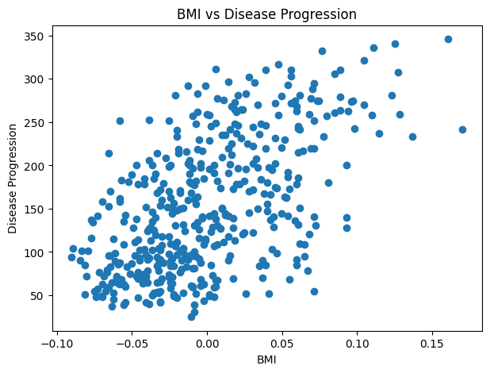
Fig 4: BMI vs Disease Progression (Scatter Plot)
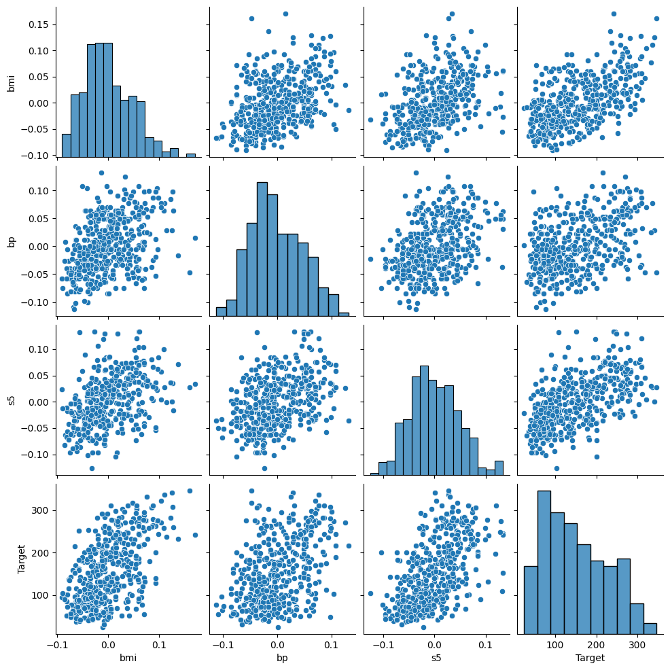
Fig 5: Pair Plot (bmi, bp, s5, Target)

