**Mini Project Report on**



**ChatBot**



**Submitted in partial fulfillment of the requirement for the award of the degree of**

**BACHELOR OF TECHNOLOGY**

**IN**

**COMPUTER SCIENCE & ENGINEERING**

**Submitted by:**

**Sahil Gupta**   **2017539**

***Under the Mentorship of***

**Dr Sumit Pundir**

**Professor**



**Department of Computer Science and Engineering**

**Graphic Era (Deemed to be University)**

**Dehradun, Uttarakhand**

**January 2023**

GEU logo

**CANDIDATE’S DECLARATION**

I hereby certify that the work which is being presented in the project report entitled **“ChatBot”** in partial fulfillment of the requirements for the award of the Degree of Bachelor of Technology in Computer Science and Engineeringof the Graphic Era (Deemed to be University), Dehradun shall be carried out by the under the mentorship of **Dr Sumit Pundir,Professor**, Department of Computer Science and Engineering, Graphic Era (Deemed to be University), Dehradun.

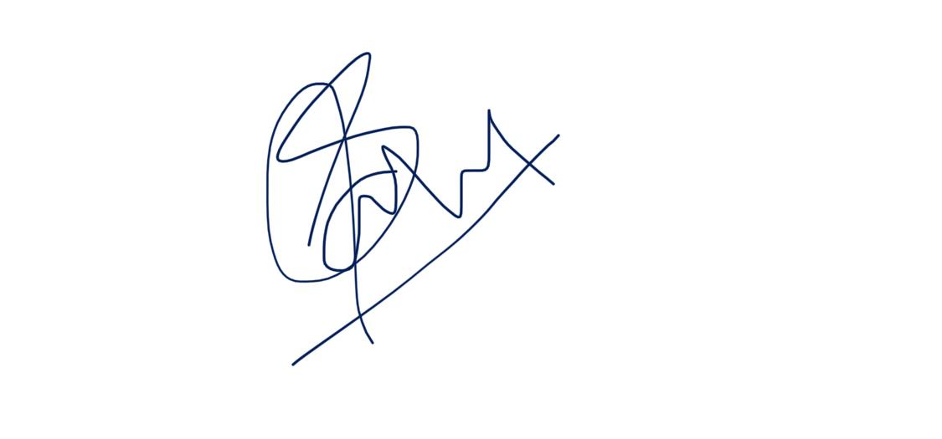

Sahil Gupta 2017539

**Table of Contents**

|  |  |  |
| --- | --- | --- |
| **Chapter No.** | **Description** | **Page No.** |
| Chapter 1 | Introduction | **1** |
| Chapter 2 | Methodology | **2** |
| Chapter 3 | Result and Discussion | **4** |
| Chapter 4 | Conclusion and Future Work | **5** |
|  | References | **6** |

**Chapter 1**

**Introduction**

* 1. **Introduction**

A chatbot, at its most basic, is a computer programme that mimics and interprets human interaction (spoken or typed), enabling users to converse with digital gadgets as if they were speaking to real people. Chatbots can be as basic as one-line programmes that respond to straightforward questions, or they can be as complex as digital assistants that learn and develop over time to provide ever more individualised service as they acquire and process more data.

They are like human assistant only, but just virtually. The chatbot can be designed as per one’s requirement and needs. I can vary from person to person and business to business. And it is so simple and easy to build it for daily usage.

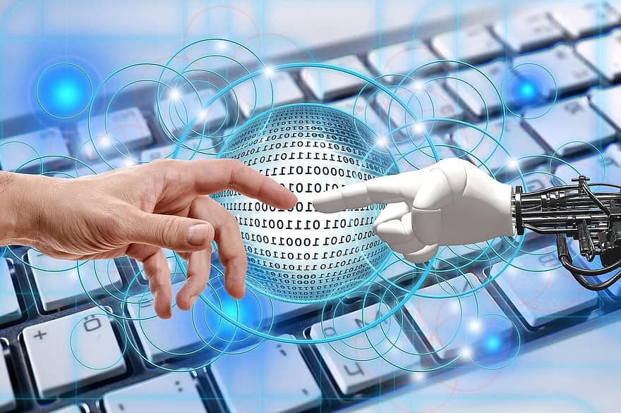

**Chapter 2**

**Methodology**

**1).** In order to train a chatbot, you must first collect and prepare a corpus of conversational data. Tokenizing and stemming your text data are two tasks that NLTK can help you with.

**2).** Once your dataset is ready, you can use scikit-learn to vectorize your text data and create a model to predict how something will react when given a new input. You can utilise a variety of models for this purpose, including word embedding models and bag-of-words models.

**3).** The next step is to build a method for your chatbot to actually converse with users. To achieve this, you can set up a loop that requests information from the user and then applies your model to forecast a response based on that input.

**4).** By altering your model's various parameters, such as the amount of your training dataset or the complexity of your model architecture, you can then fine-tune the performance of your chatbot. You might also want to add further capabilities, including the capacity to handle synonyms or unidentified terms.

**5).** Finally, you can test your chatbot by having it converse with actual users or by assessing how well it performs on a set of test cases that have already been created. The performance of your chatbot can then be further enhanced by using this feedback.

**Chapter 3**

**Result and Discussion**

After the implementation of the methodology the chatbot can actually reply to your questions and not only this it can really take up the conversation.

The **“NLTK”** library I used is very useful for the chatbot. The preferred Python API for NLP (Natural Language Processing) is NLTK (Natural Language Toolkit). To prepare text data for subsequent analysis, such as with ML models, it is a very potent tool. It assists in turning language into numbers so that the model can more easily work with them.

The **“TFIDVECTORIZATION”** library I used of sci-kit learn is also very helpful in vectorizing the sentence and word tokens, which not only creates the bag of words but also keep the frequency count of the words and sentence.

After the overall concatenation of all these libraries and tokens the chatbot is simply ready to carry out a conversation or give you the desired information.

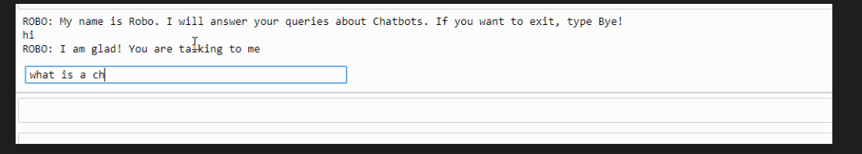

**Chapter 4**

**Conclusion and Future Work**

Now, the chatbot is ready with all the information and data needed. Ready and open for a good conversation with a human being.

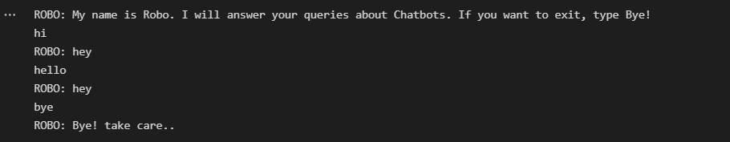

**4.1 Future Work**

1. In the future I can use some python library to give this chatbot a separate window for the conversation.
2. And ofcourse the data feeding is endless, we can we endless amount of data to it.

**References**

1. <https://www.nltk.org/install.html>
2. https://medium.com/analytics-vidhya/building-a-simple-chatbot-in-python-using-nltk-7c8c8215ac6e