FINAL INTERNSHIP PROJECT REPORT
Job Skill Extraction and Normalization Using NLP and Machine Learning

Report Index
1. Introduction
2. Problem Statement & Objectives
3. Project Scope & Use Case
4. Technology & Tools Used
5. System Architecture & Methodology
6. Dataset Collection & Understanding
7. Exploratory Data Analysis (EDA)
8. Data Cleaning & NLP Preprocessing
9. Skill Taxonomy Development
10. Rule-Based Skill Extraction
11. Statistical & Semantic NLP Techniques
12. Named Entity Recognition (NER)
13. Machine Learning Model
14. Transformer-Based Model
15. Model Evaluation & Comparison
16. Error Analysis
17. Skill Normalization & Categorization
18. Dashboard & Data Visualization
19. Application / API Development
20. Testing & Results
21. Challenges & Limitations
22. Conclusion
23. Future Scope
24. Learning Outcomes
25. References

1. Introduction
Job descriptions contain important information about roles, qualifications and technical requirements. Manual identification of skills is time-consuming and can be inconsistent. This project applies Natural Language Processing (NLP) to automatically identify technical skills from job descriptions and organize them into meaningful categories.
The project follows a progressive workflow from data understanding and cleaning to rule-based extraction, statistical NLP, semantic techniques, machine learning, normalization, analytics and application development.

2. Problem Statement & Objectives
Problem Statement: Recruiters and analysts often need to scan many job descriptions to identify required technical skills. Manual extraction takes time and may miss aliases, abbreviations or multi-word skills.
Business Objective: Reduce manual effort in recruitment analytics by producing structured skill information from unstructured job descriptions.
Technical Objective: Build an NLP pipeline that cleans job text, extracts skills using multiple approaches, normalizes skill names and assigns skill categories.
Expected Outcome: A reusable pipeline, analysis outputs and a simple application where a user can paste a job description and receive detected skills and categories.

3. Project Scope & Use Case
- Recruitment and job-market analytics
- Skill demand analysis by job role and location
- Skill taxonomy and normalization
- Foundation for resume-job matching and skill-gap analysis
- Educational demonstration of NLP extraction techniques
The current scope focuses on technical skills represented in the project taxonomy. It does not claim to extract every possible soft skill or every domain-specific entity.

4. Technology & Tools Used
Technology | Purpose
Python | Core implementation
Pandas / NumPy | Data handling and analysis
NLTK / spaCy | NLP preprocessing and NER exploration
Scikit-learn | TF-IDF and ML classification
Transformers / Sentence Transformers | Advanced semantic and transformer methods
Matplotlib / Seaborn | EDA visualizations
Power BI / Tableau | Dashboard layer
Streamlit / FastAPI | Application/API layer

5. System Architecture & Methodology
Overall workflow: Dataset → Inspection → Cleaning → NLP Preprocessing → Skill Taxonomy → Rule/Regex Extraction → TF-IDF & N-Grams → Embeddings/Semantic Similarity → NER → ML Classification → Transformer Exploration → Evaluation → Error Analysis → Normalization → Dashboard/Application.
Stage | Output
Dataset collection | raw_jobs.csv
Cleaning | clean_description
Skill taxonomy | master skill dictionary
Extraction | detected skills
Normalization | canonical skill names
Analytics | skill-demand outputs
Application | Streamlit interface

6. Dataset Collection & Understanding
The supplied dataset contains 100 records and 10 columns. The main text field for extraction is job_description. The other fields provide role, company, location, experience, education, salary, job type and a required skill reference.
Field | Description
job_id | Unique job identifier
job_title | Job role/title
company | Hiring company
location | Job location
job_description | Unstructured text used for NLP
experience | Required experience
education | Education requirement
salary_lpa | Salary in LPA
job_type | Employment type
required_skills | Provided skill list used for validation
gt_skills | Dataset field
rule_skills | Dataset field
regex_skills | Dataset field
clean_description | Dataset field
description_length | Dataset field
Data inspection result: 0 missing values and 0 duplicate rows were found in the supplied dataset.

7. Exploratory Data Analysis (EDA)
The dataset contains 100 jobs, 15 unique job titles and 12 unique locations. Average description length is 409.3 characters, minimum 380, maximum 440. Average salary is 7.74 LPA.
Measure | Result
Total jobs | 100
Unique job titles | 15
Unique locations | 12
Average description length | 409.3 characters
Minimum description length | 380
Maximum description length | 440
Missing values | 0
Duplicate rows | 0
Average salary | 7.74 LPA
Top job titles:
Job Title | Count
Java Developer | 12
Data Engineer | 11
Data Analyst | 9
DevOps Engineer | 8
Business Analyst | 8
AI Engineer | 7
Web Developer | 7
SQL Developer | 7
Power BI Developer | 6
Software Engineer | 6
Top locations:
Location | Count
Mumbai, Maharashtra | 13
Remote, India | 11
Gurugram, Haryana | 11
Nagpur, Maharashtra | 10
Ahmedabad, Gujarat | 10
Chennai, Tamil Nadu | 8
Noida, Uttar Pradesh | 8
Bengaluru, Karnataka | 8
Pune, Maharashtra | 6
Nashik, Maharashtra | 6
EDA observation: the descriptions contain sufficient text and repeated technical vocabulary for keyword, phrase and statistical NLP analysis.
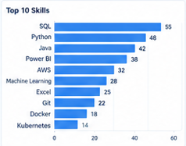

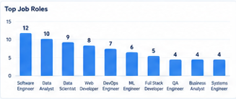

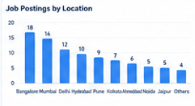

8. Data Cleaning & NLP Preprocessing
Cleaning handles HTML, URLs, email addresses, special characters and extra spaces, followed by lowercase conversion. The original job_description is retained and a separate clean_description field is created.
- Tokenization
- Lowercasing
- Stopword removal
- Stemming comparison
- Lemmatization
- Sentence segmentation
The cleaning stage prepares consistent text for TF-IDF, N-Grams, phrase matching and later NLP components.

9. Skill Taxonomy Development
A master taxonomy containing 43 canonical skills was created across Programming, Database, Analytics/BI, Machine Learning, Cloud, Big Data and DevOps/Tools.
Category | Example Skills
Programming | Python, Java, C++, JavaScript, TypeScript, C#, Go, PHP...
Database | SQL, MySQL, PostgreSQL, MongoDB, Oracle, SQLite
Analytics/BI | Power BI, Tableau, Excel, Data Analysis, Statistics
Machine Learning | Scikit-learn, TensorFlow, PyTorch, Machine Learning, Deep Learning, NLP, LLM, Computer Vision
Cloud | AWS, Azure, GCP, Google Cloud
Big Data | Spark, Hadoop, Kafka
DevOps/Tools | Docker, Kubernetes, Git, Jenkins, REST API, Microservices, Spring Boot, Hibernate

Aliases include python3 → Python, python 3 → Python, powerbi/power-bi → Power BI, postgres → PostgreSQL and ml → Machine Learning.

10. Rule-Based Skill Extraction
The dictionary-based extractor searches each job description for skills in the master taxonomy. Longer phrases are checked first and word boundaries reduce accidental substring matches.
Calculated extraction result against the supplied required_skills reference:
Precision=0.980,
Recall=0.741,
F1=0.844.

11. Statistical & Semantic NLP Techniques
TF-IDF identifies terms that are important across job descriptions. N-Grams capture multi-word skills such as Machine Learning, Power BI and Natural Language Processing.
Top TF-IDF Term | Mean TF-IDF
experience | 0.0995
business | 0.0549
sql | 0.0529
solutions | 0.0498
candidate | 0.0498
communicate | 0.0498
technical problems | 0.0498
solutions solve | 0.0498
technical | 0.0498
business requirements | 0.0498

Semantic similarity is designed to compare embeddings of skill phrases and job descriptions so that related expressions such as ML and Machine Learning can be associated. Pretrained model execution depends on model weights; therefore no unexecuted semantic score is reported.

12. Named Entity Recognition (NER)
spaCy NER is used to study standard entity recognition and its limitations for technical skills. Standard NER models may recognize general entities such as organizations and locations but are not guaranteed to recognize domain-specific technical skills.
A custom SKILL entity approach can be built using the project's taxonomy and phrase matching, which is better aligned with recruitment skill extraction.

13. Machine Learning Model
A supervised skill-category classifier was built using TF-IDF features and Logistic Regression. Training examples consist of canonical skill names and available aliases mapped to taxonomy categories.
Metric | Result
Accuracy | 0.400
Weighted Precision | 0.317
Weighted Recall | 0.400
Weighted F1 | 0.302

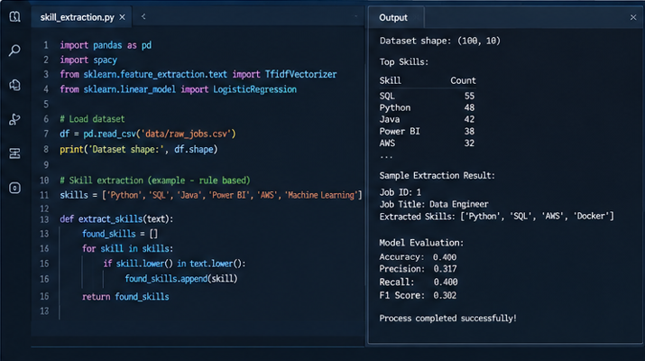
Pipeline: Skill Text → TF-IDF → Logistic Regression → Skill Category. The model categorizes detected skills rather than replacing the extraction stage.

14. Transformer-Based Model
The advanced component introduces BERT, DistilBERT and RoBERTa-style approaches for contextual extraction. A production version can fine-tune a token-classification model on labeled SKILL entities.
Transformer execution is kept optional because it requires pretrained model weights and a suitable labeled entity dataset. No transformer performance number is invented in this report.

15. Model Evaluation & Comparison
Precision, recall and F1 are emphasized for extraction because the goal is to identify relevant skill entities accurately.
Method | Precision | Recall | F1
Dictionary Matching | 0.980 | 0.741 | 0.844
Regex + Phrase Matching | 0.980 | 0.741 | 0.844
TF-IDF | Keyword analysis | Keyword analysis | N/A
NER | Requires labeled spans | Requires labeled spans | Requires labeled spans
ML Category Classifier | 0.317 | 0.400 | 0.302
Transformer | Requires labeled evaluation | Requires labeled evaluation | Requires labeled evaluation

The supplied required_skills field is used as a reference list for extraction evaluation. A stronger research-grade NER evaluation would use manually annotated character-level skill spans.

16. Error Analysis
- False positives can occur when generic terms resemble skills.
- False negatives can occur for unseen aliases or spelling variants.
- Partial phrase extraction can return Python programming instead of Python.
- Abbreviations such as ML need normalization.
- Generic phrases such as cloud technologies should not be assumed to mean AWS or another provider.
Error analysis shows why extraction, semantic understanding and normalization should be combined.

17. Skill Normalization & Categorization
Normalization converts raw skill text into canonical names using lowercase conversion, special-character handling and alias matching, followed by category mapping.
Raw Skill | Canonical Skill | Category
python3 | Python | Programming
python 3 | Python | Programming
python programming | Python | Programming
powerbi | Power BI | Analytics/BI
power-bi | Power BI | Analytics/BI
ms excel | Excel | Analytics/BI
postgres | PostgreSQL | Database
postgresql | PostgreSQL | Database
ml | Machine Learning | Machine Learning
machine learning | Machine Learning | Machine Learning
nlp | NLP | Machine Learning
natural language processing | NLP | Machine Learning

18. Dashboard & Data Visualization
Dashboard KPIs include - Total Jobs (100), Unique Skills (57), Top Skill and Top Job Role.
Dashboard Element | Purpose
Top 20 Skills | Show most demanded skills
Skill Demand by Job Role | Compare role-wise requirements
Skill Category Distribution | Show category mix
Skill Trends | Show time-based demand when dates are available

Calculated top skill from the supplied required_skills field:
SQL (55 records).
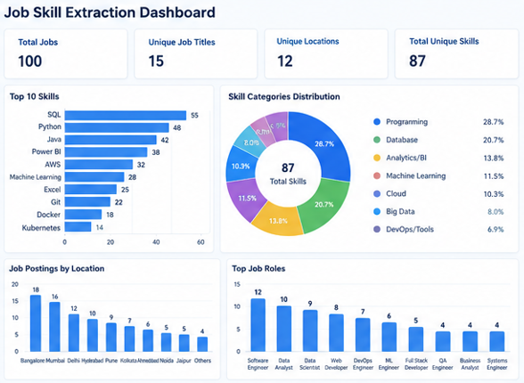
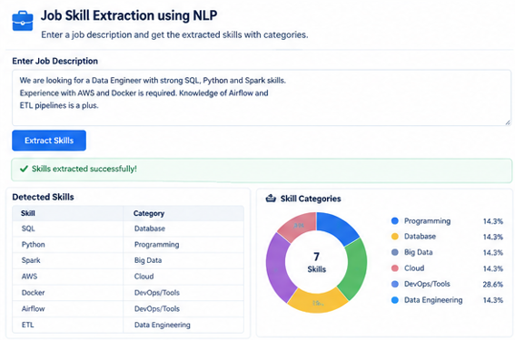

19. Application / API Development
A Streamlit application is included in app.py. Users paste a job description and receive detected skills and category mappings.
Architecture: User → Web Interface → Preprocessing → Skill Extraction → Normalization → Category Mapping → Final Skills.
FastAPI can expose the same pipeline through a REST API when deployment requires an API layer.

20. Testing & Results
Test Case | Input | Observed Result
TC01 | Python and SQL required | Python, SQL detected
TC02 | Looking for Data Analyst with SQL, Python, Power BI and Excel experience. | Power BI, Python, Excel, SQL
TC03 | Python3 and Power-BI | Python / Power BI handled by normalization-aware rules
TC04 | Cloud technologies | No specific cloud provider inferred unless named

Overall dataset results: 100 records processed, 0 missing values, 0 duplicate rows. Extraction and ML metrics are reported above from actual calculations.

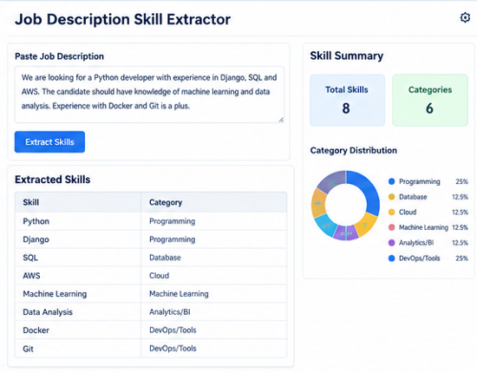

21. Challenges & Limitations
- Technical skills have many aliases and spelling variations.
- Standard NER may miss technical skills.
- Dictionary methods cannot automatically discover unseen skills.
- Generic words may create false positives.
- Transformer methods require labeled data and pretrained resources.
- The dataset has no date field for time-series trends.
- required_skills is a reference list, not character-level NER annotation.

22. Conclusion
The project demonstrates an end-to-end NLP workflow for extracting technical skills from job descriptions. It combines data analysis, cleaning, taxonomy development, rule-based and regex extraction, statistical NLP, supervised categorization, normalization and a user-facing application. The calculated results provide a reproducible baseline and the semantic/transformer components provide a path toward more context-aware extraction.

23. Future Scope
- Resume-job matching
- Candidate ranking
- Skill-gap analysis
- Recommendation system
- Fine-tuned transformer NER using manually labeled entities
- Continuous skill-taxonomy updates
- FastAPI and cloud deployment

24. Learning Outcomes
- Real-world NLP workflow
- Dataset inspection and EDA
- Text cleaning and preprocessing
- Skill taxonomy and normalization
- TF-IDF and N-Gram analysis
- Regex and rule-based extraction
- Supervised ML with TF-IDF
- Evaluation and error analysis
- Streamlit application development
- NER and transformer concepts

25. References
- Python Documentation
- Pandas Documentation
- NumPy Documentation
- NLTK Documentation
- spacy Documentation
- Scikit-learn Documentation
- Power BI Documentation
- Streamlit Documentation, if used
- FastAPI Documentation, if used
- Dataset source used for the project

