# **USCS3P01:USCS303-Operating System (OS) Practical-06**

## 

## **Banker’s Algorithm**

Contents

USCS3P01:USCS303-Operating System (OS) Practical-06 1

Banker’s Algorithm 1

Practical Date 2

Parctical Aim 2

Banker's Algorithm 2

Data Structures reqiured in Banker's Algorithm 5

Algorithm 6

Safety 6

Resource- Allocation 7

Solved Example 8

Question 8

Implementation 9

Input 12

Output 12

Sample Output 12

### **Practical Date :** 20th August , 2021(Friday)

### **Parctical Aim :** Write a Java program that implements the banker's algorithm

### 

### **Banker's Algorithm**

### **Banker's Algorithm**

- Content:

• For the banker's algorithm to operate, each process has to a priority specify its maximum requirement of resources.

• Process:

• One can find out whether the system is in the safe state or not.

• One can also determine whether a process's request for allocation of resources be safely granted immediately.

• Prior Knowledge:

• Data structures used in bankers algorithm.

• Safety algorithm and resource request algorithm.

Banker’s Algorithm

• The resource-allocation-graph algorithm is not applicable to a resource allocation system with multiple instances of each resource type.

• The deadlock-avoidance algorithm that we describe next is applicable to such a system but is less efficient than the resource-allocation graph scheme.

• This algorithm is commonly known as the banker's algorithm.

• Banker's algorithm is a deadlock avoidance algorithm.

• It is named so because this algorithm is used in banking systems to determine whether a loan can be granted or not.

• The name was chosen because the algorithm could be used in a banking system to ensure that the bank never allocated its available cash in such a way that it could no longer satisfy the needs of all its customers.

• Consider there are n account holders in a bank and the sum of the money in all of their accounts is S.

• Every time a loan has to be granted by the bank, it subtracts the loan amount from the total money the bank has

• Then it checks if that difference is greater than 5.

• It is done because, only then, the bank would have enough money even if all the n account holders draw all their money at once.

• When a new thread enters the system, it must declare the maximum number of instances of each resource type that it may need

• This number may not exceed the total number of resources in the system.

• When a user requests a set of resources, the system must determine whether the allocation of these resources will leave the system in a safe state.

• If it will, the resources are allocated; otherwise, the thread must wait until some other thread releases enough resources.

**Data Structures reqiured in Banker's Algorithm**

**Data Structures reqiured in Banker's Algorithm**

* Several data structures must be maintained to implement the banker's algorithm.
* These data structures encode the state of the resource-allocation system.
* We need the following data structures, where n is the number of threads in the system and m is the number of resources types:

**Data structures**

**Available:**

A vector of length m indicates the number of available resources of each type. If Available[j] equals k, then k instances of resource type Rj are available.

**Max:**

An n * m matrix defines the maximum demand of each thread. If Max[i][j] equals k, then thread Ti may request at most k instances of resource type Rj.

**Allocation:**

An n * m matrix defines the number of resources of each type currently allocated to each thread. If **Allocation[i][j]** equals k, then thread Ti is currently allocated k instances of resource type Rj.

**Need:**

An n * m matrix indicates the remaining resource need of each thread. If Need[i][j] equals k, then thread Ti may need k more instances of resources type Rj to complete its task.

**Need[i][j] = Max[i][j] - Allocation[i][j]**

### **Algorithm:**

### **Safety:**

**Safety Algorithm**

**Step 1:** Let Work and Finish be vectors of length m and n, respectively.

initialize Work = Available and Finish[i]= flase for i =0,1,.....,n-1**.**

**Step 2:** Find an index i such that both

**Step 2.1:** Finish[i] == false

**Step 2.2:** Needi <= Work

if no such i exists, go to **Step 4.**

**Step 3**: Work= Work+Allocationi

Finish[i] = true

Go to **Step 2.**

**Step 4**: if Finish[i] == true for all i, then the system is in a safe state.

### 

### **Resource- Allocation:**

**Resource-Request Algorithm**

* Let **Requesti** be the request vector for thread Ti.
* if **Requesti [j] == k**, then thread Ti wants k instances of resource type Rj.
* When a request for resources is made by thread Ti, the following actions are taken:

**Step 1:** if Requesti <= Needi, go to **Step 2.** otherwise, raise an error condition,

since the thread has exceeded its maximum claim.

**Step 2:** if Requesti <= Available, go to **Step 3.** otherwise, Ti must wait,

since the resources are not available.

**Step 3:** Have the system prented to have allocated the requested resources to thread Ti,

by modifying the state as follows:

Available = Available - Requesti

Allocationi = Availablei + Requesti

Needi = Needi - Requesti

if the resulting resource-allocation state is safe, the transaction is

completed, and thread Ti is allocated its resources. However, if the

new state is unsafe, then Ti must wait for **Requesti,** and the old

resource-allocation state is restored.

### **Solved Example:**

### **Solved Example**

### **Question:01**

Write a Java program that implements the banker's algorithm

Consider the following system:

Calculate the content of the need matrix ?

Check if the system is in a safe state?

### **Solution:**

### Consider a system with five threads T0 through T4 and three resource types A,B and C.

### Resource type A has ten instances , resource Type B has five instances and resource type C

### has seven instances.Suppose that the following snapshot represent current state of the system:

|  |  |  |  |
| --- | --- | --- | --- |
| **Threads** | **Allocations** | **Max** | **Available** |
|  | **A B C** | **A B C** | **A B C** |
| **T0** | **0 1 0** | **7 5 3** | **3 3 2** |
| **T1** | **2 0 0** | **3 2 2** |  |
| **T2** | **3 0 2** | **9 0 2** |  |
| **T3** | **2 1 1** | **2 2 2** |  |
| **T4** | **0 0 2** | **4 3 3** |  |

Need Matrix = Max – Allocation

|  |  |  |  |  |
| --- | --- | --- | --- | --- |
|  |  |  |  |  |
| **Threads** | **Allocations** | **Max** | **Available** | **Need** |
|  | **A B C** | **A B C** | **A B C** | **A B C** |
| **T0** | **0 1 0** | **7 5 3** | **3 3 2** | **7 4 3** |
| **T1** | **2 0 0** | **3 2 2** |  | **1 2 2** |
| **T2** | **3 0 2** | **9 0 2** |  | **6 0 0** |
| **T3** | **2 1 1** | **2 2 2** |  | **0 1 1** |
| **T4** | **0 0 2** | **4 3 3** |  | **4 3 1** |

We claim that the system is currently in a safe state.

Indeed, the sequence < T1,T3,T4,T0,T2> satisfies the safety criteria.

### **Implementation:**

//Name:sahil jadhav

//Batch No:B2

//PRN:2020016400783091

//Date:20-08-2021

import java.util.Scanner;

public class P6_BankersAlgo_SJ

{

private int need[][], allocate[][], max[][], avail[][], np, nr;

private void input()

{

Scanner sc = new Scanner(System.in);

System.out.print("Enter no. of processes: ");

np = sc.nextInt(); // no. of process

System.out.print("Enter no. of resources : ");

nr = sc.nextInt(); // no. of resources

need = new int[np][nr]; // initializing arrays

max = new int[np][nr];

allocate = new int[np][nr];

avail = new int[1][nr];

for (int i = 0; i < np; i++) {

System.out.print("Enter allocation matrix for process P" + i + ": ");

for (int j = 0; j < nr; j++) allocate[i][j] = sc.nextInt(); // allocation matrix

}

for (int i = 0; i < np; i++) {

System.out.print("Enter maximum matrix for process P" + i + ": ");

for (int j = 0; j < nr; j++)

max[i][j] = sc.nextInt(); // max matrix

}

System.out.print("Enter available matrix for process PO: ");

for (int j = 0; j < nr; j++)

avail[0][j] = sc.nextInt(); // available matrix

sc.close();

} // input() ends

private int[][] calc_need()

{

for (int i = 0; i < np; i++)

for (int j = 0; j < nr; j++) // calculating need matrix

need[i][j] = max[i][j] - allocate[i][j];

return need;

} // calc_need() ends

private boolean check(int i) {

// checking if all resources for ith process can be allocated

for (int j = 0; j < nr; j++)

if (avail[0][j] < need[i][j])

return false;

return true;

} // check() ends

public void isSafe()

{

input();

calc_need();

boolean done[] = new boolean[np];

int j = 0;

// printing Need Matrix

System.out.println("========Need Matrix========");

for (int a = 0; a < np; a++) {

for (int b = 0; b < nr; b++) {

System.out.print(need[a][b] + "\t");

}

System.out.println();

}

System.out.println("Allocated process: ");

while (j<np) { // until all process allocated

boolean allocated = false;

for (int i = 0; i < np; i++)

if (!done[i] && check(i)) { // trying to allocate

for (int k = 0; k < nr; k++)

avail[0][k] = avail[0][k] - need[i][k] + max[i][k];

System.out.print("P" +i+" > ");

allocated = done[i] = true;

j++;

} // if block

if (!allocated)

break; // if no allocation

} // while ends

if (j == np) // if all processes are allocated

System.out.println("\nSafely allocated");

else

System.out.println("All/Remaining process can\'t be allocated safely");

}//isSafe() ends

public static void main(String[] args) {

new P6_BankersAlgo_SJ().isSafe();

}

}// class ends

### **Input:**

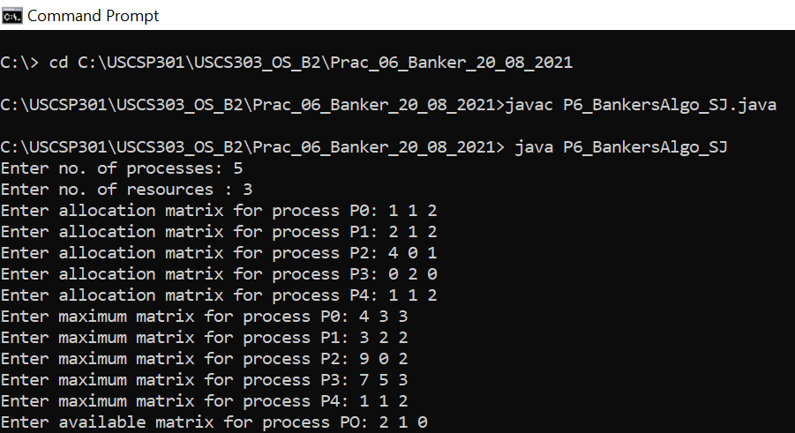

### 

### **Output:**

### 

### 

### **Sample Output:**

**Question: 01**

Calculate the content of the need matrix ?

Check if the system is in a safe state?

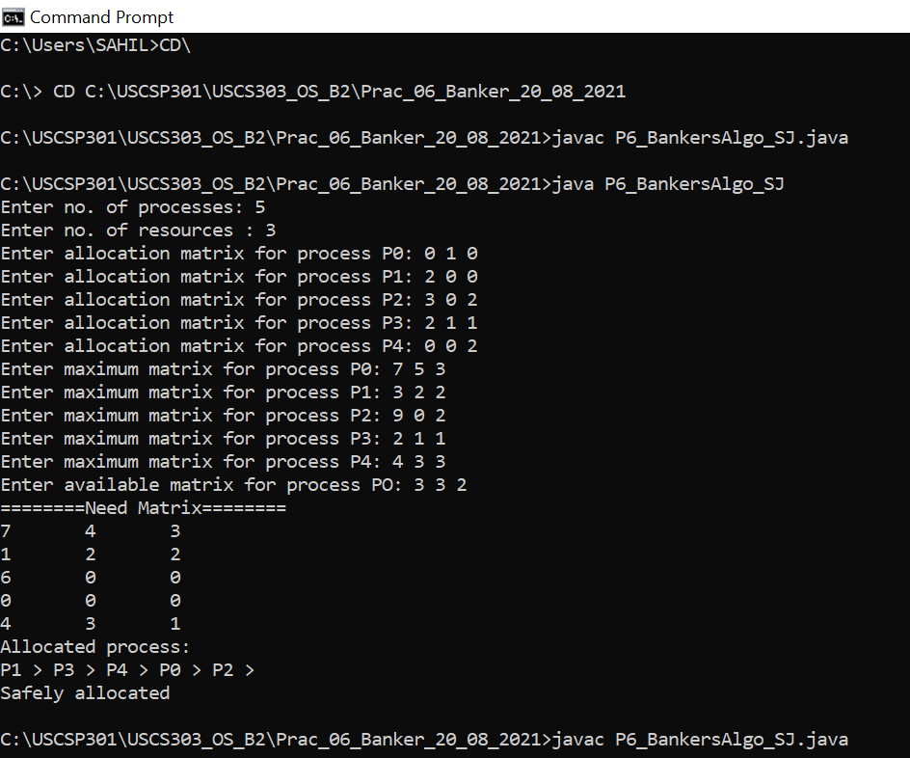

**Question:02**

Calculate the content of the need matrix ?

Check if the system is in a safe state?

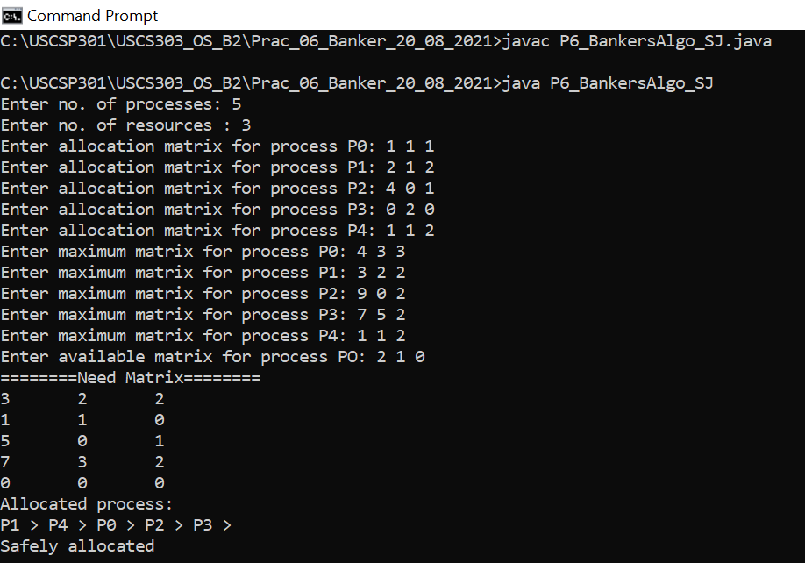

**Question:03**

Consider the following example containting five processes and 4 types of resources:

Calculate the Need Matrix and the sequence of safety allocation ?

