**Front-end Web development**

**(Portfolio )**

**Submitted by- Sahil,**

**Std_ID: 500237277**

Task 1 : Setting up the foundation for code which include all the html, css and js file to run the code properly.

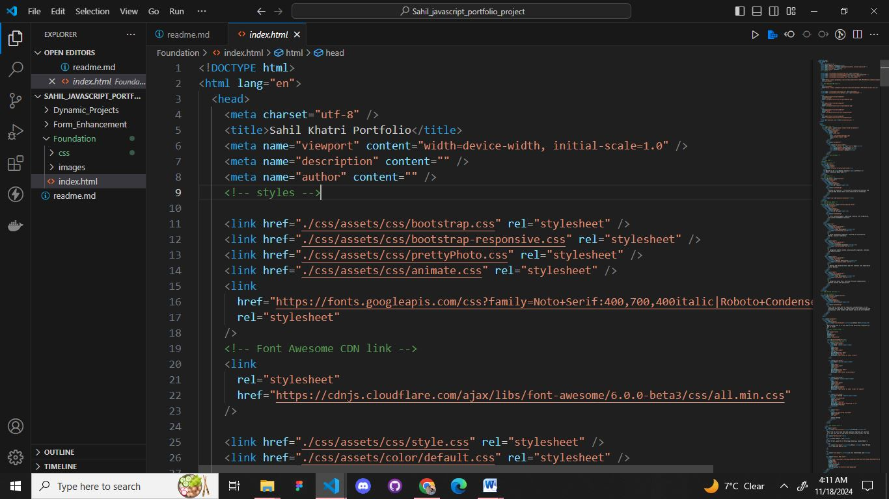

After setting up foundation for portfolio website, here is the output of website.



Task 2: Adding the dynamic project in file which will render automatically in index.html file and we can change easily if we want to update data in future.

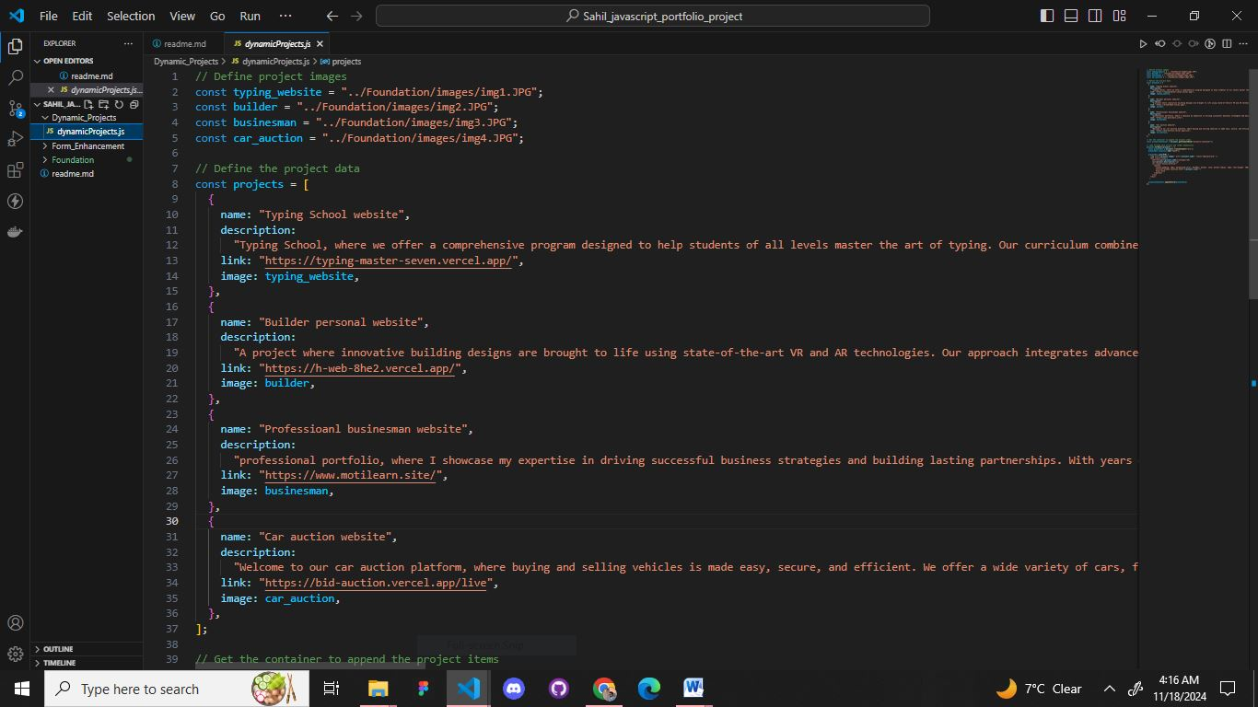

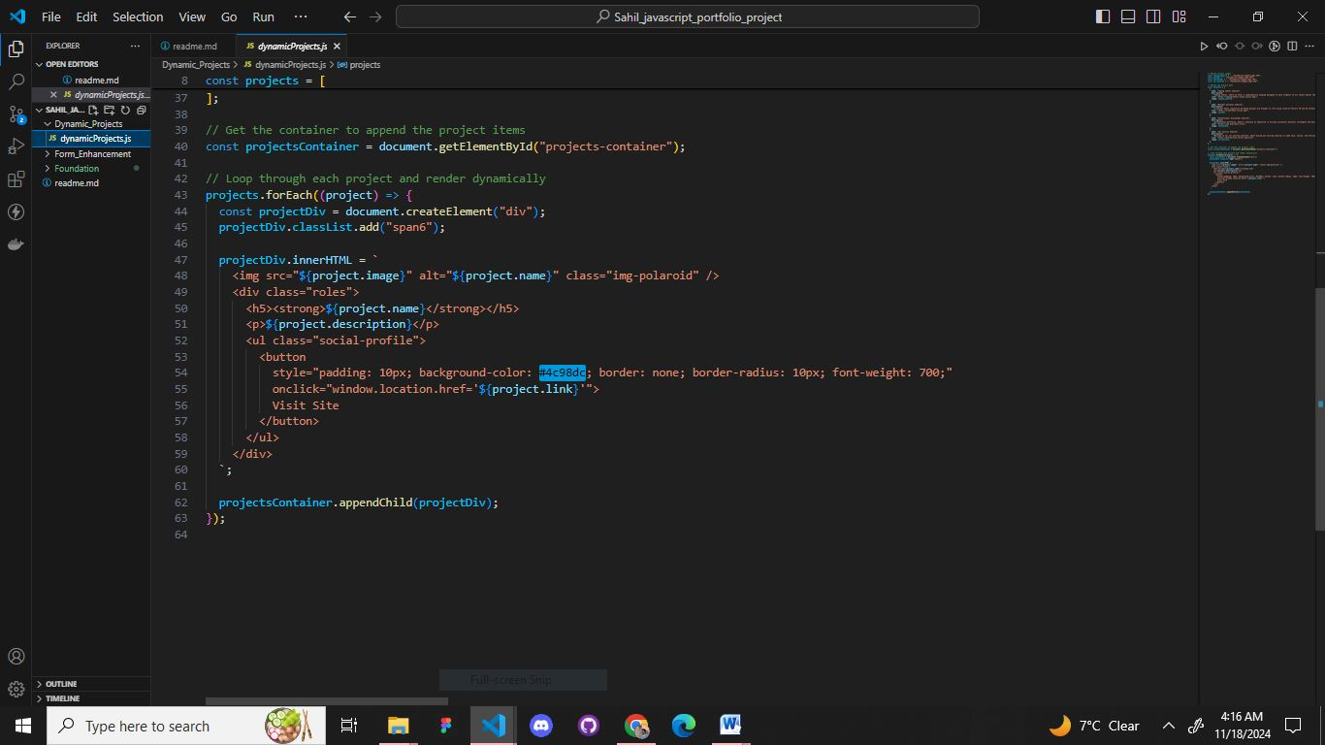

After adding data we can add style also by which it can be visible according to our website theme

And here is the successful outcome with **title**, **description** and **link** –

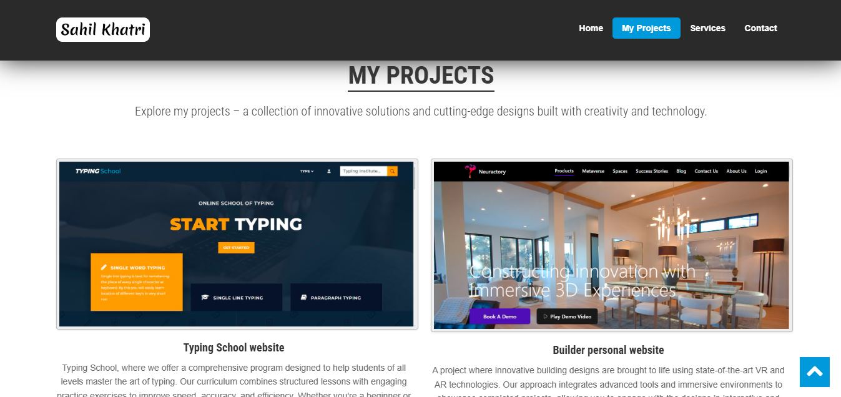

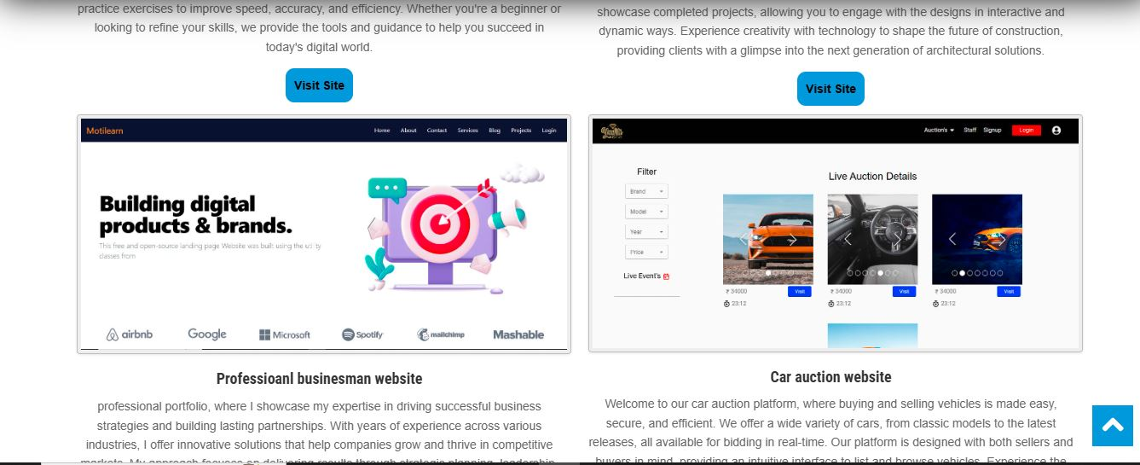

Task 3: Implementing the error handling and form validation so user can not submit blank form. If user tries to send empty then it will show an alert with error message

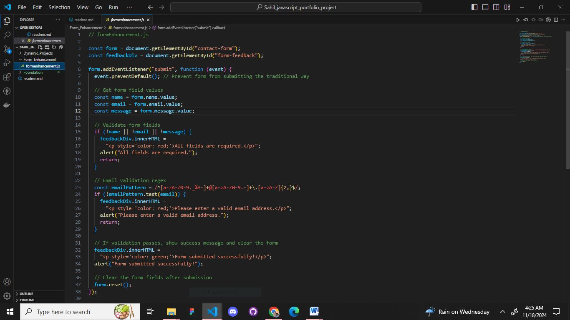

Error handling –

1. If email is empty or incorrect -

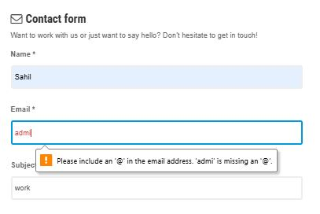

1. Alert - If any or all field are empty

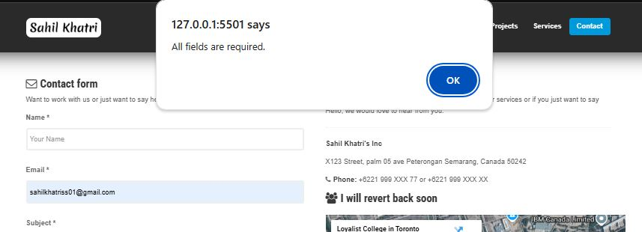

1. Success alert – If form is not empty and if get submitted

