1. **Web Api using custom model class**

**EmployeeController.cs**

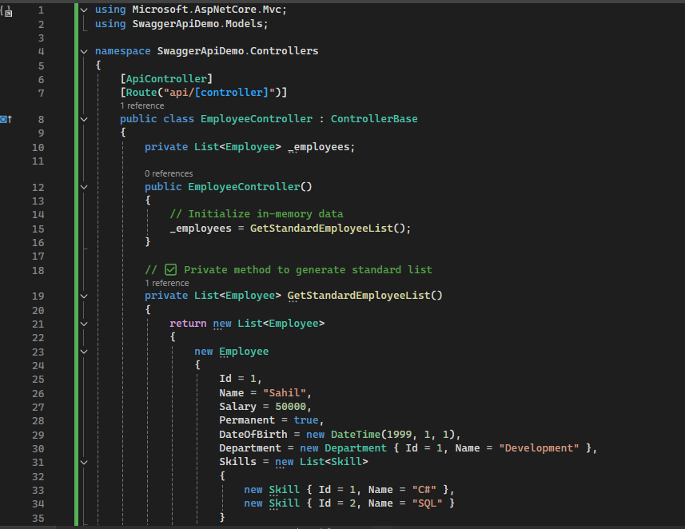

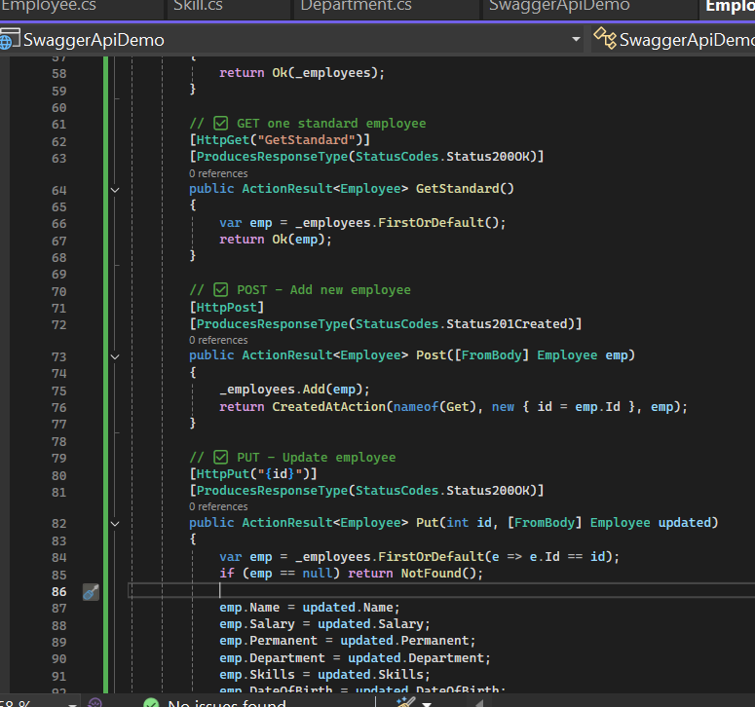

**Department.cs**

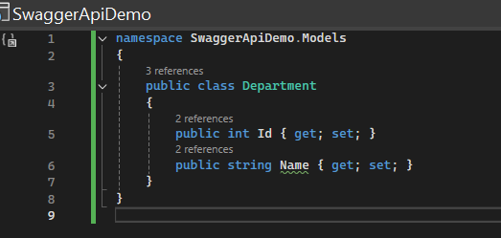

Skill.cs

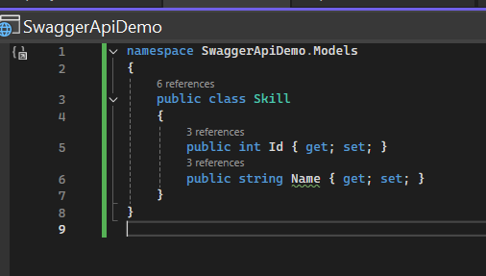

Employee.cs

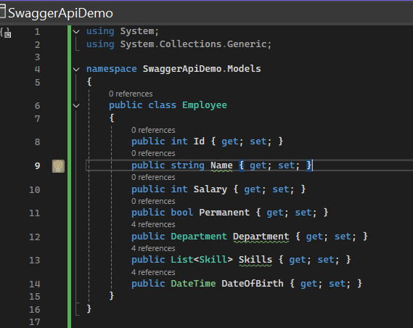

Output:

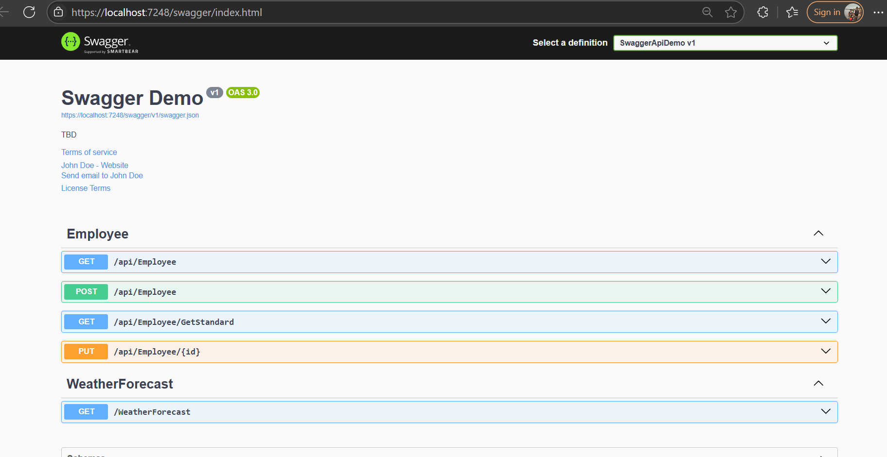

1. **Create a Custom action filter for Authorization.**

Program.cs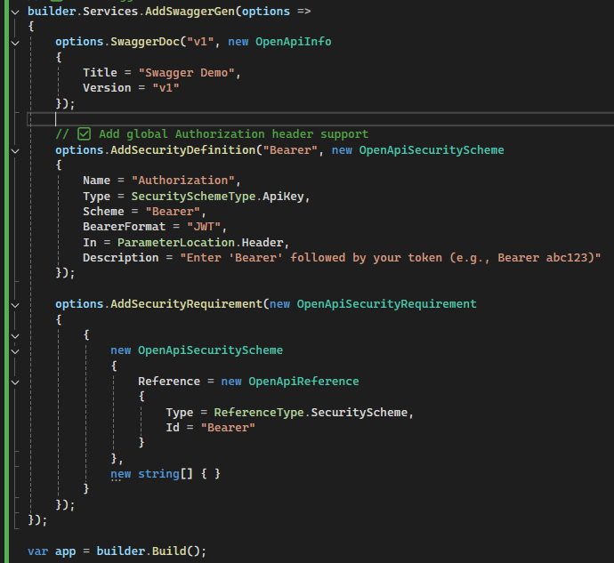

CustomAuthFilter.cs

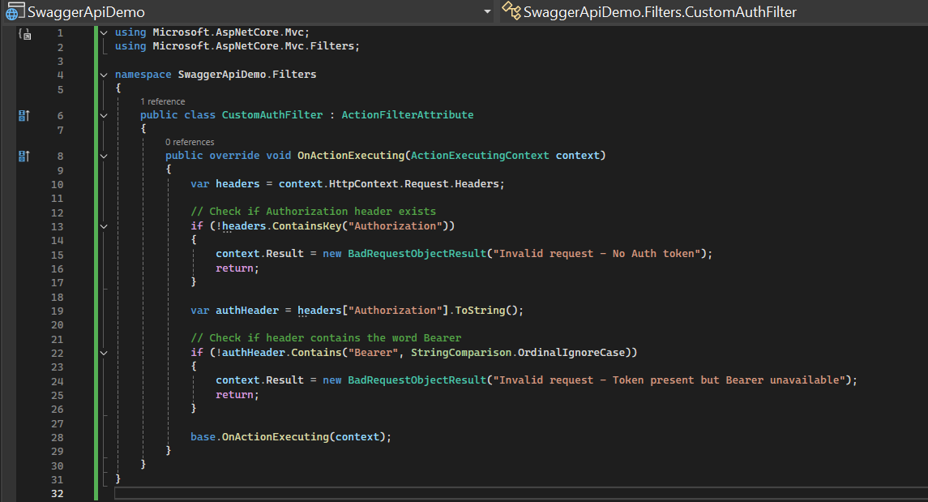

Output:

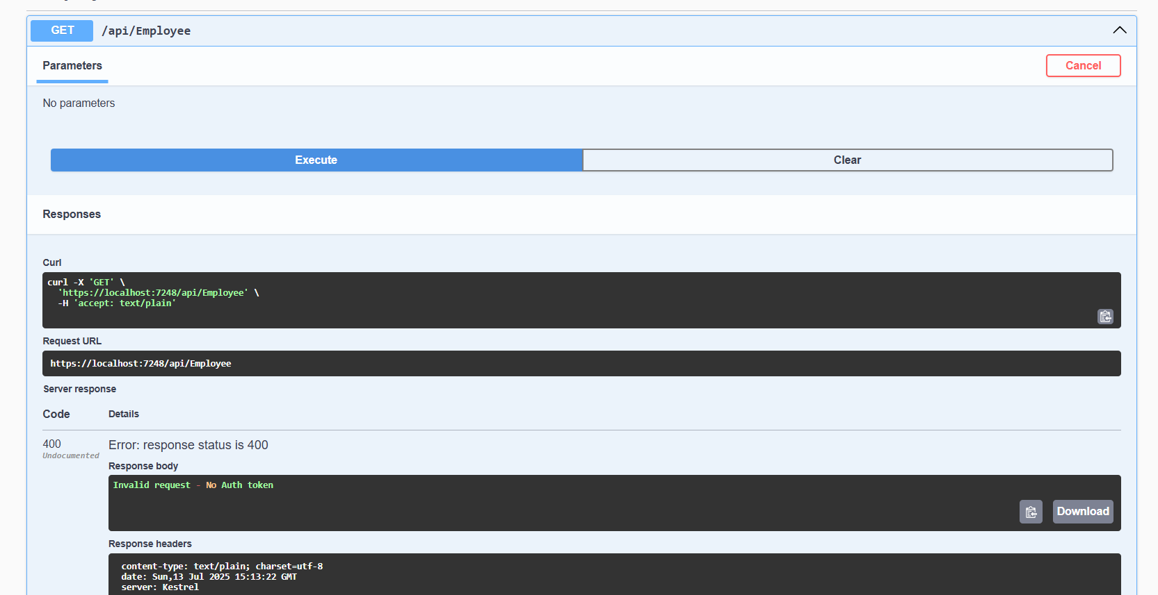

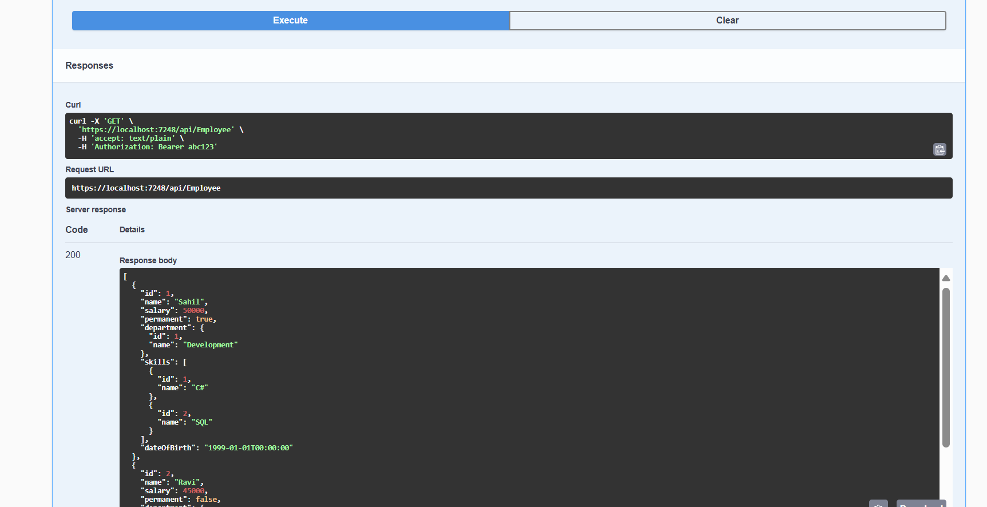

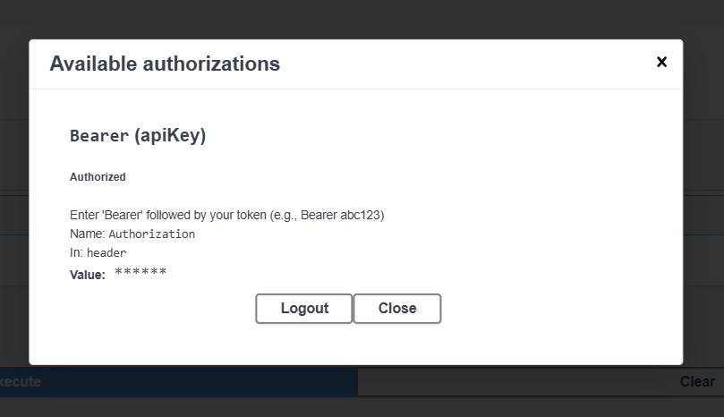

1. **Custom Exception filter**

EmployeeController.cs

[HttpGet("Throw")]

[ProducesResponseType(StatusCodes.Status500InternalServerError)]

public ActionResult<string> ThrowError()

{

throw new Exception("Test Exception from EmployeeController!");

}

Program.cs

builder.Services.AddControllers(options =>

{

options.Filters.Add<SwaggerApiDemo.Filters.CustomExceptionFilter>();

});

CustomerExceptionFilter.cs

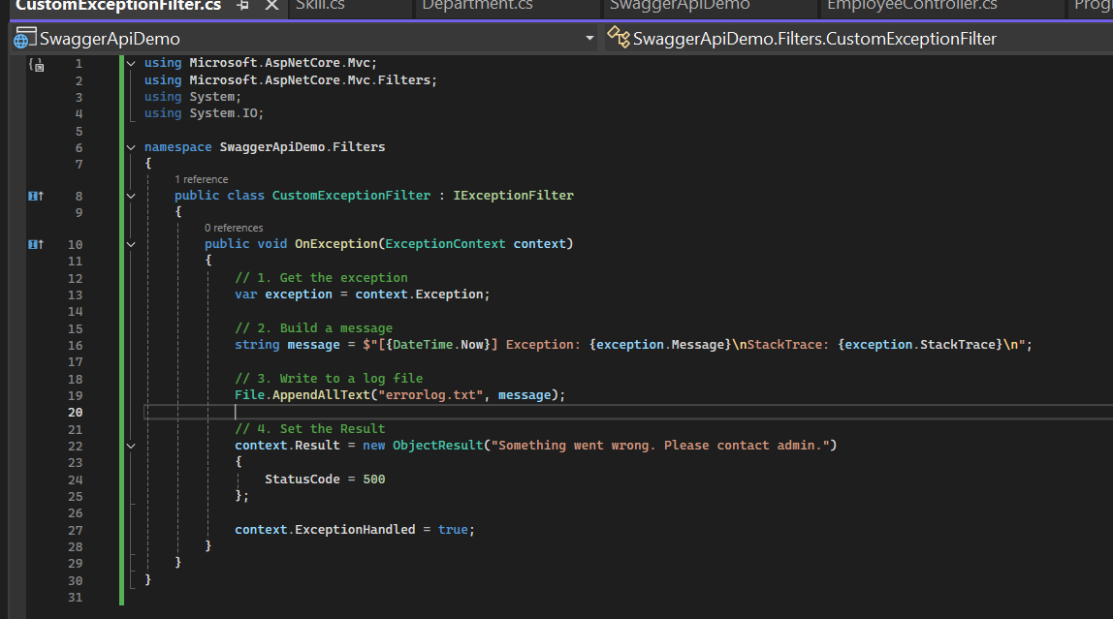

Output:

