**Question 1: Implement JWT Authentication in ASP.NET Core Web API**

Post /api/Auth/login

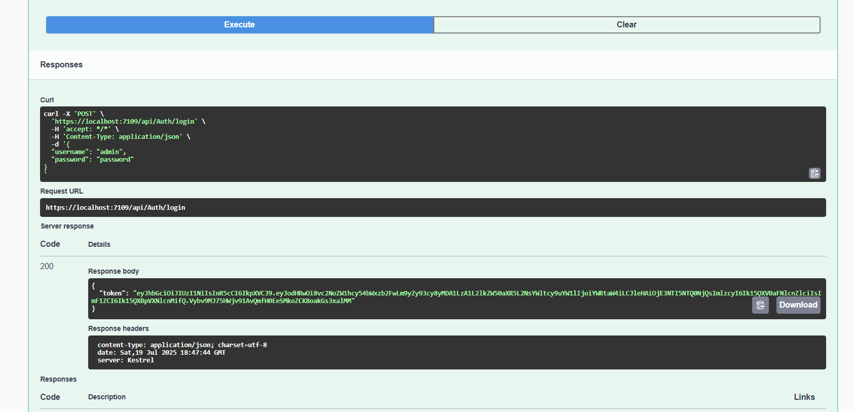

Post /api/Test/secure

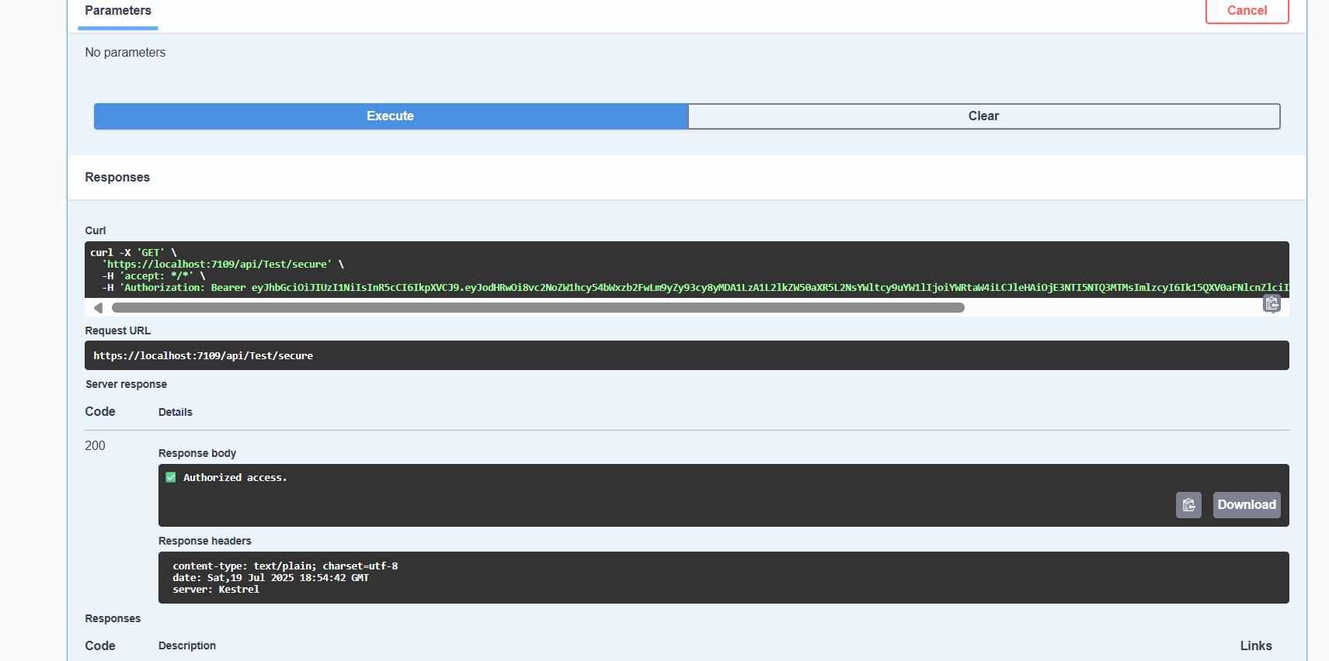

Post/api/Test/open

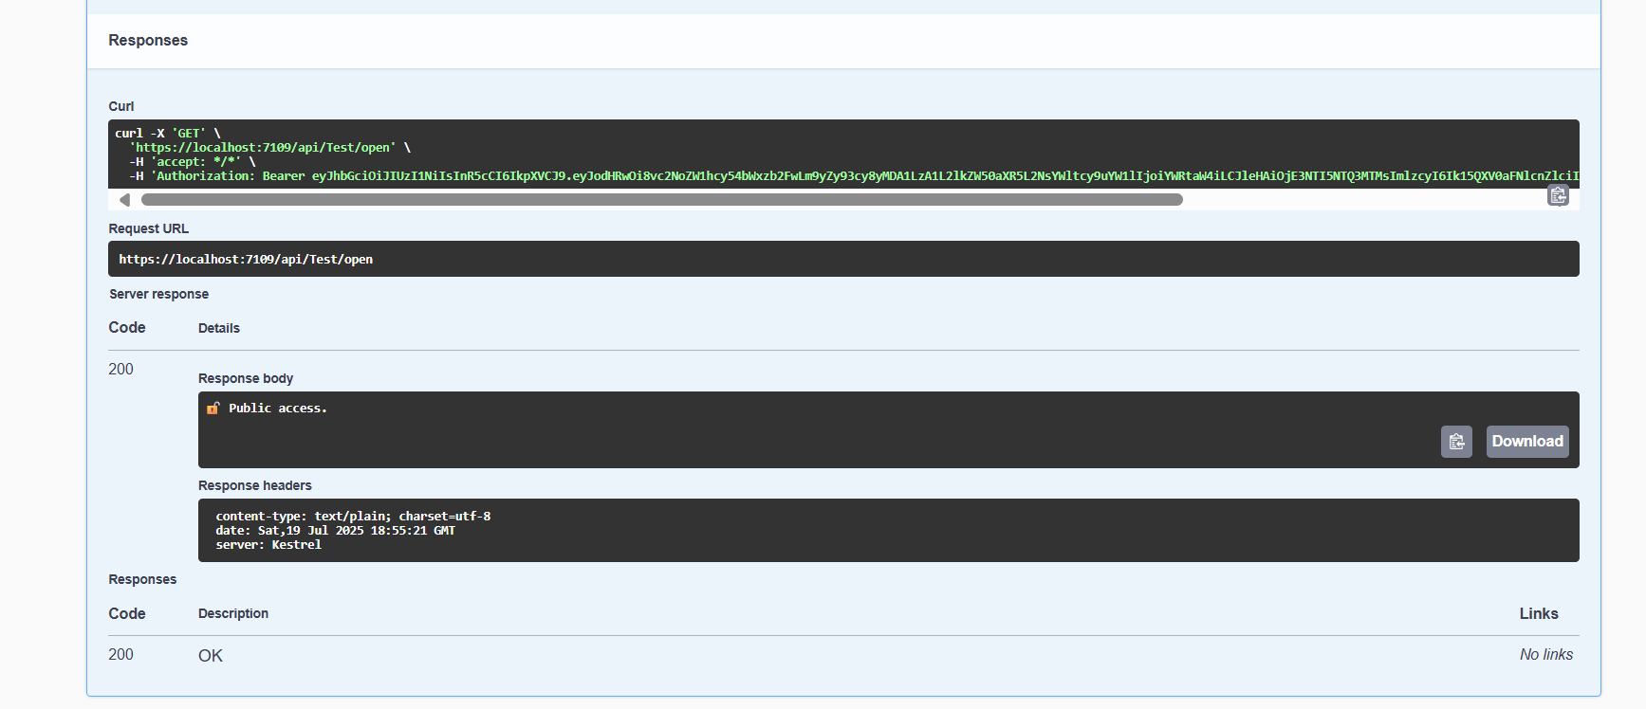

**Question 2: Secure an API Endpoint Using JWT**

GET /api/Secure/data

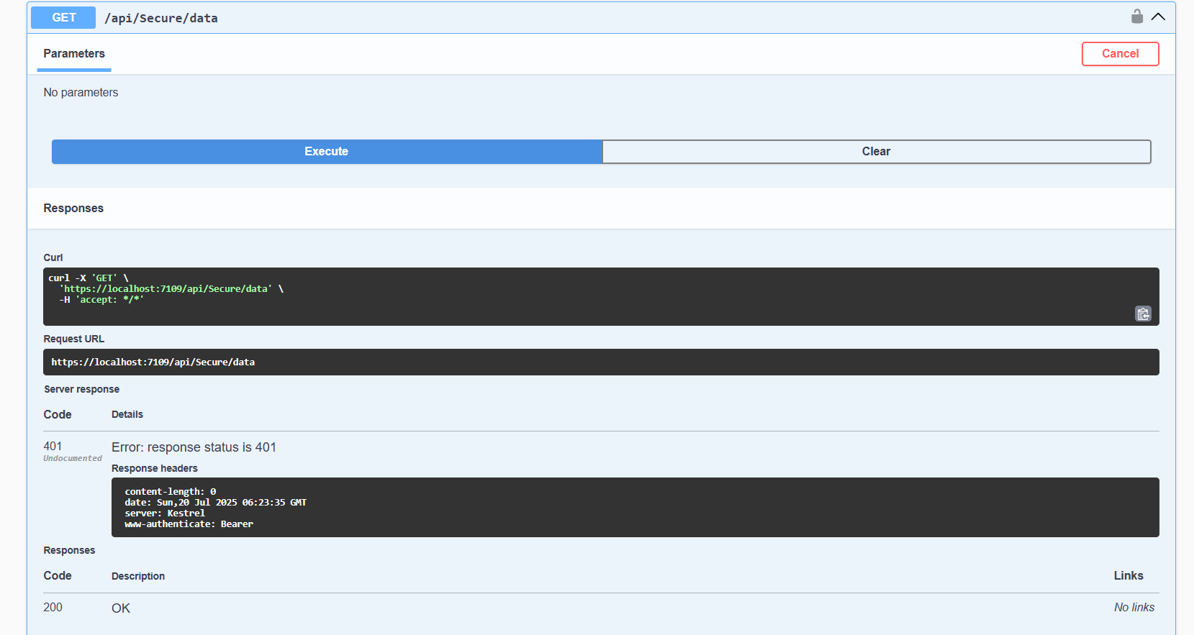

POST /api/Auth/login

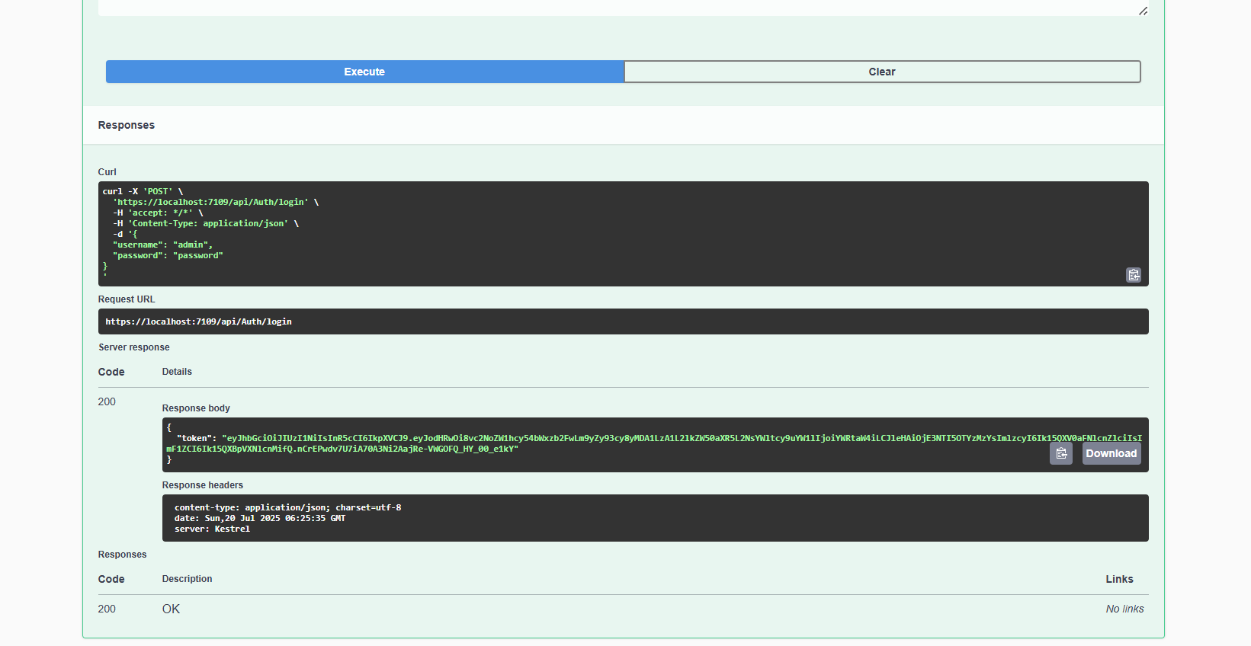

GET /api/Secure/data

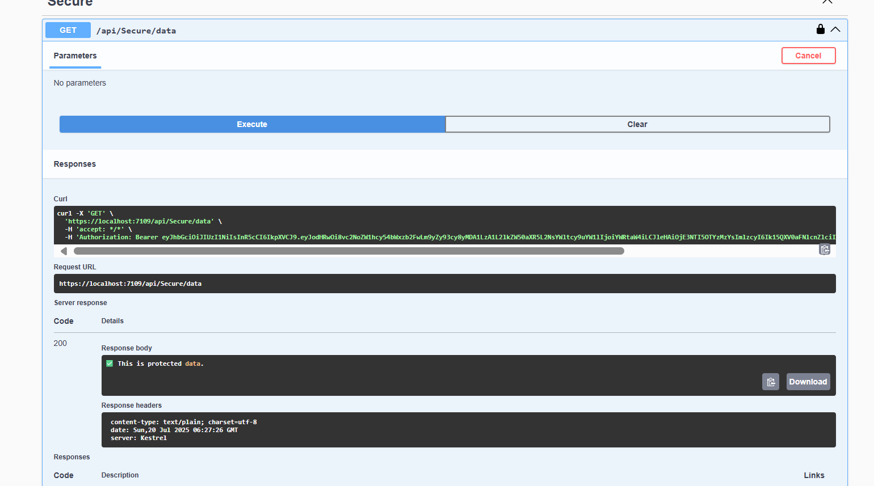

**Question 3: Add Role-Based Authorization**

POST /api/Auth/login

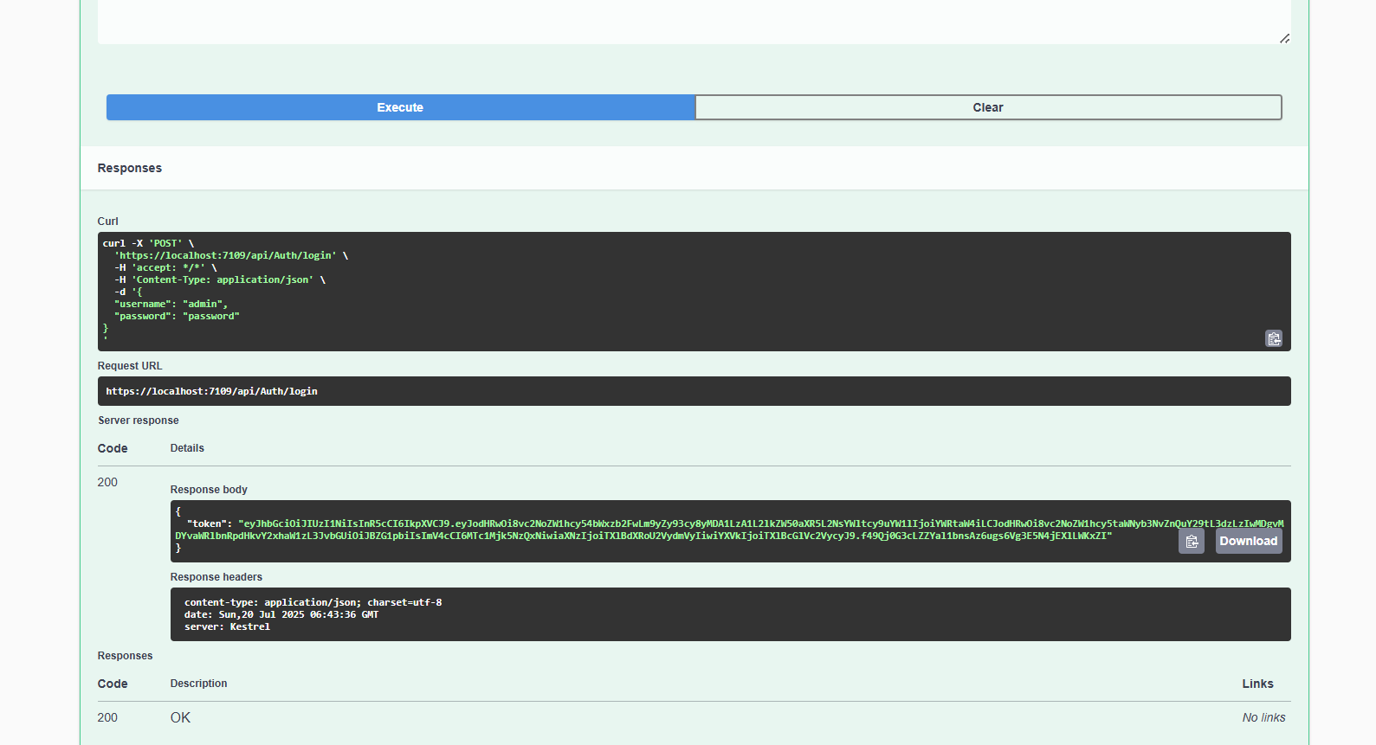

GET /api/admin/dashboard

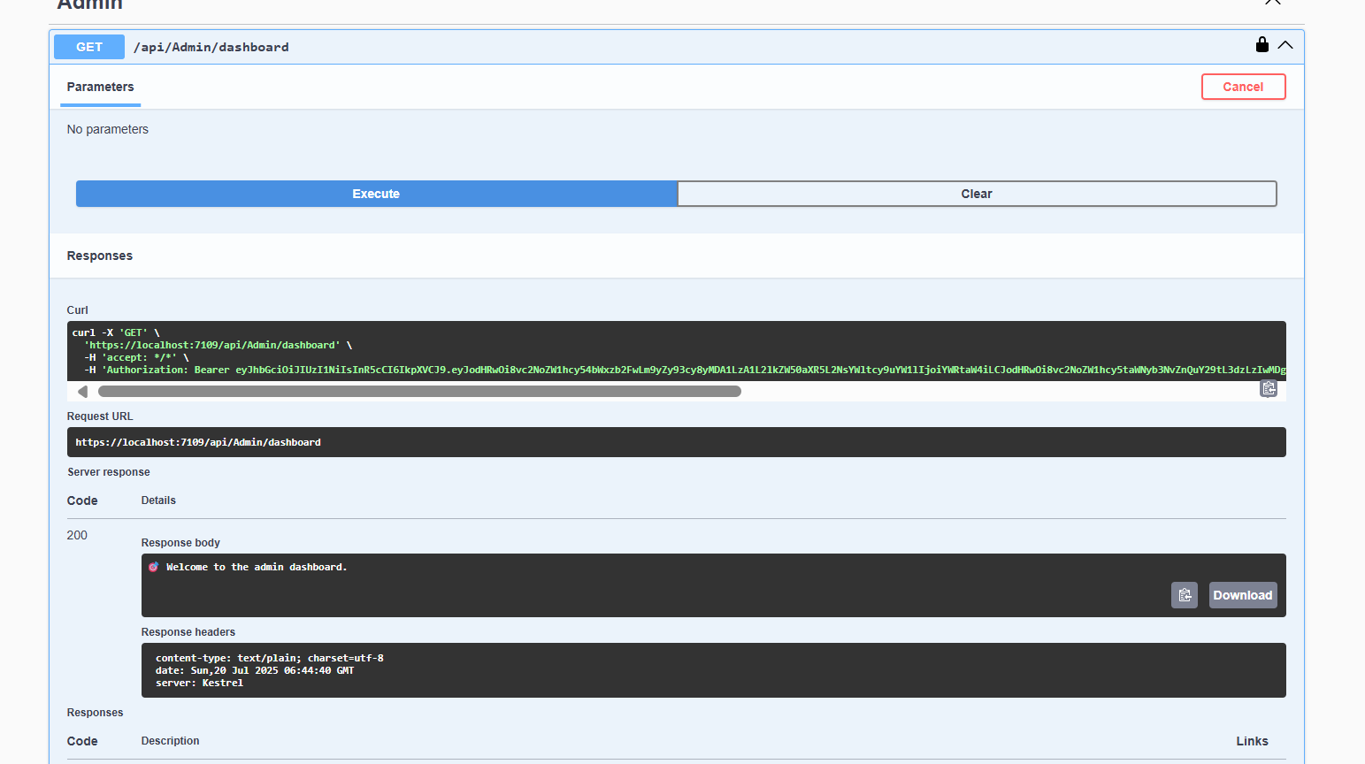

**Question 4: Validate JWT Token Expiry and Handle Unauthorized Access**

GET /api/Secure/data

