**PROBLEM 01**

Urgent Orders

Sorting the orders

Receive the order

Start

YES

Urgent order delieveries

Fragile Items?

YES NO

Deliver with other orders

Deliever items carefully

End

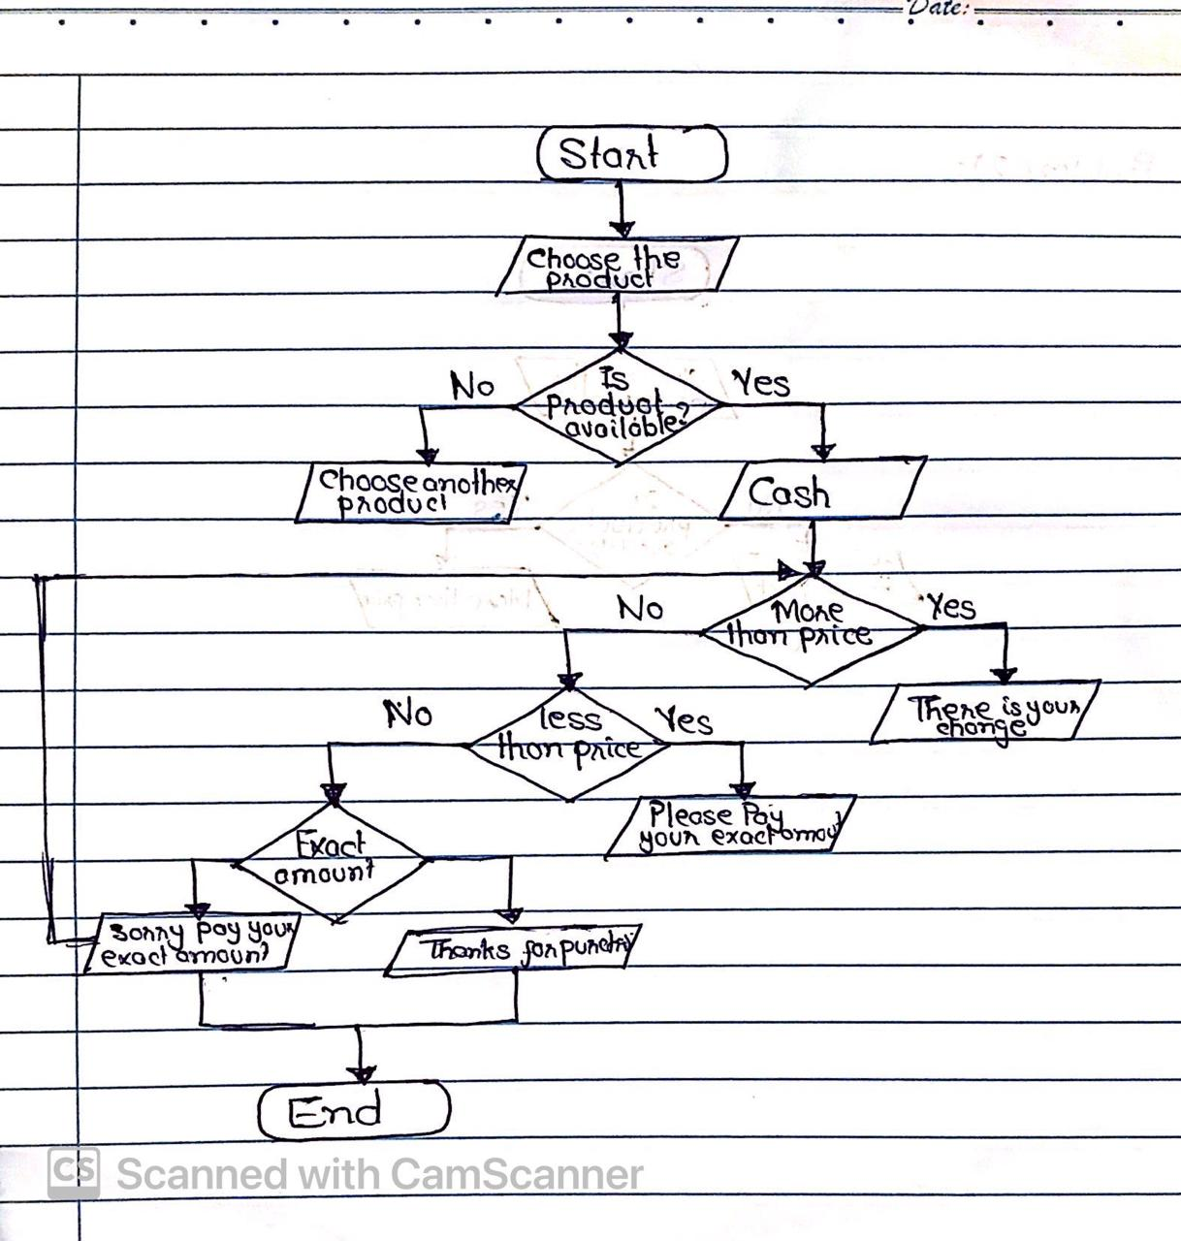Problem 02: Imagine you are automating the process of a vending machine. Create a flowchart that includes decision points for user input, selecting products, accepting payment, and dispensing the correct item. Include error-handling for invalid inputs and insufficient funds.

(PSEUDO CODE)

Problem 01: Write pseudocode to find the smallest number among three given variables. Implement a decision-making structure to compare the variables.

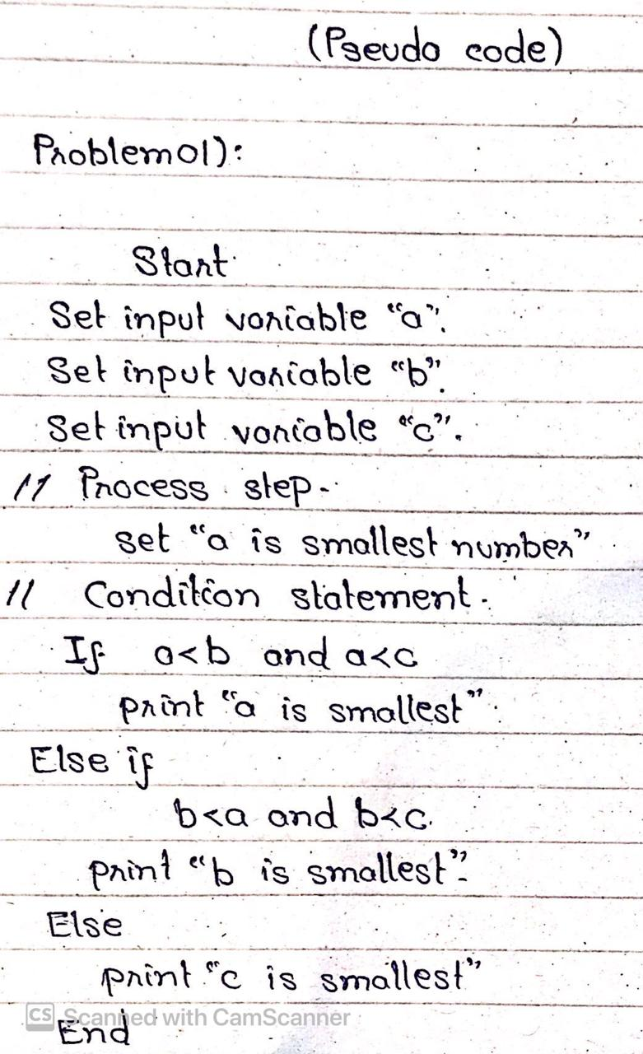

Problem 03: Develop pseudocode for a basic calculator that performs multiplication and division. The pseudocode should prompt the user for two numbers and an operator, then display the result of the operation.

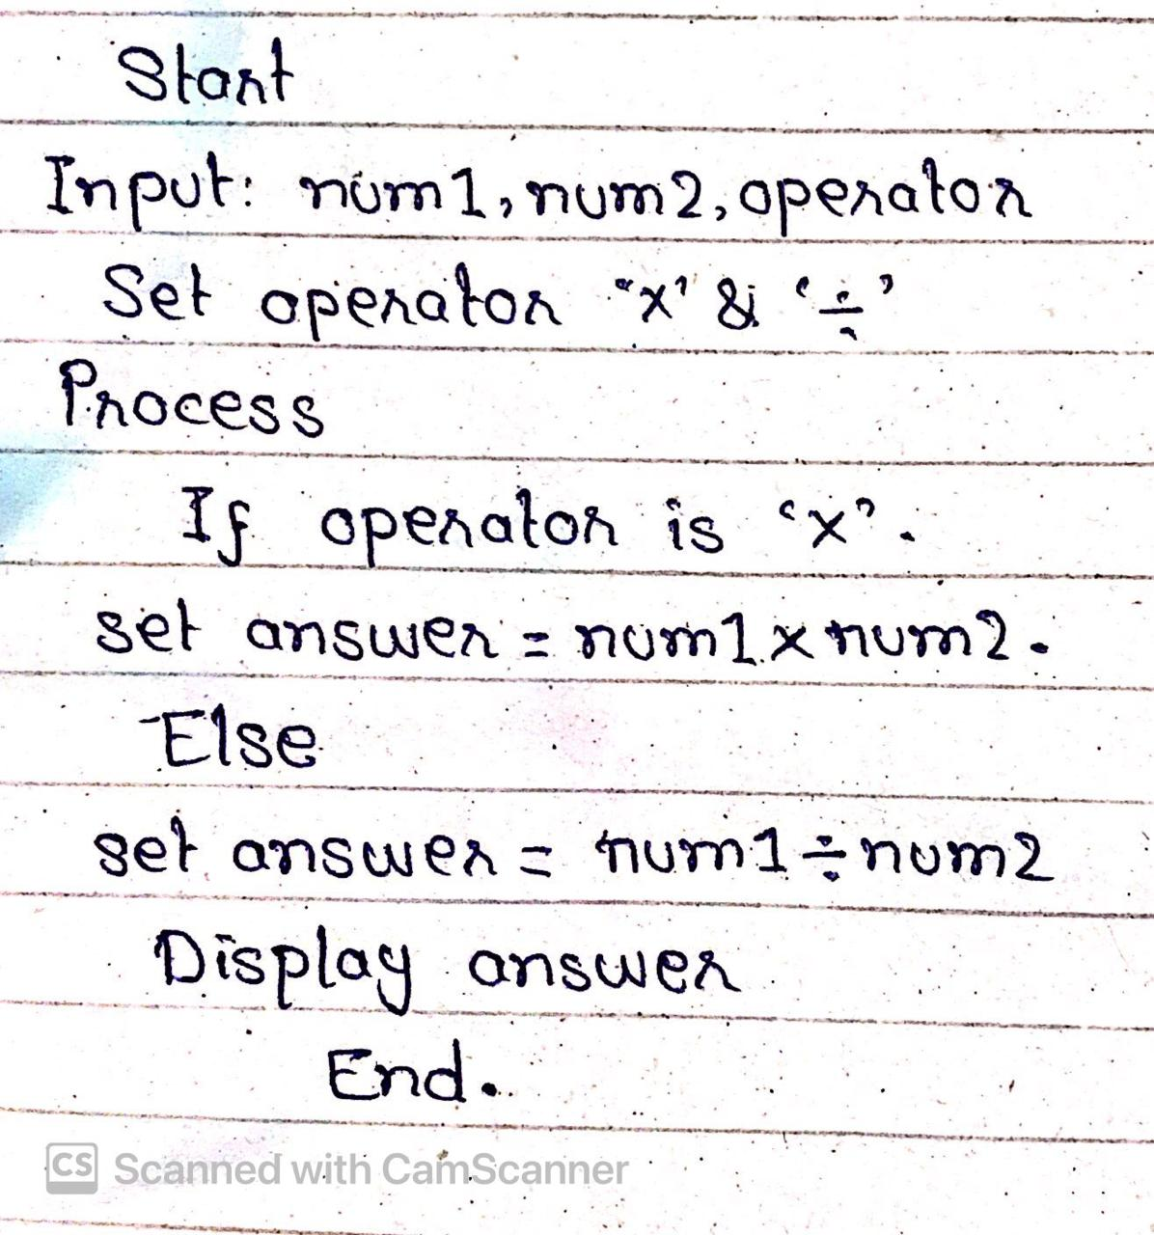

(ALGORITHM)

Problem 01: Write an algorithm to determine whether a number is a prime number. The algorithm should iterate through possible divisors and determine if the number has any divisors other than 1 and itself.

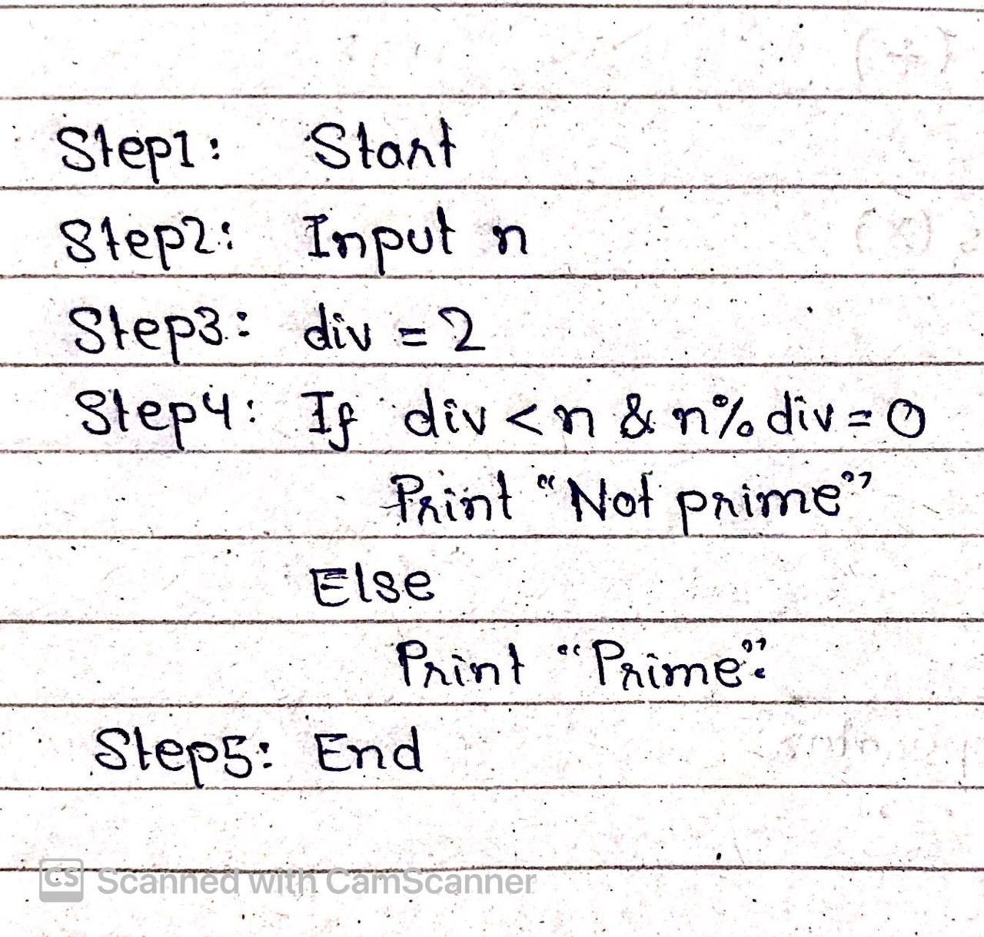

Problem 02: Create an algorithm that asks the user for a day number (1-365) and outputs the corresponding day of the week, assuming that January 1st is a Monday.

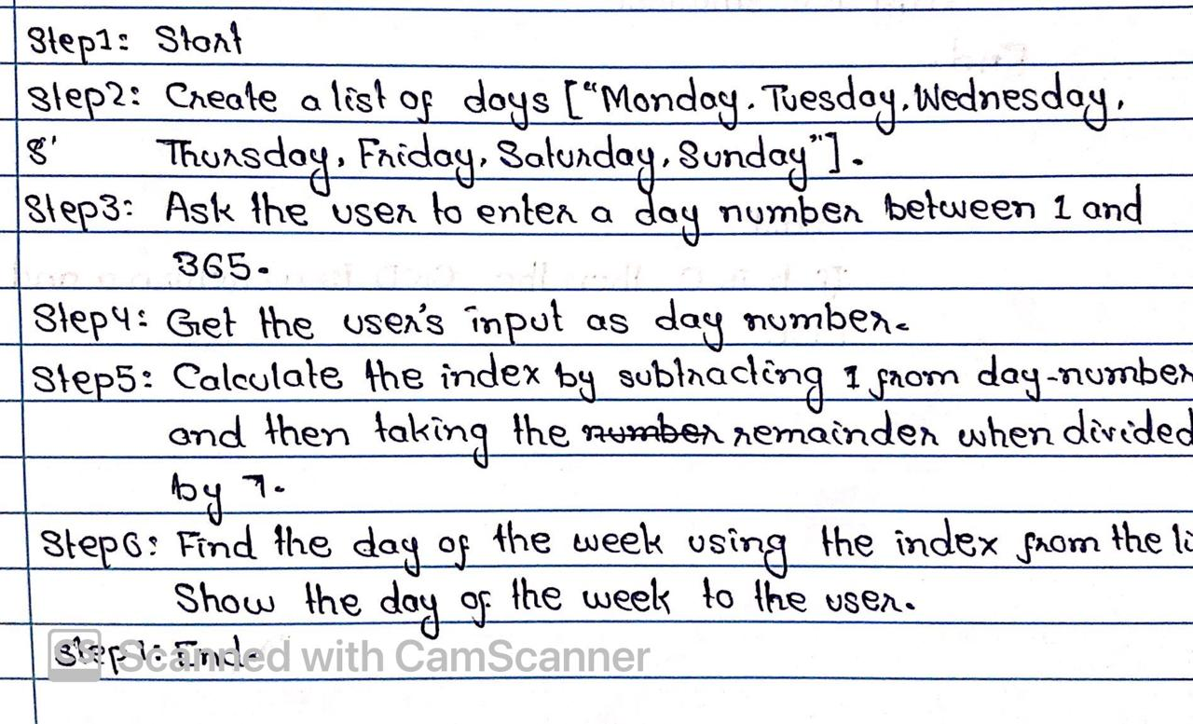

Problem 03: Develop an algorithm for a program that takes two numbers as input and finds the Greatest Common Divisor (GCD) of the two numbers using the Euclidean algorithm.

