Analysis of Aadhaar Enrolment, Demographic Update, and Biometric Trends Across India

Hackathon:
UIDAI Data Hackathon 2026
Team Type:
Team Leader: Sahil Laghave Member: Om Dhanapune, Atharva Kandalkar
Tools Used:
Python, Pandas, Matplotlib, Jupyter Notebook

1.ABSTRACT

This project analyzes Aadhaar enrolment, demographic updates, and biometric updates using UIDAI open datasets. Large-scale CSV datasets were processed to identify enrolment patterns, update efficiency, and operational gaps across Indian states and districts. The study highlights state-wise trends, age group distribution, and discrepancies between enrolment and update processes, providing insights into data maintenance efficiency and potential infrastructural challenges.

2.PROBLEM STATEMENT

Aadhaar is a critical identity infrastructure in India. However, maintaining accurate demographic and biometric data after enrolment is equally important. This project aims to analyze Aadhaar enrolment data and compare it with demographic and biometric update datasets to identify trends, efficiencies, and gaps at state and district levels.
Identify meaningful patterns, trends, anomalies, or predictive indicators and translate them into clear insights or solution frameworks that can support informed decision-making and system improvements.

3.DATASETS USED

Dataset 1: Enrolment Dataset
Columns: date, state, district, pincode, age_0_5, age_5_17, age_18_greater
Size: ~1.5 million records (merged from multiple files)
Dataset 2: Demographic Update Dataset
Columns: date, state, district, pincode, demo_age_5_17, demo_age_17_
Size: ~2 million records
Dataset 3: Biometric Update Dataset
Columns: date, state, district, pincode, bio_age_5_17, bio_age_17_
Size: ~1.86 million records

4.METHODOLOGY

- Loaded large CSV files using Pandas and merged split datasets.
- Standardized date formats using day-first parsing.
- Created total enrolment, demographic update, and biometric update metrics.
- Aggregated data state-wise and district-wise.
- Performed ratio analysis to compare updates against enrolments.
- Visualized trends using bar and pie charts.

5.KEY ANALYSIS & RESULTS

5.1 Age Group Distribution Analysis

The enrolment data reveals a highly skewed age-wise distribution, indicating Aadhaar’s predominant role in early-life identity registration.
0–5 years: ~65.3% of total enrolments
5–17 years: ~31.6%
18+ years: ~3.1%
This dominance of the 0–5 age group suggests widespread adoption of Aadhaar during birth registration and early childhood services, such as immunization, school admission, and welfare scheme linkage.

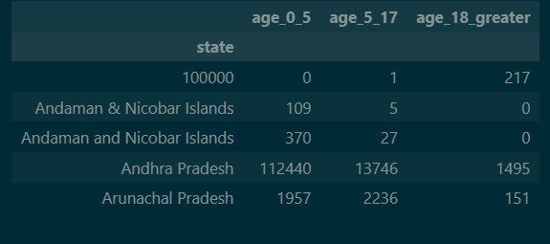

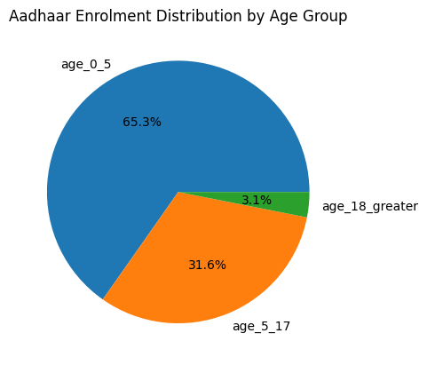
Insight:
Aadhaar has effectively transitioned from an adult identity system to a birth-linked digital identity platform.
5.2 State-Wise Enrolment Patterns

State-level aggregation shows that Uttar Pradesh, Bihar, and Madhya Pradesh lead in total Aadhaar enrolments.
This trend is primarily driven by:
- Large population bases
- High birth rates
- Extensive rural coverage under UIDAI enrolment programs
However, high enrolment volumes do not automatically translate into efficient update mechanisms, highlighting the importance of examining update ratios rather than absolute counts alone.

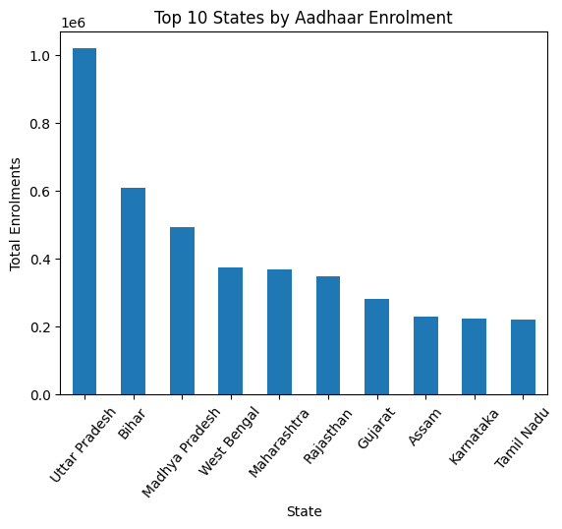
Insight:
Population scale significantly influences enrolment volume, but operational efficiency varies independently.

5.3 District-Level Concentration Effects

District-wise analysis reveals a strong concentration effect, where a small number of districts contribute disproportionately to national enrolment figures.
Notably, Thane district (Maharashtra) emerged as the highest enrolment district, which is unexpected due to its predominantly urban profile.

This anomaly can be attributed to:
- High population density
- Migration-driven registrations
- Centralized enrolment centers serving adjacent regions enrolment

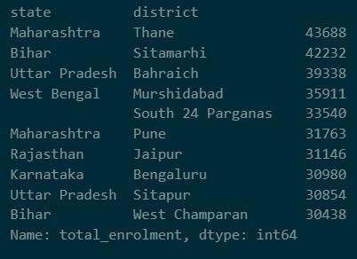

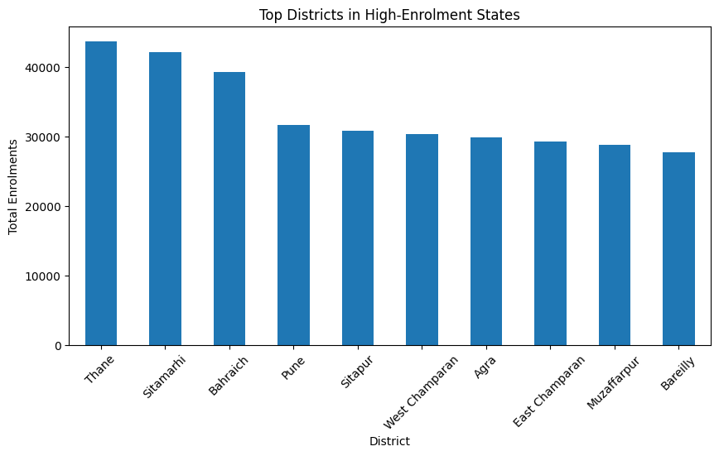

Insight:
Urban districts may act as regional enrolment hubs, inflating district-level statistics beyond resident population estimates.

5.4 State-wise Enrolment, Update, and Biometric Comparison

The comparative analysis of Aadhaar enrolment, demographic updates, and biometric updates across major states reveals significant variation in operational performance.
From the chart, Uttar Pradesh and Maharashtra dominate in overall Aadhaar activity, showing very high counts in all three categories. Bihar and Madhya Pradesh also demonstrate substantial enrolment volumes, reflecting their large population bases.
However, the relationship between enrolment and updates is not uniform across states. In several states, biometric updates exceed demographic updates, indicating a stronger focus on biometric verification after enrolment.

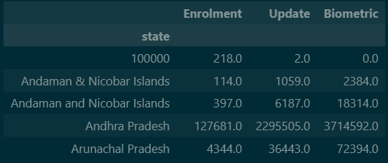

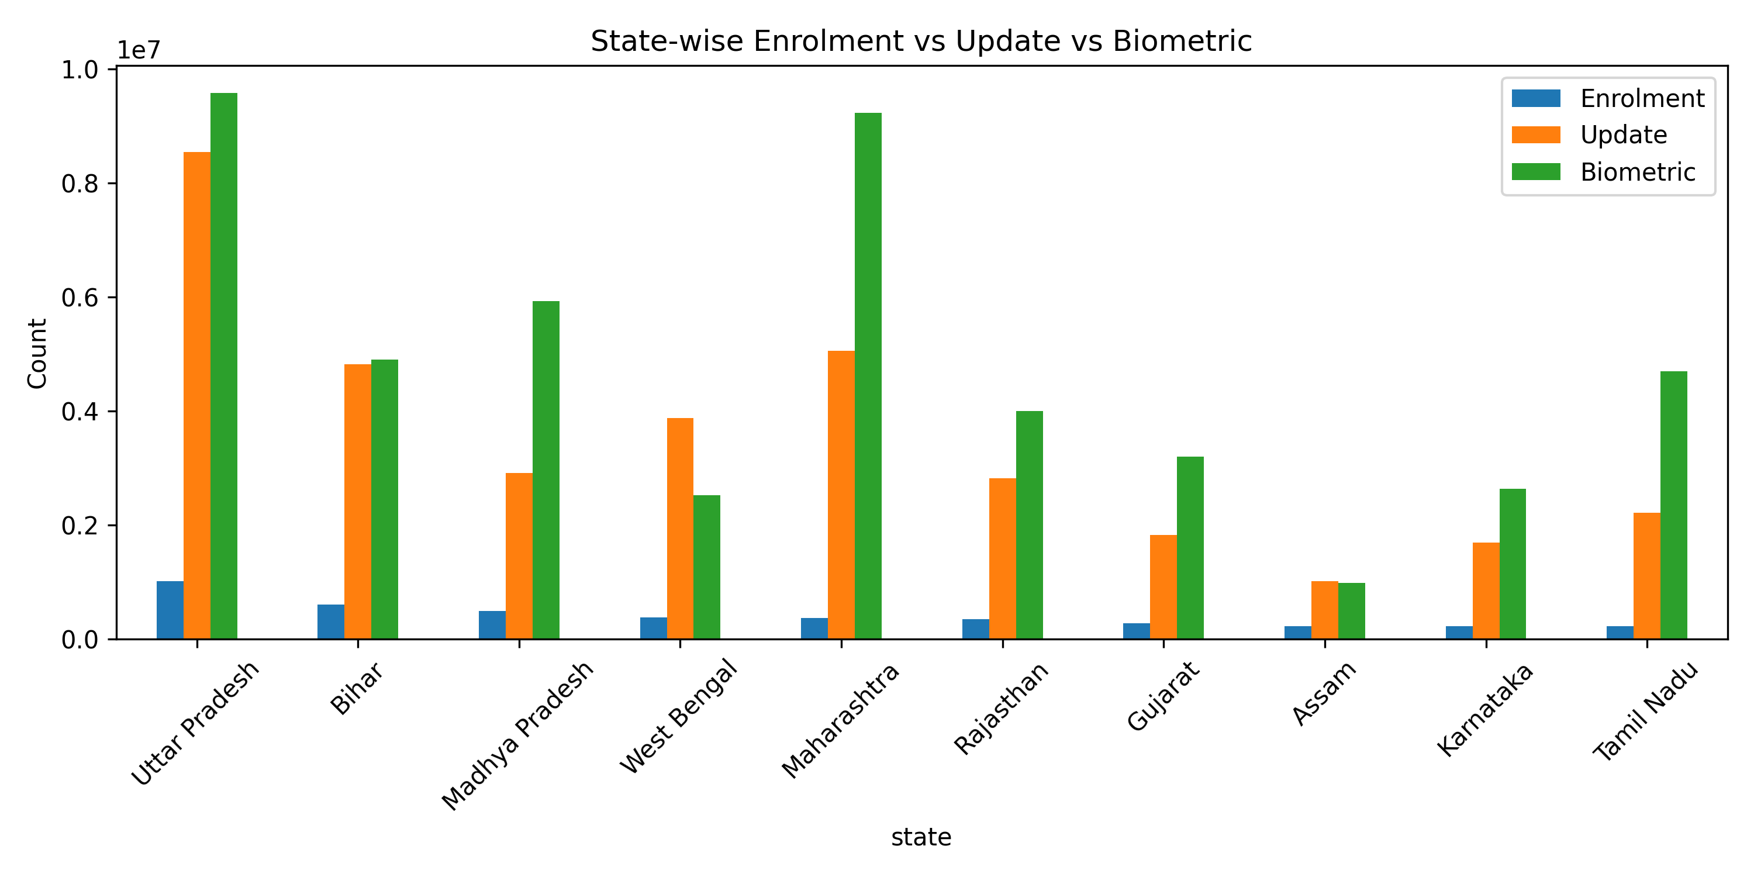
Key Observation:
High enrolment does not always guarantee proportional demographic or biometric updates, highlighting uneven post-enrolment maintenance.

5.5 Biometric-to-Enrolment Ratio Analysis

The biometric-to-enrolment ratio chart highlights union territories and smaller regions such as Daman & Diu, Andaman & Nicobar Islands, Dadra & Nagar Haveli, and Odisha as top performers.
These regions show exceptionally high biometric ratios, which suggests:
- Faster biometric capture cycles
- Better administrative efficiency
- Smaller population sizes enabling quicker processing
In contrast, large states with massive enrolment volumes display relatively lower ratios, not due to poor performance, but due to scale and logistical complexity.

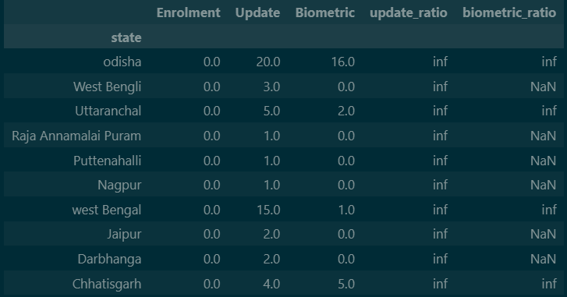

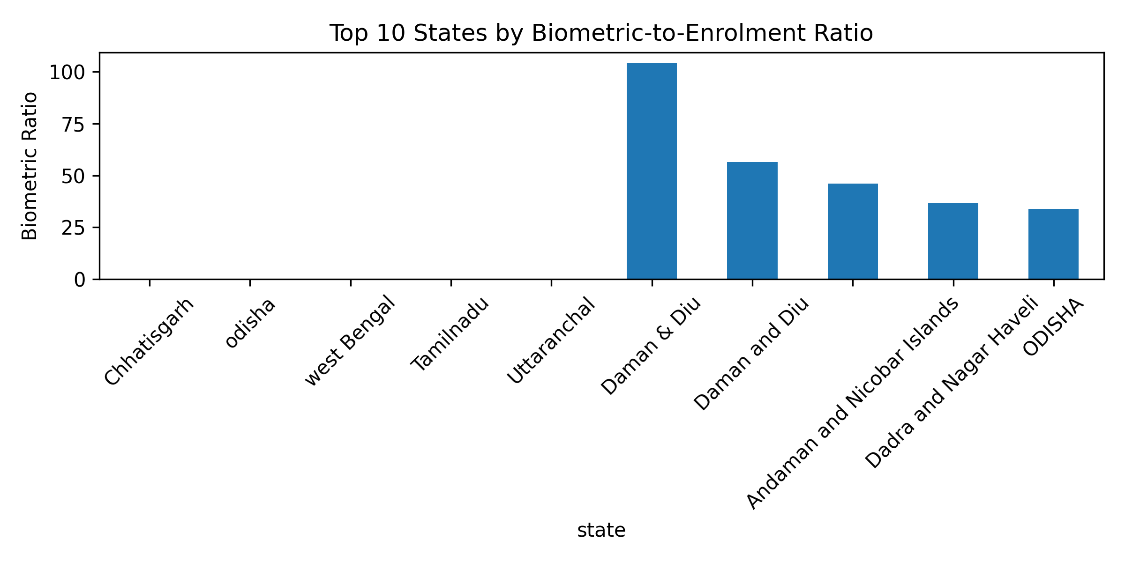
Important Insight
Smaller administrative regions outperform larger states in biometric completion efficiency due to manageable population size and focused infrastructure.
5.6 Update-to-Enrolment Ratio Analysis

The update-to-enrolment ratio chart shows very low ratio values across all states, indicating that demographic updates occur far less frequently than enrolments.
This is expected because:
Demographic updates are event-driven (name, address, DOB changes)
Enrolment is a one-time mandatory process
The chart still helps identify relative leaders in maintaining updated demographic records.

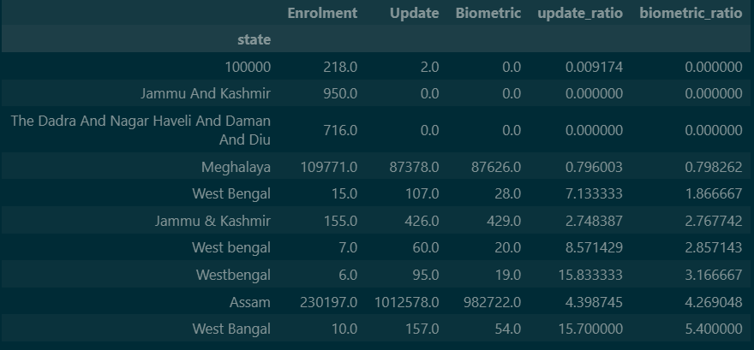

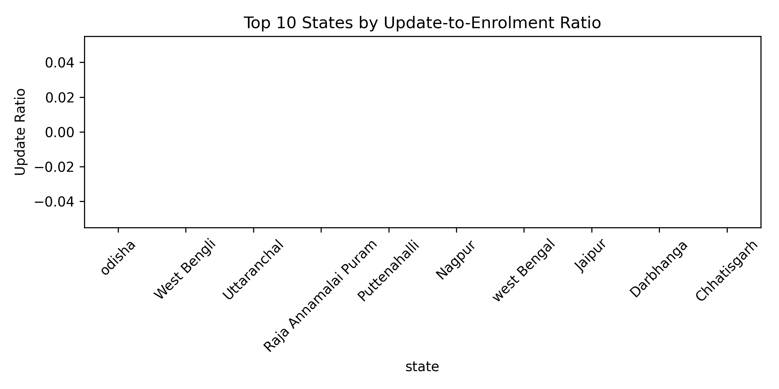

Key Interpretation:
Low update ratios are natural and do not indicate failure; instead, they reflect the stability of demographic data after enrolment.

5.7 Operational Gaps & Policy Implications

By combining enrolment scale with ratio analysis, the following gaps emerge:
Large states face scale-related challenges in keeping biometric updates proportional.
Smaller states and UTs demonstrate higher efficiency per enrolment.
There exists a clear need for targeted infrastructure improvements in high-population states.

Policy-Level Insight:
Aadhaar service strategies should be region-specific, focusing on scale optimization for large states and best-practice replication from high-performing UTs.

6. CONCLUSION

This project demonstrates that while Aadhaar enrolment coverage in India is extensive, post-enrolment data maintenance varies significantly across regions. High-volume states dominate absolute numbers, whereas smaller regions excel in efficiency metrics.
The ratio-based analysis provides a deeper understanding beyond raw counts, helping identify both operational strengths and improvement areas. Such insights can assist UIDAI and policymakers in enhancing service delivery, infrastructure planning, and data quality management.

7. FUTURE SCOPE

- Region-specific performance benchmarking
- Time-series analysis of update completion
- Predictive modeling for biometric backlog
- Integration with population density metrics

