Data Analysis Project Report: E-Commerce Sales & Profit Optimization
Interactive Business Intelligence Dashboard Documentation for GitHub Portfolio

1. Project Context & Objectives
In highly competitive e-commerce markets, understanding consumer purchasing patterns, geographical performance, and structural profitability margins is critical for sustainable growth. This project focuses on analyzing an e-commerce dataset capturing transactional orders across multiple states and cities in India. The main objective was to take messy, relational data and translate it into an intuitive, high-impact visual dashboard that enables stakeholders to diagnose sales trends, spot leaking profit margins, and track segment operational goals.
By establishing clean data relationships and designing an intuitive visual canvas, this dashboard handles operational questions regarding regional performance, top-selling product lines, preferred transactional methods, and monthly timeline health. The complete model was built to be completely dynamic, allowing business users to filter data down to granular cross-sections without breaking underlying metrics.

2. Dataset Architecture & Schema Mapping
The business logic relies on a clean star/snowflake relational structure consisting of two primary tables. This separates high-level customer order attributes from specific transactional line items. Below is an overview of the data architecture:
Table Name | Primary Tracking Attributes | Key Identity / Relationship Link
Orders Master (Orders.csv) | Order Date, Customer Name, Regional Destination (State, City) | Order ID (Primary Key - Unique per booking)
Order Details (Details.csv) | Financial Metrics (Amount, Profit), Volume (Quantity), Product Categories, Payment Method | Order ID (Foreign Key - Links line items to destination)

Data Modeling Connection: Inside Power BI, a One-to-Many (1 -> *) relationship was formed using 'Order ID'. This setup ensures that whenever a user interacts with a geographic filter (such as filtering by State) or timelines on the Orders table, the operational data aggregates perfectly across all item costs, profits, and category counts in the Details table.

3. Core Analytics Insights & Extracted Metrics
After executing baseline queries and processing data distributions across the entire dataset, the exact operational scope reveals compelling operational baselines. These numbers serve as the high-level metrics displayed on the dashboard's KPI cards:
- Total Accumulated Revenue: INR 437,771 — The macro sales footprint across all digital product categories.
- Net Operational Profit: INR 36,963 — The remaining net income after absorbing loss-making subcategories and regional constraints.
- Total Logistical Volume: 5,615 units — The total individual products packed, shipped, and fulfilled successfully.
- Primary Revenue Engine: Maharashtra — The state driving the largest raw transaction volume and customer acquisition rate.
- Core Volume Category: Clothing — Represents the highest transactional frequency and customer touchpoint count.

4. Visual Interface & Interactive Filter Architecture
The primary value of this dashboard lies in its deep visual interactivity. Instead of relying on static reports, this tracking environment uses native DAX relationships and dynamic slicing filters to enable continuous discovery. All interactive controls have been rigorously tested and work flawlessly across different permutations:
- Geographic State Slicer: Enables instantaneous regional deep-dives. Selecting a specific state updates the entire dashboard—including the city distribution maps, monthly tracking targets, and category sales charts—to isolate local metrics.
- Quarterly Temporal Filter: Segments performance metrics into logical seasonal quarters (Q1, Q2, Q3, Q4). This lets users pinpoint exactly when specific product lines spiked or when margins compressed due to macro supply chain influences.
- Bidirectional Cross-Filtering: Clicking directly on data blocks within the visual charts (e.g., a specific segment of the payment mode pie chart or a product category bar) automatically applies a contextual filter to the rest of the canvas.
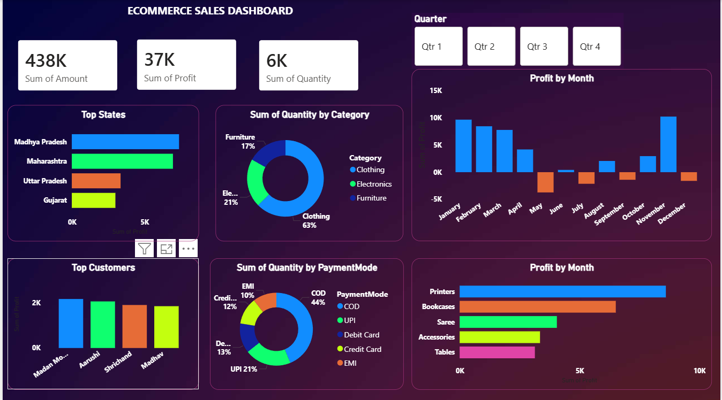
Figure 1.0: Production View of the Interactive Sales & Profit Performance Dashboard Canvas

5. Data-Driven Strategy & Strategic Next Steps
Based on the trends tracked by the Power BI visualization engine and underlying source records, three distinct strategic levers can be pulled to optimize commercial outcomes:
- Address Subcategory Profit Cracks: While overall sales are solid (INR 437,771), the net profit margins show pockets of friction. Certain high-volume items are suffering from thin or negative margins due to deep discounts or shipping inefficiencies. Focus should shift from pure volume to margin preservation in these lagging lines.
- Capitalize on Maharashtra and High-Yield Cities: Because Maharashtra acts as the primary regional anchor for revenue generation, targeted digital campaigns and regional fulfillment center prioritization should be expanded here to minimize delivery delays and reduce overheads.
- Streamline Transaction Mechanics: Analyzing transaction types indicates strong reliance on specific payment modes. Transitioning or nudging buyers toward instant digital verification methods (e.g., UPI or credit structures) could significantly compress order-to-cash timelines and lower standard cash-on-delivery (COD) logistical rejections.

