Box Model:

<!DOCTYPE html>

<html>

<head>

    <title>Demo | Box Model</title>

<style>

div {

  background-color: rgb(192, 153, 153);

  width: 750px;

  height: 350px;

  border: 15px solid rgb(7, 20, 62);

  padding: 50px;

  margin:  20px;

}

</style>

</head>

<body>

<h2> Box Model</h2>

<p>The CSS box model is essentially a box that wraps around every HTML element.

   It consists of: borders, padding, margins, and the actual content.</p>

<div>Hello!!! Welcome to SOU.</div>

</body>

</html>

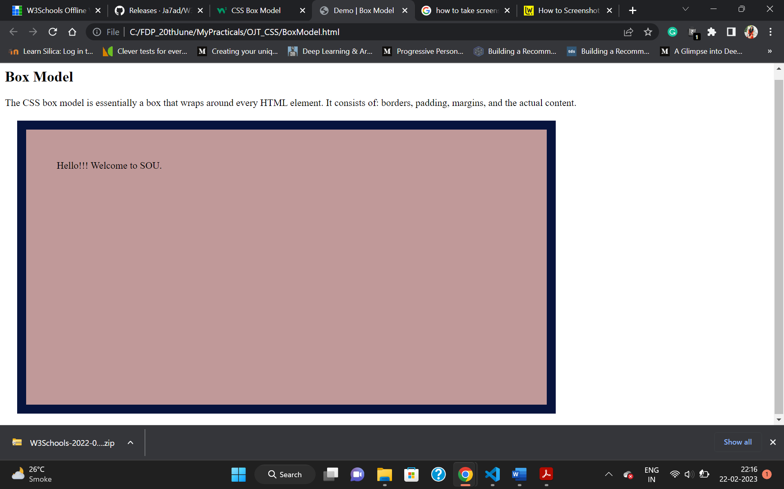

ToolTip:

<!DOCTYPE html>

<html>

<style>

.tooltip {

  position: relative;

  display: inline-block;

  border-bottom: 1px dotted black;

}

.tooltip .tooltiptext {

  visibility: hidden;

  width: 120px;

  background-color: black;

  color: #fff;

  text-align: center;

  border-radius: 6px;

  padding: 5px 0;

  /* Position the tooltip */

  position: absolute;

  z-index: 1;

}

.tooltip .tooltiptext1 {

  visibility: hidden;

  width: 120px;

  background-color: black;

  color: #fff;

  text-align: center;

  border-radius: 6px;

  padding: 5px 0;

  /* Position the tooltip Right*/

  position: absolute;

  z-index: 1;

  top: -5px;

  left: 105%;

}

.tooltip .tooltiptext2 {

  visibility: hidden;

  width: 120px;

  background-color: black;

  color: #fff;

  text-align: center;

  border-radius: 6px;

  padding: 5px 0;

  /* Position the tooltip Left */

  position: absolute;

  z-index: 1;

  top: -5px;

  right: 105%;

}

.tooltip .tooltiptext3 {

  visibility: hidden;

  width: 120px;

  background-color: black;

  color: #fff;

  text-align: center;

  border-radius: 6px;

  padding: 5px 0;

  /* Position the tooltip Top */

  position: absolute;

  z-index: 1;

  bottom: 100%;

  left: 50%;

  margin-left: -60px;

}

.tooltip .tooltiptext4 {

  visibility: hidden;

  width: 120px;

  background-color: black;

  color: #fff;

  text-align: center;

  border-radius: 6px;

  padding: 5px 0;

  /* Position the tooltip Bottom*/

  position: absolute;

  z-index: 1;

  top: 100%;

  left: 50%;

  margin-left: -60px;

}

.tooltip:hover .tooltiptext  {

  visibility: visible;

}

.tooltip:hover .tooltiptext1 {

  visibility: visible;

}

.tooltip:hover .tooltiptext2 {

  visibility: visible;

}

.tooltip:hover .tooltiptext3 {

  visibility: visible;

}

.tooltip:hover .tooltiptext4{

  visibility: visible;

}

</style>

<body style="text-align:center;">

<h2>Basic Tooltip</h2>

<p>Move the mouse over the text below:</p>

<div class="tooltip">Hover over me

  <span class="tooltiptext">Tooltip text</span>

</div>

<hr>

<h2>Right Tooltip</h2>

<p>Move the mouse over the text below:</p>

<div class="tooltip">Hover over me

  <span class="tooltiptext1">Tooltip text</span>

</div>

<hr>

<h2>Left Tooltip</h2>

<p>Move the mouse over the text below:</p>

<div class="tooltip">Hover over me

  <span class="tooltiptext2">Tooltip text</span>

</div>

<hr>

<h2>Top Tooltip</h2>

<p>Move the mouse over the text below:</p>

<div class="tooltip">Hover over me

  <span class="tooltiptext3">Tooltip text</span>

</div>

<hr>

<h2>Bottom Tooltip</h2>

<p>Move the mouse over the text below:</p>

<div class="tooltip">Hover over me

  <span class="tooltiptext4">Tooltip text</span>

</div>

</body>

</html>

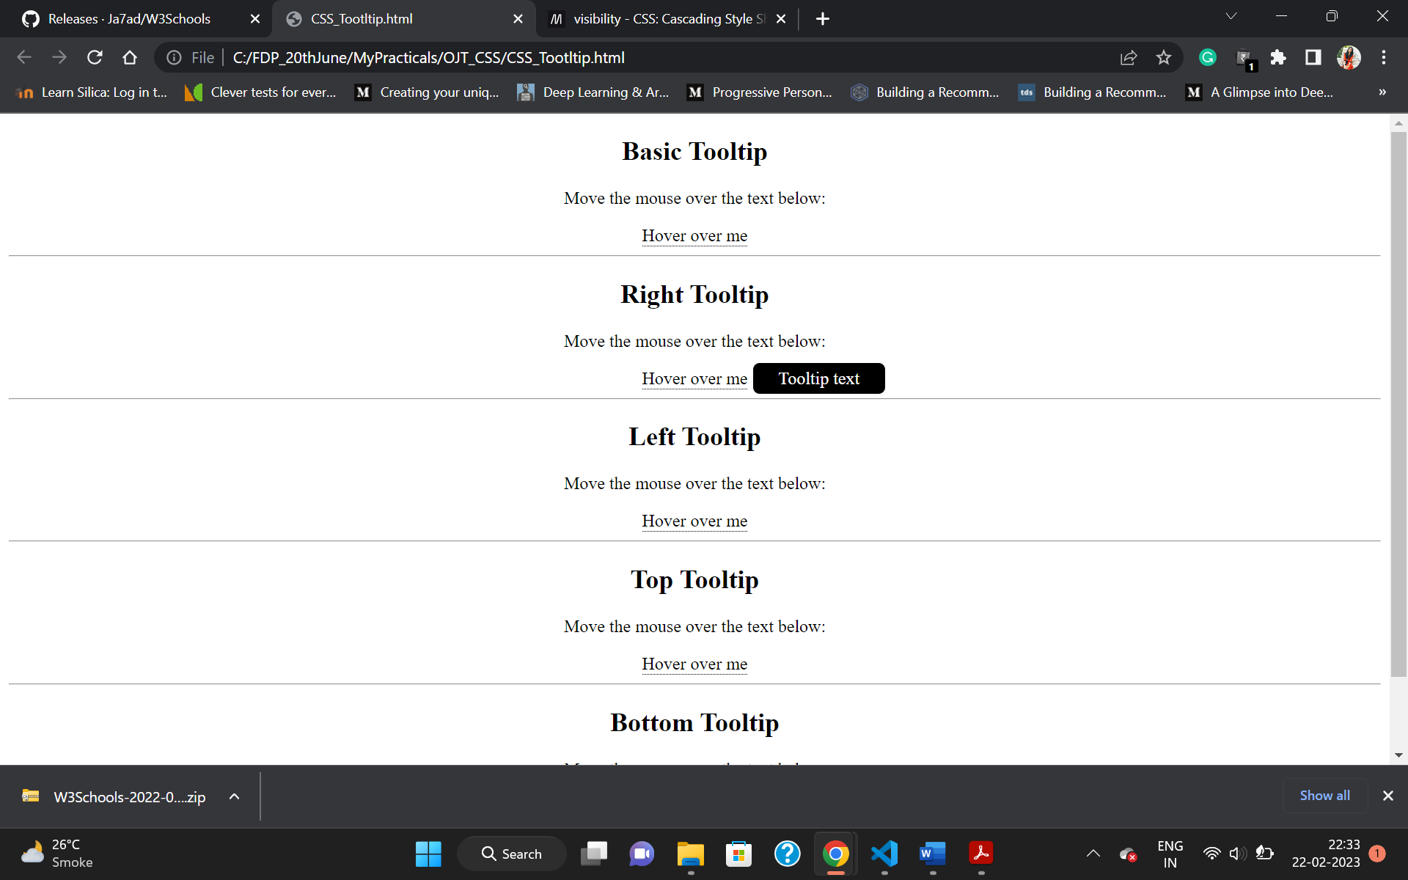

CSS Animations:

<!DOCTYPE html>

<html>

    <head>

        <style type="text/css">

            div {

              width: 100px;

              height: 100px;

              background-color: red;

              position:relative;

              animation-name:Demo;

              animation-duration:10s;

              animation-iteration-count:infinite;

             }

            @keyframes Demo{

            /*

                0%{background-color:red; left:0px; top:0px;transform:rotate(0deg);}

                25%{background-color:yellow; left:200px; top:0px;transform:rotate(90deg);}

                50%{background-color:blue; left:200px; top:200px;transform:rotate(180deg);}

                75%{background-color:green; left:0px; top:200px;transform:rotate(270deg);}

                100%{background-color:red; left:0px; top:0px;transform:rotate(360deg);}

            */

            from{top:0px;}

            to {top:200px;}

            }

        </style>

    </head>

    <body>

        <div></div>

    </body>

</html>

Wild Card Selectors *, ^, $:

<!DOCTYPE html>

<html>

  <head>

        <style>

            [class*="color"]{

             background-color:#8a3131;

             color:rgb(212, 193, 25);

            }

            [class^="val"]{

            background-color:rgb(109, 134, 142);

            color:rgb(47, 0, 128);

            }

            [class$="str"]{

            background-color:rgb(0, 128, 23);

            color:rgb(207, 91, 34);

            }

        </style>

  </head>

  <body>

    <h1 class="firstcolor">Wild Card Selector</h1>

    <h1 class="second">Wild Card Selector</h1>

    <h1 class="third_color">Wild Card Selector</h1>

    <h1 class="val_string">Wild Card Selector</h1>

    <h1 class="val_next_line">Wild Card Selector</h1>

    <h1 class="nextstr">Wild Card Selector</h1>

    <h1 class="another_str">Wild Card Selector</h1>

  </body>

</html>

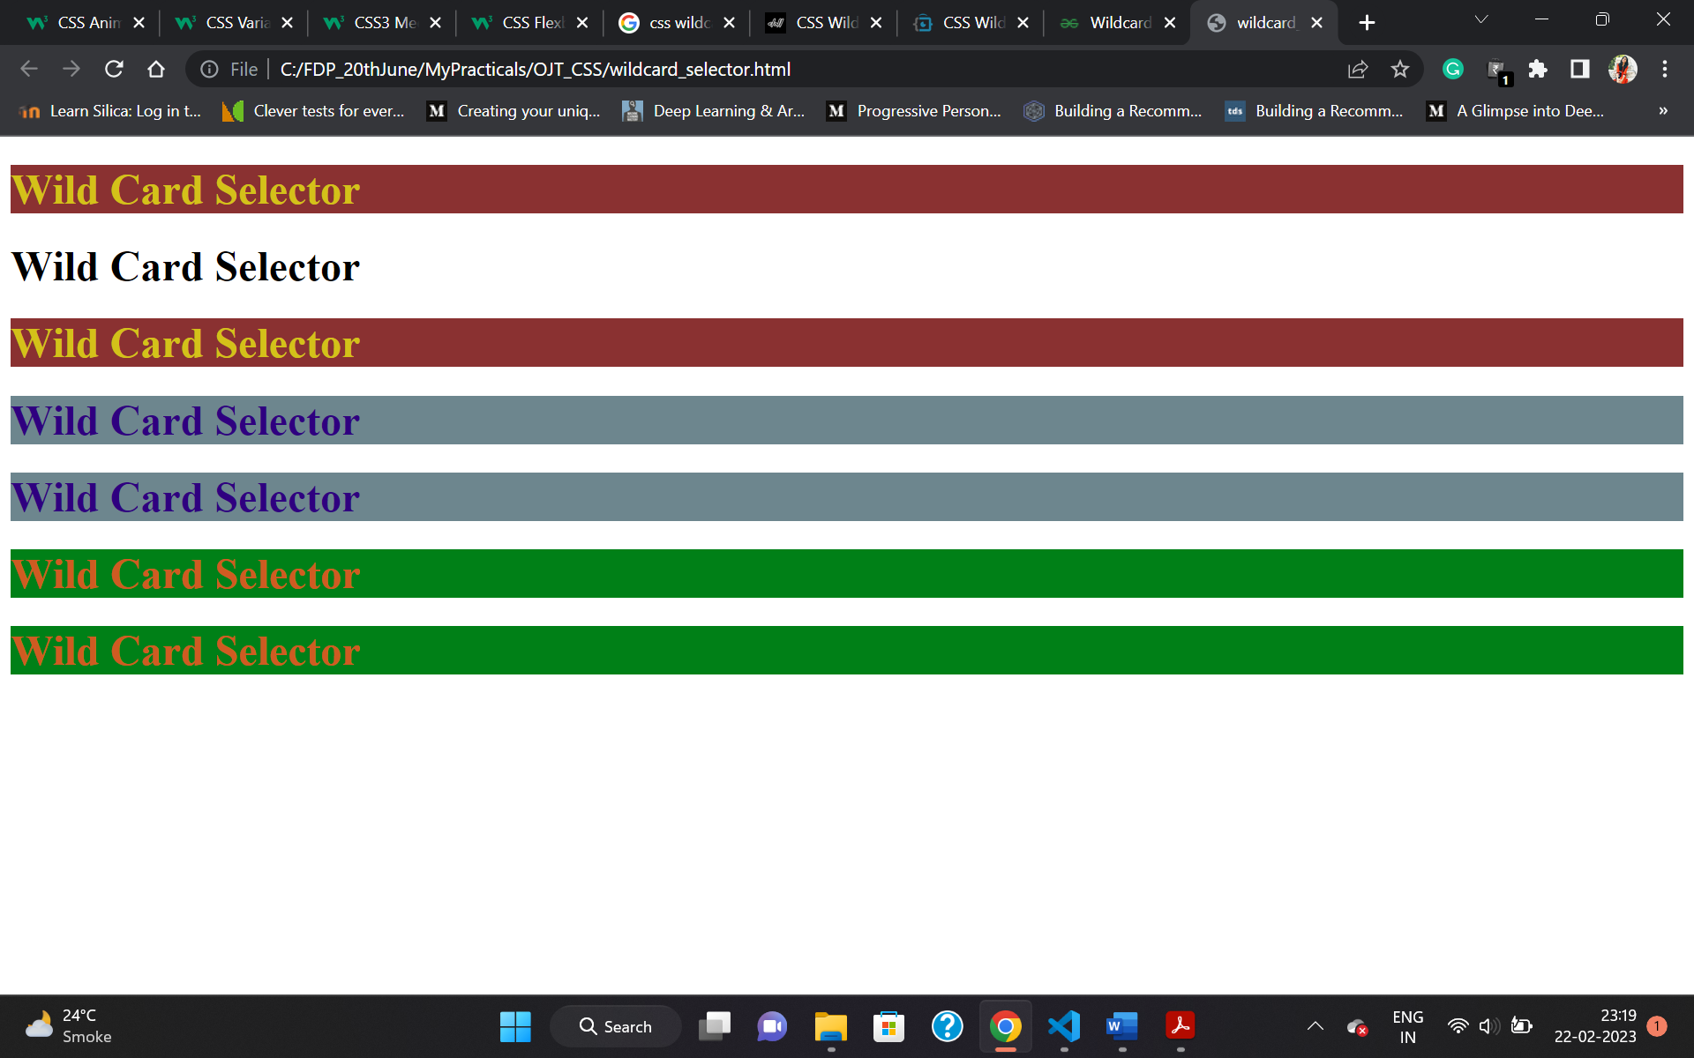

CSS Variables:

<!DOCTYPE html>

<html>

<head>

<style>

:root {

  --blue: hsl(227, 89%, 32%);

  --white: #ffffff;

}

body {

  background-color: var(--blue);

}

h2 {

  border-bottom: 2px solid var(--blue);

}

.container {

  color: var(--blue);

  background-color: var(--white);

  padding: 15px;

}

button {

  background-color: var(--white);

  color: var(--blue);

  border: 1px solid var(--blue);

  padding: 5px;

}

</style>

</head>

<body>

<h1>Using the var() Function</h1>

<div class="container">

  <h2>Hello</h2>

  <p> Hello!!!!  Hello!!!! Hello!!!!  Hello!!!! Hello!!!! Hello!!!! Hello!!!! Hello!!!! Hello!!!! Hello!!!! Hello!!!!</p>

  <p> Hello!!!!  Hello!!!! Hello!!!!  Hello!!!! Hello!!!! Hello!!!! Hello!!!! Hello!!!! Hello!!!! Hello!!!! Hello!!!!</p>

    <p>

    <button>Yes</button>

    <button>No</button>

  </p>

</div>

</body>

</html>

