Name: Pagadala Sahil Naidu

Subject: Neural Networks & Deep Learning

Course ID: CS-5720

Email: [sxp86940@ucmo.edu](mailto:sxp86940@ucmo.edu)

CRN: 22317

**Click the ICP6 link to access the assignment in GitHub.**

[**https://github.com/Sahilnaidupagadala03/Neural_Networks_Deeplearning**](https://github.com/Sahilnaidupagadala03/Neural_Networks_Deeplearning)

**Below is Voice over video.**

[**https://youtu.be/49dgs9aL0q4**](https://youtu.be/49dgs9aL0q4)

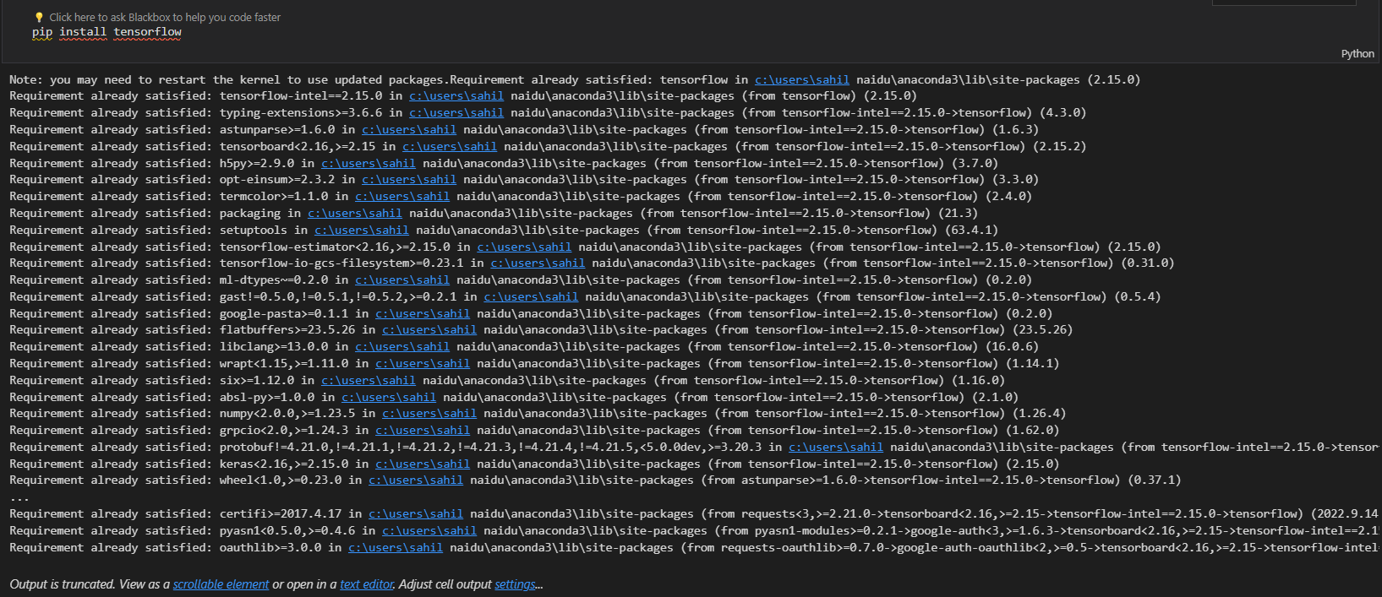

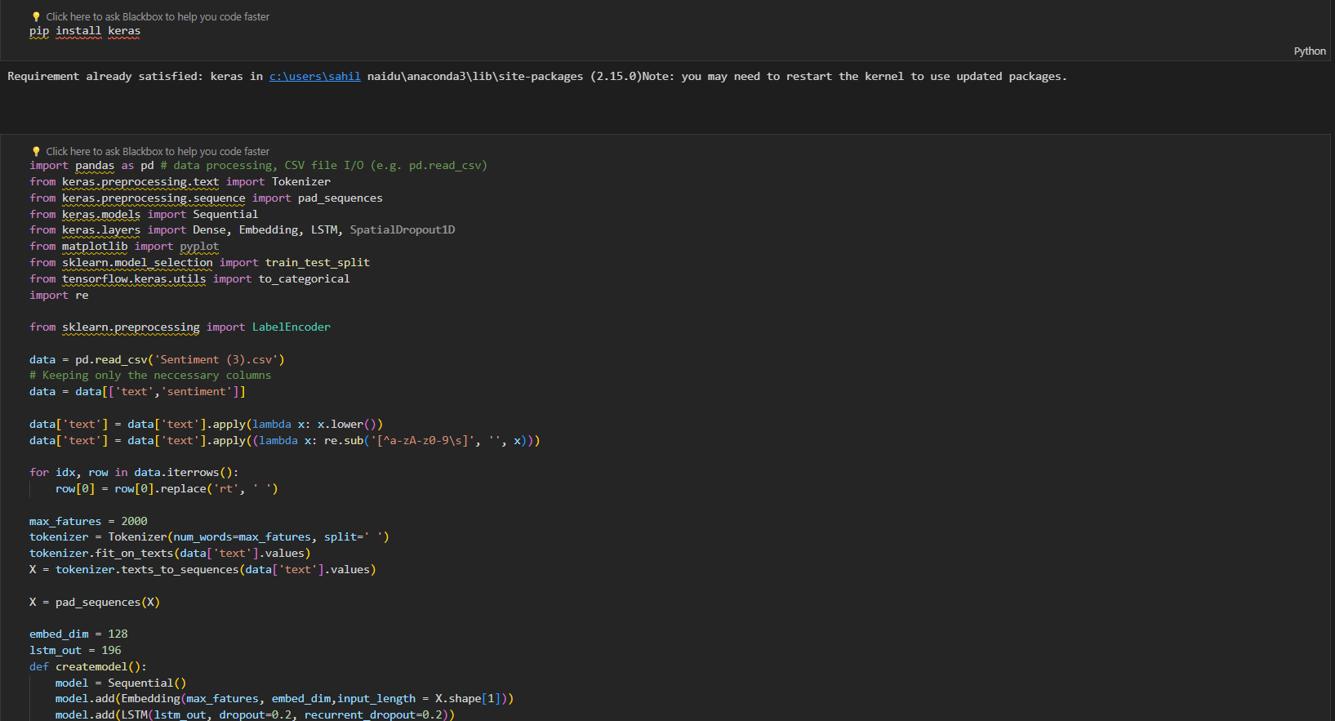

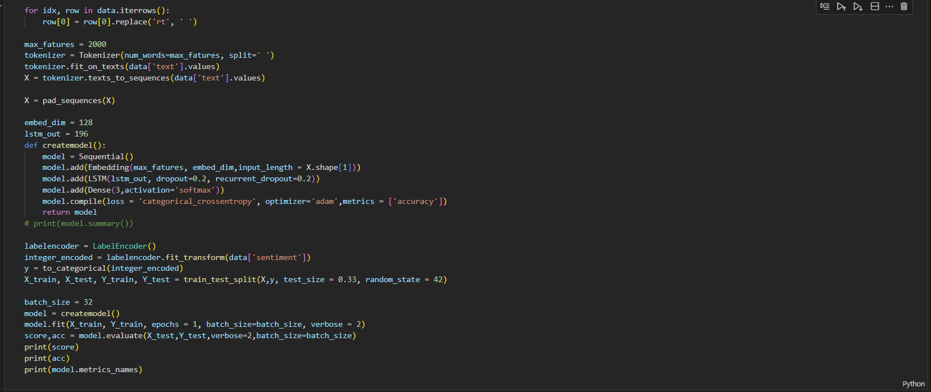

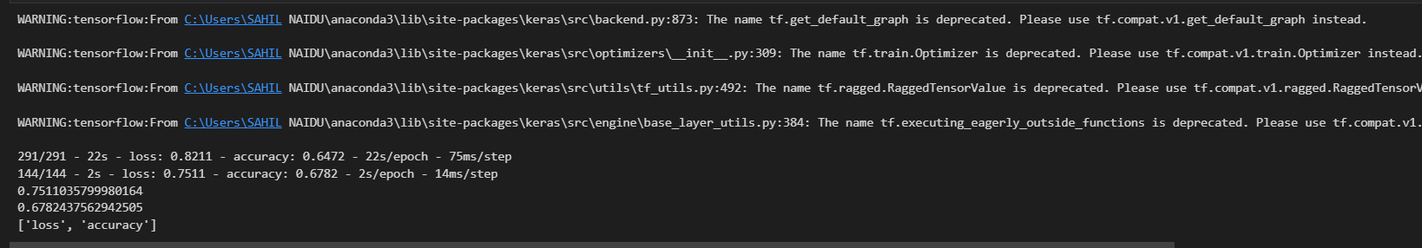

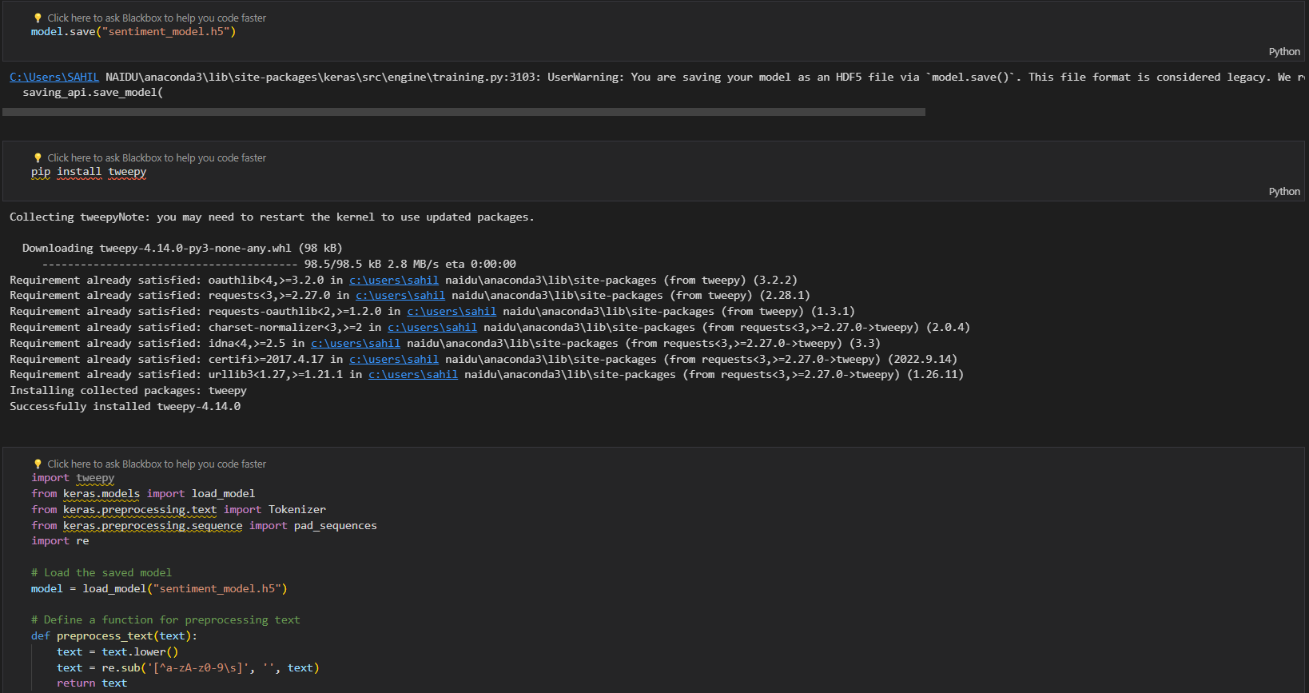

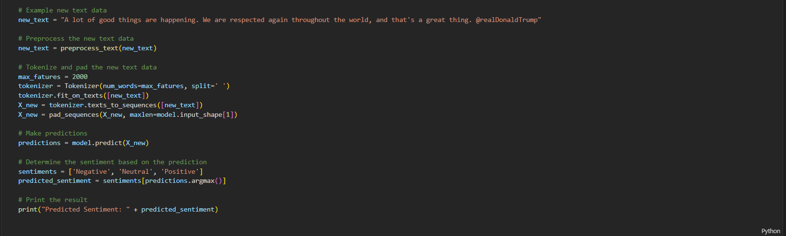

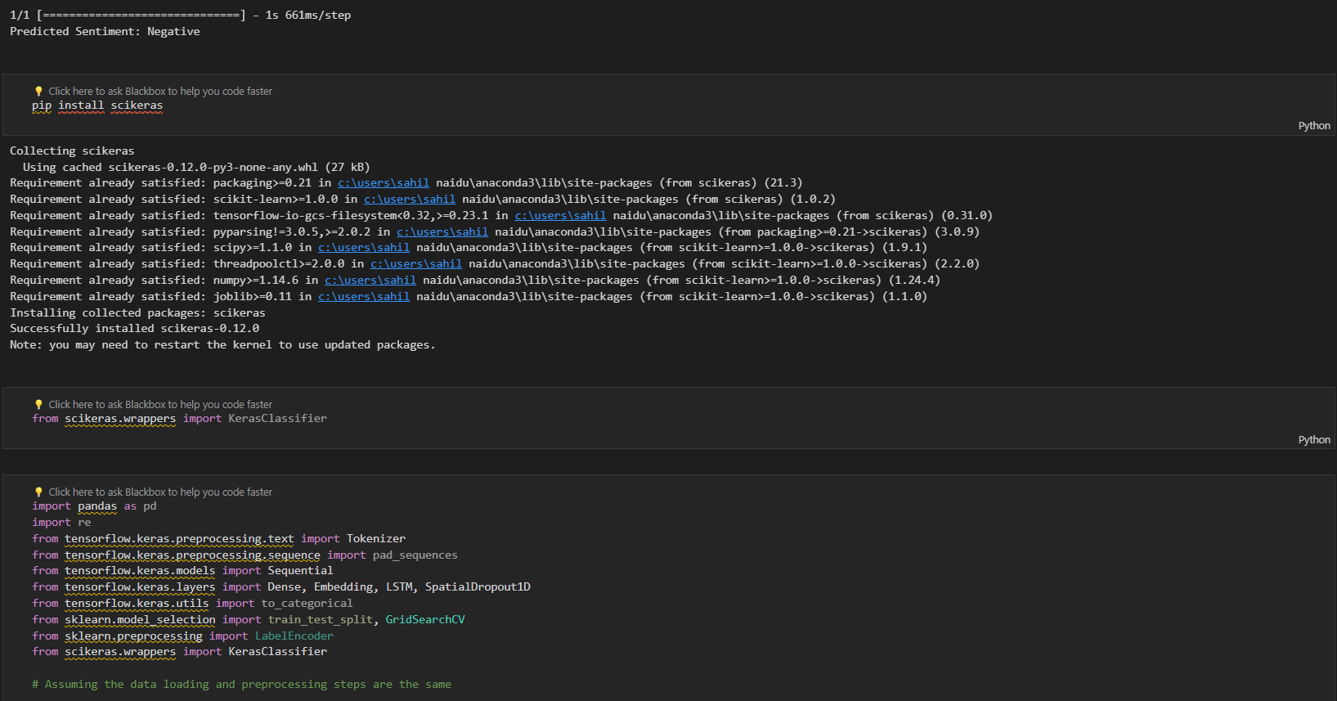

9