Name: Pagadala Sahil Naidu

Subject: Neural Networks & Deep Learning

Course ID: CS-5720

Email: [sxp86940@ucmo.edu](mailto:sxp86940@ucmo.edu)

CRN: 22317

**Click the Assignment1.ipynb link to access the assignment in GitHub.**

[**https://github.com/Sahilnaidupagadala03/Neural_Networks_Deeplearning**](https://github.com/Sahilnaidupagadala03/Neural_Networks_Deeplearning)

**Below is Voice over video.**

[**https://youtu.be/i_VSd-_4CiE**](https://youtu.be/i_VSd-_4CiE)

**Question 1-a**

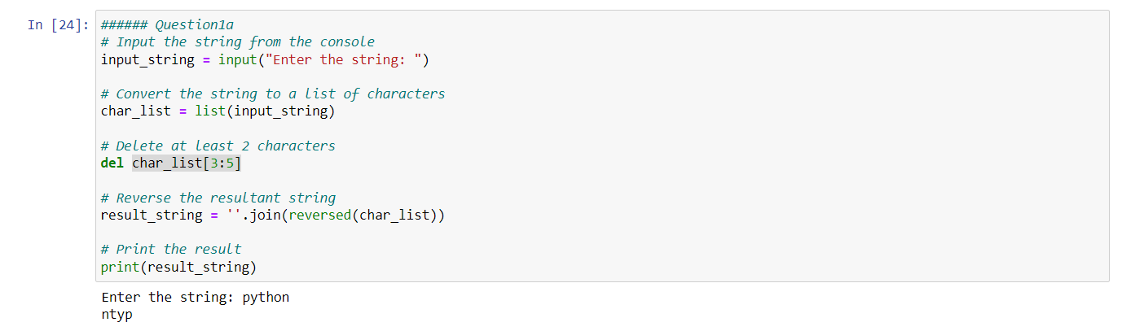

The user is prompted to enter a string through the console using the input function. The entered string is stored in the variable input_string. The string is then converted into a list of characters using the list function, and the resulting list is stored in the variable char_list. At least the first two characters from the list (char_list) are deleted using the del statement. The syntax del char_list[3:5] removes the elements at indices 3 and 4 from the list. The modified list is then reversed using the reversed function, and the reversed characters are joined into a string using join. The reversed string is stored in the variable result_string.

The final reversed string (result_string) is printed to the console using the print statement.

**Question 1-b**

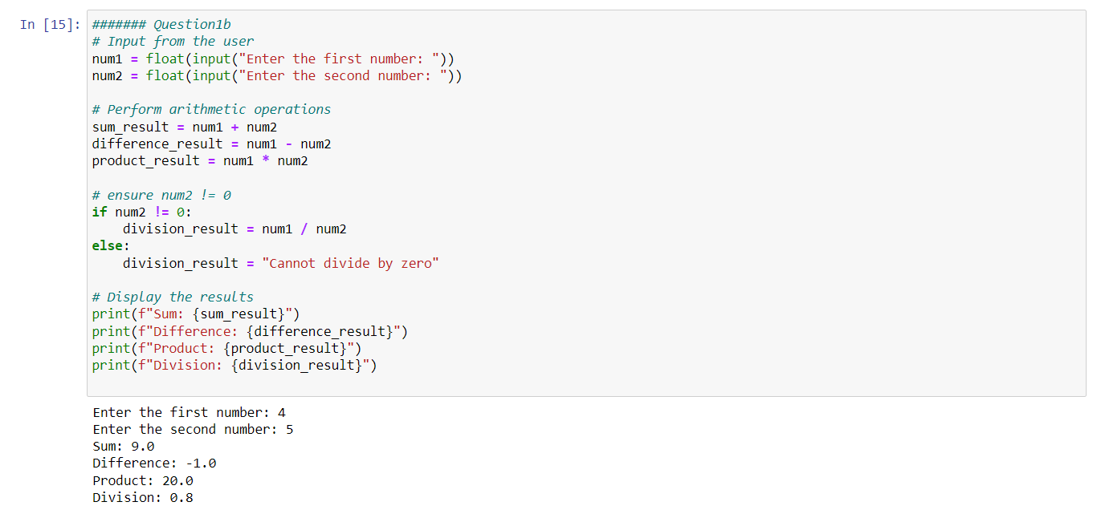

The user is prompted to enter the first and second numbers through the console, and the input is converted to floating-point numbers using float(). The values are stored in the variables num1 and num2. The sum of num1 and num2 is stored in the variable sum_result. The difference between num1 and num2 is stored in the variable difference_result. The product of num1 and num2 is stored in the variable product_result.

The code checks if num2 is not equal to zero before performing division. If num2 is not zero, the division result is calculated and stored in the variable division_result. If num2 is zero, a message "Cannot divide by zero" is stored in division_result to avoid division by zero error. The results of the arithmetic operations are printed to the console using the print statement, with formatted strings (f-string) to display the variable values in the output.

**Question 2**

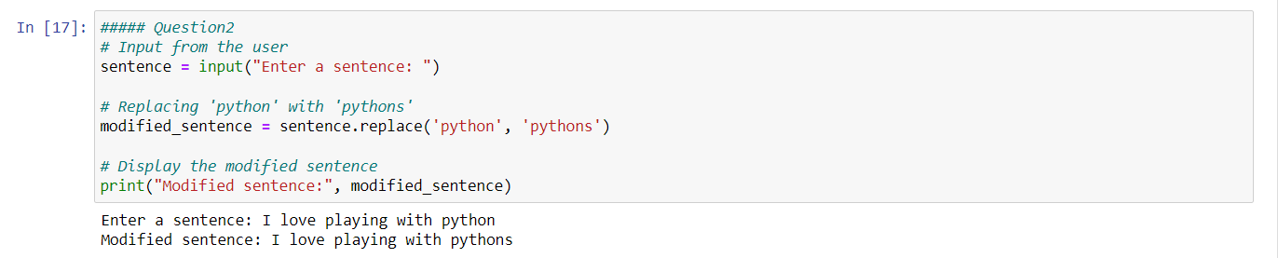

The user is prompted to enter a sentence through the console, and the input is stored in the variable sentence. The replace method is used to replace all occurrences of the substring 'python' with 'pythons' in the input sentence. The modified sentence is stored in the variable modified_sentence. The modified sentence is printed to the console using the print statement.

**Question 3**

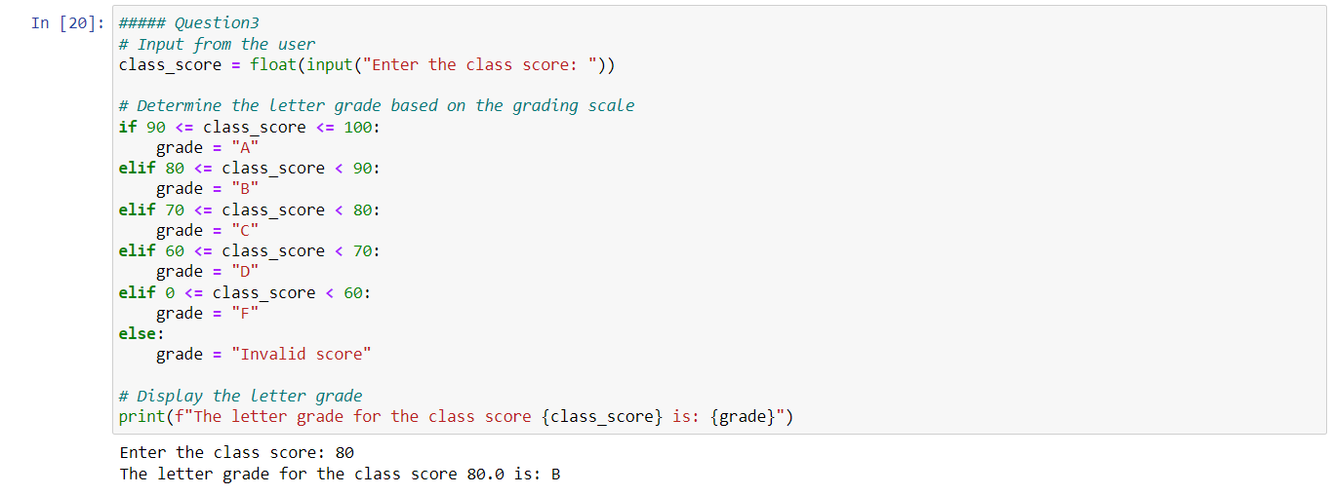

The user is prompted to enter a class score through the console, and the input is converted to a floating-point number using float(). The value is stored in the variable class_score. The code uses a series of if-elif-else statements to determine the letter grade based on the following grading scale:

A: 90-100

B: 80-89

C: 70-79

D: 60-69

F: 0-59

If the entered score does not fall into any of these ranges, the grade is set to "Invalid score."

The determined letter grade is printed to the console using the print statement, incorporating the entered class score and the calculated letter grade into a formatted string (f-string).