Name: Pagadala Sahil Naidu

Subject: Neural Networks & Deep Learning

Course ID: CS-5720

Email: [sxp86940@ucmo.edu](mailto:sxp86940@ucmo.edu)

CRN: 22317

**Click the ICP3 named link to access the assignment in GitHub.**

[**https://github.com/Sahilnaidupagadala03/Neural_Networks_Deeplearning**](https://github.com/Sahilnaidupagadala03/Neural_Networks_Deeplearning)

**Below is Voice over video.**

[**https://youtu.be/UUfwtnK8uqo**](https://youtu.be/UUfwtnK8uqo)

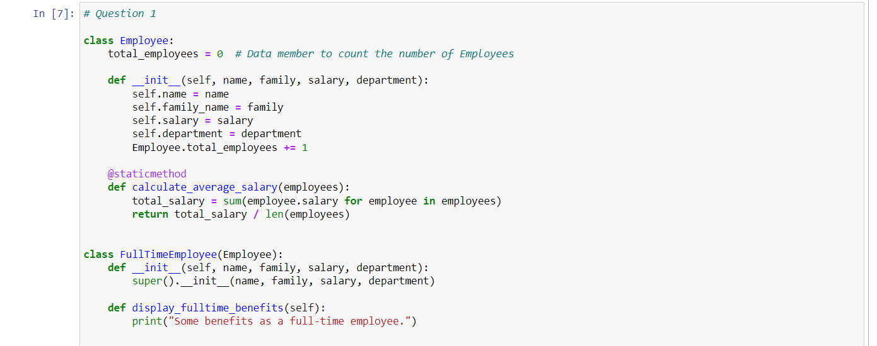  
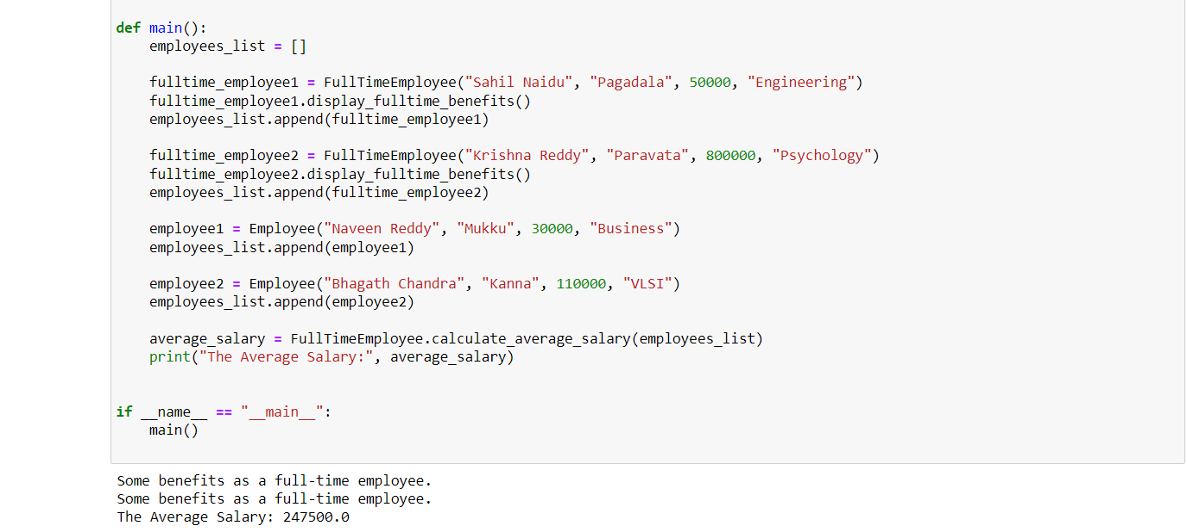

The employee class has a method to determine the average wage of a list of workers as well as a data member (total_employees) to count the number of employees. Since FullTimeEmployee is a subclass of Employee, all of the parent class's methods and attributes are passed down to it. Because calculate_average_salary is a static method, it is independent of the class instance. Using a list of workers as an input, it determines the average income. Initialization is done using the __init__ method for both Employee and FullTimeEmployee. The FullTimeEmployee class calls the parent class's __init__ function by using super().__init__. A common class variable, total_employees is used by all instances of the class. It records the total number of workers. After creating instances of FullTimeEmployee and Employee and appending them to the employees_list, the main function computes and outputs the average wage of the workforce. Some benefits for full-time employees are printed using the display_fulltime_benefits method, which is exclusive to the FullTimeEmployee class.

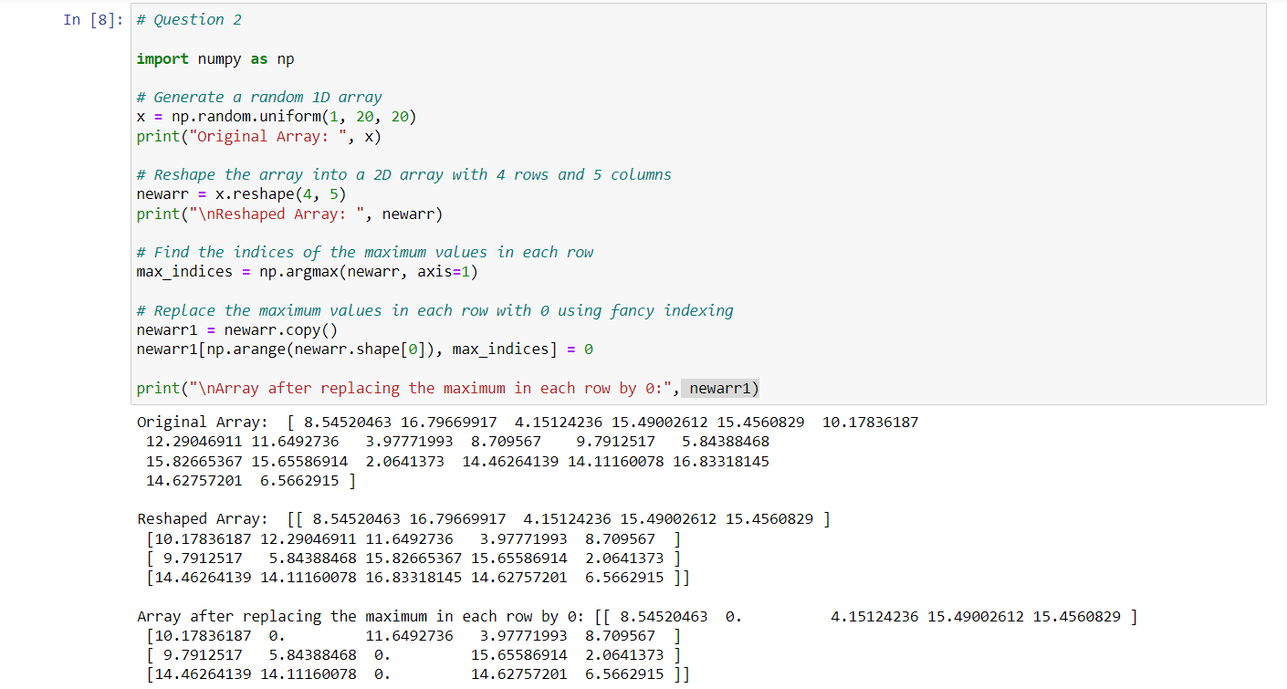

The given Python code manipulates arrays by using the NumPy module. First, 20 random numbers are selected at random from a uniform distribution between 1 and 20 to create a 1D array called x. After that, the array is rearranged to create the 2D array newarr, which has 4 rows and 5 columns. The argmax function with axis=1 is then used in the code to determine the indices of the maximum values along each row. To maintain the original state, a copy of the array called newarr1 is made. By using clever indexing, 0 is substituted for the maximum values in every row. Lastly, the updated array, newarr1, is displayed to indicate the outcome of replacing 0 for the maximum values in each row.