

2024

**FUNCTIONALITY REQUIREMENT SPECIFIACTION (FRS)**

PROJECT: CERTIFICATION PORTAL

prePARed BY: sahil kuamr

DATE: 12/02/2024

Overview: -

For companies, this certification portal provides a consolidated platform for obtaining and managing credentials. For those seeking certification, it provides an easy-to-use interface and reduced procedures. The portal wants every user to have a smooth and effective experience. The primary goal of the certification portal is to give people and companies an easy method to pursue certificates. From application to completion, it seeks to streamline the certification process and guarantee the dependability and openness of the certification processes.

Requirement: -

Determining the certification portal's features and functioning, describing the user interface, and, if necessary, integrating the portal with current systems are all included in the project scope. Assuring scalability for further improvements is another aspect of it. In order for the certification portal to install correctly on the web server, certain extensions need to be enabled.

* PHP
* Database (My SQL)
* Web server (Apache)

**Functionality Requirement: -**

1. **Login Module: -** A login module is a set of tools and functions that allow you to authenticate users and manage their sessions.

* **Username: -** The username functionality in software testing involves verifying its correct input and handling of validation, error messages, and security measures.
* **Password: -** The password functionality in software testing involves verifying its secure storage, encryption, and handling of validation, error messages, and security measures.
* **Login Button: -**The login button functionality in software testing involves verifying that it successfully authenticates users and grants access to the application or system.

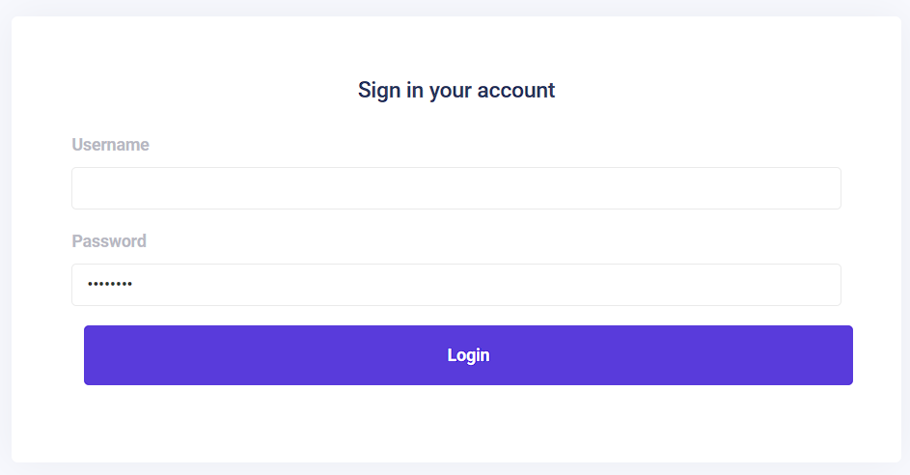

1. **Header: -** A login module is a set of tools and functions that allow you to authenticate users and manage their sessions: -

* **Logo: -** For refresh the application and go directly to login module.
* **Profile: -** The profile functionality in software testing involves verifying the correct creation, editing, and viewing of user profiles, as well as customization options.
* **Navigation Drawer: -** This has the ability to compress to merely display their logo and extend to display the names of each module.

**There are some sub-modules in navigation drawer:**

1. **Dashboard Module: -** A dashboard is a tool for managing information that collects, organizes, and shows data so the user can keep an eye on it all.

* **Key Performance Indicator’s(KPIs): -** Show the total students, total batches, joined and un-joined student.
* **College List: -** Show the college name, total student, joined and un-joined students in the list.



1. **Session List Module: -** This module contains the session list's data: -

* **CRUD Operation: -** CRUD operations are the four basic functions of persistent storage: create, read, update, and delete. They are also used to describe user interface conventions for data manipulation and access.
* **List of Session: -** Display the session's serial number, start and end months, whether it's a Y/N session, and the actions to edit and delete it.
* **Add new Section: -** Include the date of the start and end of the session, the session's status (active or inactive), and a save button for saving the newly created session.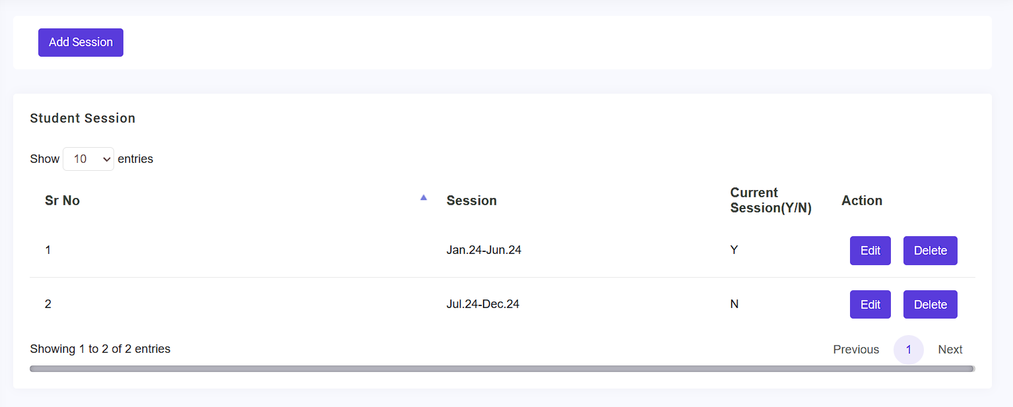

1. **Course list Module: -** This module displays the following features: -

* **CRUD Operation: -** CRUD operations are the four basic functions of persistent storage: create, read, update, and delete. They are also used to describe user interface conventions for data manipulation and access.
* **Search bar: -** To search the courses by their name.
* **List of courses: -** contain the serial no., name of courses, total no. of students and an action for edit and delete.
* **Add new courses: -** Name of the courses and a save button.



1. **College list Module: -** This module displays the following features: **-**

* **Add new college: -** Name of the courses and a save button.
* **Search bar: -** To search the courses by their name.
* **CRUD operation: -** CRUD operations are the four basic functions of persistent storage: create, read, update, and delete. They are also used to describe user interface conventions for data manipulation and access.
* **List of colleges: -**display the student's serial number, college name, total number of students, joined and un-joined students, and an edit and delete action.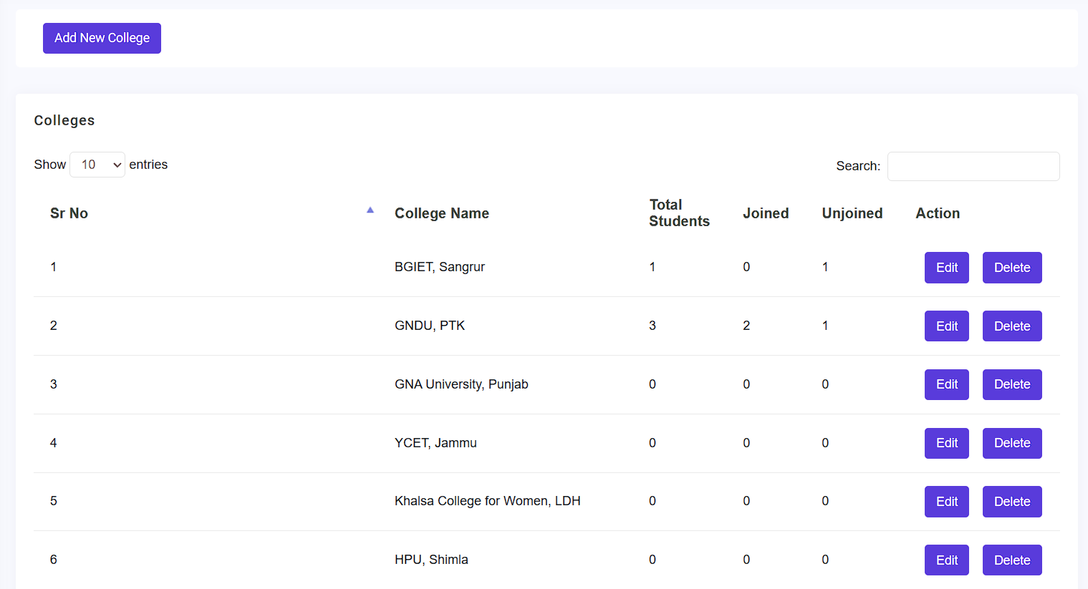

1. **Trainer List Module: -** The following features in this module are:

* **CRUD Operation: -** CRUD operations are the four basic functions of persistent storage: create, read, update, and delete. They are also used to describe user interface conventions for data manipulation and access.
* **Search bar: -** To search the courses by their name.
* **List of Trainer: -** Include the serial number, name of the trainer, gender, phone number, email address, technology they teach, the total number of batches, and an edit and delete button.
* **Add new trainer: -** contains the trainer’s name, trainer gender, their phone no., email Id, technology and a save button.
* **Filter: -** Technology filter.

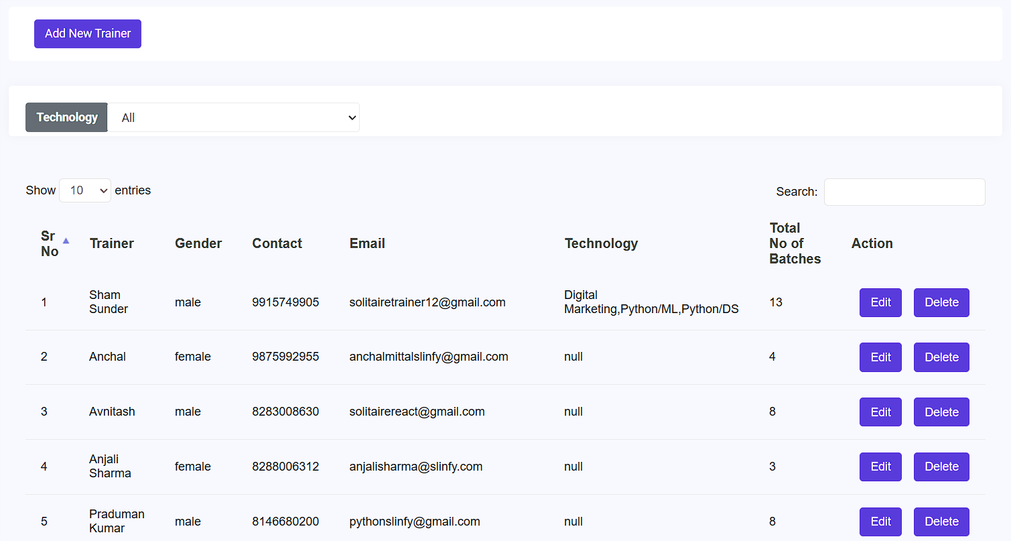

1. **Batch List Module: -** The following features in this module are: -

* **Add new batch: -**Contain the batch name, session, start and end timing of session, technology, batch assigned to trainer, class room, duration of the session and a save button.
* **Filters: -** Technology filter, trainers filter and a duration filter.
* **Search bar: -**To search the Batch by their name.
* **CRUD operation:** CRUD operations are the four basic functions of persistent storage: create, read, update, and delete. They are also used to describe user interface conventions for data manipulation and access.
* **List of Batches:** Show the serial no., batch name, session name, session start and end timing, trainer allocate, class room allocate, technology, duration, total no. of students and an action.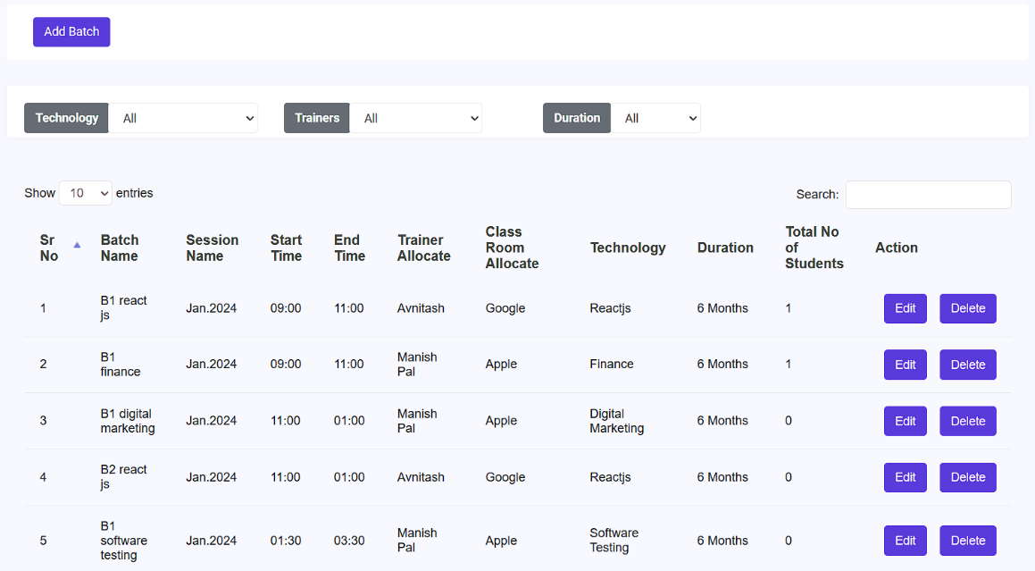

1. **Student List Module: -** The following features in this module are: -

* **CRUD Operation: -** CRUD operations are the four basic functions of persistent storage: create, read, update, and delete. They are also used to describe user interface conventions for data manipulation and access.
* **Search bar: -** To search the student by their name.
* **List of students: -** Display the following: the course duration, start and end dates, email count, action, serial number, student name, father name, gender, session, college name, contact number, email address, status, name of technology learned, total fees, registration fees, pending fees, and so on.
* **Add new students: -** It includes the student's name, father's name, gender, session, college name, contact number, email address, status, name of technology learned, total fees, registration fees, pending fees, course duration, start and end dates, batch assignment, and a save button.
* **Filter: -** Technology, college, batch, duration, session and a calendar filter used in this module.
* Upload the excel file of the students.
* Download the list of students.
* Send the confirmation to the student by through email.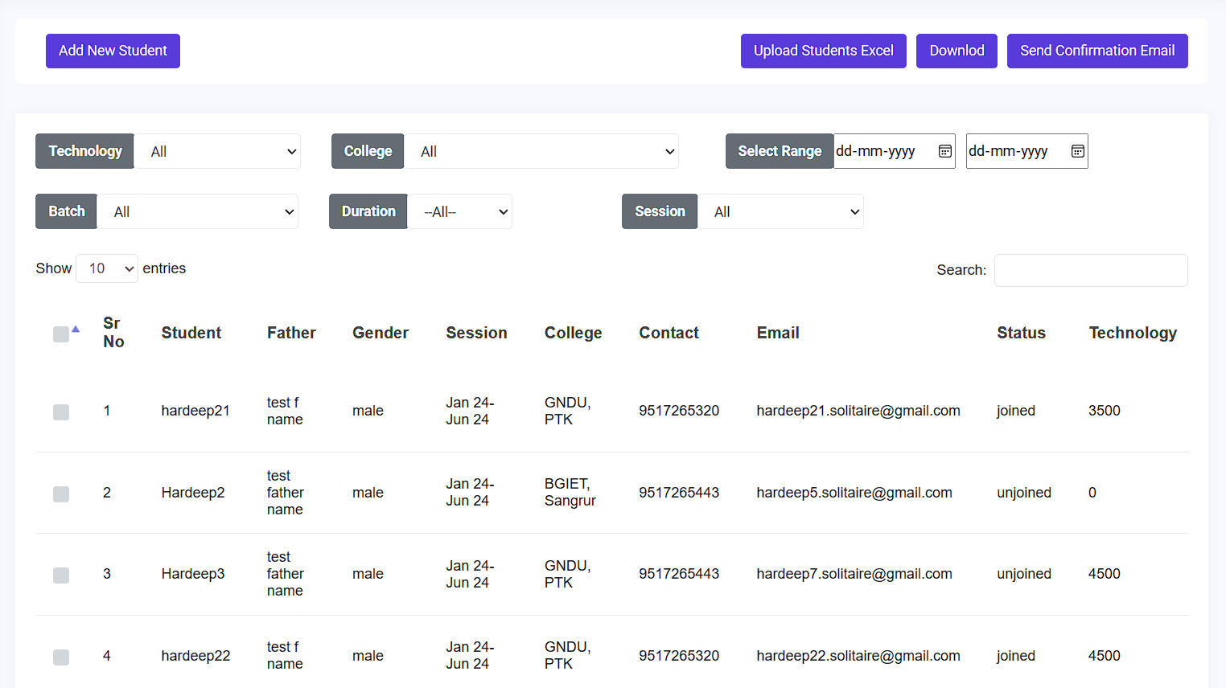

1. **Student certification Module: -** The following features in this module are: -

* **Search bar: -** To search the student by their name.
* **List of students: -** Show the serial no., student name, their father’s name, gender of student, session, college name, contact no. of student, email Id, status, name of technology they learn, total fees, registration fees, pending fees, duration of course, start and end date of course, email count and an action.
* **Filters: -** Technology, college, batch, duration, session and a calendar filter used in this module.
* Download the list of students.
* Send the certificate to the student by an email.