Industrial Interaction Report on
AI PRODUCT DESCRIPTION GENERATOR

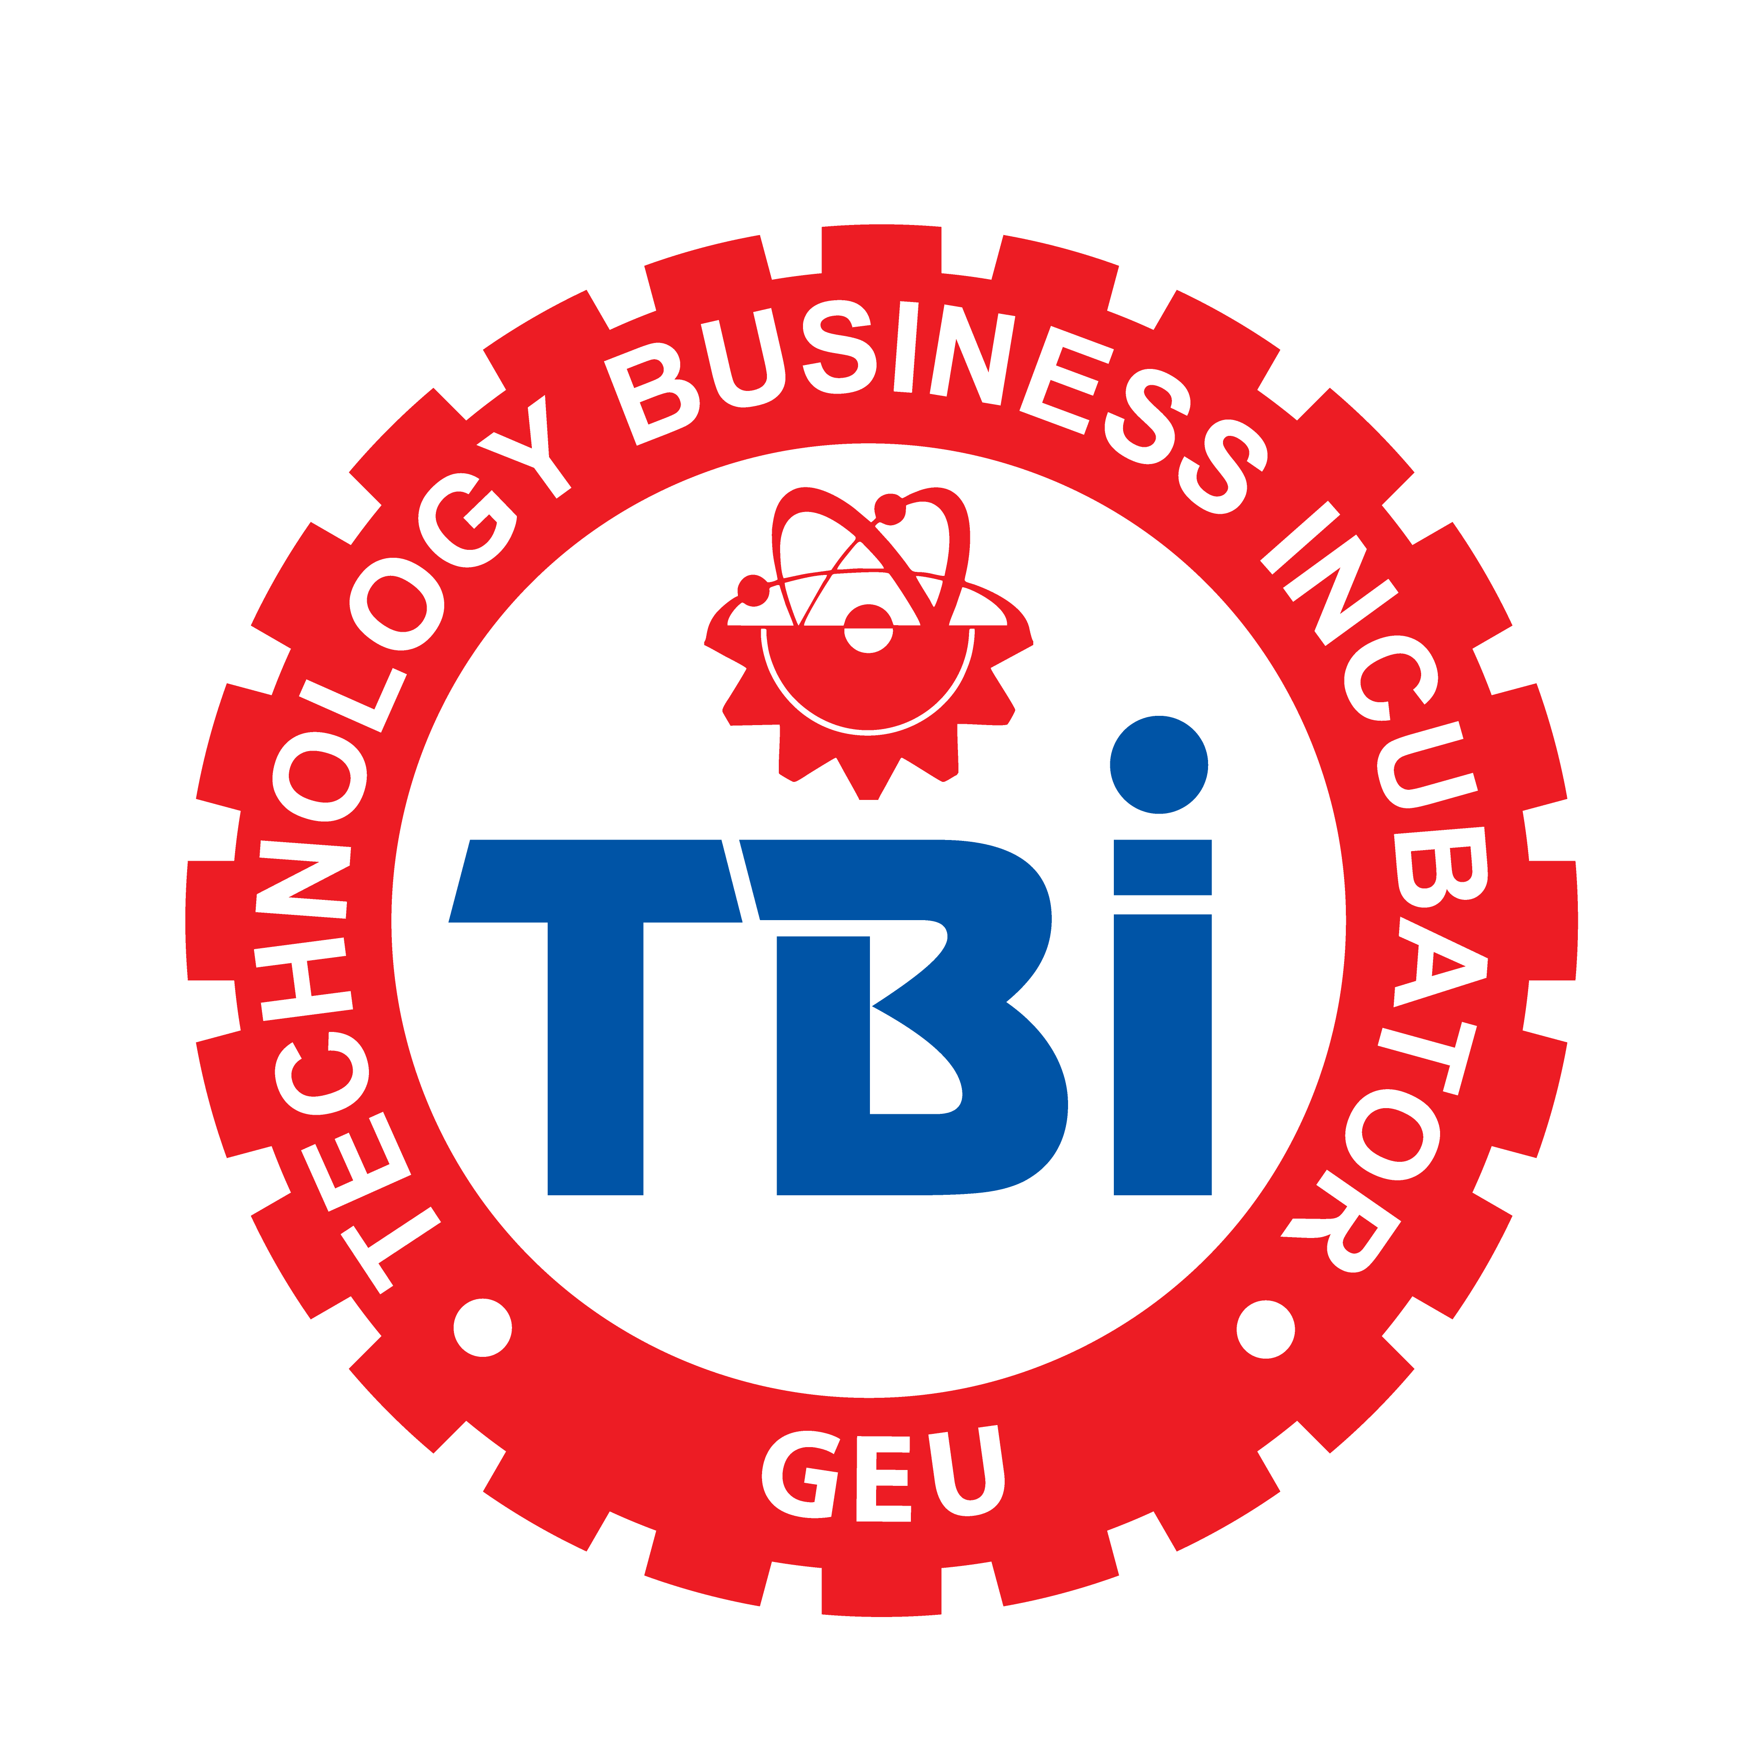
Technology Business Incubator (TBI-GEU)
Submitted in partial fulfilment of the requirement for the award of the degree of

BACHELOR OF TECHNOLOGY
IN
COMPUTER SCIENCE & ENGINEERING

Submitted by:

Sahil Sharma University Roll No.2023583



Department of Computer Science and Engineering
Graphic Era (Deemed to be University)
Dehradun, Uttarakhand
2026-27



CANDIDATE’S DECLARATION

I hereby certify that the work which is being presented in the Industrial Interaction report entitled “AI Product Description Generator” in partial fulfillment of the requirements for the award of the Degree of Bachelor of Technology in Computer Science and Engineering (Computer Science and Engineering) in the Department of Computer Science and Engineering of the Graphic Era (Deemed to be University), Dehradun shall be carried out by the undersigned under the supervision of Ms. Sarishma Dangi, CEO, Technology Business Incubator (TBI-GEU), Graphic Era (Deemed to be University).

Student Signature
Sahil Sharma
Intern ID: TBI-26100973
Branch: Computer Science & Engineering

g
OFFER LETTER
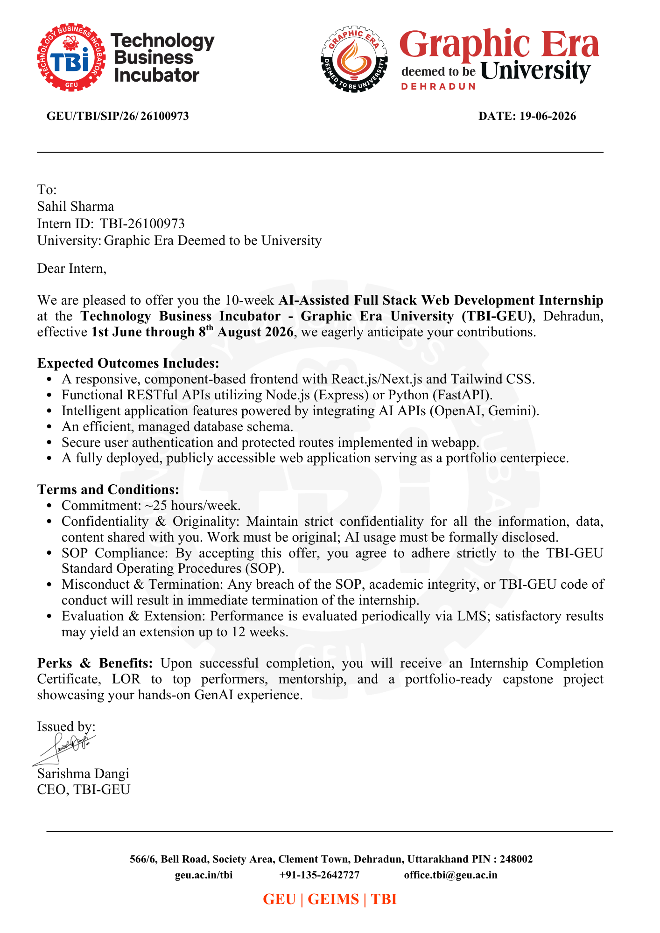

CONTACT DETAILS OF REPORTING PERSON
Name: Ms. Sarishma Dangi
Designation: CEO, Technology Business Incubator (TBI-GEU)
Organization: Technology Business Incubator, Graphic Era (Deemed to be University)
Address: 566/6, Bell Road, Society Area, Clement Town, Dehradun, Uttarakhand – 248002
Phone: +91-135-2642727
Email: office.tbi@geu.ac.in
Website: geu.ac.in/tbi

Internship Report Table of Contents
Chapter | Title | Sub-sections | Page
- | ACKNOWLEDGEMENT | - | vi
CHAPTER 1 | ABOUT THE COMPANY | 1.1 Technology Business Incubator (TBI-GEU)  1.2 Location and Contact  1.3 Objective of the Internship Programme | 1
CHAPTER 2 | WORK RESPONSIBILITIES | 2.1 Key Responsibilities  2.2 Weekly Work Pattern | 2
CHAPTER 3 | PROJECT OVERVIEW AND TECHNOLOGY STACK | 3.1 Project Title  3.2 Project Description  3.3 Technology Stack Used  3.4 Features Implemented | 3
CHAPTER 4 | DEVELOPMENT WORK DONE DURING THE INTERNSHIP | 4.1 Requirement Analysis and UI Planning  4.2 Frontend Development  4.3 Backend and API Development  4.4 Database Integration  4.5 Authentication – Google OAuth and JWT  4.6 AI Integration – Google Gemini API  4.7 Search and Delete Functionality  4.8 Testing and Deployment Preparation | 5
CHAPTER 5 | CHALLENGES FACED AND HOW THEY WERE SOLVED | 5.1 Google OAuth Callback Issues  5.2 JWT Authentication Errors  5.3 MongoDB Atlas Connection Problems  5.4 CORS Errors  5.5 Handling Gemini API Response Format  5.6 Responsive UI Issues  5.7 General Debugging | 8
CHAPTER 6 | SKILLS LEARNED | 6.1 Technical Skills  6.2 Professional Skills | 10
CHAPTER 7 | CONCLUSION | - | 11

ACKNOWLEDGEMENT
I would like to express my sincere gratitude to the Technology Business Incubator, Graphic Era (Deemed to be University) for giving me the opportunity to complete my Industrial Interaction internship in AI-Assisted Full Stack Web Development.
I am extremely thankful to Ms. Sarishma Dangi, CEO, TBI-GEU, for her constant guidance, valuable feedback and encouragement throughout the internship period. Her support helped me understand real-world software development practices and complete my project successfully.
I would also like to thank the mentors and team members at TBI-GEU for their technical guidance during the development and debugging of my project. Their suggestions helped me improve the quality of my work at every stage.
Finally, I am grateful to the Department of Computer Science and Engineering, Graphic Era (Deemed to be University), for providing me this platform to gain practical exposure and apply my academic knowledge to a live project.

Sahil Sharma

CHAPTER 1
ABOUT THE COMPANY

1.1 Technology Business Incubator (TBI-GEU)
The Technology Business Incubator (TBI-GEU) is a technology and startup incubation unit set up at Graphic Era (Deemed to be University), Dehradun. TBI-GEU works towards promoting innovation among students by supporting them in building real, working technology products instead of only studying theory in the classroom.
As part of its activities, TBI-GEU runs a structured internship programme called the AI-Assisted Full Stack Web Development Internship. This is a 10-week programme in which student interns are guided to design, build and deploy a complete full-stack web application that uses modern tools such as React.js, Node.js, MongoDB and Generative AI APIs like Gemini or OpenAI.
The internship is not a theory-based training. Every intern is assigned a real project with a fixed timeline, weekly evaluation through TBI-GEU's Learning Management System (LMS), and mentorship from experienced professionals. The programme also expects interns to follow proper Standard Operating Procedures (SOP), maintain confidentiality of the work, and disclose any use of AI tools honestly.

1.2 Location and Contact
TBI-GEU is located at 566/6, Bell Road, Society Area, Clement Town, Dehradun, Uttarakhand – 248002, within the Graphic Era University campus.

1.3 Objective of the Internship Programme
- To give students exposure to industry-standard full stack development.
- To help students build a deployable, portfolio-ready project.
- To train students in integrating modern AI APIs into real applications.
- To improve problem solving, debugging and documentation skills.
- To prepare students for software development job roles.

CHAPTER 2
WORK RESPONSIBILITIES
During the 10-week internship at TBI-GEU, I was assigned the role of a Full Stack Developer Intern working on a single capstone project titled “AI Product Description Generator”. My responsibilities were not limited to writing code; I was expected to handle the project the way it would be handled in an actual product team, from planning to final testing.

2.1 Key Responsibilities
- Understanding the project requirement given by the mentor and breaking it down into smaller tasks.
- Designing the overall structure of the application, including pages, components and API routes.
- Developing the frontend of the application using React.js and Tailwind CSS.
- Developing the backend using Node.js and Express.js, including all REST APIs.
- Setting up and managing the MongoDB Atlas database using Mongoose.
- Implementing secure login using Google OAuth and JWT-based authentication.
- Integrating the Google Gemini AI API to generate product descriptions.
- Testing each feature manually using Postman and the browser before moving to the next task.
- Fixing bugs, handling errors and improving the responsiveness of the application.
- Maintaining code on GitHub with proper commit messages.
- Reporting weekly progress to the mentor through the TBI-GEU LMS.

2.2 Weekly Work Pattern
I worked for approximately 25 hours every week as required by the internship terms. The work was divided roughly as follows: the first two weeks were used for requirement analysis, UI planning and setting up the project repository; the middle weeks were used for actual frontend and backend development along with database and authentication work; and the last two weeks were used for AI integration, testing, debugging and preparing the project for deployment.

CHAPTER 3
PROJECT OVERVIEW AND TECHNOLOGY STACK

3.1 Project Title

FasalAI – AI-Powered Crop Disease Detection and Farmer Advisory System

3.2 Project Description

FasalAI is a full-stack web application built using the MERN stack (MongoDB, Express.js, React.js, and Node.js) integrated with Artificial Intelligence (Google Gemini API and Convolutional Neural Networks). The purpose of the application is to assist farmers, agricultural workers, and field advisors in early crop disease diagnosis, obtaining structured treatment plans, summarizing complex agricultural advisory texts, and receiving real-time AI expert consultation.
Agricultural yield losses often occur when crop diseases are diagnosed too late or treated with improper pesticides. FasalAI solves this problem by providing a farmer-friendly web platform. A user first creates an account or logs in using JWT authentication or GitHub OAuth. After logging in, the farmer can upload an image of an affected crop leaf to receive an instant machine-learning prediction with a confidence score.
Furthermore, the user can leverage the AI Disease Analyzer (powered by Google Gemini API) to generate a comprehensive treatment plan containing organic alternatives, severity level ratings, and recovery timelines. The platform also includes an AI Text Summariser for simplifying complex agricultural articles, an AI Advisory Chatbot for interactive Q&A, and a Crop Health History dashboard where users can view, search, filter, and delete past disease detection records.

3.3 Technology Stack Used
Layer | Technologies Used
Frontend | React.js, Vite, Tailwind CSS, React Router, Context API
Backend | Node.js, Express.js
Database | MongoDB Atlas, Mongoose
Authentication | Google OAuth, JWT Authentication
AI Integration | Google Gemini API
Tools Used | Git, GitHub, VS Code, Postman

3.4 Features Implemented
- User Authentication & Authorization: Secure JWT-based registration/login, password hashing via bcryptjs, optional GitHub OAuth 2.0 login, and protected routes on both frontend and backend.
- Image-Based Crop Disease Detection: Convolutional Neural Network (CNN) integration for detecting leaf diseases with confidence score evaluation.
- AI Disease Analyzer: Gemini-powered structured treatment generator producing JSON outputs with severity ratings, chemical/organic treatment steps, and recovery timelines.
- AI Text Summariser: Converts lengthy agricultural advisory text into concise bulleted action points and simplified terminology for farmers.
- AI Farming Advisory Chatbot: Interactive assistant using Gemini API with Markdown rendering for open-ended crop care queries.
- Crop Health History & Tracking: Persistent store of past diagnoses and AI treatment plans linked to the authenticated user ID.
- Search & Filter Functionality: Real-time searching through past diagnoses by crop name or disease status.
- Delete Functionality: Asynchronous removal of outdated or unwanted disease detection records.
- Farmer-Centric Responsive UI: Modern dark-themed, mobile-first design optimized for readability on basic smartphones.
- RESTful Architecture: Modular REST APIs handling client-server interactions.
- Cloud Database Hosting: Scalable cloud deployment on MongoDB Atlas

CHAPTER 4
DEVELOPMENT WORK DONE DURING THE INTERNSHIP
This chapter describes the actual development work I carried out week by week during the internship. Screenshots of the working application have been added at the relevant places; the marked boxes below should be replaced with the actual screenshots before final submission.

4.1 Requirement Analysis and UI Planning
In the first week, I studied the problem statement given by my mentor and listed out the pages and features the application would need – a login page, a dashboard to create descriptions, a history page and a search option. I made simple wireframes on paper before starting any coding, so that the frontend layout was clear in my mind.

4.2 Frontend Development
I built the frontend using React.js with Vite as the build tool, since Vite gives a much faster development server compared to Create React App. I used React Router to handle navigation between the Login, Home, History and Search pages. Tailwind CSS was used to style all the components quickly and keep the design consistent, and I used the Context API to share the logged-in user's data across different components without passing props manually at every level.
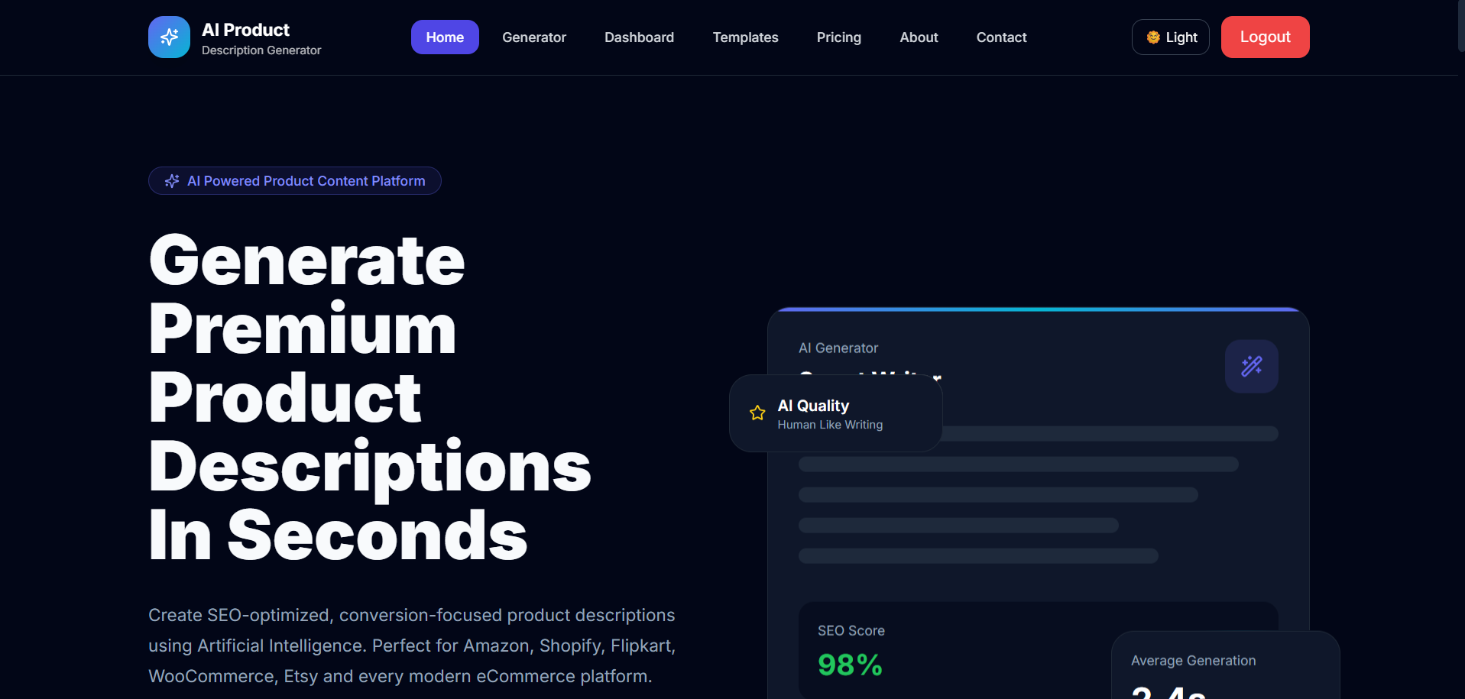
Fig. 4.1 Home Page
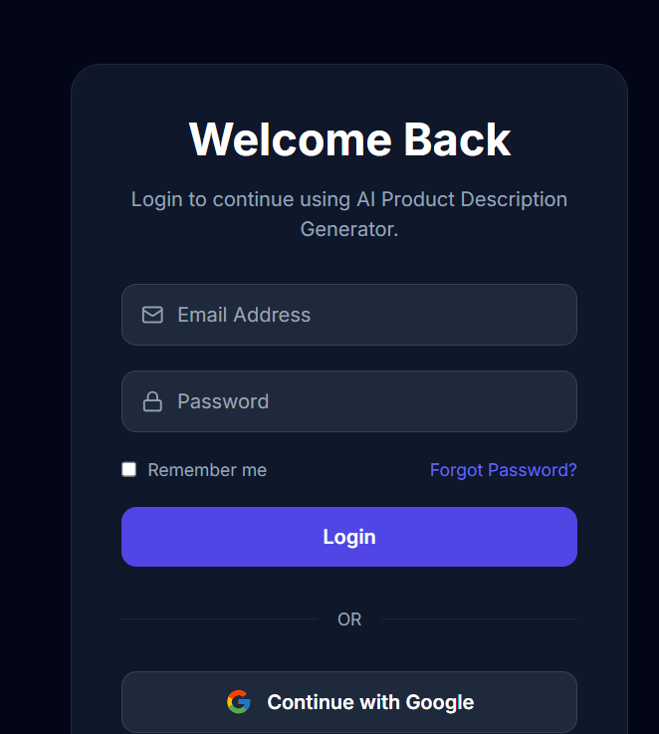
Fig. 4.2 Login Page

4.3 Backend and API Development
The backend was built using Node.js and Express.js. I created separate REST API routes for authentication, generating descriptions, saving products, searching products and deleting products. Each route was tested individually in Postman before connecting it to the frontend, which made it much easier to find the exact place where something was going wrong.

4.4 Database Integration
I used MongoDB Atlas as the cloud database and Mongoose to define schemas for the User and Product collections. The Product schema stores the product name, category, generated description, the user it belongs to, and the date it was created. This made it simple to later add the search and history features, since I could just query the database using the logged-in user's ID.

4.5 Authentication – Google OAuth and JWT
For login, I implemented Google OAuth so that users do not need to create a separate password. Once Google confirms the user's identity, my backend generates a JWT (JSON Web Token) and sends it to the frontend. This token is then attached to every future request so that protected routes only respond to logged-in users. I also added middleware on the backend to check this token before allowing access to any product-related API.
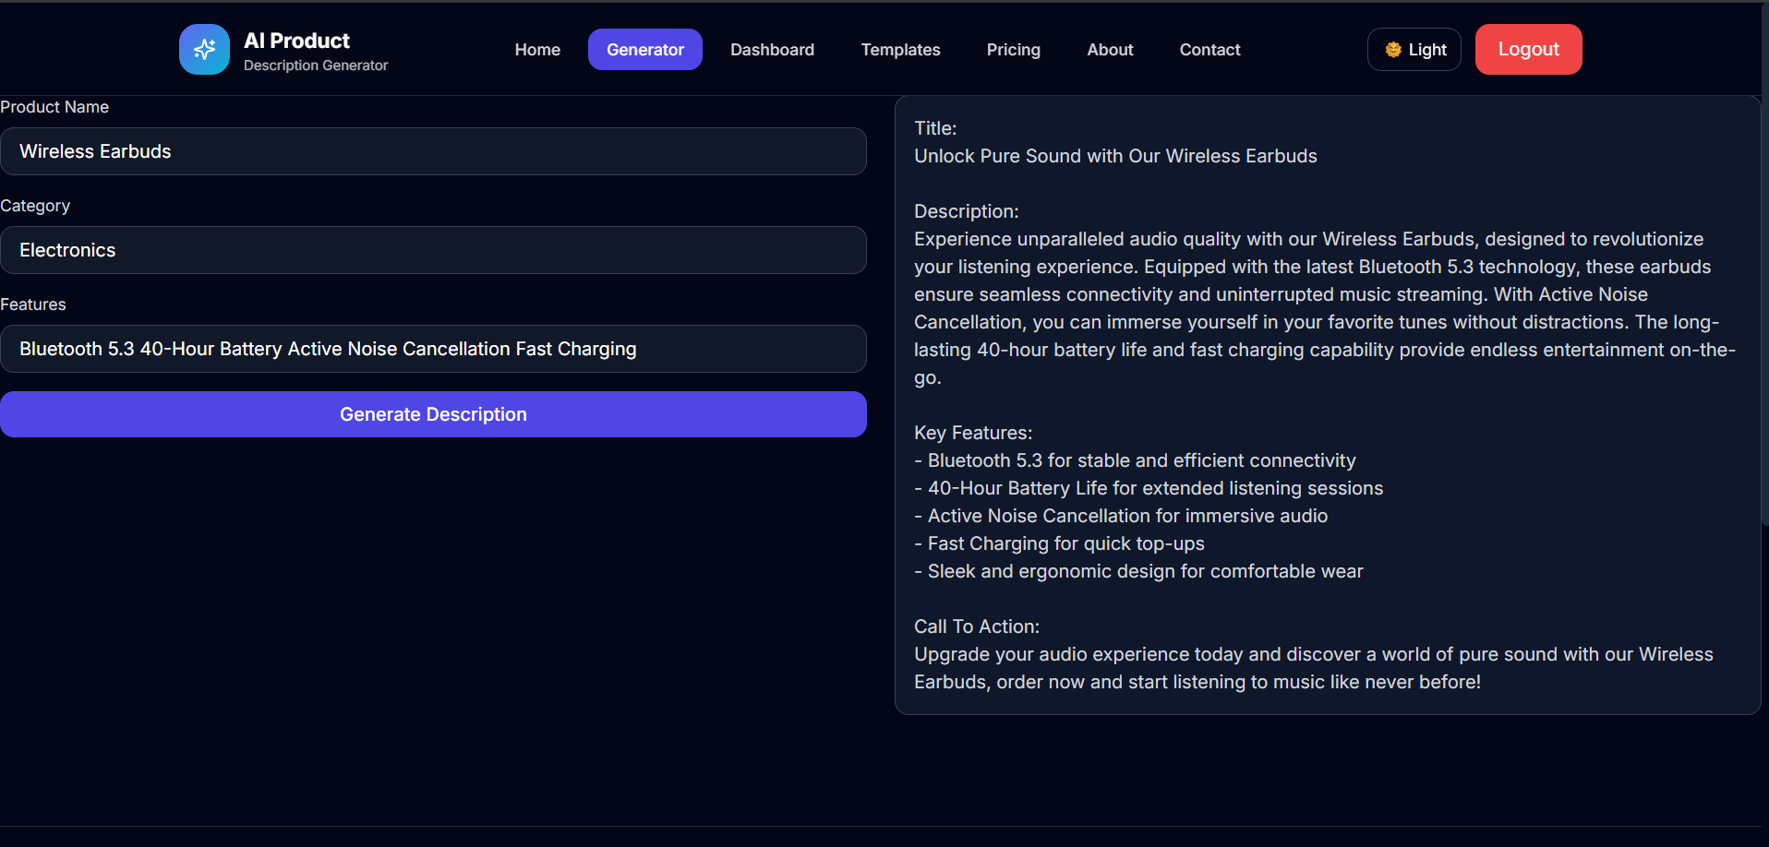
Fig. 4.3 AI Description Generation

4.6 AI Integration – Google Gemini API
The core feature of the project is AI-based description generation. When a user submits the product name, category and key features, the backend sends this data to the Google Gemini API with a clear prompt asking it to write a short, professional product description. The response from Gemini is cleaned up on the backend before being sent to the frontend, so that the user only sees the final description and not any extra text.

4.7 Search and Delete Functionality
I added a search bar on the History page that filters the saved products by name or category using a backend query. I also added a delete button on each saved product card, which calls a DELETE API and removes that entry from both the database and the screen without needing to reload the page.
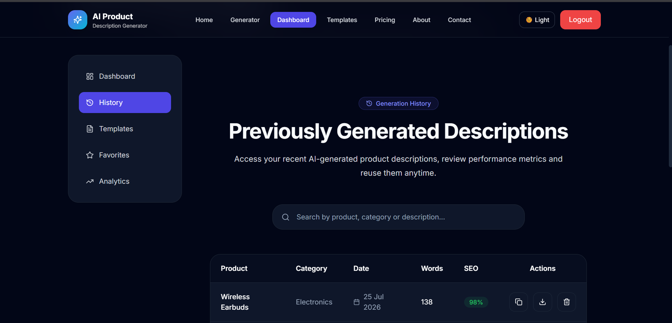
Fig. 4.4 Product History
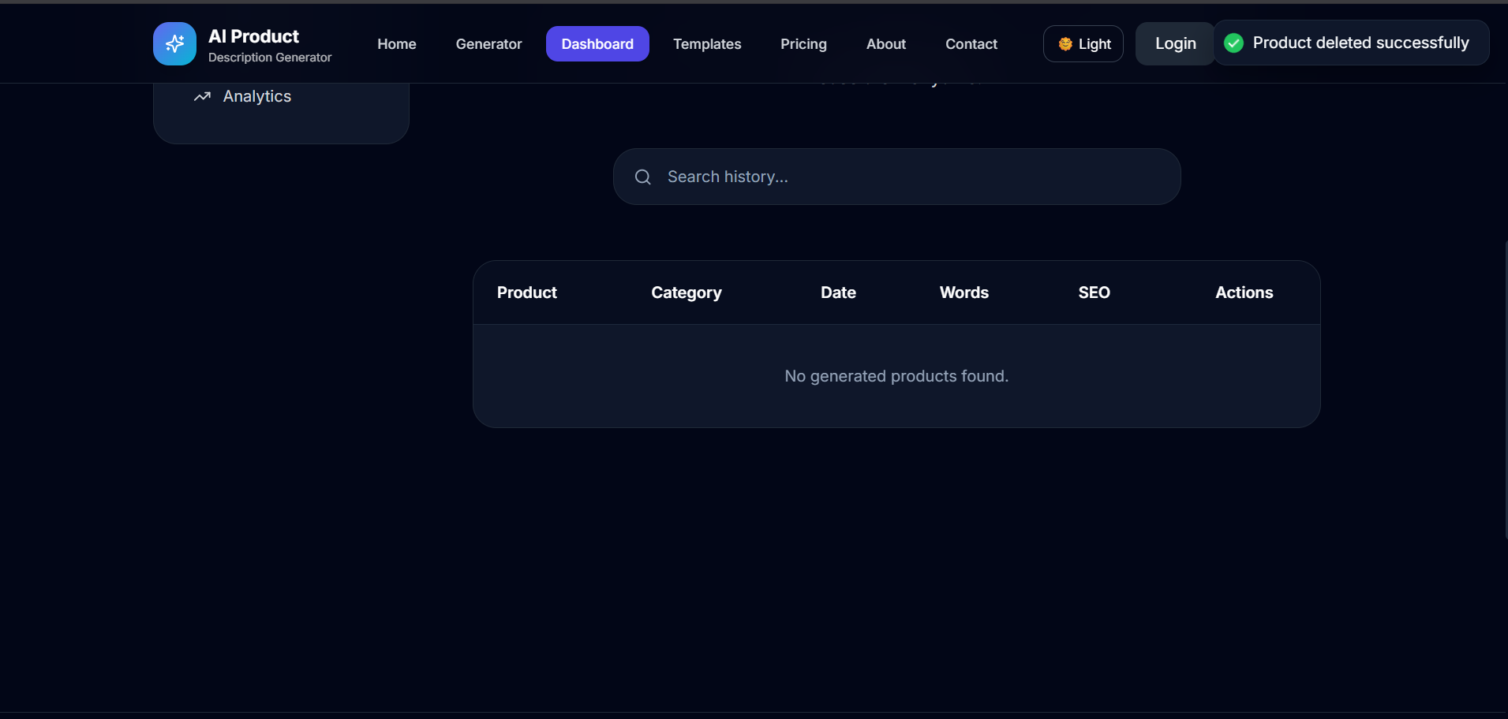
Fig. 4.5 Delete Product

4.8 Testing and Deployment Preparation
Once all the features were working individually, I tested the complete flow multiple times – logging in, generating a description, saving it, searching for it and deleting it – to make sure nothing broke when features were used together. I also checked the application on different screen sizes to confirm the responsive design was working correctly, and prepared environment variables and configuration files needed for deployment.

CHAPTER 5
CHALLENGES FACED AND HOW THEY WERE SOLVED
Like any real project, I faced several practical problems during development. This chapter lists the main challenges I faced and the way I solved each one.

5.1 Google OAuth Callback Issues
In the beginning, the Google login was redirecting to an error page instead of coming back to my application. After checking the Google Cloud Console settings, I found that the authorised redirect URI I had configured did not exactly match the one my backend was using. Correcting the redirect URI in both places solved the issue.

5.2 JWT Authentication Errors
At one point, protected routes were rejecting valid logged-in users with a 401 error. I found that the token was not being attached correctly in the request headers from the frontend. I fixed this by setting up a common Axios instance that automatically adds the token to every API call, instead of adding it manually in each component.

5.3 MongoDB Atlas Connection Problems
My backend was failing to connect to MongoDB Atlas when I first deployed the environment variables. This turned out to be because my current IP address was not whitelisted in the Atlas network access settings. Adding the correct IP access rule resolved the connection error.

5.4 CORS Errors
When I connected the React frontend to the Express backend, the browser blocked several requests with a CORS (Cross-Origin Resource Sharing) error. I resolved this by properly configuring the cors middleware on the backend to allow requests only from my frontend's URL.

5.5 Handling Gemini API Response Format
The response returned by the Gemini API was not always in a clean, ready-to-display format; sometimes it included extra line breaks or repeated text. I wrote a small helper function on the backend to clean and format the AI response before sending it to the frontend.

5.6 Responsive UI Issues
Some components looked fine on a laptop screen but broke on smaller mobile screens. I went through each page again using Tailwind's responsive classes and fixed the layout so that it adjusts properly across different screen sizes.

5.7 General Debugging
Overall, most of my time went into debugging small issues rather than writing new code. I got into the habit of checking the browser console, the backend terminal logs and Postman responses together whenever something did not work, which made it much faster to find the actual cause of a problem.

CHAPTER 6
SKILLS LEARNED
This internship gave me practical, hands-on experience that goes beyond what is usually covered in classroom teaching. The skills I gained can be grouped into technical and professional skills.

6.1 Technical Skills
- Building responsive user interfaces using React.js and Tailwind CSS
- Creating and structuring REST APIs using Node.js and Express.js
- Designing schemas and managing data using MongoDB and Mongoose
- Implementing real authentication systems using Google OAuth and JWT
- Integrating third-party AI APIs (Google Gemini) into a live application
- Using Git and GitHub for version control and code management
- Testing APIs using Postman and debugging using browser developer tools

6.2 Professional Skills
- Problem solving under a fixed weekly timeline
- Independent debugging and root-cause analysis
- Time management while balancing multiple small tasks
- Writing clear documentation and commit messages
- Communicating progress and blockers with a mentor

CHAPTER 7
CONCLUSION
The 10-week Industrial Interaction internship at the Technology Business Incubator, Graphic Era (Deemed to be University), gave me the opportunity to move beyond textbook learning and build a complete, working full stack web application on my own. Starting from requirement analysis and ending at a tested, deployment-ready product, I was able to experience almost every stage of real-world software development.
Working on the AI Product Description Generator helped me understand how the different parts of a MERN stack application – frontend, backend, database and authentication – come together, and how a third-party AI API like Google Gemini can be integrated into a normal web application to add real value for users.
The challenges I faced with OAuth, JWT, MongoDB Atlas and CORS taught me more about debugging and problem solving than any single classroom lecture could have. I am confident that the technical and professional skills gained during this internship will be directly useful to me in my future academic projects as well as in a full-time Software Development or Full-Stack Developer role.
I am thankful to TBI-GEU for this opportunity and to my mentor for the constant support and guidance throughout the internship.

