**Assignment**

**1.Using GitLab web IDE Git commands to interact with Gitlab**

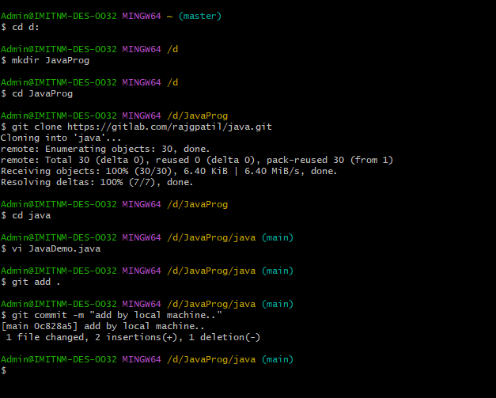

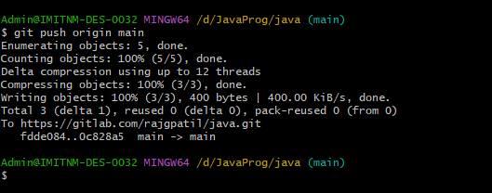

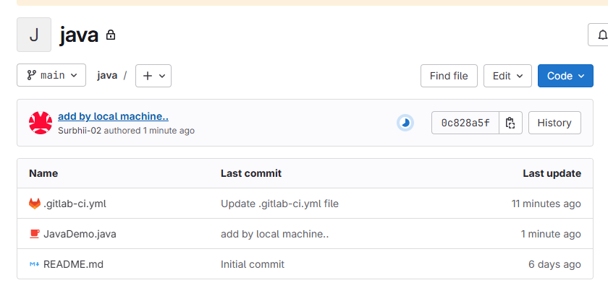

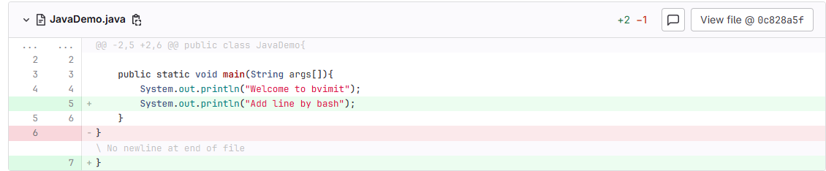

**2 Performing merge requests using GitLab**

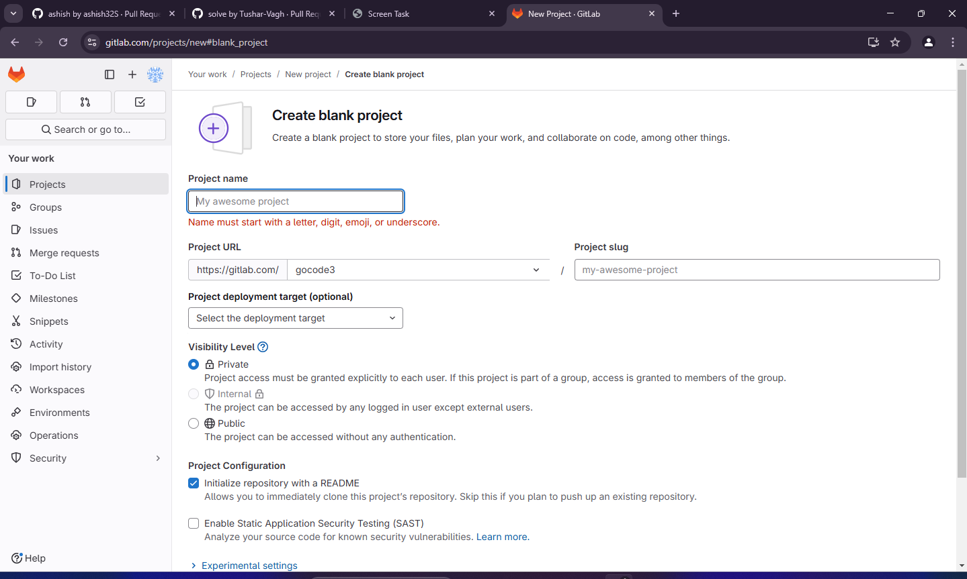

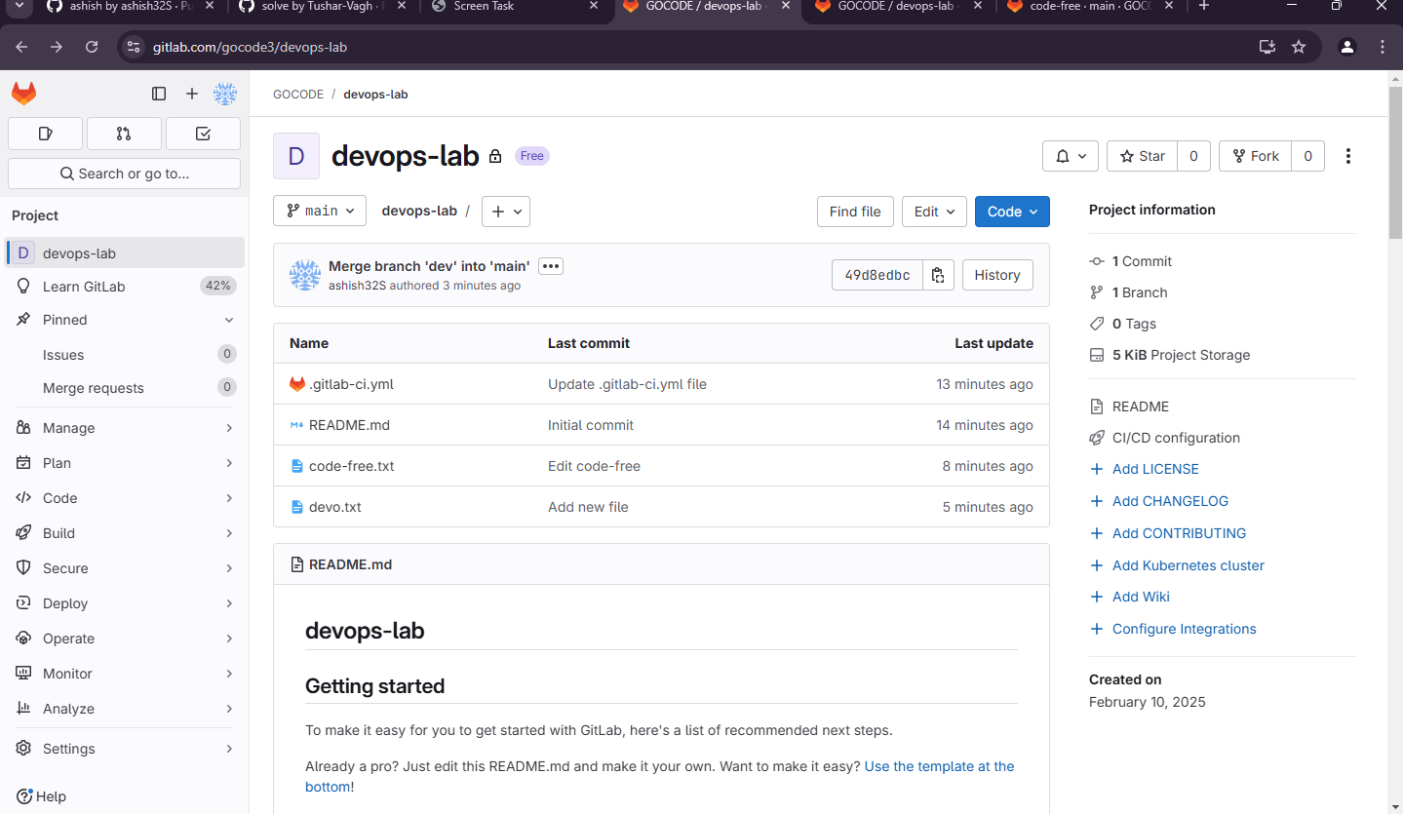

**Merge the dev branch into main**

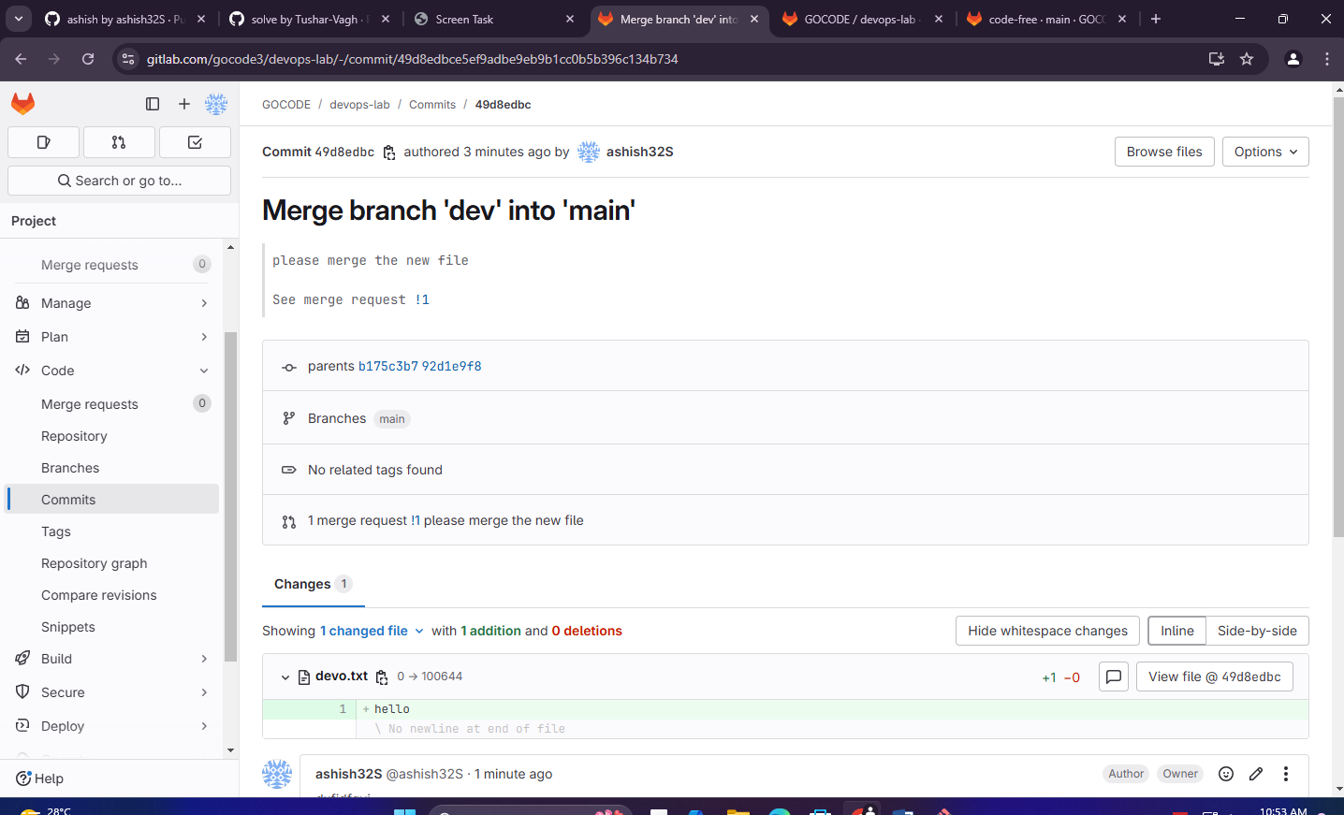

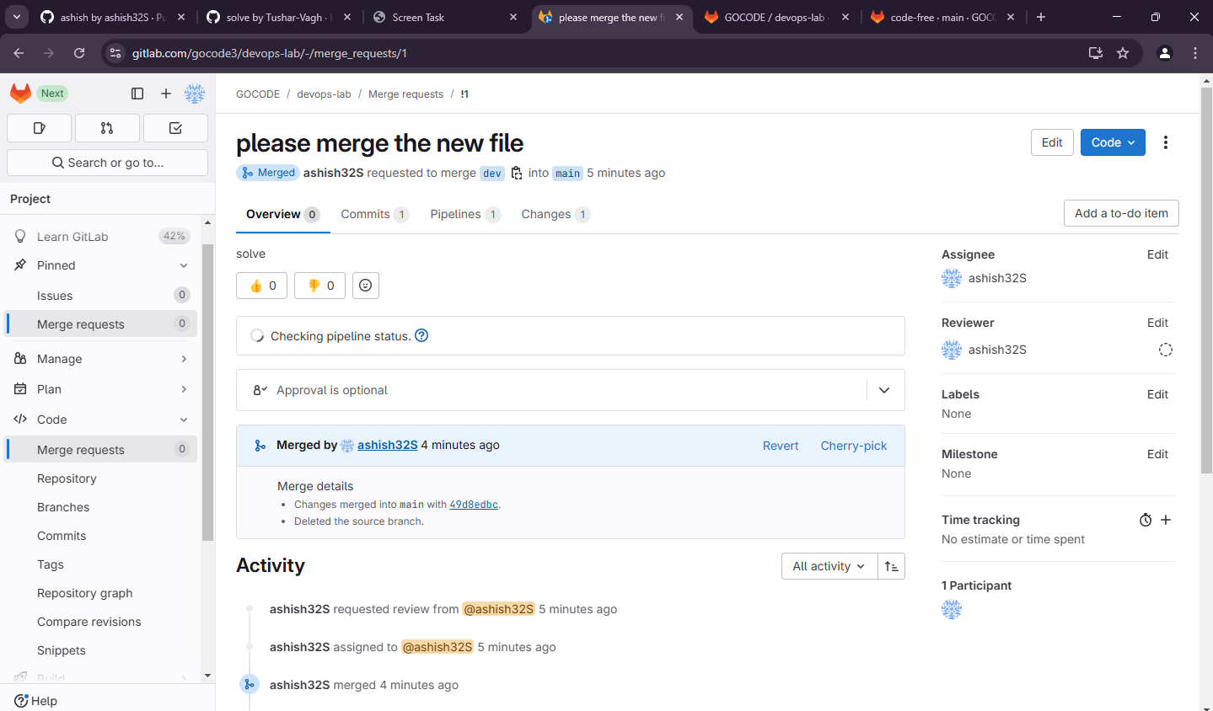

**3. Workflow management in GitLab**

*CI/CD*

*# This file is a template, and might need editing before it works on your project.*

*# This is a sample GitLab CI/CD configuration file that should run without any modifications.*

*# It demonstrates a basic 3 stage CI/CD pipeline. Instead of real tests or scripts,*

*# it uses echo commands to simulate the pipeline execution.*

*#*

*# A pipeline is composed of independent jobs that run scripts, grouped into stages.*

*# Stages run in sequential order, but jobs within stages run in parallel.*

*#*

*# For more information, see: https://docs.gitlab.com/ee/ci/yaml/#stages*

*#*

*# You can copy and paste this template into a new `.gitlab-ci.yml` file.*

*# You should not add this template to an existing `.gitlab-ci.yml` file by using the `include:` keyword.*

*#*

*# To contribute improvements to CI/CD templates, please follow the Development guide at:*

*# https://docs.gitlab.com/ee/development/cicd/templates.html*

*# This specific template is located at:*

*# https://gitlab.com/gitlab-org/gitlab/-/blob/master/lib/gitlab/ci/templates/Getting-Started.gitlab-ci.yml*

stages:          *# List of stages for jobs, and their order of execution*

  - build

  - test

before_script:

  - apt-get update && apt-get install -y openjdk-17-jdk *#Install Java*

build:       *# This job runs in the build stage, which runs first.*

  stage: build

  script:

    - javac JavaDemo.java *#Run java File*

    - ls -l

  artifacts:

    paths:

      - JavaDemo.class

  only:

    - main

test:   *# This job also runs in the test stage.*

  stage: test    *# It can run at the same time as unit-test-job (in parallel).*

  script:

    - ls -l

    - java JavaDemo

  only:

    - main

