SEM-Based Perovskite Solar Cell Defect Annotation and Detection Using Classical Image Processing and Deep Learning

Abstract
Perovskite solar cells require careful microstructural control because defects such as pinholes, residual PbI2-rich regions, and background morphology variations can influence charge transport, recombination, and device stability. This project develops a Python-based annotation, preprocessing, and object-detection workflow for scanning electron microscopy (SEM) images of perovskite thin films. The system combines an interactive Streamlit annotation interface, YOLO-format label generation, OpenCV and Segment Anything Model (SAM) assisted auto-annotation, patch-based dataset preparation, and model benchmarking across YOLOv8, YOLO11, and Faster R-CNN pipelines. The implemented dataset workflow stores five classes: PbI2, 3D pinholes, 3D-2D pinholes, 3D background, and 3D-2D background. The main experimental split contains 4,701 image patches, with 3,759 training, 467 validation, and 474 testing samples. Six YOLO training runs are available in the repository. Among them, YOLO11m achieved the highest recorded performance, with mAP50 of 0.4219 and mAP50-95 of 0.1905. The results indicate that real-time object detectors are useful for rapid SEM defect localization, but the moderate mAP scores also show that small, low-contrast, texture-similar defects remain challenging. The work contributes a reproducible end-to-end toolchain for laboratory annotation, model training, evaluation, and future extension toward more robust microscopy defect analytics.

Keywords
Perovskite solar cells; SEM image analysis; defect detection; YOLO; Faster R-CNN; Streamlit annotation.

1. Introduction
Scanning electron microscopy is a central characterization tool for thin-film photovoltaic materials because it reveals grain morphology, pinholes, phase segregation, surface coverage, and other microstructural features that are difficult to quantify from electrical measurements alone. In perovskite solar cells, SEM morphology is commonly used to infer film quality, identify fabrication problems, and compare additive or processing strategies. However, manual inspection is slow, subjective, and difficult to scale when researchers need to review hundreds or thousands of images across multiple compositions and processing conditions.
The SEM-Annotation project addresses this gap by converting a manual image-inspection workflow into a practical annotation and model-training application. The repository contains a Streamlit application (app.py), modular handlers for manual and automatic annotation, utility scripts for patch generation and dataset splitting, classical image-processing filters, YOLO and Faster R-CNN training logic, and saved experiment outputs. The project is not a single model; it is a complete workflow for turning microscopy images into labeled data, training detectors, comparing models, and feeding predictions back into the annotation loop.
The central problem is to detect and localize perovskite defects from SEM images while keeping the workflow usable for researchers who may not be deep-learning engineers. The application therefore uses a practical hybrid approach. Manual annotation provides human control and ground truth. OpenCV methods provide transparent, parameterized detection for bright PbI2-like particles and dark pinhole-like regions. SAM provides promptable or automatic segmentation capability when available. YOLO models support fast localization and auto-labeling after training. Faster R-CNN is included as a two-stage baseline for comparison.
The project scope includes annotation, dataset organization, preprocessing, training, benchmarking, and visualization. It does not claim a final industrial-grade defect detector. Instead, it gives a strong applied foundation: a working app, generated labels, trained model artifacts, and enough modularity to improve the dataset and models iteratively.

1.1 Objectives
- Build a usable SEM image annotation interface for defect bounding boxes and polygon-like labels.
- Support automatic and semi-automatic annotation using YOLO inference, OpenCV threshold/morphology methods, and SAM when the checkpoint is available.
- Prepare YOLO-compatible datasets with train/validation/test split files and class metadata.
- Train and compare multiple object-detection models using mAP50, mAP50-95, precision, recall, F1 score, and training time.
- Document implementation choices, advantages, limitations, and future improvements in formal manuscript format.

1.2 Contributions
- A Streamlit app with five functional tabs: Data Explorer & Labeling, Train Model, Auto-Annotation Inference, Multi-Model Benchmark, and Model Comparison.
- A modular source layout that separates UI logic, model management, handlers, filters, datasets, and scripts.
- A patch-based dataset workflow that converts original SEM images into 224 x 224 training samples with adjusted YOLO labels.
- A benchmark-ready training pipeline for YOLO11 and Faster R-CNN, with saved JSON metrics and visual outputs.
- A classical PerovskiteDefectFilter implementation that can detect bright PbI2 particles, dark pinholes, needle-like crystals, and grain-boundary-like artifacts without requiring deep learning.

2. Literature Review
The literature relevant to this project spans perovskite material characterization, SEM defect analysis, object detection, image segmentation, and classical image processing. Recent perovskite-specific works increasingly combine SEM images with deep learning and web-based deployment, which closely aligns with this repository. The literature also shows why a hybrid approach is reasonable: deep models learn complex textures but require careful annotation and sufficient examples, while classical filters remain useful for interpretable bright/dark feature extraction.
Study | Method / Domain | Key Finding | Relation to This Project | Observed Gap
Pan et al., 2025 | Deep SEM segmentation for perovskite materials | Identifies lead iodide, perovskite, and defect domains; highlights manual SEM bottleneck. | This project localizes classes with YOLO boxes and adds app-based annotation. | Needs segmentation-grade labels and validation across more morphologies.
Scientific Reports FAPbI3 framework, 2025 | Multi-model SEM defect detection and Streamlit deployment | Combines preprocessing, deep learning, and practical app deployment. | Very similar motivation; this project adds explicit YOLO benchmarking artifacts and OpenCV/SAM assisted annotation. | Current repo needs stronger model-comparison UI linkage and per-class analysis.
Dey et al., 2022 | Mask R-CNN defect detection in SEM images | Shows instance segmentation can improve defect extent estimation. | This project uses Faster R-CNN and YOLO; Mask R-CNN could be a future extension. | Instance masks would improve pinhole shape modeling beyond bounding boxes.
SEM defect ML/DL review, 2021 | Survey of SEM defect classification and detection | Summarizes CNN and deep-learning approaches for semiconductor SEM inspection. | Supports computer vision for SEM defect workflows. | Perovskite-specific datasets remain limited.
Redmon et al., 2015 | YOLO real-time object detection | Frames detection as single-pass regression, enabling fast inference. | Justifies YOLO for interactive auto-labeling. | YOLO can struggle with small, dense defects and localization precision.
Ren et al., 2015 | Faster R-CNN with RPN | Two-stage detector improves proposal quality using shared convolutional features. | Used as a comparison baseline through torchvision Faster R-CNN. | Training and inference cost are higher than YOLO.
Ronneberger et al., 2015 | U-Net biomedical segmentation | Effective segmentation with few biomedical images. | Relevant future path for pixel-level SEM defect masks. | Requires segmentation masks rather than current box labels.
Kirillov et al., 2023 | Segment Anything | Promptable foundation segmentation model trained on very large mask data. | Repository includes SAM handler for auto-annotation. | Default SAM masks need material-specific filtering and class assignment.
Canny, 1986; OpenCV docs | Edge detection | Formalizes low-error, well-localized edge detection. | Canny is available in OpenCV auto-annotation. | Edges alone over-detect grain boundaries in textured SEM images.
Otsu, morphology, CLAHE literature | Classical thresholding and contrast enhancement | Contrast and morphology remain strong for bright/dark blob extraction. | Used in OpenCV handler and PerovskiteDefectFilter. | Sensitive to illumination, scale, and threshold choices.

The gap addressed by this implementation is practical integration. Many papers present a model or algorithm, but a laboratory workflow needs annotation, preprocessing, dataset splitting, training orchestration, metric visualization, and iterative correction. This project connects those steps in one repository.

3. Project Overview and Repository Analysis
The repository is organized around a Streamlit entry point and a modular src package. The main entry point is app.py, which presents five app modes through the sidebar. The src/model_handler.py file encapsulates YOLO model loading, training, validation metric extraction, dataset preparation, and auto-label inference. The src/handlers package contains user-interface and auto-annotation handlers. The src/filters package contains classical image-processing pipelines, including an adaptive kernel engine and a dedicated PerovskiteDefectFilter. The scripts folder contains standalone utilities for splitting datasets, training all models, generating benchmark PDFs, validating images, and running classical-filter experiments.

3.1 Technology Stack and Rationale
Technology | Role | Why Used | Benefits | Limitations
Python 3.10 | Main language | Scientific prototyping and ecosystem compatibility. | Broad library support; simple scripts; reproducible. | Dependency conflicts can occur across CUDA/PyTorch versions.
Streamlit | Interactive app UI | Rapid dashboard and annotation workflow without custom frontend. | Simple to run with streamlit run app.py; good for lab demos. | Complex state, drawing tools, and large uploads need more engineering.
Ultralytics YOLO | Object detection | Fast one-stage detector for auto-labeling loops. | Easy training API; stores curves, weights, and metrics. | Small SEM defects can be difficult; metrics are moderate.
Torch / Torchvision | Deep-learning backend and Faster R-CNN | Supports GPU training and two-stage baseline. | Flexible custom dataset; strong pretrained backbones. | Longer training and more code than YOLO API.
OpenCV | Classical image processing | Thresholding, morphology, Canny, CLAHE, contours. | Transparent, parameterized detection for bright/dark features. | Requires tuning per image class and microscope condition.
Pillow / NumPy / Pandas | Image I/O, array math, data tables | Standard scientific Python utilities. | Reliable data conversion and metric manipulation. | Large images can be memory-heavy without batching.
streamlit-drawable-canvas | Manual drawing UI | Rectangles, free drawing, and polygon-like drawing modes. | Enables human-in-loop annotation. | Current code does not yet reload YOLO labels back to canvas objects.
YAML / JSON | Dataset and metric metadata | YOLO config and model metrics are easy to inspect. | Human-readable and script-friendly. | Path consistency must be maintained carefully.

3.2 Dataset Description
The repository contains balanced_dataset with 440 images and 440 label files, plus split files containing 352 train, 44 validation, and 44 test entries. The model-training split used in the current benchmark is dataset_split_224, containing 4701 image patches and 4701 YOLO label files. Its split files contain 3759 training, 467 validation, and 474 testing samples. The patch size is 224 x 224 pixels, chosen to reduce GPU memory use and make training possible on limited VRAM.
Class ID | Class Name | Object Instances in dataset_split_224 labels
0 | PbI2 | 2910
1 | 3D_pinholes | 3995
2 | 3D-2D_pinholes | 3661
3 | 3D_background | 0
4 | 3D-2D_background | 0

Background classes are represented mainly by images with empty labels. The split contains 1811 non-empty label files. Empty-label background patches are useful because they teach YOLO what not to predict, but the ratio must be controlled so that the detector does not become overly conservative.

4. Application Tabs and Functional Benefits
Tab | Main Functions | Benefit | Current Limitation
Data Explorer & Labeling | Browse class folders, track progress, jump to first unlabeled image, draw labels, run SAM/OpenCV annotation, save YOLO labels. | Supports human-in-loop ground truth creation. | Default path is machine-specific; existing labels are not rendered back to canvas.
Train Model | Collect image-label pairs, write YOLO dataset YAML, train selected YOLO model. | Allows small training runs from UI. | Long training can block Streamlit; scripts are safer for full runs.
Auto-Annotation Inference | Use trained YOLO or SAM to auto-label selected class folders. | Accelerates labeling after an initial model exists. | YOLO confidence must be tuned; SAM checkpoint must be separate.
Multi-Model Benchmark | Train queued models with shared settings and save metrics. | Supports reproducible comparison. | App queue currently differs from broader script training queue.
Model Comparison | Load JSON metrics, render table/chart, identify best model. | Turns outputs into decision support. | Live run exposed path mismatch: app searches runs/metrics, while metrics exist in src/runs/metrics.

5. Methodology
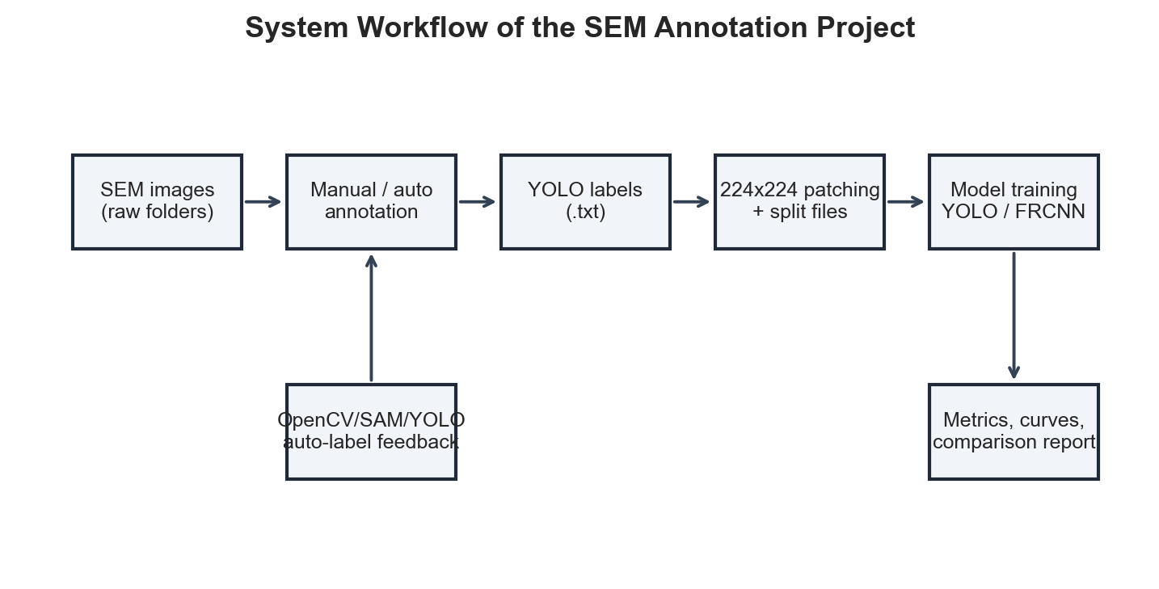
Figure 1. End-to-end workflow implemented by the SEM-Annotation repository.
The annotation workflow begins with a class folder selected in the Data Explorer tab. The app scans images using utility functions, checks whether matching YOLO .txt files exist, and reports progress. Users annotate manually through a drawable canvas over the image. Rectangles are converted to YOLO center coordinates, width, and height. Free-draw or polygon paths are converted to normalized coordinate sequences when enough points are available.
The quick auto-annotation path provides two modes. OpenCV is used for fast, interpretable detection of bright or dark features. SAM is available for segmentation-style masks when segment-anything and the checkpoint file are installed. YOLO inference is available in the Auto-Annotation tab, where a trained model predicts bounding boxes and writes YOLO label files for images that are not already annotated.
Classical image processing is used because SEM defects often have intensity signatures: PbI2-rich particles tend to be bright, while pinholes tend to be dark. The OpenCV handler supports thresholding, bright thresholding, top-hat transforms, HSV brightness masks, adaptive thresholding, Canny edges, watershed-style preprocessing, CLAHE, brightness/contrast adjustment, and contour filtering by area.
The splitting scripts create smaller patches from larger SEM images. Bounding boxes are converted from YOLO normalized coordinates to absolute coordinates, clipped to patch boundaries, and converted back into normalized patch-space labels. This preserves labels during patch generation while allowing training on memory-limited hardware.
YOLO training is implemented through Ultralytics. ModelHandler.train_model loads weights, chooses GPU if available, trains the model, loads best.pt, validates it, and writes JSON records containing mAP50, mAP50-95, precision, recall, F1, epochs, image size, training time, and weight path. Faster R-CNN training uses torchvision with a ResNet-50 FPN backbone and a custom dataset that converts YOLO labels into torchvision target dictionaries.

5.1 Pseudocode
Algorithm 1: Patch-based YOLO dataset preparation
Input: SEM image folder, YOLO label folder, patch size P, overlap O.
1. For each image, read the corresponding YOLO label file.
2. Convert each normalized label into absolute corner coordinates.
3. Generate sliding-window patch coordinates with stride P x (1 - O).
4. Clip intersecting boxes to patch boundaries.
5. Discard boxes whose visible ratio is below the threshold.
6. Convert clipped boxes back to normalized YOLO patch coordinates.
7. Save patch image and matching label file.
8. Write data.yaml and train/val/test index files.
Algorithm 2: Hybrid auto-annotation
Input: Image list and output label directory.
1. Select method based on defect class or user configuration.
2. For OpenCV, convert to grayscale and optionally apply CLAHE and brightness/contrast adjustment.
3. Apply threshold, top-hat, color mask, adaptive threshold, Canny, or watershed preprocessing.
4. Extract contours and filter by area.
5. Convert valid contours into YOLO bounding boxes and write label files.
6. For YOLO, run model prediction, extract normalized boxes, and write labels.
7. For SAM, generate masks, filter by predicted IoU, convert mask extents into boxes, and write labels.

6. Module-by-Module Code Analysis
File | Purpose | Benefit | Limitation / Improvement
app.py | Streamlit entry point; defines sidebar navigation and all five app modes. | Integrates labeling, training, auto-annotation, benchmarking, and comparison. | Single-file UI is easy to run but large; future refactor could split tabs.
src/model_handler.py | YOLO loading, training, validation, metrics, dataset preparation, and auto-labeling. | Centralizes model logic. | Metric output path differs from current app comparison path.
src/logger_setup.py | Redirects stdout/stderr to app.log. | Preserves app logs. | File handle management could be context-aware.
src/handlers/canvas_ui.py | Drawable canvas over SEM images with class and drawing controls. | Manual annotation UI. | TODO remains for loading existing YOLO labels.
src/handlers/opencv_handler.py | Parameterized contour-based auto-annotation. | Fast, explainable baseline. | Thresholds require tuning.
src/handlers/sam_handler.py | SAM automatic mask generation and conversion to YOLO boxes. | Segmentation-assisted labeling. | Requires checkpoint; class assignment is defaulted.
src/handlers/utils.py | Directory and image-file listing helpers. | Reusable file scanning. | Only scans direct files.
src/utils/annotation_utils.py | YOLO read/write, coordinate conversion, clipping, and pair collection. | Essential for patching. | Could validate malformed labels more strictly.
src/datasets/frcnn_dataset.py | Torch Dataset that reads YOLO labels and returns Faster R-CNN targets. | Bridges YOLO labels to torchvision. | No dedicated augmentation pipeline.
src/filters/adaptive_kernel.py | Variance, gradient, entropy, adaptive kernel maps, hybrid responses. | Adapts filter scale to local texture. | Heavier than simple thresholds.
src/filters/classical_blend.py | CLAHE, top-hat, black-hat, LoG, DoG, Gabor, Hessian, LBP, DCT, entropy. | Library of interpretable filters. | Some functions are expensive and not fully wired into app.
src/filters/perovskite_defect_filter.py | Mode-aware classical detector with dataclasses and NMS. | Domain-specific no-training baseline. | Needs quantitative validation against ground truth.
scripts/split_dataset.py | Sliding-window patch split with box clipping. | Preserves labels during patching. | Can overwrite output directory.
scripts/split_and_train_pipeline.py | Patching, balancing, splitting, and starting training. | Automates preprocessing. | String-replaces training script path, which is brittle.
scripts/train_all_gpu.py | YOLO11 and Faster R-CNN training orchestration. | Reproducible batch training. | Large monolithic script; hard-coded CUDA assumptions.
scripts/generate_benchmark_report.py / create_benchmark_pdf.py | PDF report generation from JSON metrics. | Automated charts and summaries. | Separate from manuscript report.
scripts/dynamic_kernel_detector.py / demo_pdf_filter.py | Run classical detector experiments and save overlays. | Qualitative visualizations. | Classical detections need threshold tuning.

A line-by-line reading of the implementation shows a design preference for practical reproducibility: simple file-based datasets, YOLO text labels, JSON metrics, and batch scripts. The tradeoff is that several paths are hard-coded to the original Windows machine, and some UI paths diverge from training output paths.

7. Results and Discussion
Model | mAP50 | mAP50-95 | Precision | Recall | F1 | Epochs | ImgSz | Train Time (h)
yolo11m | 0.4219 | 0.1905 | 0.4488 | 0.4820 | 0.4648 | 50 | 224 | 1.14
yolo11s | 0.3957 | 0.1734 | 0.4326 | 0.4582 | 0.4450 | 50 | 224 | 0.62
yolov8s | 0.3779 | 0.1629 | 0.4553 | 0.4249 | 0.4396 | 50 | 224 | 0.46
yolo11l | 0.3526 | 0.1602 | 0.4054 | 0.4315 | 0.4180 | 50 | 224 | 2.95
yolov8m | 0.3528 | 0.1535 | 0.3976 | 0.4300 | 0.4132 | 50 | 224 | 0.65
yolov8l | 0.2374 | 0.0891 | 0.3040 | 0.3083 | 0.3061 | 50 | 224 | 1.17

The strongest recorded model is yolo11m, with mAP50 = 0.4219, mAP50-95 = 0.1905, precision = 0.4488, recall = 0.4820, and F1 = 0.4648. The result suggests that YOLO11m currently gives the best balance of localization quality and training cost in the available experiments.
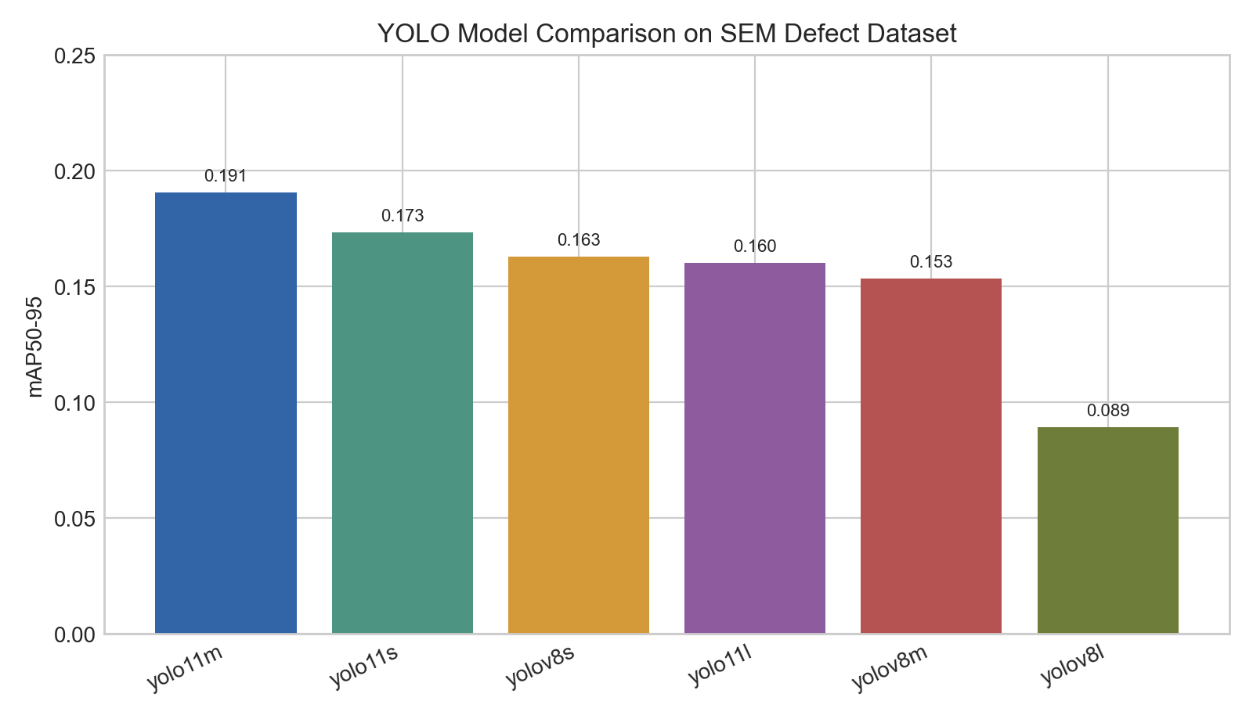
Figure. Model Map5095 Comparison.
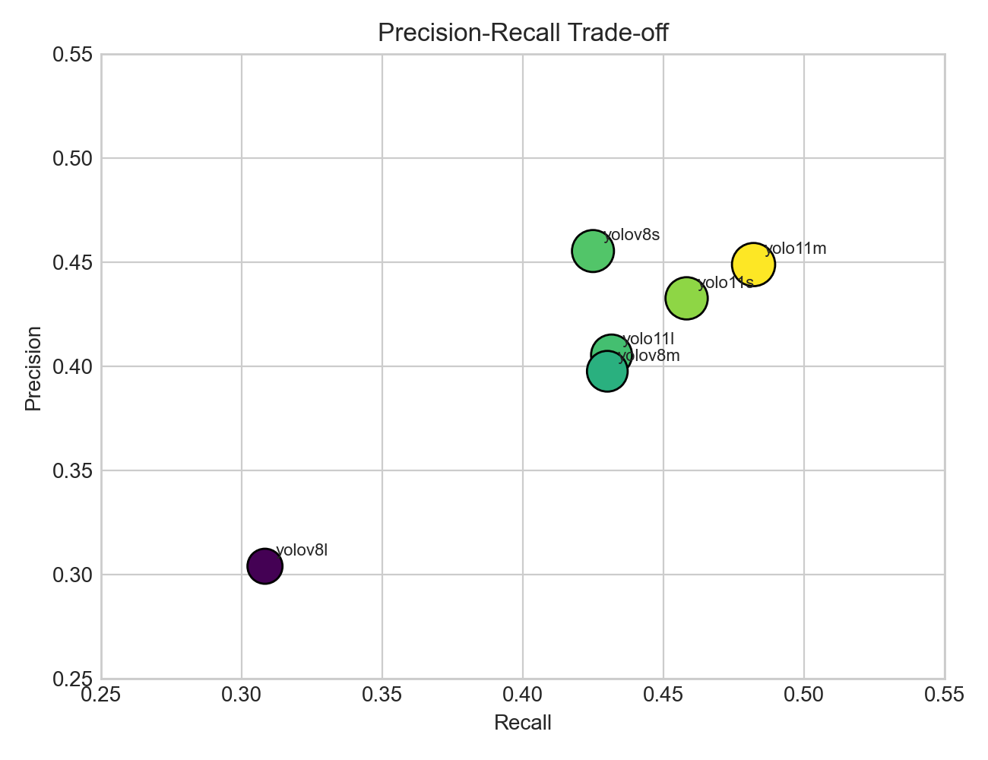
Figure. Precision Recall Scatter.
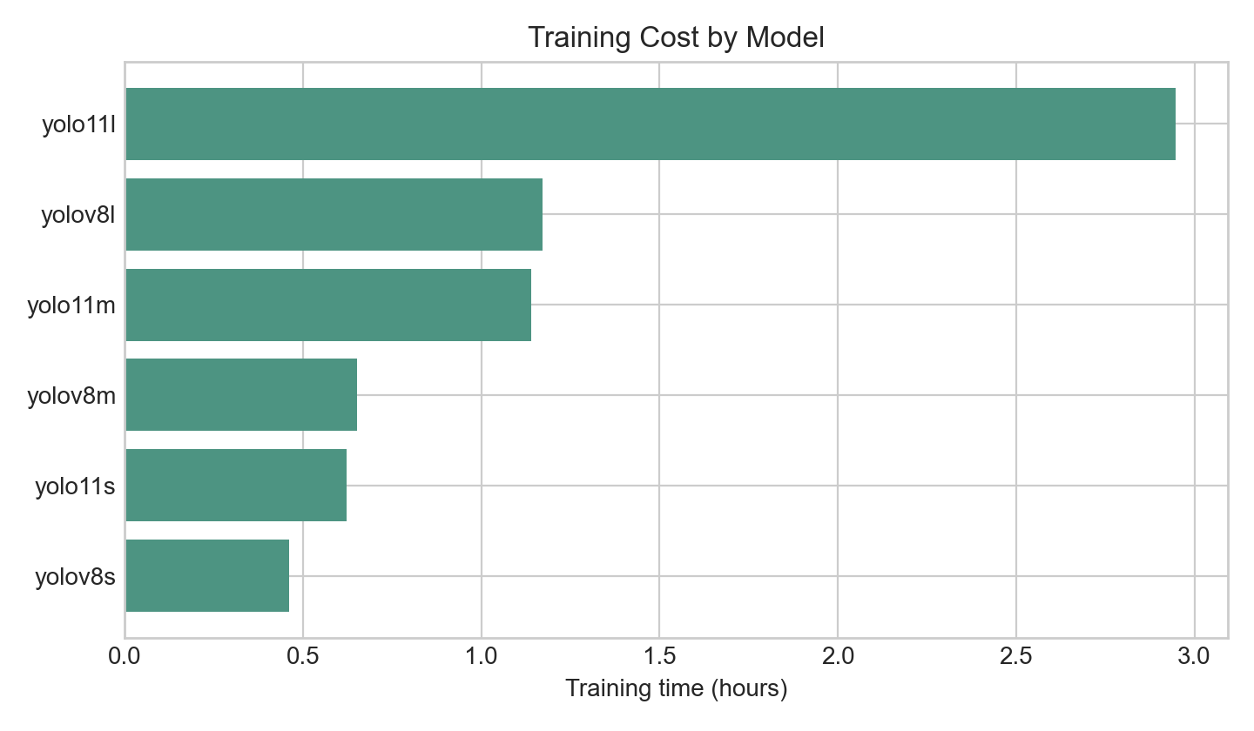
Figure. Training Time.
The quantitative scores are moderate rather than high. This is expected for small SEM defects because defect objects may occupy very few pixels inside a 224 x 224 patch, while the surrounding grain texture often resembles the target classes. mAP50 is higher than mAP50-95 because mAP50 is more forgiving about box localization. The stricter mAP50-95 metric penalizes boundary errors, which are common when defects are irregular or partially visible after patching.

7.1 Qualitative Visualizations
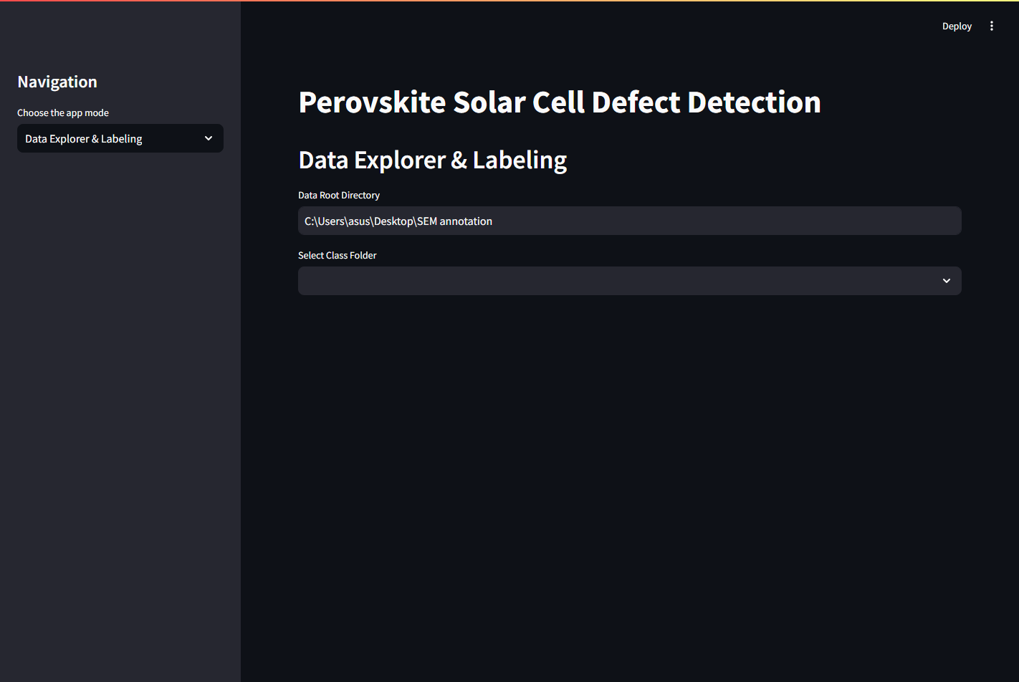
Figure 2. Live Data Explorer & Labeling tab from streamlit run app.py.
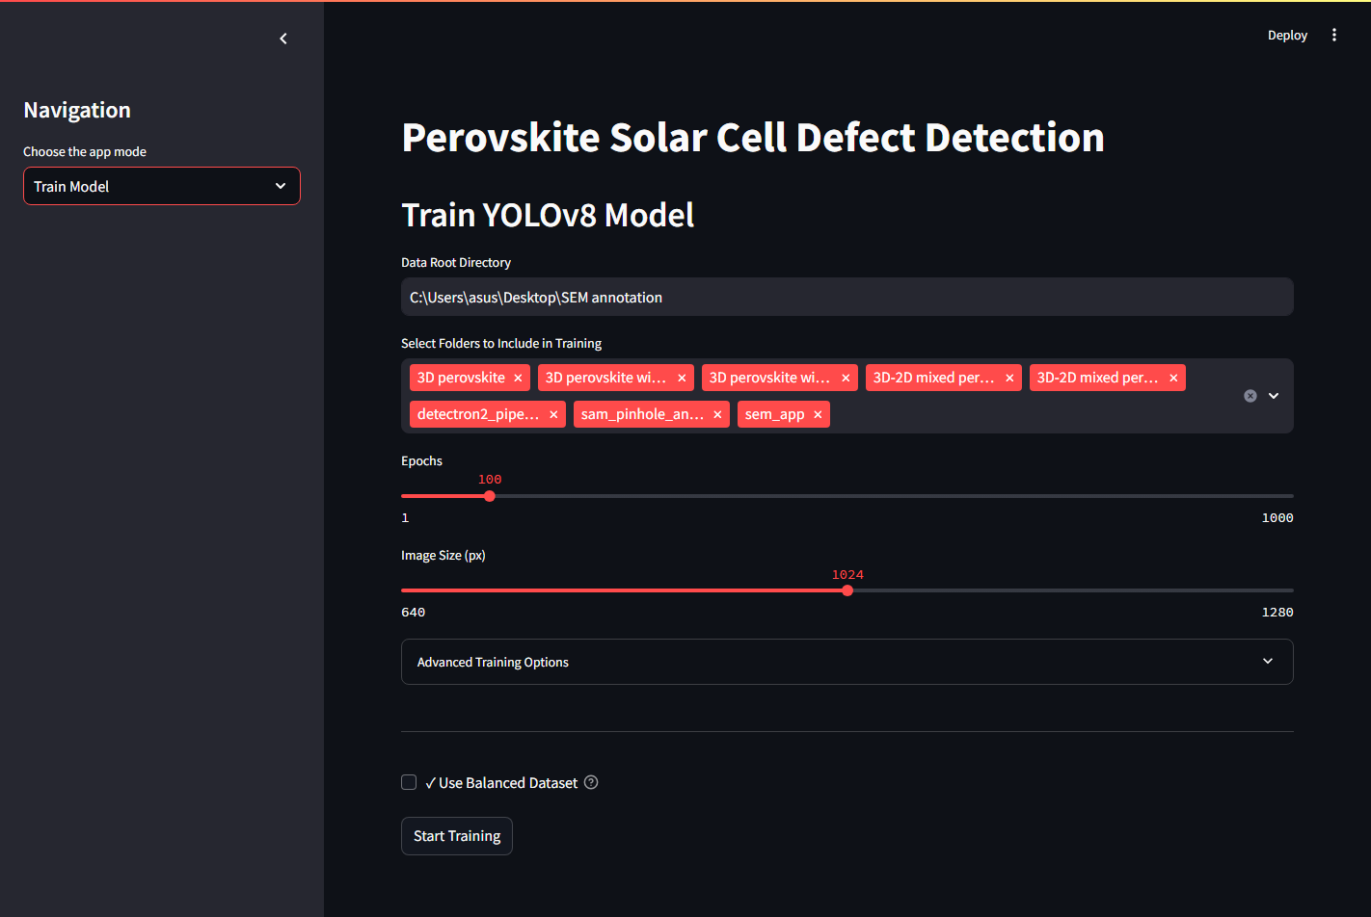
Figure 3. Live Train Model tab.
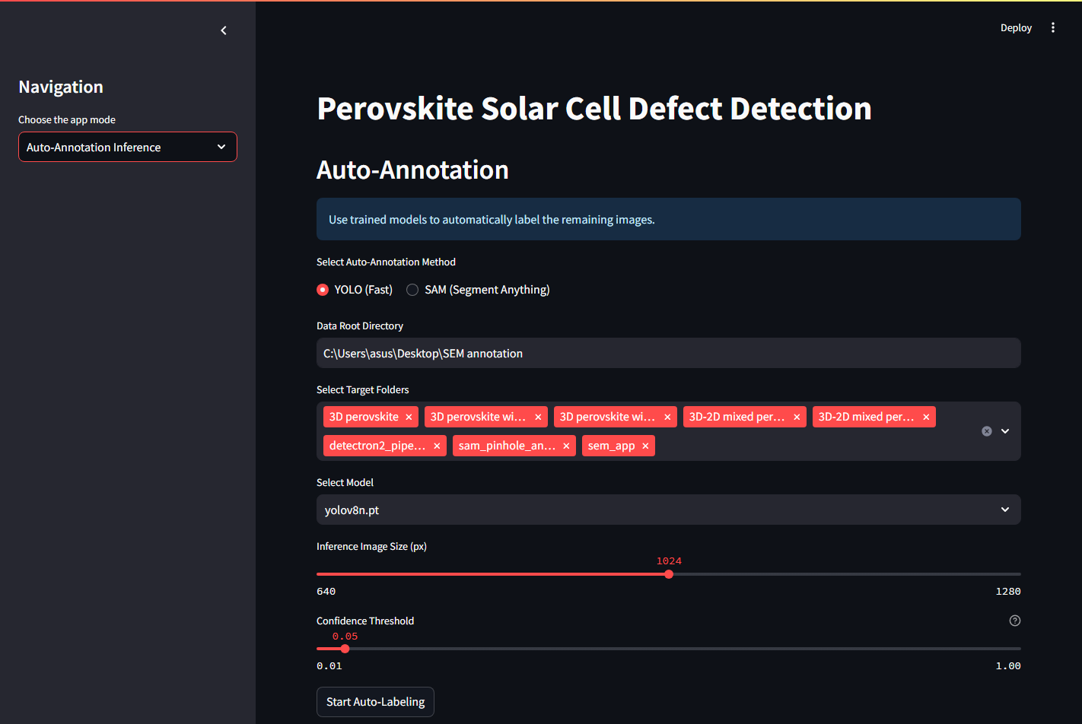
Figure 4. Live Auto-Annotation Inference tab.
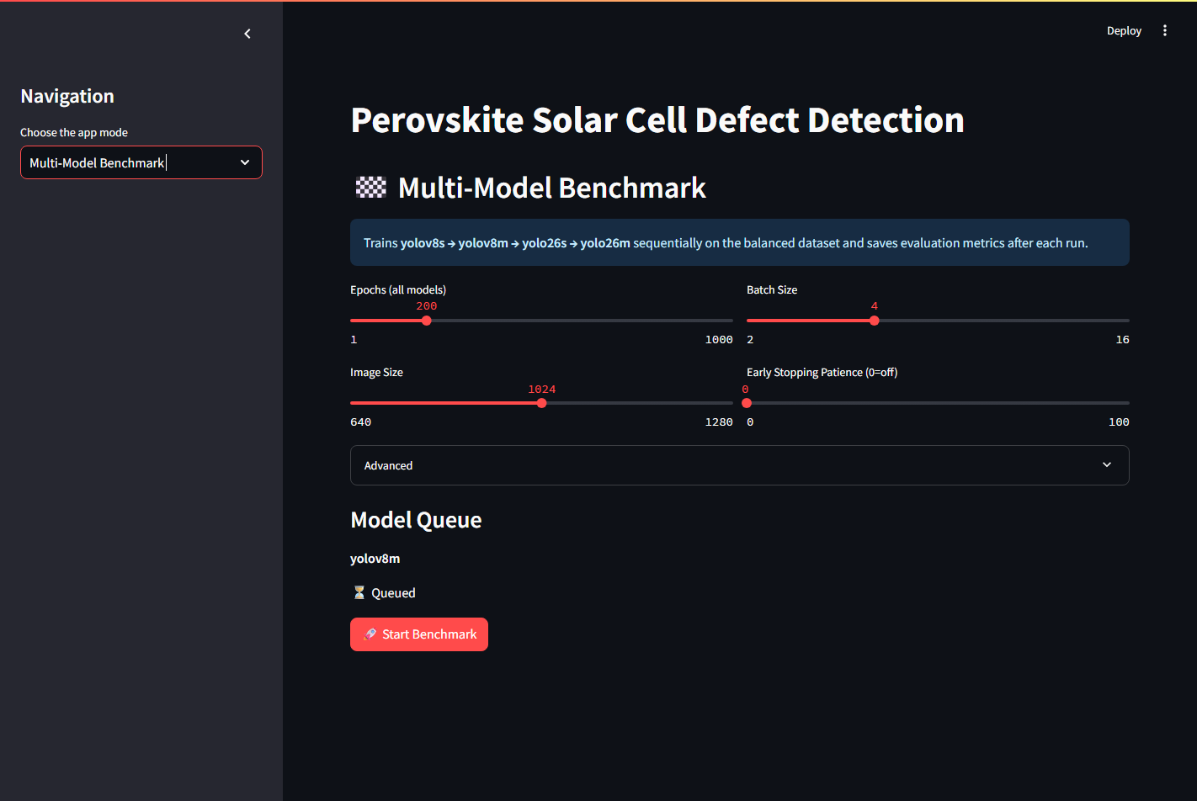
Figure 5. Live Multi-Model Benchmark tab.
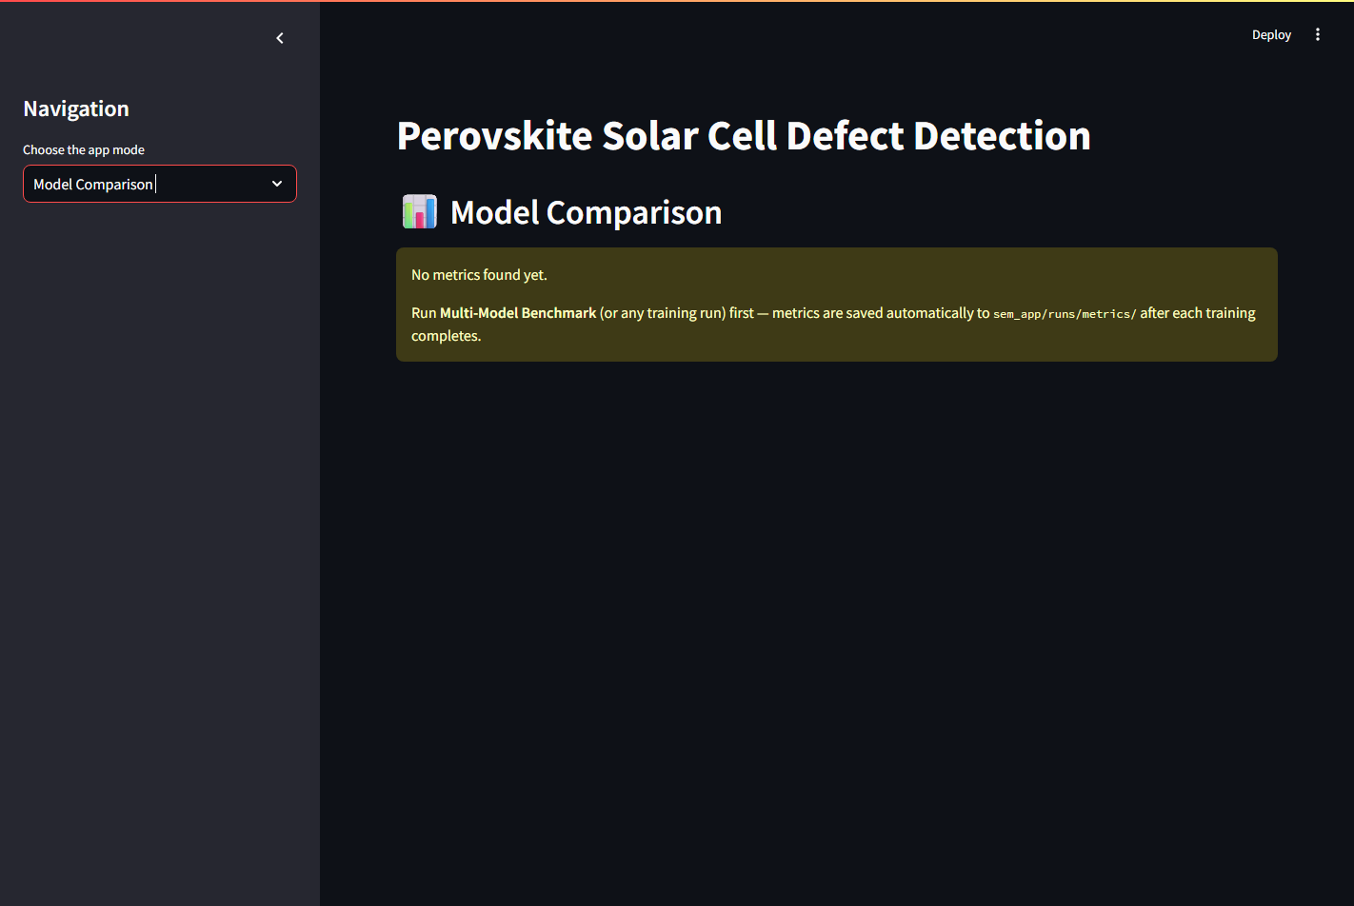
Figure 6. Live Model Comparison tab showing the current metric path mismatch limitation.
-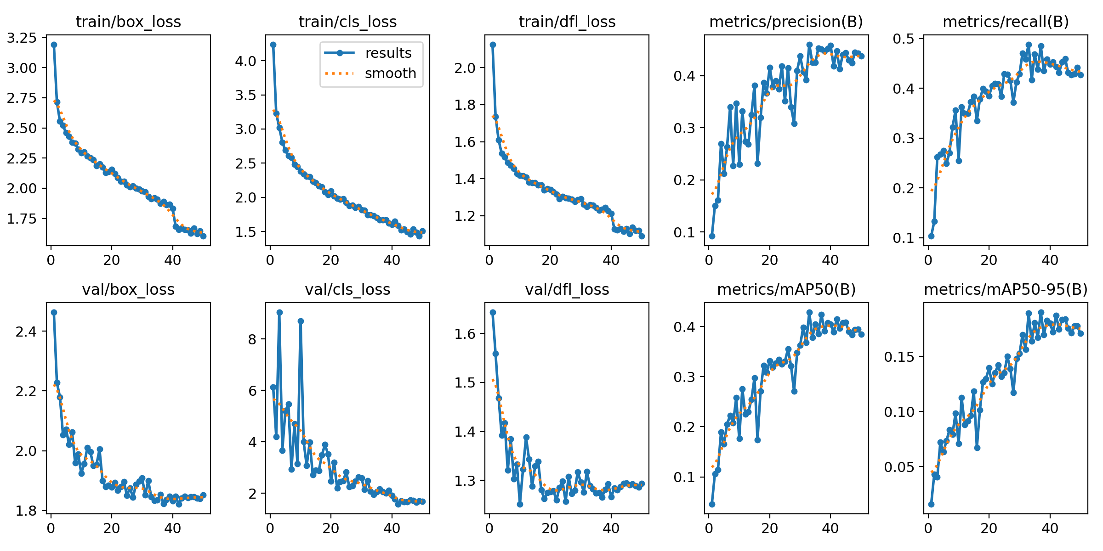
Figure 7. YOLO11m training curves generated by Ultralytics.
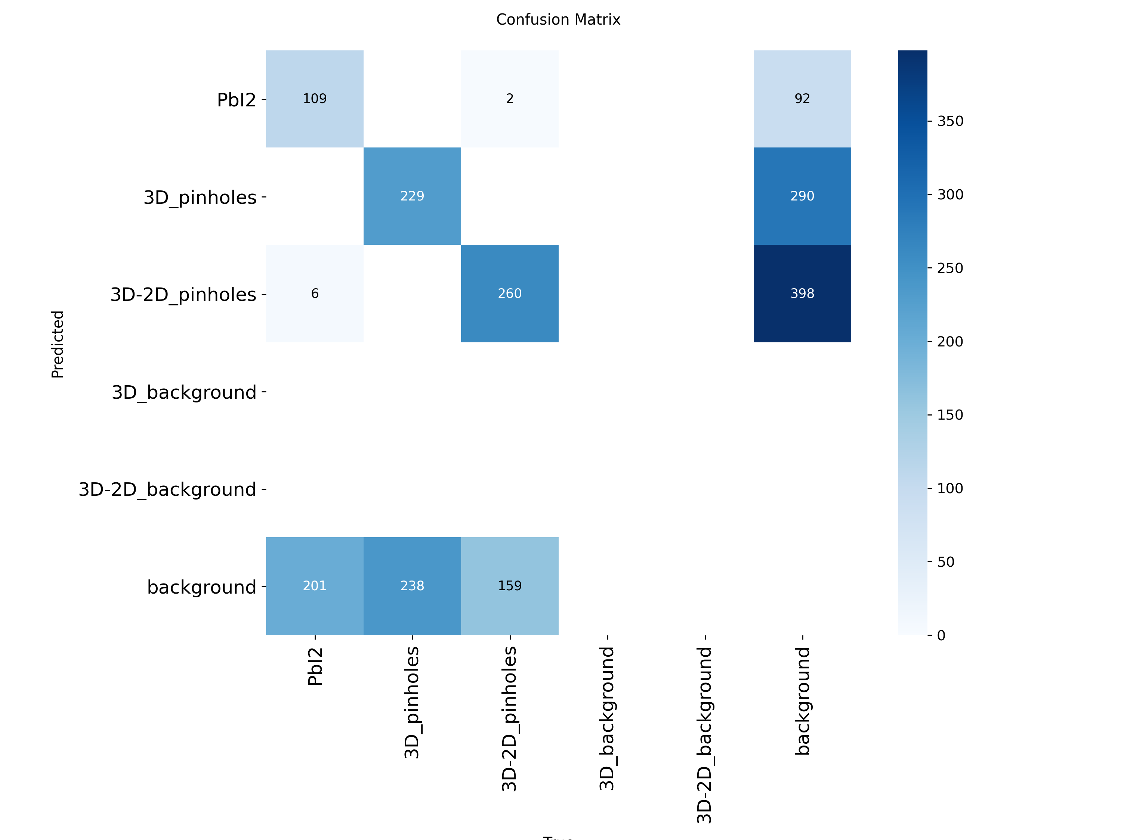
Figure 8. YOLO11m confusion matrix artifact.
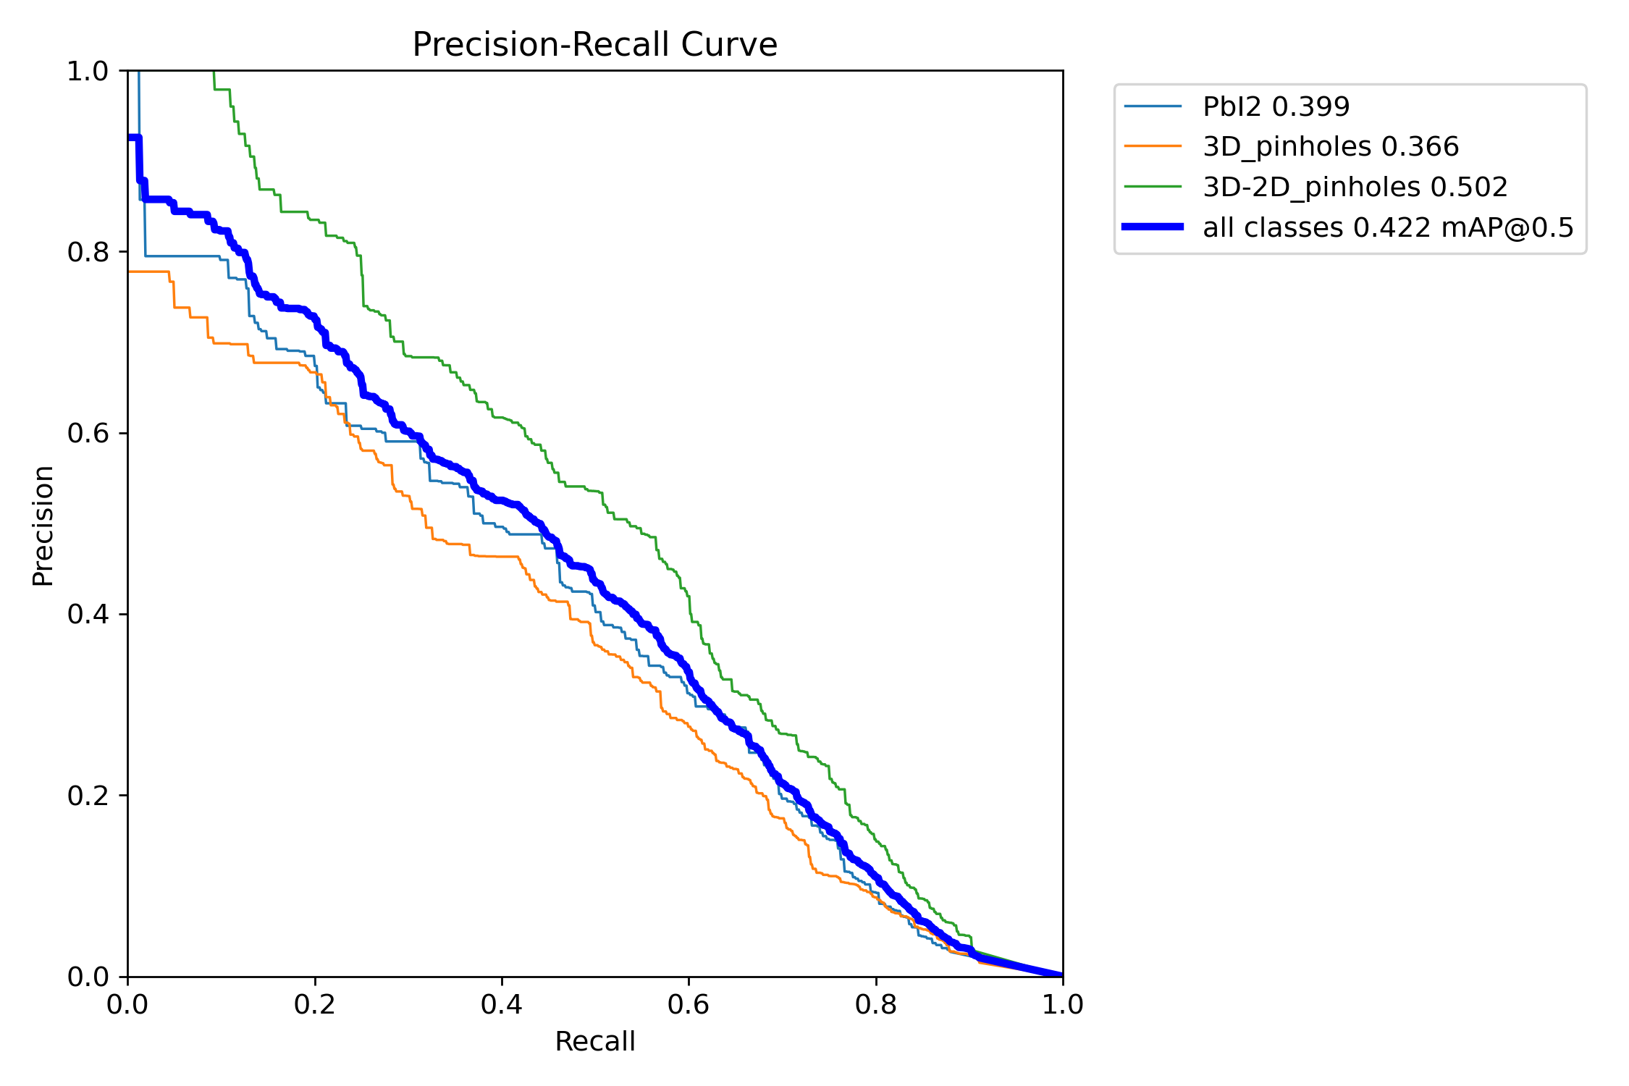
Figure 9. YOLO11m precision-recall curve artifact.
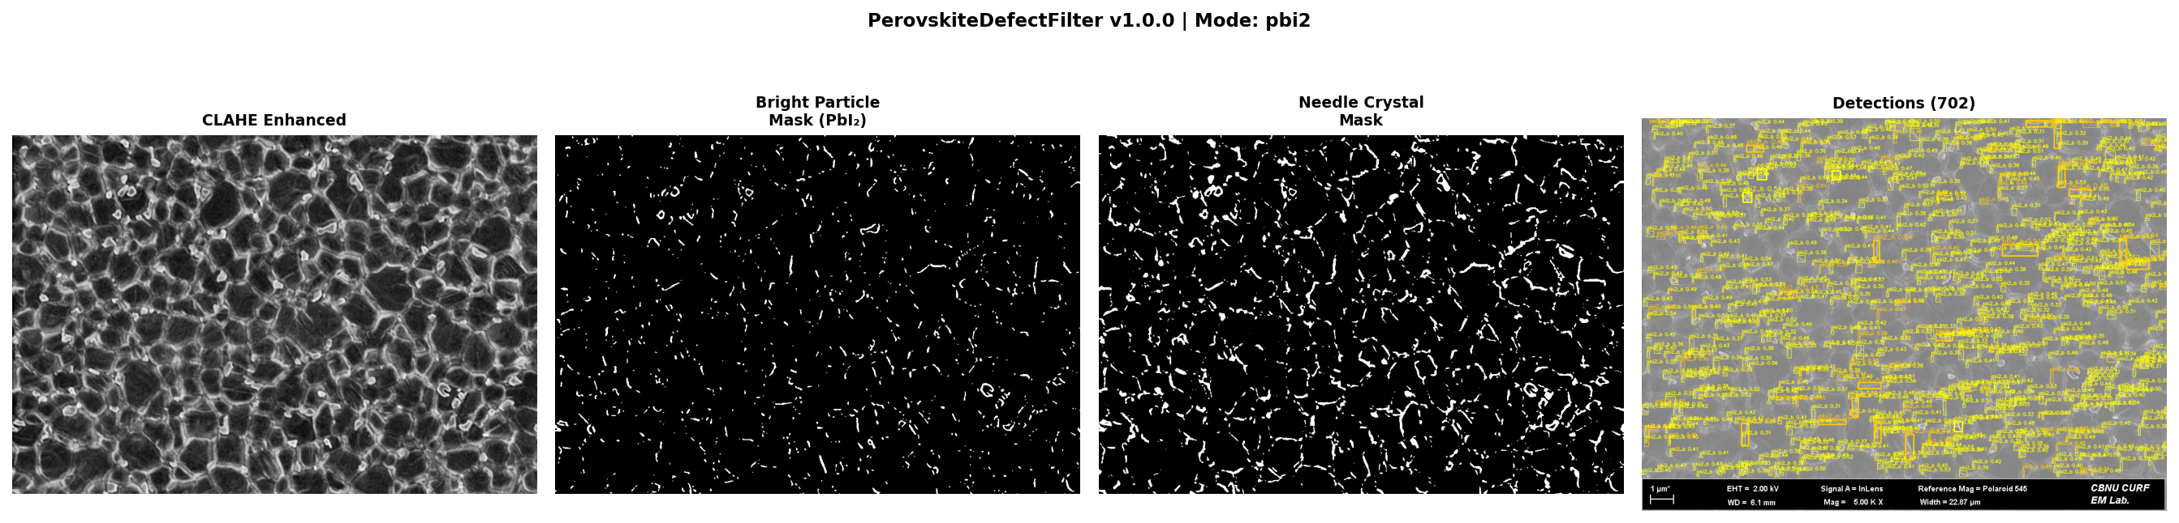
Figure 10. Classical PerovskiteDefectFilter pipeline for a PbI2 sample.
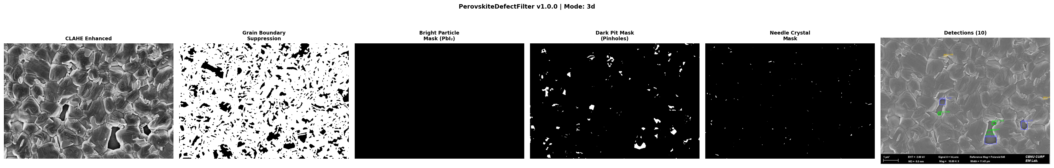
Figure 11. Classical PerovskiteDefectFilter pipeline for a 3D pinhole sample.

7.2 Error Analysis
- Small-object limitation: defects may be tiny relative to the patch, producing weak localization signals.
- Texture ambiguity: grain boundaries, pores, and lighting gradients can mimic pinholes or PbI2 particles.
- Patch context loss: 224 x 224 patches reduce memory load but remove broader film context.
- Path mismatch in app comparison: training metrics are in src/runs/metrics; the live Model Comparison tab searches runs/metrics.
- Manual-label dependency: model quality depends heavily on annotation consistency and coverage.
- Class imbalance: background images are useful, but too many empty labels can bias the detector against predictions.

8. Pros, Cons, and Design Tradeoffs
Decision | Pros | Cons | Interpretation
Streamlit UI | Fast to build, easy to demonstrate, no frontend stack. | State handling and long-running training can be fragile. | Good for academic/lab tool; production may need job queue and API backend.
YOLO labels | Simple text files, widely supported. | Bounding boxes are less precise than masks. | Appropriate first version; segmentation labels can be added later.
224 x 224 patches | Fits low VRAM and increases sample count. | May lose contextual cues and split defects. | Useful for RTX 3050-class hardware; test larger sizes later.
OpenCV auto-labeling | Transparent and fast; no GPU required. | Threshold tuning is image-dependent. | Excellent assistant for first-pass labels, not final ground truth.
SAM | Strong general segmentation prior. | Needs checkpoint and class assignment logic. | Promising for future mask labels.
YOLO11m best result | Best mAP50-95 among available runs. | Still moderate absolute performance. | Needs more data, higher resolution, augmentation, and per-class diagnosis.
Faster R-CNN baseline | Strong two-stage architecture and pretrained backbone. | Longer training and more custom code. | Useful benchmark, especially for small objects.

9. Conclusion and Future Work
This project successfully implements a complete SEM annotation and defect-detection workflow for perovskite solar cell images. It provides manual annotation, auto-labeling, classical image-processing filters, YOLO training, Faster R-CNN training infrastructure, benchmark reporting, and saved experimental results. The strongest available model is YOLO11m, but the moderate mAP50-95 score indicates that the current dataset and modeling choices still leave significant room for improvement. The repository is valuable because it moves beyond a single algorithm and provides the full loop required in practice: annotate, train, compare, correct, and repeat.

9.1 Future Work
- Fix metric path consistency by making the app load both runs/metrics and src/runs/metrics, or by standardizing all outputs under one directory.
- Render existing YOLO labels back into the canvas so users can edit previous annotations visually.
- Add per-class mAP, confusion-matrix interpretation, and error examples to the Model Comparison tab.
- Evaluate larger patch sizes such as 448 or 640 pixels for additional SEM context.
- Add SEM-specific augmentation: contrast jitter, blur/noise, rotation, scale, and synthetic defect insertion.
- Introduce segmentation models such as U-Net, Mask R-CNN, or YOLO segmentation for irregular pinholes and PbI2 regions.
- Create a formal README submission checklist with dataset permissions, model files, trained weights, and reproducible commands.
- Use external plagiarism and AI-similarity tools before final institutional submission.

10. Submission Compliance Notes
- Document format: this file is generated as a .docx manuscript in single-column format with 1 inch margins and Times New Roman 12 pt body text.
- GitHub repository link: insert the final repository URL on the title page before submission.
- Datasets and model files: the local repository includes data folders and YOLO model weights; confirm that dataset sharing is permitted before pushing to GitHub.
- README: the repository includes README.md, PROJECT_STRUCTURE.md, PIPELINE_README.md, QUICK_REFERENCE.md, and benchmark documentation.
- Plagiarism/AI reports: this environment cannot generate an official similarity or AI report. Those reports must be generated using the institution-approved service and submitted separately.

References
[1] J. Guo Pan, L. Wang, and X. Cai, “Automated and Scalable SEM Image Analysis of Perovskite Solar Cell Materials via a Deep Segmentation Framework,” arXiv:2509.26548, 2025. https://arxiv.org/abs/2509.26548
[2] “A multi-model deep learning framework for SEM-based defect detection in FAPbI3 Perovskite thin films,” Scientific Reports, 2025. https://www.nature.com/articles/s41598-025-25848-x
[3] B. Dey et al., “Deep Learning based Defect classification and detection in SEM images: A Mask R-CNN approach,” arXiv:2211.02185, 2022. https://arxiv.org/abs/2211.02185
[4] “A Review on Machine and Deep Learning for Semiconductor Defect Classification in Scanning Electron Microscope Images,” Applied Sciences, vol. 11, no. 20, 9508, 2021. https://www.mdpi.com/2076-3417/11/20/9508
[5] “Investigation of Well-Defined Pinholes in TiO2 Electron Selective Layers Used in Planar Heterojunction Perovskite Solar Cells,” Nanomaterials, 2020. https://www.mdpi.com/2079-4991/10/1/181
[6] J. Redmon, S. Divvala, R. Girshick, and A. Farhadi, “You Only Look Once: Unified, Real-Time Object Detection,” arXiv:1506.02640, 2015. https://arxiv.org/abs/1506.02640
[7] S. Ren, K. He, R. Girshick, and J. Sun, “Faster R-CNN: Towards Real-Time Object Detection with Region Proposal Networks,” arXiv:1506.01497, 2015. https://arxiv.org/abs/1506.01497
[8] O. Ronneberger, P. Fischer, and T. Brox, “U-Net: Convolutional Networks for Biomedical Image Segmentation,” arXiv:1505.04597, 2015. https://arxiv.org/abs/1505.04597
[9] A. Kirillov et al., “Segment Anything,” arXiv:2304.02643, 2023. https://arxiv.org/abs/2304.02643
[10] K. He, X. Zhang, S. Ren, and J. Sun, “Deep Residual Learning for Image Recognition,” CVPR, 2016.
[11] T.-Y. Lin et al., “Feature Pyramid Networks for Object Detection,” CVPR, 2017.
[12] T.-Y. Lin, P. Goyal, R. Girshick, K. He, and P. Dollar, “Focal Loss for Dense Object Detection,” ICCV, 2017.
[13] K. He, G. Gkioxari, P. Dollar, and R. Girshick, “Mask R-CNN,” ICCV, 2017.
[14] J. Canny, “A Computational Approach to Edge Detection,” IEEE TPAMI, vol. 8, no. 6, 1986.
[15] N. Otsu, “A Threshold Selection Method from Gray-Level Histograms,” IEEE Transactions on Systems, Man, and Cybernetics, 1979.
[16] K. Zuiderveld, “Contrast Limited Adaptive Histogram Equalization,” Graphics Gems IV, 1994.
[17] J. Serra, Image Analysis and Mathematical Morphology, Academic Press, 1982.
[18] G. Bradski, “The OpenCV Library,” Dr. Dobb’s Journal of Software Tools, 2000.
[19] OpenCV Documentation, “CLAHE,” 2026. https://docs.opencv.org/4.x/d2/d74/tutorial_js_histogram_equalization.html
[20] OpenCV Documentation, “More Morphology Transformations,” 2026. https://docs.opencv.org/3.4/d3/dbe/tutorial_opening_closing_hats.html
[21] OpenCV Documentation, “Canny Edge Detector,” 2026. https://docs.opencv.org/3.4/da/d5c/tutorial_canny_detector.html
[22] Streamlit Documentation, “Streamlit documentation,” 2026. https://docs.streamlit.io/
[23] Ultralytics, “Mean Average Precision (mAP),” 2026. https://www.ultralytics.com/glossary/mean-average-precision-map
[24] Torchvision Documentation, “fasterrcnn_resnet50_fpn,” 2026. https://docs.pytorch.org/vision/0.26/_modules/torchvision/models/detection/faster_rcnn.html
[25] A. Paszke et al., “PyTorch: An Imperative Style, High-Performance Deep Learning Library,” NeurIPS, 2019.
[26] A. Kojima, K. Teshima, Y. Shirai, and T. Miyasaka, “Organometal Halide Perovskites as Visible-Light Sensitizers for Photovoltaic Cells,” JACS, 2009.
[27] H.-S. Kim et al., “Lead Iodide Perovskite Sensitized All-Solid-State Submicron Thin Film Mesoscopic Solar Cell,” Scientific Reports, 2012.
[28] M. M. Lee et al., “Efficient Hybrid Solar Cells Based on Meso-Superstructured Organometal Halide Perovskites,” Science, 2012.
[29] G. Niu, X. Guo, and L. Wang, “Review of Recent Progress in Chemical Stability of Perovskite Solar Cells,” Journal of Materials Chemistry A, 2015.
[30] M. Saliba et al., “Cesium-containing triple cation perovskite solar cells,” Energy & Environmental Science, 2016.
[31] S. D. Stranks et al., “Electron-Hole Diffusion Lengths Exceeding 1 Micrometer in an Organometal Trihalide Perovskite Absorber,” Science, 2013.
[32] D. W. deQuilettes et al., “Impact of microstructure on local carrier lifetime in perovskite solar cells,” Science, 2015.
[33] W. S. Yang et al., “Iodide management in formamidinium-lead-halide-based perovskite layers for efficient solar cells,” Science, 2017.
[34] H. J. Snaith, “Perovskites: The Emergence of a New Era for Low-Cost, High-Efficiency Solar Cells,” Journal of Physical Chemistry Letters, 2013.
[35] W. Tress, “Perovskite Solar Cells on the Way to Their Radiative Efficiency Limit,” Advanced Energy Materials, 2017.

Appendix A. Detailed Function Inventory
Function / Method | Purpose and Benefit
ModelHandler.__init__ | Loads a YOLO model from a path or pretrained model name. Benefit: single constructor for trained and pretrained weights.
ModelHandler.save_metrics | Extracts Ultralytics validation metrics and writes JSON. Benefit: repeatable comparison across runs.
ModelHandler.train_model | Trains YOLO, validates best weights, and saves metrics. Benefit: compact training API used by app and scripts.
ModelHandler.predict | Runs inference with confidence and image-size parameters. Benefit: reusable for auto-labeling.
ModelHandler.prepare_data_and_yaml | Copies images/labels into YOLO train/val structure and writes data.yaml. Benefit: converts manual labels into training data.
ModelHandler.auto_annotate_folder | Predicts boxes and writes YOLO labels for each image. Benefit: accelerates annotation review.
annotation_interface | Displays the image canvas and drawing controls. Benefit: allows visual label creation.
auto_annotate_with_opencv | Runs threshold/morphology/contour detection and writes YOLO labels. Benefit: fast interpretable auto-labeling.
auto_annotate_with_sam | Generates SAM masks and converts them into YOLO boxes. Benefit: segmentation-assisted labeling.
read_yolo_labels/write_yolo_labels | Read and write standard YOLO label records. Benefit: format consistency.
yolo_to_absolute/absolute_to_yolo | Convert normalized YOLO boxes to pixel boxes and back. Benefit: needed for patch clipping.
clip_box_to_patch | Clips a bounding box to a patch and applies visibility filtering. Benefit: avoids invalid partial labels.
SEMFasterRCNNDataset.__getitem__ | Loads image tensor and Faster R-CNN target dict. Benefit: adapts YOLO labels to torchvision.
AdaptiveKernelEngine.compute_* maps | Computes variance, gradient, entropy, and kernel size maps. Benefit: adaptive scale selection.
PerovskiteDefectFilter.detect | Runs mode-aware classical detection and NMS. Benefit: no-training baseline and visualization pipeline.
split_image_with_labels | Creates fixed-size patches and transformed labels. Benefit: memory-efficient training data.
organize_stratified_split | Creates train/val/test index files while preserving class distribution. Benefit: reproducible evaluation.
train_yolo_models | Runs YOLO training queue with batch sizes and metrics. Benefit: automates experiments.
train_faster_rcnn | Trains torchvision Faster R-CNN baseline. Benefit: compares two-stage detection to YOLO.
generate_benchmark_report/create_benchmark_pdf | Loads JSON metrics and builds charts. Benefit: reporting automation.

Appendix B. Example Usage Commands
Launch app: streamlit run app.py
Run full pipeline: python scripts/split_and_train_pipeline.py
Train YOLO11 and Faster R-CNN: python scripts/train_remaining_models.py
Train all configured models: python scripts/train_all_gpu.py
Generate benchmark PDF: python scripts/generate_benchmark_report.py
Run classical detector demo: python scripts/demo_pdf_filter.py
Run dynamic classical filter: python scripts/dynamic_kernel_detector.py --max-images 10
Verify split images: python scripts/_verify_images.py

Appendix C. Practical README Checklist for GitHub Submission
- Project description and problem statement.
- Environment setup with Python version and CUDA/PyTorch notes.
- Dataset folder structure and sharing permissions.
- How to launch the app and use each tab.
- How to train models and generate reports.
- Model weight locations and expected disk size.
- Known limitations, including metric path mismatch and SAM checkpoint requirement.
- License and citation information.

Appendix D. Extended Implementation Walkthrough
This appendix expands the code analysis into a practical reviewer-facing walkthrough. It is written to explain not only what each file does, but why the implementation uses that structure and where the design can be improved in future versions.

app.py imports and configuration
The application begins by importing Streamlit, operating-system helpers, the local handler utilities, logging setup, warnings, and logging. Warnings from torch and Streamlit are suppressed because notebook-like reruns and model libraries can otherwise produce repeated non-critical messages. The page is configured in wide layout so SEM images, tables, and charts can be displayed with enough horizontal space. This choice improves usability during annotation, but suppressing warnings can hide useful debugging details during development.

app.py navigation
The sidebar selectbox defines the entire user-facing structure. The five app modes are mutually exclusive, which keeps the interface simple for non-expert users. The downside is that the single app.py file becomes long because each tab is implemented as a conditional block. A future refactor could create one module per tab while preserving the same Streamlit behavior.

Data Explorer path handling
The Data Explorer tab begins with a text input for the data root. The current default path is machine-specific, pointing to a desktop folder. This is acceptable for a local prototype, but for GitHub submission the default should be relative to the repository, or the README should explicitly tell users how to change it. The report documents this because reproducibility is an evaluation criterion.

Label progress logic
For each selected class folder, the app compares images against label files in the repository-level labels directory. This gives a simple progress count and a jump-to-first-unlabeled workflow. The benefit is immediate feedback while labeling. The limitation is that a label file is counted as complete even if it is empty or incorrect.

Navigation state
The image index is stored in st.session_state. This is the standard Streamlit pattern for preserving state across reruns caused by button clicks. Bounds checking prevents invalid indices when folders change. This small detail avoids common UI errors during annotation.

OpenCV quick annotation controls
The OpenCV controls choose a class ID based on the selected folder and expose threshold, contrast, CLAHE, and area parameters. This is useful because PbI2 and pinhole defects have different intensity signatures. The implementation favors user-adjustable parameters instead of a hidden fixed rule, which is valuable in SEM images where illumination and magnification vary.

Canvas annotation conversion
When users save annotations, rectangle objects are converted into YOLO normalized x-center, y-center, width, and height. Path and polygon objects are converted into normalized point sequences. This supports both bounding box and segmentation-like labels, but the rest of the training pipeline primarily expects bounding boxes, so polygon support should be clarified before segmentation training.

Train Model tab
The Train Model tab collects labeled image/label pairs and calls ModelHandler to prepare a YOLO dataset. It exposes model path, epochs, image size, and batch size. This makes small experiments accessible from the app, while the separate scripts are more appropriate for long GPU runs.

Auto-Annotation Inference tab
The inference tab is designed as an annotation accelerator. It scans selected folders and writes YOLO label files only for images that do not already have labels. This prevents accidental overwriting during normal use. The OpenCV quick annotation in the Data Explorer can overwrite when explicitly selected, which is appropriate for one-image correction.

Multi-Model Benchmark tab
The benchmark tab writes a balanced data.yaml and trains queued models with shared settings. In the current app, the queue is narrower than the batch scripts. This difference should be resolved to avoid confusion: either the app should expose the full configured model list, or it should state that full benchmarking is script-based.

Model Comparison tab
The comparison tab builds a table from metric JSON files and highlights best values. During live execution, this tab reported no metrics because it searches runs/metrics while model_handler.py writes metrics to src/runs/metrics. This is an important real-world integration issue. The model data are present, but the UI path must be corrected before final demonstration.

ModelHandler constructor
ModelHandler accepts either a concrete .pt path or a pretrained model name. This matters because Ultralytics can load local trained weights and can also download known model names. The constructor therefore supports both research experimentation and deployment of trained weights.

ModelHandler metrics saving
The save_metrics method reads the Ultralytics validation object, extracts box metrics, computes F1 from precision and recall, and writes a timestamped JSON file. JSON is a sensible choice because it is easy for the Streamlit app, Python scripts, and report generators to parse.

ModelHandler training
The train_model method validates the data.yaml path, infers a model name, creates a timestamped run name, selects GPU when available, calls Ultralytics training, then validates best.pt. This provides a complete train-and-evaluate routine in one call. The main improvement needed is configurable output root so all scripts and app tabs agree on metric locations.

ModelHandler auto annotation
The auto_annotate_folder method converts predictions into YOLO label files. It skips images with existing labels to protect human work. The default confidence is low, which is appropriate when the detector is weak and predictions are meant for human review rather than final automated decision-making.

Canvas UI module
The canvas module is deliberately small. It loads an image, scales the display width, exposes class and drawing controls, and returns canvas data to app.py. This separation keeps drawing-specific code out of the main app. The TODO for reloading existing labels is a high-priority improvement because reviewers expect annotation tools to support correction of saved labels.

OpenCV handler
The OpenCV handler implements several classical methods in one function. Thresholding and inverse thresholding detect dark pinholes or bright particles, top-hat enhances small bright objects, color masks use HSV brightness, adaptive thresholding handles local intensity changes, and Canny captures edges. Contour filtering converts binary masks into bounding boxes. This is easy to understand, but a class-based strategy pattern would be cleaner if more methods are added.

SAM handler
The SAM handler imports segment-anything lazily so the app can still run when SAM is not installed. It checks for a default ViT-H checkpoint and returns zero detections if the checkpoint is missing. This defensive design avoids application failure. The limitation is that masks are assigned class 1 by default, so material-specific class inference remains future work.

Annotation utilities
The annotation utilities are the geometric backbone of the pipeline. They convert YOLO normalized labels into pixel coordinates, clip boxes during patching, write normalized labels, and collect image-label pairs. These functions are small but critical; errors here would corrupt the dataset. The implementation uses NumPy clipping to keep coordinates within valid ranges.

Faster R-CNN dataset
The Faster R-CNN dataset scans image and label paths or reads split index files. YOLO labels are converted to absolute x1, y1, x2, y2 boxes, and class IDs are incremented by one because torchvision reserves label zero for background. Empty-label images return empty box tensors, enabling background examples without crashing the dataloader.

Adaptive kernel engine
The adaptive kernel engine computes local variance, gradient magnitude, and entropy maps to estimate image complexity. It maps complexity to morphological kernel sizes, then applies top-hat, black-hat, Laplacian, and Difference-of-Gaussian responses. This is useful for SEM because defects appear at multiple scales, but it is more computationally expensive than simple global thresholding.

Classical filter blend
The ClassicalFilterBlend class collects reusable filters such as CLAHE, top-hat, black-hat, Laplacian-of-Gaussian, Difference-of-Gaussian, Gabor filters, Hessian blob detection, local binary pattern variance, DCT high-frequency response, unsharp masking, and entropy. It functions like a toolbox for future experiments. Some methods are currently experimental and not wired into the main app.

PerovskiteDefectFilter profiles
PerovskiteDefectFilter uses mode profiles for PbI2, pinhole, 3D, 3D-2D, and 2D-like images. Each profile contains kernel sizes, percentiles, area ranges, circularity thresholds, solidity thresholds, and whether bright, dark, or needle-like defects should be detected. This profile design is more maintainable than hard-coded if-statements scattered across the pipeline.

PerovskiteDefectFilter detection
The detect method crops the SEM metadata bar, auto-selects a mode when requested, preprocesses using Gaussian blur and CLAHE, optionally suppresses grain boundaries, extracts bright/dark/needle masks, computes contour features, filters detections, and applies NMS. It also stores debug stages for visualization. This is a strong explainability feature because users can inspect intermediate masks.

split_dataset.py
The split_dataset script uses a sliding window with overlap. Unlike a non-overlapping split, overlap reduces the chance that a defect is always cut at a patch boundary. The min-visible-ratio check discards labels when only a tiny fraction of the object remains visible, which reduces noisy training targets.

split_and_train_pipeline.py
The split-and-train script performs patch generation, background balancing, train/val/test splitting, and training launch. It documents a practical end-to-end workflow. However, the script modifies train_all_gpu.py by string replacement to redirect the source dataset, which is brittle. A command-line argument or configuration file would be safer.

train_all_gpu.py
The training script sets logging, model queue, Faster R-CNN hyperparameters, split ratios, dataset paths, and class names. It checks whether models already have best.pt weights and skips completed runs. This makes long training resumable. It also uses Windows-friendly DataLoader worker settings to avoid freezing.

Faster R-CNN training loop
The Faster R-CNN loop filters empty-target batches during training because torchvision detection losses require ground-truth boxes. It computes validation loss while keeping the model in train mode under no_grad, saves the best validation-loss checkpoint, saves last.pt, and computes a simple mAP-like score on the test set. The implementation is practical, although the simple mAP function is not a full COCO evaluator.

Benchmark report scripts
The benchmark scripts read metric JSON files and generate PDF summaries with tables, charts, precision-recall plots, training-time plots, and recommendations. This supports repeatable experiment reporting. The new Word manuscript generator created for this task extends that idea into the required academic report format.

