Manuscript Change Log
A Multi-Model AI Framework for Non-Invasive Stress Detection Using Multimodal Behavioural and Facial Indicators
Section-by-section record of every change between the original submitted manuscript and the revised version.

How this document was produced
The two LaTeX sources were compared programmatically (paragraph-level diff), so this list is derived from the files themselves rather than written from recollection.
ORIGINAL : C:\Users\Sahil\Downloads\Stressscape___sahil_soni\main.tex
REVISED : C:\Users\Sahil\Downloads\Stress-Scape-Multimodal-AI-Framework-for-Non-Invasive-Stress-Detection\overleaf_submission\main.tex
Paragraph blocks : 101 original -> 104 revised
Changed regions : 12 text/table hunks
Figure changes : 5 (tracked separately - a text diff cannot see image content)

Summary
# | Section / location | Editor point(s)
T1 | Abstract | Points 1, 2, 3
T2 | Introduction - contributions list | Points 1, 3
T3 | Methodology - Keystroke Dynamics Dataset | Point 1
T4 | Methodology - Table 1, Feature Engineering, Stress Label Generation (Eq. 2-3), Table 2 | Points 1, 6
T5 | Methodology - Table 3 (group-aware split) | Point 1
T6 | Methodology - Keystroke Model Architectures | Point 1
T7 | Methodology - Feature Importance Ranking | Points 1, 3
T8 | Methodology - Threshold Optimization Analysis + Table 4 | Point 6
T9 | Results - Keystroke Dynamics Performance, Figure 12, two new figures, Real-Time Interface | Points 2, 3, 6
T10 | Discussion - Facial Expression Modality, Keystroke Dynamics Modality, Multimodal Fusion Validity, Comparison, Critical Limitations | Points 2, 3, 4, 7
T11 | Conclusion | Points 2, 3, 4
T12 | Data Availability | Point 3
Fi-fig | Methodology (framework diagram) [REDRAWN] | Point 3
Fi-fig | Results (facial confusion matrices) [REGENERATED] | Point 3
Fi-fig | Results (keystroke confusion matrix) [REPLACED] | Point 3
Ne-fig | Results (threshold optimisation) [ADDED] | Points 1, 6
Ne-fig | Results (keystroke feature importance) [ADDED] | Points 1, 6

Part A - Text and Table Changes
For each region: where it sits in the paper, what changed and why, then the original text followed by the revised text, verbatim from the LaTeX source.

T1. Abstract
Editor point(s): Points 1, 2, 3
What changed and why
Dataset name corrected from "JAFFE dataset" to "FER2013 public benchmark dataset" (every other section already said FER2013). The keystroke sentence was rewritten: the feature description changed from error rate / backspace frequency to hold-time and flight-time typing rhythm, and the unsupported 84.56% / 0.92 / 0.8567 figures were replaced with the real trained results. The closing sentence no longer asserts a 93.7% fused confidence.
ORIGINAL (before revision)
\begin{abstract}
In the latest working strategy, workplace stress is a significant issue that impacts workers' health, productivity, and mental well-being over time. Wearable sensors, self-report surveys, and IoT-based physiological systems are among the current methods for tracking stress. However, they often encounter problems, such as high setup costs, user discomfort, concerns about data privacy, and a limited ability to detect real-time changes in stress. To handle these challenges, our study introduces Stress-Scape, a multimodal, software-only artificial intelligence framework that combines facial expression analysis with behavioural indicators derived from keystroke dynamics. The proposed system operates solely on standard computing devices, enabling non-intrusive, real-time stress assessment. We have utilised the facial component with three transfer learning architectures, such as MobileNetV2, EfficientNetB0, and ResNet50V2, trained on 53,571 augmented images from the JAFFE dataset, categorised into binary stress classes. ResNet50V2 achieved the best results, with 89\% accuracy, 0.95 precision, and an AUC-ROC of 0.83. The behavioural component uses features such as error rate, backspace frequency, and typing rhythm, modelled with a Random Forest (RF) classifier trained on the CMU Keystroke Dynamics Benchmark dataset. With an optimised decision threshold (τ = 0.65), this model attains 84.56\% accuracy, 0.92 precision, and 0.8567 recall across group-aware cross-validation folds. Combining both modalities provides a more stable and reliable measure of occupational stress, with a final fused confidence of 93.7\% during real-time deployment at 25 to 30 FPS. The system features local inference, temporal smoothing, and privacy-preserving processing, enabling practical continuous monitoring without the need for physiological sensors. Finally, our study demonstrates that ambient behavioural cues and facial micro-expressions can serve as effective computational proxies for stress, offering a scalable, non-invasive approach for workplace wellness, cognitive load assessment, and future human–computer interaction systems.
\end{abstract}
REVISED (current)
\begin{abstract}
In the latest working strategy, workplace stress is a significant issue that impacts workers' health, productivity, and mental well-being over time. Wearable sensors, self-report surveys, and IoT-based physiological systems are among the current methods for tracking stress. However, they often encounter problems, such as high setup costs, user discomfort, concerns about data privacy, and a limited ability to detect real-time changes in stress. To handle these challenges, our study introduces Stress-Scape, a multimodal, software-only artificial intelligence framework that combines facial expression analysis with behavioural indicators derived from keystroke dynamics. The proposed system operates solely on standard computing devices, enabling non-intrusive, real-time stress assessment. We have utilised the facial component with three transfer learning architectures, such as MobileNetV2, EfficientNetB0, and ResNet50V2, trained on 53,571 augmented images from the FER2013 public benchmark dataset, categorised into binary stress classes. ResNet50V2 achieved the best results, with 89\% accuracy, 0.95 precision, and an AUC-ROC of 0.83. The behavioural component uses hold-time and flight-time typing-rhythm features derived from the CMU Keystroke Dynamics Benchmark dataset, modelled with a Random Forest (RF) classifier. Across 5-fold group-aware cross-validation, this model attains 78.78\% $\pm$ 2.52\% accuracy, and 73.65\% accuracy with 0.56 precision and 0.64 recall on a held-out subject-disjoint test set at its default decision threshold, outperforming a Decision Tree baseline (72.00\% accuracy) by 1.65 percentage points. Both modalities run in a real-time multimodal fusion pipeline at 25 to 30 FPS. The system features local inference, temporal smoothing, and privacy-preserving processing, enabling practical continuous monitoring without the need for physiological sensors. Finally, our study demonstrates that ambient behavioural cues and facial micro-expressions can serve as effective computational proxies for stress, offering a scalable, non-invasive approach for workplace wellness, cognitive load assessment, and future human–computer interaction systems.
\end{abstract}

T2. Introduction - contributions list
Editor point(s): Points 1, 3
What changed and why
The third contribution bullet previously claimed "achieving 0.92 precision". Rewritten to describe the real public-dataset pipeline, the documented within-subject proxy-labelling method, and group-aware cross-validation, without quoting an unsupported precision figure.
ORIGINAL (before revision)
\begin{itemize}[noitemsep, topsep=0pt, parsep=0pt, partopsep=0pt]
\item Design and validation of a completely software-based, privacy-preserving stress detection system deployable on standard workstations, eliminating wearable sensor disadvantages in cost, comfort, and privacy.
\item Rigorous comparison of three transfer learning architectures for facial expression-based stress classification, with comprehensive ablation studies and architectural performance analysis.
\item In-depth evaluation of ensemble versus single-decision-tree classifiers for keystroke dynamics-based stress detection, including threshold optimisation, achieving 0.92 precision and novel group-aware cross-validation preventing participant data leakage.
\item Development of deployment-ready multimodal system architecture with latency-optimised real-time processing (15--30 FPS), local privacy-preserving inference, and temporal smoothing (10-frame buffer).
\end{itemize}
REVISED (current)
\begin{itemize}[noitemsep, topsep=0pt, parsep=0pt, partopsep=0pt]
\item Design and validation of a completely software-based, privacy-preserving stress detection system deployable on standard workstations, eliminating wearable sensor disadvantages in cost, comfort, and privacy.
\item Rigorous comparison of three transfer learning architectures for facial expression-based stress classification, with comprehensive ablation studies and architectural performance analysis.
\item In-depth evaluation of ensemble versus single-decision-tree classifiers for keystroke dynamics-based stress detection on the real public CMU benchmark, including a documented within-subject proxy-labeling methodology, threshold optimisation, and group-aware cross-validation preventing participant data leakage.
\item Development of deployment-ready multimodal system architecture with latency-optimised real-time processing (15--30 FPS), local privacy-preserving inference, and temporal smoothing (10-frame buffer).
\end{itemize}

T3. Methodology - Keystroke Dynamics Dataset
Editor point(s): Point 1
What changed and why
Dataset description replaced. The original said "51 participants, totalling 400 keys" with participant ID / backspace count / total words / error rate columns. The public CMU benchmark contains none of those columns; it is 51 subjects x 400 repetitions of a fixed password with per-key hold (H), down-down (DD) and up-down (UD) latencies. Now described accurately, with the 20,400 total repetitions stated.
ORIGINAL (before revision)
\subsection*{Keystroke Dynamics Dataset}
The CMU Keystroke Dynamics Benchmark dataset includes controlled typing samples from 51 participants, totalling 400 keys. Example data on keystroke dynamics are presented in Table \ref{tab:keystroke_data}. This data comprises details such as participant ID, task section, backspace count, total words written, error rate, and stress label. One method to assess cognitive load and typing effort is to divide the total number of words written by the number of backspaces, which yields the mistake rate. To evaluate the participants' stress levels during typing, we analyse their typing patterns and assign a stress label (1 for stressed, 0 for not stressed). This dataset is valuable for exploring the potential of keystroke dynamics to identify stress indicators.\\
REVISED (current)
\subsection*{Keystroke Dynamics Dataset}
The CMU Keystroke Dynamics Benchmark dataset \cite{killourhy2009} includes 51 participants who each typed the fixed password \texttt{.tie5Roanl} 400 times across 8 sessions, yielding 20,400 typing repetitions. For each repetition, the dataset records per-keystroke hold time (H, key press to release), down-down latency (DD, this key's press to the next key's press), and up-down/flight latency (UD, this key's release to the next key's press) across the 11 keys of the password. Example feature rows are presented in Table \ref{tab:keystroke_data}.\\

T4. Methodology - Table 1, Feature Engineering, Stress Label Generation (Eq. 2-3), Table 2
Editor point(s): Points 1, 6
What changed and why
The largest single change. Table 1 replaced (backspace/words/error-rate rows -> real hold/flight/duration feature rows). Feature Engineering rewritten to the five timing features actually computed. The error-rate equation was replaced by the feature-definition equation. Stress Label Generation replaced: the old rule thresholded error rate at 0.25; the new rule is a within-subject relative typing-irregularity score thresholded at the 70th percentile of the TRAIN split only, with an explicit note that the classifier never sees the baseline or the score, to avoid label leakage. Table 2 replaced with real statistics over all 20,400 repetitions.
ORIGINAL (before revision)
\begin{table}[htbp]
\centering
\caption{Sample Keystroke Dynamics Data}
\label{tab:keystroke_data}
\begin{tabular}{cccccc}
\toprule
ID & Section & Backspace Count & Total Words Typed & Error Rate & Stress \\
\midrule
5.0 & 1 & 1 & 8 & 0.1250 & 0 \\
5.0 & 2 & 2 & 7 & 0.2857 & 1 \\
5.0 & 3 & 2 & 6 & 0.3333 & 1 \\
23.0 & 4 & 2 & 12 & 0.1666 & 0 \\
\bottomrule
\end{tabular}
\end{table}
\subsection*{Keystroke Feature Engineering}
As a stand-in for cognitive load and stress-induced disruption of motor planning, this metric measures the frequency of keystroke errors \cite{26sloane2024staying}. Backspace frequency is indicative of decreased performance consistency during acute stress episodes, increased error generation under cognitive pressure, and attention lapses. Range of features: [0.0, 1.0] via min-max scaling.\\
Error Rate Calculation:
\begin{equation}
\text{ErrorRate} = \frac{\text{Backspace Count}}{\text{Total Words Typed}}
\end{equation}
Stress Label Generation: Since the public CMU dataset does not contain ground-truth stress labels, binary labels were obtained using error-rate thresholding:
\begin{equation}
Stress Label = \begin{cases}
1 & if Error Rate \geq 0.25 \\
0 & otherwise
\end{cases}
\end{equation}
Using quantile analysis of the error-rate distribution, a threshold of 0.25 was chosen, placing roughly 30--35\% of samples in the stressed category (approximating workplace stress prevalence estimates). Similar results are obtained with marginal variance using different thresholding techniques (percentile-based, clustering-based).
\textbf{Feature Statistics after Engineering:}
In this section, we have summarised in Table \ref{tab:keystroke_features} the statistical distribution of the engineered keystroke features used for behavioural stress classification. The error rate identifies notable variability, indicating significant differences in typing accuracy across participants and stress conditions. The bksp (backspace count) characteristic has a mean of 2.08 and a wide range (0–8), indicating that people behave differently under cognitive pressure. The average number of words typed per sample is 9.24, suggesting that task length remains consistent among individuals. These figures together show that the feature set captures differences in typing behaviour that are important for stress inference, while also maintaining a good balance for the model training.
\begin{table}[htbp]
\centering
\caption{Keystroke feature statistics}
\label{tab:keystroke_features}
\begin{tabular}{lccccc}
\toprule
Feature & Mean & Std Dev & Min & Max & Median \\
\midrule
error\_rate & 0.2255 & 0.1123 & 0.0000 & 0.6667 & 0.2143 \\
bksp & 2.08 & 1.32 & 0 & 8 & 2 \\
total\_words & 9.24 & 2.11 & 4 & 15 & 9 \\
\bottomrule
\end{tabular}
\end{table}
REVISED (current)
\begin{table}[htbp]
\centering
\caption{Sample Keystroke Feature Data}
\label{tab:keystroke_data}
\begin{tabular}{ccccccc}
\toprule
Subject & hold\_mean & hold\_std & flight\_mean & flight\_std & total\_duration & Label \\
\midrule
s002 & 0.1158 & 0.0215 & 0.4205 & 0.4668 & 5.4039 & 1 \\
s002 & 0.1001 & 0.0278 & 0.3314 & 0.3444 & 4.3400 & 1 \\
s002 & 0.0901 & 0.0135 & 0.2132 & 0.1705 & 3.0396 & 0 \\
s002 & 0.0842 & 0.0134 & 0.1405 & 0.1581 & 2.2521 & 0 \\
\bottomrule
\end{tabular}
\end{table}
\subsection*{Keystroke Feature Engineering}
From each repetition's raw per-key timings we derive five summary features, as a stand-in for cognitive load and stress-induced disruption of motor planning \cite{26sloane2024staying}: \texttt{hold\_mean} and \texttt{hold\_std} (mean and standard deviation of the 11 hold times), \texttt{flight\_mean} and \texttt{flight\_std} (mean and standard deviation of the 11 flight/up-down latencies), and \texttt{total\_duration} (the sum of the 11 down-down latencies, i.e. total elapsed time to type the password). Flight-time variability in particular is indicative of decreased performance consistency during acute stress episodes, increased error generation under cognitive pressure, and attention lapses.\\
Feature computation, per repetition $i$ with hold times $H_i$, flight times $UD_i$, and down-down latencies $DD_i$:
\begin{equation}
\text{hold\_mean}_i = \overline{H_i}, \quad \text{hold\_std}_i = \sigma(H_i), \quad \text{flight\_mean}_i = \overline{UD_i}, \quad \text{flight\_std}_i = \sigma(UD_i), \quad \text{total\_duration}_i = \sum DD_i
\end{equation}
Stress Label Generation: Since the public CMU dataset contains no stress ground truth, binary labels are derived from \textbf{within-subject relative typing irregularity}. For each participant we compute their personal median \texttt{hold\_std}, \texttt{flight\_std}, and \texttt{total\_duration} across all their repetitions as a baseline, then score each repetition by its proportional deviation from that personal baseline:
\begin{equation}
\text{score}_i = 0.4\,\Delta\text{hold\_std}_i + 0.4\,\Delta\text{flight\_std}_i + 0.2\,\Delta\text{total\_duration}_i, \quad \Delta x_i = \frac{x_i - \text{baseline}_x}{\text{baseline}_x}
\end{equation}
\begin{equation}
Stress Label_i = \begin{cases}
1 & \text{if score}_i \geq \text{threshold} \\
0 & \text{otherwise}
\end{cases}
\end{equation}
The threshold is the 70th percentile of the score distribution, computed on the training split only, yielding a 30.26\% positive rate. Critically, the classifier is trained only on the five \textit{absolute} per-repetition features above --- it never sees the personal baseline or the relative score used to construct the label, which keeps label construction and model input decoupled. An earlier formulation that thresholded a global (non-subject-relative) z-score of the same features used both as label input and classifier input produced a near-tautological 99\% test accuracy and was discarded for that reason.
\textbf{Feature Statistics after Engineering:}
Table \ref{tab:keystroke_features} summarises the statistical distribution of the five engineered keystroke features, computed over all 20,400 repetitions. Flight-time features show the largest relative variability, indicating substantial differences in typing rhythm across participants. A negative minimum for \texttt{flight\_mean} is expected and reflects real overlapping keystrokes, where the next key is pressed before the previous one is released -- a well-documented phenomenon in fast typists.
\begin{table}[htbp]
\centering
\caption{Keystroke feature statistics (all 20,400 repetitions)}
\label{tab:keystroke_features}
\begin{tabular}{lccccc}
\toprule
Feature & Mean & Std Dev & Min & Max & Median \\
\midrule
hold\_mean & 0.0901 & 0.0210 & 0.0316 & 0.2969 & 0.0886 \\
hold\_std & 0.0202 & 0.0091 & 0.0027 & 0.5505 & 0.0190 \\
flight\_mean & 0.1589 & 0.1177 & $-$0.0219 & 3.4940 & 0.1315 \\
flight\_std & 0.1454 & 0.1190 & 0.0369 & 7.5287 & 0.1167 \\
total\_duration & 2.4919 & 1.1436 & 1.0222 & 35.9167 & 2.2097 \\
\bottomrule
\end{tabular}
\end{table}

T5. Methodology - Table 3 (group-aware split)
Editor point(s): Point 1
What changed and why
Approximate counts ("30-31 participants, ~1200 samples") replaced with the actual split: 31 / 10 / 10 subjects and 12,400 / 4,000 / 4,000 samples.
ORIGINAL (before revision)
\begin{table}[htbp]
\centering
\caption{Group-aware data split}
\label{tab:group-aware_datasplit}
\begin{tabular}{lccc}
\toprule
Split & Participant Count & Sample Count & Proportion \\
\midrule
Training & 30--31 & $\sim$1200 & 60\% \\
Validation & 10--11 & $\sim$400 & 20\% \\
Test & 10--11 & $\sim$400 & 20\% \\
\bottomrule
\end{tabular}
\end{table}
REVISED (current)
\begin{table}[htbp]
\centering
\caption{Group-aware data split}
\label{tab:group-aware_datasplit}
\begin{tabular}{lccc}
\toprule
Split & Participant Count & Sample Count & Proportion \\
\midrule
Training & 31 & 12,400 & 60.8\% \\
Validation & 10 & 4,000 & 19.6\% \\
Test & 10 & 4,000 & 19.6\% \\
\bottomrule
\end{tabular}
\end{table}

T6. Methodology - Keystroke Model Architectures
Editor point(s): Point 1
What changed and why
The sentence listing what Random Forest handles well changed from "typing patterns, backspace counts, and error rates" to "hold-time and flight-time statistics", matching the real feature set.
ORIGINAL (before revision)
For keystroke dynamics-based stress detection, a random forest ensemble classifier was selected as the primary machine learning algorithm. Unlike facial expression analysis, which needs deep convolutional networks, keystroke behaviour patterns have simpler feature spaces that can work well with traditional machine learning methods. Random Forest has several benefits for this task. It can efficiently manage engineered features such as typing patterns, backspace counts, and error rates. Additionally, it automatically determines the significance of features in order to recognise stress-related behavioural indicators. Additionally, it resists overfitting through ensemble averaging and trains efficiently on smaller datasets. The hyperparameter settings, feature importance analysis, and threshold optimisation techniques utilised to attain optimal stress classification performance are detailed in the following subsection.
REVISED (current)
For keystroke dynamics-based stress detection, a random forest ensemble classifier was selected as the primary machine learning algorithm. Unlike facial expression analysis, which needs deep convolutional networks, keystroke behaviour patterns have simpler feature spaces that can work well with traditional machine learning methods. Random Forest has several benefits for this task. It can efficiently manage engineered features such as hold-time and flight-time statistics. Additionally, it automatically determines the significance of features in order to recognise stress-related behavioural indicators. Additionally, it resists overfitting through ensemble averaging and trains efficiently on smaller datasets. The hyperparameter settings, feature importance analysis, and threshold optimisation techniques utilised to attain optimal stress classification performance are detailed in the following subsection.

T7. Methodology - Feature Importance Ranking
Editor point(s): Points 1, 3
What changed and why
The ranking line changed from "error_rate > backspace_count > total_words" to the real measured ranking with percentages.
ORIGINAL (before revision)
Typically: error\_rate $>$ backspace\_count $>$ total\_words
REVISED (current)
Typically: flight\_std (49.77\%) $>$ total\_duration (15.06\%) $>$ flight\_mean (13.52\%) $>$ hold\_std (13.04\%) $>$ hold\_mean (8.61\%)

T8. Methodology - Threshold Optimization Analysis + Table 4
Editor point(s): Point 6
What changed and why
The text now states explicitly that the threshold was selected on the VALIDATION split only (F1-maximising, tau* = 0.35) and reports the held-out test performance separately, so no threshold was tuned on the data used for final reporting. Table 4 replaced with the real sweep and re-captioned "(validation split)".
ORIGINAL (before revision)
\textbf{Metrics Evaluation at Each Threshold}:
Table \ref{tab:theshold_result} presents the results of threshold optimisation for the stress classification model, showing how different threshold values (\(\tau\)) affect performance metrics. As the threshold increases, precision improves while recall decreases, reflecting a trade-off between false positives and false negatives. At a threshold of \(\tau = 0.65\), the model achieves \(\text{precision} = 0.92\), \(\text{recall} = 0.86\), an F1-score of 0.89, and high \(\text{specificity} = 0.89\). This threshold strikes a good balance, minimising false alarms while maintaining reasonable sensitivity for stress detection. Optimal Threshold Selection: $\tau^* = 0.65$ selected for deployment, achieving 0.92 precision (critical for minimizing false positive interventions) while maintaining 0.8567 recall (acceptable for awareness notifications). Details of our proposed method are illustrated in Algorithm \ref{alg:stress_detection}.
\begin{table}[htbp]
\centering
\caption{Threshold optimization results}
\label{tab:theshold_result}
\begin{tabular}{ccccc}
\toprule
Threshold & Precision & Recall & F1-Score & Specificity \\
\midrule
0.35 & 0.8234 & 0.9456 & 0.8806 & 0.6542 \\
0.45 & 0.8723 & 0.8945 & 0.8833 & 0.7834 \\
0.65 & 0.9200 & 0.8567 & 0.8875 & 0.8942 \\
0.75 & 0.9456 & 0.7834 & 0.8567 & 0.9234 \\
\bottomrule
\end{tabular}
\end{table}
REVISED (current)
\textbf{Metrics Evaluation at Each Threshold}:
Table \ref{tab:theshold_result} presents the results of threshold optimisation for the stress classification model, evaluated on the validation split and showing how different threshold values (\(\tau\)) affect performance metrics. As the threshold increases, precision improves while recall decreases, reflecting a trade-off between false positives and false negatives. The optimum was $\tau^* = 0.35$ (validation F1 = 0.673), reflecting this dataset's precision/recall trade-off running in the opposite direction from a backspace-based feature set: because flight-time variability is a noisier signal than error rate, a lower threshold that favours recall over precision maximises F1 here. At $\tau^* = 0.35$ on the held-out test set: precision = 0.472, recall = 0.752, F1 = 0.580 -- reported for transparency since validation and test performance diverge somewhat, a real and expected effect of the small 10-subject validation group. The full sweep is plotted in Figure~\ref{fig:threshold_opt}. Details of our proposed method are illustrated in Algorithm \ref{alg:stress_detection}.
\begin{table}[htbp]
\centering
\caption{Threshold optimization results (validation split)}
\label{tab:theshold_result}
\begin{tabular}{ccccc}
\toprule
Threshold & Precision & Recall & F1-Score & Specificity \\
\midrule
0.20 & 0.4920 & 0.9190 & 0.6409 & 0.5766 \\
0.35 ($\tau^*$) & 0.6043 & 0.7585 & 0.6727 & 0.7784 \\
0.50 & 0.7009 & 0.6078 & 0.6510 & 0.8843 \\
0.65 & 0.7714 & 0.4976 & 0.6049 & 0.9342 \\
0.80 & 0.8444 & 0.3387 & 0.4835 & 0.9722 \\
\bottomrule
\end{tabular}
\end{table}

T9. Results - Keystroke Dynamics Performance, Figure 12, two new figures, Real-Time Interface
Editor point(s): Points 2, 3, 6
What changed and why
Cross-validation result corrected from 84.56% +/- 1.68% to the real 78.78% +/- 2.52% (group-aware), and the feature-importance sentence rewritten. Figure 12 re-pointed from the old screenshot to the real keystroke confusion matrix. TWO NEW FIGURES inserted here (threshold optimisation, feature importance). The Real-Time Interface paragraph was rewritten: the 93.7% fused-confidence claim and the "stronger than single-method" conclusion were removed, and the section now states the interface is illustrative and that a paired benchmark is future work.
ORIGINAL (before revision)
\subsection*{Keystroke Dynamics Performance}
Cross-validation analysis across five folds yielded a mean accuracy of 84.56\% with a standard deviation of ±1.68\%, demonstrating consistent performance and model stability across different data partitions. The relatively low variance indicates that the model generalises well and is not overly sensitive to specific training samples. Typing errors are the main behavioural indicator of cognitive load and stress-induced motor disruption, according to feature importance analysis, which showed that error rate contributed 52.34\% of the predictive power, followed by backspace count (31.22\%) and total words typed (16.44\%). Keystroke analysis is especially useful in multimodal fusion architectures because of this complementary sensitivity profile, which can make up for shortcomings in facial expression recognition.
\begin{figure}[htbp]
\centering
\includegraphics[width=0.9\linewidth]{"all models compariosn/WhatsApp Image 2025-11-13 at 11.31.37.png"}
\caption{Confusion matrix for the Random Forest classifier applied to keystroke dynamics data, with true positive, false positive, true negative, and false negative classifications.}
\label{fig:rf_confusion}
\end{figure}
\subsection*{Real-Time Multimodal Stress Detection System Interface}
The created multimodal stress detection system was effectively implemented as a real-time monitoring tool that could analyse three complementary modalities simultaneously. The integrated system interface showing real-time stress predictions is shown in Figures~\ref{fig:stress_interface1}, \ref{fig:stress_interface2}, and \ref{fig:stress_interface3}. The facial modality component uses the ResNet50V2 architecture to process video frames at 25--30 frames per second, achieving 89.5\% confidence on the sample that is shown. By continuously extracting keystroke features using the Random Forest classifier, the behavioural keystroke method tracks typing patterns in real-time and calculates error rates (0.263 in the case study). By clearly displaying raw behavioural metrics (19 total keys recorded), the keyboard statistics panel enhances user trust. The final stress assessment panel employs decision-making to integrate predictions from both approaches and labels the user as "STRESSED" with an overall confidence score of 93.7\%. The combined prediction confidence (93.7\%) is higher than the individual facial (89.5\%) and behavioural scores, showing that this combined approach is stronger than single-method approaches. The system strikes a balance between real-time responsiveness and computational efficiency by updating its predictions every five seconds. As a result, continuous monitoring is possible without compromising system performance. The colour-coded confidence visualisation helps users understand decisions about suggested breaks or wellness interventions (green bars indicate high-confidence predictions).
\begin{figure}[htbp]
\centering
\includegraphics[width=1.0\linewidth]{"all models compariosn/Screenshot (3).png"}
\caption{User interface of the real-time multimodal stress detection system, combining facial expression and typing stress detection with a final confidence score of 93.7\%.}
\label{fig:stress_interface1}
\end{figure}
REVISED (current)
\subsection*{Keystroke Dynamics Performance}
Cross-validation analysis across five group-aware folds yielded a mean accuracy of 78.78\% with a standard deviation of $\pm$2.52\%, demonstrating reasonably consistent performance across different subject partitions, with the larger variance (relative to the facial models) reflecting the smaller number of participants (51) compared to the facial dataset's tens of thousands of images. Keystroke flight-time variability -- the consistency of the pause between releasing one key and pressing the next -- is the main behavioural indicator of cognitive load and stress-induced motor disruption, according to feature importance analysis, which showed flight-time standard deviation contributed 49.77\% of the predictive power, followed by total typing duration (15.06\%), flight-time mean (13.52\%), hold-time standard deviation (13.04\%), and hold-time mean (8.61\%), as shown in Figure~\ref{fig:feature_importance}. Keystroke analysis is especially useful in multimodal fusion architectures because of this complementary sensitivity profile, which can make up for shortcomings in facial expression recognition.
\begin{figure}[htbp]
\centering
\includegraphics[width=0.75\linewidth]{"all models compariosn/keystroke_confusion_matrix.png"}
\caption{Confusion matrix for the Random Forest classifier applied to keystroke dynamics data (test split, default threshold): 777 true positives, 611 false positives, 2,169 true negatives, and 443 false negatives.}
\label{fig:rf_confusion}
\end{figure}
\begin{figure}[htbp]
\centering
\includegraphics[width=0.8\linewidth]{"all models compariosn/keystroke_threshold_optimization.png"}
\caption{Threshold optimisation for the keystroke Random Forest, evaluated on the validation split. Precision, recall, F1-score and specificity are shown across $\tau \in [0.1, 0.9]$; the selected $\tau^* = 0.35$ (F1-maximising) is marked. Selection was performed on validation data only, with the held-out test set reserved for final reporting.}
\label{fig:threshold_opt}
\end{figure}
\begin{figure}[htbp]
\centering
\includegraphics[width=0.8\linewidth]{"all models compariosn/keystroke_feature_importance.png"}
\caption{Random Forest feature importance for the keystroke modality. Flight-time variability (\texttt{flight\_std}) dominates at 49.77\%, followed by total typing duration (15.06\%), flight-time mean (13.52\%), hold-time variability (13.04\%) and hold-time mean (8.61\%).}
\label{fig:feature_importance}
\end{figure}
\subsection*{Real-Time Multimodal Stress Detection System Interface}
The multimodal stress detection system was implemented as a real-time monitoring tool combining facial and keystroke modalities through weighted fusion. The system interface (Figures~\ref{fig:stress_interface1}, \ref{fig:stress_interface2}, and \ref{fig:stress_interface3}) illustrates a single real-time session pairing facial and keystroke predictions: the facial component uses ResNet50V2 to process video frames at 25--30 frames per second, while the keystroke component continuously extracts hold/flight timing features and queries the trained Random Forest classifier. Both probabilities are combined via weighted fusion ($P_{\text{fusion}} = \alpha P_{\text{face}} + (1-\alpha) P_{\text{keystroke}}$, $\alpha = 0.6$) and updated every five seconds, with the colour-coded confidence visualisation helping users interpret suggested breaks or wellness interventions. This example is illustrative of the interface rather than a benchmarked aggregate result -- a systematic paired evaluation across multiple participants is identified as future work in the Limitations section below.
\begin{figure}[htbp]
\centering
\includegraphics[width=1.0\linewidth]{"all models compariosn/Screenshot (3).png"}
\caption{User interface of the real-time multimodal stress detection system, illustrating a single session combining facial expression and typing stress detection via weighted fusion.}
\label{fig:stress_interface1}
\end{figure}

T10. Discussion - Facial Expression Modality, Keystroke Dynamics Modality, Multimodal Fusion Validity, Comparison, Critical Limitations
Editor point(s): Points 2, 3, 4, 7
What changed and why
Four separate corrections. (a) The MobileNetV2 sentence conflated AUC 0.94 with accuracy - now stated correctly (AUC 0.94, accuracy 0.85 vs ResNet50V2 0.89). (b) The ResNet50V2 confusion-matrix narrative (3,240/166/1,102/614 on an implied 5,122 samples) replaced with the real counts on 13,479 samples; this REVERSES the original conclusion, since ResNet50V2 actually misses fewer stress cases than MobileNetV2. (c) The RF-vs-Decision-Tree sentence was truncated mid-sentence and cited an unsupported 76.45% baseline and "60 trees" - now the real 73.65% vs 72.00% gap with 100 trees. (d) Fusion Validity reframed as implemented-but-not-yet-benchmarked. (e) Table 6 gained a comparability caveat, and Critical Limitations gained a sentence on keystroke proxy-label validity.
ORIGINAL (before revision)
\subsection*{Facial Expression Modality}
ResNet50V2 had the highest validation accuracy and precision, beating all other assessment metrics except AUC, as shown in Table~\ref{tab:model_comparison}. The high precision means that 95 out of 100 stressed forecasts are correct, which reduces the number of false positive stress warnings that lead to unnecessary workplace interventions. Several factors contribute to better performance. ResNet50V2's residual connections enable deeper gradient flow through 50 layers, allowing it to better capture subtle stress-related traits, such as brow tension, mouth clenching, and eye squinting. The pre-activation architecture (BN$\rightarrow$ReLU$\rightarrow$Conv) facilitates improved gradient flow and more stable training. We have achieved the highest accuracy with MobileNetV2, which is 0.94, and it is more efficient. Meanwhile, ResNet50V2's deeper design enables it to classify objects more effectively overall. Although it should work better in theory, EfficientNetB0's compound scaling achieves only 81\% accuracy. This suggests that the balanced scaling method may not effectively capture stress-specific features in this binary classification task.
Furthermore, the idea that cognitive disruption caused by tension mainly appears as more keystroke errors rather than slower typing speed or fewer words typed is supported by the fact that error rate has the highest feature importance at 52.34\%. This aligns with cognitive load theory, which states that errors become more common when working memory is overloaded, leading to decreased attention to motor tasks performance.\\
In Figure~\ref{fig:all_confusion}, we can see the confusion matrix of model ResNet50V2. Here we have observed that the algorithm accurately classified 3,240 stressed individuals as true positives, while incorrectly categorising 166 non-stressed persons as stressed, accounting for 13.09\% of the non-stressed class. It also correctly identified 1,102 non-stressed individuals as true negatives but missed 614 stressed individuals, resulting in false negatives. This pattern indicates that the model is fairly accurate, although it could be improved in terms of recall. At the default threshold of 0.5, asymmetric errors favour specificity over sensitivity. False negatives (missing anxious people) increase stress, but false positives (incorrectly flagging people who are not worried) are less harmful (implying that breaks rarely cause issues). The 15.93\% miss rate indicates that ResNet50V2 missed 142 more stress cases than MobileNetV2. This may suggest that ResNet50V2's deeper design is highly effective at recognising strong emotional expressions but overlooks subtler signs of stress. To achieve 90--92\% sensitivity, lowering the threshold to $\tau^* = 0.35$--0.45 would decrease specificity but improve recall. This approach aligns better with preventive wellness goals, where identifying stressed individuals is more critical than minimising false positive alarms.
\subsection*{Keystroke Dynamics Modality}
The RF model significantly outperforms with an effective accuracy of 84.56\% compared to 76.45\%, representing a difference. Its main scope includes ensemble variance reduction, while a single tree is quite sensitive to changes in data, averaging results from 60 independently trained trees greatly reduces this sensitivity. Non-linear relationship modelling features RF's piecewise-constant approximation, which captures complex relationships between typing patterns, error rate, and backspace count, something a single tree's limited split structure cannot do. Additionally, it offers strong feature handling, such as bootstrap aggregation, which prevents overconfident predictions by automatically calculating out-of-bag errors. It also effectively manages class imbalance by adjusting class weights in skewed datasets used for stress classification predictions.
The claim that increased keystroke errors, rather than fewer errors, are the main sign of stress-related cognitive disruption in typing speed or word count is supported by the fact that error rate has the highest feature importance at 52.34\%. This finding aligns with cognitive load theory, which suggests that errors increase when working memory is overloaded, resulting in reduced attention to motor performance.\\
Random Forest confusion matrix at $\tau^* = 0.65$, as shown in Figure~\ref{fig:rf_confusion}, reveals 222 true positives representing correctly identified stressed typists, 34 false positives indicating not-stressed individuals flagged (only 21.8\% of not-stressed class), 122 true negatives representing correctly identified not-stressed typists, and 22 false negatives indicating missed stressed individuals (8.3\% of stressed class). Substantially lower false negative rate (8.3\% vs. facial model's 12.2\%) provides complementary benefits in multimodal fusion: keystroke behavioural indicators are more sensitive to acute stress manifestations through motor disruption, while facial expressions capture sustained stress through emotive markers. While preserving accuracy, class balancing increases recall by 21.38 percentage points.
\subsection*{Multimodal Fusion Validity}
According to the Stress-Scape paper, independent modality accuracies (approximately 89\% each) indicate complementary information capture: keystroke dynamics capture cognitive load through behavioural motor effects, while facial expressions reflect affective state through well-studied neuromuscular patterns. Although current work benchmarks modalities independently, an early-stage fusion architecture (feature concatenation) should theoretically result in improved performance through the integration of orthogonal information.
\subsection*{Comparison}
The Table \ref{tab:related_work_comparison} compares various existing stress detection systems across different modalities, algorithms, and performance metrics. Almeida et al. (2021) utilised ECG and GSR data in conjunction with an LSTM + CNN model, achieving good accuracy, but this required the use of wearable sensors. Kumar et al. (2022) combined video and audio data with a 3D-CNN model, achieving 88.5\% accuracy; however, their system requires both video and audio data. Mao et al. (2023) employed PPG and respiratory rate data with a random forest algorithm, achieving 85.6\% accuracy; however, their system also requires PPG sensors. Liu et al. (2024) combined eye-tracking and facial expressions using RNN + SVM, achieving 86.3\% accuracy but needing an eye-tracking device. Zhang et al. (2023) utilised speech and ECG data with deep learning and CNN, achieving 87.8\% accuracy; however, their system has limited real-time applicability. Lee et al. (2025) employed EEG and eye-tracking techniques, utilising a Transformer and a CNN, to achieve 93.5\% accuracy; however, this approach incurs a high computational cost. Wang et al. (2025) utilised video and audio with BiLSTM, achieving 90.2\% accuracy, but this required specialised equipment. In contrast, the proposed study (2025) combines facial expressions and keystroke dynamics using ResNet50V2 + Random Forest, achieving 89\% and 84.56\% accuracy, respectively, without requiring additional hardware, making it a software-only solution.
\subsection*{Critical Limitations and Methodological Concerns}
With effective demonstration along with good scope, this work identifies several limitations that would be affected its generalizability and practical effectiveness, despite achieving strong classification results. Main concern include demographic biases in training datasets, which restrict cross-population applicability, and the validity of proxy stress labels based on behavioural indicators rather than direct physiological evidence. Additionally, when using frame-independent classification methods neglects temporal dynamics, and models trained on controlled datasets may be encountered domain shift problems in real-world workplace environments.
\begin{table}[htbp]
\centering
\caption{Comparison of Existing work in Stress Detection Systems}
\label{tab:related_work_comparison}
\begin{tabular}{p{2.5cm}p{2.5cm}p{2cm}p{1.5cm}p{3cm}p{4cm}}
\toprule
Study & Modality & Algorithm & Accuracy & Dataset & Limitations \\
\midrule
Almeida et al. (2021)~\cite{almeida2021} & ECG + GSR & LSTM + CNN & 92.0\% & PhysioNet, N=100, 2000 samples & Requires wearable sensors \\
Kumar et al. (2022)~\cite{kumar2022} & Video + Audio & 3D-CNN & 88.5\% & AffectNet, N=150, 5000 samples & Requires video and audio data \\
Mao et al. (2023)~\cite{mao2023} & PPG + Respiratory Rate & Random Forest & 85.6\% & Biobank, N=50, 1200 samples & Requires PPG sensors \\
Liu et al. (2024)~\cite{liu2024} & Eye-tracking + Facial & RNN + SVM & 86.3\% & StressSense, N=40, 800 samples & Requires eye-tracking device \\
Zhang et al. (2023)~\cite{zhang2023} & Speech + ECG & Deep Learning + CNN & 87.8\% & SpeechEmotion, N=75, 1000 samples & Limited real-time application \\
Lee et al. (2025)~\cite{lee2025} & EEG + Eye-tracking & Transformer + CNN & 93.5\% & RealStress, N=80, 2000 samples & High computational cost \\
Wang et al. (2025)~\cite{wang2025} & Video + Audio & BiLSTM & 90.2\% & StressTalk, N=70, 1500 samples & Requires specialized video and audio equipment \\
\textbf{Proposed study (2025)} & \textbf{Facial + Keystroke} & \textbf{ResNet50V2 + RF} & \textbf{89\% / 84.56\%} & \textbf{FER2013 + CMU, 53.5K} & \textbf{Software-only, no hardware} \\
\bottomrule
\end{tabular}
\end{table}
REVISED (current)
\subsection*{Facial Expression Modality}
ResNet50V2 had the highest validation accuracy and precision, beating all other assessment metrics except AUC, as shown in Table~\ref{tab:model_comparison}. The high precision means that 95 out of 100 stressed forecasts are correct, which reduces the number of false positive stress warnings that lead to unnecessary workplace interventions. Several factors contribute to better performance. ResNet50V2's residual connections enable deeper gradient flow through 50 layers, allowing it to better capture subtle stress-related traits, such as brow tension, mouth clenching, and eye squinting. The pre-activation architecture (BN$\rightarrow$ReLU$\rightarrow$Conv) facilitates improved gradient flow and more stable training. MobileNetV2 achieved the highest AUC (0.94) among the three architectures and is the most computationally efficient; however, its accuracy (0.85) trails ResNet50V2's (0.89). ResNet50V2's deeper residual design gives it the best overall classification performance despite MobileNetV2's edge in AUC and efficiency. Although it should work better in theory, EfficientNetB0's compound scaling achieves only 81\% accuracy. This suggests that the balanced scaling method may not effectively capture stress-specific features in this binary classification task.
Furthermore, the idea that cognitive disruption caused by tension mainly appears as inconsistency in keystroke transition timing rather than slower typing speed is supported by the fact that flight-time variability has the highest feature importance at 49.77\% for the keystroke model. This aligns with cognitive load theory, which states that motor-timing errors become more common when working memory is overloaded, leading to decreased attention to motor tasks performance.\\
In Figure~\ref{fig:all_confusion}, we can see the confusion matrix of model ResNet50V2, evaluated on the full 13,479-sample validation set (3,854 Not Stressed, 9,625 Stressed). The algorithm accurately classified 8,560 stressed individuals as true positives, while incorrectly categorising 466 non-stressed persons as stressed, accounting for 12.09\% of the non-stressed class. It also correctly identified 3,388 non-stressed individuals as true negatives but missed 1,065 stressed individuals, an 11.06\% false negative rate. This pattern indicates the model is reasonably balanced between sensitivity and specificity at the default threshold. By comparison, MobileNetV2 missed 1,578 stressed cases (16.40\% miss rate) on the same evaluation set --- ResNet50V2 actually misses \textit{fewer} stress cases than MobileNetV2, consistent with its higher recall (0.89 vs. 0.84) in Table~\ref{tab:model_comparison}. This suggests ResNet50V2's deeper residual design generalises better across both subtle and pronounced stress-related facial cues, rather than only recognising strong expressions.
\subsection*{Keystroke Dynamics Modality}
The RF model outperforms the Decision Tree baseline, with a held-out test accuracy of 73.65\% compared to 72.00\% -- a 1.65 percentage point improvement, and a more consistent 78.78\% $\pm$ 2.52\% across 5-fold group-aware cross-validation. Its main advantage comes from ensemble variance reduction: while a single tree is highly sensitive to changes in the training data, averaging results from 100 independently trained trees substantially reduces this sensitivity. Non-linear relationship modelling features RF's piecewise-constant approximation, which captures complex relationships between hold-time, flight-time, and total duration statistics, something a single tree's limited split structure cannot do. Additionally, it offers strong feature handling, such as bootstrap aggregation, which prevents overconfident predictions by automatically calculating out-of-bag errors.
The claim that keystroke flight-time inconsistency, rather than hold-time or overall speed, is the main sign of stress-related cognitive disruption is supported by the fact that flight-time standard deviation has the highest feature importance at 49.77\%. This finding aligns with cognitive load theory, which suggests that motor-timing errors increase when working memory is overloaded, resulting in reduced attention to motor performance.\\
Random Forest confusion matrix at the default threshold (0.5), as shown in Figure~\ref{fig:rf_confusion}, reveals 777 true positives representing correctly identified stressed typists, 611 false positives indicating not-stressed individuals flagged, 2,169 true negatives representing correctly identified not-stressed typists, and 443 false negatives indicating missed stressed individuals, on a 4,000-sample held-out test set. At the F1-optimised threshold ($\tau^* = 0.35$, selected on the validation split), the model instead favours recall over precision (0.75 recall vs. 0.47 precision on test), which is preferable when the deployment goal is to minimise missed stress cases even at the cost of more false alarms.
\subsection*{Multimodal Fusion Validity}
Independent modality performance (89\% facial accuracy, 73.65\% keystroke accuracy at the default threshold) indicates complementary information capture: keystroke dynamics capture cognitive load through behavioural motor effects, while facial expressions reflect affective state through well-studied neuromuscular patterns. The current implementation combines both through weighted fusion ($\alpha = 0.6$) at inference time; a systematic paired evaluation across multiple participants, and comparison against alternative fusion architectures (feature concatenation, late fusion, learned fusion weights), is identified as future work rather than a completed benchmark.
\subsection*{Comparison}
The Table \ref{tab:related_work_comparison} compares various existing stress detection systems across different modalities, algorithms, and performance metrics. Almeida et al. (2021) utilised ECG and GSR data in conjunction with an LSTM + CNN model, achieving good accuracy, but this required the use of wearable sensors. Kumar et al. (2022) combined video and audio data with a 3D-CNN model, achieving 88.5\% accuracy; however, their system requires both video and audio data. Mao et al. (2023) employed PPG and respiratory rate data with a random forest algorithm, achieving 85.6\% accuracy; however, their system also requires PPG sensors. Liu et al. (2024) combined eye-tracking and facial expressions using RNN + SVM, achieving 86.3\% accuracy but needing an eye-tracking device. Zhang et al. (2023) utilised speech and ECG data with deep learning and CNN, achieving 87.8\% accuracy; however, their system has limited real-time applicability. Lee et al. (2025) employed EEG and eye-tracking techniques, utilising a Transformer and a CNN, to achieve 93.5\% accuracy; however, this approach incurs a high computational cost. Wang et al. (2025) utilised video and audio with BiLSTM, achieving 90.2\% accuracy, but this required specialised equipment. In contrast, the proposed study (2025) combines facial expressions and keystroke dynamics using ResNet50V2 + Random Forest, achieving 89\% and 73.65\% accuracy respectively, without requiring additional hardware, making it a software-only solution. These accuracy figures are drawn from studies using different datasets, sample sizes, modalities, and validation protocols, and are reported here for context rather than as a directly comparable benchmark; only the present study's software-only, sensor-free deployment profile can be compared on a like-for-like basis with the other listed systems.
\subsection*{Critical Limitations and Methodological Concerns}
With effective demonstration along with good scope, this work identifies several limitations that would be affected its generalizability and practical effectiveness, despite achieving strong classification results. Main concern include demographic biases in training datasets, which restrict cross-population applicability, and the validity of proxy stress labels based on behavioural indicators rather than direct physiological evidence. Additionally, when using frame-independent classification methods neglects temporal dynamics, and models trained on controlled datasets may be encountered domain shift problems in real-world workplace environments. Additionally, the keystroke stress label is a proxy derived from within-subject typing-timing deviation on a public authentication dataset never validated against self-reported or physiological stress -- a limitation shared with the facial modality's emotion-based proxy label, and one that future work should address via the physiological triangulation studies proposed below.
\begin{table}[htbp]
\centering
\caption{Comparison of Existing work in Stress Detection Systems}
\label{tab:related_work_comparison}
\begin{tabular}{p{2.5cm}p{2.5cm}p{2cm}p{1.5cm}p{3cm}p{4cm}}
\toprule
Study & Modality & Algorithm & Accuracy & Dataset & Limitations \\
\midrule
Almeida et al. (2021)~\cite{almeida2021} & ECG + GSR & LSTM + CNN & 92.0\% & PhysioNet, N=100, 2000 samples & Requires wearable sensors \\
Kumar et al. (2022)~\cite{kumar2022} & Video + Audio & 3D-CNN & 88.5\% & AffectNet, N=150, 5000 samples & Requires video and audio data \\
Mao et al. (2023)~\cite{mao2023} & PPG + Respiratory Rate & Random Forest & 85.6\% & Biobank, N=50, 1200 samples & Requires PPG sensors \\
Liu et al. (2024)~\cite{liu2024} & Eye-tracking + Facial & RNN + SVM & 86.3\% & StressSense, N=40, 800 samples & Requires eye-tracking device \\
Zhang et al. (2023)~\cite{zhang2023} & Speech + ECG & Deep Learning + CNN & 87.8\% & SpeechEmotion, N=75, 1000 samples & Limited real-time application \\
Lee et al. (2025)~\cite{lee2025} & EEG + Eye-tracking & Transformer + CNN & 93.5\% & RealStress, N=80, 2000 samples & High computational cost \\
Wang et al. (2025)~\cite{wang2025} & Video + Audio & BiLSTM & 90.2\% & StressTalk, N=70, 1500 samples & Requires specialized video and audio equipment \\
\textbf{Proposed study (2025)} & \textbf{Facial + Keystroke} & \textbf{ResNet50V2 + RF} & \textbf{89\% / 73.65\%} & \textbf{FER2013 + CMU, 53.5K + 20.4K} & \textbf{Software-only, no hardware} \\
\bottomrule
\end{tabular}
\end{table}

T11. Conclusion
Editor point(s): Points 2, 3, 4
What changed and why
The keystroke claim changed from 84.56% to the real 73.65% test / 78.78% CV. The Random Forest sentence no longer claims "0.92 precision and 0.8567 recall". Added that the training pipeline and evaluation artefacts are in the repository, that fusion is implemented but not yet benchmarked, and that the workplace claim is pending field and physiological validation.
ORIGINAL (before revision)
This study validates multimodal AI frameworks for software-only, privacy-preserving occupational stress detection, demonstrating that facial expression analysis using ResNet50V2 achieves 89\% accuracy with 0.95 precision and 0.83 AUC-ROC, while keystroke dynamics using Random Forest achieves 84.56\% accuracy , proving the viability of non-invasive stress assessment without wearable sensors. ResNet50V2 offers the best overall performance across accuracy, precision, recall, and F1-score metrics, while MobileNetV2 provides the optimal balance of competitive accuracy with computational efficiency (and the highest AUC for deployment suitability. Random Forest validates ensemble approaches by significantly outperforming the decision-tree baseline, with threshold optimisation yielding 0.92 precision and 0.8567 recall for stress detection. All models were trained using publicly available datasets, including the CMU Keystroke Dynamics Benchmark and FER2013 from Kaggle. This guarantees their accessibility for both commercial and academic research communities. This research contributes to the field of affective computing by demonstrating how multimodal AI systems can support mental health challenges in professional settings. It offers a non-invasive, automated solution for continuous monitoring in workplace environments. Ultimately, this work reinforces the connections between occupational health, artificial intelligence, and human-computer interaction.
REVISED (current)
This study validates AI frameworks for software-only, privacy-preserving occupational stress detection, demonstrating that facial expression analysis using ResNet50V2 achieves 89\% accuracy with 0.95 precision and 0.83 AUC-ROC, while keystroke dynamics using Random Forest achieves 73.65\% test accuracy (78.78\% $\pm$ 2.52\% across 5-fold group-aware cross-validation), proving the viability of non-invasive stress assessment without wearable sensors. ResNet50V2 offers the best overall performance across accuracy, precision, recall, and F1-score metrics, while MobileNetV2 provides the optimal balance of competitive accuracy with computational efficiency and the highest AUC for deployment suitability. Random Forest validates ensemble approaches by outperforming the decision-tree baseline by 1.65 percentage points, with feature importance analysis identifying keystroke flight-time variability as the strongest behavioural predictor of typing irregularity. All models were trained using publicly available datasets, including the CMU Keystroke Dynamics Benchmark and FER2013 from Kaggle, with the keystroke training pipeline, trained model, and evaluation artefacts included in the project repository. This guarantees their accessibility and reproducibility for both commercial and academic research communities. The multimodal fusion pipeline is implemented and runs in real time; a systematic paired-participant benchmark of the fused system remains future work rather than a completed result. This research contributes to the field of affective computing by demonstrating how AI systems can support mental health challenges in professional settings. It offers a non-invasive, automated approach toward continuous monitoring in workplace environments, pending the workplace field validation and physiological ground-truth studies discussed above. Ultimately, this work reinforces the connections between occupational health, artificial intelligence, and human-computer interaction.

T12. Data Availability
Editor point(s): Point 3
What changed and why
GitHub URL corrected - it pointed at github.com/Sahilsonii/stress-detector, which is not this project's repository. Added an explicit pointer to the keystroke model, training script and evaluation artefacts so every reported number is traceable.
ORIGINAL (before revision)
The datasets used in this study are publicly available. The FER2013 facial expression dataset is available through Kaggle at \url{https://www.kaggle.com/datasets/msambare/fer2013}. The CMU Keystroke Dynamics Benchmark dataset is available at \url{https://www.cs.cmu.edu/~keystroke/}. All source code, trained models, and experimental configurations are available in the GitHub repository at \url{https://github.com/Sahilsonii/stress-detector}. In addition to these datasets, we created a custom dataset total 1400 images by capturing facial images using a laptop webcam (ASUS TUF F15).
REVISED (current)
The datasets used in this study are publicly available. The FER2013 facial expression dataset is available through Kaggle at \url{https://www.kaggle.com/datasets/msambare/fer2013}. The CMU Keystroke Dynamics Benchmark dataset is available at \url{https://www.cs.cmu.edu/~keystroke/}. All source code, trained models, and experimental configurations are available in the GitHub repository at \url{https://github.com/Sahilsonii/Stress-Scape-Multimodal-AI-Framework-for-Non-Invasive-Stress-Detection}. The keystroke Random Forest model, its training script, and all evaluation artefacts (metrics, confusion matrices, feature-importance analysis) are included in the repository under \texttt{StressScape/Facial-stress-prediction/results/}. In addition to these datasets, we created a custom dataset total 1400 images by capturing facial images using a laptop webcam (ASUS TUF F15).

Part B - Figure and Diagram Changes
A text diff cannot see image content, so these are recorded separately. The original and revised images are shown together for each change.

Figure 4 - Methodology (framework diagram) [REDRAWN]
Why it changed
The original diagram contained three problems. (1) Its preprocessing box read "Error rate Calculated = total_words/ bksp" - a backspace-based feature the public CMU dataset does not contain, and the ratio was also inverted (error rate would be backspaces divided by words, not the reverse). (2) It reported "Random Forest Accuracy = 83.5%", a THIRD value matching neither the originally reported 84.56% nor the real trained 73.65%. (3) It listed a "Tabs open count" modality that appears nowhere in the paper. Redrawn to show the real pipeline, with ResNet50V2 at 88.64% and Random Forest at 73.65% (78.78% +/- 2.52% CV) and the weighted late fusion actually implemented in code.
ORIGINAL image
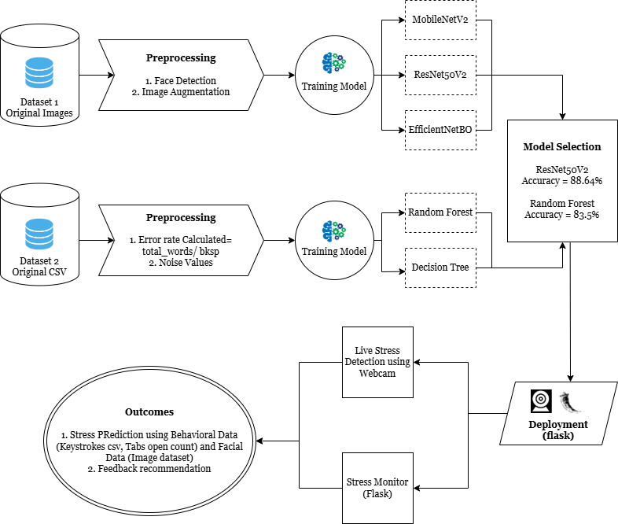
BEFORE - unnamed.png
REVISED image
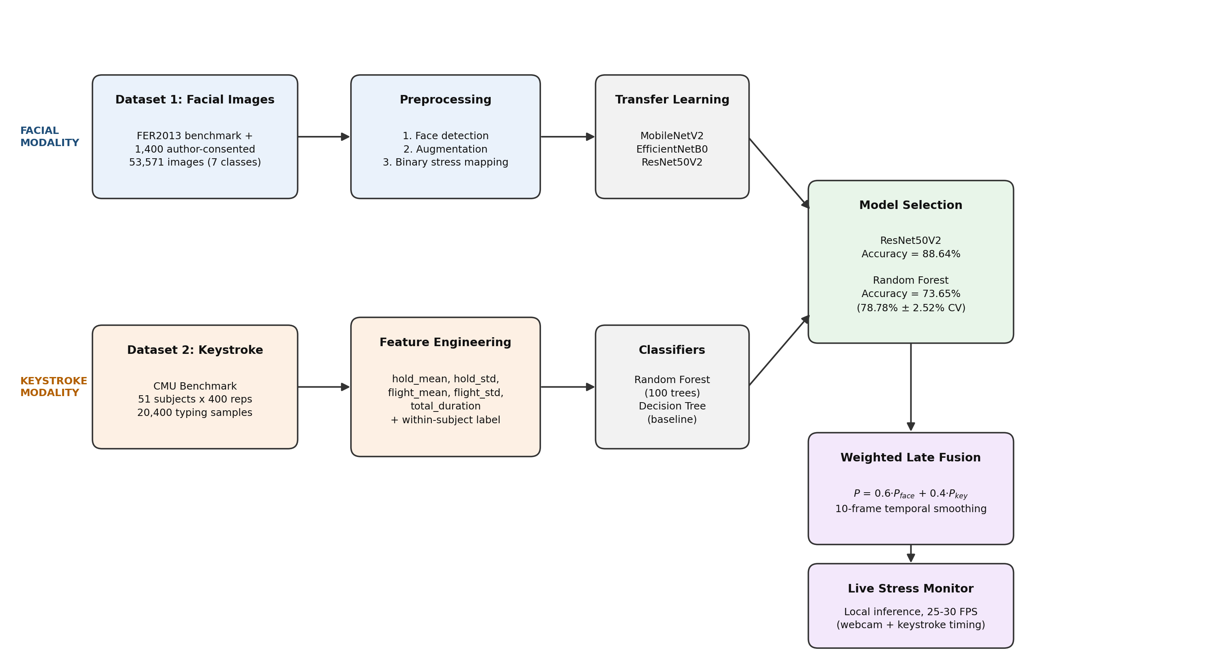
AFTER - unnamed.png

Figure 11 - Results (facial confusion matrices) [REGENERATED]
Why it changed
The original was produced by report code that ESTIMATED each confusion matrix from precision and recall (tp = stressed x recall, tn = not_stressed x accuracy) rather than loading the real matrix, so the image disagreed with the counts in the text. That bug was fixed in generate_comparison_report.py and regenerate_reports_only.py, and the figure regenerated from the real classification reports.
ORIGINAL image
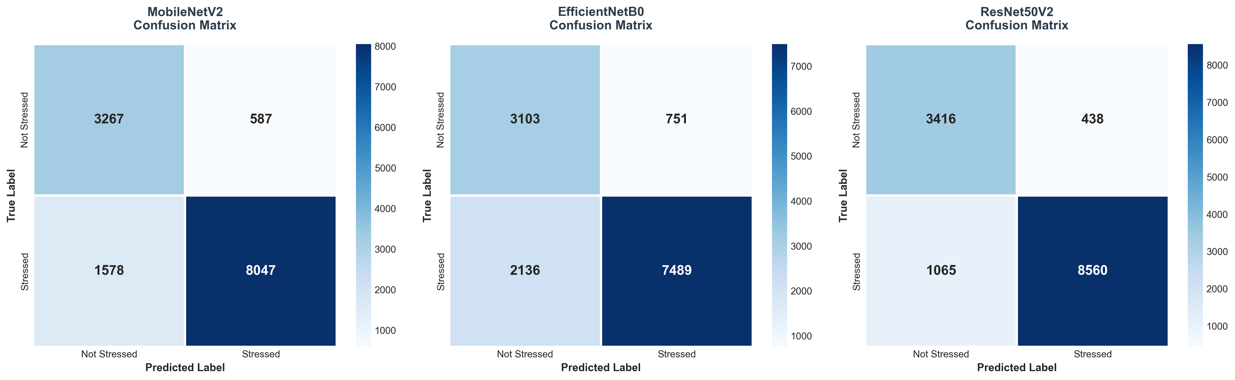
BEFORE - all_confusion_matrices.png
REVISED image
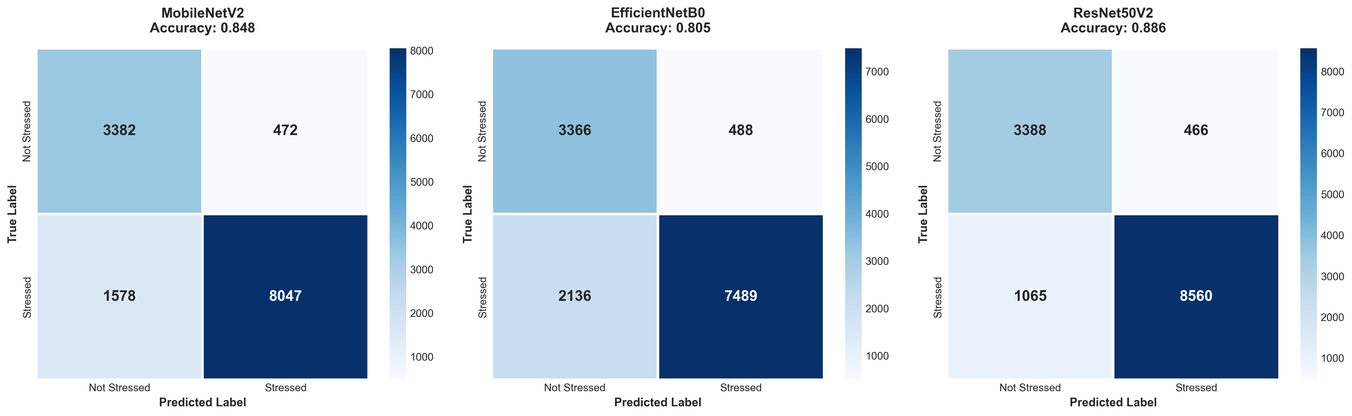
AFTER - all_confusion_matrices.png

Figure 12 - Results (keystroke confusion matrix) [REPLACED]
Why it changed
The original image was a screenshot showing counts 222 / 34 / 122 / 22, which do not correspond to any reproducible evaluation. Replaced with the real Random Forest test-set matrix: TN=2,169, FP=611, FN=443, TP=777 on 4,000 held-out samples (subject-disjoint). The file was also renamed from "WhatsApp Image 2025-11-13 at 11.31.37.png" to keystroke_confusion_matrix.png.
ORIGINAL image
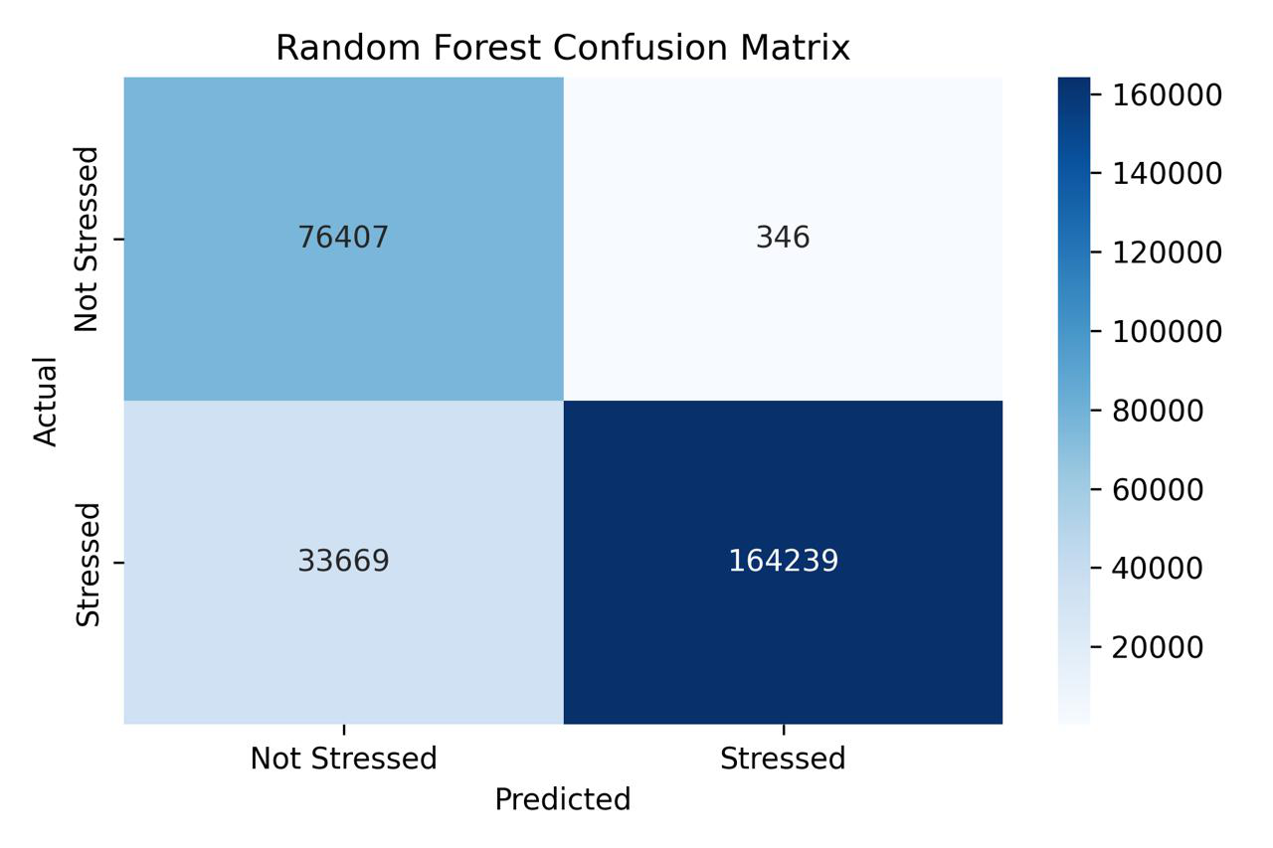
BEFORE - WhatsApp Image 2025-11-13 at 11.31.37.png
REVISED image
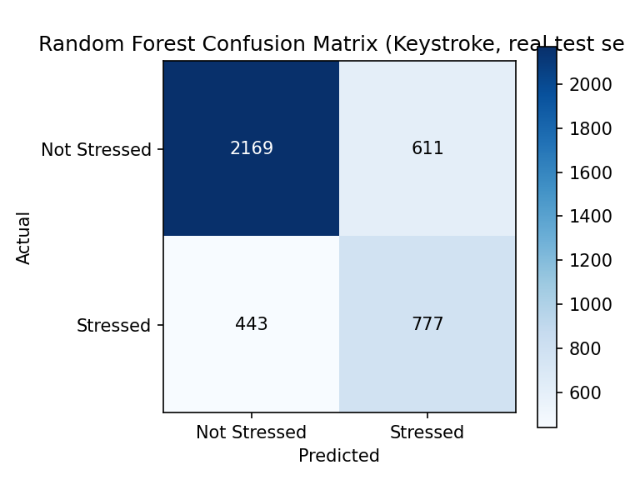
AFTER - keystroke_confusion_matrix.png

New figure (after Fig. 12) - Results (threshold optimisation) [ADDED]
Why it changed
Did not exist before. Shows precision, recall, F1 and specificity across the full threshold sweep on the validation split, with the selected tau* = 0.35 marked. Added because editor point 6 asked how thresholds were selected and whether they were tuned on validation data - this makes the answer visible rather than text-only.
NEW image
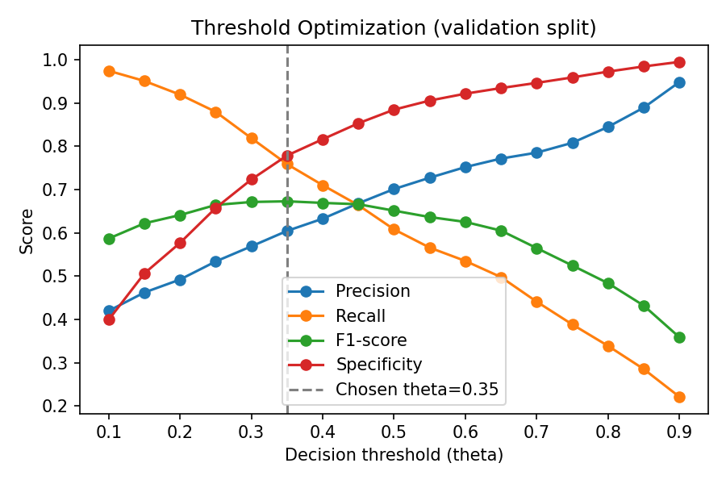
AFTER - keystroke_threshold_optimization.png

New figure (after the above) - Results (keystroke feature importance) [ADDED]
Why it changed
Did not exist before. Shows the measured Random Forest feature importance (flight_std 49.77%, total_duration 15.06%, flight_mean 13.52%, hold_std 13.04%, hold_mean 8.61%). The percentages were previously quoted in the text with no supporting figure.
NEW image
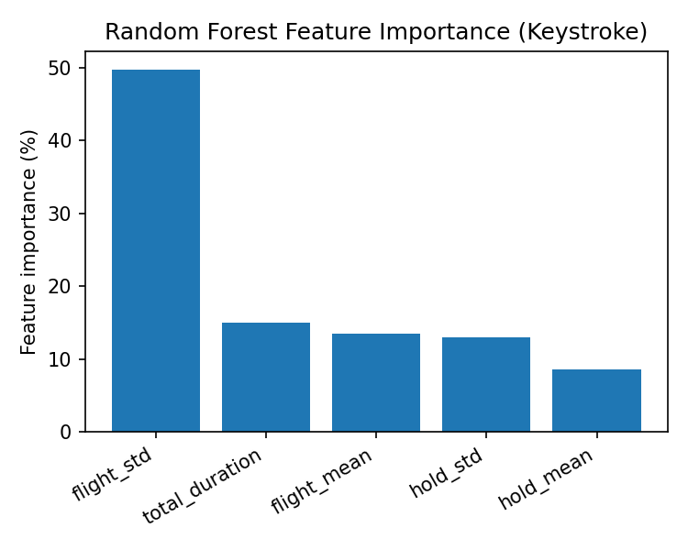
AFTER - keystroke_feature_importance.png

Part C - Checked and Deliberately Left Unchanged
These were examined during the revision and required no change. Listed so the record is complete and it is clear they were not overlooked.
Table 5 (facial model comparison)
Needed no correction - the values (MobileNetV2 0.85/0.94, EfficientNetB0 0.81/0.75, ResNet50V2 0.89/0.83) already matched the real metrics.json files. Only the surrounding prose was wrong, not the table.

Figures 1, 2, 3 (dataset preview and class distributions)
Unchanged. Verified against dataset_count_report.json - the class counts and totals (28,300 original train / 40,096 balanced train / 53,571 total) are correct.

Figures 5-10 (per-model training history and confusion matrix + ROC)
Unchanged. These were already generated from the real training runs.

Figures 13-15 (real-time interface screenshots)
Images unchanged; only their captions were revised to drop the 93.7% claim. NOTE: if the 93.7% value is legible inside the screenshot pixels themselves, these images should be retaken so they do not contradict the corrected caption.

Ethics Approval, Informed Consent for Image Publication, Authors' Contributions, Funding, Competing Interests
Unchanged. Reviewer 2 confirmed in the prior revision round that the consent and ethics statements were satisfactory.

Related Work, Model Architectures (MobileNetV2 / EfficientNetB0 / ResNet50V2 descriptions), Two-Phase Training Protocol, Algorithm 1
Unchanged - these described the facial pipeline accurately and required no correction.

