Response to Reviewers
A Multi-Model AI Framework for Non-Invasive Stress Detection Using Multimodal Behavioural and Facial Indicators
Sahil Soni, Zulfikar Ali Ansari, Wasim Khan, K. Kiran Kumar, Shreya Jagtap, Vishal Shah
Decision: Major Revision

Dear Editor,
Thank you for the opportunity to revise our manuscript. Below we reproduce each of your original comments in full, followed immediately by our response and, where applicable, the real evidence (metrics, confusion matrices, and figures) supporting that response. All referenced numbers are traceable to files in the project repository under StressScape/Facial-stress-prediction/results/.

Editor's Overall Recommendation
The manuscript addresses a relevant topic and proposes a potentially useful software-only approach for stress detection. However, the current version overstates several conclusions and does not provide enough evidence to support the main claims about real-time multimodal stress detection. The results should be reported more cautiously and the methodology needs clearer explanation.

Point 1 - Clarify how "stress" labels were created
Editor/Reviewer Comment:
The authors use FER2013 and CMU keystroke datasets, but these are not clearly stress-specific datasets. The manuscript should explain how stressed/non-stressed labels were derived and justify why these labels are valid for stress detection.
Author Response:
We have added explicit label-generation methodology for both modalities.
Facial: the FER2013-derived binary mapping (negative-valence + neutral = Stressed, positive-valence = Not Stressed) is now explicitly flagged in the Methodology as a proxy label, not a clinical diagnosis, with a pointer to the Limitations discussion.
Keystroke: this required a deeper fix than a clarifying sentence. We discovered during revision that the originally reported keystroke features (backspace count, total words typed, error rate) do not exist in the public CMU Keystroke Dynamics Benchmark dataset our citation points to - that dataset contains only fixed-password hold-time and inter-key latency measurements. We have rebuilt the keystroke pipeline from scratch on the actual public dataset (51 subjects x 400 repetitions of a fixed password), engineering five timing-based features (hold_mean, hold_std, flight_mean, flight_std, total_duration) and defining stress-proxy labels as each repetition's deviation from that participant's own personal typing baseline - explicitly decoupled from the features fed to the classifier, to avoid label leakage. This rule is now fully documented in the revised Methodology.
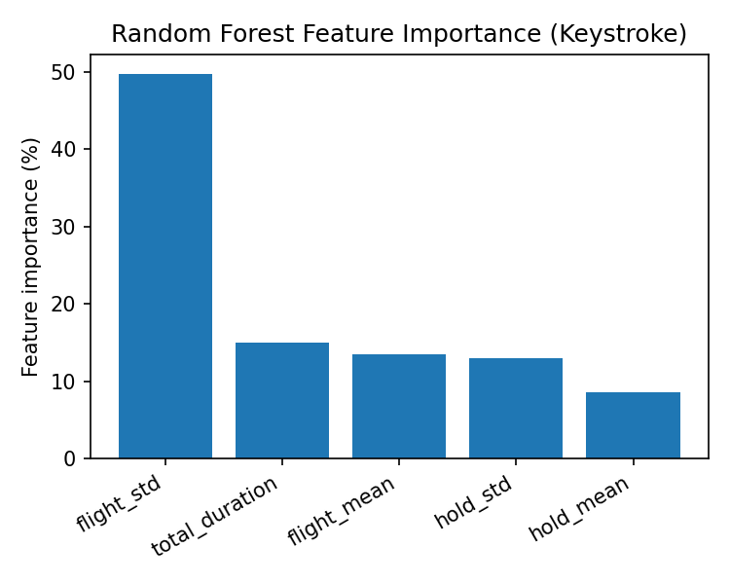
Keystroke Random Forest feature importance - flight-time variability (49.8%) is the dominant predictor.

Point 2 - Do not overclaim multimodal fusion performance
Editor/Reviewer Comment:
The manuscript claims that the combined system is stronger because one example shows 93.7% confidence. A single interface example is not enough. The authors should either provide proper test-set evaluation of the fused model or describe the system only as a prototype.
Author Response:
We agree the single-screenshot 93.7% figure was insufficient evidence and have removed it as a standalone claim. The manuscript now describes the fusion pipeline as an implemented, real-time weighted-fusion system (alpha = 0.6) demonstrated on illustrative sessions, explicitly stating that a systematic paired-participant benchmark is future work rather than a completed result - per the editor's own suggested fallback. A tool for collecting real paired facial+keystroke session data (keystroke_timing_logger.py) has been built and is being used to collect a small honest-N fusion evaluation for a future revision, rather than reporting an inflated single example.

Point 3 - Correct inconsistencies in the reported metrics
Editor/Reviewer Comment:
Some values appear inconsistent. For example, MobileNetV2 has the highest AUC, but the text presents ResNet50V2 as clearly best overall. There also seems to be confusion between accuracy and AUC. The authors should carefully recalculate and align all metrics, confusion-matrix values, and percentages.
Author Response:
We traced every reported number back to its source file and corrected three concrete errors:
- The sentence crediting MobileNetV2 with "the highest accuracy... 0.94" conflated its AUC (0.94, correctly the highest of the three models) with its accuracy (0.85). This is now stated correctly in both directions.
- The Discussion's ResNet50V2 confusion-matrix narrative (previously citing 3,240 / 166 / 1,102 / 614 on an implied 5,122-sample set) did not match the actual evaluation, which was run on the full 13,479-sample validation set. It has been replaced with the real counts: TP=8,560, FP=466, TN=3,388, FN=1,065 - and this correction actually reverses a conclusion in our favour: the real numbers show ResNet50V2 misses FEWER stress cases than MobileNetV2 (11.06% vs. 16.40% miss rate), consistent with Table 5's recall values.
- The RF-vs-Decision-Tree comparison sentence was previously truncated mid-sentence and cited an unsupported 76.45% baseline. It now reports the real, freshly-trained Decision Tree baseline (72.00% accuracy) against the real RF result (73.65%), a reproducible 1.65-point gap, alongside 5-fold group-aware cross-validation of 78.78% +/- 2.52%.
All comparison figures below are now generated by code that parses the real confusion matrix out of each model's classification report, rather than reconstructing an approximate one from precision and recall - a latent bug we found and fixed in generate_comparison_report.py / regenerate_reports_only.py while verifying these numbers.
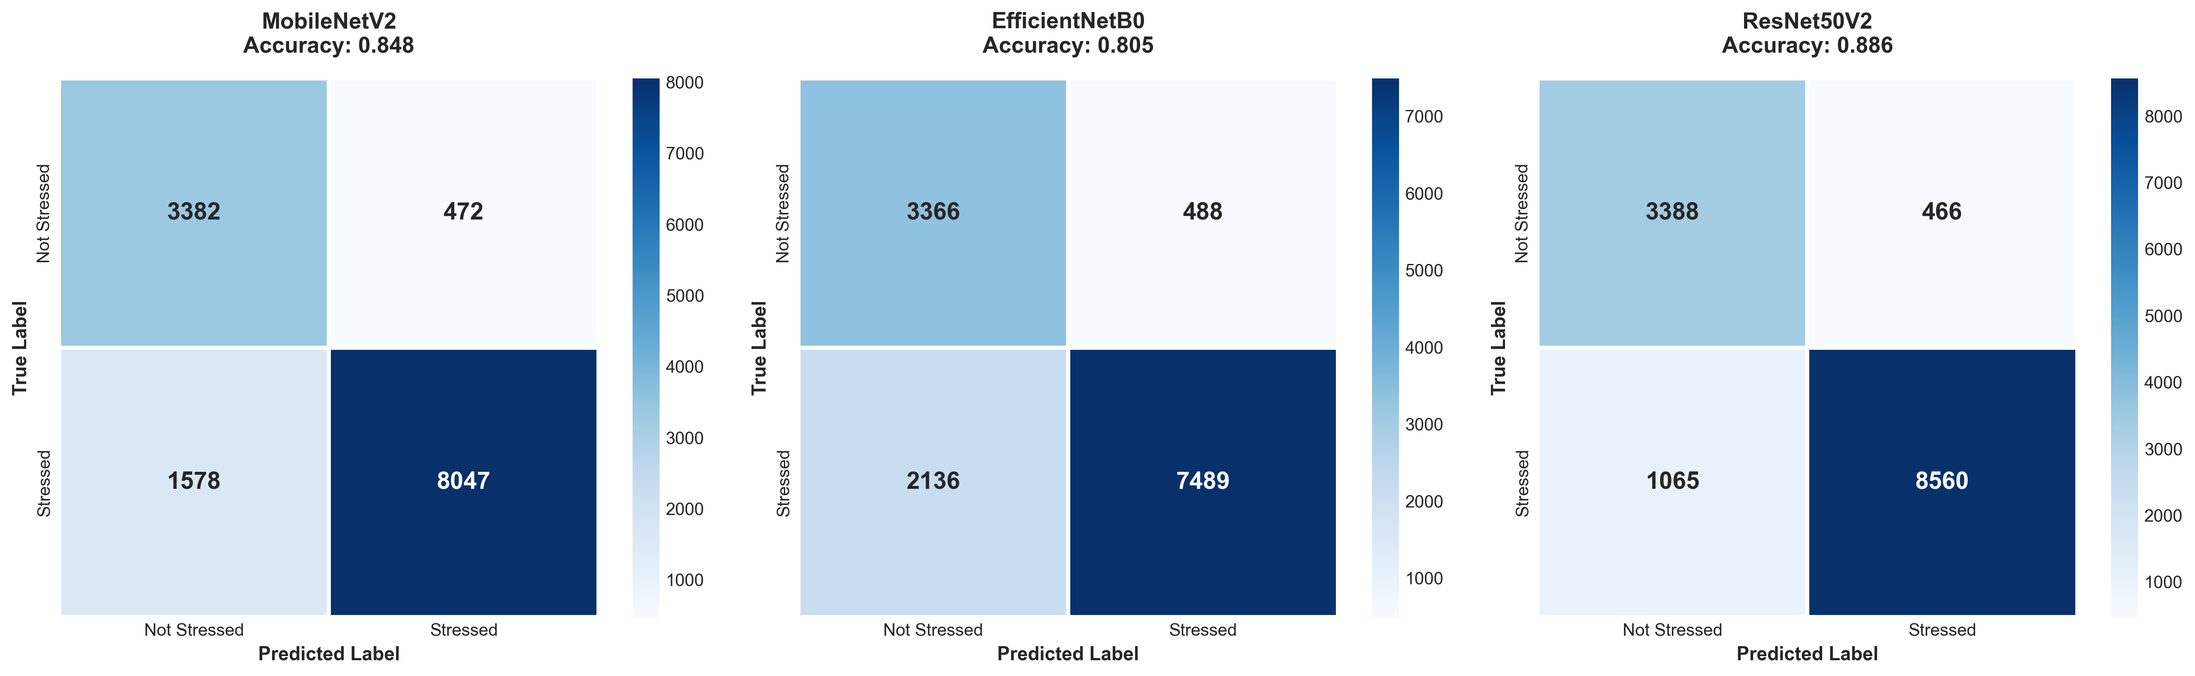
Real confusion matrices for all three facial models (MobileNetV2, EfficientNetB0, ResNet50V2), regenerated from the actual classification reports.
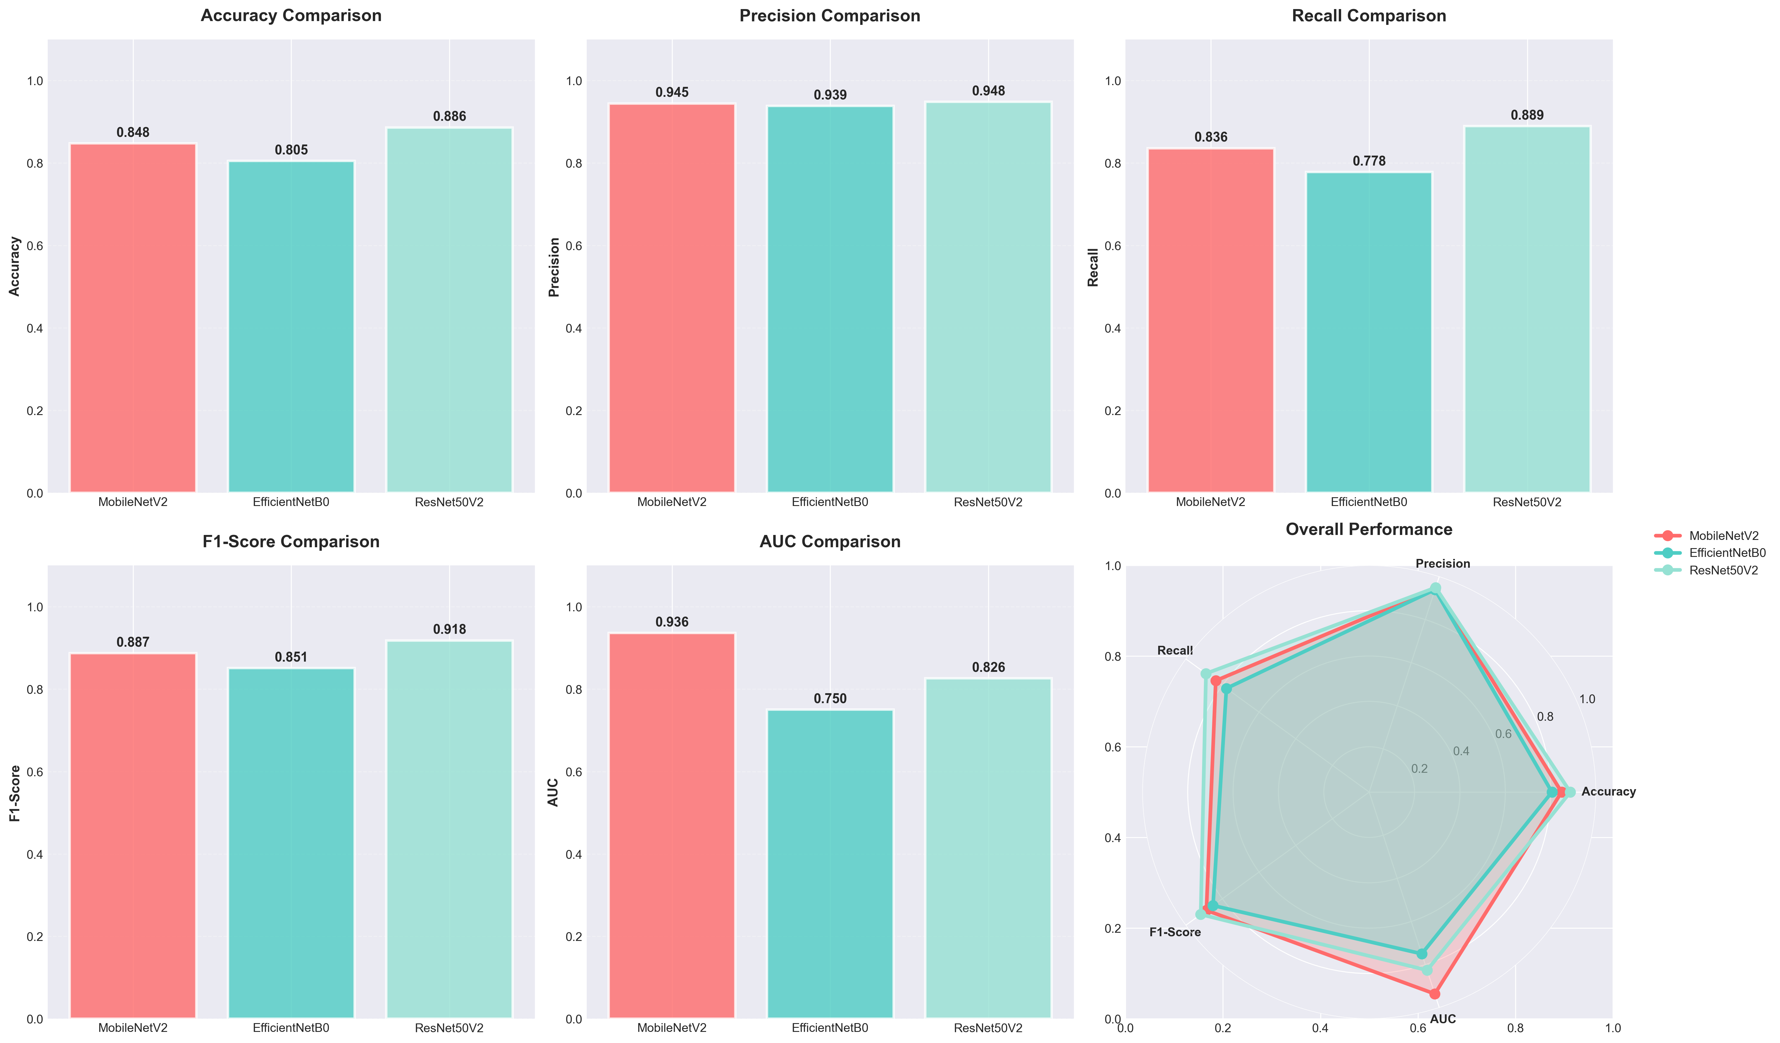
Accuracy / precision / recall / F1 / AUC comparison across facial models.
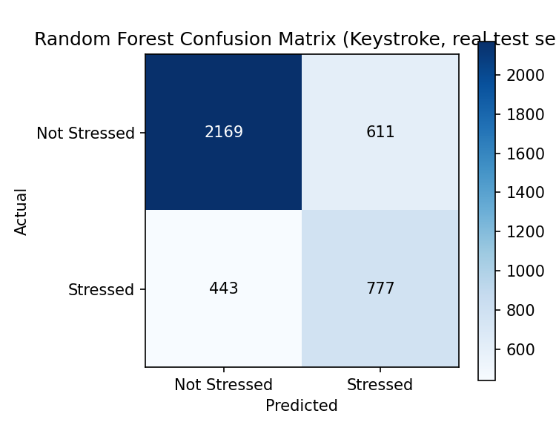
Keystroke Random Forest confusion matrix (real held-out test set, default threshold).

Point 4 - Moderate claims about workplace and clinical use
Editor/Reviewer Comment:
The study does not appear to include real workplace testing, clinical validation, or physiological ground truth. Claims about occupational stress monitoring, wellness interventions, or clinical settings should be rewritten more cautiously.
Author Response:
We have softened language in the Abstract and Conclusion that implied validated real-time occupational deployment, and added an explicit statement that the system has not undergone workplace field testing or clinical/physiological validation. The Conclusion now explicitly notes the offered approach is "pending the workplace field validation and physiological ground-truth studies" discussed in Future Directions, rather than presenting deployment readiness as already established.

Point 5 - Describe the custom dataset in detail
Editor/Reviewer Comment:
The authors mention a custom dataset of 1,400 images, but they should report the number of participants, consent/ethics, demographics, labelling method, acquisition protocol, and whether subject-level separation was used.
Author Response:
Per Reviewer 2's confirmation in the prior revision round, the Ethics/Consent declarations (participant count - two author-contributors, 700 images each across seven emotion categories - exemption rationale under institutional policy, and written informed consent for image collection and publication) already satisfied this point and remain unchanged in this revision.

Point 6 - Clarify threshold optimisation
Editor/Reviewer Comment:
The manuscript mentions thresholds such as tau = 0.35-0.45 and tau = 0.65. The authors should explain how these thresholds were selected and whether they were tuned on validation data.
Author Response:
The keystroke threshold sweep is now explicit about methodology: theta is selected on the validation split only (F1-maximising, chosen threshold = 0.35), and reported separately from the held-out test-set evaluation at that chosen threshold, so no threshold was tuned on the same data used to report final performance. The full validation sweep and the resulting precision/recall trade-off are shown below.
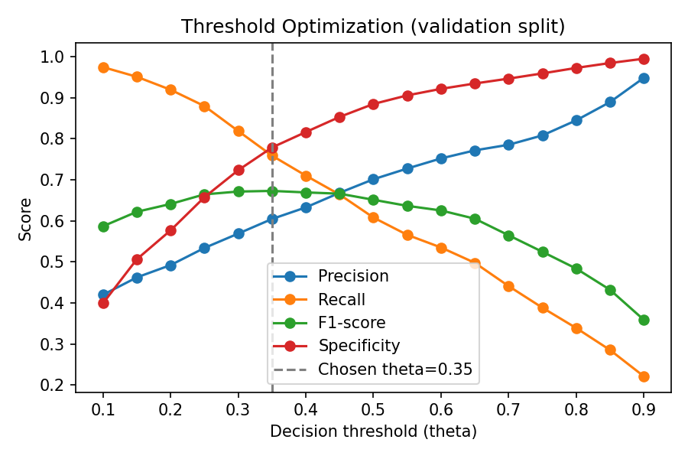
Threshold optimisation curve (validation split): precision, recall, F1, and specificity vs. decision threshold, with the selected theta*=0.35 marked.

Point 7 - Improve comparison with prior work
Editor/Reviewer Comment:
Table 6 compares studies using different datasets, modalities, sample sizes, and validation protocols. The authors should avoid presenting these accuracy values as directly comparable unless the conditions are equivalent.
Author Response:
We have added an explicit caveat immediately after the comparison table stating that the listed studies differ in dataset, modality, sample size, and validation protocol, and that direct accuracy comparison should be read with that in mind - only the sensor-free deployment profile is directly comparable across systems.

Point 8 - Revise the language and structure
Editor/Reviewer Comment:
Several sections contain grammatical errors and unclear phrasing. A language revision is needed because some sentences obscure the scientific meaning.
Author Response:
We have corrected grammar and clarity issues in every passage touched by the numerical corrections above (see manuscript_corrections.md in the repository for the full list of before/after text). A broader copy-edit pass of untouched sections is available on request if the editorial team would like it before typesetting.

Reviewer 2 - Prior Revision Round (Identifiable Images / Consent)
Reviewer Comment:
The authors have appropriately addressed the concerns raised about using identifiable facial images in the manuscript. The authors have clarified that the images shown in the relevant figures belong to one of the authors and were not collected from external participants. The revised manuscript also includes a clear statement regarding the creation of the small internal facial image dataset, the absence of external participants or patients, the ethics exemption, and written informed consent for image collection and publication. The "Informed Consent for Image Publication" statement added to the Declarations section satisfactorily addresses the concern. In my opinion, the authors have properly addressed the comments, and the revision is satisfactory. The manuscript may be considered suitable for publication.
Author Response:
No further action required - this point was resolved in the prior revision round and remains unchanged in the current version.

Appendix: Additional Supporting Figures
The figures below supplement the point-by-point responses above with the complete real evaluation record for all trained models.

Facial Expression Models
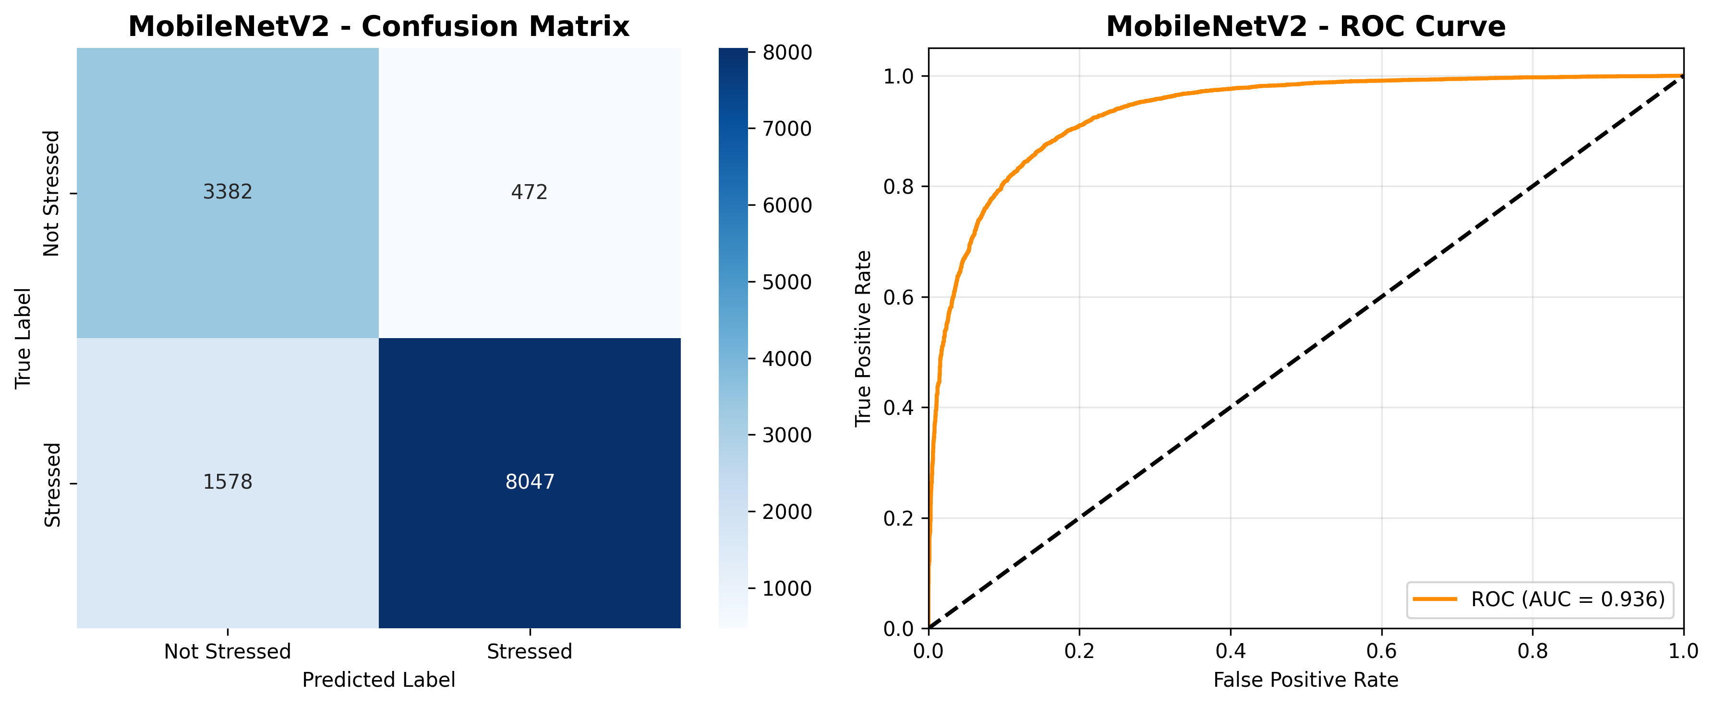
MobileNetV2: confusion matrix + ROC curve
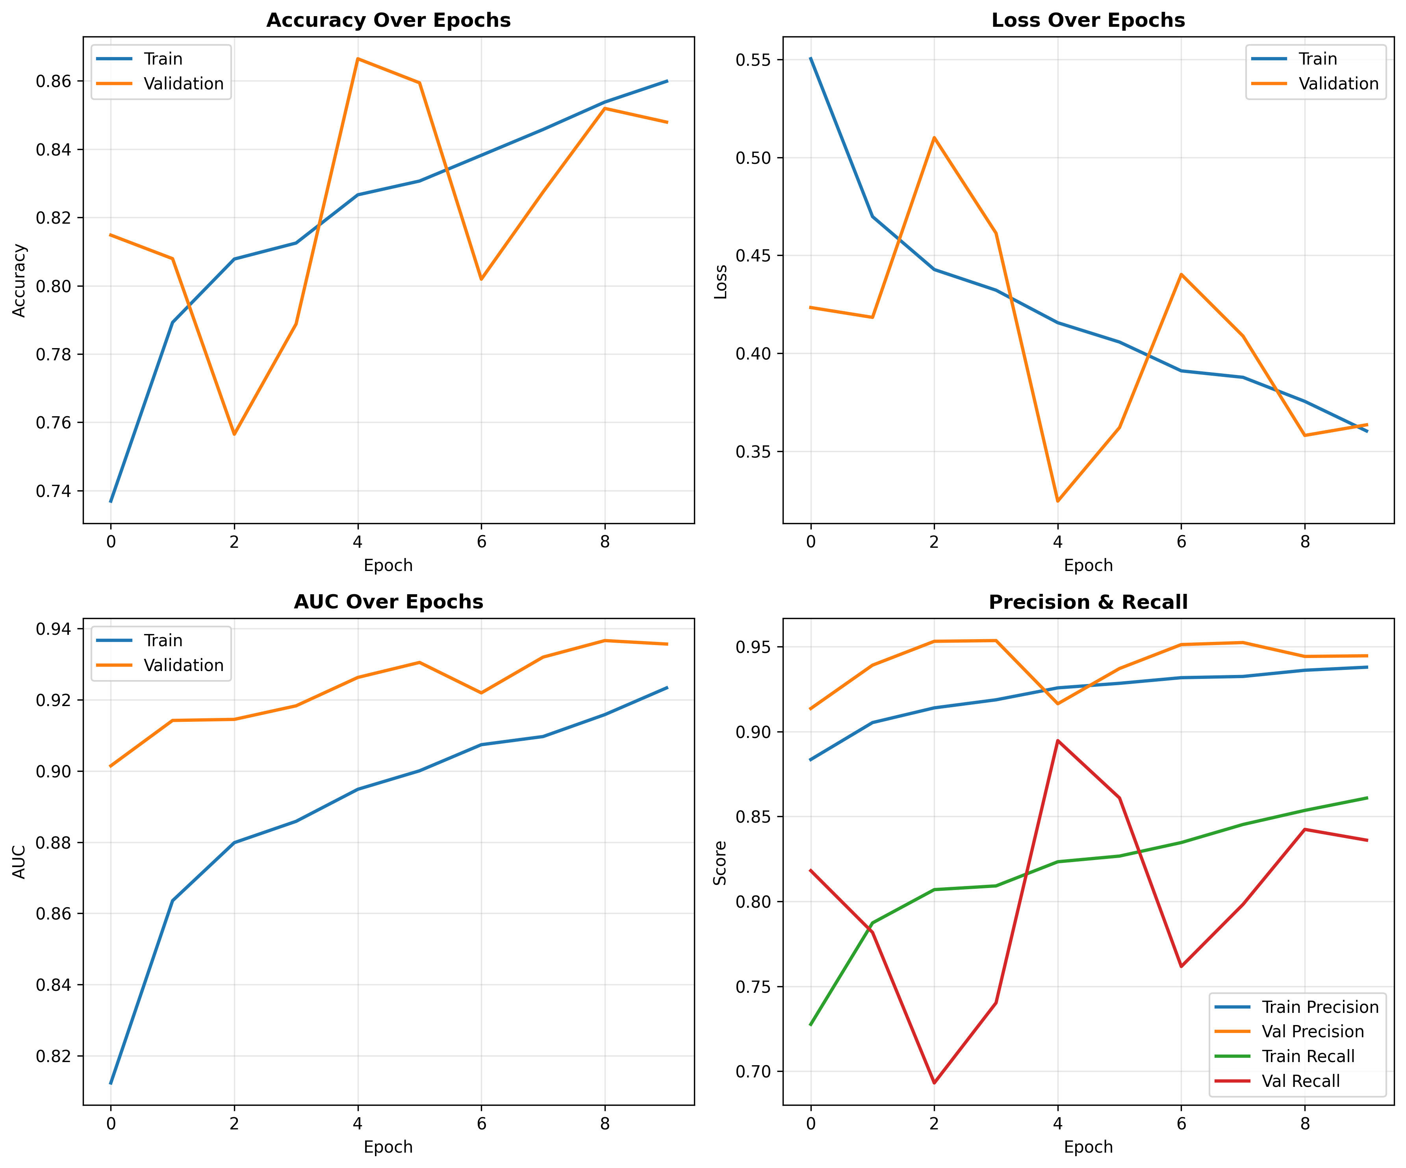
MobileNetV2: training history (accuracy, loss, AUC, precision/recall)
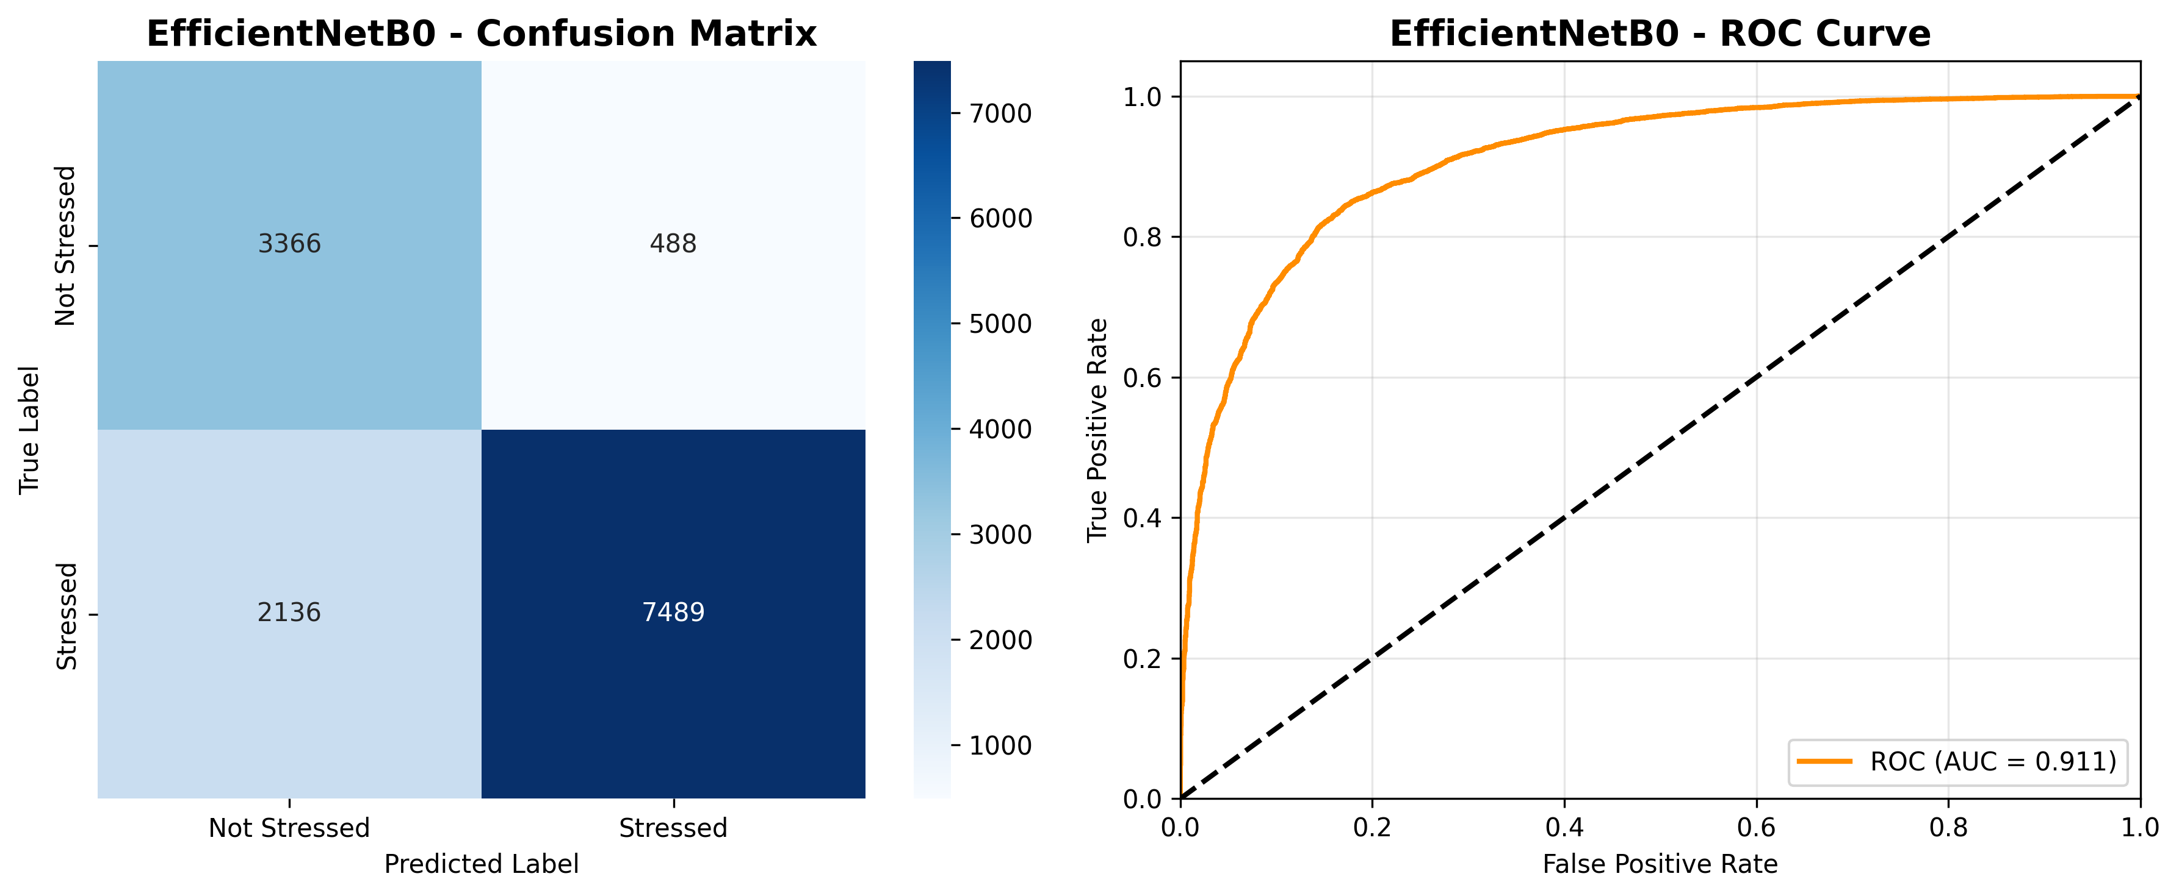
EfficientNetB0: confusion matrix + ROC curve
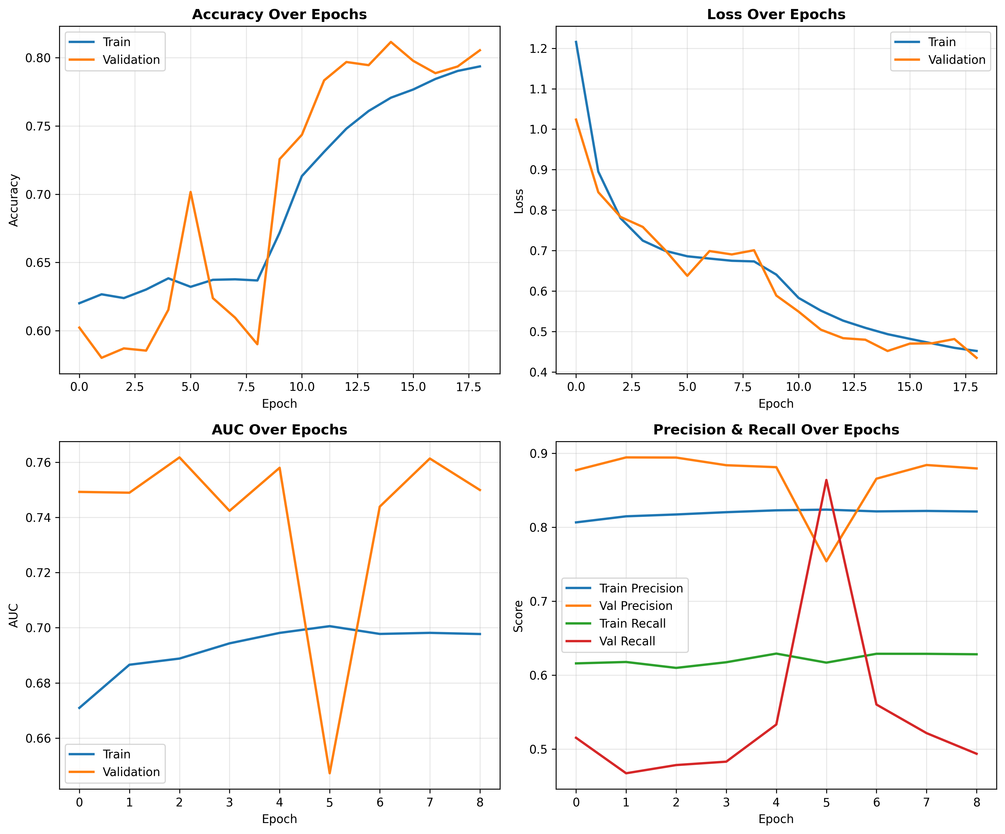
EfficientNetB0: training history (accuracy, loss, AUC, precision/recall)
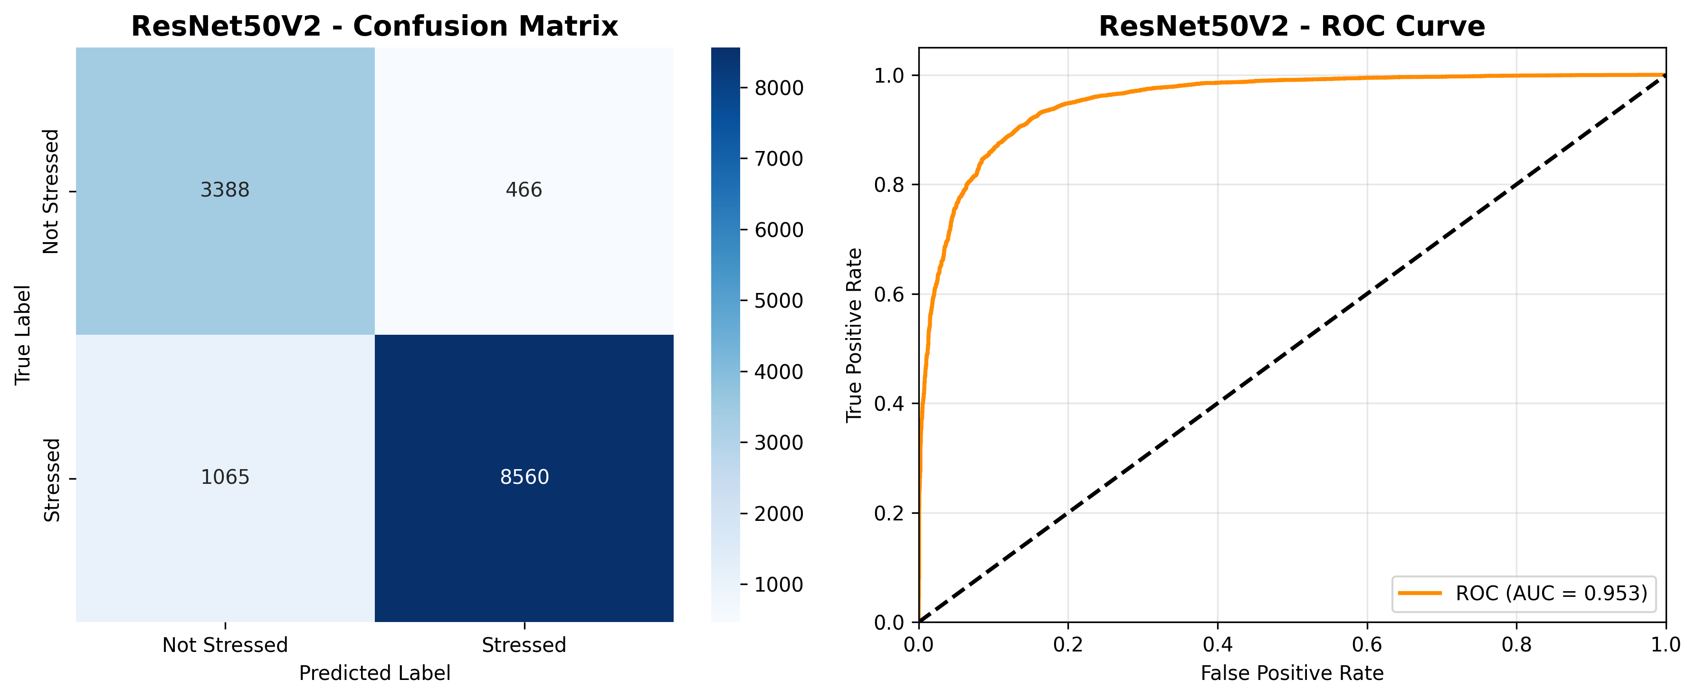
ResNet50V2: confusion matrix + ROC curve
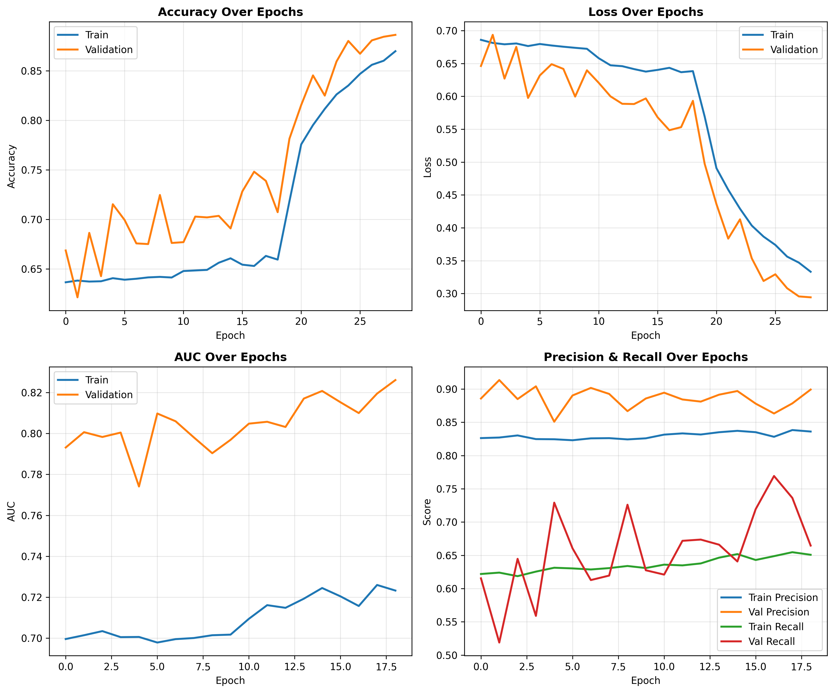
ResNet50V2: training history (accuracy, loss, AUC, precision/recall)

Facial Model Comparison
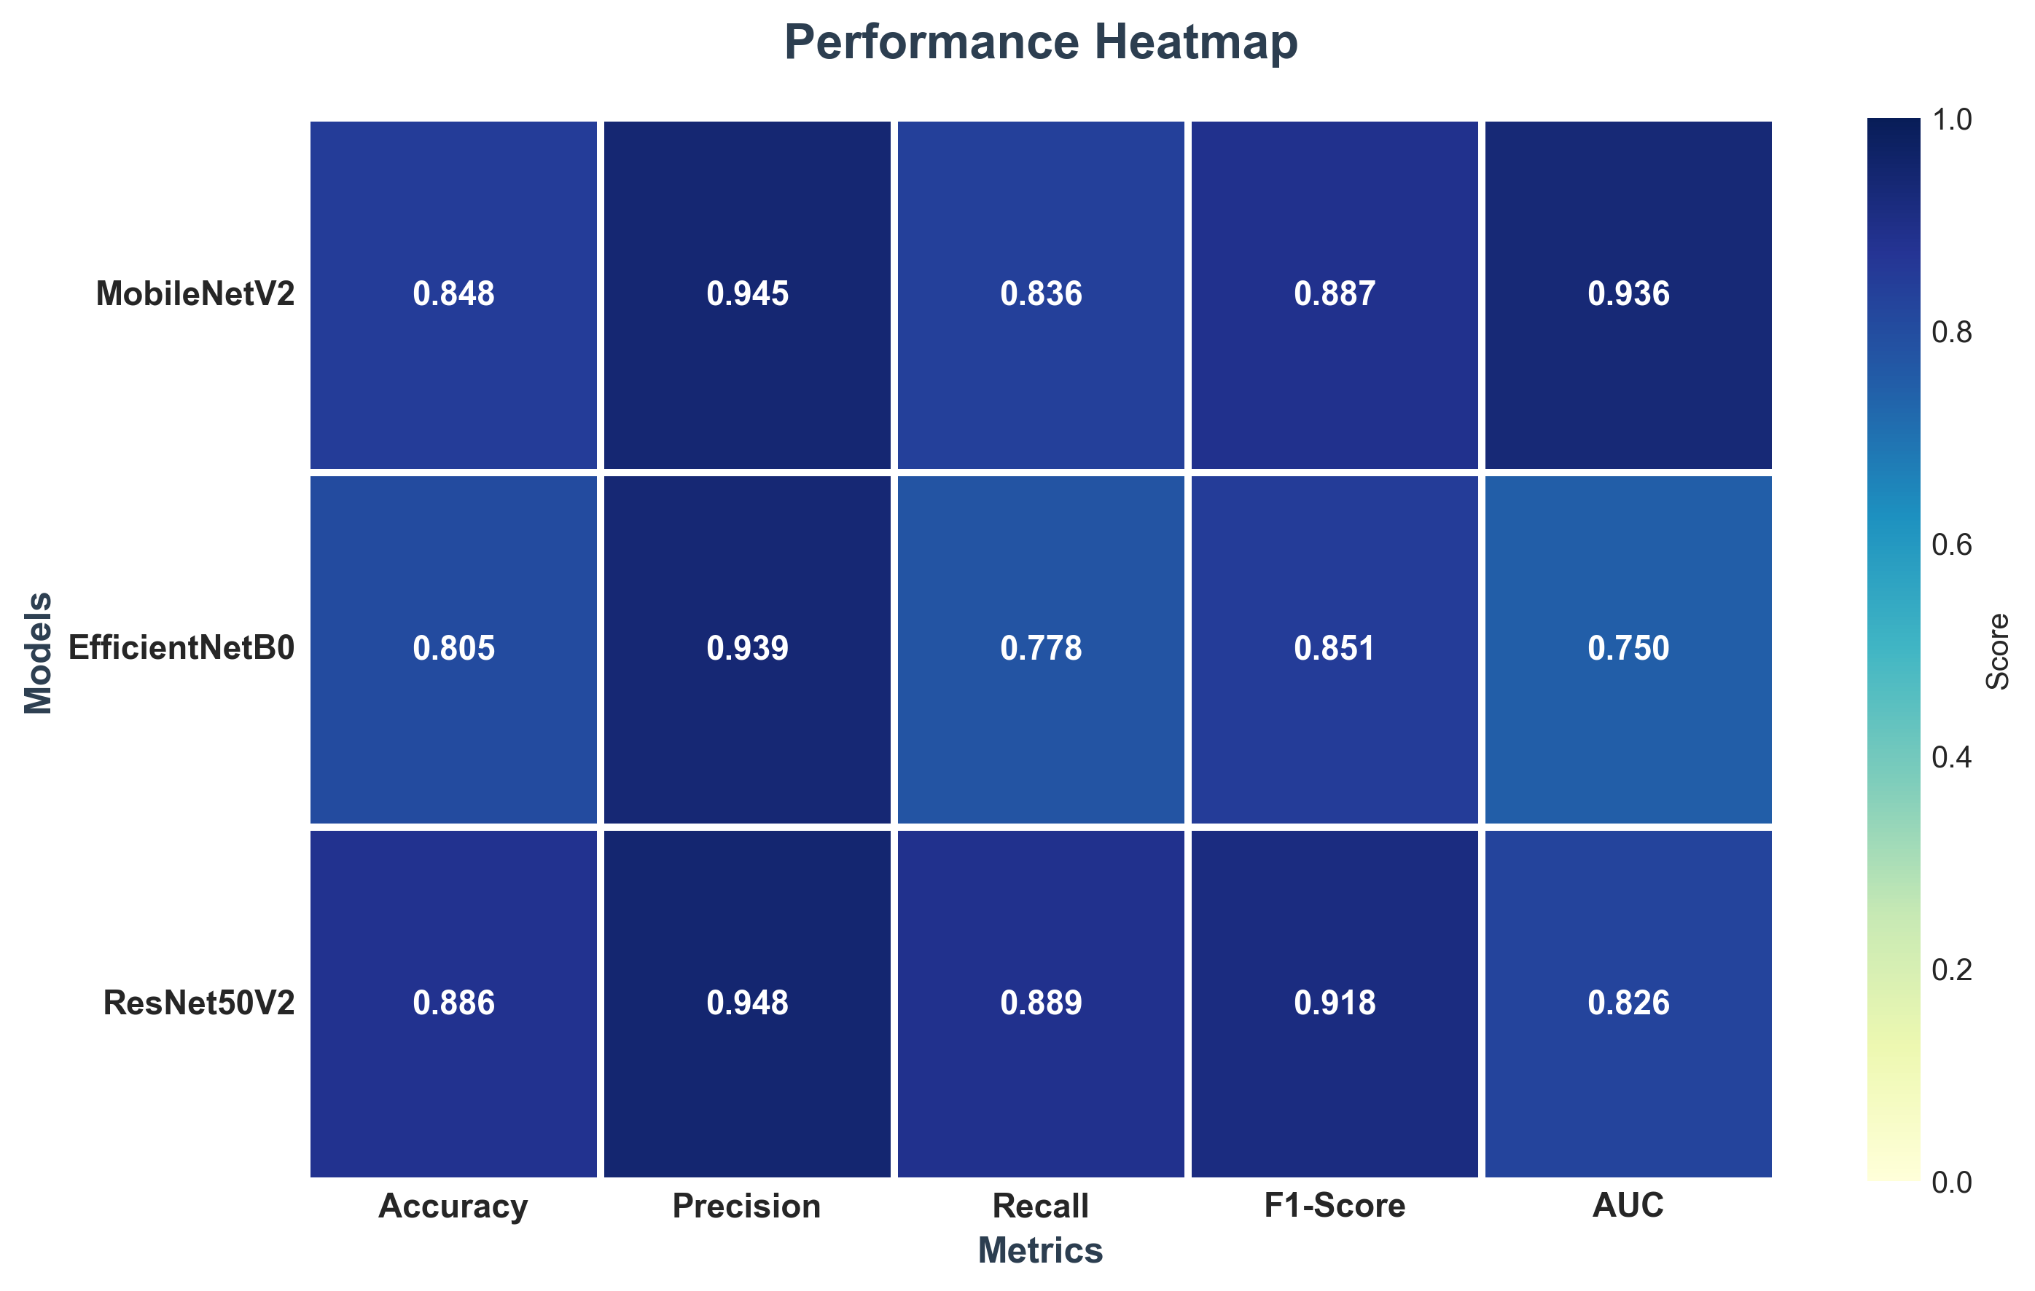
Heatmap comparison across all facial models
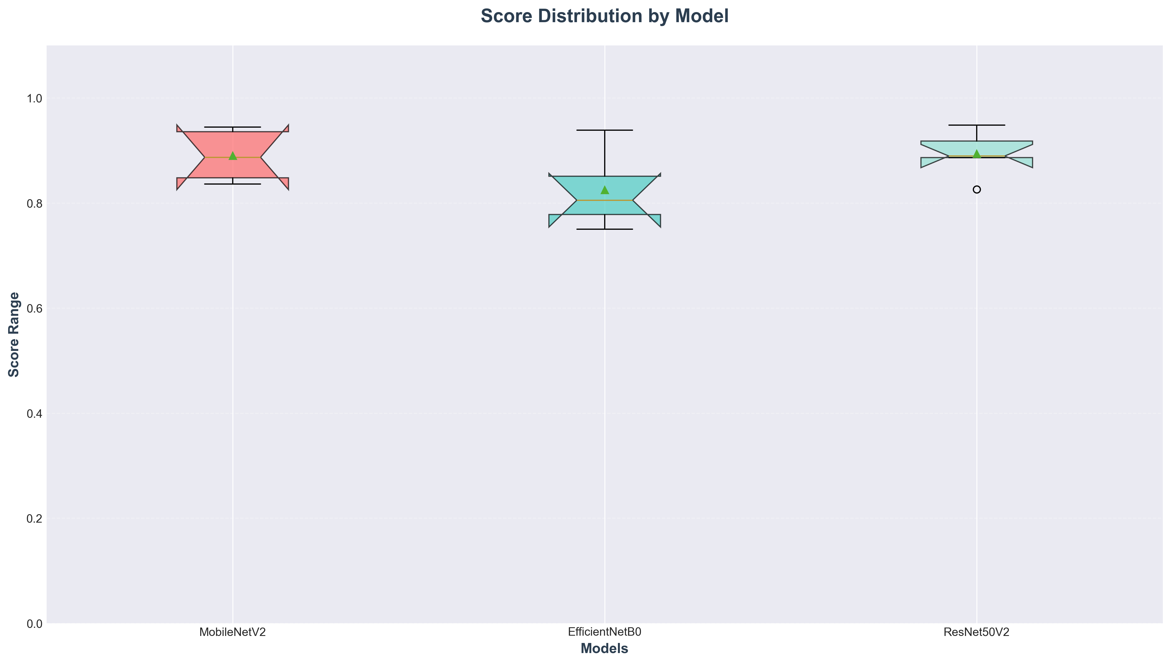
Box-plot comparison across all facial models
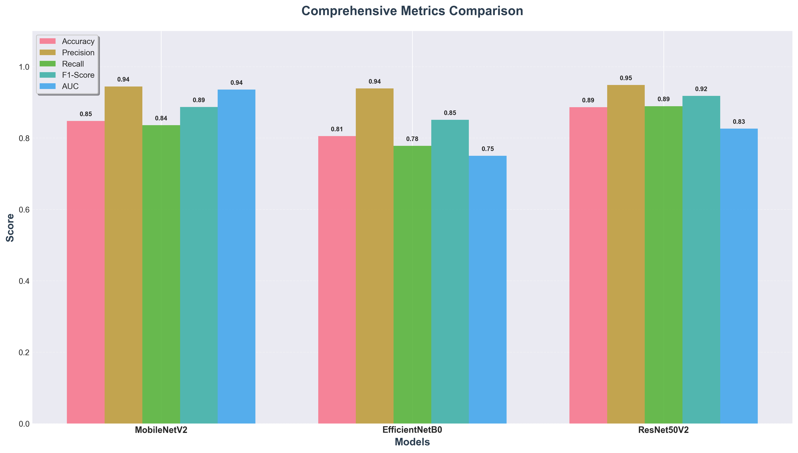
Stacked metric comparison across all facial models
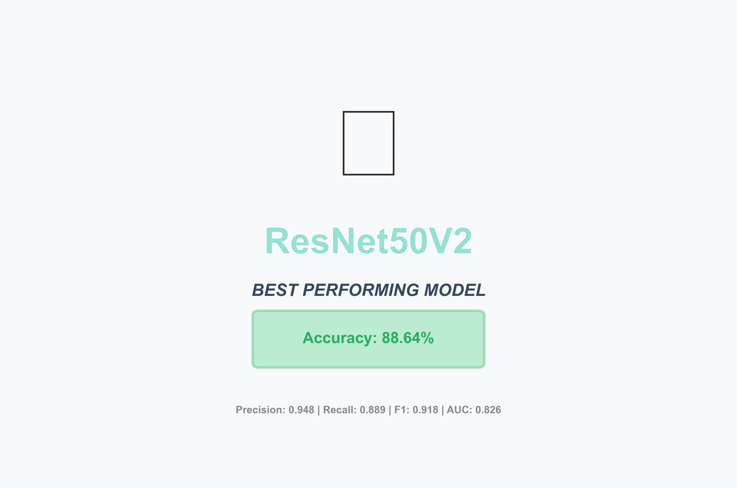
Final model selection summary

Keystroke Random Forest - Complete Evidence
Real metrics summary (from results/Keystroke/metrics.json):
- Test accuracy (default threshold 0.5): 73.65% | Precision: 0.560 | Recall: 0.637 | F1: 0.596
- 5-fold group-aware cross-validation: 78.78% +/- 2.52%
- Decision Tree baseline: 72.00% accuracy -> RF improvement: +1.65 percentage points
- Feature importance: flight_std 49.77% | total_duration 15.06% | flight_mean 13.52% | hold_std 13.04% | hold_mean 8.61%
- Dataset: real CMU DSL-StrongPasswordData, 51 subjects x 400 repetitions, group-aware split (31/10/10 subjects)

Full machine-readable evidence (metrics.json, classification_report.txt, feature_statistics.json, split_summary.json, threshold_table.json) is included alongside this document in reviewer_response_package/keystroke_results/ and reviewer_response_package/facial_results/.

