Gebze Technical University
Computer Engineering

CSE 222
2017 Spring

HOMEWORK 1 REPORT

ŞAHİN EĞİLMEZ
131044059

Course Assistant:
1. System Requirements

-JAVA 1.8
-INTELIJ IDEA 2015
-CSV FILES
-GO TO OTHER DETAİLS

2. Use Case Diagrams

3. Class Diagrams

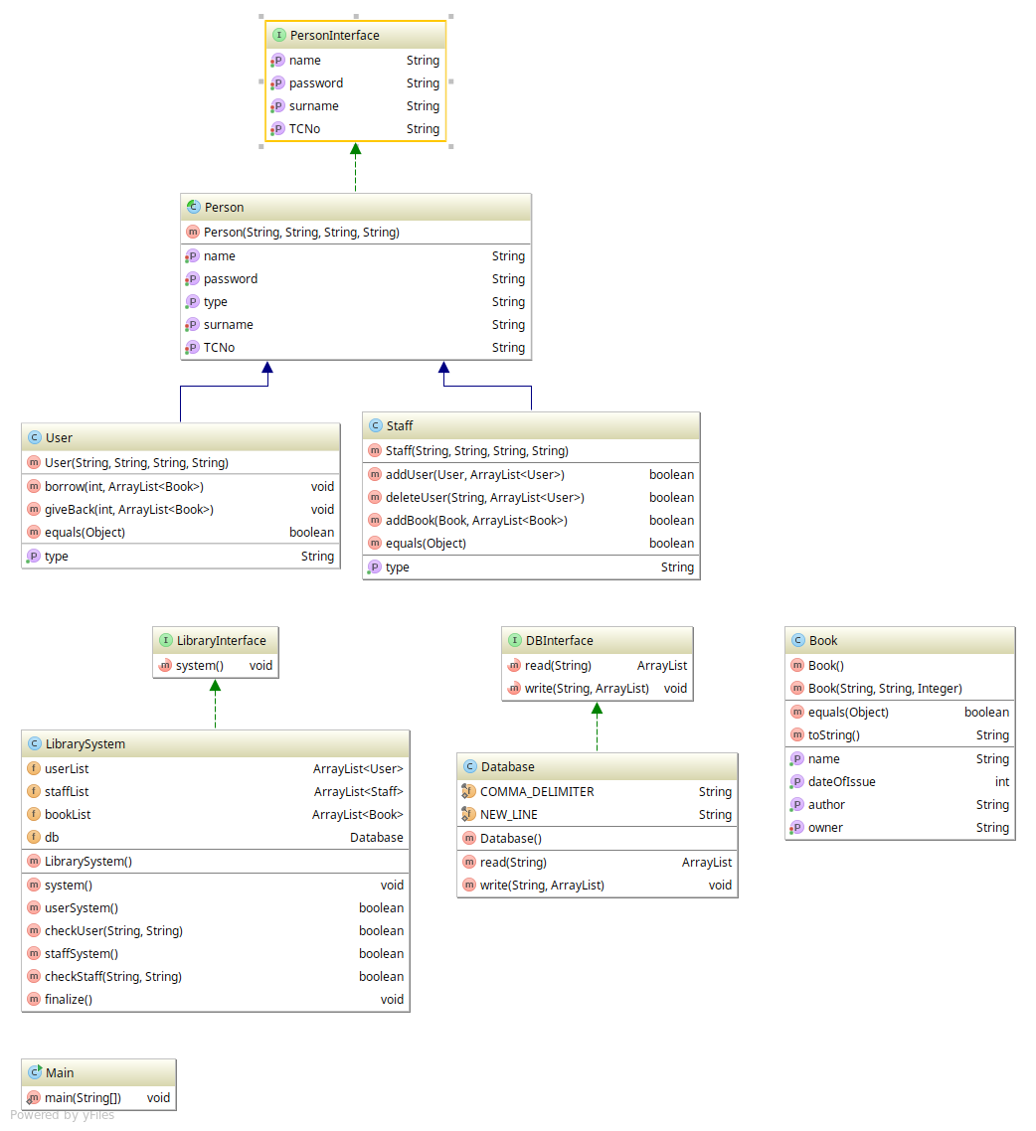

4. Other Details

Program start admin staff account : TC ID : 00000000000 PASSWORD : 1

GITHUB REPOSITORY : https://github.com/SahinEgilmez/Homeworks/tree/master/131044059_hw1

5. Problem Solutions Approach

First, I decided to keep the data of users and staffs separately. Because they have different features. The data of the books had to be kept separate. I needed to create three files and save the data. Database class does this by reading and writing methods. Users and employees are derived from the Person class because they are individuals. I started by giving the staffs the task of adding books and users. Then I made the users tend to borrow books and give them the ability to give. Lastly I gave special tasks such as changing the password. When the problem is handled, the data is read from the files first, then the operations are done and the last file is written. That is, the data will be lost when an extraordinary program ends.

6. Test Cases

The program starts with one registered in the admin account. Without this account, it would not be possible to progress because there would not be a staff to make additions. This account's tc ID number is 00000000000. This number was entered, the user and books were added and the situation was tested. As a result, the system passed the test.

Users:

29954102608,ŞAHİN,EĞİLMEZ,1
25647852688,FERHAT,GUZELSU,1
Staffs:

00000000000,admin,admin,1
12551496676,ONDER,TUNA,1
Books :
Fareler ve insanlar,Johm steinbeck,1905,29954102608
Tutunamayanlar,Oguz Atay,1970,00000000000
Beyaz Kurt, Jack London,1880,29954102608
suç ve ceza,dosto,1850,29954102608
kumarbaz,dosto,1855,29954102608
ince mehmed,yaşar kemal,1940,2564785268

7. Running and Results

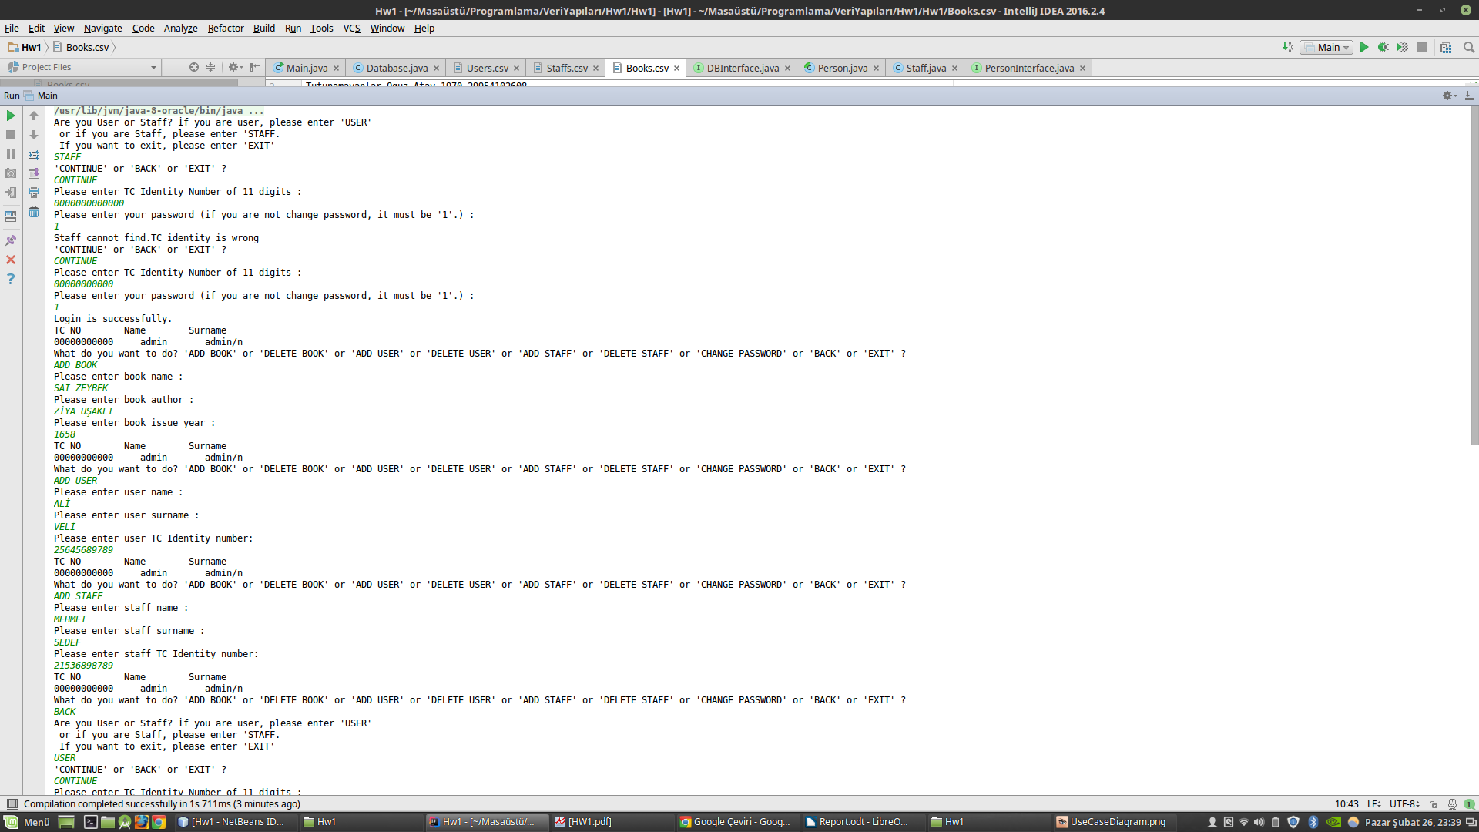

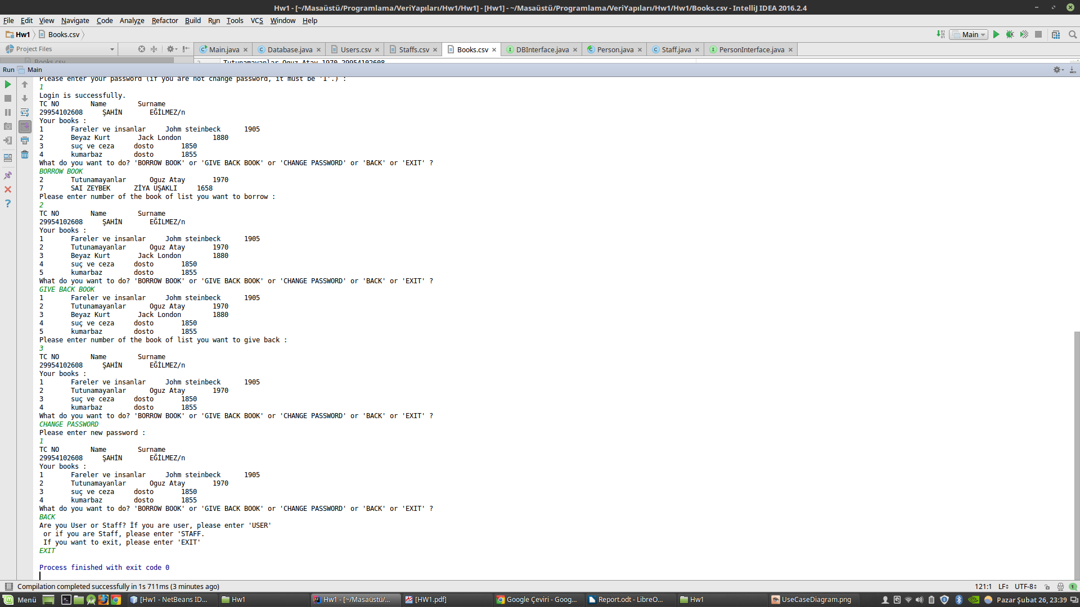

Q2. In the concept of ADT, Java provides encapsulation that ensures the access to data using only specific methods and the development of data structures independently from data type. How can C programming language provide these features?

-Structures can be used to encapsulate with the C language. The variables used in the structures to be written and functions for the use of other properties are written. Each feature and function is described in the form of use, adding a commentary line. However, since there are no mechanisms such as public or private in C language, the encapsulation process remains the information of the programmer who uses the written code. That is, the programmer can directly access the features in the structure, not the functions specified, but make the system useless. Because of this, the encapsulation process can not be performed with full certainty. However encapsulation can be achieved in the closest way.

