Gebze Technical University
Computer Engineering

CSE 222
2017 Spring

HOMEWORK 2 REPORT

ŞAHİN EĞİLMEZ
131044059

Course Assistant:

Q1-)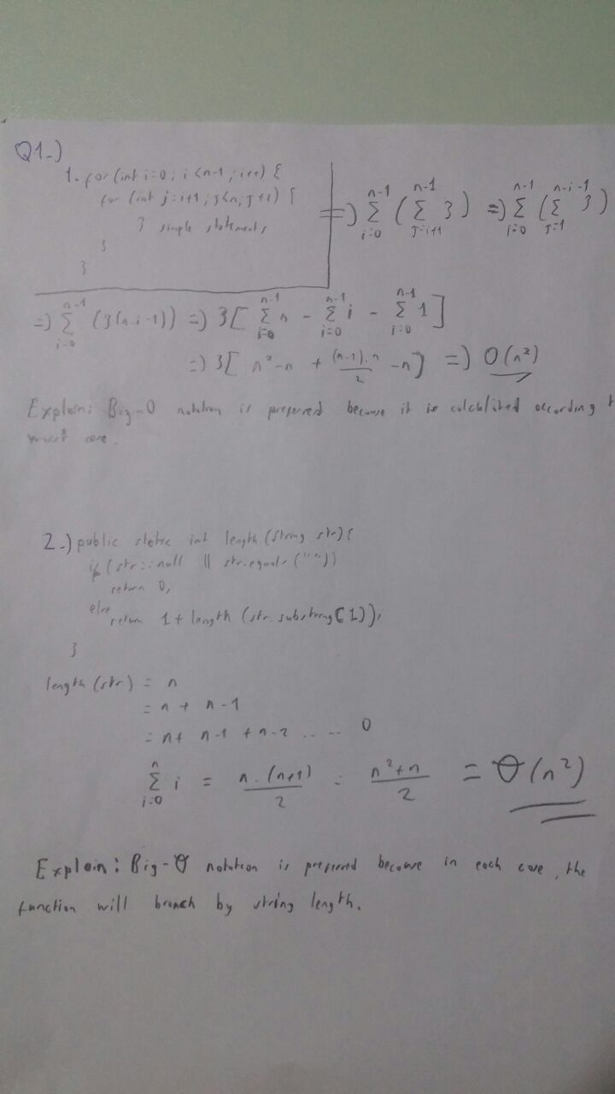

Q2-)
Q3-)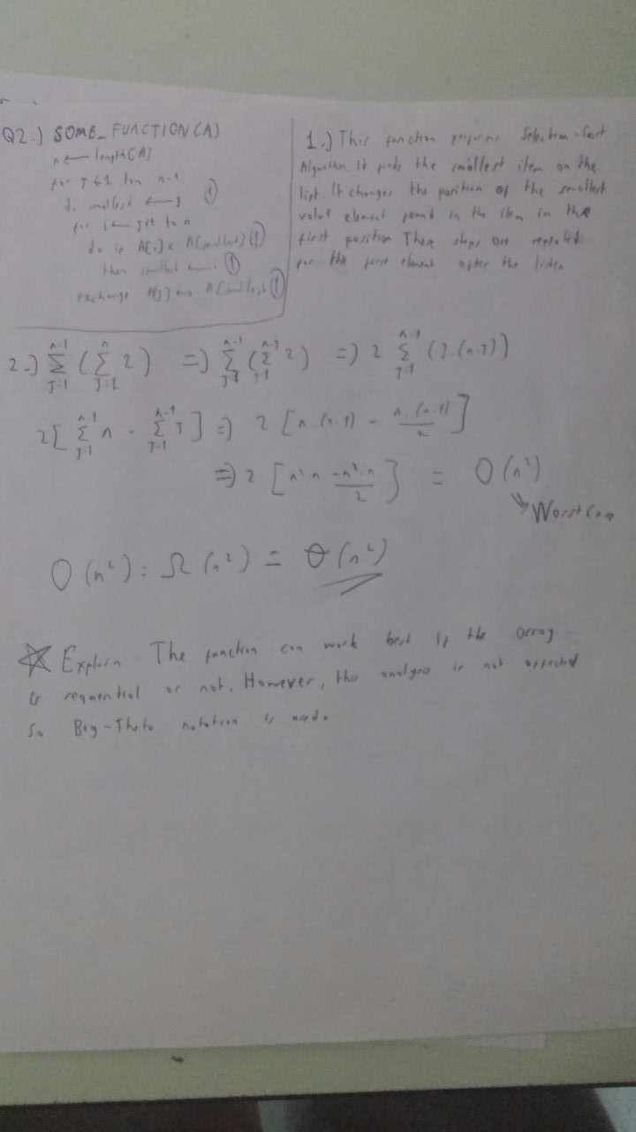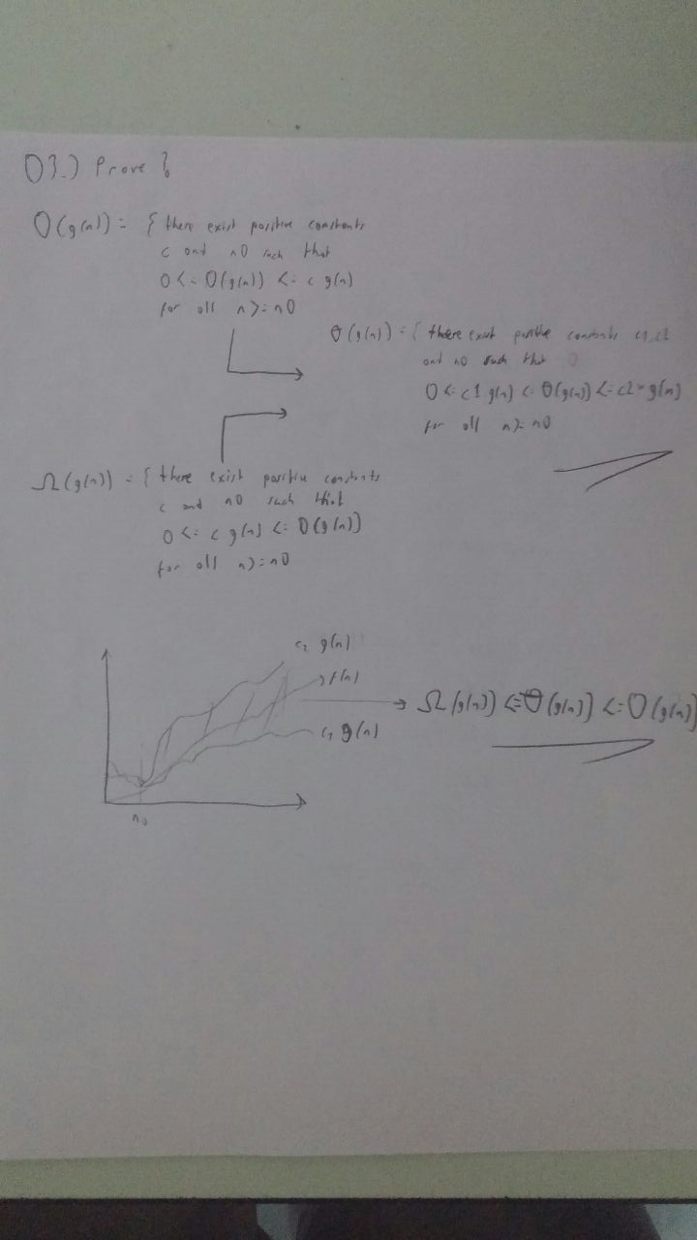

Q4-)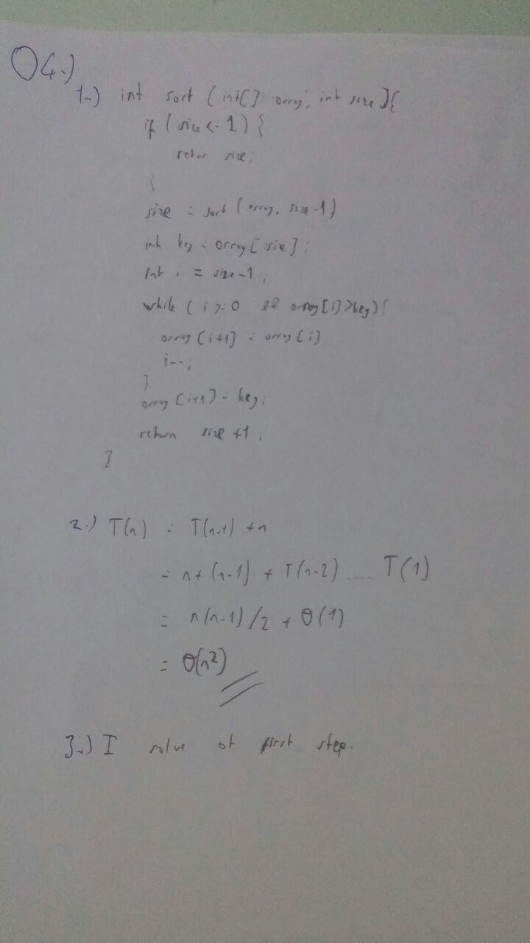

Q5-)

