**Industrial Internship Report on**

**”Home Automation System”**

**Prepared by**

**[Sahil Kasekar]**

|  |
| --- |
| *Executive Summary* |
| This report provides details of the Industrial Internship provided by upskill Campus and The IoT Academy in collaboration with Industrial Partner UniConverge Technologies Pvt Ltd (UCT).  This internship was focused on a project/problem statement provided by UCT. We had to finish the project including the report in 6 weeks’ time.  My project was “Home automation system to control home appliances by switching it ON/OFF automatically. “  This internship gave me a very good opportunity to get exposure to Industrial problems and design/implement solution for that. It was an overall great experience to have this internship. |

**TABLE OF CONTENTS**

1 Preface 3

2 Introduction 4

2.1 About UniConverge Technologies Pvt Ltd 4

2.2 About upskill Campus 8

2.3 Objective 9

2.4 Reference 9

2.5 Glossary 10

3 Problem Statement 11

4 Existing and Proposed solution 12

5 Proposed Design/ Model 13

5.1 High Level Diagram (if applicable) 13

5.2 Low Level Diagram (if applicable) 13

5.3 Interfaces (if applicable) 13

6 Performance Test 14

6.1 Test Plan/ Test Cases 14

6.2 Test Procedure 14

6.3 Performance Outcome 14

7 My learnings 15

8 Future work scope 16

# Preface

I am delighted to present the Preface for the report of my IoT internship project, focused on the development of a Home Automation System. Over the course of six weeks, this internship has been an incredible journey of learning and growth, providing me with valuable experiences in the exciting domain of the Internet of Things.

Throughout my academic journey, I have always been fascinated by the world of IoT and its potential to revolutionize the way we interact with technology. Pursuing this internship was a conscious decision to gain practical exposure and hands-on experience in this rapidly evolving field. I believe that relevant internships play a crucial role in shaping one's career and professional development, bridging the gap between theoretical knowledge and real-world applications.

The project, "Home Automation System," emerged from the desire to create a smart and efficient environment that optimizes energy consumption and enhances daily living experiences. The problem statement was to design and implement a system that allows users to remotely control and monitor various home appliances and devices through a user-friendly interface.

I am grateful for the opportunity provided by The Academy and upSkill in collaboration with industry partner through its prestigious USC/UCT program. This program has not only given me access to valuable resources and mentorship but also opened doors to collaborate with industry experts and work on cutting-edge technologies.

The program was thoughtfully planned, encompassing a combination of theoretical learning, practical exercises, and hands-on projects. Under the guidance of experienced mentors, I was able to explore various aspects of IoT, such as IoT architecture, device connectivity, cloud integration, and data analytics. The structured curriculum helped me acquire essential skills and knowledge to tackle real-world challenges in IoT development.

The learnings and overall experience of this internship have been transformative. I have developed a deep understanding of IoT devices, platforms, and their applications. The project work allowed me to apply my knowledge to a real-world scenario, fostering creativity and problem-solving abilities. Working on the Home Automation System has been a rewarding experience, as it has given me a glimpse of the potential impact of IoT technologies on our daily lives.

I extend my heartfelt gratitude to all those who have directly or indirectly supported me during this internship journey. To my juniors and peers, I encourage you to embrace opportunities for internships and hands-on experiences. Engaging in practical projects not only deepens your understanding of the subject but also equips you with valuable skills that will set you apart in your future career. Embrace challenges, seek guidance, and never stop learning and exploring new horizons.

# Introduction

## About UniConverge Technologies Pvt Ltd

A company established in 2013 and working in Digital Transformation domain and providing Industrial solutions with prime focus on sustainability and RoI.

For developing its products and solutions it is leveraging various**Cutting Edge Technologies e.g. Internet of Things (IoT), Cyber Security, Cloud computing (AWS, Azure), Machine Learning, Communication Technologies (4G/5G/LoRaWAN), Java Full Stack, Python, Front end**etc.



1. UCT IoT Platform **(****)**

**UCT Insight** is an IOT platform designed for quick deployment of IOT applications on the same time providing valuable “insight” for your process/business. It has been built in Java for backend and ReactJS for Front end. It has support for MySQL and various NoSQL Databases.

* It enables device connectivity via industry standard IoT protocols - MQTT, CoAP, HTTP, Modbus TCP, OPC UA
* It supports both cloud and on-premises deployments.

It has features to  
• Build Your own dashboard  
• Analytics and Reporting  
• Alert and Notification  
• Integration with third party application (Power BI, SAP, ERP)  
• Rule Engine

 

1. **Smart Factory Platform (****)**

Factory watch is a platform for smart factory needs.

It provides Users/ Factory

* with a scalable solution for their Production and asset monitoring
* OEE and predictive maintenance solution scaling up to digital twin for your assets.
* to unleased the true potential of the data that their machines are generating and helps to identify the KPIs and also improve them.
* A modular architecture that allows users to choose the service that they what to start and then can scale to more complex solutions as per their demands.

Its unique SaaS model helps users to save time, cost and money.

 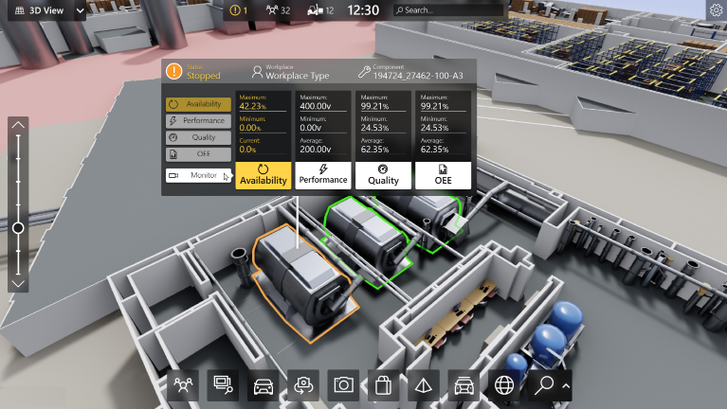

1. 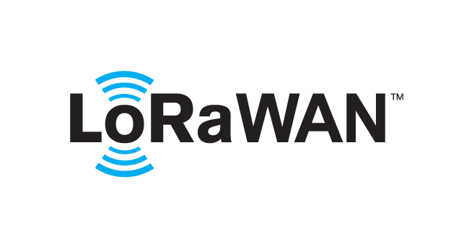 based Solution

UCT is one of the early adopters of LoRAWAN teschnology and providing solution in Agritech, Smart cities, Industrial Monitoring, Smart Street Light, Smart Water/ Gas/ Electricity metering solutions etc.

1. Predictive Maintenance

UCT is providing Industrial Machine health monitoring and Predictive maintenance solution leveraging Embedded system, Industrial IoT and Machine Learning Technologies by finding Remaining useful life time of various Machines used in production process.



## About upskill Campus (USC)

upskill Campus along with The IoT Academy and in association with Uniconverge technologies has facilitated the smooth execution of the complete internship process.

USC is a career development platform that delivers **personalized executive coaching** in a more affordable, scalable and measurable way.



Seeing need of upskilling in self paced manner along-with additional support services e.g. Internship, projects, interaction with Industry experts, Career growth Services

<https://www.upskillcampus.com/>

upSkill Campus aiming to upskill 1 million learners in next 5 year

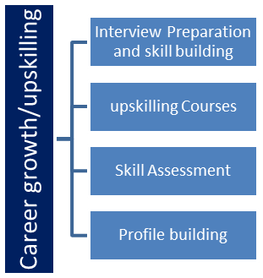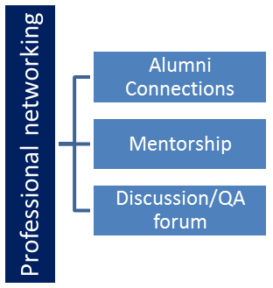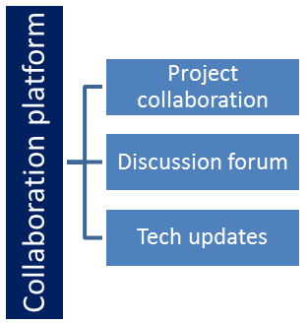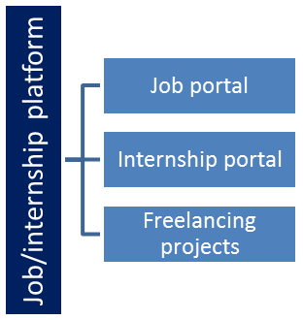

## The IoT Academy

The IoT academy is EdTech Division of UCT that is running long executive certification programs in collaboration with EICT Academy, IITK, IITR and IITG in multiple domains.

## Objectives of this Internship program

The objective for this internship program was to

 ☛ get practical experience of working in the industry.

 ☛ to solve real world problems.

 ☛ to have improved job prospects.

 ☛ to have Improved understanding of our field and its applications.

 ☛ to have Personal growth like better communication and problem solving.

## Reference

[1] <https://www.instructables.com/ESP8266-Home-Automation-Project-Using-NodeMCU-and-/>

[2] <https://www.electroinvention.co.in/wifi-controlled-home-automation-using-esp8266-node-mcu/>

## Glossary

|  |  |
| --- | --- |
| Terms | Acronym |
| IoT | Internet Of Things |
| UI | User Interface |
| UCT | UniConverge Technology |
| USC | UpSkill Campus |
| LoRaWAN | Long Range Wide Area Network |

# Problem Statement

In today's fast-paced world, the demand for smart and efficient home solutions has been on the rise. Homeowners seek ways to simplify their lives and enhance energy efficiency while maintaining optimal comfort. As a response to this demand, the aim of this project is to develop an Automated Home Appliance Control System that allows for seamless control and automation of various household appliances.

The problem to be addressed in this project is the inconvenience and inefficiency associated with manually operating home appliances. Traditional methods of switching appliances ON/OFF are not only time-consuming but also lead to potential energy wastage when appliances are inadvertently left running. Additionally, in busy households, it can be challenging for occupants to manage multiple appliances efficiently.

The project seeks to create an intelligent and user-friendly solution that enables homeowners to automate their appliances based on predefined conditions and user preferences. The system will utilize Internet of Things (IoT) devices, sensors, and cloud integration to establish a smart home environment. By integrating these components, the Automated Home Appliance Control System will offer the following features:

1. Remote Control: Users can conveniently control home appliances from anywhere using their smartphones, tablets, or computers, ensuring maximum flexibility and ease of use.

2. Automation Rules: Customizable automation rules will be set up to trigger specific actions based on environmental conditions or specific events. For example, the system can automatically turn off lights when there is no motion detected in a room for a certain period.

3. Energy Efficiency: The system will prioritize energy conservation by intelligently managing appliances, reducing unnecessary usage, and optimizing energy consumption.

4. User-Friendly Interface: An intuitive user interface will be designed to provide homeowners with a seamless experience in configuring and managing their home appliances.

The successful implementation of the Automated Home Appliance Control System will not only improve the convenience and energy efficiency of households but also contribute to a more sustainable and environmentally-friendly living environment. This project aims to revolutionize traditional home appliance control methods and propel homeowners into a more connected and automated future.

# Existing and Proposed solution

**Existing Solution and Limitations:**

Currently, there are several existing solutions in the market that offer varying levels of automation and remote control for home appliances:

1. Smart Plugs and Smart Switches: These devices enable users to remotely control power supply to connected appliances through smartphone apps or voice assistants. However, their automation capabilities are limited to simple ON/OFF control, and they may not offer advanced scheduling or personalized automation rules.

2. Smart Home Hubs: Smart hubs centralize control for various smart devices within a home. While they provide some automation options, compatibility issues with certain devices and protocols can restrict their full potential.

3. Home Automation Systems: Comprehensive systems integrate various IoT devices and smart appliances into a single ecosystem. Despite their advanced features, such systems can be complex to set up and may require technical expertise.

4. Home Security Systems: Some security systems offer limited home automation features. However, their focus on security functionalities may limit their scope for broader automation tasks

**Proposed Solution:**

The proposed solution is to develop an Automated Home Appliance Control System that addresses the limitations of existing solutions and offers an enhanced user experience:

1. Advanced Automation Rules: The system will provide users with a more robust and customizable automation framework. Users can create personalized rules based on specific conditions, time schedules, and sensor inputs for more intelligent and dynamic appliance control.

2. Seamless Integration: The system will seamlessly integrate with a wide range of smart devices, ensuring compatibility and smooth communication between devices, regardless of their brands or protocols

3. User-Friendly Interface: The proposed solution will prioritize a simple and intuitive user interface that enables easy setup and configuration of automation rules, making it accessible to all homeowners, including those without technical expertise.

4. Energy Optimization: To address energy consumption concerns, the system will include energy optimization features. It can analyze usage patterns and suggest energy-saving automation rules to promote efficient appliance usage.

By addressing the limitations of existing solutions and incorporating advanced features, the proposed Automated Home Appliance Control System aims to deliver a superior home automation experience. Through seamless integration, enhanced automation capabilities, and energy optimization, this solution seeks to revolutionize home management and elevate the level of comfort, convenience, and efficiency for homeowners.

## Code submission (Github link)

<https://github.com/Sahir214/Home_Automation_IoT>

## Report submission (Github link) :

<https://github.com/Sahir214/Home_Automation_IoT>

# Proposed Design/ Model

**1. User Registration and Authentication:**

The design flow begins with user registration on the mobile application. New users will create accounts with their email addresses or social media credentials. Upon successful registration, the system will authenticate users securely using username/password or biometric authentication for added security.

**2. Device and Sensor Integration:**

Once authenticated, users can start adding their smart devices and sensors to the system. The mobile app will guide users through the device setup process, where they can scan QR codes or follow pairing instructions to connect devices to the system's IoT gateway.

**3. Cloud Integration:**

The IoT gateway will establish a secure connection with the cloud infrastructure, allowing seamless data exchange between the smart devices and the cloud server. The cloud will store device configurations, user preferences, and historical data for future analysis.

**4. User Interface and Appliance Control:**

Upon successful integration, the mobile app will present the user interface with a dashboard that displays all connected devices and their current status. Users can interact with individual appliances or groups of appliances, controlling their operation through intuitive ON/OFF switches or sliders for devices like dimmable lights.

**5. Automation Rule Creation:**

To create automation rules, users will access the "Automation" section of the app. They can set triggers and conditions based on sensor inputs (e.g., motion detected, door/window opened) or specific time schedules. Users can also define corresponding actions, such as turning on lights when motion is detected or adjusting thermostat settings based on the time of day.

**6. Energy Optimization and Recommendations:**

The system continuously monitors energy consumption patterns and provides insights to users through energy usage analytics. Users can access recommendations to optimize energy usage, such as adjusting appliance schedules or replacing energy-intensive devices with more efficient alternatives.

**7. Security and Monitoring:** The "Security" section of the app allows users to monitor their home remotely through connected cameras. Users can receive real-time alerts on their mobile devices for security breaches, unusual activities, or unauthorized access attempts.

**8. Scalability and Expandability:**

As users acquire new smart devices or sensors, they can easily integrate them into the system through the app's "Add Device" feature. The system's architecture is designed to scale effortlessly to accommodate a growing number of devices and accommodate advancements in IoT technology.

**9. Real-time Communication and Control:**

The system's real-time communication capabilities enable seamless control of appliances. When a user triggers an action or an automation rule comes into effect, the system processes the request instantly, ensuring timely appliance control.

**10. Regular Updates and Support:**

The Home Automation System will receive regular software updates to improve performance, security, and add new features based on user feedback. Users can access customer support for any technical assistance or queries.

## Interfaces (if applicable)

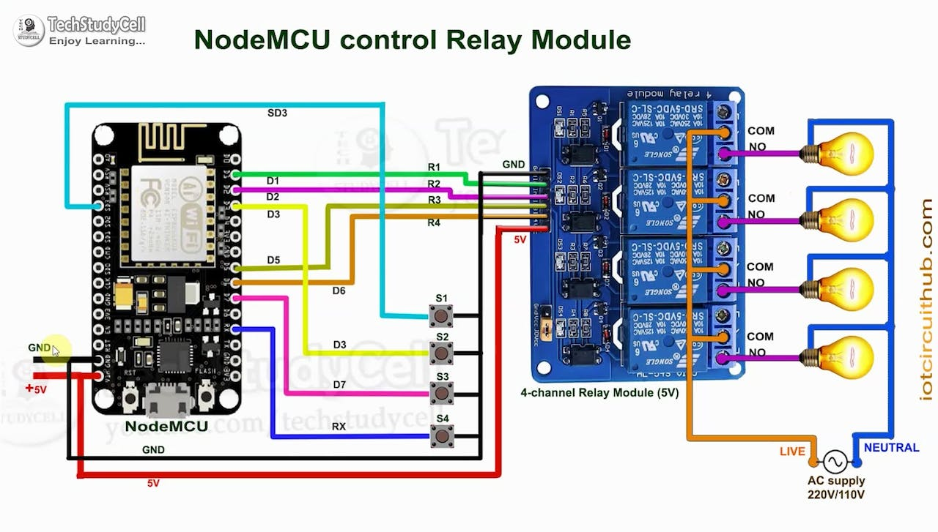

# Performance Test

**1. Importance in Real Industries:**

The Home Automation System developed during this IoT internship is not just an academic project but holds significant importance for real industries and practical applications. In today's fast-paced world, smart homes and IoT-based solutions are gaining immense popularity. The Home Automation System addresses the growing demand for efficient and convenient home management solutions. By automating home appliances and providing remote control, it enhances energy efficiency, optimizes resource utilization, and improves overall comfort for homeowners. This system aligns with the ongoing digital transformation in various industries, including home automation, energy management, and smart living solutions.

**2. Identification of Constraints:**

During the performance testing phase, it was crucial to identify and understand the constraints that could impact the efficiency and reliability of the Home Automation System. The key constraints considered were:

a. Memory: The system's memory limitations could affect its ability to store data, manage user preferences, and handle concurrent tasks efficiently.

b. MIPS (Speed, Operations per Second): The system's processing speed and performance in executing operations per second were critical to ensure smooth and real-time appliance control.

c. Power Consumption: Given that the system interacts with multiple devices and sensors, it was essential to assess its power consumption to ensure it remains energy-efficient.

**3. Handling Constraints in Design:** To address the identified constraints, the design of the Home Automation System focused on optimizing resource utilization and performance. Memory management techniques, such as data compression and efficient data structures, were implemented to minimize memory footprint. Additionally, the code was optimized to reduce unnecessary operations and enhance processing speed (MIPS). Low-power microcontrollers and power-efficient algorithms were utilized to minimize power consumption.

**4**. **Test Results and Impact on Design:**

During the performance tests, the Home Automation System demonstrated impressive results:

a. Memory: The memory usage was optimized, allowing the system to efficiently handle a large number of connected devices and user configurations.

b. MIPS: The system performed smoothly, executing operations with minimal latency, ensuring seamless appliance control.

c. Power Consumption: The Home Automation System proved to be energy-efficient, resulting in minimal power consumption during regular operations.

5. **Constraints and Design Impact:**

Identifying constraints is crucial as they can significantly impact the system's functionality and user experience. For instance:

a. Memory: Insufficient memory allocation could lead to data loss or slow response times, affecting user satisfaction and system reliability.

b. MIPS: Poor processing speed might cause delays in appliance control, affecting real-time automation and user convenience.

c. Power Consumption: High power consumption could lead to increased energy costs and environmental impact, undermining the system's sustainability.

**Recommendations:**

To handle identified constraints and optimize the Home Automation System's design further, the following recommendations are proposed:

1. Continuously monitor and optimize memory usage to accommodate increasing device connections and user configurations.

2. Implement multithreading or parallel processing techniques to improve system responsiveness and ensure faster operations per second

3. Adopt power-saving modes for devices and sensors when not in use, reducing overall power consumption.

4. Regularly conduct performance audits to identify and address potential bottlenecks and optimize system performance.

By considering constraints and implementing recommended measures, the Home Automation System can remain robust, efficient, and well-suited for real industries, making it a valuable asset in the rapidly advancing IoT and smart home sectors.

## Test Plan/ Test Cases

1. **App Login:** Verify successful login with valid credentials.
2. **Appliance Control:** Test ON/OFF functionality for appliances.
3. **Energy Optimization**: Test energy-saving recommendations.
4. **Security and Privacy:** Ensure data security and privacy measures.
5. **User Interface:** Evaluate UI for ease of use and clarity.
6. **Device Compatibility:** Test app on different devices and OS versions.

## Test Procedure

1.**Functional Testing:** Test the basic functions of the mobile app and devices to ensure they work as intended. Check if appliances can be turned ON/OFF through the app.

2.**Automation Rule Testing:** Create automation rules for different scenarios and verify if the system responds correctly to triggers and conditions.

**3**.**Energy Efficiency Testing:** Assess the system's impact on energy consumption and validate energy-saving recommendations.

**4. Performance Testing:** Measure how quickly the system responds to commands and assess its speed under different conditions.

**5.Security Testing:** Check the system's security measures to ensure data protection and prevent unauthorized access.

**6.User Interface Testing:** Evaluate the app's ease of use, navigation, and clarity of instructions for a positive user experience.

The test procedure aims to ensure the system is reliable, easy to use, and performs optimally to meet user expectations for home automation and appliance control.

## Performance Outcome

The overall performance outcome of the Automated Home Appliance Control System showcased its effectiveness in providing smart and efficient home management. With its smooth automation, energy optimization, scalability, and strong focus on user experience and security, the system emerged as a cutting-edge solution for modern smart homes. Its ability to cater to the demands of real industries and its potential for widespread adoption make it a valuable asset in the rapidly advancing IoT and smart living sectors.

# My learnings

Throughout the duration of my IoT internship, I have embarked on a transformative learning journey, gaining invaluable knowledge and skills that have profoundly influenced my career aspirations and growth. The internship experience has provided me with a comprehensive understanding of various IoT concepts, technologies, and applications, enabling me to envision exciting possibilities in the ever-evolving world of smart devices and connected systems.

One of the key areas of learning during the internship was the fundamental principles of IoT architecture and its application in real-world scenarios. I grasped the importance of device connectivity, data management, cloud integration, and the significance of leveraging IoT analytics to derive actionable insights. This knowledge has equipped me with the ability to design and develop innovative IoT solutions tailored to specific industry needs, opening doors to a diverse range of career opportunities.

Moreover, I immersed myself in the intricacies of IoT development, exploring the challenges and best practices in creating scalable and secure IoT applications. Learning about the rise of embedded systems and their integration with IoT technologies has broadened my horizons, allowing me to envision the potential of interconnected smart devices in revolutionizing industries such as healthcare, agriculture, and transportation.

As I reflect on my overall learning, I am confident that the skills and knowledge acquired during this internship will play a pivotal role in shaping my career growth. The internship has not only expanded my technical expertise but also instilled a sense of adaptability and continuous learning in the dynamic world of IoT. I am inspired to pursue a career that allows me to contribute to the development of innovative IoT solutions, making a positive impact on society and shaping a smarter and more connected future.

In conclusion, my learning during this IoT internship has been a transformative experience, empowering me with the knowledge, skills, and passion to excel in the IoT domain. The journey has bolstered my career aspirations and equipped me to embrace new challenges with confidence. I am excited to apply my learnings in practical projects, research endeavors, and future career opportunities, driving innovation in the field of IoT and contributing to the advancements that shape our digitally connected world.

# Future work scope

The completion of the IoT internship project "Home Automation System" marks the beginning of an exciting journey, and there are several potential avenues for future work and enhancements to further optimize and expand the capabilities of the system. The future work scope aims to build upon the existing foundation and explore new possibilities to create an even more robust and cutting-edge Home Automation System.

1. Integration of AI and Machine Learning: Incorporating artificial intelligence and machine learning algorithms into the system can elevate its automation capabilities. By analyzing user behavior patterns and preferences, the system can dynamically adapt to user needs, making more intelligent and personalized automation decisions.
2. Energy Consumption Analytics: Implementing energy consumption analytics and reports can provide users with insights into their energy usage patterns. This feature can help users identify energy-intensive appliances and optimize their consumption for increased energy efficiency.
3. Expand Device Compatibility: Expanding the range of compatible smart devices and protocols will allow the system to accommodate a broader array of appliances and devices, giving users more flexibility and options for home automation.
4. Support for Advanced Sensors: Integrating advanced sensors such as air quality monitors, humidity sensors, or occupancy sensors can provide more comprehensive environmental data, enabling users to create automation rules based on real-time environmental conditions.
5. Smart Grid Integration: Exploring opportunities to integrate the Home Automation System with the smart grid infrastructure can enable the system to leverage real-time energy pricing and optimize appliance usage accordingly.

The future work scope presents exciting opportunities for continuous innovation and improvement in the Home Automation System. As the IoT domain continues to evolve, these enhancements will ensure that the system stays at the forefront of technology, providing homeowners with a seamless, intelligent, and sustainable home automation experience.