UNIT-3
1. TF-IDF (Term Frequency-Inverse Document Frequency)
TF-IDF (Term Frequency–Inverse Document Frequency) is a statistical method used in natural language processing and information retrieval to evaluate how important a word is to a document in relation to a larger collection of documents.
TF-IDF combines two components:
1. Term Frequency (TF): Measures how often a word appears in a document. A higher frequency suggests greater importance. If a term appears frequently in a document, it is likely relevant to the document’s content.
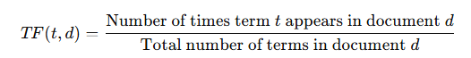
2. Inverse Document Frequency (IDF): Reduces the weight of common words across multiple documents while increasing the weight of rare words. If a term appears in fewer documents, it is more likely to be meaningful and specific.

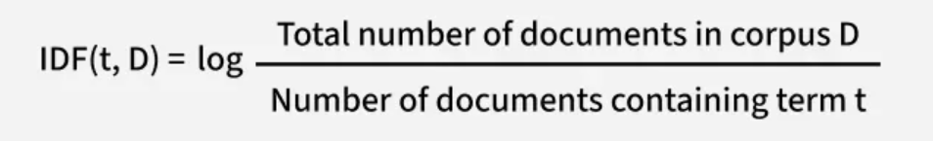

This balance allows TF-IDF to highlight terms that are both frequent within a specific document and distinctive across the text document, making it a useful tool for tasks like search ranking, text classification and keyword extraction.
Converting Text into vectors with TF-IDF
Let's take an example where we have a corpus (a collection of documents) with three documents and our goal is to calculate the TF-IDF score for specific terms in these documents.
- Document 1: "The cat sat on the mat."
- Document 2: "The dog played in the park."
- Document 3: "Cats and dogs are great pets."
Our goal is to calculate the TF-IDF score for specific terms in these documents. Let’s focus on the word "cat" and see how TF-IDF evaluates its importance.

Step 1: Calculate Term Frequency (TF)
For Document 1:
- The word "cat" appears 1 time.
- The total number of terms in Document 1 is 6 ("the", "cat", "sat", "on", "the", "mat").
- So, TF(cat,Document 1) = 1/6
For Document 2:
- The word "cat" does not appear.
- So, TF(cat,Document 2)=0.
For Document 3:
- The word "cat" appears 1 time.
- The total number of terms in Document 3 is 6 ("cats", "and", "dogs", "are", "great", "pets").
- So TF (cat,Document 3)=1/6
In Document 1 and Document 3 the word "cat" has the same TF score. This means it appears with the same relative frequency in both documents. In Document 2 the TF score is 0 because the word "cat" does not appear.
Step 2: Calculate Inverse Document Frequency (IDF)
- Total number of documents in the corpus (D): 3
- Number of documents containing the term "cat": 2 (Document 1 and Document 3).
$$IDF(cat,D)=log\frac{3}{2}≈0.176$$
Step 3: Calculate TF-IDF
The TF-IDF score for "cat" is 0.029 in Document 1 and Document 3 and 0 in Document 2 that reflects both the frequency of the term in the document (TF) and its rarity across the corpus (IDF).
The TF-IDF score is the product of TF and IDF:
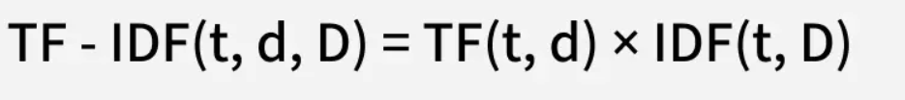
- For Document 1: TF-IDF (cat, Document 1, D)=0.167 * 0.176 = 0.029
- For Document 2: TF-IDF(cat, Document 2, D)=0x 0.176=0
- For Document 3: TF-IDF (cat, Document 3, D)=0.167 x 0.176 = 0.029
2.Pointwise Mutual Information (PMI)
Definition: PMI is a statistical measure used in NLP and information theory to quantify the association or co-occurrence strength between two events (typically words) compared to what would be expected if they were statistically independent.
Formula:
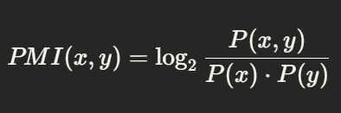
Where:
- P(x, y) = joint probability of x and y co-occurring
- P(x) = marginal probability of x
- P(y) = marginal probability of y
Interpretation:
PMI Value | Meaning
PMI > 0 | Words co-occur more than by chance (positive association)
PMI = 0 | Words are statistically independent
PMI < 0 | Words co-occur less than by chance (negative association)

Example:
Consider a corpus. If "ice" and "cream" frequently appear together:
- P("ice", "cream") is high
- P("ice") · P("cream") is lower
- → PMI > 0 → strong positive association

Positive PMI (PPMI):
Since negative PMI values are unreliable (sparse data), PPMI replaces negatives with 0:
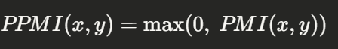
This is widely used in word vector representations.
Applications:
- Word Embeddings – constructing co-occurrence matrices
- Collocation detection – finding meaningful word pairs ("New York", "ice cream")
- Information Retrieval – measuring term relevance
- Sense disambiguation – identifying word meaning from context
Limitations:
- PMI is biased toward rare events (low-frequency pairs can have inflated PMI)
- Sensitive to data sparsity
- Negative PMI values are statistically unreliable

3. Word2Vec
Word2Vec is a word embedding technique in natural language processing (NLP) that allows words to be represented as vectors in a continuous vector space. Researchers at Google developed word2Vec that maps words to high-dimensional vectors to capture the semantic relationships between words. It works on the principle that words with similar meanings should have similar vector representations. Word2Vec utilizes two architectures:
1. CBOW (Continuous Bag of Words)
The CBOW model predicts the current word given context words within a specific window. The input layer contains the context words and the output layer contains the current word. The hidden layer contains the dimensions we want to represent the current word present at the output layer.
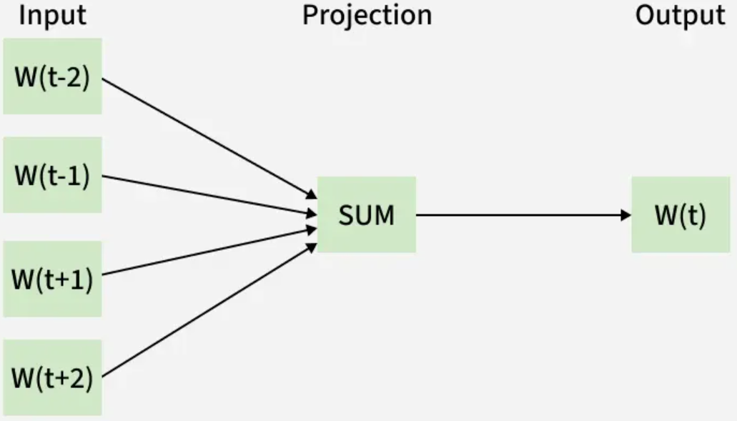
2. Skip Gram
The Skip gram predicts the surrounding context words within specific window given current word. The input layer contains the current word and the output layer contains the context words. The hidden layer contains the number of dimensions in which we want to represent current word present at the input layer.
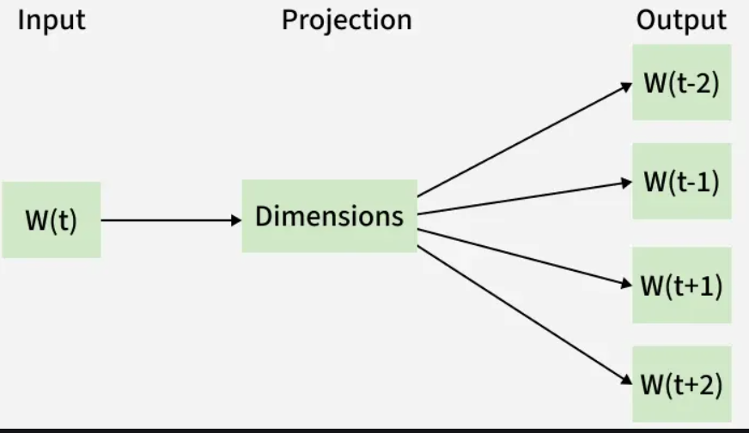
Applications
- Machine Translation
- Sentiment Analysis
- Named Entity Recognition (NER)
- Information Retrieval
- Text Classification

4.Applications of TF-IDF:
1. Information Retrieval (Search Engines)
Documents and queries are represented as TF-IDF vectors and ranked using cosine similarity. Forms the basis of the Vector Space Model. Used in Elasticsearch and Apache Lucene.
2. Document Classification
TF-IDF vectors are used as features for classifiers like SVM, Naive Bayes, Logistic Regression for spam detection, news categorization, and sentiment analysis.
3. Keyword Extraction
Words with the highest TF-IDF scores in a document are extracted as keywords. Used in SEO, content tagging, and document indexing.
4. Text Summarization
Sentences are scored by the TF-IDF weights of their words. High-scoring sentences are selected for extractive summaries.
5. Document Clustering
Documents converted to TF-IDF vectors are grouped using K-Means or hierarchical clustering for topic discovery and corpus organization.
6. Recommender Systems
Items described by text (articles, products) are represented as TF-IDF vectors and matched to user preferences using cosine similarity (content-based filtering).
7. Named Entity Recognition (NER) — Feature Engineering
TF-IDF scores serve as features to help identify important terms that are likely named entities in a text.

Applications of PPMI
1. Word Similarity & Semantic Relatedness
PPMI vectors measure how semantically related two words are by their co-occurrence strength. Words like "doctor" and "hospital" get high PPMI scores, used in building semantic similarity systems.
2. Word Sense Disambiguation (WSD)
Different senses of a word (e.g., "bank" — river vs. financial) have different high-PPMI context words. PPMI helps distinguish which sense is being used in context.
3. Collocation Detection
PPMI detects meaningful multi-word expressions like "New York", "ice cream", "machine learning" by identifying word pairs that co-occur far more than by chance.
4. Sentiment Analysis — Lexicon Building
PPMI measures association between words and sentiment labels (positive/negative). Helps automatically build sentiment lexicons from raw corpus data.
5. Cross-lingual / Multilingual NLP
PPMI vectors built for multiple languages help align word spaces across languages, supporting bilingual lexicon induction and cross-lingual transfer.
6.Analogy and Relational Reasoning
PPMI-based vectors capture linear relational structure in language, enabling analogy tasks like:
king − man + woman ≈ queen
Paris − France + Italy ≈ Rome
7. Named Entity Recognition (NER)
PPMI captures strong associations between entity names and their context words (e.g., "Einstein" co-occurs highly with "physicist", "relativity"), aiding NER systems.
8. Information Extraction
PPMI identifies strongly associated word pairs in text, helping extract relationships between entities such as:
"Einstein" → high PPMI with → "Germany", "physics", "Nobel"

Unit-4
1. Part-of-Speech (POS) Tagging

Definition: POS Tagging is the process of assigning a part-of-speech or lexical class marker to each word in a sentence (and all sentences in a collection). It identifies the grammatical role of every word based on both its meaning and context.

Input: "the lead paint is unsafe"
Output: the/DET lead/N paint/N is/V unsafe/Adj

Why is POS Tagging Useful?
- Stemming/Lemmatization: Knowing a word's POS helps produce accurate base forms
- Parsing: POS tags enable parsers to build syntax trees without maintaining a large lexicon
- Information Extraction: Helps find names, relations, and entities in text
- Word Sense Disambiguation: Resolves ambiguity — e.g., 'bank' as noun vs. verb
- Text-to-Speech: Improves pronunciation by recognizing grammatical roles
- Named Entity Recognition (NER): Identifies names, places, organizations
- Machine Translation: Aids in understanding sentence structure for better translations
- Information Retrieval: Enhances search accuracy by understanding user queries

Challenges in POS Tagging
- Ambiguity: Same word can have different POS tags in different contexts
- "back" → JJ (the back door), NN (on my back), RB (win voters back), VB (back the bill)
- Context Dependency: The correct tag for a word depends on surrounding words
- Out-of-Vocabulary Words: New or unknown words create tagging difficulties
- Different models (rule-based, statistical, ML) handle ambiguity differently

Types of Ambiguity
Type | Description | Example
Lexical Ambiguity | Word has multiple meanings or roles | "bank" — noun (river bank) or verb (to bank)
Syntactic Ambiguity | Ambiguity from sentence structure | "Flying planes can be dangerous" — flying as verb or adjective

POS Tagging Approaches
Approach | Description | Example/Tool
Rule-Based | Hand-crafted grammar rules and contextual frame rules. E.g., if word ends in '-ing' and preceded by a verb, tag as VB | ENGTWOL
Transformation-Based (TBL) | Predefined + automatically induced rules generated during training. Starts with initial tags, then applies learned transformations | Brill Tagger
Stochastic / HMM | Combines tag sequence probabilities and word frequency. Uses Hidden Markov Model with emission and transition probabilities | HMM Tagger
Deep Learning | Neural models like Meta-BiLSTM achieving ~97% accuracy | BiLSTM-CRF, BERT

Rule-Based Tagging — Example
Sentence: "The quick brown fox jumps over the lazy dog."
Step 1 — Lexical Lookup: "brown" → [ADJ, NN]
Step 2 — Apply Rules: Rule 1: word after DET = ADJ → "brown" = ADJ
Output: The/DET quick/ADJ brown/ADJ fox/NN jumps/VBZ over/IN lazy/ADJ dog/NN

Evaluation of POS Tagging
- Compared against a manually coded Gold Standard test set
- Overall accuracy typically reaches 96–97% on standard corpora
- Evaluated on: overall error rate, per-tag error rates, per-word error rates, tag confusions
- 100% accuracy is impossible even for human annotators due to inherent ambiguity

2. English Word Classes (Parts of Speech)

Definition: English Word Classes (Parts of Speech) are categories of words grouped by their grammatical role and syntactic behavior. They are also called lexical categories, morphological classes, or lexical tags.

Traditional Parts of Speech
Word Class | Description | Examples
Noun (N) | Names a person, place, thing, or idea | dog, city, algorithm, freedom
Pronoun (PRP) | Refers to an entity or event | she, who, I, he, they, it
Verb (V) | Refers to actions and processes | run, is, compute, believe
Adjective (JJ) | Properties or qualities of nouns | red, tall, good, white, young
Adverb (RB) | Modifiers of verbs, adjectives, other adverbs | very, slowly, home, unfortunately
Preposition (IN) | Shows relationships between words | in, on, by, at, over
Conjunction (CC) | Connects words, phrases, or clauses | and, but, because, or
Interjection (UH) | Exclamation, greeting, yes/no response | wow, ouch, yes, hello

Open vs Closed Word Classes
Class | Description | Examples
Open Class | Readily accept new words; expand over time. Content words that carry core meaning. | Nouns, Verbs (e.g., 'google', 'tweet'), Adjectives, Adverbs
Closed Class | Rarely accept new words; more static. Function words that provide grammatical structure. | Pronouns, Prepositions, Conjunctions, Determiners, Articles

Closed Class Words — Examples
- Prepositions: on, under, over, near, beside
- Particles: up, down, on, off (used in phrasal verbs — give up, turn off)
- Determiners: a, an, the, this, those
- Pronouns: she, who, I, me, mine
- Conjunctions: and, but, or, because
- Auxiliary Verbs: can, may, should, will, must
- Numerals: one, two, three, third

Open Class Words — Subtypes
- Proper Nouns: Names of specific people/places — Boulder, Eli Manning (capitalized in English)
- Common Nouns: Count nouns (goat/goats — can be counted) and Mass nouns (snow, salt — not counted)
- Adverbs: Directional (home, here), Degree (very, extremely), Manner (slowly, delicately)
- Verbs: Carry morphological affixes — eat / eats / eaten / eating

Penn Treebank POS Tagset
The Penn Treebank is the most widely used standard tagset in NLP, with approximately 45 tags.

Tag | Meaning | Tag | Meaning
NN | Noun, singular | VB | Verb, base form
NNS | Noun, plural | VBD | Verb, past tense
NNP | Proper noun, singular | VBG | Verb, gerund/present participle
NNPS | Proper noun, plural | VBN | Verb, past participle
JJ | Adjective | VBP | Verb, non-3rd-person singular
JJR | Adjective, comparative | VBZ | Verb, 3rd-person singular
RB | Adverb | DT | Determiner
IN | Preposition/subordinating conj. | CC | Coordinating conjunction
PRP | Personal pronoun | CD | Cardinal number
MD | Modal | UH | Interjection

Popular Tagsets Comparison
Tagset | No. of Tags | Use Case
Penn Treebank | ~45 tags | Most widely used in NLP; standard for English
Brown Corpus | ~80+ tags | Older, finer distinctions
Universal POS | ~17 tags | Simplified; designed for cross-linguistic use

3. Named Entities and Named Entity Tagging

Definition: Named Entity Recognition (NER) is the NLP task of identifying and classifying named entities in text into predefined categories such as Person, Organization, Location, Date, Money, etc. It is a sequence labeling task — each token is assigned an entity tag.

Types of Named Entities
Entity Type | Tag | Examples
Person | PER | Albert Einstein, Sachin Tendulkar, Elon Musk
Organization | ORG | Google, WHO, United Nations, ISRO
Location / GPE | LOC / GPE | India, Visakhapatnam, Mount Everest
Date / Time | DATE / TIME | January 2024, Monday, 3:00 PM
Money | MONEY | $500 million, Rs. 10,000
Percentage | PERCENT | 12.5%, fifty percent
Facility | FAC | Eiffel Tower, Golden Gate Bridge
Product | PRODUCT | iPhone 15, Tesla Model 3

NER Tagging Schemes — BIO / IOB2
The BIO tagging scheme is the standard for NER:
Tag | Meaning | Usage
B-XXX | Beginning of entity XXX | First token of a named entity
I-XXX | Inside entity XXX | Continuation tokens of the same entity
O | Outside — not an entity | Tokens that are not part of any entity

"Barack Obama visited New York yesterday"
B-PER I-PER O B-LOC I-LOC O

Other Tagging Schemes
Scheme | Tags Used | Feature
IOB1 | B, I, O | B only when same entity type follows immediately
BIOES | B, I, O, E, S | E=End of entity, S=Single-token entity; richer boundaries

Approaches to NER
Approach | Method | Tools
Rule-Based | Regex patterns, gazetteers, lexicon lookups | GATE, NLTK rules
Feature-Based ML | Hand-crafted features fed into CRF or SVM | Stanford NER, CRFSuite
Neural | BiLSTM-CRF, CNN-CRF for sequence labeling | spaCy, Flair
Transformer-Based | BERT, RoBERTa fine-tuned for NER | HuggingFace, spaCy v3

Features Used in NER
- Word identity: current word, previous/next words
- Character features: prefixes (un-, pre-), suffixes (-tion, -ing, -ed)
- Capitalization: capitalized words are likely proper nouns
- Gazetteer features: lists of known names, cities, organizations
- POS tags of surrounding words
- Word shape: e.g., 'London' matches pattern Xx+ (initial capital)

Applications of NER
- Information Extraction: extracting entities from news, medical records
- Question Answering: identifying answer candidates
- Knowledge Graph construction
- Biomedical NLP: identifying drugs, diseases, genes
- Search Engine Enhancement: entity-based search and indexing

4. HMM Part-of-Speech Tagging
Definition: HMM POS Tagging is a probabilistic sequence labeling approach. POS tags are treated as hidden states and words are observations. The goal is to find the most probable tag sequence for a given word sequence.
Core Idea
Goal: Find the best tag sequence t* that maximizes the probability:
t* = argmax P(t1,t2,...,tn | w1,w2,...,wn)
By Bayes' theorem, this simplifies to:
t* = argmax P(w1...wn | t1...tn) * P(t1...tn)

Two Key Assumptions
- Markov Assumption: P(ti | t1...ti-1) = P(ti | ti-1) — current tag depends only on previous tag
- Output Independence: P(wi | t1...tn, w1...wn) = P(wi | ti) — word depends only on its own tag

HMM Components
Component | Description | Formula
States (Q) | Set of all POS tags | Q = {NN, VB, DT, JJ, ...}
Observations (O) | Words in the vocabulary | O = {the, dog, runs, ...}
Transition Prob (A) | Probability that tag ti-1 is followed by ti | A = C(ti-1, ti) / C(ti-1)
Emission Prob (B) | Probability that word wj is generated by tag ti | B = C(ti, wj) / C(ti)
Initial Prob (π) | Probability of a tag starting a sentence | π[i] = C(ti at start) / N sentences

Simplified HMM Formula
t* = argmax PROD[i] P(wi | ti) * P(ti | ti-1)
P(wi | ti) = Emission probability | P(ti | ti-1) = Transition probability

Training HMM — Maximum Likelihood Estimation
- Use annotated corpora (e.g., Penn Treebank) to compute counts
- Transition: A[ti-1][ti] = Count(ti-1, ti) / Count(ti-1)
- Emission: B[ti][wj] = Count(ti, wj) / Count(ti)
- Smoothing (Laplace / add-one) needed to handle zero probabilities for unseen events

Worked Example — Emission Probabilities
Given sentences: Mary Jane can see Will | Spot will see Mary | Will Jane spot Mary? | Mary will pat Spot

Word | Noun | Modal | Verb
Mary | 4/9 | 0 | 0
Jane | 2/9 | 0 | 0
Will | 1/9 | 3/4 | 0
Spot | 2/9 | 0 | 1/4
Can | 0 | 1/4 | 0
See | 0 | 0 | 2/4
pat | 0 | 0 | 1

Transition Probability Table
From \ To | N | M | V | <E>
<S> | 3/4 | 1/4 | 0 | 0
N | 1/9 | 3/9 | 1/9 | 4/9
M | 1/4 | 0 | 3/4 | 0
V | 4/4 | 0 | 0 | 0

Viterbi Algorithm — Optimizing HMM
Definition: The Viterbi algorithm is a dynamic programming algorithm that efficiently finds the most likely (optimal) tag sequence — called the Viterbi path — without exhaustively computing all possible combinations.
Step | Description | Formula
Initialization | Start at first word using initial and emission probs | viterbi[t][1] = π[t] * B[t][w1]
Recursion | At each step, keep only the highest-probability incoming path | viterbi[t][i] = max_{t'} viterbi[t'][i-1] * A[t'][t] * B[t][wi]
Backtracking | Trace back pointers from end to start to find optimal sequence | Follow max-probability path backward

Why Viterbi?
- Without Viterbi: For 45 tags and sentence of length n, there are 45^n combinations — exponentially infeasible
- Viterbi prunes low-probability paths at each step, reducing complexity to O(N² * T)
- Returns exactly ONE optimal path — the best tag sequence

Disadvantages of HMM
- Independence Assumption: Ignores long-range dependencies between words
- Limited Expressiveness: Cannot easily incorporate arbitrary features (capitalization, suffix, prefix)
- Inability to Capture Hierarchical Structure: Flat state representation only
- Sparse Data Problem: Emission probabilities are unreliable for rare word-tag pairs

5. Maximum Entropy Markov Model (MEMM)
Definition: MEMM is a discriminative sequence labeling model that improves over HMM by considering dependencies between neighboring states and the entire observed sequence. It computes the conditional probability P(Y|X) rather than joint probability.

MEMM vs HMM
Aspect | HMM | MEMM
Model type | Generative — models P(X, Y) | Discriminative — models P(Y|X)
P(X) modeling | Yes — models P(X) | No — ignores P(X), reducing workload
Feature use | Limited — only words and tags | Can use richer context features
Normalization | Global | Local — per state
Drawback | Strong independence assumptions | Label Bias problem

Labeling Bias Problem in MEMM
MEMM uses local normalization — each state's transitions are normalized independently. States with fewer outgoing transitions receive higher probability per transition, causing the model to favor states with fewer choices.

- States with more outgoing transitions have lower per-transition probabilities
- Model tends to select states with fewer convertible options — biased prediction
- CRF addresses this problem by using global normalization instead of local normalization

Example of Label Bias
P(1->1->1->1) = 0.4 × 0.45 × 0.5 = 0.09 ← optimal
P(2->2->2->2) = 0.2 × 0.3 × 0.3 = 0.018
P(1->2->1->2) = 0.6 × 0.2 × 0.5 = 0.06
P(1->1->2->2) = 0.4 × 0.55 × 0.3 = 0.066
State 2 has more convertible states, so its per-transition probability is diluted — MEMM incorrectly prefers states with fewer outgoing transitions.

6. Conditional Random Fields (CRF)
Definition: A Conditional Random Field (CRF) is a discriminative probabilistic graphical model used for sequence labeling. Unlike HMM (generative), CRF directly models the conditional probability P(Y|X) — the probability of the label sequence Y given the entire observation sequence X — using global normalization.
CRF vs HMM vs MEMM
Aspect | HMM | MEMM | CRF
Type | Generative | Discriminative | Discriminative
Models | P(X, Y) | P(Y|X) locally | P(Y|X) globally
Normalization | Global | Local (per state) | Global (entire sequence)
Features | Limited | Rich features | Rich arbitrary features
Label Bias | No | Yes — has label bias | No — resolves label bias
Independence | Strong assumptions | Less strict | No strict assumptions
Performance | Lower | Medium | Best on NER/POS tasks

CRF Probability Formula — Linear Chain CRF
P(Y|X) = (1/Z(X)) * exp( SUM_k lambda_k * f_k(y_{i-1}, y_i, X, i) )
Where:
- f_k = feature functions — arbitrary functions of input X and labels Y
- lambda_k = learned feature weights (optimized during training)
- Z(X) = normalization constant (partition function) — ensures probabilities sum to 1

Feature Functions in CRF
CRF's power comes from its ability to use overlapping, non-independent, arbitrary features:
Feature Type | Example Feature Function
Word identity | Current word is 'London'
Previous word | Word at position i-1 is 'visited'
Suffix feature | Word ends with '-tion', '-ing', or '-ed'
Capitalization | Word starts with uppercase letter
POS tag | Current POS tag is NN
Gazetteer | Word found in list of known city names
Bigram tag | Previous tag is B-PER and current tag is I-PER
Word shape | Word matches pattern Xx+ (e.g., 'London')
How CRF Resolves Label Bias
- MEMM uses local normalization — each state independently normalizes its transition probabilities
- CRF uses global normalization — the normalization constant Z(X) is computed over the entire sequence
- This means CRF evaluates the best label sequence globally, not greedily state by state
- CRF computes the joint probability of the entire label sequence for the full observation sequence

Training CRF
- Maximize conditional log-likelihood: L(lambda) = SUM log P(Y|X) - regularization term
- Gradient computed using the Forward-Backward algorithm
- Optimized using L-BFGS or gradient descent
- L2 regularization term prevents overfitting: penalizes large feature weights

Inference in CRF — Viterbi Decoding
- Same Viterbi dynamic programming algorithm as in HMM is used for decoding
- Finds the label sequence Y* = argmax P(Y|X) efficiently

CRF for NER — Example
"Barack Obama visited New York yesterday"
B-PER I-PER O B-LOC I-LOC O
CRF ensures consistent labeling — e.g., I-PER cannot follow O or B-LOC. It models tag transition dependencies globally.

Advantages of CRF
- No label bias problem — uses global normalization (unlike MEMM)
- Handles overlapping, non-independent, arbitrary features gracefully
- No strict independence assumptions (unlike HMM)
- Computes optimal global label sequence — not local greedy decisions
- State-of-the-art on NER, POS tagging, and sequence chunking tasks
Disadvantages of CRF
- Highly computationally complex during training — expensive to optimize
- Difficult to re-train incrementally when new data becomes available
- Slower than HMM for large label sets and long sequences
7. Evaluation of Named Entity Recognition
Definition: Evaluation of NER measures how accurately a system identifies and classifies named entities compared to a gold-standard annotated dataset. Standard metrics are Precision, Recall, and F1-Score computed at the entity level.
Core Evaluation Metrics
Metric | Formula | Meaning
Precision (P) | TP / (TP + FP) | Of all entities predicted, how many are actually correct?
Recall (R) | TP / (TP + FN) | Of all actual gold entities, how many were found?
F1-Score | 2 × P × R / (P + R) | Harmonic mean of Precision and Recall
Accuracy | Correct tokens / Total tokens | Token-level correctness (less common for NER)

TP, FP, FN in NER
Term | Meaning | Example
True Positive (TP) | Entity correctly predicted — span AND type both match gold standard | Predicted B-PER, Gold is B-PER ✓
False Positive (FP) | Entity predicted by model but not in gold standard (spurious entity) | Predicted B-ORG, Gold is O ✗
False Negative (FN) | Gold entity missed entirely by the model | Gold is B-LOC, Predicted O ✗

Evaluation Types — Exact vs Partial Match
Evaluation Type | Description
Exact / Strict Match (Standard) | Both the entity span boundaries AND entity type must match exactly. Most commonly used in benchmarks.
Partial Match | Credit given if span partially overlaps, even if full span does not match.
Type Match Only | Only the entity type is checked, regardless of exact span boundaries.
Span Match Only | Only the span boundary is checked, regardless of entity type classification.

Example Evaluation
Gold: [Barack Obama](PER) [New York](LOC) [Google](ORG)
Predicted: [Barack Obama](PER) [New York](PER) [Googl](ORG)

Entity | Result | Reason
Barack Obama (PER) | TP | Span and type both exactly correct
New York (LOC) | FP + FN | Type mismatch — predicted PER instead of LOC
Google (ORG) | FP + FN | Span boundary wrong — 'Googl' vs 'Google'

Macro vs Micro Averaging
Averaging | Calculation | When to Use
Micro-Average | Aggregate TP, FP, FN across all entity types, then compute P/R/F1 | When overall system performance matters most
Macro-Average | Compute F1 per entity type separately, then take simple average | When equal weight to all entity classes is needed
Weighted Average | Macro average weighted by class frequency | When class imbalance exists in the dataset

