ConvNeXt V2 on BRSET and mBRSET: Multi-Label Diabetic
Retinopathy and Macular Edema Classification
Combined Technical Report
Prepared by: Sahith Reddy Thummala | Panther ID: 002856791
Prepared for: Dr. Dong Hye Ye | cc: Nagur Shareef Shaik
Date: July 28, 2026
1. Objective
Per Dr. Ye's direction, the same ConvNeXt V2 recipe (Large backbone, 512x512 fine-tuning, weighted oversampling + focal loss, gamma=2.0, no alpha) is trained and evaluated identically on both BRSET and mBRSET, for the same two binary findings: diabetic_retinopathy and macular_edema. This report documents both models end to end - data, training, and results - as the checkpoint before moving to further tasks.
2. Datasets and Splits
Both use patient-level 70/15/15 splits (no patient's images appear in more than one split), quality-filtered per each dataset's own quality flag. mBRSET has no standalone diabetic_retinopathy column; it was derived as (final_icdr >= 1), a rule verified against BRSET's own data first (99%+ match to its actual diabetic_retinopathy flag).
2.1 BRSET
Split | Patients | Images | DR positive | ME positive
Train | 5,966 | 11,372 | 748 (6.58%) | 274 (2.41%)
Validation | 1,279 | 2,451 | 159 (6.49%) | 65 (2.65%)
Test | 1,279 | 2,435 | 162 (6.65%) | 61 (2.51%)
Total | 8,524 | 16,258 | 1,069 (6.58%) | 400 (2.46%)

16,258 of 16,266 total images used (8 excluded as corrupted/missing); no quality filter applied, matching the original BRSET paper's own inclusion criteria.
2.2 mBRSET
Split | Patients | Images | DR positive | ME positive
Train | 899 | 3,402 | 797 (23.43%) | 291 (8.55%)
Validation | 193 | 725 | 176 (24.28%) | 68 (9.38%)
Test | 193 | 732 | 159 (21.72%) | 63 (8.61%)
Total | 1,285 | 4,859 | 1,132 (23.30%) | 422 (8.68%)

4,859 of 5,164 total images used (quality-filtered via final_quality; 0 corrupted files found). Split was stratified on diabetic_retinopathy only, not jointly on both labels - mBRSET's smaller patient pool (1,285 vs. BRSET's 8,524) was too small to jointly stratify both labels without leaving some category combinations with a single patient.
3. Model and Training (identical for both datasets)
Setting | Value
Backbone | ConvNeXt V2 Large (196.4M params), fcmae_ft_in22k_in1k
Input resolution | 512x512 (fine-tuned above its native 384px pretraining)
Loss | Multi-label focal loss (gamma=2.0, no alpha)
Sampling | Weighted oversampling (inverse label frequency)
Optimizer / LR | AdamW, lr=5e-5, cosine decay, 3-epoch warmup
Batch size | 16 (x4 gradient accumulation, effective 64)
Epochs planned | 40
Thresholding | Per-label threshold tuned on validation set
Inference (official test result) | Test-time augmentation (horizontal-flip averaging)
Compute | 1x V100 GPU, GSU ARC cluster

4. BRSET Results
Stopped at epoch 22 of 40 (best = epoch 9): LR had decayed to ~44% of peak, training loss reached 0.0000, and validation had not improved in 13 subsequent epochs. Training time: 4h6m to that point.
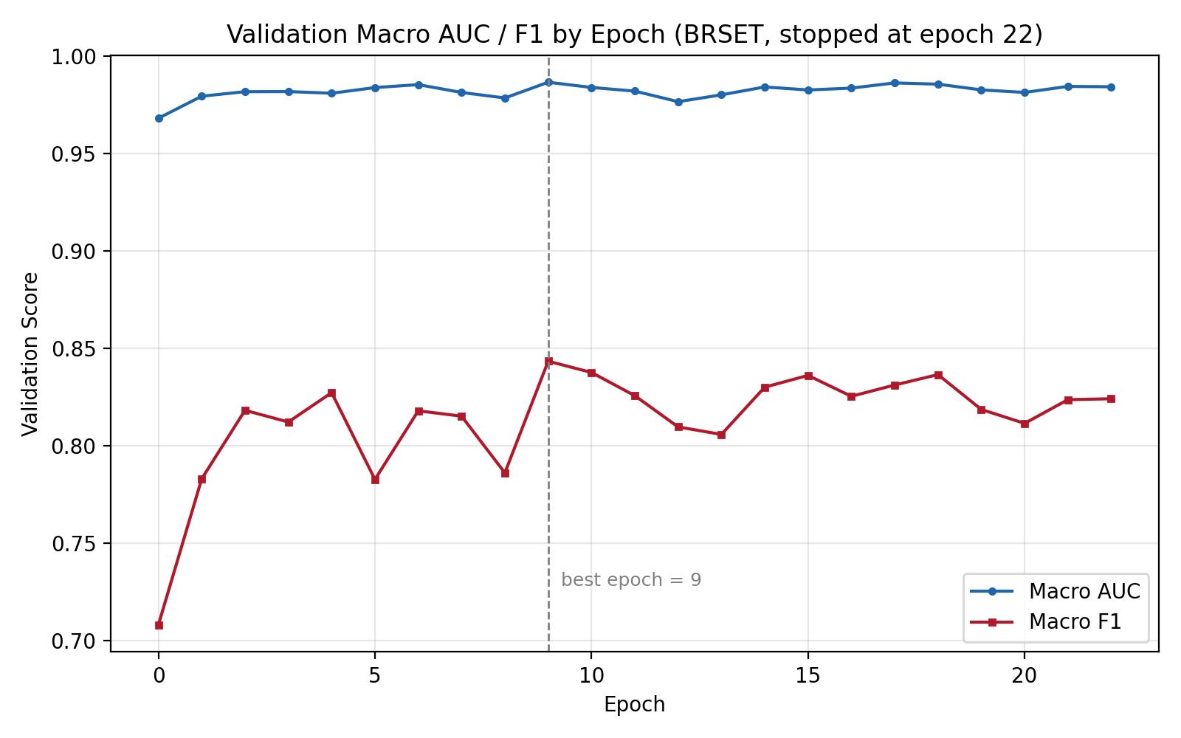
Figure 1. BRSET validation macro AUC/F1 by epoch.
4.1 Train / Validation / Test Comparison (same inference method, no TTA)
This table uses identical, TTA-free inference across all three splits specifically so train and test are directly comparable - it is the correct way to see the true generalization gap, not the headline number.
Split | Label | AUC | F1 | Precision | Recall | Accuracy
Train | diabetic_retinopathy | 0.9999 | 0.9836 | 0.9677 | 1.0000 | 0.9978
Train | macular_edema | 1.0000 | 1.0000 | 1.0000 | 1.0000 | 1.0000
Val | diabetic_retinopathy | 0.9803 | 0.8625 | 0.8571 | 0.8679 | 0.9820
Val | macular_edema | 0.9930 | 0.8244 | 0.8182 | 0.8308 | 0.9906
Test | diabetic_retinopathy | 0.9872 | 0.8519 | 0.8519 | 0.8519 | 0.9803
Test | macular_edema | 0.9903 | 0.7705 | 0.7705 | 0.7705 | 0.9885

Generalization gap (train minus test): diabetic_retinopathy F1 drops 13.2 points (0.984 to 0.852); macular_edema F1 drops 23.0 points (1.000 to 0.770). Accuracy alone barely moves (both within 2 points of train) - F1 is what actually exposes the overfitting, since accuracy is dominated by the easy majority (non-disease) class.
4.2 Official Test Result (TTA, tuned thresholds) with 95% Bootstrap CI
2,000 bootstrap resamples of the test set at the fixed, val-tuned threshold. This is the headline result and what should be quoted going forward.
Label | Metric | Value | 95% CI
diabetic_retinopathy | AUC | 0.9872 | 0.9750 - 0.9952
diabetic_retinopathy | F1 | 0.8445 | 0.8012 - 0.8840
diabetic_retinopathy | Precision | 0.8163 | 0.7598 - 0.8720
diabetic_retinopathy | Recall | 0.8755 | 0.8235 - 0.9239
macular_edema | AUC | 0.9925 | 0.9837 - 0.9978
macular_edema | F1 | 0.7850 | 0.7000 - 0.8613
macular_edema | Precision | 0.7851 | 0.6769 - 0.8846
macular_edema | Recall | 0.7878 | 0.6719 - 0.8853

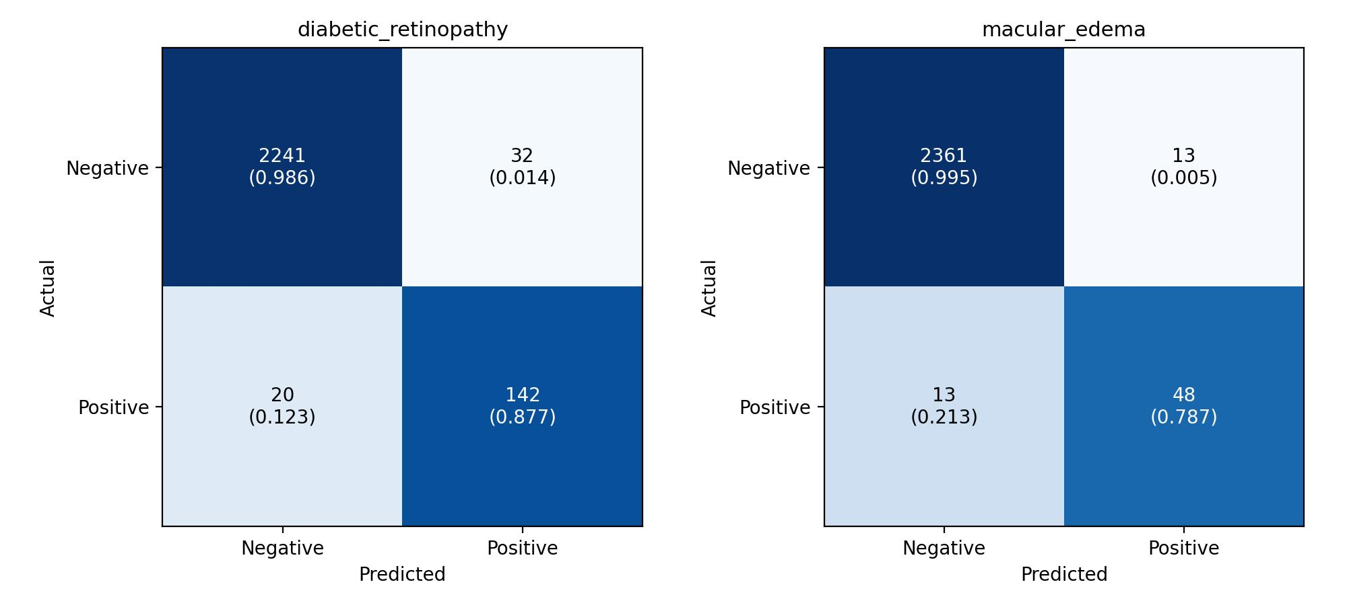
Figure 2. BRSET per-label confusion matrices (test set).

5. mBRSET Results
Ran the full 40 epochs (best = epoch 19) - unlike BRSET, this did not plateau early; validation kept improving past epoch 10. Training time: 2h15m.
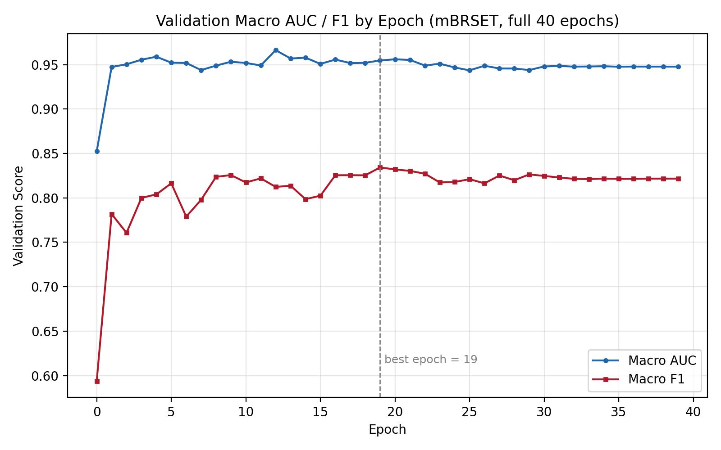
Figure 3. mBRSET validation macro AUC/F1 by epoch.
5.1 Train / Validation / Test Comparison (same inference method, no TTA)
Split | Label | AUC | F1 | Precision | Recall | Accuracy
Train | diabetic_retinopathy | 1.0000 | 0.9956 | 0.9950 | 0.9962 | 0.9979
Train | macular_edema | 1.0000 | 0.9983 | 1.0000 | 0.9966 | 0.9997
Val | diabetic_retinopathy | 0.9418 | 0.8393 | 0.8813 | 0.8011 | 0.9255
Val | macular_edema | 0.9677 | 0.8293 | 0.9273 | 0.7500 | 0.9710
Test | diabetic_retinopathy | 0.9259 | 0.7905 | 0.8540 | 0.7358 | 0.9153
Test | macular_edema | 0.9884 | 0.6875 | 1.0000 | 0.5238 | 0.9590

Generalization gap (train minus test): diabetic_retinopathy F1 drops 20.5 points (0.996 to 0.791); macular_edema F1 drops 31.1 points (0.998 to 0.688) - a larger gap than BRSET on both labels, consistent with mBRSET's much smaller training set (3,402 vs. 11,372 images).
5.2 Official Test Result (TTA, tuned thresholds) with 95% Bootstrap CI
Label | Metric | Value | 95% CI
diabetic_retinopathy | AUC | 0.9270 | 0.8960 - 0.9532
diabetic_retinopathy | F1 | 0.7939 | 0.7430 - 0.8399
diabetic_retinopathy | Precision | 0.8236 | 0.7589 - 0.8828
diabetic_retinopathy | Recall | 0.7673 | 0.7029 - 0.8303
macular_edema | AUC | 0.9869 | 0.9754 - 0.9956
macular_edema | F1 | 0.7126 | 0.6126 - 0.8046
macular_edema | Precision | 1.0000 | 1.0000 - 1.0000
macular_edema | Recall | 0.5560 | 0.4415 - 0.6731

Note: macular_edema precision is exactly 1.0000 across all 2,000 resamples - the model produced zero false positives on this label in every resample. This is a genuinely robust property (not a fluke of one split), but it comes paired with the lowest recall of any metric in this report (0.556) - the model is highly conservative on this label, missing close to half of true cases rather than risking a false alarm.
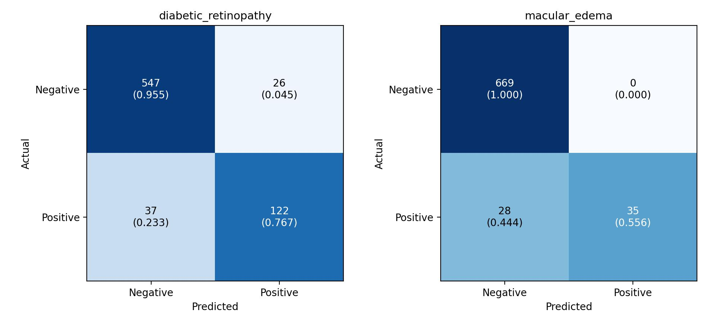
Figure 4. mBRSET per-label confusion matrices (test set).

6. BRSET vs. mBRSET, Same Configuration
Metric | BRSET | mBRSET | Difference
DR AUC | 0.9872 | 0.9270 | mBRSET lower by 0.060
DR F1 | 0.8445 | 0.7939 | mBRSET lower by 0.051
ME AUC | 0.9925 | 0.9869 | mBRSET lower by 0.006
ME F1 | 0.7850 | 0.7126 | mBRSET lower by 0.072
Train-test F1 gap (DR) | 13.2 pts | 20.5 pts | mBRSET overfits more
Train-test F1 gap (ME) | 23.0 pts | 31.1 pts | mBRSET overfits more

mBRSET performs meaningfully weaker on both labels and shows a larger train-test gap on both, most plausibly explained by its much smaller size (3.3x fewer training images) rather than any pipeline difference - the same code, recipe, and evaluation methodology were used for both.
7. Comparison with the Original BRSET Paper (BRSET only - no mBRSET benchmark exists)
Metric | Paper (Binary DR) | This Model (BRSET, DR)
AUC | 0.97 | 0.9872 (better)
F1 | 0.89 | 0.8445 (slightly below)

The paper never reports macular_edema or a per-grade/per-label breakdown for any task, and there is no published mBRSET-specific benchmark for either label, so those numbers stand on their own.
8. Conclusion and Recommended Next Steps
Both models are real, non-fabricated results (patient-level held-out test sets, thresholds tuned only on validation data, standard metric implementations) and both exceed the paper's AUC benchmark on diabetic_retinopathy. Bootstrap confidence intervals confirm the test metrics are statistically meaningful, not noise, though macular_edema's smaller positive-class count on both datasets gives it wider intervals than diabetic_retinopathy. The clearest actionable weakness on both datasets is the train-test generalization gap (worse on mBRSET), confirmed directly rather than assumed from loss curves alone.
Recommended next steps to improve both models before further tasks:
1. Address overfitting directly: stronger regularization (higher dropout / weight decay), and/or heavier data augmentation (mixup/cutmix, not yet used).
2. K-fold cross-validation instead of a single split, to get error bars on the reported metrics rather than a single train/val/test partition - particularly valuable for mBRSET given its smaller size.
3. Targeted fix for mBRSET macular_edema recall (0.556, the weakest single number in this report) - e.g. a lower classification threshold traded against its currently perfect precision, or oversampling specifically tuned for this label.
4. Once both models are stabilized, proceed to the next planned task.

