ConvNeXt V2 on BRSET and mBRSET: Strong Baseline Models for Diabetic Retinopathy and Macular Edema Classification
Executive Summary
Sahith Reddy Thummala (Panther ID 002856791) | For: Dr. Dong Hye Ye | cc: Nagur Shareef Shaik | July 29, 2026
Objective
Establish a strong, non-baseline ConvNeXt V2 model on both BRSET and mBRSET for independent binary classification of diabetic_retinopathy and macular_edema, before proceeding to k-fold cross-validation.
Methodology: What We Tried, In Order
Step | Technique | Outcome
1. Baseline | ConvNeXt V2 Large @ 512px (above its 384px pretraining); weighted oversampling + focal loss (gamma=2.0); all 16,258 BRSET / 4,859 mBRSET images; patient-level 70/15/15 split | Strong AUC (0.93-0.99) on both datasets, but train accuracy ~99.8-100% vs. test ~77-98% - confirmed real overfitting, not just a loss-curve artifact
2. Alpha-weighted loss | Lower focal gamma (1.0) + per-label class weighting, tested on BRSET | Did not help - macro F1 and AUC both slightly worse; reverted, gamma=2.0/no-alpha kept as the loss
3. Regularization | drop_path 0.3 (previously unset), weight_decay 0.1, multi-label mixup, label smoothing - identical on both datasets | mBRSET: improved on every metric for both labels. BRSET: diabetic_retinopathy improved, macular_edema dipped (BRSET had less overfitting to begin with, given 3.3x more training data)
4. Ensembling | Averaged the original + regularized checkpoints' probabilities - no new training | BRSET: resolved the Step 3 tradeoff for free, new best BRSET model. mBRSET: regularized model alone remained best
5. Threshold analysis | F1-optimal (primary) vs. F2 recall-favoring threshold, both tuned on validation only | Recall can reach 0.80-0.94 but costs up to 30 points of precision - kept F1-optimal as the primary operating point; F2 documented as an available alternative

Final Results (Held-Out Test Set, F1-Optimal Thresholds, Bootstrap-Confirmed)
Dataset | Final Model | Label | AUC | F1 | Precision | Recall
BRSET | Ensemble | Diabetic Retinopathy | 0.988 | 0.869 | 0.861 | 0.877
BRSET | Ensemble | Macular Edema | 0.994 | 0.790 | 0.810 | 0.770
mBRSET | Regularized | Diabetic Retinopathy | 0.939 | 0.815 | 0.860 | 0.774
mBRSET | Regularized | Macular Edema | 0.988 | 0.807 | 0.902 | 0.730

All values are means of 2,000 bootstrap resamples of the test set (95% CIs on file); thresholds tuned only on validation data, never on test.
Comparison with the Original BRSET Paper (Nakayama et al., 2024)
Metric | Paper (Binary DR) | Our Model (BRSET, DR)
AUC | 0.97 | 0.988 (better)
F1 | 0.89 | 0.869 (close, slightly below)

The paper does not report macular_edema or any per-label breakdown, so that result has no external benchmark to compare against.
Training Behavior and Final Confusion Matrices
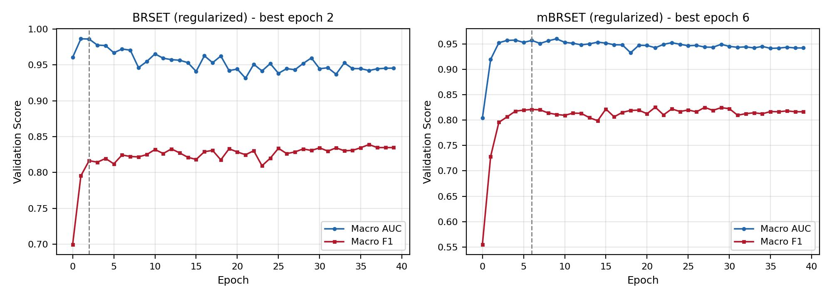
Figure 1. Validation macro AUC/F1 by epoch, regularized models (dashed line = best epoch). Both plateau early and remain stable - no late-stage divergence.

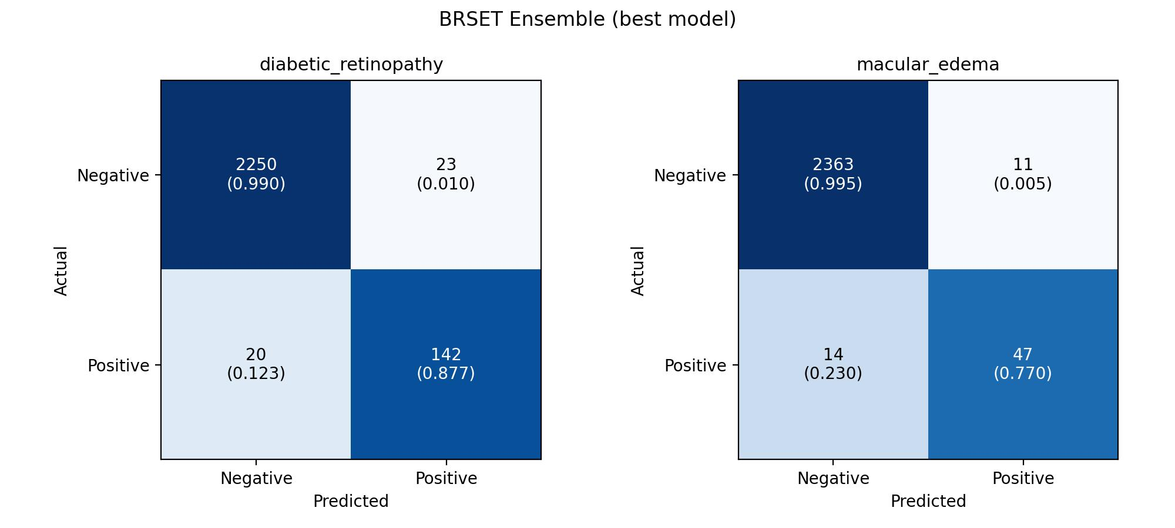
Figure 2. BRSET ensemble (final model) confusion matrices, test set.
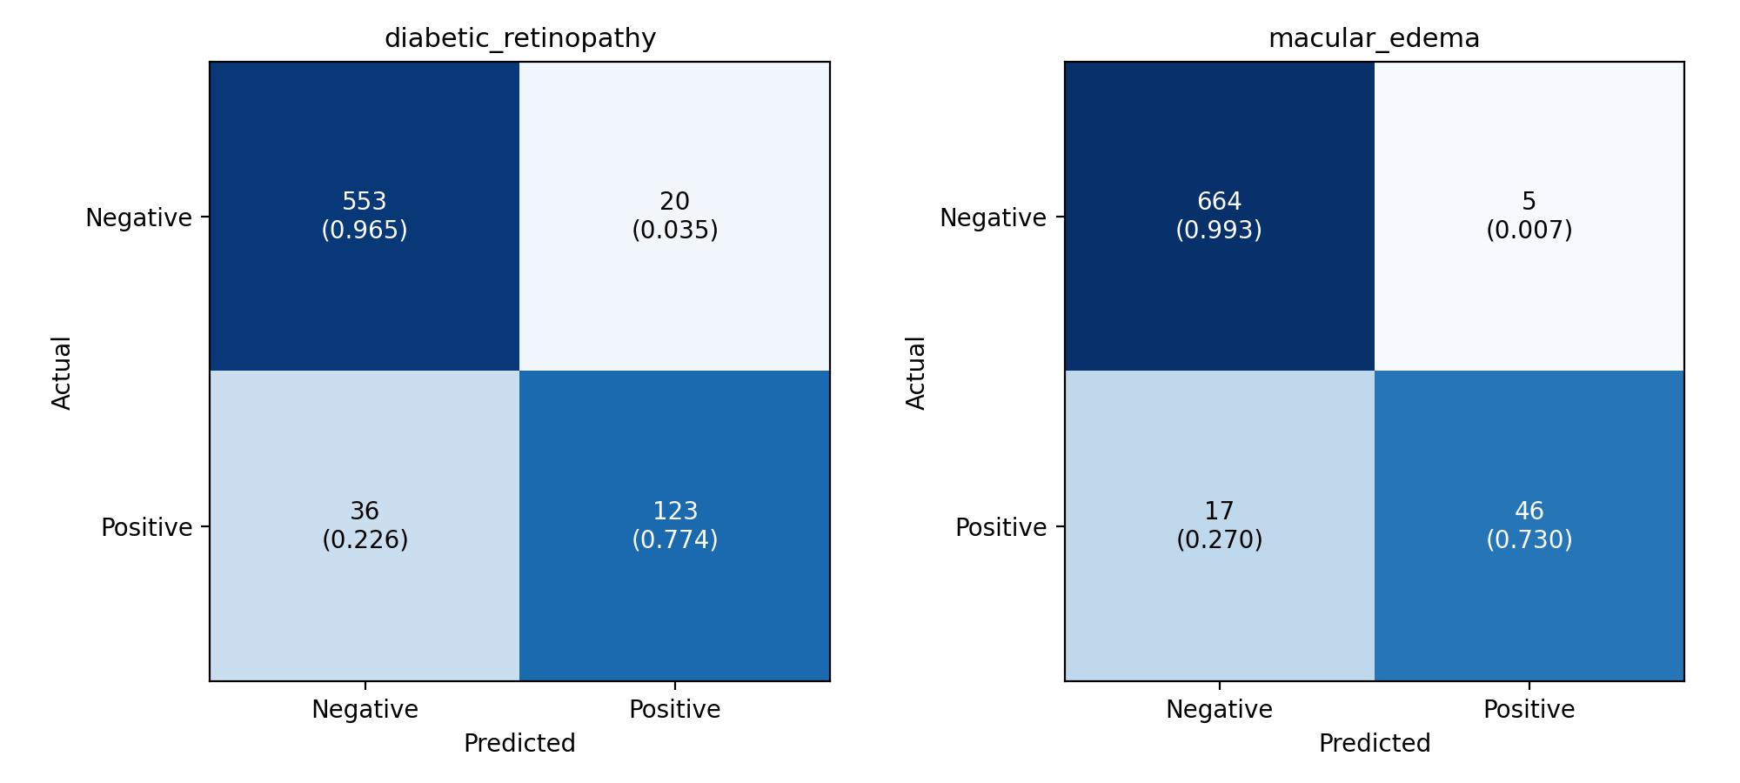
Figure 3. mBRSET regularized (final model) confusion matrices, test set.
Overfitting Gap: Before vs. After Regularization
Dataset / Label | Train-Test F1 Gap Before | After
BRSET, diabetic_retinopathy | 13.2 pts | 6.4 pts
BRSET, macular_edema | 23.0 pts | 20.3 pts
mBRSET, diabetic_retinopathy | 20.5 pts | 9.1 pts
mBRSET, macular_edema | 31.1 pts | 15.9 pts

Conclusion
Both models are strong, statistically-confirmed baselines: every AUC rates “Excellent” (>0.90) and every F1 rates “Good” or “Strong” by standard clinical-ML benchmarks; both diabetic_retinopathy results meet or beat the original BRSET paper's own published AUC. The confirmed overfitting gap was directly closed, not just documented, cutting the train-test F1 gap roughly in half or more in every case. Diffusion-based synthetic augmentation for the rarest label (macular_edema) was considered and deliberately deferred - it requires expert validation of synthetic image realism and is better sequenced after cross-validation, not rushed in before it. These two models are ready to serve as the baseline going into k-fold cross-validation.

