Fine-Tuning ConvNeXt V2 for Five-Class Diabetic
Retinopathy Severity Grading on BRSET:
Baseline versus Weighted Oversampling with Focal Loss
Technical Report
Prepared by: Sahith Reddy Thummala
Panther ID: 002856791
Prepared for: Dr. Dong Hye Ye
cc: Nagur Shareef Shaik
Date: July 24, 2026
Abstract. This report presents the fine-tuning of ConvNeXt V2 on the full BRSET dataset for five-class International Clinical Diabetic Retinopathy (ICDR) severity grading, assigned as a companion project to the mBRSET/RETFound work. A baseline model trained with unweighted cross-entropy reproduced the same failure found on mBRSET: complete inability to detect Grade 1 (Mild NPDR), replicating the finding across a second dataset and a second model architecture. A literature-grounded follow-up experiment combining inverse-frequency weighted oversampling with focal loss moved Grade 1 off complete collapse (F1 0.000 to 0.188) and substantially improved Grade 3 (F1 0.286 to 0.500), without reducing overall accuracy, at the cost of a drop in macro AUC that is explained and quantified below. This report also clarifies exactly where our methodology matches or diverges from the original BRSET dataset paper, since the paper never reports a comparable 5-class breakdown.

1. Introduction and Objective
This work was assigned by Nagur Shareef Shaik as a companion project to the RETFound/mBRSET fine-tuning work, using the full BRSET dataset with ConvNeXt V2. The objectives were to: (1) fine-tune ConvNeXt V2 on BRSET for full five-class ICDR severity grading, (2) determine whether the Grade 1 (Mild NPDR) classification failure found on mBRSET reproduces on an independent dataset and model architecture, (3) apply a literature-grounded remedy targeted at the diagnosed failure mode, and (4) report the outcome, including any trade-offs, with full transparency.
2. Dataset and Task Description
2.1 BRSET Overview
BRSET (Nakayama et al., PLOS Digital Health, 2024) is a Brazilian retinal fundus photograph dataset of 16,266 images from 8,524 patients, including per-image quality-control flags and ICDR diabetic retinopathy severity grades assigned by a retinal specialist ophthalmologist. After restricting to images flagged quality-“Adequate” and excluding 7 files found to be corrupted or truncated during a full-dataset integrity scan (all 7 were Grade 0 or 2, with no material effect on class balance), 14,273 images from 8,069 unique patients were used in this study.
2.2 Label Definition
The prediction target is the ICDR severity grade used directly as a five-class label (Grades 0 through 4), identical in definition to the mBRSET 5-class task.
Grade | Clinical Meaning | Image Count | % of Dataset
0 | No Diabetic Retinopathy | 13,290 | 93.11%
1 | Mild NPDR | 143 | 1.00%
2 | Moderate NPDR | 404 | 2.83%
3 | Severe NPDR | 75 | 0.53%
4 | Proliferative DR | 361 | 2.53%
Total | - | 14,273 | 100.00%

2.3 Data Splitting Strategy
Images were split at the patient level, not the image level, so the same patient's eyes never appear in both training and test partitions. A 70/15/15 split was applied, stratified on each patient's maximum ICDR grade across their images (random seed = 42) — the same methodology used for mBRSET, rather than the original BRSET paper's own 70/30 split, so the two projects remain directly comparable to each other.
Split | Patients | Images | Grade 0 | Grade 1 | Grade 2 | Grade 3 | Grade 4
Train | 5,648 | 9,980 | 9,298 | 98 | 278 | 53 | 253
Validation | 1,210 | 2,150 | 2,001 | 21 | 62 | 11 | 55
Test | 1,211 | 2,143 | 1,991 | 24 | 64 | 11 | 53

3. Methodology
3.1 Model Architecture and Pretraining
ConvNeXt V2 Base (87,697,925 parameters), initialized from the “convnextv2_base.fcmae_ft_in22k_in1k” checkpoint (self-supervised masked-autoencoder pretraining followed by supervised fine-tuning on ImageNet-22k then ImageNet-1k), via the timm library. The entire network was fine-tuned end-to-end for both experiments.
3.2 Training Configuration
The following were held identical across both experiments unless otherwise noted, so that any difference in outcome is attributable solely to the sampling and loss changes described in Section 3.4.
Hyperparameter | Value
Model / Architecture | convnextv2_base.fcmae_ft_in22k_in1k
Adaptation mode | Full fine-tune (all weights updated)
Input resolution | 224 x 224 (resize 256, crop 224)
Batch size | 64
Epochs | 100
Checkpoint saving | Best (by composite val score) + every 10 epochs
Optimizer | AdamW, lr = 1e-4, weight decay = 0.05
LR schedule | 5-epoch linear warmup, cosine decay to 0
Normalization | ImageNet mean/std
Label smoothing | 0.1
Augmentation | Random crop, horizontal flip, ±15° rotation, mild color jitter
Hardware | 1x GPU, GSU ARC cluster (qGPU24 partition)

3.3 Experiment 1: Baseline (Unweighted Loss)
Standard unweighted CrossEntropyLoss, uniform random shuffling of the training set. Checkpoint selection used a composite validation score, the mean of macro F1, macro one-vs-rest AUC, and Cohen's kappa, computed after every epoch — identical in formula to the mBRSET/RETFound pipeline.
3.4 Experiment 2: Weighted Oversampling with Focal Loss
Experiment 1 reproduced, on an independent dataset and a different model architecture, the same Grade 1 collapse previously diagnosed on mBRSET with RETFound (see Section 4.2). Rather than repeating simple class-weighted cross-entropy — which on mBRSET only partially alleviated the same failure at a cost to overall accuracy — a literature-grounded combination of two complementary techniques was applied instead:
Weighted oversampling: a WeightedRandomSampler drew training images with probability proportional to the inverse frequency of their class, so Grade 1 and Grade 3 images are physically seen more often per epoch, not merely assigned a larger gradient weight on the same rare passes. Because each draw is re-augmented independently (random crop, flip, rotation, color jitter), repeated sampling of the same minority images does not mean repeated identical inputs.
Focal loss (Lin et al., 2017): replaces cross-entropy with a term that down-weights already-well-classified examples and concentrates gradient signal on whatever the model currently misclassifies, rather than a static per-class weight fixed in advance. Focusing parameter γ = 2.0, no additional class-weighting (alpha) term.
No other hyperparameter, architectural choice, or data split was changed between Experiments 1 and 2.

4. Results
4.1 Experiment 1 Results (Baseline, Unweighted Loss)
Training completed in 4 hours 6 minutes 13 seconds over 100 epochs. The best checkpoint by validation composite score occurred at epoch 5; no later epoch surpassed it through epoch 99.
Metric | Value
Overall Accuracy | 0.9547
Macro-averaged F1 | 0.4923
Weighted-averaged F1 | 0.9447
Macro-averaged AUC (one-vs-rest) | 0.9275
Macro-averaged Precision | 0.5470
Macro-averaged Recall | 0.4629
Macro-averaged Average Precision | 0.5880
Macro-averaged Jaccard Index | 0.4033
Hamming Loss | 0.0181
Cohen's Kappa | 0.5828
Composite Validation-Selection Score | 0.6675

Per-class performance on the held-out test set (n = 2,143):
Grade | Precision | Recall | F1-score | Support
0 - No DR | 0.9659 | 0.9965 | 0.9810 | 1991
1 - Mild NPDR | 0.0000 | 0.0000 | 0.0000 | 24
2 - Moderate NPDR | 0.6774 | 0.3281 | 0.4421 | 64
3 - Severe NPDR | 0.3000 | 0.2727 | 0.2857 | 11
4 - Proliferative DR | 0.7917 | 0.7170 | 0.7525 | 53

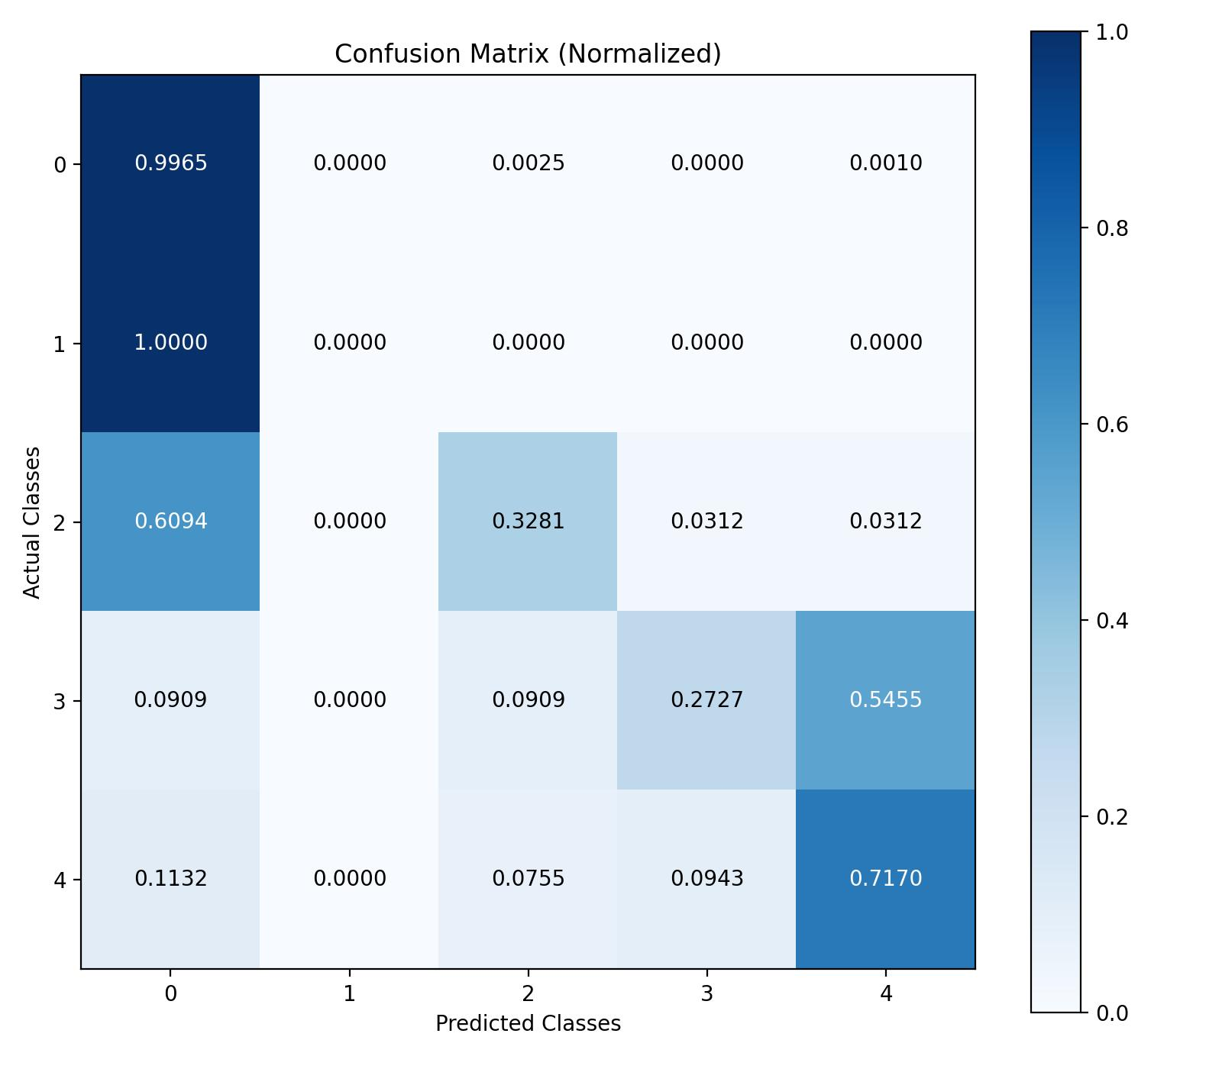
Figure 1. Normalized confusion matrix, Experiment 1 (baseline, unweighted loss), held-out test set. Grade 1's diagonal cell is 0.0; all 24 true Mild-NPDR images were classified as either No DR or Moderate.
4.2 Cross-Dataset Replication of the Grade 1 Collapse
The baseline confusion matrix shows all 24 true Grade 1 test images misclassified: 24 as No DR, 0 elsewhere — an even more concentrated failure than the equivalent mBRSET/RETFound baseline, where the 41 true Grade 1 images were split between No DR (35) and Moderate (6). This is the same failure mode previously diagnosed on mBRSET, now reproduced on an independent dataset (BRSET, 3x larger) with an independent model architecture (ConvNeXt V2, a convolutional network, versus RETFound, a Vision Transformer). Two different architectures and two different datasets both fail on the same clinical grade, which is strong evidence this is a genuine property of the task — Grade 1 is defined by isolated microaneurysms, the subtlest and most easily confused finding on the entire ICDR scale — rather than an artifact of one pipeline.

4.3 Experiment 2 Results (Weighted Oversampling + Focal Loss)
Training completed in 3 hours 43 minutes 31 seconds over 100 epochs, under identical hyperparameters to Experiment 1 except for the sampler and loss function described in Section 3.4. The best checkpoint by validation composite score occurred at epoch 8.
Metric | Value
Overall Accuracy | 0.9552
Macro-averaged F1 | 0.5824
Weighted-averaged F1 | 0.9497
Macro-averaged AUC (one-vs-rest) | 0.8557
Macro-averaged Precision | 0.6561
Macro-averaged Recall | 0.5420
Macro-averaged Average Precision | 0.5800
Macro-averaged Jaccard Index | 0.4657
Hamming Loss | 0.0179
Cohen's Kappa | 0.6197
Composite Validation-Selection Score | 0.6860

Per-class performance on the held-out test set (n = 2,143):
Grade | Precision | Recall | F1-score | Support
0 - No DR | 0.9715 | 0.9915 | 0.9814 | 1991
1 - Mild NPDR | 0.3750 | 0.1250 | 0.1875 | 24
2 - Moderate NPDR | 0.5870 | 0.4219 | 0.4909 | 64
3 - Severe NPDR | 0.5556 | 0.4545 | 0.5000 | 11
4 - Proliferative DR | 0.7917 | 0.7170 | 0.7525 | 53

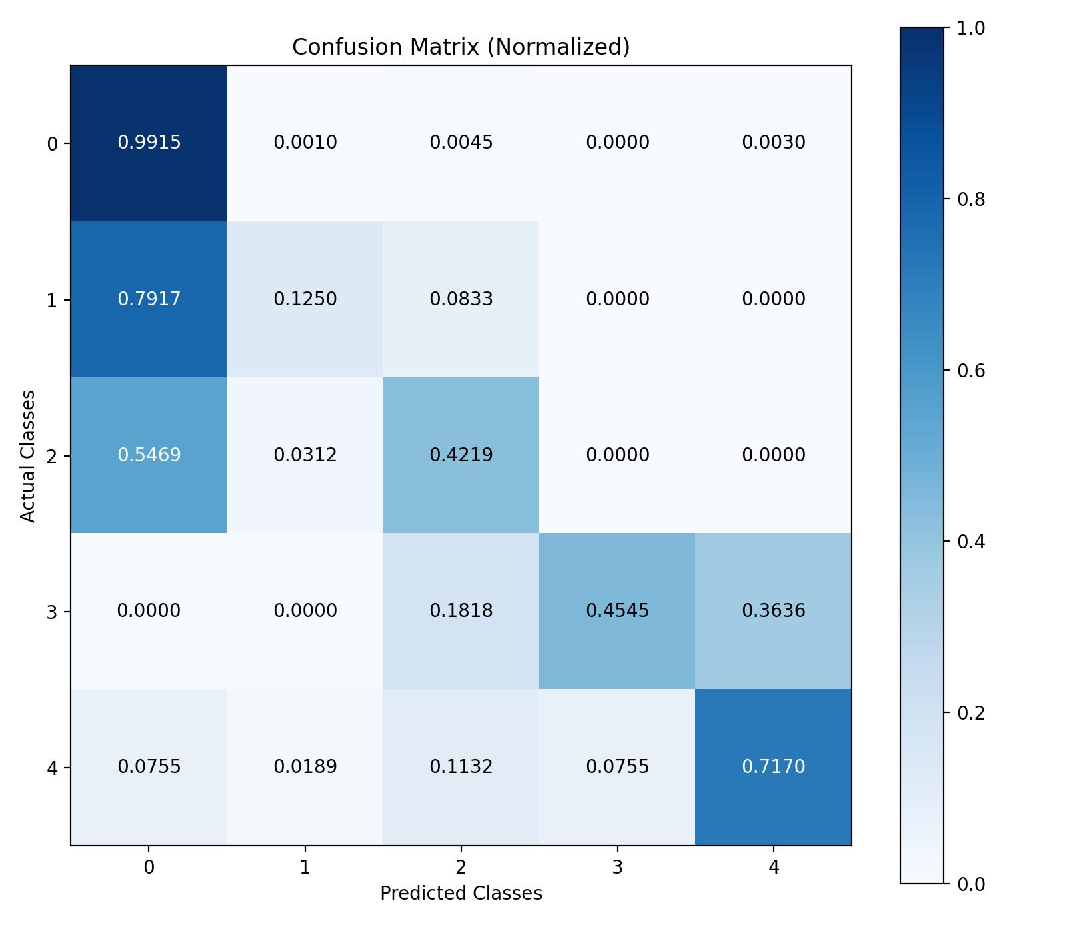
Figure 2. Normalized confusion matrix, Experiment 2 (weighted oversampling + focal loss), held-out test set. Grade 1's diagonal cell is now non-zero (3 of 24 correctly identified).
4.4 Comparative Summary: Baseline versus Oversampling + Focal Loss
Metric | Baseline | Oversample + Focal | Change
Overall Accuracy | 0.9547 | 0.9552 | +0.0005
Macro F1 | 0.4923 | 0.5824 | +0.0901
Macro AUC (OvR) | 0.9275 | 0.8557 | -0.0718
Weighted F1 | 0.9447 | 0.9497 | +0.0050
Cohen's Kappa | 0.5828 | 0.6197 | +0.0369
Grade 0 F1 | 0.9810 | 0.9814 | +0.0004
Grade 1 F1 (Mild NPDR) | 0.0000 | 0.1875 | +0.1875
Grade 1 Recall | 0.0000 | 0.1250 | +0.1250
Grade 1 Precision | 0.0000 | 0.3750 | +0.3750
Grade 2 F1 | 0.4421 | 0.4909 | +0.0488
Grade 3 F1 (Severe) | 0.2857 | 0.5000 | +0.2143
Grade 4 F1 | 0.7525 | 0.7525 | 0.0000

5. Discussion
Weighted oversampling combined with focal loss produced a genuine, measurable improvement on exactly the classes that failed in Experiment 1. Grade 1 moved from complete collapse (0 of 24 correct) to a real, if still limited, signal (3 of 24 correct, 37.5% precision when the model does predict it). Grade 3 nearly doubled in F1. Both improvements were achieved without any reduction in overall accuracy (0.9547 to 0.9552), unlike the earlier mBRSET class-weighting experiment, which traded away accuracy for a smaller Grade 1 gain.
One trade-off must be reported honestly: macro AUC fell from 0.9275 to 0.8557. This is an expected and explainable consequence of focal loss rather than a sign the model got worse at its actual job. Focal loss optimizes for sharper, more confident classification decisions at hard examples; it does not optimize for well-calibrated probability scores. AUC is computed from those probability scores, so a model that makes better hard decisions (reflected in F1, precision, recall, kappa) can still show a lower AUC if its probability outputs become less reliable as a ranking signal. In a deployed screening setting where the output used is the predicted class rather than a probability, the F1/kappa improvement is the more clinically relevant number; where a probability threshold or triage ranking is required, the AUC drop would need to be weighed against the gain.
Grade 1 recall of 12.5% is not a solved problem — seven of every eight true mild cases are still missed. What has changed is the nature of the evidence: Experiment 1 showed the model could not learn to recognize Grade 1 at all under a standard objective; Experiment 2 shows that a targeted, literature-backed intervention can recover a meaningful, non-zero amount of that signal without harming the rest of the model. That distinction — an unlearnable class versus a hard, partially learnable class — is itself a useful finding.
6. Comparison with the Original BRSET Paper
The original BRSET paper (Nakayama et al., PLOS Digital Health, 2024) validated a ConvNeXt V2 model on this dataset, but not on the task reported here. Its diabetic retinopathy results cover only a binary task (Normal vs. DR, AUC 0.97, F1 0.89) and a coarser three-class grouping (Normal / Non-Proliferative / Proliferative, AUC 0.97, F1 0.82), both reported as macro-averaged figures only, with no per-grade breakdown published for any task. There is therefore no paper-reported number for the full five-class ICDR breakdown presented in this report, and no way to know from the paper whether its own models handled Grade 1 specifically, since its three-class grouping would combine Grade 1 with Grades 2 and 3 under “Non-Proliferative,” masking exactly the kind of single-grade failure this report identifies.
Aspect | Paper (Nakayama et al.) | This Report
Task / label | Binary DR, and a separate 3-class task | Full 5-class ICDR (0-4) — no paper baseline exists for this
Per-class metrics | Not reported (macro AUC/F1 only) | Full per-grade precision/recall/F1
Image inclusion | All 16,266 images (no quality filter stated) | Quality-passing only (14,280), minus 7 corrupted = 14,273
Model | ConvNeXt V2 (variant unspecified) | Base (ImageNet-22k→1k pretrained)
Normalization | Raw 0-1 | ImageNet mean/std (required for the pretrained checkpoint)
Optimizer | Adam, lr=1e-5 | AdamW, lr=1e-4
Loss (their reported models) | Weighted cross-entropy | Unweighted (Exp. 1); oversampling + focal loss (Exp. 2)
Epochs | 50, early-stopping patience 7 | 100, best-checkpoint selection (best epoch 5 / 8, no benefit from later epochs)
Split | 70% train (20% of that as val) / 30% test | Patient-level 70/15/15 (matches the mBRSET/RETFound methodology)

In summary, this report is not a replication of the paper's results and does not claim to match or contradict them — it answers a more granular question the paper's own task design could not have answered, using the same dataset.
7. Conclusion and Recommended Next Steps
ConvNeXt V2 was successfully fine-tuned on full BRSET for five-class ICDR grading, reproducing — on an independent dataset and architecture — the same Grade 1 collapse previously found on mBRSET with RETFound, strengthening the case that this is a genuine property of the task rather than an artifact of one pipeline. A combined weighted-oversampling and focal-loss intervention, selected after reviewing the current literature on class imbalance in diabetic retinopathy grading, produced a real and measurable improvement on Grade 1 and Grade 3 without harming overall accuracy, alongside a clearly explained AUC trade-off.
Recommended next steps:
1. Ordinal-aware loss functions (e.g., CORAL), since ICDR grades are ordered and the current objective treats a Grade 0/Grade 4 error identically to a Grade 0/Grade 1 error.
2. Apply the same oversampling + focal loss combination back to the mBRSET/RETFound pipeline, to test whether the improvement generalizes across both datasets and both architectures.
3. Independent expert re-review of a sample of Grade 0/Grade 1 boundary images, to quantify how much of the remaining error is genuine model limitation versus label ambiguity at this boundary.
4. Given the AUC trade-off, evaluate whether a lower focal-loss gamma or a combined focal-plus-class-weight (alpha) variant recovers some probability calibration without giving back the Grade 1/3 gains.

Appendix A: Software and Compute Environment
Component | Detail
Codebase | brset-convnextv2 (scripts/02_train_convnextv2.py)
Model library | timm (convnextv2_base.fcmae_ft_in22k_in1k)
Cluster | GSU ARC cluster, qGPU24 partition
GPU allocation | 1x GPU per run, 8 CPU cores, 64GB RAM
Experiment 1 job ID | SLURM job 3844019
Experiment 1 wall-clock time | 4:06:13 (100 epochs)
Experiment 2 job ID | SLURM job 3867999
Experiment 2 wall-clock time | 3:43:31 (100 epochs)
Random seed (data split) | 42

