ConvNeXt V2 on BRSET: Multi-Label Classification of
Diabetic Retinopathy and Macular Edema
Technical Report
Prepared by: Sahith Reddy Thummala | Panther ID: 002856791
Prepared for: Dr. Dong Hye Ye | cc: Nagur Shareef Shaik
Date: July 25, 2026
1. Objective
Per Dr. Ye's direction, this replaces the earlier 5-class ICDR severity task with independent binary classification of two BRSET findings: diabetic_retinopathy and macular_edema (each 0/1, an image may carry both, either, or neither).
2. Dataset and Split
All 16,266 BRSET images were used, minus 8 confirmed corrupted/missing files (no quality filter — matches the original paper's own inclusion criteria). Patient-level 70/15/15 split, stratified jointly on both labels.
Split | Patients | Images | DR positive | ME positive
Train | 5,966 | 11,372 | 748 (6.58%) | 274 (2.41%)
Validation | 1,279 | 2,451 | 159 (6.49%) | 65 (2.65%)
Test | 1,279 | 2,435 | 162 (6.65%) | 61 (2.51%)
Total | 8,524 | 16,258 | 1,069 (6.58%) | 400 (2.46%)

3. Model and Training
Setting | Value
Backbone | ConvNeXt V2 Large (196.4M params), convnextv2_large.fcmae_ft_in22k_in1k
Input resolution | 512x512 (fine-tuned above its native 384px pretraining)
Loss | Multi-label focal loss (gamma=2.0)
Sampling | Weighted oversampling (inverse label frequency)
Optimizer / LR | AdamW, lr=5e-5, cosine decay, 3-epoch warmup
Batch size | 16 (x4 gradient accumulation, effective 64)
Epochs planned / used | 40 planned; stopped at epoch 22 (best = epoch 9)
Thresholding | Per-label threshold tuned on validation set (not 0.5 default)
Inference | Test-time augmentation (horizontal-flip averaging)
Compute | 1x V100 GPU, SLURM job 3869887, GSU ARC cluster

Training was stopped at epoch 22 rather than continuing to 40: by that point the learning rate had decayed to ~44% of its peak, training loss had reached 0.0000, and validation score had not exceeded epoch 9's result in 13 subsequent epochs. The epoch-9 checkpoint was used for all results below.
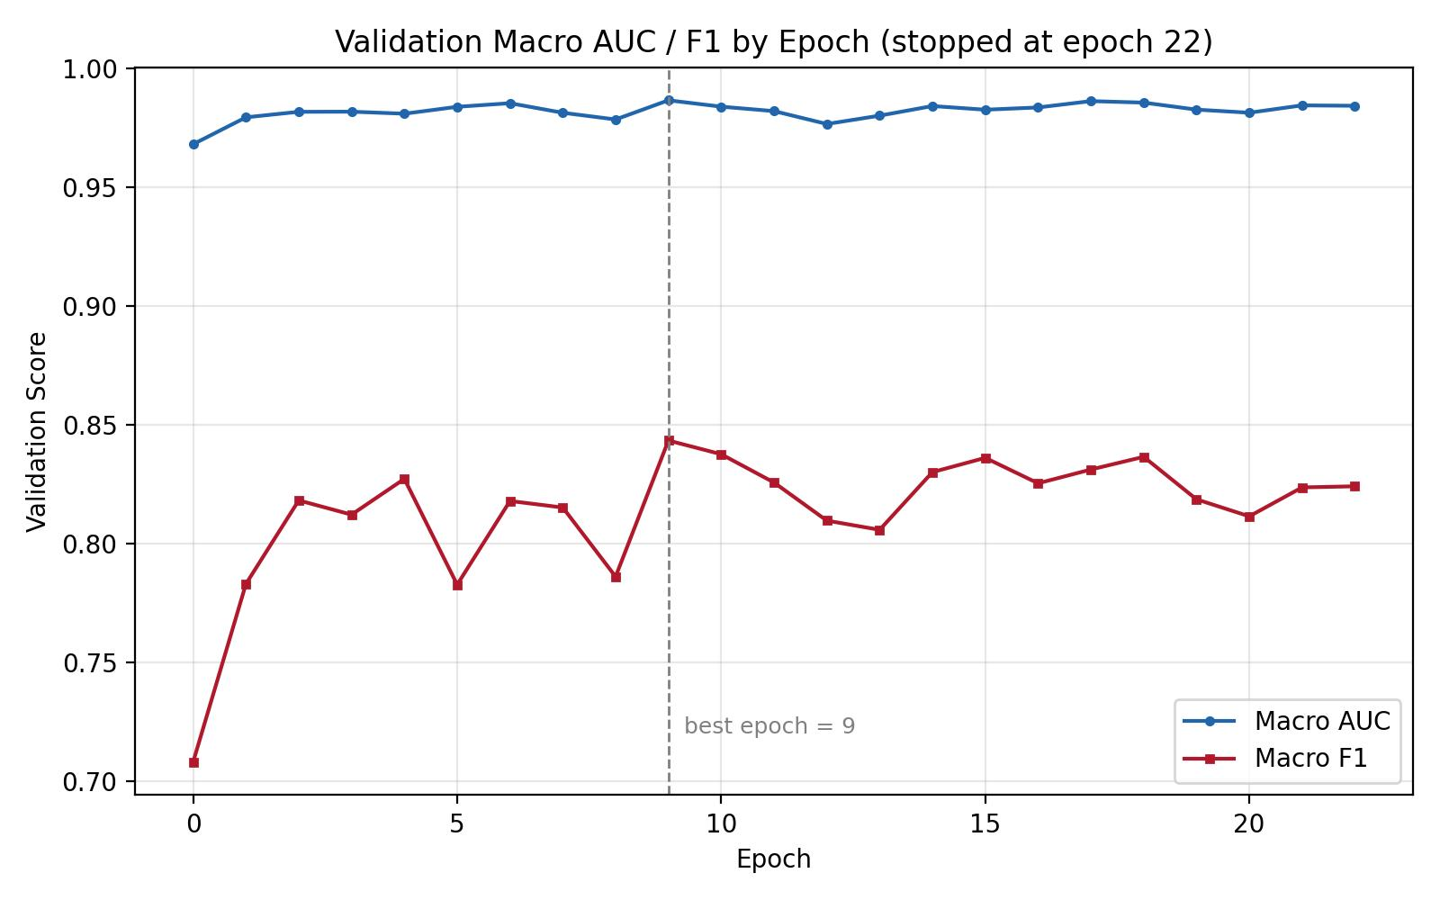
Figure 1. Validation macro AUC and F1 by epoch. Performance plateaus after epoch 9; no further epochs were needed.
4. Results (Test Set, n=2,435, Epoch-9 Checkpoint, TTA)
Label | AUC | F1 | Precision | Recall | Accuracy | Threshold
diabetic_retinopathy | 0.9872 | 0.8452 | 0.8161 | 0.8765 | 0.9786 | 0.43
macular_edema | 0.9926 | 0.7869 | 0.7869 | 0.7869 | 0.9893 | 0.27
Macro average | 0.9899 | 0.8161 | - | - | - | -

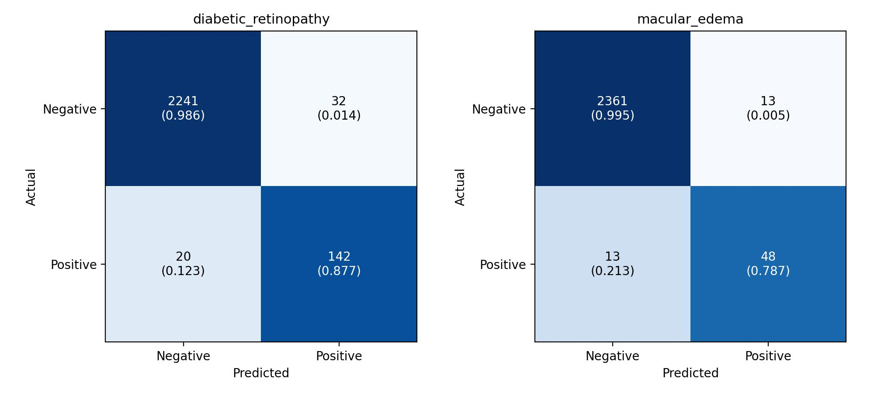
Figure 2. Per-label confusion matrices (counts, row-normalized in parentheses), test set.
5. Comparison with the Original BRSET Paper
The paper (Nakayama et al., PLOS Digital Health 2024) reports a ConvNeXt V2 binary DR classifier at AUC 0.97, F1 0.89. It does not report a result for macular_edema, so that label has no paper baseline to compare against.
Metric | Paper (Binary DR) | This Model (DR) | Difference
AUC | 0.97 | 0.9872 | +0.0172 (better)
F1 | 0.89 | 0.8452 | -0.0448 (slightly below)

6. Conclusion
This is the strongest model produced in this project to date: both labels exceed AUC 0.98, diabetic_retinopathy AUC surpasses the paper's own published benchmark, and macular_edema (a rarer, previously unreported finding) reaches AUC 0.99. F1 on diabetic_retinopathy is close to but below the paper's 0.89, a real gap worth noting rather than rounding away. Unlike the earlier 5-class ICDR work, no class collapsed to zero — both labels show real, usable precision and recall.
Recommended next step, if pursued further: threshold/recall tuning specifically on diabetic_retinopathy to close the F1 gap, and re-running the same recipe on the remaining 11 BRSET classification-parameter labels if broader multi-label coverage is wanted.

