Roll No. :11,12,13 Project-Name: Random Password Generator

import random

import string

def password_generator(length):

 characters = string.ascii_letters + string.digits + "!"+"@"+"#"+"$"+"%"+"^"+"&"+"+"+"("+"*"+")"+"_"+""+"}"+"{"+"["+"]"+";"+","+"."+"/"+"?"+":"+"~"+"`"

 password = "".join(random.choice(characters) for i in range(length))

 if check_password(password):

    return password

 else:

    return password_generator(length)

def check_password(password):

    if (any(char.islower() for char in password) and

            any(char.isupper() for char in password) and

            any(char.isdigit() for char in password) and

            any(char in string.punctuation for char in password)):

            return True

    else:

            return False

#_main_

def ask():

 length = int(input("Enter the length of the password: "))

 if length < 12:

    print("Password should be atleast of 12 characters")

 elif length >= 12:

    print(password_generator(length))

ask()

Taking Input:

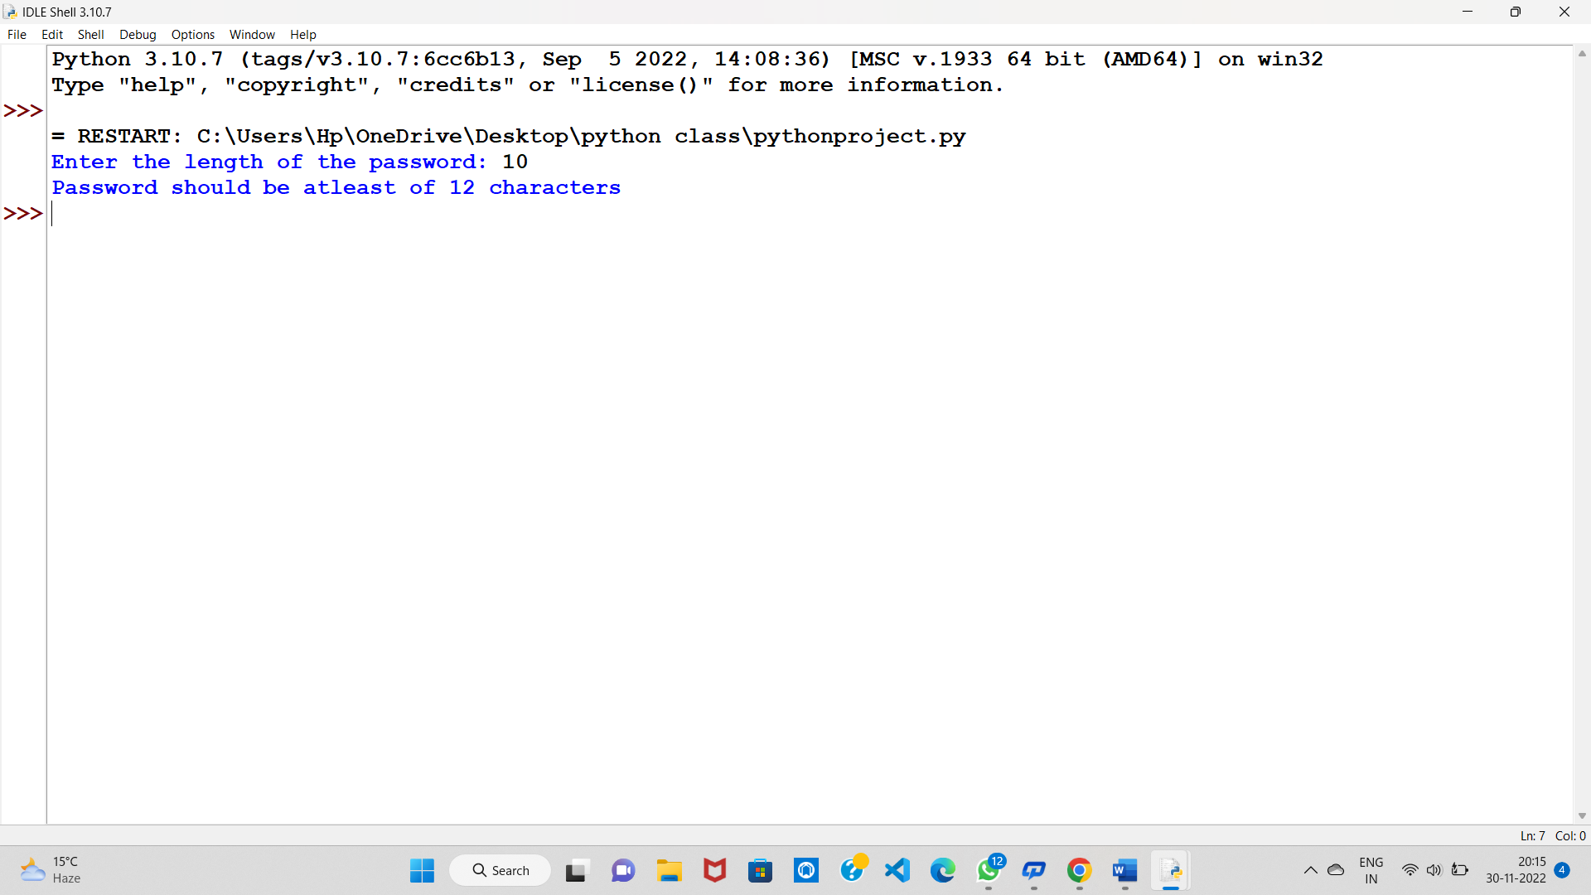

Taking Input Again:

