**Course Registration Application**

**Information:**

**Used Technology: MongoDb, ExpressJS, Angular, Node (MEAN)**

**Version Information:**

|  |  |
| --- | --- |
| Angular | 8.3.6 |
| Node | 12.11.0 |
| MongoDB | 4.2.1 |

**NPM Packages used in FrontEnd:**

|  |  |
| --- | --- |
| bootstrap | 4.4.1 |
| font-awesome | 4.7.0 |
| @ng-bootstrap/ng-bootstrap | 5.1.4 |
| rxjs | 6.4.0 |

**NPM Packages used in BackEnd:**

|  |  |
| --- | --- |
| express | 4.17.1 |
| cors | 2.8.5 |
| fawn | 2.1.5 |
| joi | 14.3.1 |
| Joi-objectid | 3.0.1 |
| lodash | 4.17.15 |
| mongoose | 5.7.13 |
| jsonwebtoken | 8.5.1 |

**Screenshots**

**UI**

**Login Screen:**

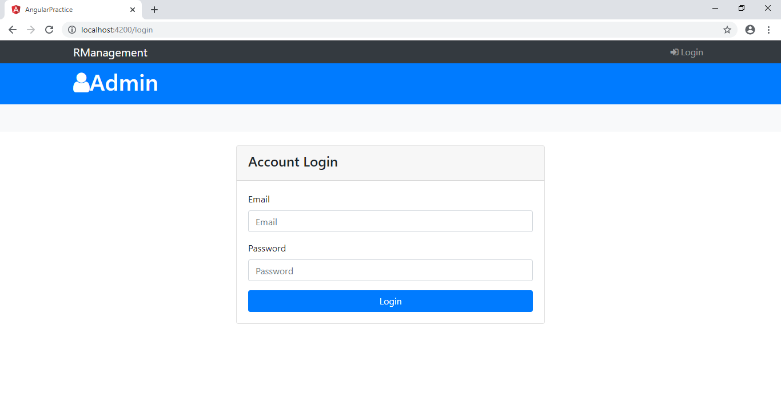**Dashboard UI:**

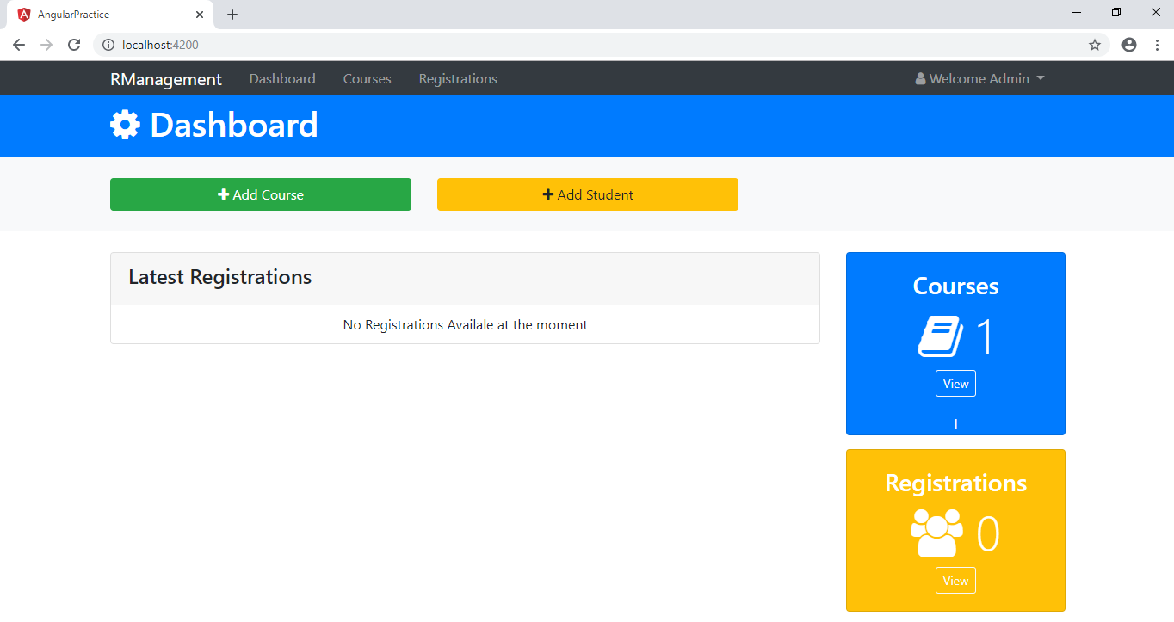

**Courses UI:**

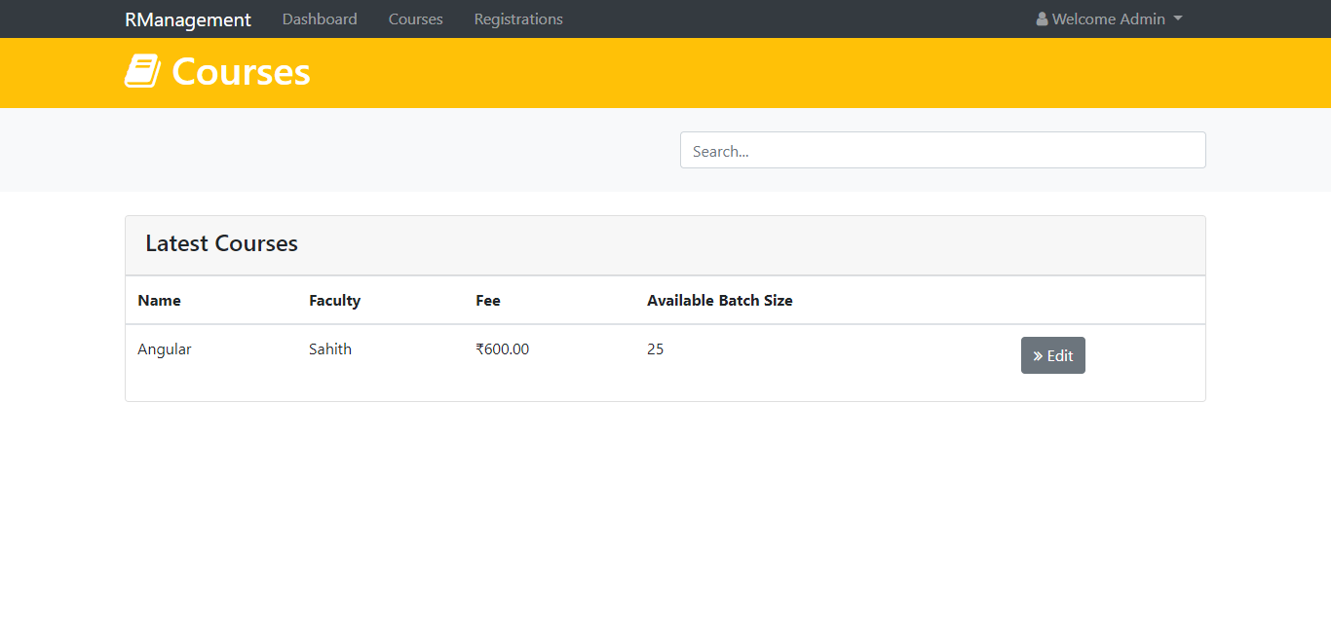

**Registrations UI:**

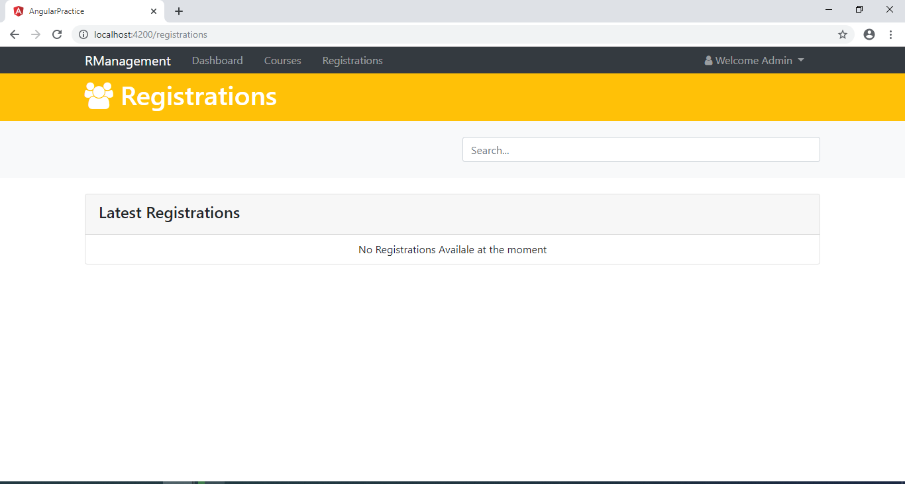

**Add Course UI:**

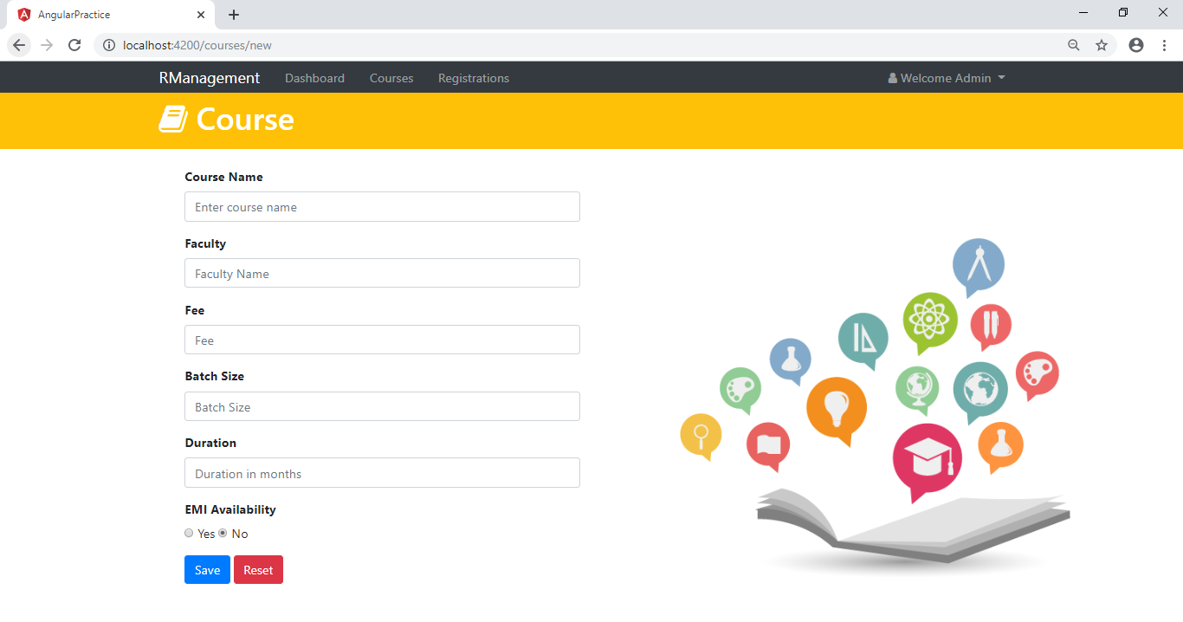

**Add Registration UI:**

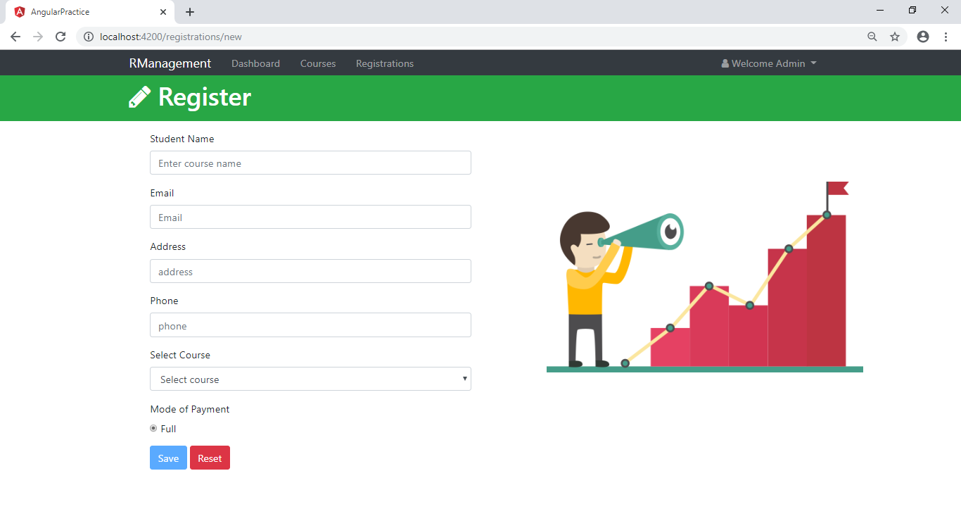

**Validations**

**The below validations logic is implemented at both backend and frontend**

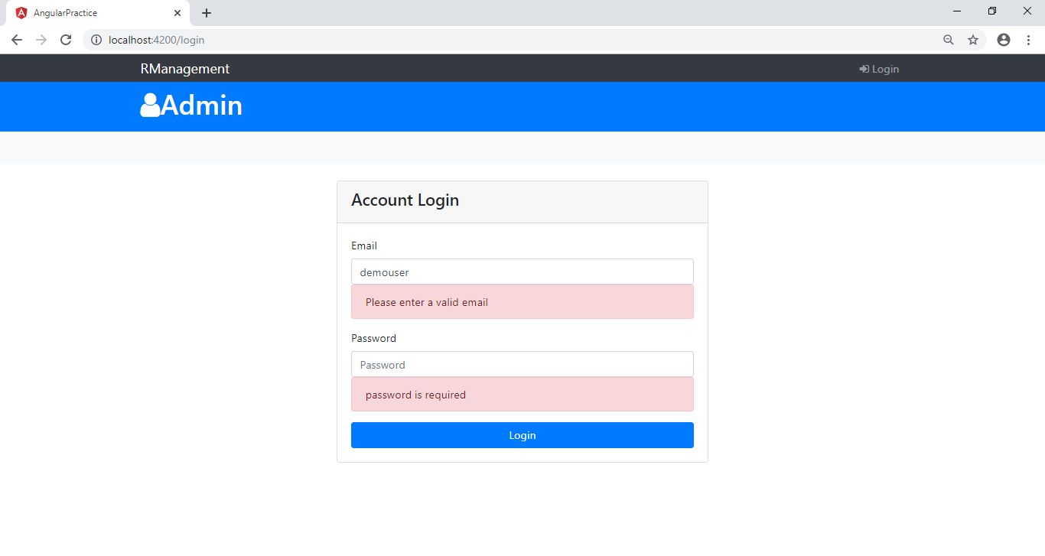

Successful login itself redirect to further routes else it will be redirected to login page itself even if we try to visit other routes. Authentication and Authorization implemented by JWT token.

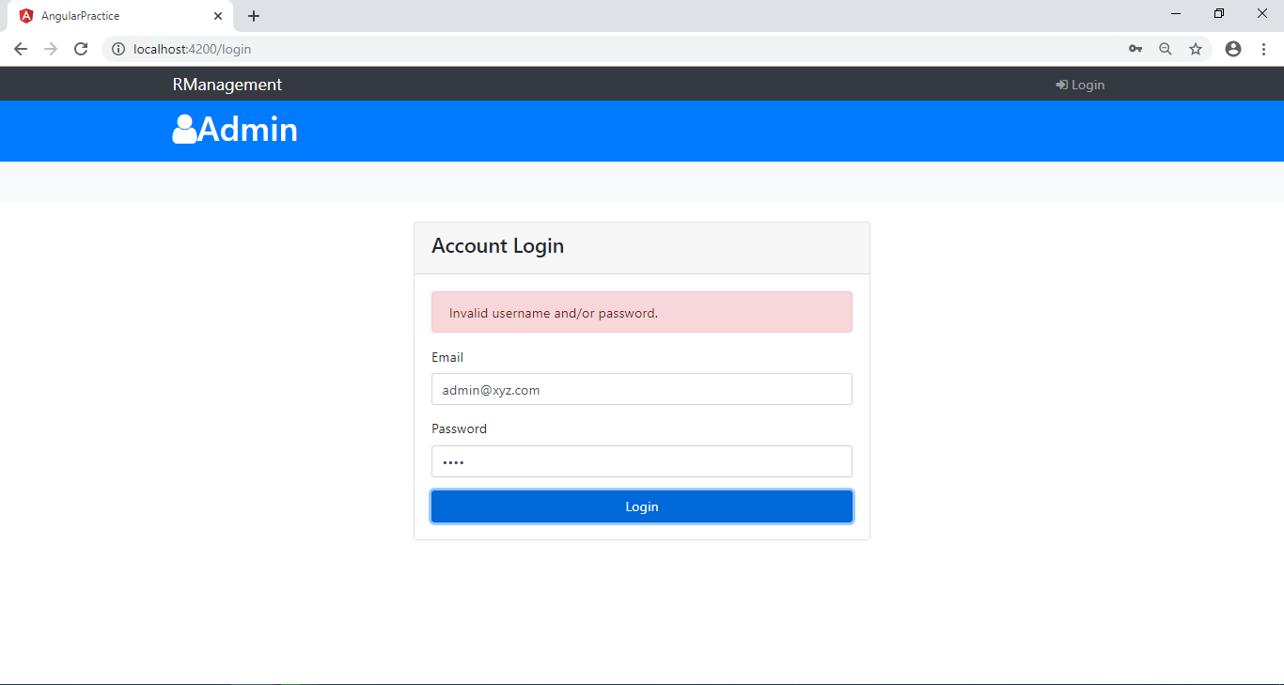

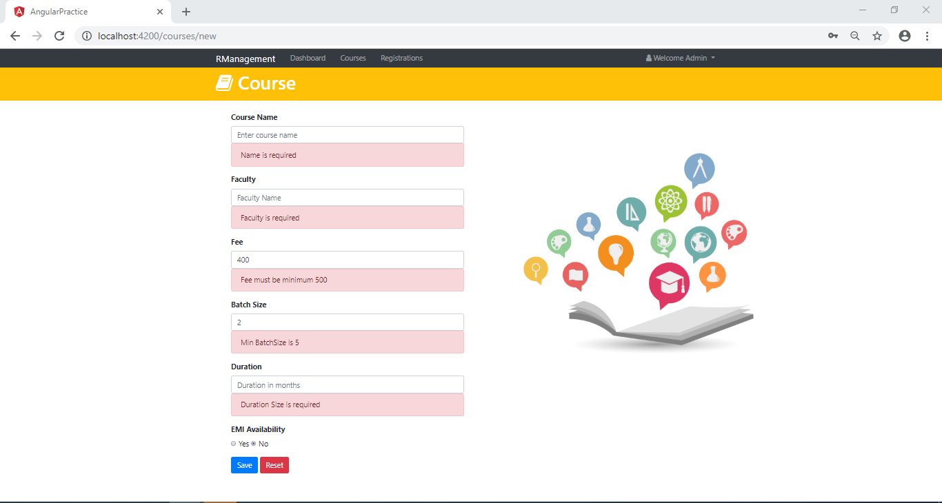

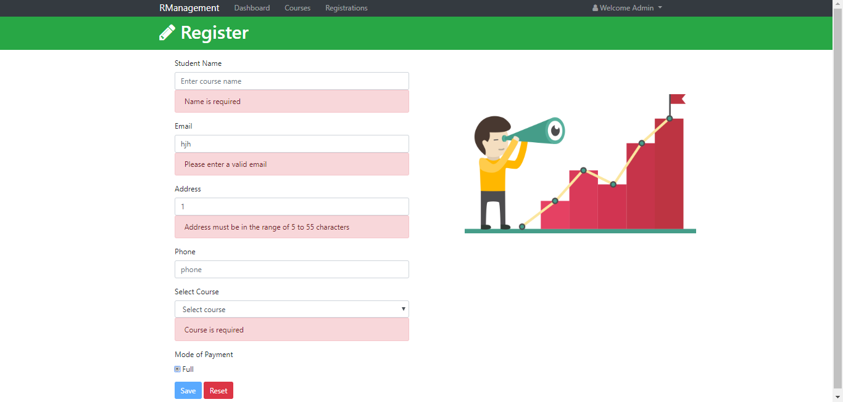

**Once Course is added providing valid details**

**1) it will redirect to courses which has details with updated course**

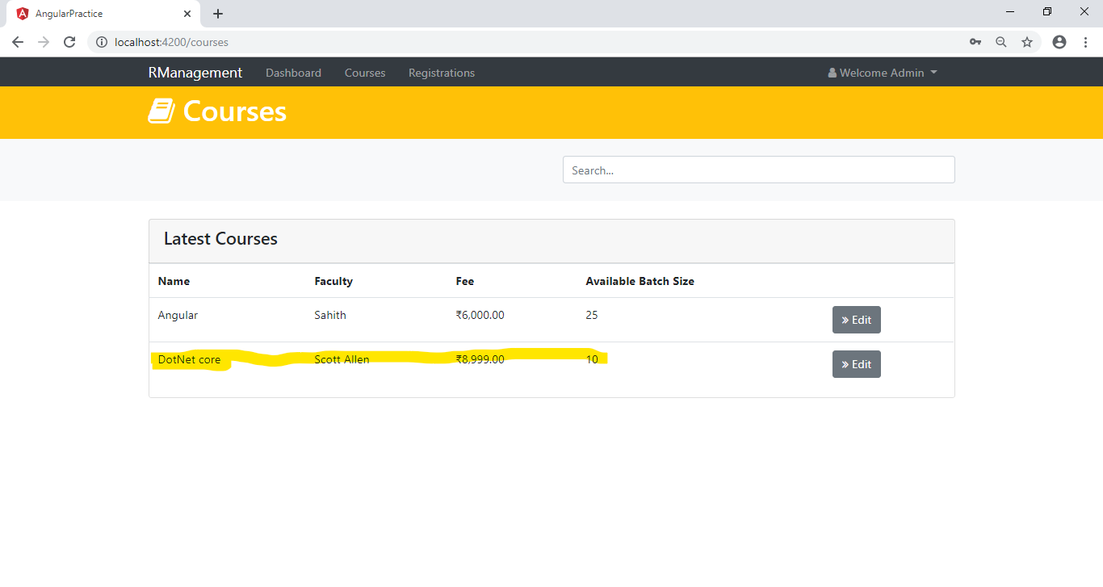

**2) Updates the dashboard**

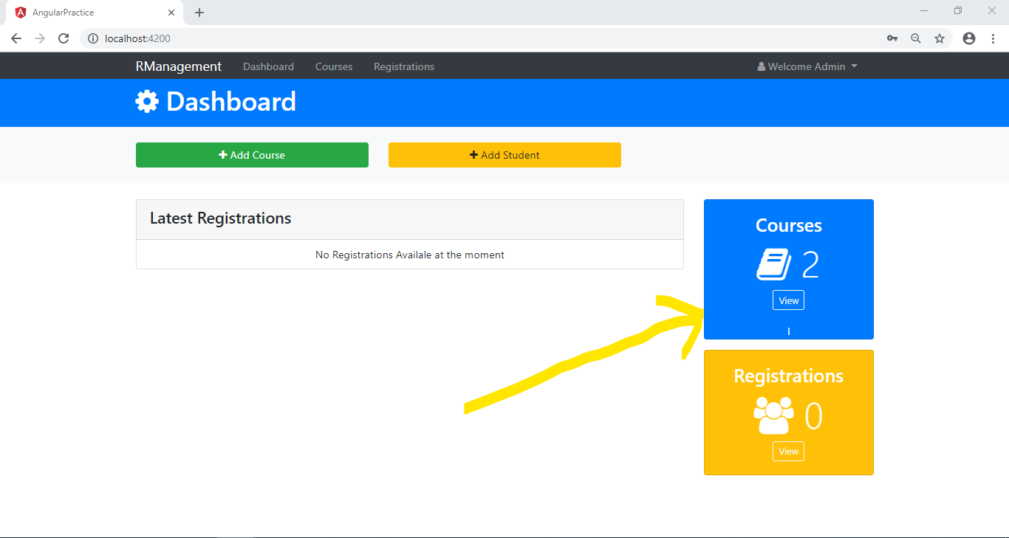

**3) Updates the courses in Registration form**

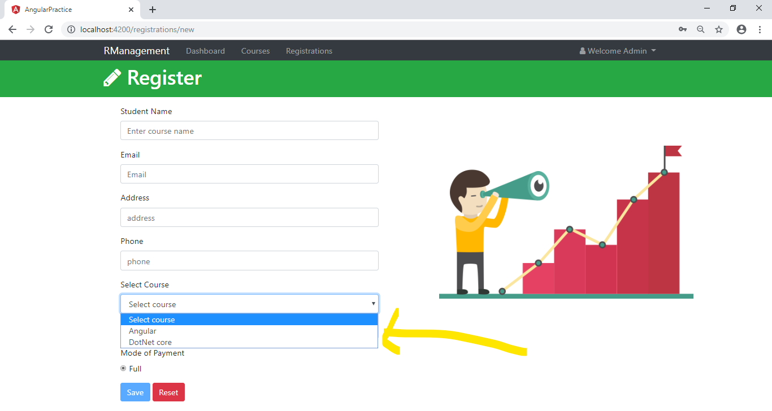

**Once Registration is added by Providing valid details:**

**1) it will redirect to courses which has details with the updated course**

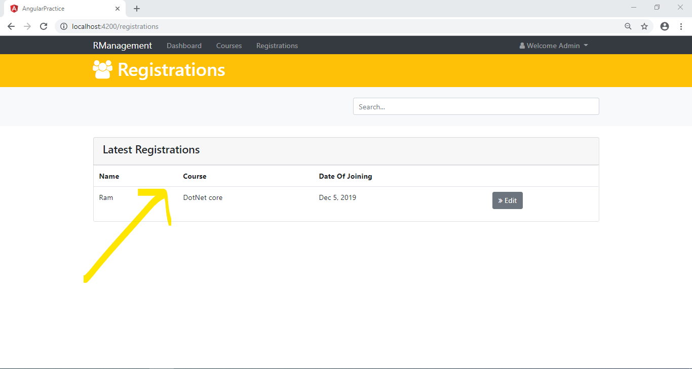

**2) Updates the dashboard**

