**Assignment Reflection**

For

Information and Communication Technology, Master of Science in Project Management

ICT 4370

By,

Sahith Yarlagadda

University of Denver, University College

June 5, 2022

Faculty: Abeer Khaleq, PhD

Director: Molly Smith, PhD

Dean: Michael J. McGuire, MLS

**Table of Contents**

Upgrades 1

Additional Useful Functionality 1

Challenges 1

Overall Experience 2

Documentation 2

Enhancement Screenshots 3

# Reflection and Area of Improvements

The total arrangement of assignments was very useful in downplaying the ideas of Python programming. The steady necessities for every task permitted us to make a completely practical application. The updates I have made in assignment are out to display the data from a JSON file using an UI. Based on the feedback I have I improved my code from hardcoding to appending the data using for loop and feeding the JSON file data into data frames and plotting the Average and Standard deviations of stocks than multiplying the number of shares in stock data and prices in JSON file. We have utilized the "Pandas" library to perform statistics. This library has an expansive arrangement of administrations which we ought to learn and comprehend. We didn't get a lot of chance to deal with the web-administrations and UI libraries of Python since we were accomplishing such a great deal other work. Yet, as an area of progress, I need to change my code to construct a web UI on the highest point of this application.

# New Functionality

My experience with new functionality using libraries like Tkinter and creating function modules for creating GUI has made me understand deep usage of development in python and how easy it is compared to other technologies as well using the predefined libraries

The functional wasn’t hard to implement as I found required documentation and references online to read and understand Tkinter. First, I had issues creating the functions for the user interface I had spent a huge amount of time as I had no prior experience.

# Documentation

The documentation was easy to find regarding Tkinter and on how to install it based on the application and version we are using. Also, the documentation in python.org has helped a lot by providing basic examples on usage of Tkinter. I have used Stackeroverflow as my reference for creating my code and troubleshoot the errors in between the creation.

# Added Functionality

I have added database creation using classes and also used “Tkinter” library to create GUI where we can select the JSON file to import the data using “Select the file”, “OK” and “Exit” features which are created using functions created in the “GUI_Input” module and also I have calculated Average and Standard Deviation. Also, I have created database tables for Investor, Stock and Bonds using “sqLite3” library. Below are the screenshots from my work.

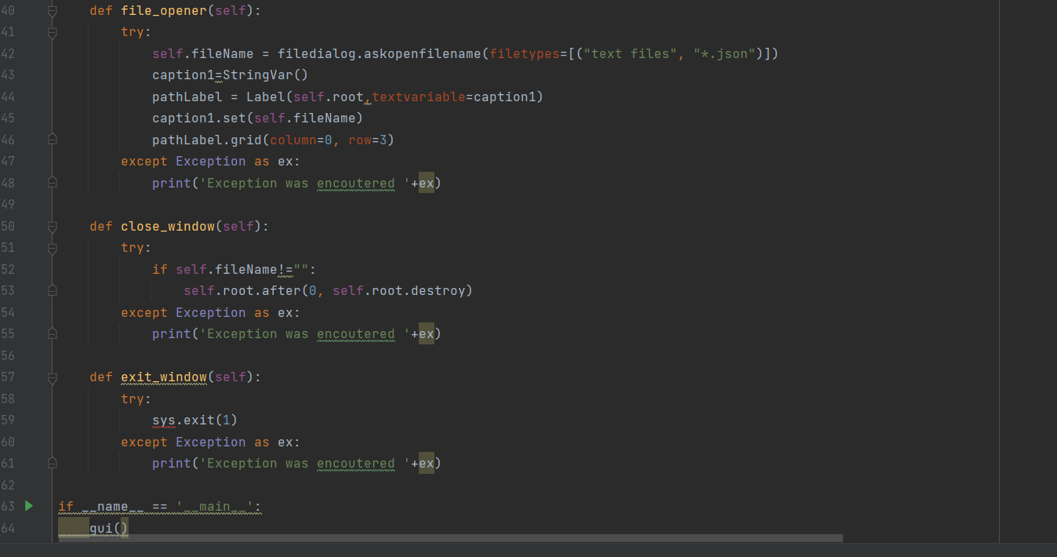

Figure.1

The figure contains the code to create the features on GUI and to select the file path to feed the JSON file for visualization.

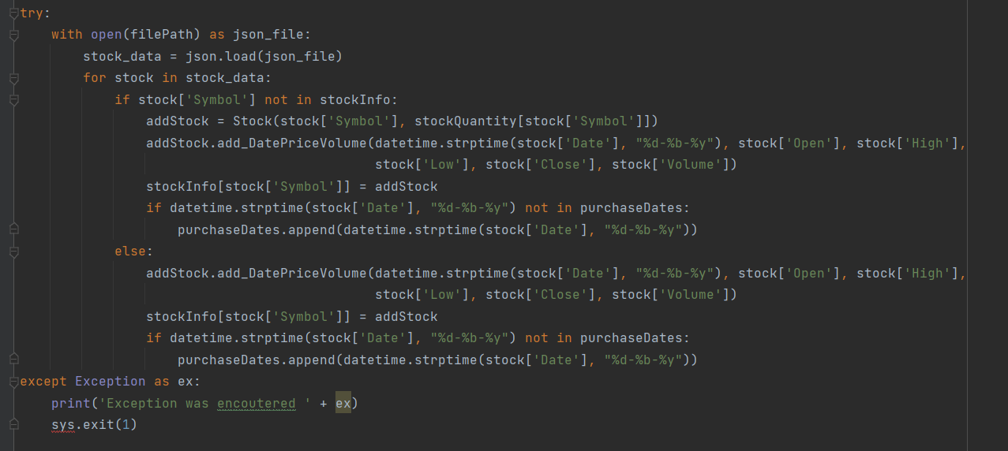

Figure.2

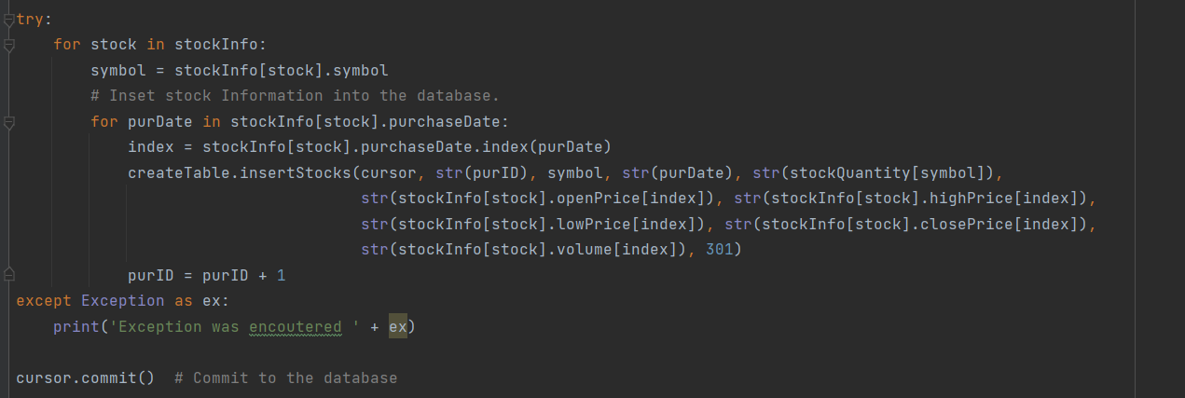

Figure.3

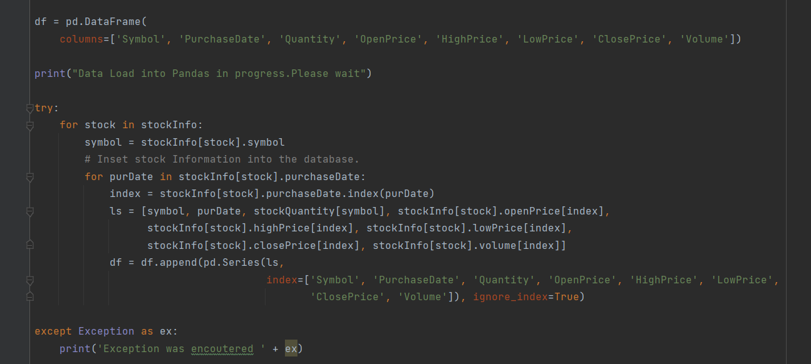

Figure.4

The figure 2 and 3, 4 depicts the usage of loops for appending the data with the symbols and binding the data using indexing and feed the data into Dictionary “StockInfo” and then to feed into DataFrame for calculations and visualization.

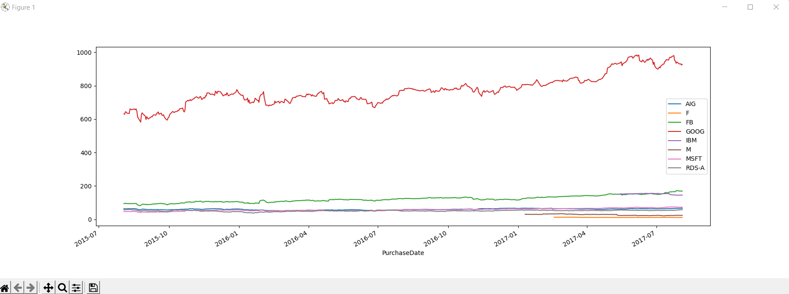

Figure.5

Finally, the figure.5 depicts the “Closing Price” with respect to the purchase date of each stock when the JSON file feeded to the GUI path.