OPGRID

Student Opportunity Intelligence Platform
Engineering Design Overview

Executive Summary

What is OpGrid
OpGrid is a full-stack opportunity intelligence platform for students. It collects public internships, hackathons, fellowships, competitions, and early-career roles, enriches each listing with structured metadata, and gives every user a private workspace to discover, save, track, and tailor applications.

The Problem
Students must monitor fragmented job boards, company career pages, communities, and event platforms while managing application stages, deadlines, follow-ups, and resume variants in separate tools. Listings expire quickly and repeated manual checking makes prioritization difficult.

The Solution
• Discover public opportunities from curated sources and targeted web discovery
• Filter and enrich listings by category, eligibility relevance, location, stipend, deadline, and tags
• Track application and hackathon stages with notes, deadlines, reminders, and follow-ups
• Maintain private resume versions and compare a resume against a target job description
• Send optional email and Telegram alerts for new listings and approaching deadlines

Target Users
Primary: Indian Computer Science students and recent graduates seeking internships, hackathons, fellowships, and entry-level roles. Secondary: student communities and mentors helping applicants maintain a structured opportunity pipeline.

Key Engineering Innovation
A request-scoped security model pairs Supabase Auth with Row-Level Security. Browser requests are authenticated and executed with the user session; trusted schedulers alone use service access. Discovery uses deterministic canonical URL and fingerprint deduplication before AI enrichment, limiting duplicate records and unnecessary model usage.

Core Value Proposition
• One private place to discover and prioritize time-sensitive opportunities
• A tracker designed for both recruitment and multi-stage hackathon workflows
• Cost-controlled enrichment with deterministic fallback behavior
• Source links remain visible so users can verify eligibility and application requirements

Product Journey

Complete User Flow
┌──────────────┐
│ Sign In │ Supabase email and password authentication
└──────┬───────┘
│
↓
┌──────────────┐
│ Discover │ Feed filters, search, deadline sorting
└──────┬───────┘
│
↓
┌──────────────┐
│ Save Track │ Save listing, set reminder, create application
└──────┬───────┘
│
↓
┌──────────────┐
│ Prepare │ Resume versioning and JD keyword analysis
└──────┬───────┘
│
↓
┌──────────────┐
│ Follow Up │ Stage updates, deadlines, email or Telegram alerts
└──────────────┘

Value Accumulation
• More saved opportunities → clearer personal priorities
• More tracker history → reliable view of deadlines and follow-ups
• More resume versions → better role-specific tailoring
• More structured metadata → faster filtering and comparison

High Level Architecture

Architecture Philosophy
The system separates the responsive student experience from automated discovery. The frontend is statically exported and can be served with the Express API in one Docker image. The API protects user-scoped data, while background jobs independently scrape, enrich, deduplicate, notify, and record operational health.
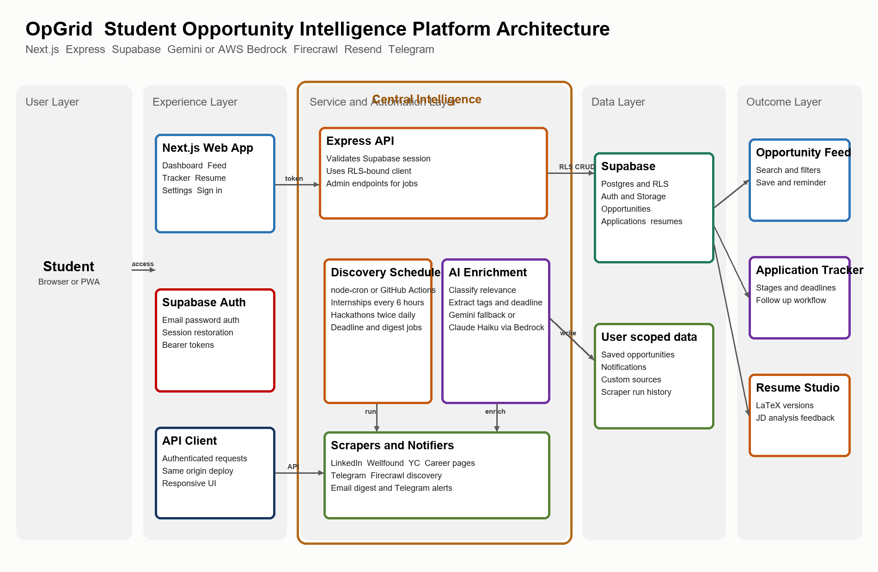

System Flow

Complete Opportunity Lifecycle
1. Discovery: Scheduled scrapers collect candidates from supported public sources and Firecrawl discovery.
2. Normalization: The worker canonicalizes URLs and bounds the number of candidates processed in each run.
3. Duplicate prevention: Canonical URL and deterministic title/company fingerprint checks prevent duplicate opportunity records.
4. Enrichment: Gemini 2.5 Flash enriches relevance, tags, stipend, remote status, PPO possibility, and deadline. AWS Bedrock Claude Haiku can be used when AWS is configured.
5. Storage: New records are written to Supabase. User actions remain isolated by Row-Level Security.
6. Notification: Optional Telegram alerts announce new opportunities; daily digest and deadline jobs handle time-sensitive follow-up.
7. Student action: The user filters the feed, saves listings, creates applications, manages milestones, and uses Resume Studio for role-specific preparation.

Engineering Decisions
Decision | Reason | Tradeoff | Alternative Considered
Supabase with RLS | Combines Postgres, Auth, and user-scoped authorization with minimal operational setup. | Schema and policy migrations must be carefully coordinated. | Custom auth plus self-managed PostgreSQL.
Express API plus static Next.js export | One deployable service can serve the UI, API, health check, and optional scheduler. | Long-running scraping is unsuitable for short serverless execution limits. | Separate Vercel UI and worker deployment.
Deterministic deduplication | Canonical URLs and fingerprints avoid extra AI cost and make merge decisions auditable. | Cannot identify every semantically similar posting. | LLM or fuzzy-only deduplication.
Gemini with Bedrock option | Low-friction default with an AWS Claude route for environments already using Bedrock. | External model availability and formatting can vary. | Single provider with no fallback.
Scheduler or GitHub Actions | Supports always-on deployment or inexpensive external scheduling. | Only one scheduling approach should be active in production. | Manual discovery only.

Security and Privacy

Authentication and Authorization
Browser session → Bearer token → Express validates session
↓
Request scoped Supabase client
↓
Row Level Security applies per user
↓
Service role reserved for trusted scheduled jobs and admin actions
The API validates bearer tokens through Supabase before browser requests reach route handlers. It uses AsyncLocalStorage to provide an RLS-bound client for that request. Admin scraping and workflow triggers require an administrator role or the internal job secret.

Sensitive Data Handling
Opportunity listings are public-source records. Personal application notes, saved listings, reminders, resume versions, job-description analyses, source preferences, and seen state are protected as user-scoped data. The project documentation explicitly warns against enabling public resume uploads until storage and retention policy are reviewed.

Operational Security Controls
• Secrets are environment variables, never frontend configuration or committed source
• CORS permits configured origins; runtime configuration injects only public Supabase values into the static client
• Webhook access uses a Telegram secret header; workflow dispatch is administrator-only
• PDF compilation is disabled until untrusted LaTeX can run in a resource-limited sandbox

Scalability

Current Architecture Capacity
The current design is appropriate for an early beta cohort. Scraping is sequential and each source is isolated so one failure does not end a run. Limits on candidates and Firecrawl search results protect free-tier credits and external services.
Component | Current Design | Scaling Path
Frontend | Static Next.js export served with the API container. | Move to CDN or dedicated frontend hosting when traffic grows.
Express API | Single stateless container with health endpoint. | Run multiple instances behind a load balancer; keep schedulers external.
Scraping | Sequential source runners and browser tooling where needed. | Queue source jobs and add workers, rate limits, and proxy strategy only when demand justifies it.
Supabase | Managed Postgres, Auth, Storage, and RLS. | Add indexes, read strategy, and project-tier capacity based on measured load.
AI enrichment | One listing at a time with provider fallback. | Batch, cache, and queue enrichment after measuring model cost and latency.

Known Constraints
• Listings can change, expire, or become unavailable after discovery; source URLs must be verified.
• Scrapers may fail due to site changes, robots guidance, rate limits, access controls, or provider outages.
• Resume scoring is experimental and is not an ATS prediction or hiring recommendation.
• The in-process scheduler is disabled by default in the Render configuration to prevent duplicated job execution.

Future Roadmap

Near Term
• Add dependable automated test coverage beyond the current opportunity-identity smoke test
• Improve source-health telemetry and dashboard-level failure reporting
• Add a resource-limited external compiler service before enabling PDF download
• Measure discovery credit consumption before raising Firecrawl limits or run frequency

Growth Path
• Introduce a durable queue and separated worker processes for higher scraper throughput
• Add cached search and measured indexing improvements for a larger opportunity catalogue
• Expand source connectors only after terms, robots guidance, and rate limits are reviewed
• Add a browser extension or import workflow for user-submitted public listings

Technology Summary
Layer | Technology | Purpose
Frontend | Next.js 16, React 18, TypeScript, Tailwind CSS | Responsive dashboard, feed, tracker, Resume Studio, and authentication UI.
API | Node.js 22, Express, TypeScript | Authenticated application API, health endpoint, static-content serving, and job control.
Database and Auth | Supabase PostgreSQL, Auth, Row Level Security, Storage | Opportunity records plus private user data and session management.
Scraping | Axios, Cheerio, Playwright, Puppeteer, Apify, Firecrawl | Public-source collection and targeted discovery.
AI | Google Gemini 2.5 Flash; AWS Bedrock Claude 3 Haiku optional | Listing enrichment, tracker parsing, resume/JD analysis, and suggestions.
Notifications | Resend, Telegram, Telegraf | Digest, new-opportunity, deadline, and follow-up communication.
Scheduling | node-cron, GitHub Actions | Recurring scraping, digest, deadline, follow-up, and deduplication tasks.
Deployment | Docker, Render | Single-container production deployment and health monitoring.

Database Schema Overview
Data Area | Key Tables | Purpose
Discovery | opportunities, scraper_runs | Public listing catalog and scraper operational history.
Application management | applications, saved_opportunities, opportunity_user_state | Private tracking, bookmarking, reminders, and seen state.
Resume workflow | resumes, resume_versions, jd_analyses | LaTeX source, version lineage, and job-description comparisons.
Communication | notifications, notif_log, telegram_links | In-app/audit notifications and Telegram association.
Configuration | user_sources | Private custom-source configuration.

AI Model Routing
Workflow | Primary Approach | Fallback or Guardrail
Opportunity classification | Gemini 2.5 Flash structured JSON extraction. | AWS Bedrock Claude Haiku when AWS_REGION is set; deterministic keyword fallback on parsing/provider failure.
Deduplication | Canonical URL and deterministic opportunity fingerprint. | No LLM call; applications are reassigned before a duplicate record is removed.
Tracker parsing | Gemini-assisted timeline parsing for pasted text. | Normalized stage model and manual tracker entry are available.
Resume and JD | Keyword extraction, comparison, and edit suggestions. | PDF evaluation only forwards to a separately deployed private service; compilation is disabled.

Document Version: 1.0
Last Updated: October 2026
Project Status: Early Beta

