COVER PAGE
DATA MANAGEMENT PROJECT REPORT
(Project Semester August-December 2020)
Data analysis with Dashboard

Submitted by :
Name of Student: Sahithi Turubati
Registration no: 12015993

Programme and Section: KM006
Course Code: INT217

Under the Guidance of
Name of faculty coordinator – Veerpal Kaur
with UID - 25909

Discipline of CSE/IT
Lovely School of Computer Science And Engineering
Lovely Professional University, Phagwara

CERTIFICATE

This is to certify that T. Devi Sahithi (student’s name) bearing Registration no.12015993 has completed Int217 project titled, “Data analysis with dashboard” under my guidance and supervision. To the best of my knowledge, the present work is the result of his/her original development, effort and study.

School of computer science and engineering
Lovely Professional University
Phagwara, Punjab.

Date: 22-11-2022.

ACKNOWLEDGEMENT
The success and final outcome of learning data management required a lot of guidance and assistance, and I am extremely privileged to have got this all along the completion of my course and project. All I have done is only due to such supervision and assistance and I would not forget to thank them.

Primarily I would thank God for being able to complete this project with success then Family and Friends who significantly contributed during the project and helped me to complete this project and in preparation of this report.

I am thankful and fortunate enough to get constant encouragement, support and guidance from our faculty Veerpal Kaur helped us in successfully completing my course and project work. their suggestions and their instructions have served as the major contributor towards the completion of the project is gratefully acknowledged.

DECLARATION

I, Sahithi Turubati, student of Computer science and Engineering (Program name) under CSE/IT Discipline at, Lovely Professional University, Punjab, hereby declare that all the information furnished in this project report is based on my own intensive work and is genuine.

Date : 22-11-2022
Name of Student : Sahithi Turubati
Registration No. : 12015993 \

INTRODUCTION

In information technology, a dashboard is an easy to read, often single page, real-time user interface, showing a graphical presentation of the current status (snapshot) and historical trends of an organization’s or department’s key performance indicators to enable instantaneous and informed decisions to be made at a glance.
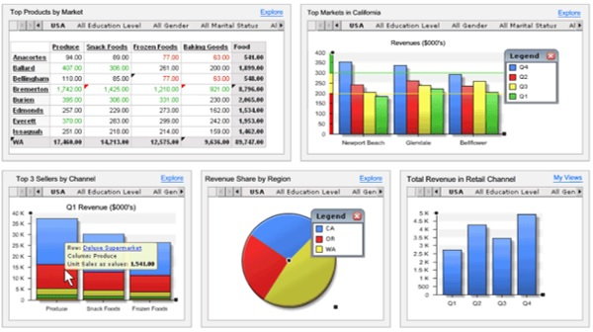

Dashboards take their name from automobile dashboards. Under the hood of your vehicle, there may be hundreds of processes that impact the performance of your vehicle. Your dashboard summarizes these events using visualizations so that you have the peace of mind to concentrate on safely operating your vehicle. In a similar way, business dashboards are used to view and/or monitor the organization’s performance with ease.

The idea of digital dashboards emerged from the study of decision support systems in the 1970s. Business dashboards were first developed in the 1980s, but due to the problems with data refreshing and handling, they were put on the shelf. In the 1990s, the information age quickened pace and data warehousing, and online analytical processing (OLAP) allowed dashboards to function adequately. However, the use of dashboards did not become popular until the rise of key performance indicators (KPIs), and the introduction of Robert S. Kaplan and David P. Norton's Balanced Scorecard. Today, the use of dashboards forms an important part of decision making.
OBJECTIVES/SCOPE OF THE ANALYSIS
- To create a pivot table and column chart which shows us the sum of math score on the basis of gender and test preparation course and make a slicer on basis of gender
- To create a pivot table and bar chart which shows us the maximum of reading score on the basis of race / ethnicity and test preparation course and make a slicer on the basis of race /ethnicity
- To create pivot table and line chart which shows us the count of the writing score on the basis of race/ethnicity and lunch they have and slicer
- To create a pie chart which shows us the sum of math score of the student on the basis of their gender and parental level of education and create a slicer on the basis of parental level of education
- To create a pivot table and bar chart which shows minimum of the writing score on the basis of test preparation course and gender
- To create a pivot table and column chart which shows us the sum of all math scores and reading scores and writing scores of students on the basis of race/ethnicity.

SOURCE OF THE DATA SET

REFERENCE : https://www.kaggle.com/datasets/hasibalmuzdadid/asia-cup-cricket-1984-to-2022

ETL PROCESS
- ETL stands for Extract, Transform and Load.
- An ETL tool extracts the data from different RDBMS source systems, transforms the data like applying calculations, concatenate, etc. and then load the data to Data Warehouse system.
- The data is loaded in the DW system in the form of dimension and fact tables.
- ETL combines all the three database function into one tool to fetch data from one database and place it into another database.
- ETL is used to integrate the data with the help of three steps Extract, Transform, and Load, and it is used to blend the data from multiple sources. It is often used to build a data warehouse.
- In the ETL process, data is extracted from the source system and convert into a format that can be examined and stored into a data warehouse or any other system.
Extract :
- Extract is the process of fetching (reading) the information from the database. At this stage, data is collected from multiple or different types of sources.
- A staging area is required during ETL load. There are various reasons why staging area is required.
- The source systems are only available for specific period of time to extract data. This period of time is less than the total data-load time. Therefore, staging area allows you to extract the data from the source system and keeps it in the staging area before the time slot ends.
- Staging area is required when you want to get the data from multiple data sources together or if you want to join two or more systems together. For example, you will not be able to perform a SQL query joining two tables from two physically different databases.
- Data extracted from source systems can be used in multiple data warehouse system, Operation Data stores, etc.
- In data transformation, you apply a set of functions on extracted data to load it into the target system. Data, which does not require any transformation is known as direct move or pass through data.
Transform
- Transform is the process of converting the extracted data from its previous form into the required form.
- You can apply different transformations on extracted data from the source system.
- For example, you can perform customized calculations. If you want sum-of-sales revenue and this is not in database, you can apply the SUM formula during transformation and load the data.
- For example, if you have the first name and the last name in a table in different columns, you can use concatenate before loading.
Load
- Load is the process of writing the data into the target database.
- During Load phase, data is loaded into the end-target system and it can be a flat file or a Data Warehouse system.
- ETL tools extract the data from all these data sources and transform the data (like applying calculations, joining fields, removing incorrect data fields, etc.) and loads into a data warehouse.
- ETL can transform unique data sets into a unified structure.
OLTP & OLAP
- Online analytical processing (OLAP) is a technology that organizes large business databases and supports complex analysis. It can be used to perform complex analytical queries without negatively affecting transactional systems.
- The databases that a business uses to store all its transactions and records are called online transaction processing (OLTP) databases.

ANALYSIS OF DATA SET
- To create a pivot table and clustered column chart which shows us theMatches win by a team with respect to bat first and bowl first create a pivot table and take result in columns and teams in rows.
- To create a pivot table we first select a cell in a data set and then select the insert tab
- it shows us a window as
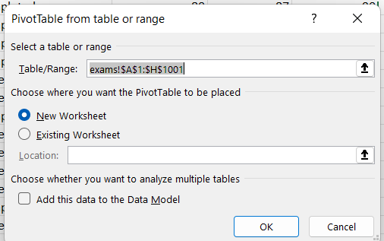

- we choose the location to place the pivot table and finally it opens a pivot table
- for pivot chart we select a cell from pivot table and then insert pivot chart of wanted format
- pivot chart for given objective will be as
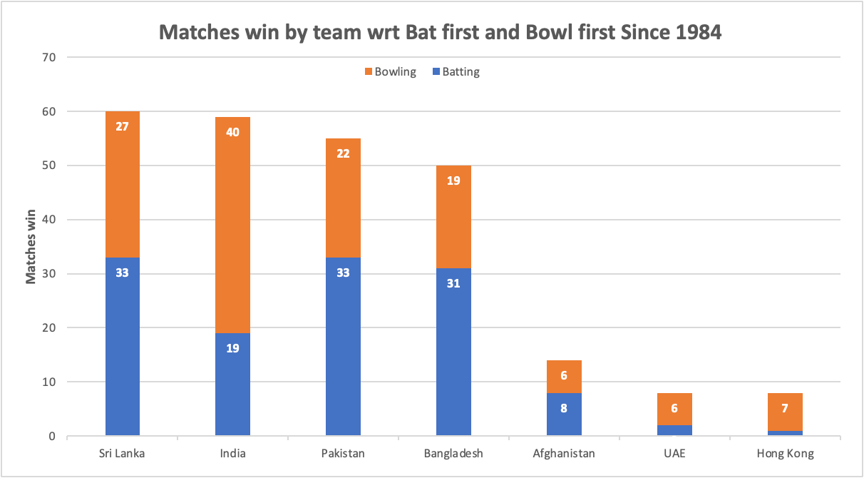

- pivot chart shows us the Matches win by a team wrt Bat and Bowl first.

2.
To create a pivot table and Donut chart which shows us the Decision taken by the team Based on toss winning and loosing.
- According to the given objective the pivot table will be as
Row Labels | Count of Result
Batting | 127
Bowling | 127
Grand Total | 254

- Donut chart will be as
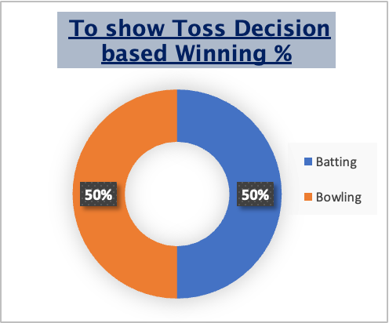

3.To create pivot table and Clustered Bar chart which shows us the Top 10 venues with most matches and winning based on bat first and bowl first.
- Pivot table for given objective will look like
Count of Result | Column Labels
Row Labels | Batting | Bowling | Grand Total
Fatullah | 5 | 5 | 10
Abu Dhabi | 5 | 5 | 10
Colombo(SSC) | 8 | 8 | 16
Colombo(RPS) | 10 | 10 | 20
Dambulla | 10 | 10 | 20
Karachi | 10 | 10 | 20
Dhaka | 12 | 12 | 24
Sharjah | 14 | 14 | 28
Dubai(DSC) | 17 | 17 | 34
Mirpur | 24 | 24 | 48
Grand Total | 115 | 115 | 230

- Clustered bar chart for the given pivot table looks like

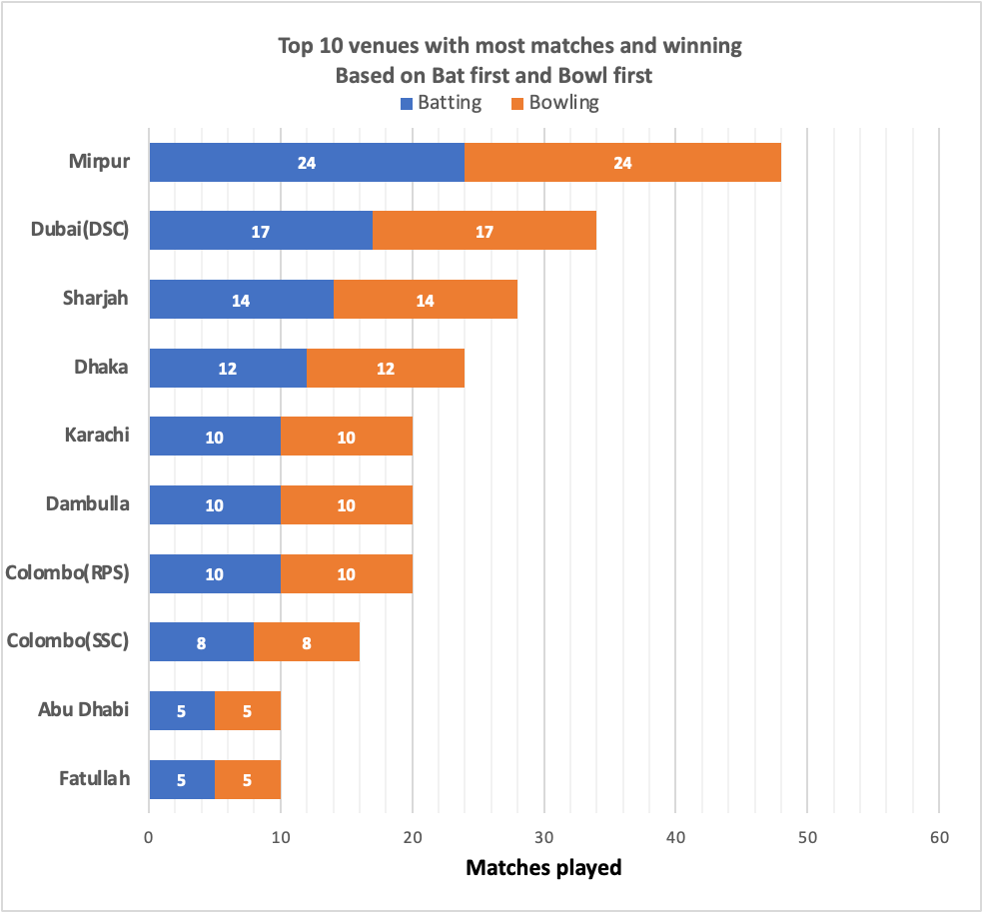

- We have also created a slicer here to look up for year based performance and it looks like
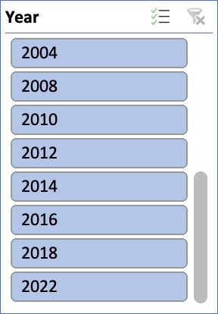

4 . To create a Column chart which shows us the Top 10 Mom Award winners we should take data of all players who have got MoM awards and sort top 10 of them and create a seperate table
- The pivot table for given objectives will be as

Player name | MoM Won
Virat Kohli | 12
Shoaib Malik | 10
Sanath Jayasuriya | 10
Shahid Afridi | 8
Kumar Sangakkara | 8
Arjuna Ranatunga | 6
Shikhar Dhawan | 6
Lasith Malinga | 6
Suresh Raina | 6
Marvan Atapattu | 6

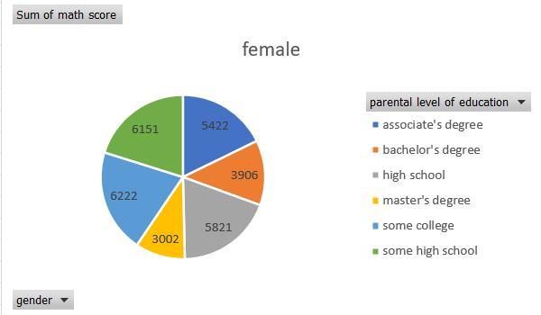
- The Column chart will be as follows

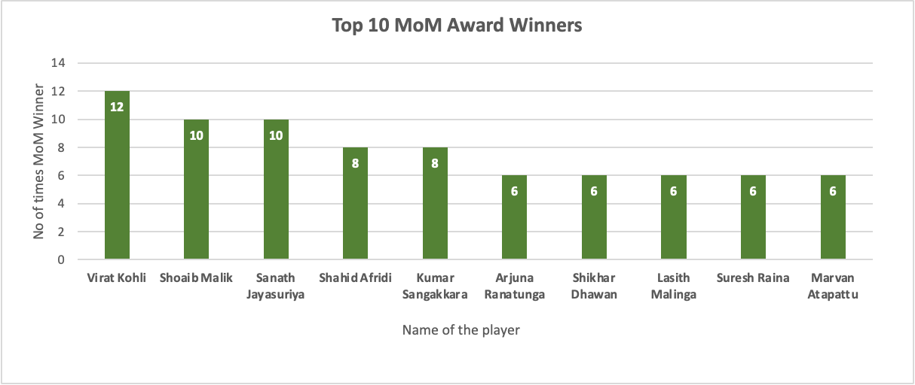

- Here also we have taken slicer for years and it goes as follows
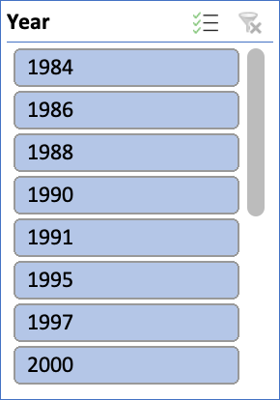

5 To create a pivot table and Tree graph which shows us the data of Highest runs scored by an individual batsman from 1984-2022
- Pivot table will be as follows

Row Labels | Sum of Runs
V Kohli | 429
Mohammad Rizwan | 281
RG Sharma | 271
Babar Hayat | 235
Ibrahim Zadran | 196
PBB Rajapaksa | 191
Sabbir Rahman | 181
Muhammad Usman | 176
Najibullah Zadran | 176
P Nissanka | 173
Mahmudullah | 173
Grand Total | 2482

- And Tree graph will be as

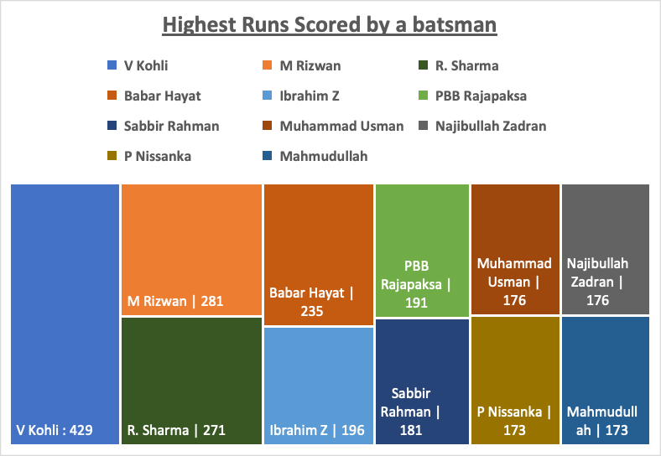

Finally created a smart art grpahic to display Year, Winnner ,Runner up and Player of the series

-> Used the Vlookup function and kpi to display them using a slicer which goes as follows

-> And the total layout with smart art graphic which is connected to slicer looks like

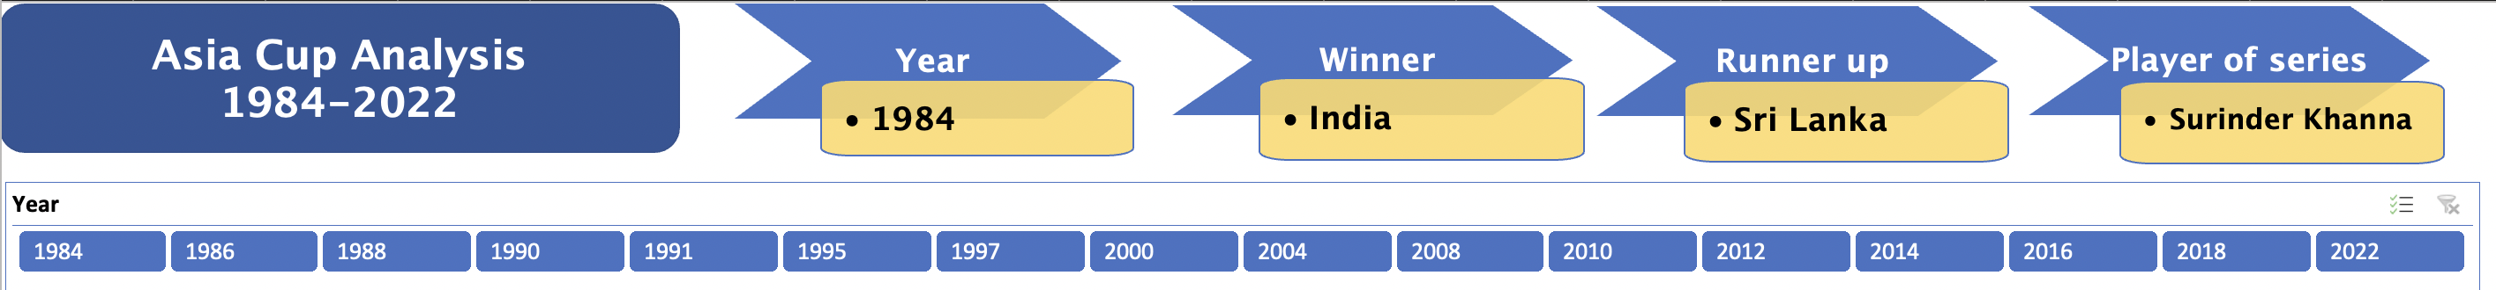
Dashboard
- After creating pivot table, pivot charts and slicers for given objectives we place in them in an order in an new sheet
- The dashboard for the given objectives will be

