WEEK 4
Hands-on 1: Create a Spring Web Project using Maven

pom.xml
xml
<project xmlns="http://maven.apache.org/POM/4.0.0"
xmlns:xsi="http://www.w3.org/2001/XMLSchema-instance"
xsi:schemaLocation="http://maven.apache.org/POM/4.0.0 http://maven.apache.org/xsd/maven-4.0.0.xsd">
<modelVersion>4.0.0</modelVersion>

<groupId>com.example</groupId>
<artifactId>spring-learn</artifactId>
<version>0.0.1-SNAPSHOT</version>
<name>spring-learn</name>
<description>Demo project for Spring Boot</description>

<parent>
<groupId>org.springframework.boot</groupId>
<artifactId>spring-boot-starter-parent</artifactId>
<version>3.2.0</version>
<relativePath/>
</parent>

<dependencies>
<dependency>
<groupId>org.springframework.boot</groupId>
<artifactId>spring-boot-starter-web</artifactId>
</dependency>
<dependency>
<groupId>org.springframework.boot</groupId>
<artifactId>spring-boot-devtools</artifactId>
<scope>runtime</scope>
<optional>true</optional>
</dependency>
<dependency>
<groupId>org.springframework.boot</groupId>
<artifactId>spring-boot-starter-test</artifactId>
<scope>test</scope>
</dependency>
</dependencies>

<build>
<plugins>
<plugin>
<groupId>org.springframework.boot</groupId>
<artifactId>spring-boot-maven-plugin</artifactId>
</plugin>
</plugins>
</build>
</project>

src/main/java/com/example/springlearn/SpringLearnApplication.java
package com.example.springlearn;

import org.slf4j.Logger;
import org.slf4j.LoggerFactory;
import org.springframework.boot.SpringApplication;
import org.springframework.boot.autoconfigure.SpringBootApplication;

@SpringBootApplication
public class SpringLearnApplication {

private static final Logger LOGGER = LoggerFactory.getLogger(SpringLearnApplication.class);

public static void main(String[] args) {
SpringApplication.run(SpringLearnApplication.class, args);
LOGGER.info("Inside main");
}
}

src/main/resources/application.properties
properties
CopyEdit
server.port=8081

src/test/java/com/example/springlearn/SpringLearnApplicationTests.java
package com.example.springlearn;

import org.junit.jupiter.api.Test;
import org.springframework.boot.test.context.SpringBootTest;

@SpringBootTest
class SpringLearnApplicationTests {

@Test
void contextLoads() {
}

OUTPUT:
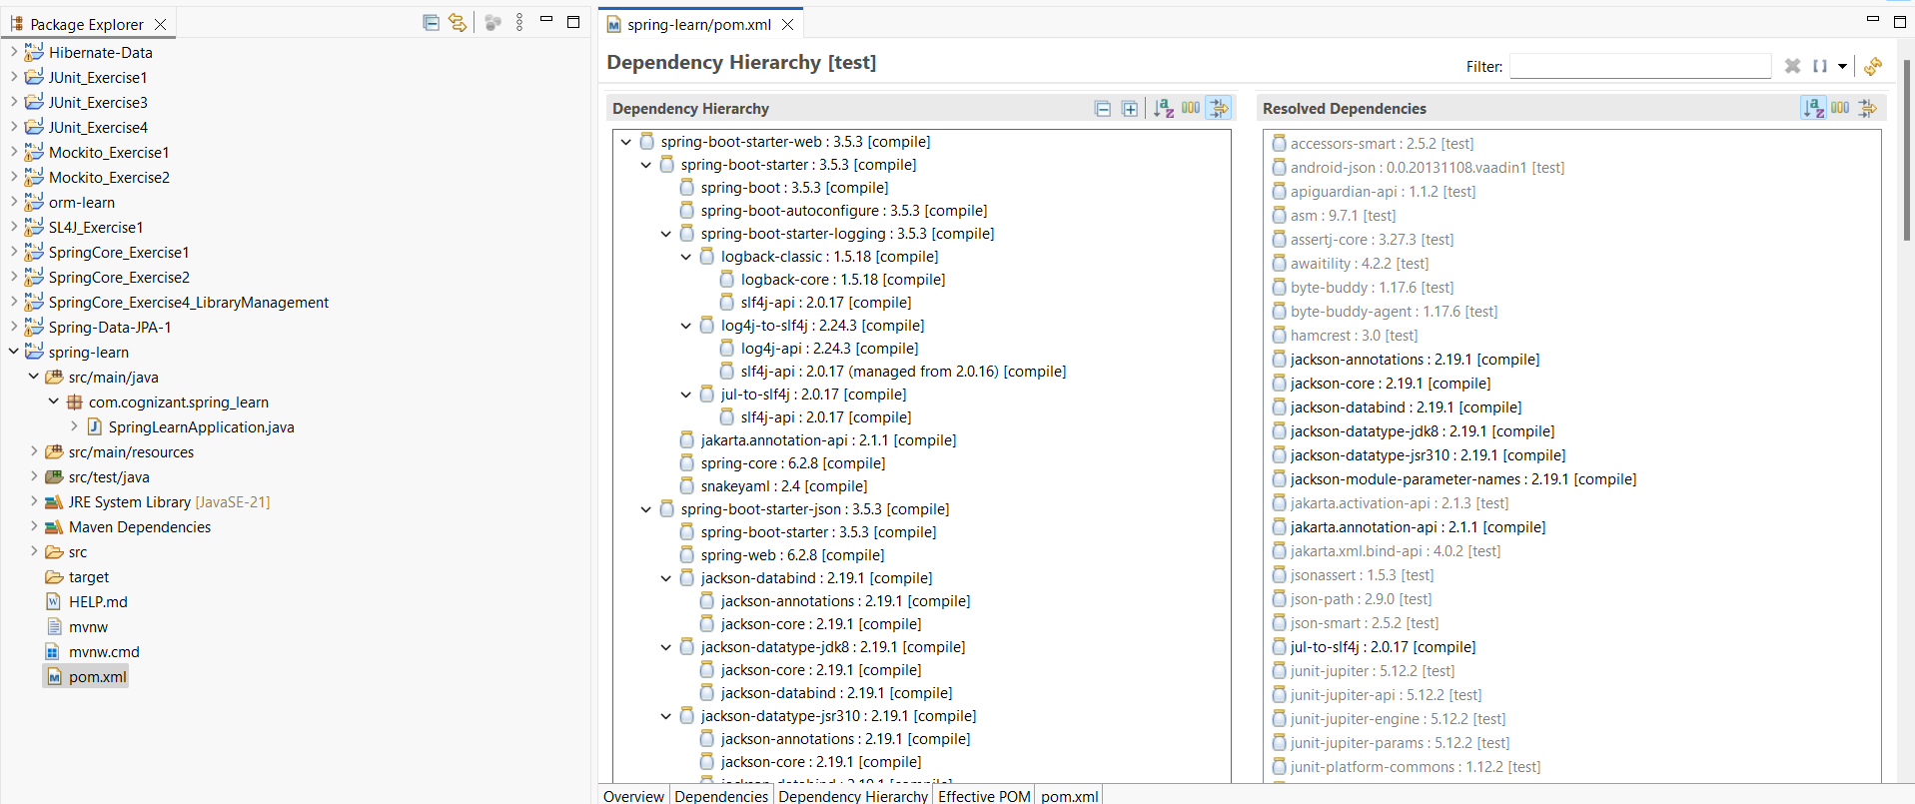

Hands on 4 Spring Core – Load Country from Spring Configuration XML
1. Create the Country Class
Country.java
package com.example.springlearn;

import org.slf4j.Logger;
import org.slf4j.LoggerFactory;

public class Country {
private static final Logger LOGGER = LoggerFactory.getLogger(Country.class);

private String code;
private String name;

public Country() {
LOGGER.debug("Inside Country Constructor.");
}

public String getCode() {
LOGGER.debug("Inside getCode()");
return code;
}

public void setCode(String code) {
LOGGER.debug("Inside setCode()");
this.code = code;
}

public String getName() {
LOGGER.debug("Inside getName()");
return name;
}

public void setName(String name) {
LOGGER.debug("Inside setName()");
this.name = name;
}

@Override
public String toString() {
return "Country [code=" + code + ", name=" + name + "]";
}
}

Create the XML Configuration File
country.xml
<?xml version="1.0" encoding="UTF-8"?>
<beans xmlns="http://www.springframework.org/schema/beans"
xmlns:xsi="http://www.w3.org/2001/XMLSchema-instance"
xsi:schemaLocation="
http://www.springframework.org/schema/beans
http://www.springframework.org/schema/beans/spring-beans.xsd">

<bean id="country" class="com.example.springlearn.Country">
<property name="code" value="IN"/>
<property name="name" value="India"/>
</bean>

</beans>

SpringLearnApplication.java
package com.example.springlearn;

import org.slf4j.Logger;
import org.slf4j.LoggerFactory;
import org.springframework.context.ApplicationContext;
import org.springframework.context.support.ClassPathXmlApplicationContext;

public class SpringLearnApplication {
private static final Logger LOGGER = LoggerFactory.getLogger(SpringLearnApplication.class);

public static void main(String[] args) {
LOGGER.debug("Inside main");
displayCountry();
}

public static void displayCountry() {
ApplicationContext context = new ClassPathXmlApplicationContext("country.xml");
Country country = (Country) context.getBean("country", Country.class);
LOGGER.debug("Country : {}", country.toString());
}
}

OUTPUT: 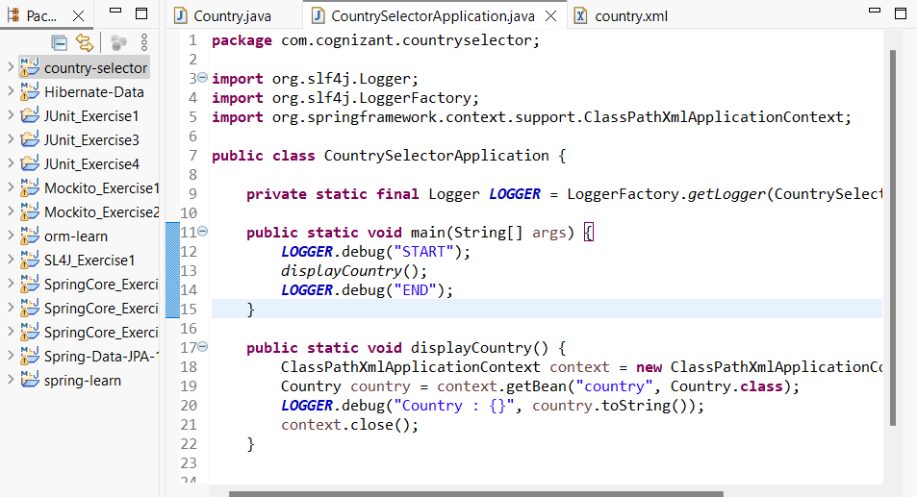
Hello World RESTful Web Service

HelloController.java:
package com.cognizant.spring_learn.controller;

import org.slf4j.Logger;
import org.slf4j.LoggerFactory;
import org.springframework.web.bind.annotation.*;

@RestController
public class HelloController {

private static final Logger LOGGER = LoggerFactory.getLogger(HelloController.class);

@GetMapping("/hello")
public String sayHello() {
LOGGER.info("START: sayHello()");
String message = "Hello World!!";
LOGGER.info("END: sayHello()");
return message;
}
}

Country RESTful Web Service
country.xml
<?xml version="1.0" encoding="UTF-8"?>
<beans xmlns="http://www.springframework.org/schema/beans"
xmlns:xsi="http://www.w3.org/2001/XMLSchema-instance"
xsi:schemaLocation="
http://www.springframework.org/schema/beans
http://www.springframework.org/schema/beans/spring-beans.xsd">

<bean id="in" class="com.cognizant.spring_learn.model.Country">
<property name="code" value="IN"/>
<property name="name" value="India"/>
</bean>
</beans>

Country.java:
package com.cognizant.spring_learn.model;

public class Country {
private String code;
private String name;

public Country() {}

public String getCode() {
return code;
}

public void setCode(String code) {
this.code = code;
}

public String getName() {
return name;
}

public void setName(String name) {
this.name = name;
}

@Override
public String toString() {
return "Country{" +
"code='" + code + '\'' +
", name='" + name + '\'' +
'}';
}
}

CountryController.java:
package com.cognizant.spring_learn.controller;

import com.cognizant.spring_learn.model.Country;
import org.slf4j.Logger;
import org.slf4j.LoggerFactory;
import org.springframework.context.support.ClassPathXmlApplicationContext;
import org.springframework.web.bind.annotation.*;

@RestController
public class CountryController {

private static final Logger LOGGER = LoggerFactory.getLogger(CountryController.class);

@RequestMapping("/country")
public Country getCountryIndia() {
LOGGER.info("START: getCountryIndia()");
ClassPathXmlApplicationContext context = new ClassPathXmlApplicationContext("country.xml");
Country country = (Country) context.getBean("in");
LOGGER.debug("Country: {}", country);
LOGGER.info("END: getCountryIndia()");
return country;
}
}
OUTPUT:
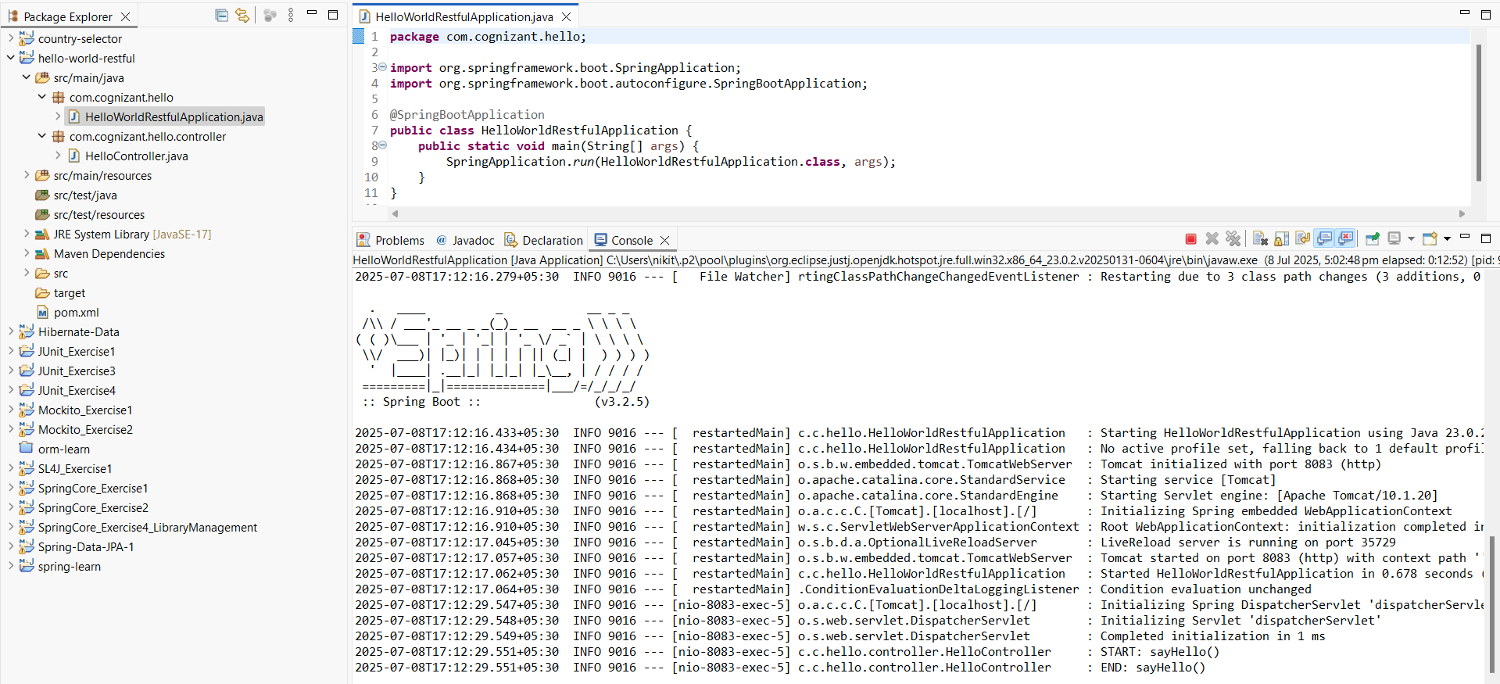

REST - Get country based on country code

Country Model
package com.cognizant.spring_learn.model;

public class Country {
private String code;
private String name;

// Constructors
public Country() {}
public Country(String code, String name) {
this.code = code;
this.name = name;
}

// Getters and Setters
public String getCode() {
return code;
}

public void setCode(String code) {
this.code = code;
}

public String getName() {
return name;
}

public void setName(String name) {
this.name = name;
}
}

country.xml
<?xml version="1.0" encoding="UTF-8"?>
<beans xmlns="http://www.springframework.org/schema/beans"
xmlns:xsi="http://www.w3.org/2001/XMLSchema-instance"
xsi:schemaLocation="
http://www.springframework.org/schema/beans
http://www.springframework.org/schema/beans/spring-beans.xsd">

<bean id="countryList" class="java.util.ArrayList">
<constructor-arg>
<list>
<bean class="com.cognizant.spring_learn.model.Country">
<property name="code" value="IN"/>
<property name="name" value="India"/>
</bean>
<bean class="com.cognizant.spring_learn.model.Country">
<property name="code" value="US"/>
<property name="name" value="United States"/>
</bean>
<!-- Add more countries if needed -->
</list>
</constructor-arg>
</bean>
</beans>

CountryService.java
package com.cognizant.spring_learn.service;

import com.cognizant.spring_learn.model.Country;
import org.springframework.beans.factory.annotation.Autowired;
import org.springframework.context.ApplicationContext;
import org.springframework.context.support.ClassPathXmlApplicationContext;
import org.springframework.stereotype.Service;

import java.util.List;

@Service
public class CountryService {

public Country getCountry(String code) throws Exception {
ApplicationContext context = new ClassPathXmlApplicationContext("country.xml");
List<Country> countryList = (List<Country>) context.getBean("countryList");

return countryList.stream()
.filter(country -> country.getCode().equalsIgnoreCase(code))
.findFirst()
.orElseThrow(() -> new Exception("Country not found"));
}
}

CountryController.java
package com.cognizant.spring_learn.controller;

import com.cognizant.spring_learn.model.Country;
import com.cognizant.spring_learn.service.CountryService;
import org.slf4j.Logger;
import org.slf4j.LoggerFactory;
import org.springframework.beans.factory.annotation.Autowired;
import org.springframework.web.bind.annotation.*;

@RestController
public class CountryController {

@Autowired
private CountryService countryService;

private static final Logger LOGGER = LoggerFactory.getLogger(CountryController.class);

@GetMapping("/countries/{code}")
public Country getCountry(@PathVariable String code) throws Exception {
LOGGER.info("START - getCountry");
Country country = countryService.getCountry(code);
LOGGER.info("END - getCountry");
return country;
}
}
OUTPUT:
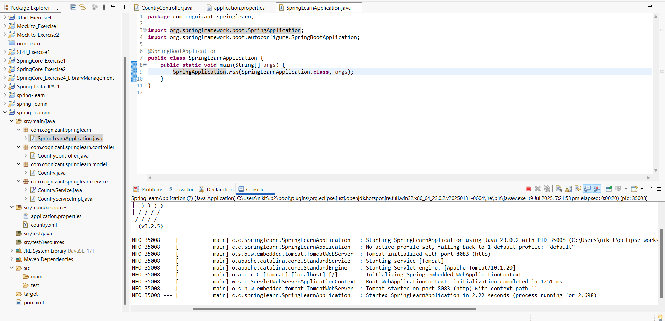

Create authentication service that returns JWT

AuthenticationController.java
package com.cognizant.springsecurity.controller;

import org.springframework.beans.factory.annotation.Autowired;
import org.springframework.security.authentication.AuthenticationManager;
import org.springframework.security.authentication.UsernamePasswordAuthenticationToken;
import org.springframework.security.core.Authentication;
import org.springframework.web.bind.annotation.GetMapping;
import org.springframework.web.bind.annotation.RestController;

import com.cognizant.springsecurity.util.JwtUtil;

import javax.servlet.http.HttpServletRequest;
import java.util.Base64;

@RestController
public class AuthenticationController {

@Autowired
private AuthenticationManager authenticationManager;

@Autowired
private JwtUtil jwtUtil;

@GetMapping("/authenticate")
public String authenticate(HttpServletRequest request) {
String authHeader = request.getHeader("Authorization");

if (authHeader != null && authHeader.startsWith("Basic ")) {
String encodedCredentials = authHeader.substring(6);
String decoded = new String(Base64.getDecoder().decode(encodedCredentials));
String[] userDetails = decoded.split(":");

String username = userDetails[0];
String password = userDetails[1];

Authentication auth = authenticationManager.authenticate(
new UsernamePasswordAuthenticationToken(username, password)
);

if (auth.isAuthenticated()) {
String token = jwtUtil.generateToken(username);
return "{\"token\":\"" + token + "\"}";
}
}
throw new RuntimeException("Invalid authentication");
}
}

JwtUtil.java
package com.cognizant.springsecurity.util;

import io.jsonwebtoken.Jwts;
import io.jsonwebtoken.SignatureAlgorithm;
import org.springframework.stereotype.Component;

import java.util.Date;

@Component
public class JwtUtil {

private final String secret = "secret-key"; // replace with secure key
private final long expirationTime = 1000 * 60 * 60; // 1 hour

public String generateToken(String username) {
return Jwts.builder()
.setSubject(username)
.setIssuedAt(new Date(System.currentTimeMillis()))
.setExpiration(new Date(System.currentTimeMillis() + expirationTime))
.signWith(SignatureAlgorithm.HS256, secret)
.compact();
}
}

SecurityConfig.java
package com.cognizant.springsecurity.config;

import org.springframework.context.annotation.Bean;
import org.springframework.context.annotation.Configuration;
import org.springframework.security.authentication.AuthenticationManager;
import org.springframework.security.config.annotation.authentication.configuration.AuthenticationConfiguration;
import org.springframework.security.config.annotation.web.configuration.EnableWebSecurity;
import org.springframework.security.config.annotation.web.builders.HttpSecurity;
import org.springframework.security.web.SecurityFilterChain;

@Configuration
@EnableWebSecurity
public class SecurityConfig {

@Bean
public SecurityFilterChain filterChain(HttpSecurity http) throws Exception {
http.csrf().disable()
.authorizeHttpRequests()
.requestMatchers("/authenticate").permitAll()
.anyRequest().authenticated()
.and()
.httpBasic();

return http.build();
}

@Bean
public AuthenticationManager authenticationManager(AuthenticationConfiguration config)
throws Exception {
return config.getAuthenticationManager();
}
}

UserDetailsServiceImpl.java
package com.cognizant.springsecurity.service;

import org.springframework.security.core.userdetails.*;
import org.springframework.stereotype.Service;

import java.util.*;

@Service
public class UserDetailsServiceImpl implements UserDetailsService {

// Dummy users (replace with DB or LDAP in real world)
private static final Map<String, String> users = new HashMap<>();

static {
users.put("user", "pwd");
users.put("admin", "admin123");
}

@Override
public UserDetails loadUserByUsername(String username) throws UsernameNotFoundException {
if (users.containsKey(username)) {
return User.builder()
.username(username)
.password("{noop}" + users.get(username)) // {noop} disables encoding
.roles("USER")
.build();
}
throw new UsernameNotFoundException("User not found");
}
}
OUTPUT:

